Grant Agreement No: 101004761
AIDAinnova
Advancement and Innovation for Detectors at Accelerators
Horizon 2020 Research Infrastructures project AIDAINNOVA

deliverable report

Report on performance of high granularity DMAPS Version 2

Deliverable: D5.2
Document identifier: | AIDAinnova-D5.2-V2.docx
Due date of deliverable: | End of Month 51 (July 2025)
Report release date: | 28/07/2025
Work package: | WP5: Depleted Monolithic Active Pixel Sensors
Lead beneficiary: | INFN
Document status: | First complete draft 2

Abstract:
This deliverable report summarizes the performance studies of Depleted Monolithic Active Pixel Sensors (DMAPS) prototypes, which primarily target excellent position resolution (high granularity), carried out in the first period of the project. Each effort resulted in one or more publications highlighted in the report.

AIDAinnova Consortium, 2023
For more information on AIDAinnova, its partners and contributors please see http://aidainnova.web.cern.ch/

The Advancement and Innovation for Detectors at Accelerators (AIDAinnova) project has received funding from the European Union’s Horizon 2020 Research and Innovation programme under Grant Agreement no. 101004761. AIDAinnova began in April 2021 and will run for 4 years.

Delivery Slip
 | Name | Partner | Date
Authored by | F. Huegging  N. Wermes  S. Grinstein | Ubonn, IFAE | 31/07/2025
Edited by | I. Surname | [Short name] | dd/mm/yy
Reviewed by | Daniela Bortoletto [Deputy Scientific coordinator] | UOXF | 20/08/2025
Approved by | Daniela Bortoletto [Deputy Scientific coordinator]  Steering Committee | UOXF | 29/08/2025

TABLE OF CONTENTS
1 Introduction 4
2 LARGE CMOS PIXEL ARRAYS IN TOWER-JAZZ 180 NM TECHNOLOGY 5
2.1 Timing studies on TJ-Monopix2 6
3 DEVELOPMENT IN LFoundry 110 NM TECHNOLOGY (ARCADIA) 8
3.1 ARCADIa project overview 8
3.2 Sensor Concepts and Technology Demonstrators 8
3.3 PROTOTYPE chips DEVELOPMENT 9
3.3.1 ARCADIA MD3 9
3.3.2 Detectors for time-of-flight measuremnts (MADPIX) 10
4 PROTOTYPE DEVELOPMENT IN LFOUNDRY 150 NM TECHNOLOGY (MINI-CACTUS) 11
5 Conclusions and FUTURE PLANs 13
6 References 13
Annex: Glossary 14

Executive summary
The production and initial tests of several Depleted Monolithic Active Pixel Sensors (DMAPS) fabricated using different CMOS technologies and primarily targeting excellent position resolution (high granularity) have been successfully performed and included in the AIDAinnova Milestone report MS18 [1], MS19 [2] and D5.1 [3]. This report presents the latest characterization of these prototypes which have led to one or more publications (highlighted in the report).

The TJ-Monopix2 and MALTA2 are two full size, matured devices, that are being characterized in the context of the AIDAinnova WP5 activities. The very encouraging results obtained before and after irradiation are summarized in D5.1 [3], D5.3 [4]and D5.4 [5]. Latest results on timing studies for TJ-Monopix2, which resulted in one publication [6], are presented in this report.

DMAPS fabricated on technologies with smaller feature sizes represent a natural path toward achieving high granularity. The LFoundry 110nm technology is being investigated within the ARCADIA project, which has produced several structures over multiple iterations, including a large-scale Main Demonstrator (MD3) and a design incorporating an intrinsic gain layer (MADPIX) for timing application. Both structures are covered in this report. Performance studies, including test beam measurements of the Main Demonstrator and timing studies on MADPIX are presented and related publications are discussed.

DMAPS exploiting both tracking and timing domains are being explored for future experiments. Within this work package, an early prototype in the LFoundry 150 nm process called Mini-Cactus has been fabricated. The promising results [10,11] are included in this report.

These activities constitute unique advances in the effort to bring the DMAPS solutions to the next generation of High Energy Physics experiments.

Introduction
Depleted Monolithic Active Pixel Detectors (DMAPS) are a key technology for the AIDAinnova project, as they represent the most interesting new direction of pixel detector development and are, therefore, a fundamental approach for both present and planned accelerator experiments.
The WP5 activities branch into two main lines: one focusing on high granularity devices, primarily targeting high position resolution, the other emphasizing radiation hardness. The production and initial testing of several high-granularity DMAPS are documented in the AIDAinnova Milestone report MS19 [2]. The current Deliverable Report provides the characterization of prototypes, which have resulted in one or more publications:
- TJ-Monopix2 and TJ-MALTA3 DMAPS sensors in the 180 nm CMOS technology
- Prototypes for exploration of the 110 nm CMOS technology
- Mini-Cactus prototypes in the 150 nm CMOS technology

Each section below summarizes the main results of these efforts, followed by the conclusions and outlook.

LARGE CMOS PIXEL ARRAYS IN TOWER-JAZZ 180 NM TECHNOLOGY

The development of Depleted Monolithic Active Pixel sensors has followed two different design approaches (Fig. 2.1): (a) the large electrode design and (b) the small electrode design. Within AIDAinnova approach (a) is pursued primarily for high radiation hardness, while approach (b) targets high granularity, i.e. small pixels, and low-noise and low-power operation, albeit with good radiation tolerance. The deliverables of designs (b) are the focus of this report.
The low-noise/low-power is due to the small charge collection electrode, which yields a small capacitance at the amplifier input. On the other hand, charge collection (signal) is more challenging, particularly under operating conditions that cause radiation damage to the structures, as is the case at the LHC. Therefore, the development focuses on achieving radiation-tolerant full charge collection and large signal-to-noise ratio to ensure high hit-detection efficiency.

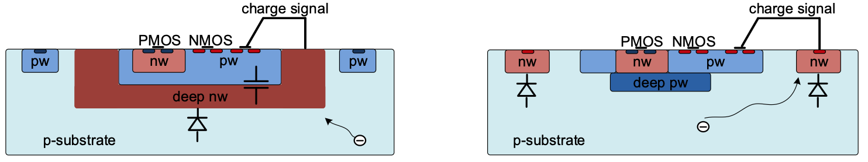
Fig. 2.1: Two approaches for DMAPS: (a) large electrode cell design, (b) small electrode cell design.

The two large area chips TJ-MALTA2 (1x2 cm²) and TJ-Monopix2 (2x2 cm²) were developed in 180 nm technology offered by Tower Semiconductor (Israel) and share common front ends components (charge collecting structure and readout amplifier) [1]. These chips are part of successive iterations in the TJ-Monopix (1 → 2) and TJ-MALTA (1 → 2 → 3) design lines. Both chips are fabricated on a common reticule (see Fig. 2.2). The key difference lies in the pixel readout architecture: while TJ-Monopix1/2 employs an established column-drain-type readout architecture, TJ-MALTA1/2/3 features a challenging low-power asynchronous readout needing GHz synchronization. The otherwise highly successful production of the Monopix1/MALTA1 prototypes showed an efficiency drop in pixel corners after irradiation which was intensively studied by interim prototyping (miniMALTA) to develop an effective solution.

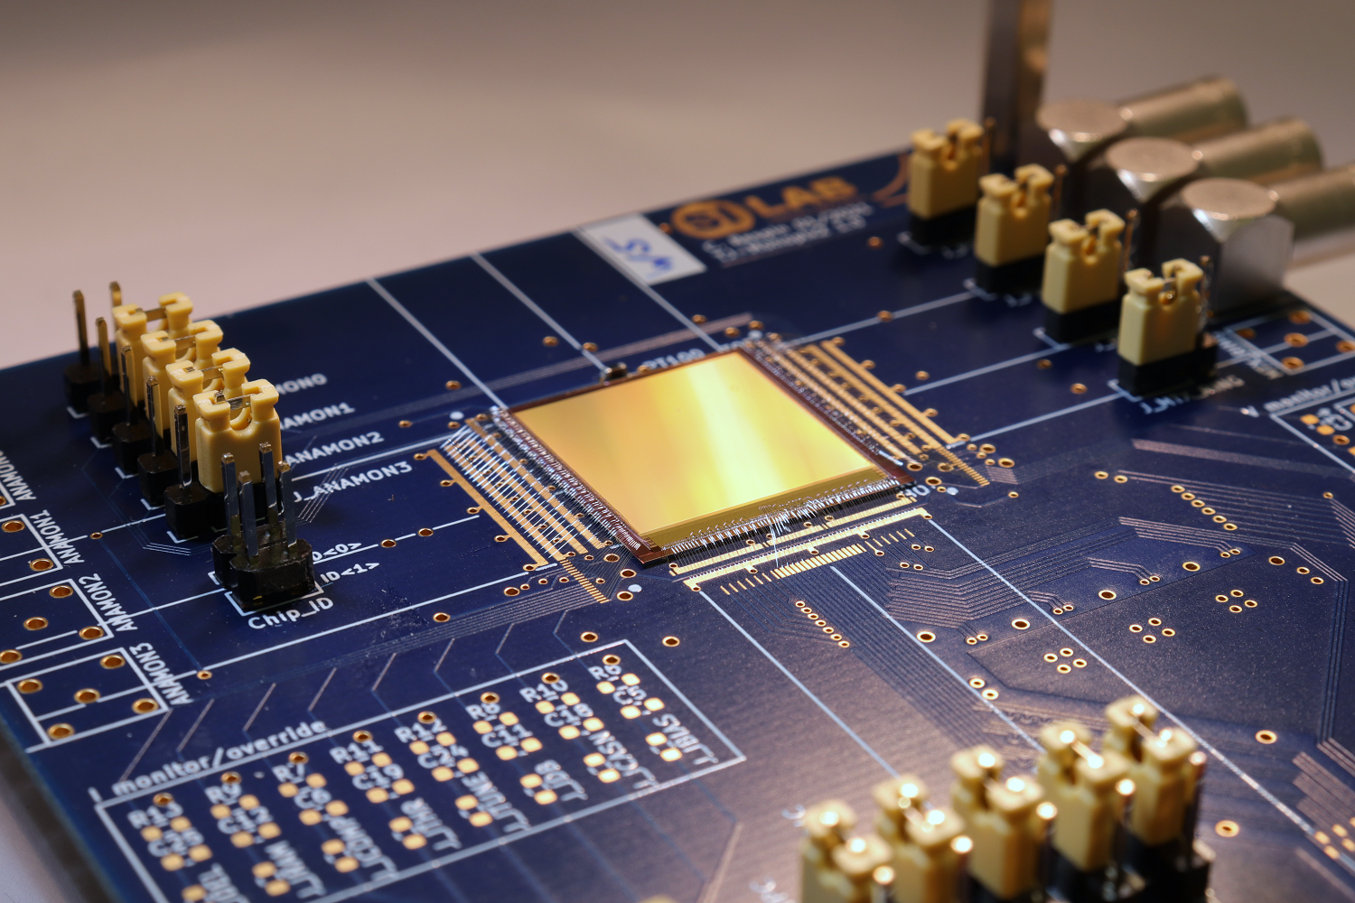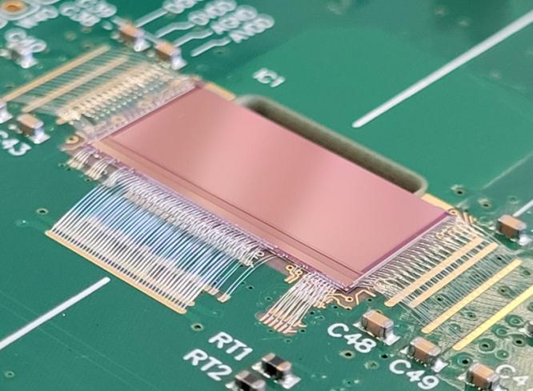
Fig. 2.2: Photographs of successfully produced TJ-Monopix2 (left) and TJ-MALTA2 (right).

The mitigation of this efficiency drop was the focus for version 2 of both chips. The following measures were implemented:
- reshaping the charge collection path by increasing the lateral electric field for better charge collection;
- improving of the first stage of the readout electronics for lower noise (primarily suppression of RTS noise) and to enable lower threshold operation;
- increasing the depletion depth by employing Czochralski (Cz) material as the substrate wafer rather than using epitaxial Si.

The TJ-Monopix2/MALTA2 chips were successfully delivered in 2021 and results were presented in D5.1 [1]. The implemented measures proved effective and solved the efficiency problem observed in the predecessor versions. Further results on their radiation tolerance are scope of the D5.4 [5]. In this report, additional results are presented for TJ-Monopix2, focusing on its timing performance, while no further results are included for TJ-MALTA2/3. The design of TJ-MiniMALTA3 [6], which incorporated several bug fixes to TJ-MALTA2, took longer than expected so that a first prototype version was received only in 2024. However, this prototype exhibited several severe flaws that prevented operation. A re-submission of this chip was necessary and happened only in April 2025 which doesn’t allow to integrate results of TJ-MALTA3 into this report.

Timing studies on TJ-Monopix2

TJ-Monopix2 has been studied with respect to its time resolution and in-time performance. The analog front-end contribution was separated from the overall timing performance by using the charge-injection circuit of the chip. A single output line is a global OR of all leading edges of the in-pixel discriminators, i.e. the fastest detected response to charge above the pixel threshold.
A time-to-digital converter with 1.5625 ns (640 MHz) binning implemented in the read-out FPGA measures the time difference between a reference signal related to the charge injection and the so-called HitOR (see Fig. 2.3). The measurement shown in Fig. 2.4 yielded a time resolution below 100 ps for the maximum injection charge which is below the most probable value deposited by minimum-ionizing particles.

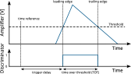
Fig. 2.3: Relevant analog and digital signals and measurement principle. The time difference between the reference signal and the leading edge is referred to as trigger delay.
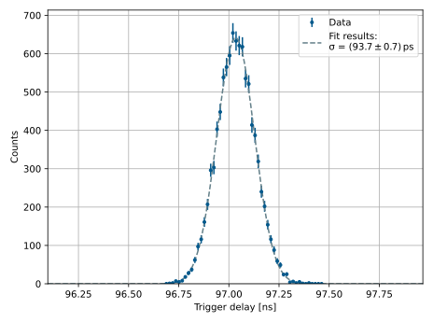
Fig. 2.4: Distribution of the measured trigger delay. A fit with a Gaussian function on data recorded with an oscilloscope yields a time resolution of 93.7 ps.
The measurement was repeated in a particle beam at the DESY II test beam facility with electrons instead of charge injection. A correction of the trigger delay based on the pixel hit position is required to accommodate for the propagation of the HitOR signal in the matrix. A scintillator is used as time reference device.
The ratio of hits registered (rising edge of the discriminator) within a given time window is referred to as in-time ratio and depicted in Fig. 2.5. For the LHC bunch spacing of 25 ns, 99.7 % of all deposited hits are registered. Even when narrowing down the time window to 15 ns, 99 % of all hits are read out within this window.
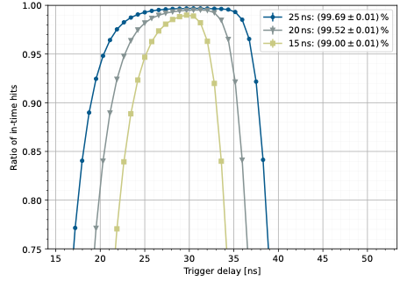
Fig. 2.5: In-time ratio of hits, depicting percentage of hits read-out within the corresponding time window. The maximum is given in the legend and can be achieved in an experiment by moving the read-out window appropriately.
The charge can be measured in TJ-Monopix2 in terms of time over threshold (TOT) which can be utilized to correct for time-walk effects offline. Applying this correction in addition to the position correction mentioned above, gives a Gaussian distribution of the trigger delay with a width of 1.25 ns as shown in Fig. 2.6. [7].
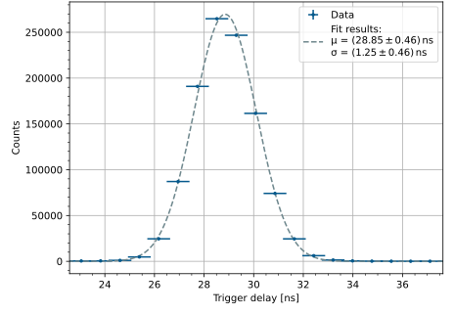
Fig. 2.6: Histogram of the measured trigger delay with respect to a scintillator in the electron beam. The large uncertainty arises from the binning of the TDC that is in a similar order of magnitude as the measured values.

DEVELOPMENT IN LFoundry 110 NM TECHNOLOGY (ARCADIA)

ARCADIa project overview
The ARCADIA project is focused on the development of a CMOS sensor design and fabrication platform based on LF11is technology. The work is also conducted in the framework of AIDAinnova WP5 Task 5.2: Development of High-Granularity DMAPS with LF 110 nm. The research and development activities cover Sensor R&D and Technology, CMOS IP Design and Chip Integration, and Data Acquisition.
A key demonstrator chip is the ARCADIA-MD3, a full-chip FDMAPS prototype for the instrumentation of a tracker detector for Future Leptonic Colliders. It features a scalable FDMAPS architecture with very low power consumption, having demonstrated an unprecedented 10 mW/cm² power density in low-power operation. The chip features a 512 × 512 pixel matrix core with a pixel size of 25 µm × 25 µm. It utilizes a triggerless data-driven readout and a low-power asynchronous architecture with a clockless pixel matrix, capable of an event rate up to 100 MHz/cm².

Sensor Concepts and Technology Demonstrators
The ARCADIA collaboration has developed fully depleted monolithic active pixel and micro strip sensors, as well as backend electronics, and has demonstrated the feasibility of implementing monolithic CMOS sensors with a gain layer for fast timing. A custom Backside Side Illumination (BSI) process enables the fabrication of thick sensors (up to 700 µm) for soft X-ray imaging.
The current report focuses on two key technology developments for future tracker and time-of-flight detectors: the ARCADIA-MD3 main FD-MAPS demonstrator chip and the R&D prototypes for fast timing.

PROTOTYPE chips DEVELOPMENT

ARCADIA MD3
The ARCADIA Fully Depleted CMOS sensor is a key outcome of the work carried out during this reporting period. The main demonstrator chip features a 512×512-pixel matrix, with each pixel measuring 25×25μm, corresponding to a total active area of 1.28×1.28cm².

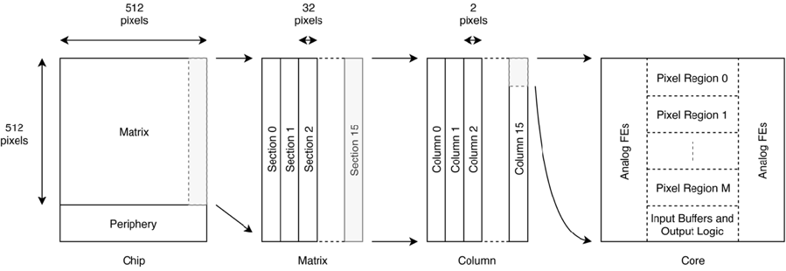
Fig. 3.1: Schematic design of the ARCADIA MD3.

The design incorporates a low-power, asynchronous, and triggerless data-driven readout architecture, with a projected event rate of up to 100 MHz/cm² (see Fig. 3.1). Performance tests of the ARCADIA main demonstrator chip, shown in Fig. 3.2 (left), have yielded promising results in terms of power efficiency. In high-rate operation (using 16 transceivers to transmit data off-chip), the power density was measured to be 17−30 mW/cm², depending on the chosen driving strength settings. For low-power operation (using a single transceiver used to transmit the data from the full matrix), the power density dropped to an unprecedented 10 mW/cm².

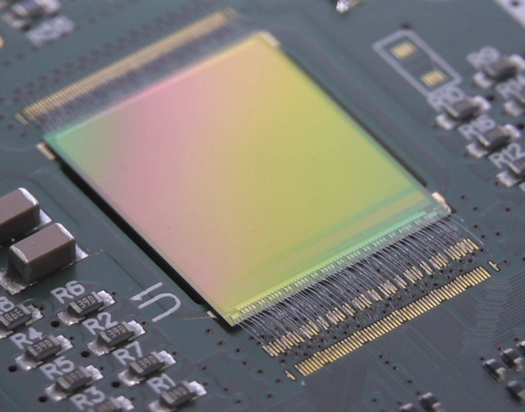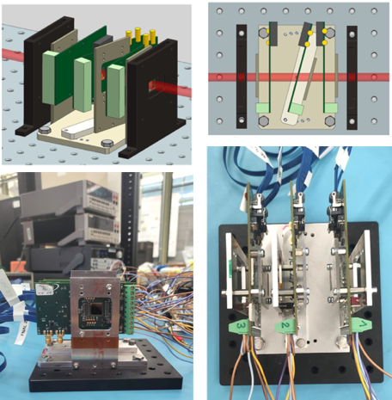
Fig. 3.2: Photo of an ARCADIA MD3 (left), arrangement of MD3 chips in test beam measurements (right).
Extensive tests have been conducted to characterize the performance of the ARCADIA sensors with various particle sources. A test beam was conducted at FNAL in July 2024 using 120 GeV protons and a mini-telescope of three ARCADIA-MD3 sensors (200 µm thick) (see Fig. 3.2, right). This test beam allowed for the first studies of cluster size, collection efficiency, and spatial resolution as a funcion of the tilt angle. The average efficiency was measured to be 99.4% ± 0.01% (see Fig. 3.3, left) with a time window of 5 µs and a spatial cut of 5 pixels, while the single-point resolution was measured to be approximately 4.7 μm as shown in Fig. 3.2 (left). Further characterization was performed using various radioactive sources, including cosmic rays, ⁹⁰Sr, ²⁴¹Am, and ⁵⁵Fe to test the sensors' response to both charged particles and photons.
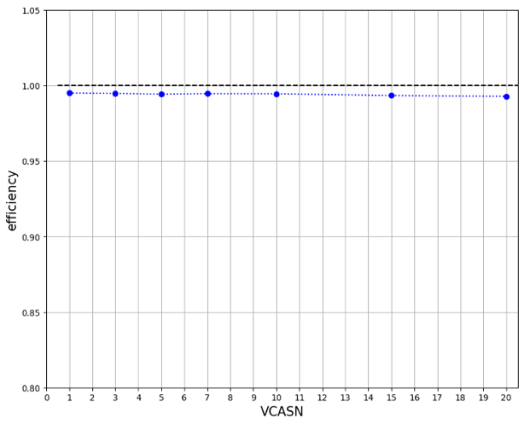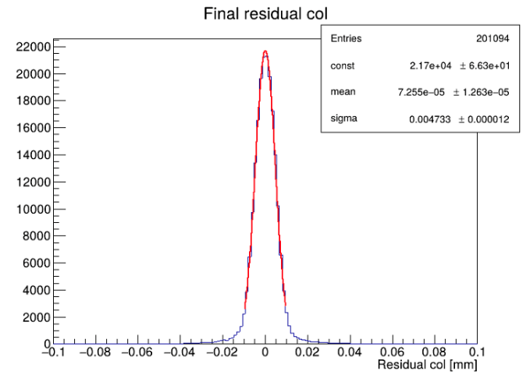
Fig. 3.3: ARCADIA MD3 efficiency (left) and position resolution (right) as measured in test beam with 120 GeV protons, see text for further details.

Detectors for time-of-flight measuremnts (MADPIX)
The MADPIX prototype is the first CMOS LGAD multi-pixel prototype with a gain layer and integrated electronics, implemented and produced as part of the ARCADIA engineering run. The initial small-scale 4 ×16 mm² demonstrator implements 8 matrices (each containing 64-pixel pads of 250 ×100 µm²) featuring different sensor and front-end design versions. The signals are read out through 64 analogue outputs on each side of the chip using a rolling shutter. The MADPIX prototype (see Fig. 3.4, middle) was tested at CERN PS in October 2024 (see Fig3.4, left). First results from the test beam show a timing resolution better than 75 ps r.m.s, with the resolution limited by the sensor (a 48 µm thick active layer on a p+ substrate), as shown in Fig. 3.4 (right). The contribution of the front-end electronics to jitter is estimated to be approximately 20 ps. The next step will be a new short-loop run with the ARCADIA mask set and a thinner n-epi active layer. In parallel, the team will also begin full-chip IP design for the ALICE3 Time-of-Flight (TOF) detector.

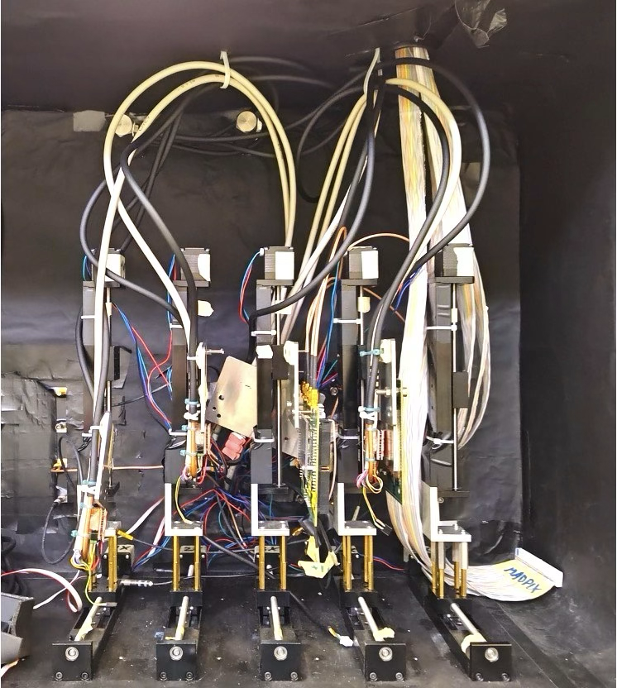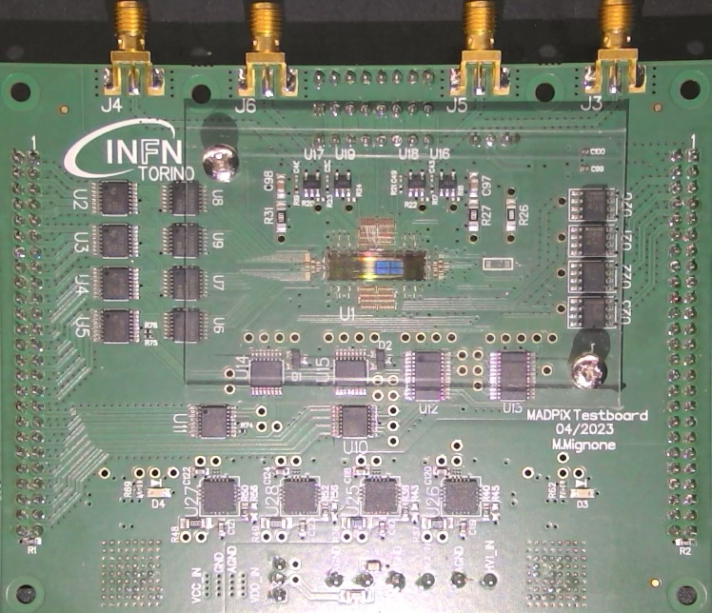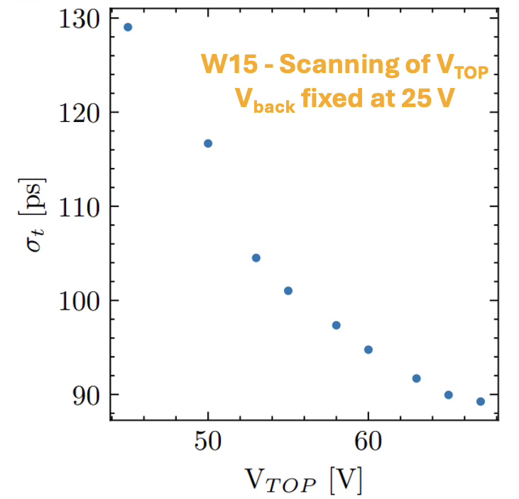
Fig. 3.4: Test setup of MADPIX in CERN PS (left); MADPIX chip mounted on PCB (middle); measured time resolution vs. top bias voltage of MADPIX (right).

R&D is ongoing to demonstrate the compatibility of the Resistive-AC-Coupled (RSD) readout scheme with the LF11 ARCADIA CMOS process flow for CMOS AC-LGADs. In this approach, an LGAD detector with continuous gain layer collects charge through a resistive n-layer, while readout is performed via induction on AC coupled pads(Fig. 3.5). This architecture enables the realization of a fully active detector, eliminating the need for isolation implants (used to prevent early breakdown) in segmented LGADs. In this detector architecture, the time resolution is approximatively independent from pixel pitch.
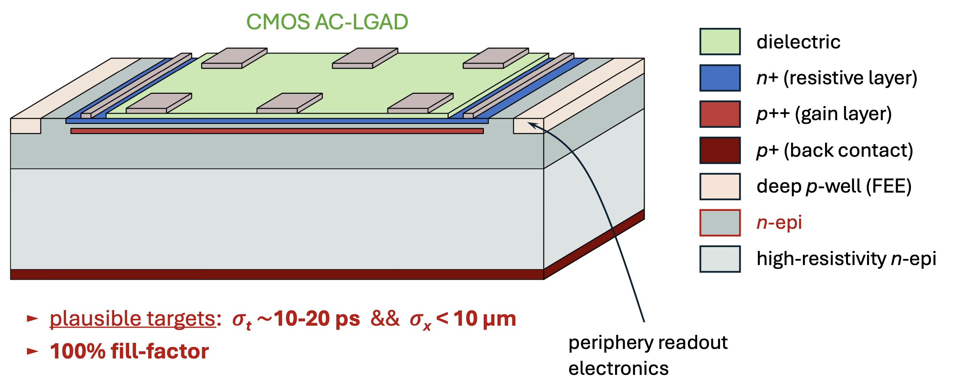
Fig. 3.5: Cross section of a LGAD detector with RSD readout.

Design activities have started to demonstrate the compatibility between the RSD readout scheme and the LF11in ARCADIA CMOS process flow, with first prototypes expected in the upcoming silicon production runs. The initial publications providing proof-of-concept and describing the CMOS integration of RSD devices were presented in [8, 9].

PROTOTYPE DEVELOPMENT IN LFOUNDRY 150 NM TECHNOLOGY (MINI-CACTUS)

DMAPS exploiting both tracking and timing capabilities are an attractive option for future experiments. Within this work package, an early prototype in the LFoundry 150 nm process called Mini-Cactus has been fabricated to explore this possibility [3].
Encouraged by the promising initial results [3, 10], the second prototype, MiniCactus-V2 was designed in LFoundry 150 nm standard CMOS technology with high substrate resistivity (2 KΩ · cm) and was characterized with particle beams. The wafers were post-processed and metalized after the fabrication and then thinned to different thicknesses: 200 μm,175 μm and 150 μm. The MiniCactus-V2 integrates two new pre-amplifiers that provide faster recovery time (≤ 25 ns) and improved time resolution. The power density in the analogue front-end is 155 mW/cm².
The test beam set up is shown in Fig. 4.1. Two timing references — a scintillator plus a photomultiplier (PMT) and a micro channel plate (MCP) — were used both as time references and for calibrating the time resolution with a three-dimension matrix. The set up also included a MiniCactus-V2 board, a GPAC/MIO and a Raspberry Pi. The Raspberry Pi was used to send the slow-control signals and the calibration injection pulses. The GPAC/MIO supplied static low voltages to control the ASICs and transmitted SPI commands from the Raspberry Pi to the ASICs. The signals from the PMT, MCP, Amp Out and HIT (from the MiniCactus-V2) were recorded with an oscilloscope (LeCroy HDO4104A) and the data were analysed offline.
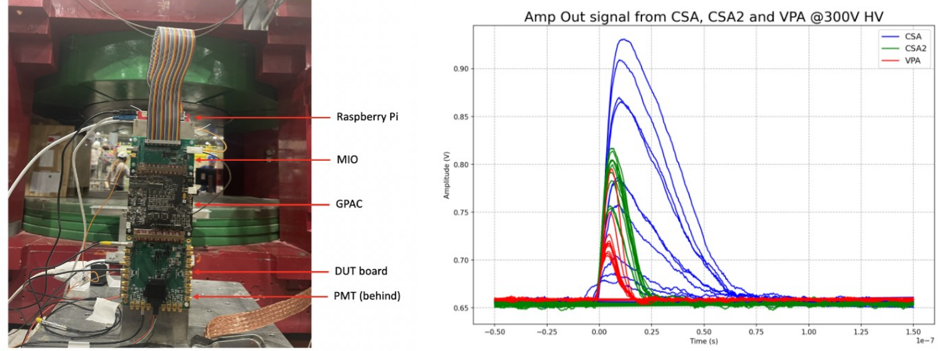

Figure 4.1: Test beam setup at CERN showing the MiniCactus-V2 boards and the readout system (left). The right plot shows the analogue outputs indicating the return to baseline is achieved within 25 ns for the new designed pre-amplifiers CSA2 and VPA (right). Taken from [11].

The time difference between the MiniCactus-V2 device and the MCP is shown in Fig. 4.2. The plot corresponds to the 0.5 × 0.5 mm² pad of a device with a thickness of 175 µm, biased at 300V, after applying the time-walk correction. From the time differences between the MCP, PMT and the device under test, one can obtain the resolution of each device. The best time resolution for the MiniCactus-V2, without optimization (without tuning of the chip parameters), was 63 ps, consistent with the previous result from MiniCactus-V1 (65 ps) [11]. However, the V2 chip shows a much better recovery time, below 25 ns. This represents a significant improvement and paves the way for future studies. Ongoing work aims to investigate the ultimate time resolution of the MiniCACTUS_V2 with optimized configurations. Tests on irradiated chips are also planned.

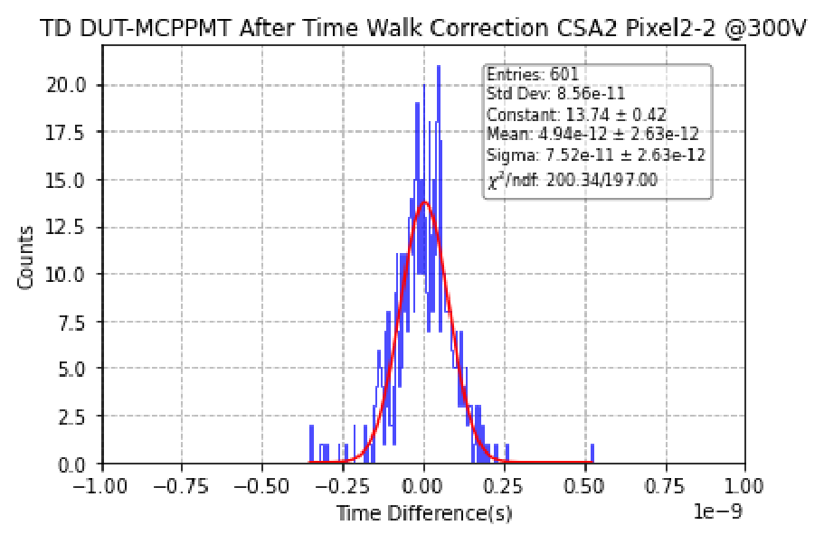
Figure 4.2: Time difference between the MiniCactus-V2 device with a pixel size of 0.5x0.5 mm² and the MCP after time-walk correction. The chip was biased to 300 V. The corresponding time resolution of the MiniCactus-V2 CSA2 is 63 ps. Taken from [11].

Conclusions and FUTURE PLANs

Results of the characterization of the high granularity DMAPS prototypes and the first devices for timing applications were presented. The TJ-Monopix2 and the TJ-MALTA2/3 large area devices delivered excellent performance in terms of operational points. These represent two of the most advanced developments worldwide, resulting in experiment-ready devices with complete readout architectures, as documented in D5.1, D5.3 and D5.4. Additionally, timing performance studies for the TJ-Monopix2 presented here demonstrates the feasibility of achieving a timing resolution of at least 1.25 ns with such DMAPS structures. Further performance results of these prototypes are expected in the future.
In parallel, a new DMAPS prototype for timing application, MiniCactus-V2, was fabricated and characterized with particle beams. The new pre-amplifiers implemented in the chip achieved an excellent time resolution of 63 ps for a 0.5×0.5 mm² pixel at 300 V. The design also enabled a fast return to baseline (< 25 ns), opening the door for the use of DMAPS in timing applications for future experiments.
The ARCADIA collaboration is continuing its R&D for the implementation of fully-depleted monolithic CMOS sensors for tracking detectors. Building on the ARCADIA-MD3 architecture and IP, the team has begun the IP development for future system-grade chips for FCC (Future Circular Collider). In addition, the group has demonstrated the possibility to fabricate sensors with a shallow gain layer beneath the collection electrode, improving the timing performance of the sensor. This option has now been adopted as the baseline technology for the ALICE3 Time-of-Flight detector. The results of this R&D are included in this report, while further production runs are scheduled for Q2 2025, targeting active-layer thicknesses of 15-25 µm to achieve ultimate timing resolution.
Finally, the first numerical studies, performed in the framework of AIDAinnova, of a monolithic CMOS RSD device, pave the way for the development of a strong candidate for the instrumentation of tracking and TOF detectors with outstanding granularity and unprecedented time resolution.

References

[1] N. Wermes, F. Huegging and S. Grinstein, “High Granularity Prototype Fabrication 1”, AIDAinnova Milestone report MS18, https://zenodo.org/record/6451880.

[2] N. Wermes, F. Huegging and S. Grinstein, “High Granularity Prototype Fabrication 2”, AIDAinnova Milestone report MS19, https://zenodo.org/records/11119559.

[3] N. Wermes, F. Huegging and S. Grinstein, “Report on performance on High Granularity DMAPS Version 1”, AIDAinnova Deliverables report D5.1, https://zenodo.org/records/8068627.

[4] N. Wermes, F. Huegging and S. Grinstein, “Report on performance of radiation-hard DMAPS”, AIDAinnova Deliverables report D5.3, https://zenodo.org/records/11190601.

[5] N. Wermes, F. Huegging and S. Grinstein, “Report of beam tests of irradiated radiation-hard DMAPS”, AIDAinnova Deliverables report D5.4, in preparation.

[6] D. Dobrijević et al., “Future developments of radiation tolerant sensors based on the MALTA architecture”, 2023 JINST 18 C03013, https://doi.org/10.1088/1748-0221/18/03/C03013.

[7] C. Bespin et al., “Timing performance of a monolithic CMOS pixel detector front-end in 180nm technology”, 2024 Panhellenic Conference on Electronics & Telecommunications (PACET), https://doi.org/10.1109/PACET60398.2024.10497069.

[8] Mandurrino, M.; Da Rocha Rolo, M.; Rivetti, A.; Margutti, G.; Di Nicolantonio, G.; Pancheri, L. Numerical Proof-of-Concept of Monolithic AC-LGAD Detectors for 4D Particle Tracking. Sensors 2025, 25, 4185. https://doi.org/10.3390/s25134185

[9] M. Mandurrino 2025 JINST 20 C07042

[10] Y, Degerli et al., “MiniCACTUS: Sub-100 ps timing with depleted MAPS”, Nuclear Instruments and Methods in Physics Research Section A, Vol 1039, Sep 2022, Page: 167002. https://doi.org/10.1016/j.nima.2022.167022.

[11] Y. Gan, et al., “The first test-beam results of MiniCACTUS-V2: an ASIC prototype with 60 ps time resolution and a fast recovery time”, 2025 JINST 20 C04013, https://doi.org/10.1088/1748-0221/20/04/C04013.

NOTE: for a full list of the AIDAinnova WP5 publications, please see the following link: https://zenodo.org/communities/aidainnova-project/search?page=1&size=20&keywords=WP5.

Annex: Glossary

Acronym | Definition
DMAPS | Depleted Monolithic Active Pixel Sensors

