Tunable Plasmonic Circular Dichroism of Hierarchical Chiral Assemblies
Jaime Gabriel Trazo,^{1$} Andrés Serrano Freijeiro,^{2$} Mikhail Mychinko,³ Nika Kutalia,¹ Marianne Impéror-Clerc,¹ Sara Bals,³ Luis M. Liz-Marzán,^{2,4,5,6} Jorge Pérez-Juste,^{2*} Isabel Pastoriza Santos,²* and Cyrille Hamon¹*
¹ Laboratoire de Physique des Solides, Université Paris-Saclay, CNRS, Orsay 91405, France.
² CINBIO, Universidade de Vigo, Departamento de Química Física, Campus Universitario As Lagoas, Marcosende, Vigo 36310, Spain
³ EMAT and NANOlab Center of Excellence, University of Antwerp, 2020 Antwerp, Belgium.
⁴ CIC biomaGUNE, Basque Research and Technology Alliance (BRTA), 20014 Donostia-San Sebastián, Spain;
⁵ Centro de Investigación Biomédica en Red de Bioingeniería, Biomateriales y Nanomedicina (CIBERBBN), 20014 Donostia-San Sebastián, Spain;
⁶ Ikerbasque, Basque Foundation for Science, 48009 Bilbao, Spain;
$ J.G.T and A.S.F contributed equally to this paper
* Corresponding authors
Jorge Pérez-Juste: juste@uvigo.gal
Isabel Pastoriza Santos : pastoriza@uvigo.gal
Cyrille Hamon : cyrille.hamon@cnrs.fr

Abstract
Plasmonic circular dichroism (PCD) is a powerful approach for enhancing chiroptical effects at the nanoscale, with promising applications such as optical information processing, sensing, and catalysis. However, a key challenge remains in achieving both strong and tunable chiral optical responses. While most strategies use either intrinsically chiral nanoparticles (NPs) or achiral NPs arranged into chiral assemblies, combining both offers a promising route to amplify chiral optical responses. Here, fourfold-twisted gold nanorods (cGNRs) were assembled by depletion-induced self-assembly (DISA) into chiral superstructures with tunable PCD properties. By reducing cGNR helicity via chemical etching, we study how building block helicity affects hierarchical structure formation. Whereas static helical supercrystals were obtained on substrates upon evaporation-induced self-assembly (EISA), DISA allowed us to dynamically modulate the interparticle distance in solution from 13 ± 1.2 nm to 6.9 ± 1.0 nm. The assembly/disassembly process was found to be fully reversible, thereby enabling a modulation of the g-factor by two orders of magnitude with a switching rate of approximately 1 hour. Beyond achieving high dissymmetry factors of 0.2, our approach establishes a reconfigurable PCD platform that is free from ligand exchange constraints and compatible with different NP shapes. Though response times remain too slow for optical computing, these findings are relevant for the development of optical modulators and memory devices based on dynamic chiral metafluids.
Keywords: chirality, nanoparticles, plasmonics, electron tomography, small angle X-ray scattering, self-assembly

Introduction
Plasmonic circular dichroism (PCD) is emerging as a powerful tool for amplifying chiroptical effects at the nanoscale, which can be driven by various mechanisms.¹⁻⁴ Here, we focus on a combination of optical activity arising from geometrical chirality, which can be observed in colloidal nanoparticles (NPs) lacking mirror and inversion symmetry, with the assembly of colloidal NPs into chiral superstructures. Colloidal PCD materials enable energy selective, dissymmetric interactions with circularly polarized light, opening potential applications in chiral sensing, enantioselective catalysis and optical information processing.⁵⁻¹¹ Various synthetic protocols have been developed to produce chiral plasmonic NPs, often involving chiral molecules or micelles,^{12, 13} while also different strategies have been employed for the assembly of achiral NPs into chiral structures.¹⁴⁻¹⁷ Although these two approaches have evolved independently, a few recent studies propose combining them to obtain materials with high and tunable dissymmetry factors.¹⁸⁻²² Some of these recent works have focused on assembling chiral NPs into achiral structures to induce a tunable PCD response, but no significant increase in the PCD amplitude was reported. Instead, different outcomes were observed: either a loss of the PCD response²⁰ or a spectral shift in the PCD signal due to plasmonic coupling.^{21, 22} PCD enhancement appears to depend critically on hierarchical chirality, as shown in another work,¹⁸ where the assembly of four-fold twisted chiral gold nanorods (cGNRs) into helical superstructures led to enhanced PCD compared to individual cGNRs.¹⁸ In the latter work, the assembly process was driven by the irreversible aggregation of colloids upon electrostatic screening. We hypothesized that introducing depletion forces in such systems would offer a greater versatility in tuning the interactions between cGNRs, thereby enabling active control over the PCD response.
Depletion-induced self-assembly (DISA) is driven by an entropic attraction between colloids upon introduction of smaller particles, as bringing the colloids closer together increases the free volume available to the depletants (typically polymers or surfactant micelles).²³⁻²⁶ The range of accessible interparticle distances is given by the size of depletant, whereas the strength of the interaction increases with the osmotic pressure, hence with the depletant concentration.²⁶ In the plasmonic NP field, DISA has been primarily used for shape purification and for the formation of assemblies on substrates, in conjunction with evaporation-induced self-assembly (EISA). Recent works has demonstrated that DISA can be used for the reversible assembly of plasmonic NPs in suspension into well-defined structures with tunable lattice parameters.^{25, 27-29} In this process, there is no need for ligand exchange because the same surfactant used during NP synthesis can also be used for DISA, where the micelles serve as effective depletants. Although various anisotropic NP shapes have been successfully assembled using DISA, the self-assembly of chiral NPs through this method remains unexplored.
Reconfigurable PCD materials offer a precise control over spectral and dynamic aspects of the PCD response, which is essential for developing responsive chiral nanodevices.^{30, 31} While PCD can be manipulated by applying external stimuli (e.g., chemical, electrical, mechanical, or electromagnetic) to NPs attached onto a substrate,³¹ their structural conformation remains largely unchanged. In contrast, chiral assemblies dispersed in solution offer a promising alternative, because colloids can be assembled, disassembled, and rearranged into tailored structures to modulate the PCD response. Beyond being fundamentally different from substrate-based strategies, such “metafluids” are isotropic, thereby avoiding the dependence of excitation incidence, and their ability to reconfigure in volume can be advantageous for chiral sensing and catalysis, by facilitating interactions between target molecules and NPs. Typically, existing reconfigurable systems rely on soft matter templates, like liquid crystals or DNA origami, to control the orientation of achiral plasmonic NPs.³¹⁻³⁵ However, these template-based approaches impose limitations on versatility and scalability, requiring processing steps such as ligand exchange and template design, which constrain NP shape, size, and achievable assemblies. Moreover, the assembly of chiral NPs into higher-order chiral nanostructures is yet to be demonstrated by these methods. In contrast, DISA offers a template-free approach that can simply consist of modulating the concentration of the surfactant used during NP synthesis to drive their assembly. Here, we show that DISA can be used to assemble higher-order chiral structures with dynamically tunable chiroptical properties. This represents a significant step toward the creation of active chiral fluids capable of controlling light's amplitude, frequency, and polarization in real time.
We report the reconfigurable assembly of cGNRs into hierarchical chiral structures. We synthesized cGNRs and controlled their helicity through precise chemical etching, resulting in nanostructures with varying lattice symmetries. Using EISA with the same cGNRs, we obtained supercrystals with a helical structure, whereas DISA allowed for tunable inter-NP distances by adjusting the depletant concentration, ranging from 13 nm to 7 nm. The g-factor of the assembled cGNRs was enhanced by two orders of magnitude compared to the isolated cGNRs measuring at the same wavelength, reaching these assemblies a highest value around 0.2. Furthermore, the PCD response could be dynamically adjusted in solution by cGNR assembly and disassembly. This work demonstrates that DISA enables the formation of template-free, reconfigurable chiral materials with tunable chiroptical properties.
Results and discussion
Fourfold-twisted of cGNRs were synthesized by seeded growth on achiral single-crystalline GNR seeds, in the presence of a molecular chiral inducer – namely L-cysteine.³⁶ To systematically adjust the helicity of the resulting cGNRs, controlled chemical etching was performed by using Au³⁺ as an oxidant, which resulted in a gradual transformation of the twisted cGNRs into achiral nanorods with rounded edges (Figure 1a). Our study focused on three GNR batches: as synthesized chiral nanorods (cGNR_1), partially-oxidized nanorods (cGNR_2) obtained by etching during 3 hours, and fully oxidized nanorods (cGNR_3) obtained by extended etching for 24 hours. The dimensions of the resulting nanoparticles, determined by transmission electron microscopy (TEM), in terms of length (L) and width (W) were as follows: cGNR_1 (L = 113.8 ± 11.3 nm, W = 59.1 ± 4.4 nm); cGNR_2 (L = 104.2 ± 10.0 nm, W = 54.9 ± 3.4 nm); cGNR_3 (L = 89.5 ± 9.9 nm, W = 60.6 ± 2.9 nm) (Figure S1). Representative cGNRs from each sample were investigated by electron tomography (ET), and the 3D reconstructions evidenced that the degree of twisting decreased in the order cGNR_1 > cGNR_2 > cGNR_3 (Figure 1b). This trend was confirmed by quantitative analysis of the twisted morphology through computation of the helicity function H(ρ,α) from the 3D reconstructions as recently reported (Figure 1c, see SI for details on the quantification).³⁷ Indeed, total helicity values H_{tot} of 0.065, 0.045, and 0.018 were determined for cGNRs obtained at increasing etching times. The positive sign of the helicity measure indicates a right-handedness of the nanorods, as expected from seed mediated growth in the presence of L-cysteine. As etching progressed, a blue-shift of the longitudinal plasmon band was observed (Figure 1d), along with a reduction in circular dichroism (Figure 1e), indicating the loss of plasmonic chirality due to cGNR etching.
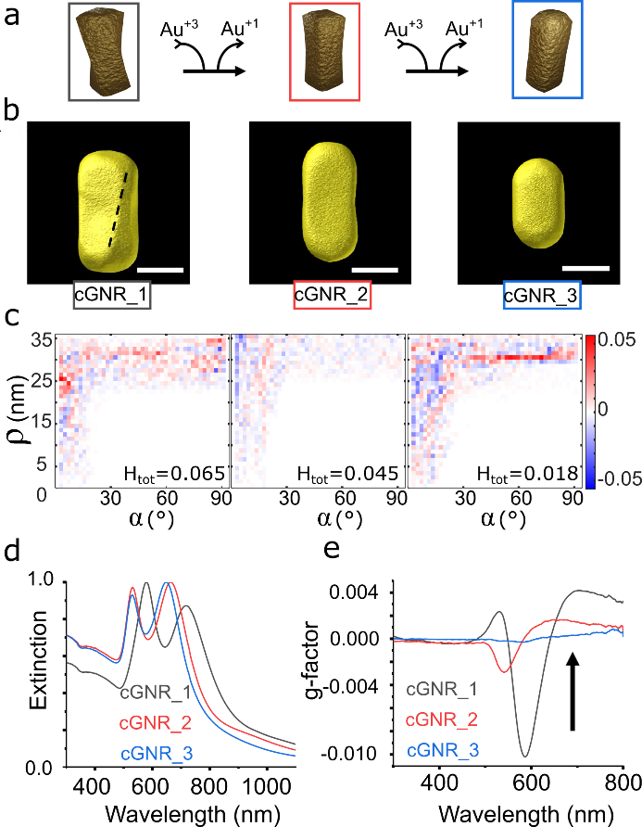
Figure 1: Reducing the helicity of twisted gold nanorods by controlled etching. (a) Scheme of the etching process to gradually reduce the helicity of cGNRs. (b) Electron tomography reconstructions of cGNRs with decreasing helicity. Scale bar is 50 nm for all images. (c) Corresponding plots of the helicity function H(ρ,α) for each cGNR. (d-e) Extinction and g-factor spectra, respectively, for the different cGNR samples.
All three cGNR colloids were then self-assembled by using two methods, EISA on a substrate and DISA in solution. For the dried assemblies, the resulting nanostructures were analyzed via in-situ small angle X-ray scattering (SAXS) and scanning electron microscopy (SEM) (Figure 2).
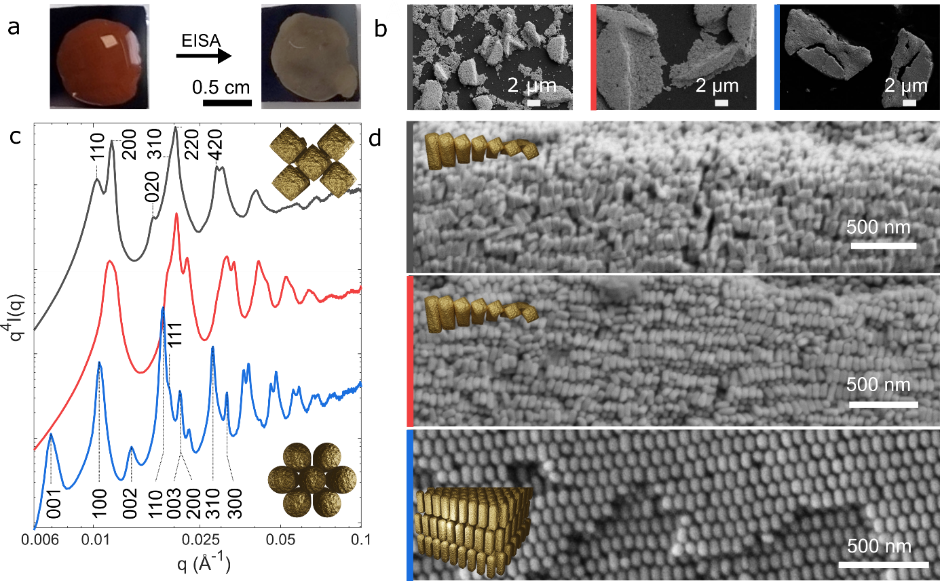
Figure 2: Self-assembly of cGNRs with varying helicity into supercrystals. (a) Photograph of a sessile droplet containing cGNR_1 before (left) and after (right) drying on a silicon substrate. (b) SEM micrographs at low magnification, corresponding to cGNR_1 (black), cGNR_2 (red) and cGNR_3 (blue) supercrystals. (c) SAXS-integrated diffractograms collected on dry supercrystals for cGNR_1 (black), cGNR_2 (red) and cGNR_3 (blue) and corresponding indexation for a 2D rectangular lattice (top) and a 3D hexagonal lattice (bottom). (d) SEM micrographs high magnification, corresponding to cGNR_1 (black), cGNR_2 (red) and cGNR_3 (blue) supercrystals.
We studied first the self-assembly of cGNRs into supercrystals by EISA. A droplet of each cGNRs sample in 2.5 mM cetyltrimethylammonium chloride (CTAC) solution was allowed to evaporate slowly on a silicon substrate (Figure 2a). Upon complete drying, supercrystals with semi-elliptical shapes and of varying sizes were analyzed by SEM (Figure 2b,d and S4-S6). The average size of the supercrystals increased as the helicity of the rods decreased, ranging from 5.3 ± 2.5 μm² for cGNR_1, to 38.1 ± 14.4 μm² for cGNR_2, and 30.3 ± 10.7 μm² for cGNR_3 (Figure S2). These results suggest that the packing frustration for cGNR_1 is more likely to introduce lattice defects than cGNR_3, which in turn causes the supercrystals to break at smaller sizes. For complementary structural analysis, we collected 2D SAXS images and processed the data to generate the integrated diffractograms shown in Figure 2c. In SAXS, the beam footprint measured approximately 175 × 300 µm², significantly larger than a single supercrystal. As a result, each measurement represents an average over multiple supercrystals, providing a broader structural overview that complements the local observations obtained through SEM. For both cGNR_1 and cGNR_2, SEM micrographs revealed a layered helical structure (Figure 2d), which was indexed as a rectangular centered (rhombic) lattice by SAXS (Figure 2c). This structure consists of stacked twisted layers of cGNRs, where each individual layer has a centered rectangular lattice. On the other hand, a hexagonal lattice structure was identified for cGNR_3 (Figure 2c). We also collected SAXS diffractograms at different positions on the sample, as the structure could vary between the edge and the center due to the coffee ring effect (Figure S3).³⁸⁻⁴⁰ While the structure of cGNR_2 supercrystals remained consistent across the substrate, cGNR_1 supercrystals were more extended at the edges of the deposit. Additionally, the orientation of cGNR_3 gradually shifted from horizontal (long axis parallel to the substrate) at the edges to vertical (long axis perpendicular to the substrate) toward the center. Variation in nanorod orientation across the sample and semi-elliptical supercrystal shapes have been observed across a range of nanorod systems with differing shapes and surface chemistries,⁴¹⁻⁴³ suggesting that the underlying mechanism is independent of these specific parameters. While the coffee-ring effect is known to generate gradients in NP and surfactant concentrations during evaporation,^{38, 40} the precise role of these gradients in directing the formation and symmetry of supercrystals is not yet fully understood. Further studies are required to disentangle the contributions of evaporation dynamics, interparticle forces, and interfacial effects to the final superstructure morphology. Overall, our experiments demonstrate that supercrystals with hierarchical chirality can be achieved through EISA for building blocks with geometrical helicity. However, since the structures are dried, they are non-reconfigurable.
Our second approach involved the self-assembly of cGNRs in solution through DISA.^{26, 29} As CTAC micelles act as effective depletants, the cGNRs were exposed to various CTAC concentrations to induce the formation of colloidal assemblies (Figure 3a).

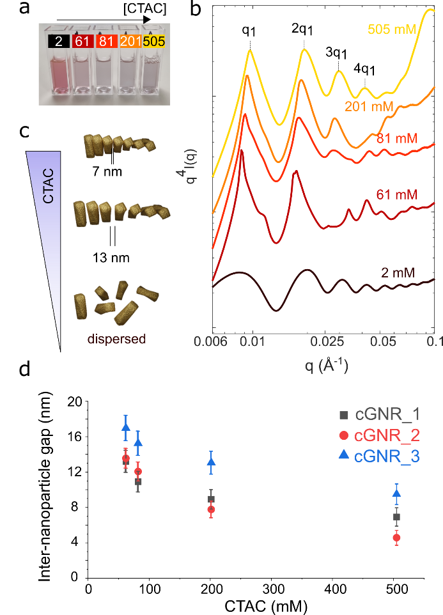
Figure 3: cGNRs assembled by DISA in solution. (a) Photograph of five cuvettes containing cGNR_1 at 2 mM, 61 mM, 81 mM, 201 mM, and 505 mM CTAC concentrations, from left to right. (b) SAXS-integrated diffractograms collected in solution for cGNR_1 at the same CTAC concentrations. (c) Schematic illustrating how variations in CTAC concentration modulate inter-NP distance. (d) Plot of inter-NP gap distance (face-to-face) as a function of CTAC concentration.
At 2.5 mM CTAC, the SAXS curves correspond to the form factor of non-interacting isolated NPs, indicating stable dispersions (Figure 3b). At CTAC concentration above 60 mM, Bragg peaks emerge, indicating the formation of colloidal cGNR assemblies. The peak indexation revealed different structures depending on nanorod helicity. The cGNR_1 sample exhibited a 1:2:3:4 peak progression, corresponding to the formation of one-dimensional (1D) nanostructures with an internal side-by-side nanorod alignment (Figure 3b). In comparison, cGNR_2 and cGNR_3 assemble in solution into 2D nanostructures, consistent with their EISA counterpart. While cGNR_2 assemble into 2D centered rectangular lattices (Figure S7a), cGNR_3 lattice is hexagonal (Figure S7b). Debye-Scherrer analysis⁴⁴ revealed that the extension of the lattices was consistently smaller for cGNR_1, compared to cGNR_3 (Figure S8). These trends align with the size analysis EISA obtained supercrystals (Figure S2), yet the smaller size of assemblies formed in solution compared to those formed upon drying suggests that the slow drying process promotes the development of higher-order structures. Although lattice symmetries were similar between EISA and DISA samples, the inter-NP gap distances differed significantly between both strategies. The inter-NP distance averaged 2.6 ± 0.9 nm in the EISA samples, whereas it ranged from 13.2 ± 1.2 nm to 6.9 ± 1.0 nm in DISA for cGNR_1 as CTAC concentration in the colloidal dispersion was varied (Figure 3c-d). This shifting equilibrium distance results from the balance between attractive forces (depletion and van der Waals) and repulsive electrostatic interactions.²⁷ Around 500 mM in CTAC, the inter-NP spacing approaches the thickness of the two surfactant bilayers coating adjacent cGNRs (≈ 6.4 nm).⁴⁵ Overall, SAXS experiments indicate that the assemblies of cGNRs formed by DISA corresponds to the helical assemblies formed by EISA in terms of lattice symmetry (but not inter-NP distance). To complement SAXS results, we carried out liquid-phase TEM (LPTEM) and cryo-TEM to image the assemblies of cGNR_1 in the direct space (Figure S9-S10). In both case, side to side arrangement was evidenced, supporting the formation of 1D nanostructures in solution. This set of experiment allowed us to confirm a larger inter-NP distance for assemblies obtained via DISA, compared to EISA, with approximately 10 nm observed in solution (Figure S10), versus 2.5 nm in the dried state, in good agreement with SAXS diffractograms. Although LPTEM and cryo-TEM confirmed the presence of large interparticle distances, they did not allow us to estimate the twist angles. This limitation stems from the tendency of such assemblies to reorganize, especially in confined environments where NPs align with interfaces. We have previously studied this effect and demonstrated that assemblies formed via DISA can undergo rearrangement before and during TEM observation, mainly due to radiolysis effects.⁴⁶
We now turn our focus on the PCD response of the colloidal assemblies mediated by DISA (Figure 4a). As a control experiment, tests were conducted at a low CTAC concentration (10 mM), where no assemblies were observed, so both extinction and CD spectra remained unaltered (Figure 4b).
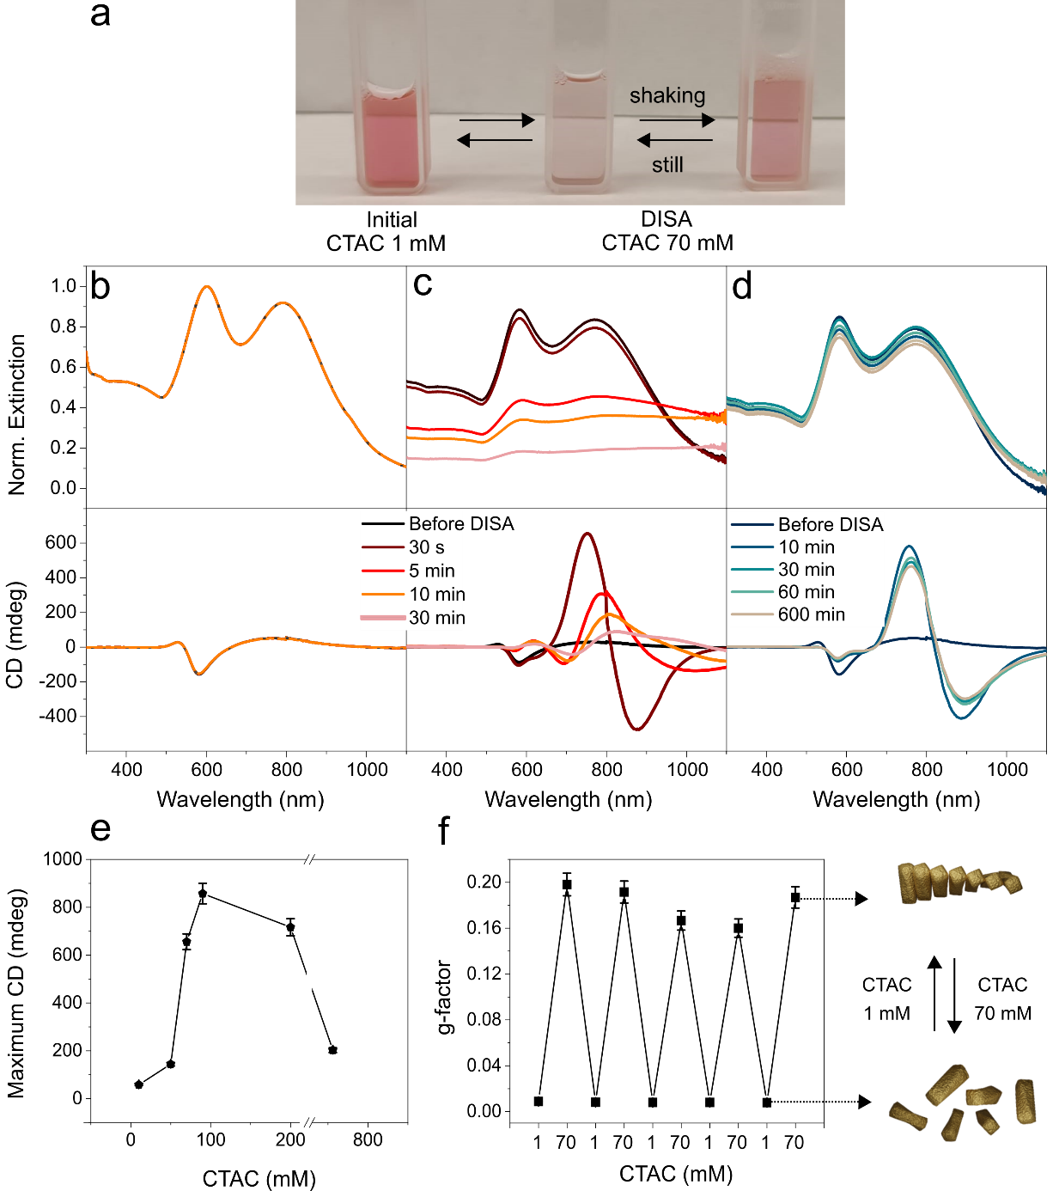
Figure 4: Reconfigurable PCD assembly of cGNR_1 via DISA. (a) Photograph of three cuvettes containing, from left to right: cGNR_1 in 1 mM CTAC; cGNR_1 in 70 mM CTAC after 30 minutes of sedimentation; and cGNR_1 in 70 mM CTAC after redispersion of the precipitate. (b-d) Self-assembly kinetics of cGNR_1 in 10 mM (b) and 70 mM (c) CTAC monitored by extinction (top) and CD (bottom) spectroscopies. (d) Extinction (top) and CD (bottom) spectra of cGNR_1 dispersion in 70 mM CTAC recorded at different times. Before optical measurements, the colloidal dispersion was manually shaken. (e) Maximum CD response as a function of CTAC concentration. (f) Reconfigurable g-factor, calculated at 740 nm, as a function of CTAC concentration cycles. Schemes illustrating the concept of reconfigurable PCD response.
At CTAC concentration above 50 mM, DISA induced significant enhancement of the chiroptical response of the cGNR suspensions (Figure 4c and Figure S11). Kinetic experiments were conducted by monitoring the CD signal throughout the self-assembly process. As shown in Figure 4c for 70 mM CTAC, assemblies formed rapidly within 30 seconds and continued to grow over the following 30 minutes. Kinetic SAXS experiments confirmed that the assemblies formed within 2 minutes (Figure S12). At the earlier stages of DISA, enhanced CD responses compared to individual cGNRs were recorded, together with a reversal of the bisignate peak of the assemblies compared to the individual NPs (Figure 4c and Figure S11). For instance, the cGNR_1 assemblies achieved an optical asymmetry g-factor of 0.2 at 740 nm which was two orders of magnitude higher than that of individual c-GNRs (0.0016 at the same wavelength). We infer that chiral amplification may arise from the formation of clusters rather than requiring extended order,¹⁸ as supported by SAXS experiments. Moreover, the inversion in chirality can be attributed to a gain in compactness when the cGNRs of a given helicity self-assemble into structures with opposite handedness.¹⁸ At later stages of the DISA process, the CD signal red-shifted and decreased in amplitude, likely due to the formation of larger assemblies that sedimented at the bottom of the cuvette (Figure 4a). Similar results were obtained for CTAC concentrations ranging from 50 to 756 mM (Figure S11). It should be noted that the decrease in CD signal at CTAC concentrations above 100 mM is due to the extremely fast depletion and sedimentation of the particles, which does not allow for a reliable measurement of the CD response of the assembly. Interestingly, at any stage of the process, the assemblies sedimented in the cuvette could be redispersed restoring a CD signal close to its initial maximum value, even after 10 hours (Figure 4d). Analyzing the extinction and CD band during the self-assembly revealed a gradual red shift due to plasmonic coupling between neighboring NPs (Figure 4c and Figure S11).⁴⁷ Since, side-to-side NP coupling would result in a blue shift of the resonance modes,¹⁸ the red shift here suggests the formation of self-assemblies with multiple coupling modes, including both side-to-side and end-to-end interactions. Interestingly, plotting the maximum CD as a function of CTAC concentration revealed a maximum when particles were dispersed in 90–200 mM CTAC (Figure 4e, Figure S11).
From the SAXS analysis, we can conclude that the overall size of the assemblies did not change significantly with the added CTAC concentration (Figure S13), counting 3-4 cGNRs per assembly and with inter-NP distances varying between 10.9 ± 1.2 nm and 8.9 ± 1.1 nm within the 90-200 mM CTAC range. Therefore, the variation of the CD response with CTAC concentration could be ascribed to the assembly of cGNRs. Similar experiments were carried out with cGNR_2 and cGNR_3 at 70 mM CTAC. As shown in Figure S14, self-assembly led to an enhanced CD signal for cGNR_2, whereas the increment was lower than for cGNR_1. In contrast, no significant CD response was detected for cGNR_3. LPTEM and Cryo-TEM analyses of the assemblies confirmed the presence of a ladder-type assembly with relatively large interparticle distances (see Figures S9-S10) but, unfortunately, these techniques did not allow us to obtain a reliable estimate of the twist angle. Recently, Liu et al. reported finite difference time domain (FDTD) simulations for assemblies comprising cGNRs with a similar morphology to those presented in our study.¹⁸ The authors studied in detail the effect of the number of particles forming the assembly, the gap distance between particles, and the rotation angle between adjacent particles. The results indicate a highest CD signal for assemblies containing 3-5 chiral nanorods, with gap distances of 3-6 nm and rotation angles between 20° and 30° (see Figure 4 in ref. 18). Interestingly, the reported FDTD simulations are in good agreement with our experimental spectra. Therefore, even though the limitations of the DISA approach do not allow an in situ determination of the rotation angle, we propose that the FDTD simulations reported in reference 18 sufficiently explain our experimental data.
We then leveraged the tunability of depletion interactions to actively adjust the PCD response of these assemblies. Initially, cGNR_1 was self-assembled via DISA at 70 mM CTAC, and the resulting sediment was subsequently redispersed in a 1 mM CTAC solution inside the same cuvette (Figure 4f and Figure S15). This cycle was repeated multiple times, leading to reversible g-factor variations spanning two orders of magnitude (from 0.0016 to 0.2 measured at 740 nm) as the system switched between disassembled and assembled states. Notably, at higher wavelengths (e.g. 880 nm), the dispersed cGNRs almost do not display chiroptical activity (g-factor around 0.001) whereas the assemblies display a high g-factor of 0.1. This demonstrates that integrating chirality across different length scales is a promising strategy for designing materials with strong chiroptical properties over a broad spectral range. Additionally, our approach enables modulation of the g-factor in solution, achieving a two-orders-of-magnitude change with a switching rate of approximately one hour, which can be accelerated by centrifugation for five minutes at 2240 rcf.
Conclusions
This work demonstrates that cGNRs can be assembled into hierarchical chiral nanostructures via DISA, exhibiting enhanced, spectrally tunable, and temporally dynamic PCD responses. Gold nanorods with a gradual degree of helicity were obtained by colloidal synthesis combined with chemical etching, allowing us to investigate how the chirality of the building blocks influences the construction of higher order chiral structures by self-assembly. Different hierarchical structures, ranging from smectic to centered rectangular, were obtained by EISA, notably forming extended helical supercrystals on substrates. In solution, the cGNRs can be reversibly assembled by DISA, resulting in a wide tunability of the PCD response. In these experiments, the inter-NP gap distance could be tuned from 13 ± 1.2 nm to 6.9 ± 1.0 nm nm by adjusting CTAC concentration. The reversible process of assembling and disassembling the NPs could be repeated multiple times inside the same cuvette, leading to variations of the g-factor by two orders of magnitude when switching between the disassembled and assembled states. This work shows that DISA can be used to form nanostructures with hierarchical chirality displaying enhanced, spectrally tunable and temporally evolving PCD responses. Besides achieving a remarkably high g-factor, we demonstrate reconfigurable PCD response with a switching rate of about 1 hour. While these rates are still too slow for display technologies or optical computing,^{48, 49} they open new possibilities for optical modulators and memory devices. Overall, DISA offers a novel pathway to achieve hierarchical chirality in plasmonic NPs, with the added advantage over purely electrostatic strategies of greater versatility, enabling reconfigurability and tunable optical responses.
Acknowledgment
The CNRS is acknowledged for funding and support. C.H. acknowledges financial support from the ANR CODENAME project (ANR-23-CE09-0032). The authors acknowledge SOLEIL for the provision of synchrotron radiation facilities (experiments 20231786) and we would like to thank Thomas Bizien for assistance in using beamline SWING. The authors thanks Stéphan Rouzière for the use of the MORPHEUS platform. The present work had benefited from the electronic microscopy facility of Imagerie-Gif, (http://www.i2bc.parissaclay.fr), member of IBiSA (http://www.ibisa.net), supported by “France-BioImaging” (ANR10-INBS-04-01), and the Labex “Saclay Plant Science” (ANR-11-IDEX-0003-02). M.M. and S.B. acknowledge financial support by the European Research Council (ERC CoG No. 815128 REALNANO). I.P.-S., J.P.-J. acknowledge the support from MICIU/AEI/10.13039/501100011033 and ERDF/EU (Grant Number: PID2022-138724NB-I00) and the Xunta de Galicia/ERDF (grant GRC ED431C 2020/09). I.P.-S., J.P.-J., L.M.L.-M. and A.S.-F. acknowledge the use of scientific and technical services of Centro de Apoio Científico e Tecnolóxico á Investigación (CACTI-Universidade de Vigo). L.M.L.-M. and S.B. acknowledge funding from the European Research Council (ERC Synergy Grant #101166855 CHIRAL-PRO).
Supporting Information Available
The supporting information contains: TEM image analysis of the cGNRs, SEM image analysis of the supercrystals, SAXS analysis of the supercrystals obtained by DISA and EISA, additional SEM images of the self-assembled systems, electron tomography reconstructions images of the assemblies, additional optical characterization of the assemblies by CD and extinction spectroscopy.
References
(1) Cho, N. H.; Guerrero-Martínez, A.; Ma, J.; Bals, S.; Kotov, N. A.; Liz-Marzán, L. M.; Nam, K. T. Bioinspired chiral inorganic nanomaterials. Nat. Rev. Bioengineer. 2023, 1 (2), 88-106.
(2) Ávalos-Ovando, O.; Santiago, E. Y.; Movsesyan, A.; Kong, X.-T.; Yu, P.; Besteiro, L. V.; Khorashad, L. K.; Okamoto, H.; Slocik, J. M.; Correa-Duarte, M. A.; et al. Chiral Bioinspired Plasmonics: A Paradigm Shift for Optical Activity and Photochemistry. ACS Photonics 2022, 9 (7), 2219-2236.
(3) Hentschel, M.; Schäferling, M.; Duan, X.; Giessen, H.; Liu, N. Chiral plasmonics. Sci. Adv. 2017, 3 (5), e1602735.
(4) Goerlitzer, E. S. A.; Puri, A. S.; Moses, J. J.; Poulikakos, L. V.; Vogel, N. The Beginner's Guide to Chiral Plasmonics: Mostly Harmless Theory and the Design of Large-Area Substrates. Adv. Opt. Mater. 2021, 9 (16), 2100378.
(5) Kim, R. M.; Huh, J. H.; Yoo, S.; Kim, T. G.; Kim, C.; Kim, H.; Han, J. H.; Cho, N. H.; Lim, Y. C.; Im, S. W.; et al. Enantioselective sensing by collective circular dichroism. Nature 2022, 612 (7940), 470-476.
(6) Negrin-Montecelo, Y.; Movsesyan, A.; Gao, J.; Burger, S.; Wang, Z. M.; Nlate, S.; Pouget, E.; Oda, R.; Comesana-Hermo, M.; Govorov, A. O.; et al. Chiral Generation of Hot Carriers for Polarization-Sensitive Plasmonic Photocatalysis. J. Am. Chem. Soc. 2022, 144 (4), 1663-1671.
(7) Both, S.; Schaferling, M.; Sterl, F.; Muljarov, E. A.; Giessen, H.; Weiss, T. Nanophotonic Chiral Sensing: How Does It Actually Work? ACS Nano 2022, 16 (2), 2822-2832.
(8) Warning, L. A.; Miandashti, A. R.; McCarthy, L. A.; Zhang, Q.; Landes, C. F.; Link, S. Nanophotonic Approaches for Chirality Sensing. ACS Nano 2021, 15 (10), 15538-15566.
(9) Im, S. W.; Ahn, H. Y.; Kim, R. M.; Cho, N. H.; Kim, H.; Lim, Y. C.; Lee, H. E.; Nam, K. T. Chiral Surface and Geometry of Metal Nanocrystals. Adv. Mater. 2020, 32 (41), e1905758.
(10) Kumar, J.; Eraña, H.; López-Martínez, E.; Claes, N.; Martín, V. F.; Solís, D. M.; Bals, S.; Cortajarena, A. L.; Castilla, J.; Liz-Marzán, L. M. Detection of amyloid fibrils in Parkinson’s disease using plasmonic chirality. Proc. Natl. Acad. Sci. U. S. A. 2018, 115 (13), 3225-3230.
(11) Tadgell, B.; García-Astrain, C.; Henriksen-Lacey, M.; Martín, V. F.; Obelleiro-Liz, M.; Liz-Marzán, L. M. Monitoring of the Local Extracellular Environment Using Chiral Gold Nanoparticles. J. Am. Chem. Soc. 2025, 147 (3), 2860-2870.
(12) Lee, H.-E.; Ahn, H.-Y.; Mun, J.; Lee, Y. Y.; Kim, M.; Cho, N. H.; Chang, K.; Kim, W. S.; Rho, J.; Nam, K. T. Amino-acid- and peptide-directed synthesis of chiral plasmonic gold nanoparticles. Nature 2018, 556 (7701), 360-365.
(13) González-Rubio, G.; Mosquera, J.; Kumar, V.; Pedrazo-Tardajos, A.; Llombart, P.; Solís, D. M.; Lobato, I.; Noya, E. G.; Guerrero-Martínez, A.; Taboada, J. M.; et al. Micelle-directed chiral seeded growth on anisotropic gold nanocrystals. Science 2020, 368 (6498), 1472-1477.
(14) Chen, W.; Bian, A.; Agarwal, A.; Liu, L.; Shen, H.; Wang, L.; Xu, C.; Kotov, N. A. Nanoparticle Superstructures Made by Polymerase Chain Reaction: Collective Interactions of Nanoparticles and a New Principle for Chiral Materials. Nano Lett. 2009, 9 (5), 2153-2159.
(15) George, J.; Thomas, K. G. Surface Plasmon Coupled Circular Dichroism of Au Nanoparticles on Peptide Nanotubes. J. Am. Chem. Soc. 2010, 132 (8), 2502-2503.
(16) Guerrero-Martínez, A.; Auguié, B.; Alonso-Gómez, J. L.; Džolić, Z.; Gómez-Graña, S.; Žinić, M.; Cid, M. M.; Liz-Marzán, L. M. Intense Optical Activity from Three-Dimensional Chiral Ordering of Plasmonic Nanoantennas. Angew. Chem. Int. Ed. 2011, 50 (24), 5499-5503.
(17) Lu, J.; Xue, Y.; Bernardino, K.; Zhang, N.-N.; Gomes, W. R.; Ramesar, N. S.; Liu, S.; Hu, Z.; Sun, T.; de Moura, A. F.; et al. Enhanced optical asymmetry in supramolecular chiroplasmonic assemblies with long-range order. Science 2021, 371 (6536), 1368-1374.
(18) Zhang, N. N.; Mychinko, M.; Gao, S. Y.; Yu, L.; Shen, Z. L.; Wang, L.; Peng, F.; Wei, Z.; Wang, Z.; Zhang, W.; et al. Self-Matching Assembly of Chiral Gold Nanoparticles Leads to High Optical Asymmetry and Sensitive Detection of Adenosine Triphosphate. Nano Lett. 2024, 24 (41), 13027-13036.
(19) Wang, S.; Zheng, L. H.; Chen, W. J.; Ji, L. K.; Zhang, L.; Lu, W. S.; Fang, Z. Y.; Guo, F. C.; Qi, L. M.; Liu, M. H. Helically Grooved Gold Nanoarrows: Controlled Fabrication, Superhelix, and Transcribed Chiroptical Switching. Ccs Chemistry 2021, 3 (9), 2473-2484.
(20) Carone, A.; Mariani, P.; Désert, A.; Parola, S. Colloidal Assemblies of Chiral Plasmonic Nanoparticles Induce Tunable Circular Dichroism Response. Adv. Opt. Mater. 2023, 11 (18), 2300119.
(21) Yao, C.; He, H.; Kong, W.; Hu, L.; Shen, X.; Tao, J.; Sang, Y.; Nie, Z. Polymer-Driven Co-Assembly of Achiral and Chiral Nanoparticles into Plasmonic Nanoclusters with Quantitatively Modulated Optical Chirality. Adv. Sci., e04850. DOI: https://doi.org/10.1002/advs.202504850.
(22) Maniappan, S.; Dutta, C.; Solís, D. M.; Taboada, J. M.; Kumar, J. Surfactant Directed Synthesis of Intrinsically Chiral Plasmonic Nanostructures and Precise Tuning of their Optical Activity through Controlled Self-Assembly. Angew. Chem. Int. Ed. 2023, 62 (21), e202300461.
(23) Frenkel, D. Order through entropy. Nat. Mater. 2015, 14 (1), 9-12
(24) Vo, T.; Glotzer, S. C. A theory of entropic bonding. Proc. Natl. Acad. Sci. U S A 2022, 119 (4), e2116414119.
(25) Young, K. L.; Personick, M. L.; Engel, M.; Damasceno, P. F.; Barnaby, S. N.; Bleher, R.; Li, T.; Glotzer, S. C.; Lee, B.; Mirkin, C. A. A directional entropic force approach to assemble anisotropic nanoparticles into superlattices. Angew. Chem. Int. Ed. 2013, 52 (52), 13980-13984.
(26) Lekkerkerker, H. N. W.; Tuinier, R.; Vis, M. Phase Behaviour of Colloidal Platelet–Depletant Mixtures. In Colloids and the Depletion Interaction, Lekkerkerker, H. N. W., Tuinier, R., Vis, M. Eds.; Lecture Notes in Physics, Springer International Publishing, 2024; pp 285-317.
(27) Young, K. L.; Jones, M. R.; Zhang, J.; Macfarlane, R. J.; Esquivel-Sirvent, R.; Nap, R. J.; Wu, J.; Schatz, G. C.; Lee, B.; Mirkin, C. A. Assembly of reconfigurable one-dimensional colloidal superlattices due to a synergy of fundamental nanoscale forces. Proc. Natl. Acad. Sci. U S A 2012, 109 (7), 2240-2245.
(28) Chiu, C.-Y.; Chen, C.-K.; Chang, C.-W.; Jeng, U. S.; Tan, C.-S.; Yang, C.-W.; Chen, L.-J.; Yen, T.-J.; Huang, M. H. Surfactant-Directed Fabrication of Supercrystals from the Assembly of Polyhedral Au–Pd Core–Shell Nanocrystals and Their Electrical and Optical Properties. J. Am. Chem. Soc. 2015, 137 (6), 2265-2275.
(29) Nag, R.; Rouviere, N.; Trazo, J. G.; Marcone, J.; Kutalia, N.; Goldmann, C.; Imperor-Clerc, M.; Alloyeau, D.; Constantin, D.; Hamon, C. Depletion-Induced Tunable Assembly of Complementary Platonic Solids. Nano Lett. 2024, 24 (51), 16368-16373.
(30) Urban, M. J.; Shen, C.; Kong, X.-T.; Zhu, C.; Govorov, A. O.; Wang, Q.; Hentschel, M.; Liu, N. Chiral Plasmonic Nanostructures Enabled by Bottom-Up Approaches. Annu. Rev. Phys. Chem. 2019, 70 (Volume 70, 2019), 275-299.
(31) Neubrech, F.; Hentschel, M.; Liu, N. Reconfigurable Plasmonic Chirality: Fundamentals and Applications. Adv. Mater. 2020, 32 (41), e1905640.
(32) Kuzyk, A.; Schreiber, R.; Zhang, H.; Govorov, A. O.; Liedl, T.; Liu, N. Reconfigurable 3D plasmonic metamolecules. Nat. Mater. 2014, 13 (9), 862-866
(33) Bagiński, M.; Tupikowska, M.; González-Rubio, G.; Wójcik, M.; Lewandowski, W. Shaping Liquid Crystals with Gold Nanoparticles: Helical Assemblies with Tunable and Hierarchical Structures Via Thin-Film Cooperative Interactions. Adv. Mater. 2020, 32 (1), 1904581.
(34) Jedrych, A.; Pawlak, M.; Gorecka, E.; Lewandowski, W.; Wojcik, M. M. Light-Responsive Supramolecular Nanotubes-Based Chiral Plasmonic Assemblies. ACS Nano 2023, 17 (6), 5548-5560.
(35) Liu, N.; Liedl, T. DNA-Assembled Advanced Plasmonic Architectures. Chem. Rev. 2018, 118 (6), 3032-3053.
(36) Ni, B.; Mychinko, M.; Gomez-Grana, S.; Morales-Vidal, J.; Obelleiro-Liz, M.; Heyvaert, W.; Vila-Liarte, D.; Zhuo, X.; Albrecht, W.; Zheng, G.; et al. Chiral Seeded Growth of Gold Nanorods Into Fourfold Twisted Nanoparticles with Plasmonic Optical Activity. Adv. Mater. 2023, 35 (1), e2208299.
(37) Heyvaert, W.; Pedrazo-Tardajos, A.; Kadu, A.; Claes, N.; González-Rubio, G.; Liz-Marzán, L. M.; Albrecht, W.; Bals, S. Quantification of the Helical Morphology of Chiral Gold Nanorods. ACS Mater. Lett. 2022, 4 (4), 642-649.
(38) Han, W.; Lin, Z. Learning from “Coffee Rings”: Ordered Structures Enabled by Controlled Evaporative Self-Assembly. Angew. Chem. Int. Ed. 2012, 51 (7), 1534-1546.
(39) Marín, Á. G.; Gelderblom, H.; Lohse, D.; Snoeijer, J. H. Order-to-Disorder Transition in Ring-Shaped Colloidal Stains. Phys. Rev. Lett. 2011, 107 (8), 085502.
(40) Deegan, R. D.; Bakajin, O.; Dupont, T. F.; Huber, G.; Nagel, S. R.; Witten, T. A. Capillary flow as the cause of ring stains from dried liquid drops. Nature 1997, 389 (6653), 827-829.
(41) Xie, Y.; Guo, S.; Ji, Y.; Guo, C.; Liu, X.; Chen, Z.; Wu, X.; Liu, Q. Self-Assembly of Gold Nanorods into Symmetric Superlattices Directed by OH-Terminated Hexa(ethylene glycol) Alkanethiol. Langmuir 2011, 27 (18), 11394-11400.
(42) Marcone, J.; Chaabani, W.; Goldmann, C.; Imperor-Clerc, M.; Constantin, D.; Hamon, C. Polymorphous Packing of Pentagonal Nanoprisms. Nano Lett. 2023, 23 (4), 1337-1342.
(43) Gómez-Graña, S.; Pérez-Juste, J.; Alvarez-Puebla, R. A.; Guerrero-Martínez, A.; Liz-Marzán, L. M. Self-Assembly of Au@Ag Nanorods Mediated by Gemini Surfactants for Highly Efficient SERS-Active Supercrystals. Adv. Opt. Mater. 2013, 1 (7), 477-481.
(44) Li, T.; Senesi, A. J.; Lee, B. Small Angle X-ray Scattering for Nanoparticle Research. Chem. Rev. 2016, 116 (18), 11128-11180.
(45) Gomez-Grana, S.; Hubert, F.; Testard, F.; Guerrero-Martinez, A.; Grillo, I.; Liz-Marzan, L. M.; Spalla, O. Surfactant (bi)layers on gold nanorods. Langmuir 2012, 28 (2), 1453-1459.
(46) Goldmann, C.; Chaabani, W.; Hotton, C.; Imperor-Clerc, M.; Moncomble, A.; Constantin, D.; Alloyeau, D.; Hamon, C. Confinement Effects on the Structure of Entropy-Induced Supercrystals. Small 2023, 19 (44), e2303380.
(47) Halas, N. J.; Lal, S.; Chang, W.-S.; Link, S.; Nordlander, P. Plasmons in Strongly Coupled Metallic Nanostructures. Chem. Rev. 2011, 111 (6), 3913-3961.
(48) Gu, T.; Kim, H. J.; Rivero-Baleine, C.; Hu, J. J. Reconfigurable metasurfaces towards commercial success. Nat. Photonics 2023, 17 (1), 48-58.
(49) Neubrech, F.; Duan, X.; Liu, N. Dynamic plasmonic color generation enabled by functional materials. Sci. Adv. 2020, 6 (36), eabc2709

Table of contents (TOC):
