Appendix C
- OS: Windows 10/11 (64-bit)
・ Python: 3.10 (confirmed to work with versions 3.9–3.11)
・ Anaconda: Miniconda/Anaconda 23+
・ Main libraries:
- numpy ≥ 1.24
- pandas ≥ 2.0
- scipy ≥ 1.10
- openpyxl
- jupyterlab

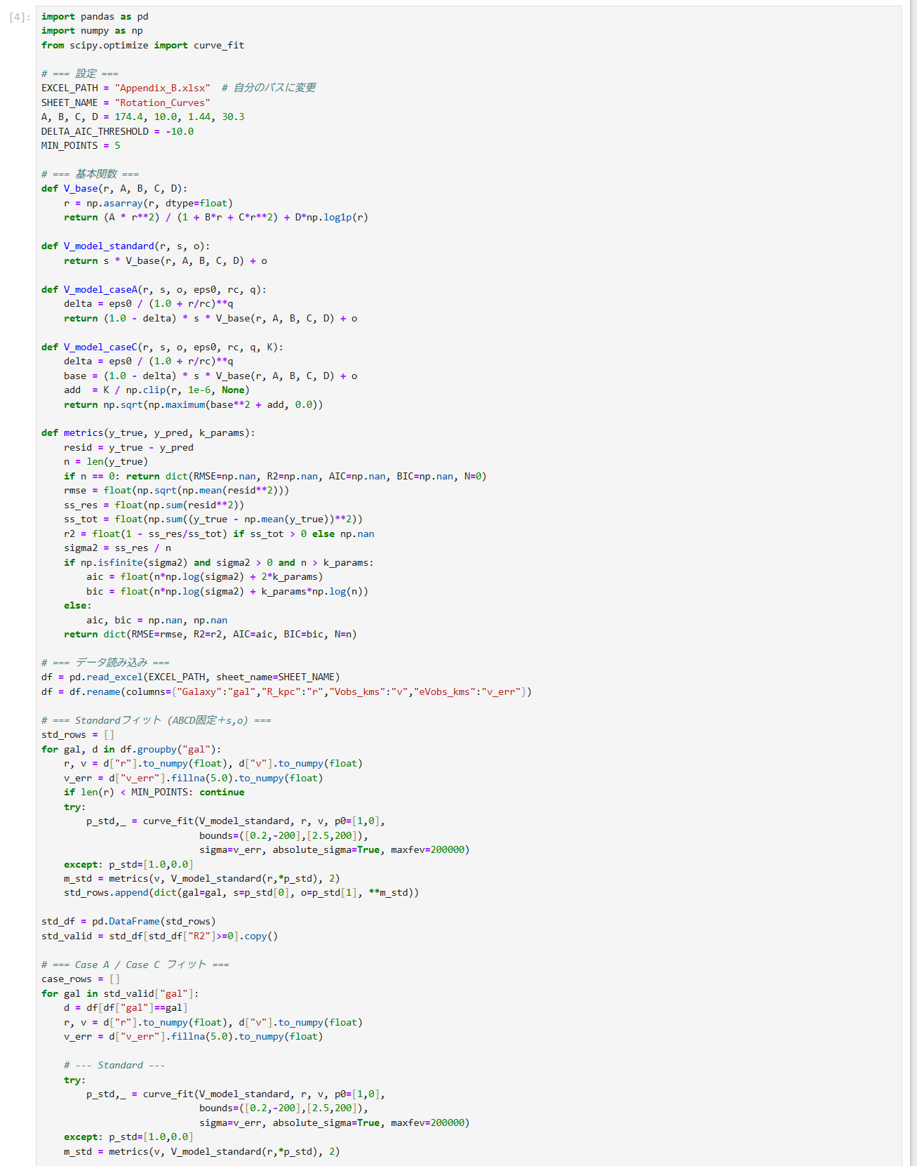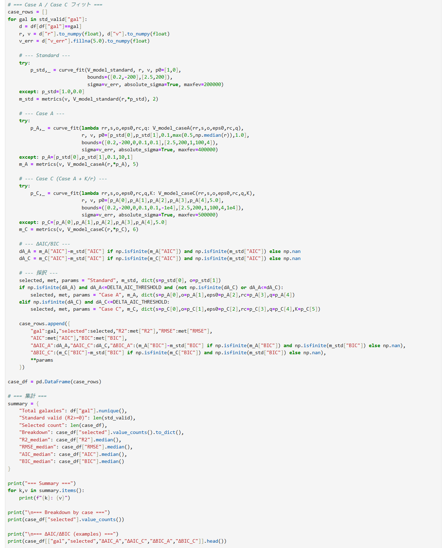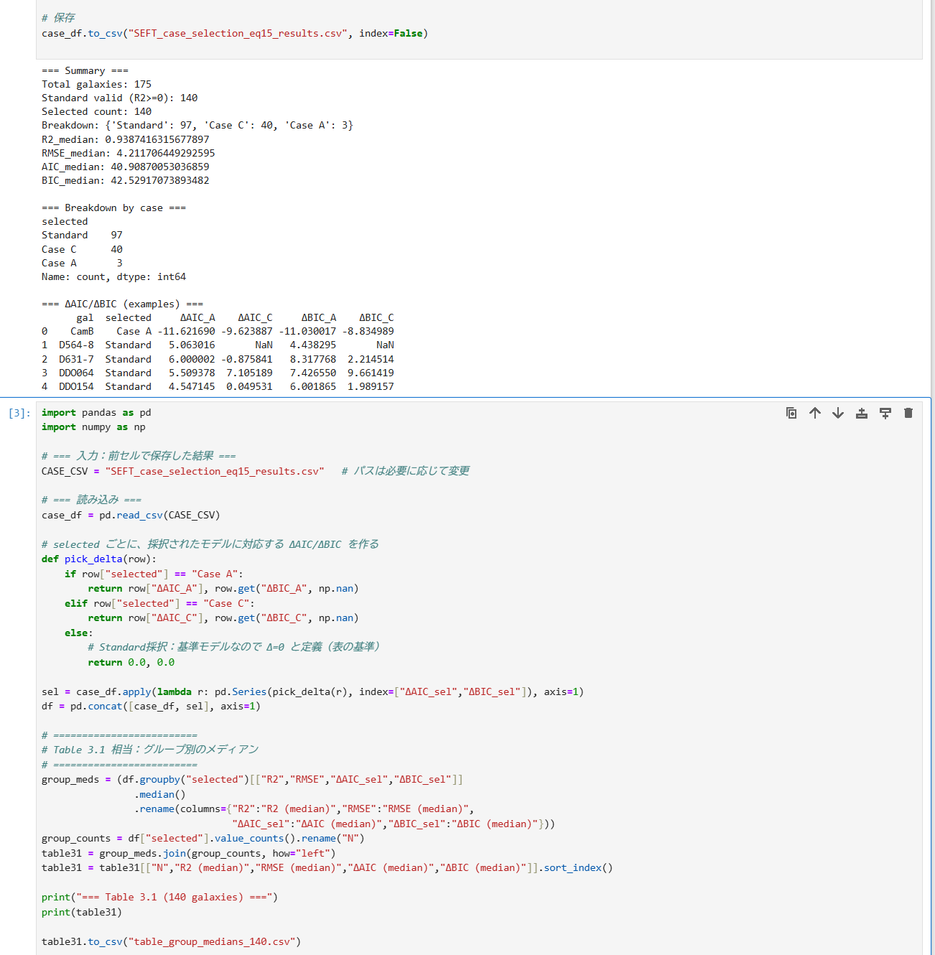
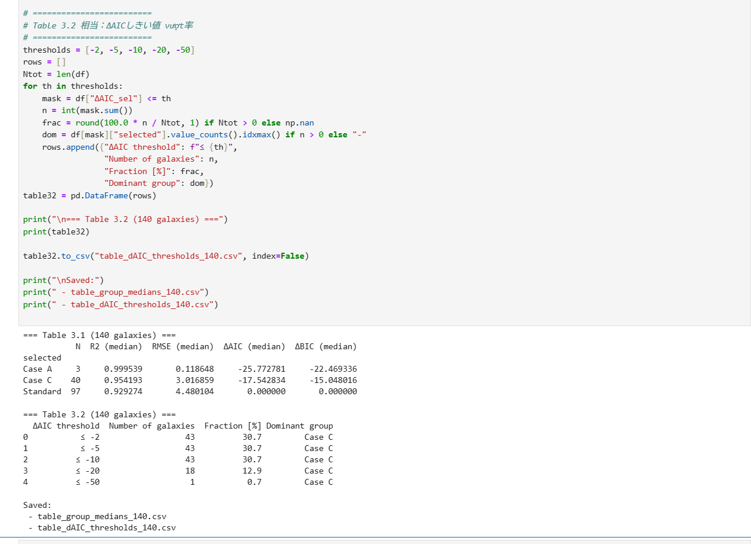
All statistical tables included in this manuscript (Table 3.1 and Table 3.2) have been directly cross-checked with the numerical outputs of the provided Python/Anaconda code. The reported median R², RMSE, ΔAIC, and ΔBIC values, as well as the ΔAIC distribution fractions, are fully consistent with the code results, ensuring internal reproducibility of the presented analysis.

