IJESRT
International Journal of Engineering Sciences & Research Technology
EFFECT OF ELEVATED TEMPERATURE ON MECHANICAL PROPERTIES OF FIBER SELF COMPACTING CONCRETE
Dr. Ahmed M. Tahwia *, Dr. Ahmed H. Abdelreheem, Saeed A. Mohaisen
* Structural Engineering Dept. Faculty of Engineering, Mansoura University, Egypt.

DOI: 10.5281/zenodo.167074
ABSTRACT
This study presents the effect of elevated temperature on mass loss ratio, ultrasonic pulse velocity, compressive strength, tensile strength, and flexural strength of self-compacting concrete (SCC) and fiber reinforced self-compacting (FRSCC). Slump flow, T₅₀ flowing time, L-box and GTM screen stabilities were investigated. The experimental program consist of six mixtures. The control mixture SCC were made without fibers. The other five mixtures made with added three different types of fibers (Polypropylene, steel, and glass). 0.1% Polypropylene fibers, 1% glass fibers and 1% steel fibers by concrete volume were used for PFSCC, GFSCC and SFSCC mixtures respectively. For HFSCC1, 0.05% polypropylene fibers and 0.5% steel fibers by concrete volume were added. For HFSCC2 mix added 0.5% glass fibers and 0.5% steel fibers by concrete volume.The properties of SCC and FRSCC mixtures at 20 °C, 200°C, 400°C, 600°C, and 800 °C were measured after 28 days. The specimens were heated by using electric furnace at a rate of 5 °C /min. The results show that the compressive strength, tensile strength and flexural strength increased with the increasing temperature up to 200 °C and decreased at a temperature higher than 200°C. The PP fibers reduced and eliminated the risk of the spalling in the SCC. With increasing temperature the concrete mixes including steel fibers and hybrid fibers appear the best mechanical properties and spalling resistance. The weight losses for the SCC mixtures with PP and steel fiber were lower than those without PP and steel fibers. In general, fibers decreased fresh concrete properties.

KEYWORDS: Self-compacting concrete; elevated temperature; Glass fibers; Steel fibers; hybrid fibers.

INTRODUCTION

Self-compacting concrete is a new class of high performance concrete characterized by it’s a highly workability, Non-segregating that can easily reach into remote corners, fill congested formworks and reinforcement without any vibration efforts ^{[1]}.The necessity requirement of self-compacting concrete SCC was proposed in 1986 by Hajime Okamura ^{[2]}.The prototype of self –compacting concrete was first completed in japan in 1988 Ozawa ^{[3]}. For SCC, it is generally necessary to use high range water reducing in order to obtain high mobility. Adding a large volume of powdered material can eliminate segregation. The powdered materials are fly ash, silica fume, lime stone powder, glass filler, quartzite filler and ground granulated blast furnace slag that can be added to increase the slump of the concrete mix and also to reduce the cost of SCC.
High temperature can cause the development of cracks and spalling. These cracks like any other cracks may eventually cause loss of structural integrity and loss in service life ^{[4]}. The high temperatures due to fire have a posative effect on the strength and deformation characteristics of the various structural components, such as columns, beams, slabs, etc. ^{[5]}.
Fiber reinforced concrete (FRC) is an example for that type of concretes which are containing fibers spreading coincidentally at three dimensions in the matrix. The fibers could inhance the toughness and stress distribution of concrete, replace the steel reinforcement partly, reduce the crack width, improve the bar spacing and decrease the labor costs. Therefore, a new type of self-compacting high performance concrete (SCHPC), fiber reinforced self-compacting high performance concrete (FRSCHPC) were proposed by Ding et al. ^{[6]}. Compressive strength and flexural strength of high strength mortar increased by using steel fibers and increased slolly by using polypropylene fibers (PP) at room temperature. At high temperature, steel fibers also increased the compressive strength and flexural strength while PP fibers caused some loosing in compressive strength and flexural strength. This behavior may be due to the melting of PP fibers which creates some pores in the matrix ^{[7]}.The inclusion of steel fiber in the concrete mix leads to a better resistance to heating impacts ^{[8]}. The objectives of this work are studying the effect of adding steel fibers, glass fibers and hybrid fibers on mechanical properties of self-compacting concrete subjected to elevated temperatures.
EXPERIMENTAL PROGRAM
Materials
Cement
In this study, ordinary Portland cement (CEM I 52.5 N) were used. The chemical and physical characteristics are satisfied the Egyptian Standard (ES 4756-1/2013) ^{[9]} and (EN 197-1/2011) ^{[10]}. The chemical composition and main compounds of cement are shown in Tables 1 and 2 respectivaly. The physical and mechanical properties are as given in Table 3.

TABLE 1 Chemical composition of cement used
Content (wt %) | Oxide composition
61.09 | Lime CaO
21.58 | Silica SiO₂
4.94 | Alumina Al₂O₃
3.56 | Ferric Oxide Fe₂O₃
1.65 | Magnesia MgO
3.22 | Sulfuric Anhydride SO₃
0.18 | K₂O
0.50 | Na₂O
2.60 | Loss on ignition, L.O.I

TABLE 2 Main compounds of cement
Compounds | Content (%)
Tricalcium Silicate C₃S | 37.16
Dicalcium Silicate C₂S | 33.91
Tricalcium Aluminate C₃A | 7.07
Tetracalcium Alumina ferrite C₄AF | 10.82

TABLE 3 Physical and mechanical properties of Portland cement
property | Test result | EN 197-1/2011
Specific surface area (cm²/gm) | 3600 | Not less than 2750
Initial setting Time (min) | 70 | Not less than 45 min
Final Setting Time (min) | 210 | --
Compressive strength 2 days | 24.2 | Not less than 20 (MPa)
Compressive strength 28 days (MPa) | 55.8 | Not less than 52.5 (MPa)

Aggregate
Coarse aggregate used in the experimental work is a crushed dolomite with a maximum nominal size of 9.5 mm. Natural sand with 4 mm maximum size was used as fine aggregates. The properties of crushed dolomite and sand used were carried out according to the Egyptian Standard (ES 1109/2008) ^{[11]}.
Silica fume
Silica fume was added in percentage of 20% by weight of cement. Table 4 shows the physical composition of the silica fume used.

TABLE 4 Physical properties of the silica fume used
Property | Value *
Specific surface area (cm²/g) | 170,000
Particle size (µm) | 8.00
Specific gravity | 2.2
*By manufactures data sheet.
Fibers
Steel fibers hooked end, Polypropylene fibers and glass fibers with round cross-section were used. Table 5 shows the physical properties of fibers.

TABLE 5 Physical properties of the used fiber
Property | Value*
Property | Steel fibers | Polypropylene fibers | Glass fibers
Length (mm) | 25 | 12 | 6
Diameter ( µm ) | 80 | 18 | 13
Density (g/cm³) | 7.85 | 0.91 | 0.91

*By manufactures data sheet.

Superplasticizer
The high-range water-reducing (HRWR) admixtures help in increasing the workability of concrete without adding water and helping the fine particles to fill the void spaces and to decrease the amount of water in the mix. In this study a superplasticizer namely ViscoCrete 3425 is a third generation superplasticizer locally produced was used. It is an aqueous solution of modified polycarboxylate and 1.08 specific gravity. It complies with ASTM C494^{[12]} -Type G and F.

Mix proportions
Six types of concrete mixtures (SCC, PFSCC, GFSCC, SFCC, HFSCC1 and HFSCC2) were designed. For all mixes, 425 kg/m³ Portland normal cement and 20% silica fume of cement weight were used. The control mix (SCC) were made without adding fibers. The other five mixtures made with added three different types of fibers (steel fiber, glass fibers and Polypropylene fiber). 0.1% Polypropylene fibers, 1% glass fiber, and 1% steel fibers by concrete volume were used for PFSCC, GFSCC and SFSCC respectively. For HFSCC1 were added 0.05% Polypropylene fibers and 0.5% steel fibers by concrete volume. For HFSCC2 were added 0.5% glass fibers and 0.5% steel fibers by concrete volume. Added more high range of water and superplasticizer to obtain the same properties of fresh concrete. The mix components of each type concrete are listed in Table 6.

TABLE 6 The components of the mixes by kg/m³
Mix | C | Sf | Aggregate |  | W | SP | Fiber
Mix | C | Sf | C.A | F.A | W | SP | S.F | G.F | PP.F
SCC | 425 | 85 | 810.5 | 810.5 | 193.8 | 4.25 | 0 | 0 | 0
PFSCC | 425 | 85 | 802.6 | 802.6 | 198.9 | 4.25 | 0 | 0 | 0.91
GFSCC | 425 | 85 | 779.1 | 779.1 | 204 | 8.5 | 0 | 9 | 0
SFSCC | 425 | 85 | 790.8 | 790.8 | 198.9 | 4.25 | 78.5 | 0 | 0
HFSCC1 | 425 | 85 | 796.7 | 796.7 | 198.9 | 4.25 | 39.25 | 0 | 0.455
HFSCC2 | 425 | 85 | 786.9 | 786.9 | 204 | 7.44 | 39.25 | 4.5 | 0

C: cement, SF: Silica fume, SP: superplasticizer, W: water, GF: glass fiber, SF: Steel fiber, PP.F: Polypropylene fiber, FA: fine aggregate, CA: coarse aggregate.

Mixing, Casting and Curing
Cement, silica fume, coarse aggregate and fine aggregate were mixed in the dry state then the water and superplasticizer weer added. In case of fiber self-compacted concrete, the fibers were added to the dry components before the water and admixtures were added. A cubes with dimensions of 50x50x50 mm for compressive tests, cylinder 50 mm diameter and 100 mm height for tensile tests, and prisms 40x40x160 mm for flexural strength were used. To study the fresh concrete properties (filling ability, passing ability and segregation resistance), the slump-flow test, T50 flowing time L-box and GTM screen stabilities were measured. Table 7 shows the fresh properties for all mixes. Specimens were then cast without vibration. The distribution of coarse aggregates on the cross-section is shown in Figure 1 which indicates that coarse aggregates are uniformly distributed within SCC. The specimens were kept at room temperature for 24 hours. The specimens placed in water until 28 days then the specimens were taken out of the water at room temperature for 24 hours.

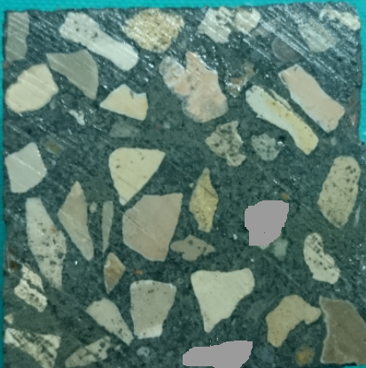
Figure 1. Distribution of coarse aggregates on cross section

TABLE 7 Workability of all mixture
Mix | SCC | PFSCC | GFSCC | SFSCC | HFSCC1 | HFSCC2
Slump-flow mm | 790 | 700 | 675 | 720 | 710 | 695
T50 cm second | 2.5 | 3.8 | 5 | 3.5 | 4.2 | 4.5
L-box H2/H1 | 0.98 | 0.85 | 0.82 | 0.92 | 0.84 | 0.83
GTM (%) | 11.2 | 9.1 | 8 | 9.3 | 8.8 | 8.6

Testing procedure
The mass and ultrasonic pulse velocity were measured befor heating. Specimens were subjected to a heating rate of 5 °C /min up to 200 °C, 400 °C, 600 °C, and 800 °C respectively by using an electric furnace. The heating curve is shown in Figure 2. The specimens were maintained at a given temperature for one hour. The specimens were taken out of the furnace to cool down at room temperature and then tested for the mass loss, ultrasonic pulse velocity, compressive strength, tensile strength and flexural strength.

Figure 2. Rate of heating

RESULTS AND DISCUSSION
Mechanical properties
Compressive strength
Figure 2 shows the result of compressive strength for six concrete mixes. The value of compressive strength is the average of the result of testing three cubes (50 mm). The compressive strength were determined at ages 28 days. Figure 3 presents the compressive strength of SCC, PFSCC, GFSCC, SFSCC, HFSCC1 and HFSCC2 at elevated temperature. It can be seen that the lowest compressive strength results were obtained from the PFSCC and SCC mixes but the SFSCC were giving the best results. In general, FRSCC including steel fibers appear the best compressive strengths. The compressive strength of SCC decreased by about 0.0%, 38.18 %, 65.66 % and 84.65 % at 200, 400 °C, 600 °C, and 800°C respectively. The compressive strength of PFSCC decreased by about 9.8 %, 44.12 %, 86.24 % and 85.49 % at 200, 400 °C, 600 °C, and 800°C respectively. For GFSCC, SFSCC, HFSCC1 and HFSCC2 samples the compressive strength increased by about 6.0, 7.7%, 2.2%, and 14.3% respectively at 200 C°. For GFSCC the compressive strength decreased at 400 °C, 600 °C, and 800°C by about 21 %, 62 % and 84.8% respectively. For SFSCC the compressive strength decreased at 400 °C, 600 °C, and 800 by about 23.1%, 45.2%, and 77.24% respectively. For HFSCC1 the compressive strength decreased at 400 °C, 600 °C, and 800°C by about 26.8 %, 61.4 % and 79.6 % respectively. For HFSCC2 the compressive strength decreased at 400 °C, 600 °C, and 800°C by about 21.5%, 49.5% and 76.5% respectively. The main reason of increasing compressive strength with increase the temperature up to 200 °C may be due to increase the cement hydration. The reduction of strength due to increase in temperature higher than 400 °C may be result of moisture driven out during heating, the incompatibility in thermal expansion between the cement paste and aggregates, the dehydration of the cement paste above 400°C, and the decomposition of the aggregate above 600 °C. Figure 4 shows the decomposition of the aggregate above 800 °C. The compressive strengths of the mixture containing PP fibers were clearly lower than that without PP fibers after being exposed to elevated temperatures. The addition of PP fiber had a significant, negative effect on the compressive strength of the concrete. The inclusion of PP fibers produced a finer residual capillary pore structure, decreased compressive strength of SCC ^{[13]}. PP fibers melt due to the lower melting point (160-180°C) during the rapid temperature increasing process, which makes free space in the micro-channels in the concrete matrix (Figure 5).

Figure 3. Relationship between compressive strength and temperature

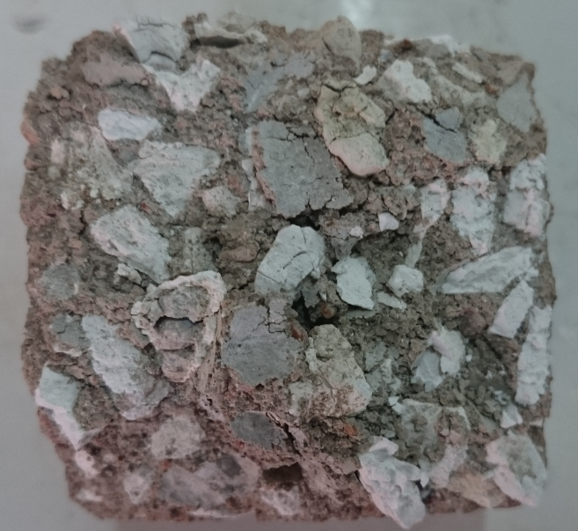
Figure 4. The decomposition of the aggregate above 800 °C

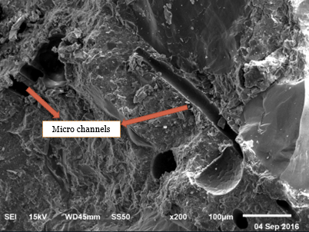
Figure 5. SEM images of PFSCC mix at 400 °C

Splliting tensile strength
Concrete is not normally designed to resist direct tension, the knowledge of tensile strength is of value of estimating the load under which cracking will develop. The absence of cracking is of considerable importance in maintaining the continuity of a concrete structure and in many cases in the prevention of corrosion ^{[14]}. The tensile strength is important characteristic for the development of cracking and hence for the prediction of durability concrete. Figure 6 shows the results of tensile strength tests of six concrete mixes at age 28 days. Three tests specimens were made to determine the splitting tensile strength for each mix, and the tensile strength is the average of this three results. At 200 °C, slight increase in tensile strength with temperature for all mixes. After heating to 400 °C the tensile strength decreased by about 29.2%, 40.4%, 17%, 10.2%, 14.3 %, and 9.4% for SCC, PFSCC, GFSCC, SFSCC, HFSCC1 and HFCC2 samples respectively. At 600 °C the tensile strength decreased by about 87%, 83.8%, 66%, 64%, 65% and 66% for SCC, GFSCC1, GFSCC2, SFSCC, and HFCC samples respectively. This loss of strength due to the thermal incompatibility between aggregates and cement, the dehydration of the cement paste above and the decomposition of the aggregate.

Figure 6. Relationship between tensile strength and temperature

Flexural strength
In this work, a plain concrete prisms was subject to flexural load. The flexural strength tests were carried out on 40 x 40 x 160 mm prisms. Figure 7 present the variation of the residual flexural strength as a function of the temperature. For SCC samples the flexural strength decreases with increases the temperature by about 2.3%, 34.9% and 91.9% at 200 °C, 400 °C and 600 °C respectively. For PFSCC samples the flexural strength decreases with increases the temperature by about 2.1%, 47.7% and 85.7% at 200 °C, 400 °C and 600 °C respectively. For the other samples the flexural strength increased at 200 °C about 4.4% to 9%. Figure 5 indicates that reduction in the flexural strength at 400 °C by about 27.8% , 24.3%, 29.6%, and 28.7% for GFSCC, SFSCC, HFSCC1 and HFSCC2 samples respectively. Figure 5 indicates that reduction in the flexural strength at 600 °C by about 80%, 79.6%, 85.7, and 81.2% for GFSCC, SFSCC, HFSCC1 and HFSCC2 samples respectively. This loss of flexural strength due to many micro and macro-cracks were produced in the specimens due to the thermal incompatibility between aggregates and cement past. Flexural strength of high strength concrete increased by using steel fibers and increased slightly by using PP fibers at 20 °C, but with rising in temperature, steel fibers also improved the compressive and flexural strength, while PP fibers caused some reduction in flexural strength under autoclave curing before high temperature exposure. This behavior may be due to the melting of PP fibers which creates some pores in the matrix ^{[7]}.

Figure 7. Relationship between flexure strength and temperature
Spalling
Thorough visual inspection was performed to evaluate the visible signs of cracking and spalling on the surface of the specimens after being subjected to high temperatures. No visible cracking or spalling was observed for all samples at the temperature between 200 °C and 400 °C. Figures 8 and 9 shows the surface character of SCC samples with and without fibers at 200 °C and 400 °C respectively. Tiny cracks began to appear extensively at approximately 600 °C. Figure 10 shows the surface character of SCC samples with and without fibers at 600 °C. Only a small amount of spalling was seen at the edges and the corners of some specimens at 600 °C. Explosive spalling occurs in SCC and GFSCC samples when the furnace temperature reached 425°C to 475°C. Figure 11 shows the explosive spalling occurs in SCC and GFSCC samples. This Explosive spalling was observed on GFSCC specimens because of the glass fiber decreases the micro cracks and decreases the permeability. Low permeability associated with dense microstructure of concrete which prevents dissipation of water vapors because of heat and leads to build up of high pore pressure. In Figure 10 it can be seen that the damage and spalling of SFSCC much less than that SCC samples. At high temperature, steel fiber can mitigate expansion of concrete due to the rapid temperature change and reduce the large temperature gradient due to the higher heat transfer coefficient, and restrict the development of crack and bridging the thermal cracks. The PP fibers eliminated the risk of the explosive spalling in the PFSCC samples. This result may be because during the rapid temperature increasing process, the PP fibers melt and vaporize, which results in the micro channels being formed in the concrete. Thus greater vapor tension in the capillaries can be alleviated and released, which may be the reason why there was no explosive spalling in the SSC with PP fibers. All of the samples shows visible spalling at the edges and the corners at 800 °C. The mixes containing steel fibers experienced no extensive cracking and spalling. Figure 12 shows the surface character of SCC samples with and without fibers at 800 °C. Figure 12 shows the damage and spalling of HFSCC2 less than other samples. This result may be because glass fiber decreases the cracks and steel fiber decreases the spalling.

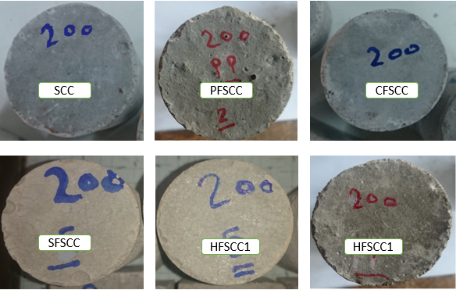
Figure 8. Surface character of SCC samples with and without fibers at 200 °C

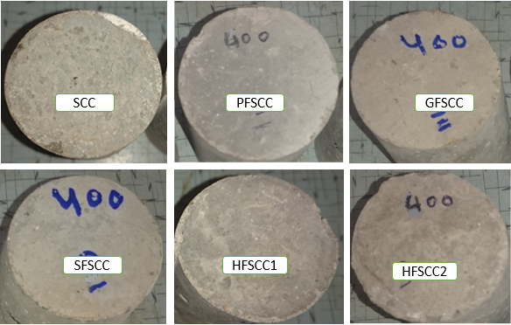
Figure 9: Surface character of SCC samples with and without fibers at 400 °C

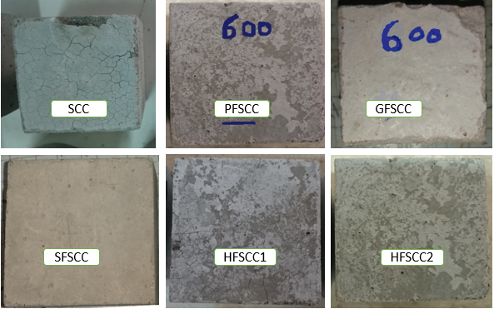
Figure 10. Surface character of SCC samples with and without fibers at 600 °C

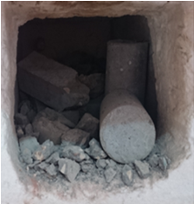
Figure 11. Explosive spalling occurs in cases of SCC and GFSCC mixes in 450 °C
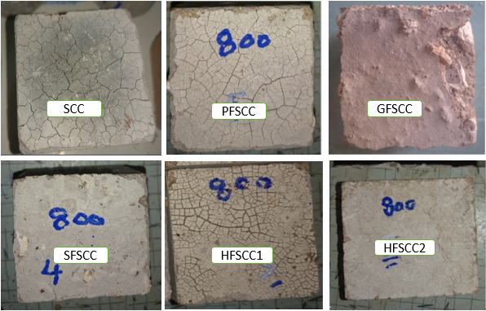
Figure 12 . Surface character of SCC samples with and without fibers at 800 °C

Mass loss ratio

The mass loss ratio is defined as the ratio of the difference between the weight at room temperature and the weight at a given temperature to the weight at room temperature. The mass of each specimen was measured at room temperature and after exposure to elevated temperature. The weight loss versus temperature was very similar for the six mixtures. The mass loss ratio was in the range of 3.1 % to 18.2% when the temperature increased from 200°C to 800°C. Its shows that the mass loss ratios of SCC were larger than that of FRSCC. The mass losses in percent of the SCC mixtures with increasing temperatures are given in Figure 13. Figure 13 shows that the weight losses for the SCC mixtures with PP and steel fiber lower than that without them fibers. There are many potential causes of weight loss after high temperature exposure in concrete. However, expulsions of chunks or spalling of the concrete from the surface layers are main reasons of weight loss ^{[15]}. In this experiment, small explosive spalling or the expulsion of chunks was observed. At low temperatures, the weight loss may be due to the departure of free water contained in the capillary pores. According to Kanema et al. (2007) ^{[16]} the weight loss between 150 and 300 °C corresponds to the evaporation of bound water. The main reason for this result was that as the concrete was subjected to heat, the melted PP fibers created micro pathways within the concrete to exhaust the water vapor.

Figure 13. Relation between the mass loss ratio and temperature

Ultrasonic pulse velocity
Figure 14 shows the results obtained from the UPV measurements of all of the SCC specimens subjected to different high temperatures. Each data point represents the average of three measurements. As shown in Figure 10 the UPV of the heated SCC specimens decreased as the temperature increased, and there was a notable reduction in UPV shortly after the specimens were subjected to elevated temperatures greater than 400 °C. Clearly, the transmission of pulse waves through a concrete mass is greatly influenced by the micro cracking of the concrete. Thus, the decrease in pulse velocity with increasing temperature is a sensitive measure of the progress of cracking in the material ^{[17]}. Thermal expansion and dehydration of the concrete due to the high temperature could lead to the formation of fissures in the concrete. With more fissures, the cracks or micro pathways delay the concrete’s pulse velocity ^{[15]}. Therefore, micro cracks reduce the pulse velocity and results in low UPV values. It can be concluded that the addition of PP fibers had a negative effect on the UPV of the SCC mixtures that were exposed to high temperatures. When the temperature was above the melting point (160-170 °C) of the PP fibers, the fibers created more randomly distributed pathways or voids in the SCC. With more fissures, the cracks or micro pathways delay the concrete’s pulse velocity^{[15]}.

Figure 14. Relation between the Ultrasonic pulse velocity and temperature

CONCLUSIONS
In this paper, a series of tests were performed to examine the changes in mechanical properties on SCC subjected to high temperatures ranging from 20 °C to 800 °C and to investigate the effect of adding steel fibers, glass fibers, polypropylene fibers and hybrid fibers on mechanical properties. Based on the experimental results presented in this paper, the following conclusions are listed.

- at 200°C the mechanical properties improved and above 200°C the mechanical properties decrease for SCC with steel fiber and SCC with glass fiber. While the mechanical properties decreased at 200°C for SCC with PP fiber.
- The concrete mixes including steel fibers and hybrid fibers shows the best mechanical properties (compression strength, splitting tensile strength, and flexural strength).
- The addition of steel fibers and PP fibers reduced and eliminated the risk of the explosive spalling in the SCC.
- The spalling occurs in cases of SCC and glass fiber SCC and lower rate in HFSCC2 when the furnace temperature about 425°C to 475°C.
- The mass loss ratio increased with the rise in temperature.
- The addition of steel fibers and PP fibers decreased the mass loss ratio.

ACKNOWLEDGEMENT
Special thanks for all technical staff of the laboratories where experimental work has been undertaken, namely, strength of materials and reinforced concrete laboratories at the faculty of engineering, Mansoura University, for providing all means of support need in this experimental work.

REFERENCES
- A. Noumowe, H. Carre, A. Daoud, and H.Toutanji, “High-strength self-compacting Concrete exposed to fire test”, Journal of Materials in Civil Engineering, Vol.18, pp.754–758, 2006.
- H.Okamura,“Self-compacting high-Performance concrete”, Concrete International, Vol. 19, No. 7, pp. 50-54, 1997.
- K.Ozawa, “Development of High Performance Concrete Based on the Durability Design of Concrete Structures”, EASEC-2, Vol. 1, pp. 445–450, 1989.
- N. Anand, G.Prince, “Experimental investigation on mechanical Properties of self-compacting concrete under elevated temperatures”, International Journal of Advances in Science Engineering and Technology,Vol. 2, No. 4, pp. 2321-9009, 2014.
- J. R. Lawson, L.T. Phan, F. Davis, “Mechanical Properties of High Performance Concrete after Exposure to Elevated Temperatures”, March, 2000, http://fire.nist.gov/bfrlpubs/fire00/
- Y. Ding, Y. Zhang, and A. Thomas, “The investigation on strength and flexural toughness of fiber cocktail reinforced self-compacting high performance concrete”, Construction and Building Materials, Vol. 23, No. 1, pp.448–52, 2009.
- S. Aydın, H. Yazıcı, and B. Baradan, “High temperature resistance of normal strength and autoclaved high strength mortars incorporated polypropylene and steel fibers, “Construction and Building Materials, Vol. 22, No.4, pp.504–512, 2008.
- A. Lau, and M. Anson, “Effect of high temperatures on high performance steel fibre reinforced concrete”, Cement and Concrete Research, Vol.36, 1698–1707, 2006.
- ES 4756-1/2013, “Cement-Part 1: Composition, Specifications and Conformity Criteria for Common Cements'', Egyptian Organization for Standardization and Quality, Egypt, 2013.
- EN 197-1/2011, “Cement-Part 1: Composition, Specifications and Conformity Criteria for Common Cements'', 2011.
- ES 1109/2008, “Aggregate Specification, Egyptian specification”, 2008, (http://www.eos.org.eg).
- ASTM C494, .Standard specification of chemical admixtures for concrete American Society for Testing and Materials Standard Practice C494, Philadelphia, Pennsylvania, 2004.
- M. Uysal, K. Yilmaz, and M. Ipek,” Properties and behavior of self-compacting concrete produced with GBFS and FA additives subjected to high temperatures”, Construction and Building Materials, Vol. 28 pp. 321–326, 2012.
- A.M. Neville, “Properties of concrete”, 5th edition, Education Books, Pitman Publishing, London, 2013.
- I. Yuksel, R. Siddique, and O. Ozkan, “Influence of high temperature on the properties of concretes made with industrial by-products as fine aggregate replacement”, Constr Build Mater, Vol. 25, pp.967–72, 2011.
- M. Kanema, M. V. G. de Morais, A. Noumowe, J. L. Gallias, and R. Cabrillac,” Experimental and numerical studies of thermo-hydrous transfers in concrete exposed to high temperature”, Heat Mass Transfer,Vol. 44, pp.149-164, 2007.
- H. Yang, Y. Lin, C. Hsiao, and L. J. You, “Evaluating residual compressive strength of concrete at elevated temperatures using ultrasonic pulse velocity”, Fire Safety Journal, Vol. 44, pp. 121–130, 2009.

