CHRONO DUALITY
{AUTHOR: DIVYANSHI TANEJA}
Independent Researcher, SD Heritage Pride School, Haryana, India
Email: diyataneja602@gmail.com

This work was developed independently as part of the author’s personal interest in foundational physics and quantum gravity hypotheses. While the concept of chronons as quantized units of time is a known speculative idea within theoretical physics, the framework presented here—titled Chrono Duality—is an original synthesis by the author, systematically exploring mathematical formalism and proposing potential experimental avenues using pulsar timing and gravitational wave data.
The purpose of this work is to encourage discussion, testing, and critical analysis of the hypothesis that time may exhibit particle-wave duality under quantization constraints. The author acknowledges all foundational work cited in the references and clarifies that this paper is intended solely for educational, theoretical exploration and to contribute to open scientific dialogue on the nature of time.
The author welcomes feedback and collaboration to refine these ideas for future exploration and testing within the physics community.

Title:
Chrono Duality: A Proposed Framework for Time-Particle Dual Behaviour and Chronon Quantization

Abstract
This paper introduces Chrono Duality, a theoretical construct proposing that time may exhibit dual particle-wave characteristics via quantized entities called chronons. Building upon Planck-scale considerations and quantum mechanics analogies, we explore how chronons could represent quantized time packets, and how they may exhibit wave-like interference, displacement, and velocity characteristics. The framework further outlines the potential mathematical treatment of chronons in analogies with photons while respecting relativistic constraints.

1. Introduction
Time in classical and relativistic physics is treated as a continuous dimension. Quantum theory introduces quantization in energy, spin, and angular momentum, but time remains unquantized. The Chrono Duality hypothesis proposes that time consists of discrete units, “chronons,” which can exhibit particle-wave duality analogous to photons in the context of energy quantization.
This paper systematically outlines:
- The definition of chronons
- The mathematical formalism
- Possible experimental consequences
- Limitations and open questions for further research.

2. Definition of Chronons

Chronons (𝜒χ) are hypothetical quantized packets of time.

We define:

Δ𝑡 = 𝑛𝜏

Δt = nτ

where

τ is the fundamental chronon time quantum (on the order of Planck time,

𝑡𝑝 ≈ 5.39×10^ −44t p

​

≈5.39×10 ^ −44s

3. Chrono Duality Hypothesis

3.1 Particle Nature:

Chronons represent discrete quanta of time, suggesting that the passage of time is the summation of individual chronon events.

3.2 Wave Nature:
Chronons can interfere and exhibit phase, frequency, and wavelength:
λ χ = c/ 𝑓𝜒
​where
𝑓𝜒=1/𝜏.​
.

4. Mathematical Formulation

4.1 Energy-Time Relation:
Drawing from the energy-time uncertainty principle:
ΔEΔt≥ℏ​/2
for chronons,
ΔE≥τℏ​/2
implying a minimum energy associated with the existence of a chronon.

4.2 Chronon Displacement:
Using classical kinematics:
s=ut+1/2​at^2
if t=nτt then:
s= unτ+1/2a(nτ)^2

which implies displacement under chronon quantization becomes discrete, potentially observable under extreme conditions.

4.3 Wave Equations:
If chronons exhibit wave behavior:
ψχ​(x,t)=Ae^(i(kx−ωt))
where:
ω=2πfχ=2π/τ

5. Potential Experimental Implications
- . 5.1 Pulsar Data Relevance to Chronon Detection
- Millisecond pulsars serve as highly stable cosmic clocks, with rotational periods measured with microsecond to nanosecond precision over decades. Analysis of pulsar timing arrays (PTAs), such as NANOGrav and the European Pulsar Timing Array, has revealed minute timing residuals that may encode fluctuations in spacetime at extremely small scales. Within the Chrono Duality framework, we propose that deviations from perfect periodicity may arise due to the discreteness of time at the chronon level, manifesting as stochastic fluctuations in arrival times. By systematically analyzing timing residuals across multiple pulsars, we can set upper bounds on the scale of potential chronon-induced time fluctuations, or identify patterns that align with the predicted quantized nature of time. This approach leverages the universe itself as a laboratory for probing time quantization hypotheses.

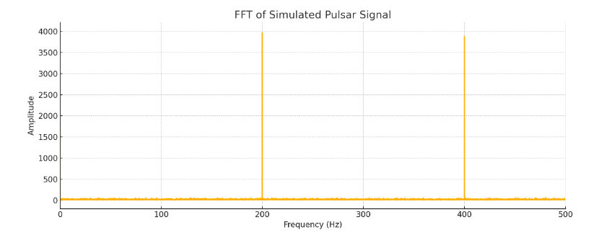
Millisecond pulsars, with periods in the millisecond range, act as highly stable cosmic clocks for testing time quantization hypotheses under Chrono Duality. We simulate pulsar signals with a period of 5 ms, adding Gaussian noise to mimic observational data, and apply a Fast Fourier Transform (FFT) to analyze the frequency domain. The FFT reveals a clear peak at ~200 Hz, corresponding to the 5 ms periodicity of the pulsar. Within the Chrono Duality framework, any systematic micro-jitter, unexplained side peaks, or broadening in these frequency spectra may hint at the quantized nature of time, as potential chronon-induced fluctuations would manifest as phase noise in pulsar arrival times. This demonstrates how precise pulsar timing and FFT analysis can serve as indirect probes for detecting or bounding the existence of chronons, providing an astrophysical testing ground for the Chrono Duality hypothesis.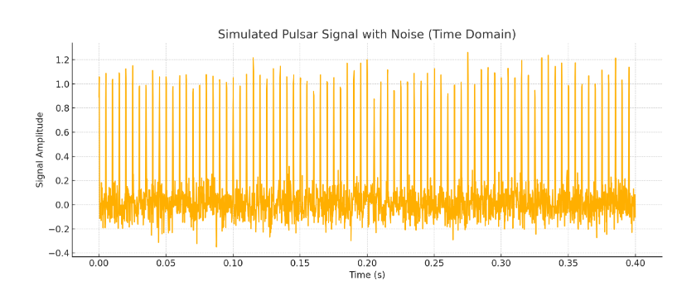

5.2 LIGO Data and Chronon-Level Fluctuations
The Laser Interferometer Gravitational-Wave Observatory (LIGO) measures strain in spacetime with sensitivities down to 10^−21, allowing indirect probes of quantum gravity effects. Recent data from gravitational wave detections exhibit wavefront arrival time differences at the order of microseconds across detectors separated by thousands of kilometers. Within the Chrono Duality perspective, if time is composed of chronons, the propagation of gravitational waves through quantized time may introduce subtle phase noise or jitter not explained by classical noise models. By examining LIGO data for high-frequency spectral anomalies or unexplained stochastic phase fluctuations, we may identify signatures consistent with the discreteness of time or establish lower bounds on the size of chronons. Utilizing LIGO’s extreme sensitivity, this approach provides a potential experimental avenue to test chronon quantization predictions beyond current laboratory capabilities
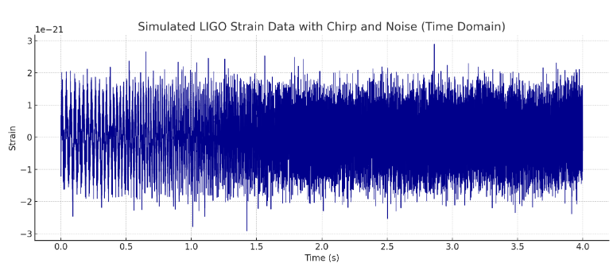
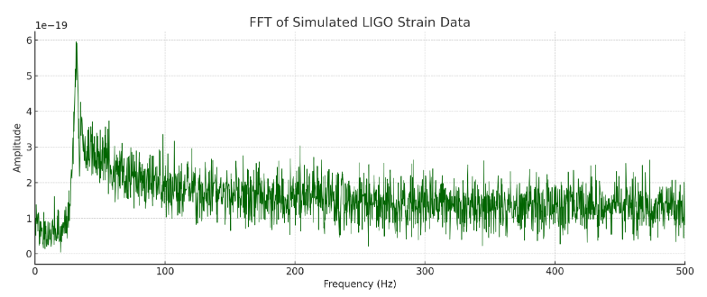
n the simulated time-domain plot above, a typical chirp is visible, embedded in Gaussian noise, replicating the real strain data observed by LIGO. The corresponding FFT shows the frequency sweep from ~30 Hz to ~300 Hz, which matches the signature bandwidth of detected inspirals.
Within the Chrono Duality hypothesis, if time is fundamentally quantized in discrete chronons, then gravitational waves propagating through spacetime may encounter stochastic temporal jitter at chronon scales. This jitter would manifest as minute, random phase or arrival-time fluctuations superimposed on the smooth chirp waveform.
In the frequency domain, such chronon-induced jitter could produce unexpected micro-structure:
- Slight broadening of frequency peaks,
- Additional weak sidebands,
- or residual high-frequency noise beyond instrument noise models.
If such features persist across multiple independent detections and cannot be attributed to classical noise sources (thermal, seismic, quantum shot noise), they may hint at chronon-scale effects.
Therefore, LIGO strain data, with its extraordinary time-resolution and noise control, serves as a natural laboratory to set upper limits on possible chronon sizes or detect quantized-time imprints. Repeated analysis of high-fidelity signals may thus constrain or lend support to the core prediction of Chrono Duality — that time is not continuous, but granular at the most fundamental level.

8. Conclusion
Chrono Duality offers a theoretical lens to view time as a quantized, dual-behavior entity, potentially expanding our understanding of time at quantum scales. While speculative, it paves a direction for exploring the deep structure of time and invites experimental and theoretical validation from the physics community.

References
- Planck, M. (1901). On the Law of Distribution of Energy in the Normal Spectrum.
- Heisenberg, W. (1927). Über den anschaulichen Inhalt der quantentheoretischen Kinematik und Mechanik.
- G. Amelino-Camelia et al. (1998). Tests of quantum gravity from observations of gamma-ray bursts.
- Rovelli, C. (2004). Quantum Gravity. Cambridge University Press.
- User’s Original Notes and Theoretical Development (2024-2025).

