Grant Agreement No: 101004761
AIDAinnova
Advancement and Innovation for Detectors at Accelerators
Horizon 2020 Research Infrastructures project AIDAINNOVA

deliverable report

Summary report of generic R&D projects and evaluation of the approach

Deliverable: D13.5
Document identifier: | AIDAinnova D13.5
Due date of deliverable: | End of Month 46
Report release date: | 04/07/2025
Work package: | WP13: Prospective and Technology-driven Dectector R&D
Lead beneficiary: | Uppsala University
Document status: | FINAL

Abstract:
To propagate the data following a collision, detectors use long cables going along the beam direction. Unfortunately, the material of the cables can degrade the precision of the measurement (scattering, nuclear interactions), impact the installation and suffer important latencies (axial readout). The WADAPT project proposes the use of wireless readout to transfer data. Wireless offers an elegant and cheaper option to cables. It allows ultra-low latency, direct communication between layers, radial readout and more flexibility in the transceiver placement. The 60 GHz band is adequate to transfer large amounts of data in both directions in real-time with minimum latency to a large number of individual devices, which otherwise will be impractical by using wire or optical connections, requiring to follow the construction. Commercial products are already available and have been tested for signal confinement, crosstalk, electromagnetic immunity, radiation hardness (up to 10^14 Neq/cm2). Initial antenna array prototype was successfully assembled, tested and finalized. Comprehensive study on antenna technologies was conducted, addressing the challenges of integration in high radiation and high-magnetic-field environments. The second prototype was assembled and validated featuring integrated low-power transceivers and embedded antennas. Substantial progress has been made toward complete system integration. Besides, performance evaluation in a HEP environment is not yet completed. However, promising results were presented at the EuCAP 2025 conference in Stockholm. Technology is being prepared for dissemination to new users, and possible new collaborations. Final integration steps are underway at UU, targeting the demonstration of a 5 Gbps data rate using our custom-built demonstration boards.

AIDAinnova Consortium, 2025
For more information on AIDAinnova, its partners and contributors please see http://aidainnova.web.cern.ch/

The Advancement and Innovation for Detectors at Accelerators (AIDAinnova) project has received funding from the European Union’s Horizon 2020 Research and Innovation programme under Grant Agreement no. 101004761. AIDAinnova began in April 2021 and will run for 4 years.

Delivery Slip
 | Name | Partner | Date
Authored by | Imran Aziz, Yasin Alekajbaf, Elmidar Zeynalli, Kristiaan Pelckmans, Richard Brenner and Dragos Dancila | Uppsala University | 26/05/25
Edited by | Rebecca Pragassa | CERN | 03/06/2025
Reviewed by | Daniela Bortoletto [Scientific coordinator] |  | 03/06/2025
Approved by | Daniela Bortoletto [Scientific coordinator]  Steering Committee |  | 4/07/2025

TABLE OF CONTENTS
1. Introduction 5
2. Development and testing of an active 60 GHz repeater 5
2.1. Repeater design 6
2.2. Fabrication and characterization 7
3. MIxed signal Interface 8
3.1. Digital QSFP28 interface 8
3.1.1. Heading level 3 13
4. More Content (landscape format) 14
4.1. More content heading level 2 14
4.1.1. More content heading level 3 14
5. FUTURE PLANS / Conclusion / relation to other AIDA-2020 work 15
6. References 15
Annex: Glossary 17

Executive summary
This deliverable summarizes the development and evaluation of a novel wireless readout system operating at 60 GHz for high-energy physics (HEP) experiments, with a focus on addressing the data acquisition challenges within detectors like ATLAS at CERN. As current systems rely on bulky and latency-prone optical cabling, our goal has been to investigate and demonstrate the feasibility of low-latency, compact, and high-speed wireless alternatives.
The WADAPT project proposes a transition to a 60 GHz wireless communication network for data and power transmission within detector environments. Initial efforts involved the design, fabrication, and successful testing of an active 60 GHz repeater board, capable of receiving, amplifying, and retransmitting wireless signals through confined slits between detector layers. This innovation addresses the shielding effect caused by the hermetic structure of tracking layers and enables radial data readout—a substantial improvement over axial-only cabling methods.
The project also advanced the development of a mixed-signal interface leveraging the ST60 chip and QSFP28 standard for high-speed digital communication. Three iterations of the QSFP28 interface board were fabricated and tested, both in standalone configurations and in conjunction with integrated RF modules (SKA2D and a custom full-duplex unit developed at Uppsala University).
In summary, this report highlights the successful design and validation of both analog and digital components required for deploying a scalable, high-performance wireless readout system in harsh HEP environments.

Introduction
The European Organization for Nuclear Research (CERN) is home to the world’s largest particle physics experiments, including the ATLAS detector, which plays a critical role in probing fundamental particles and interactions. ATLAS generates vast amounts of data during high-energy particle collisions, requiring efficient, high-speed communication systems for data acquisition and readout. Currently, this data transmission relies on an extensive network of optical cables to handle the high bandwidth requirements. However, the use of optical cables within the detector presents several challenges. These include space constraints, mechanical vulnerability, abundance of passive material, and the complexity of maintaining a large number of physical connections. Additionally, as the detector continues to evolve with the High-Luminosity Large Hadron Collider (HL-LHC) upgrade, there is an increasing demand for scalable, flexible, and less intrusive solutions to handle the projected increase in data flow.
The Wireless Allowing Data and Power Transmission (WADAPT) proposal was formed to study the feasibility of wireless technologies in High Energy Physics (HEP) experiments at CERN. To address the limitations of optical read out system, we propose a wireless communication network operating at millimeter-wave frequencies, specifically at 60 GHz, as an alternative to the current optical infrastructure. This transition from optical to wireless technology offers potential benefits such as reducing cable complexity, improving flexibility in system layout, and enhancing the overall robustness of the data transmission network within the detector. However, the proposed solution involves some challenges, e.g., the tracking layers at the detector, schematic shown in Fig. 1, are almost hermetic, acting as a Faraday cage, that allows multiple links in the volume without severe crosstalk, but doesn’t allow propagating the signal between the layers. For propagation between the layers, we have designed and developed an active repeater board, which is passed through a couple of millimetres (mm) wide slit between the modules on each layer. The repeater is also advantageous in building topological radial networks for neuromorphic tracking, as the current readout system employs optical cable that can only take out the signal axially, resulting in higher latency.

Development and testing of an active 60 GHz repeater

Repeater design
A wireless communication network operating at millimeter-wave frequencies, specifically at 60 GHz, is proposed in this project as an alternative to the current optical infrastructure. This transition from optical to wireless technology offers potential benefits such as reducing cable complexity, improving flexibility in system layout, and enhancing the overall robustness of the data transmission network within the detector. However, the proposed solution involves some challenges, e.g., the tracking layers at the detector, schematic shown in Fig. 1, are almost hermetic, acting as a Faraday cage, that allows multiple links in the volume without severe crosstalk, but doesn’t allow propagating the signal between the layers. For propagation between the layers, we have designed and developed an active repeater board, which is passed through a couple of millimetres (mm) wide slit between the modules on each layer. The repeater is also advantageous in building topological radial networks for neuromorphic tracking, as the current readout system employs optical cable that can only take out the signal axially, resulting in higher latency.
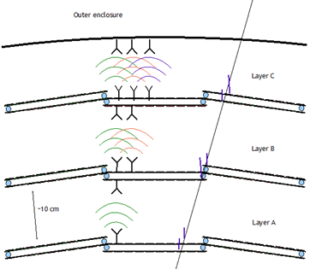

Fig. 1 Tracking layers at the ATLAS detector as CERN, showing a proposal of radial data readout through wireless links.

The designed repeater circuit employs a receiving antenna (RX ANT), an amplifier (AMP), and then the transmitting antenna (TX ANT). The RX ANT receives the 60 GHz signal from the lower layer, gets amplified by the AMP, and re-transmitted by the TX ANT on the other side of the detector layer.
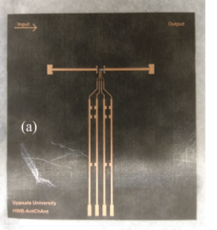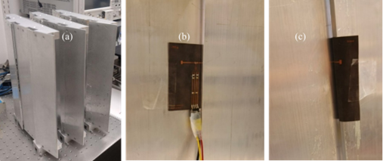
(i) (ii)
Fig. 2. (i) Fabricated active repeater board, where RX antenna is on the left, amplifier in the middle, and the TX antenna on right. (ii) Mockup for inter layer communication testing using the active repeater board

Fabrication and characterization
The figure 2 shows the fabricated structure of the repeater PCB. On the left is the RX ANT, amplifier in the center, and the TX ANT on the right. The 4-lines coming down from the center are for the DC-biasing of the amplifier. Part (b) of the figure shows the wire-bonded amplifier die, which can be understood as a zoom-in view of the center of the repeater PCB. There are two quarter wave long open-ended stubs on each side of the 50 ohm line, intended to make a short to connect with the ground pad of the die. The repeater board is tested on a mockup shown in Fig. 2 (b, c, & d). The board consists of a receiving patch antenna (right on Fig. 2a), an HMC-ALH382 amplifier (in the centre), and a transmitting antenna (on the left). The 4-lines coming down are for the DC-biasing of the amplifier. The repeater board is fixed on the mockup in a way that the receiving antenna will be, e.g., on the inner side of Layer B (Fig. 1), and the transmitting antenna will be on the outer side of the same Layer, as the 254 um thick conformal board is passed through the small slit between modules.
For a 20 cm distance between the horn antenna and the repeater board, the RX level is -19.5 dBm, while for the same setup, when the amplifier is OFF, the RX level is -45.8 dBm, as shown in Figure 3. The results represent a significant milestone towards the implementation of 60 GHz wireless links for the detector data readout.
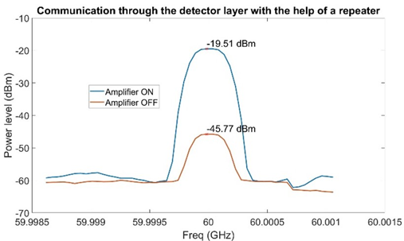
Fig. 3. The power levels when the amplifier is ON (blue) and when the amplifier is OFF (orange).

MIxed signal Interface

Digital QSFP28 interface
In this section, a high-speed data communication interface is developed to receive signals at 60 GHz using an RF front-end and demodulate them to intermediate frequency (IF) using the ST60 chip. The resulting data, with rates up to 5 Gbps, is transferred to an RFSoC for further processing. The QSFP28 interface is used as the communication protocol to transmit and receive high-speed data between the RFSoC and the RF unit.
QSFP28 (Quad Small Form-Factor Pluggable 28) is a compact and efficient transceiver module designed for high-speed data transfer. It supports up to 100 Gbps by using four parallel lanes, each operating at 25 Gbps. Its main advantages include high data rate capability, low power consumption, small form factor, and compatibility with various communication protocols. These features make it ideal for systems that require fast and reliable data transmission within limited space.
We designed a dedicated QSFP board, see Fig. 4, to convert the received 60 GHz RF signal, demodulated by the ST60 chip, and transmit the resulting high-speed data to an RFSoC using a 5 Gbps link. The main goal of this board is to establish a stable and efficient interface for high-data-rate communication.
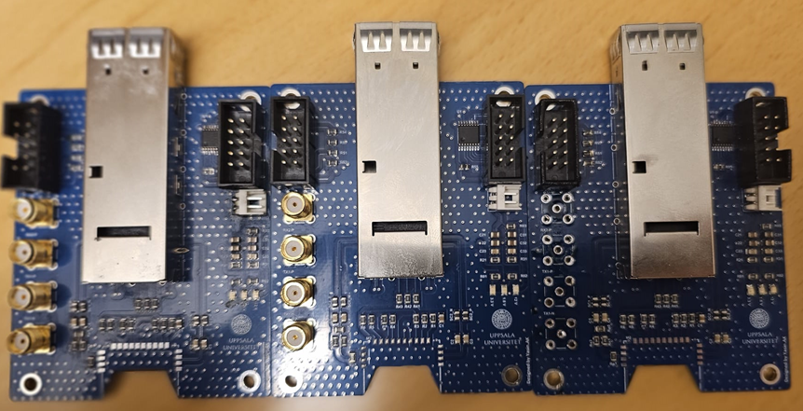
Fig. 4 Designed and fabricated QSFP28 and RF Unit interface for high speed communication
To study and validate this interface under different scenarios, the board has been developed in three versions. Each version introduces specific improvements or changes to help us analyze performance, identify limitations, and ensure reliable operation before final integration. These versions are described in detail.
The first version (G1) is a standalone QSFP28 board developed to test basic functionality and establish a reliable high-speed data path. This board was mainly used for initial debugging and validation of the electrical interface. Two of them are connected to two RFSoC for direct data transmission using wire communication. The main focus at this stage was to evaluate the performance of the QSFP28 link under controlled conditions. This setup is shown in fig. 5.
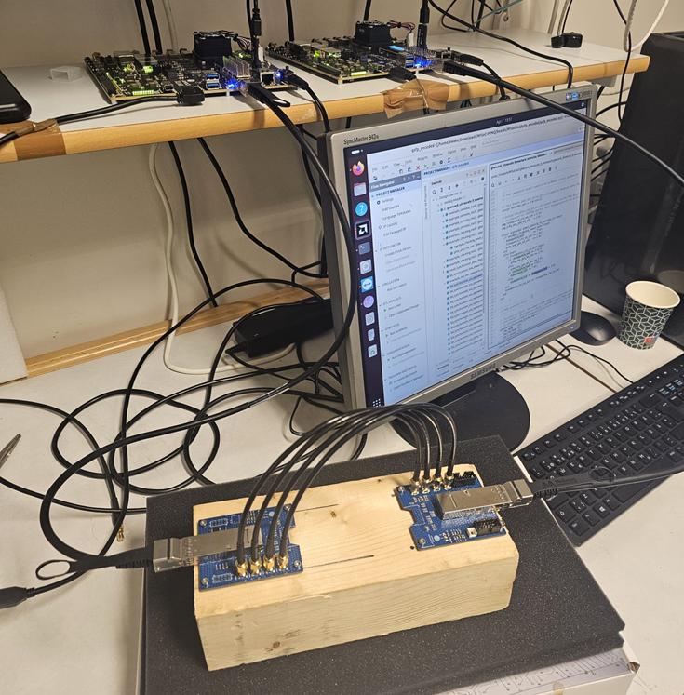
Fig. 5 Test setup for the developed QSFP28 board using a wire communication.
In the second scenario (G2), we tested the QSFP28 board together with the SKA2D as the RF front-end. Our setup used two boards: one as the transmitter and the other as a full-duplex RF transceiver unit. The SKA2D received the 60 GHz RF signal from another RFSoC, which was then demodulated by the ST60 chip on the board. The data was transferred through the QSFP28 interface to the RFSoC for further processing. This version helped us test how the system operates with real RF input and confirmed that the QSFP link can reliably handle data transfer between the RF unit, the ST60 chip, and the processing board. This setup is illustrated in Fig. 6. Also, Fig. 8 shows the test setup and the results, demonstrating RF signal availability between the developed boards.
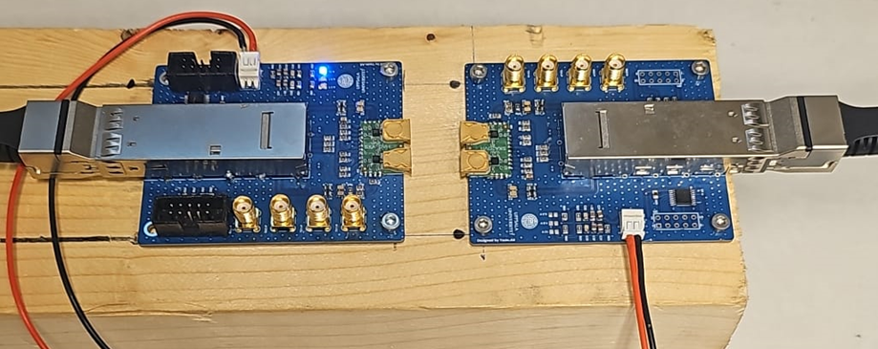
Fig. 6 Test setup with two boards, as full-duplex transceiver, using SKA2D, ST60, and QSFP28 connected to RFSoC.
SKA2DXX: SKA2Dxx is a series of RF stamp hole modules with various of horn antenna configuration. SKA2Dxx is based on leading edge ST60A2 60G mmW RF transceiver, which could achieve very low power, very high speed, short distance data transfer. These stamp hole modules can be easily mounted on other PCB motherboard.
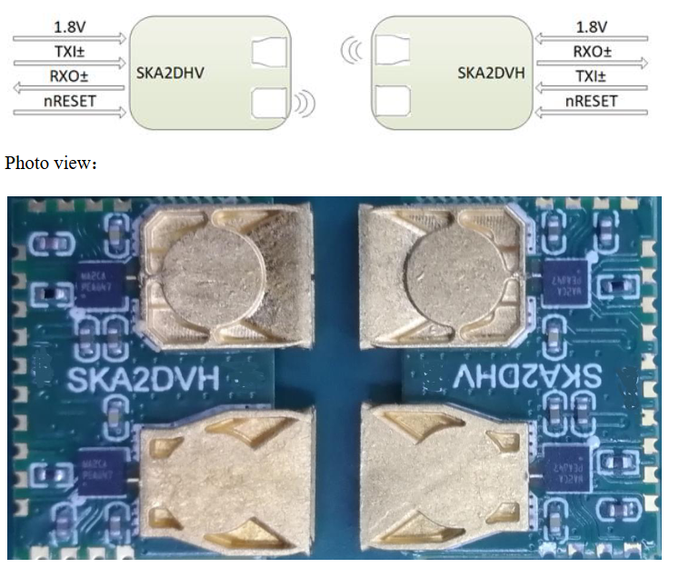
Fig. 7 SKA2D board with ST60 chip and full-duplex horn antenna.
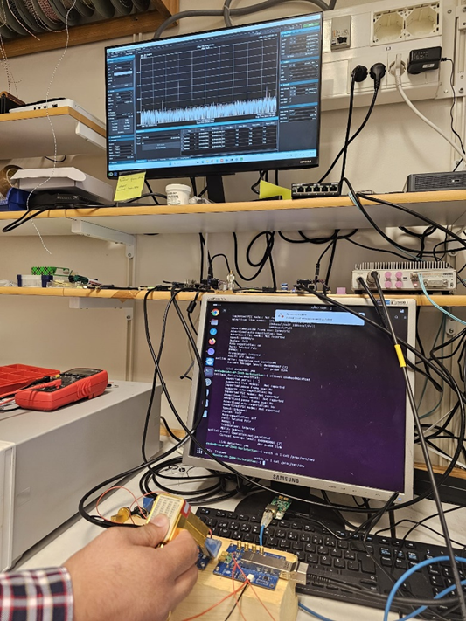
Fig. 8 Test results showing RF signal availability between the developed boards in the G2 setup
The third scenario (G3) integrates the QSFP28 board with a custom RF unit developed at Uppsala University. It combines the ST60 chip and a compact 60 GHz antenna to enable full-duplex wireless transmission. In this version, high-speed data is received wirelessly, converted to intermediate frequency, and sent to the RFSoC via the QSFP interface. Fig. 9 shows the 3D model of the RF unit designed and developed at Uppsala University, which is currently in the fabrication process.
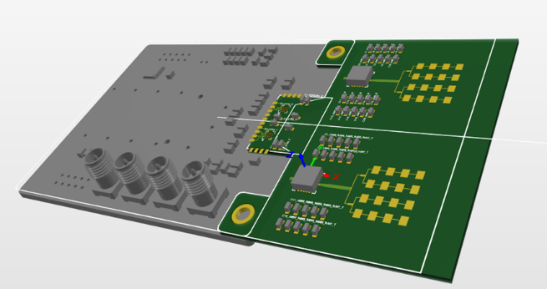  (a) | 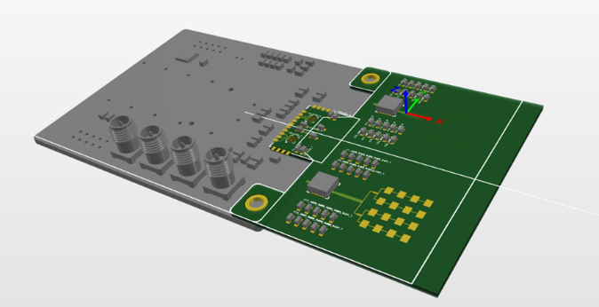  (b)
Fig. 9: 3D model of the RF unit designed at Uppsala University, currently under fabrication (a) Full duplex – one side Antennas,(b) Full duplex – opp. side Antennas

FUTURE PLANS / Conclusion / relation to other AIDA-2020 work
In the final stages of the project, focus is being directed toward full system integration and performance testing in relevant high-energy physics environments. The custom-built RF units are under fabrication and will be tested in conjunction with the full-duplex communication interface. Our goal is to finalise with the demonstration of 5 Gbps wireless data transmission using our developed boards under realistic detector conditions.
Future efforts will include:
- Final integration of the complete wireless readout chain.
- Environmental testing under radiation and magnetic field conditions typical of HEP experiments.
- Dissemination of results to new potential users and collaborators in the HEP community.
- Exploring neuromorphic radial networks supported by our repeater topology for intelligent event detection and tracking.
- Establishing links with other AIDAinnova tasks focused on fast data acquisition, low-mass systems, and system integration.
This work directly contributes to the overarching AIDAinnova goals of advancing detector technologies for future accelerator-based experiments and paves the way for wireless-enabled, scalable, and robust readout architectures for the next generation of particle detectors. The work in collaboration with our colleagues is pursued within the WADAPT initiative and DRD7 frameworks at CERN. Different projects have been submitted to the Swedish Research Council, and more projects are considered to be submitted at EU level, together with our partners in WADAPT.

