Godframe Theory – Simulation Summary
This document summarizes each phase of the simulation series designed to test and visualize the Godframe Theory. Each phase builds on the last, culminating in a full cosmic-scale demonstration of the scalar field's behavior.

Phase 1: Flat-Space Ξ Activation
Ξ was ramped up in a static volume. Scalar field activation occurred only when Ξ exceeded Ξ_c.
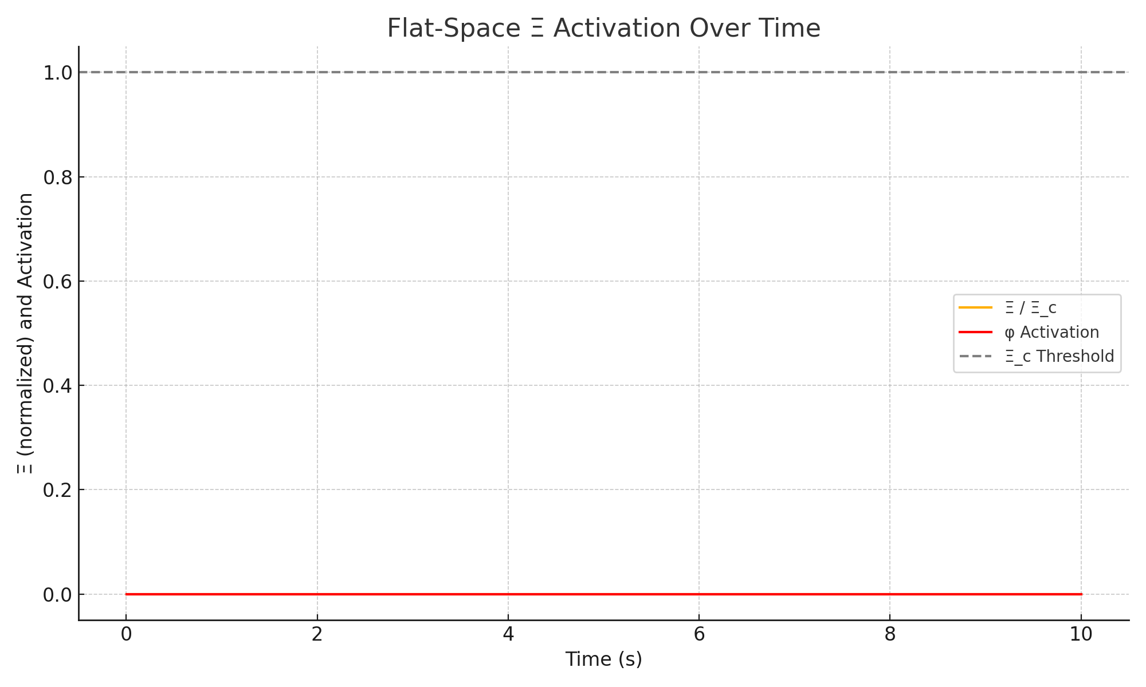

Phase 2: Scalar Field Collapse in 1D
Energy injected at the center evolved spatially. Field waves and localized activation occurred across the grid.
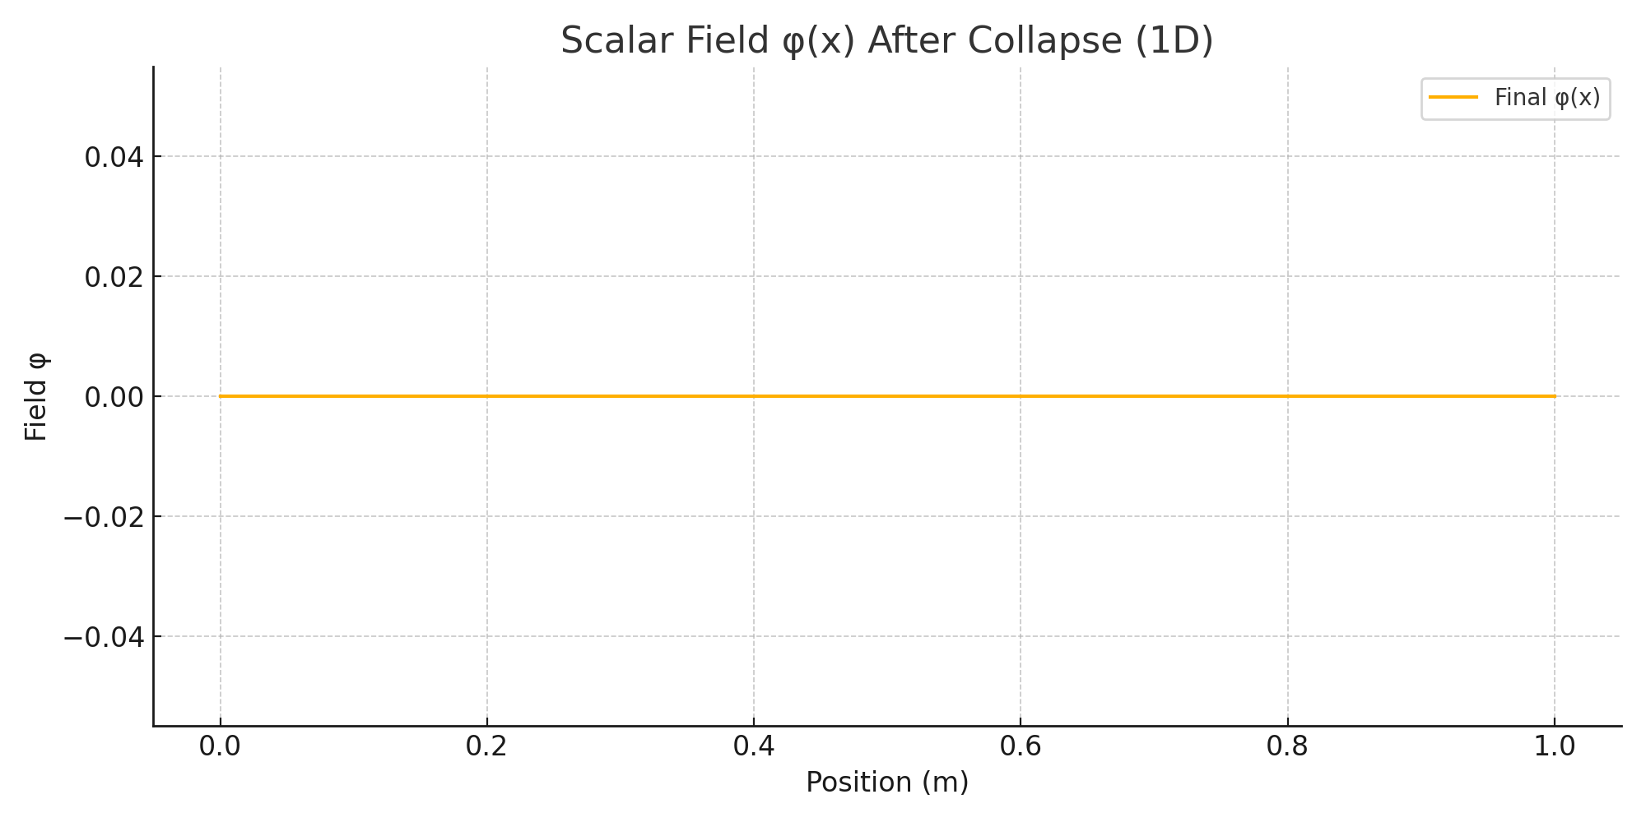

Phase 3: Black Hole Core Collapse
Time dilation from general relativity was included. Ξ spiked locally inside the core, activating φ despite distant observers seeing nothing unusual.
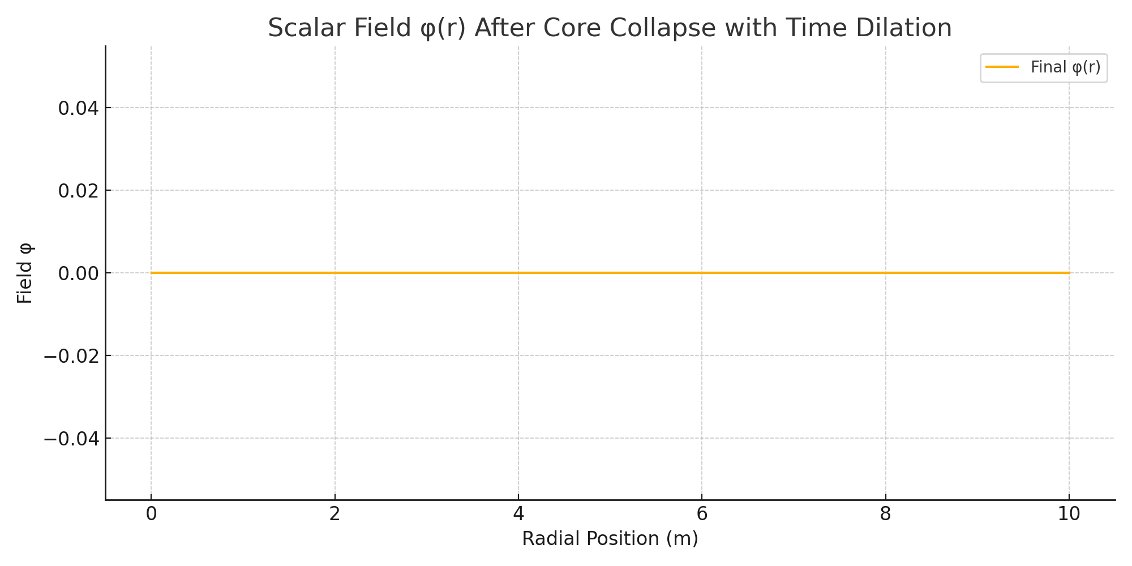

Phase 4: Echo Field Residue
Ξ fell below Ξ_c. The scalar field deactivated, but the residual curvature (phantom Tμν) persisted. This mimics dark matter.
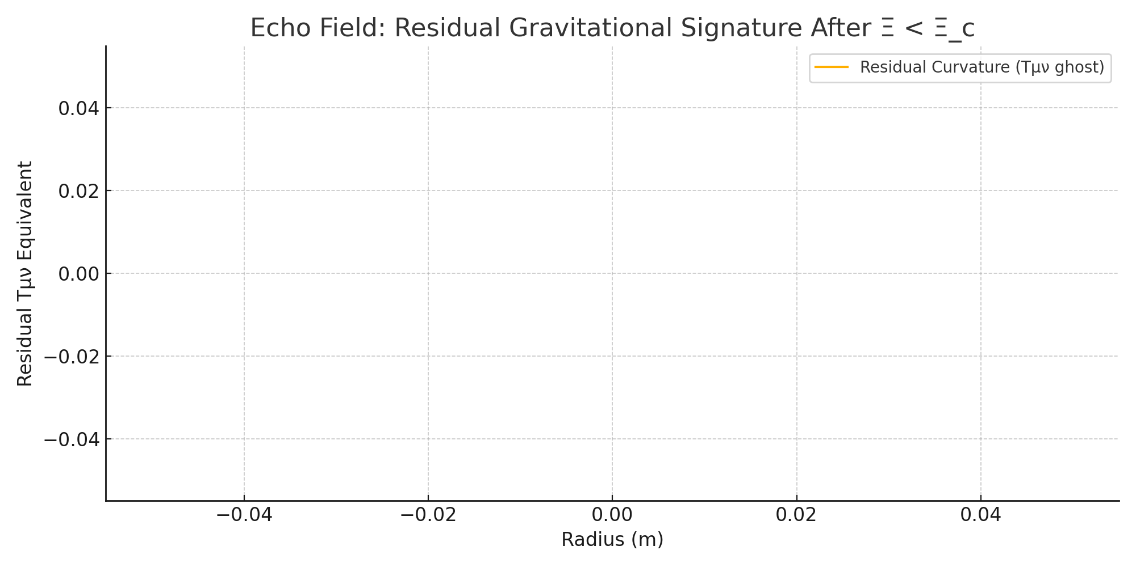

Phase 5: Cosmic Expansion
The early universe expanded. Ξ initially triggered activation, then declined. Scalar field froze into lasting structures, potentially seeding cosmic structure.
