Supporting Information
Breakthrough in Luminescence Thermometry - Supersensitive Emission Line Shift of Whispering Gallery Modes in Rhodamine B-doped Cellulose Fiber Microresonators

Przemysław Woźny,^{a,*} Kevin Soler-Carracedo,ª Małgorzata Skwierczyńska,ª Inocencio R. Martin,^{b} Piotr Kulpiński,^{c} Marcin Runowski ª
ª Faculty of Chemistry, Adam Mickiewicz University, Poznań 61-614, Poland
^{b} Departamento de Física, Instituto de Materiales y Nanotecnología (IMN), Universidad de La Laguna, San Cristóbal de La Laguna E-38200, Santa Cruz de Tenerife, Spain
^{c} Department of Mechanical Engineering, Informatics and Chemistry of Polymer Materials, Lodz University of Technology, Żeromskiego 116, Łódź 90-924, Poland

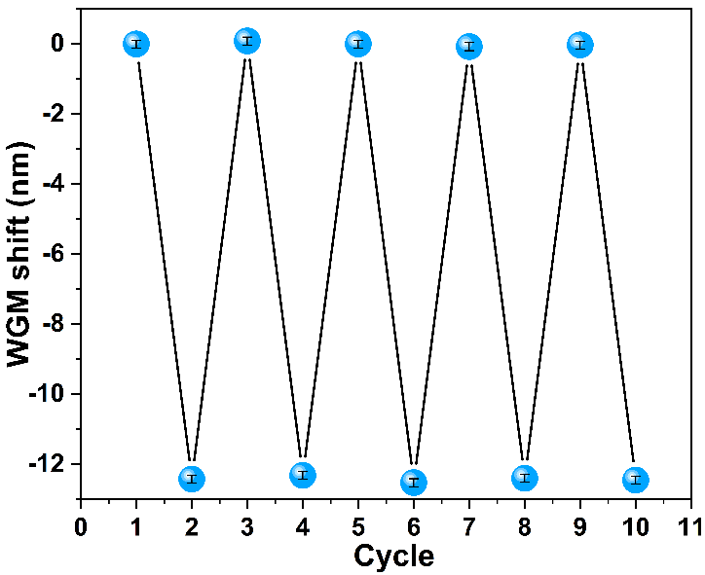
Figure. S1 Average displacement of the selected WGMs in heating-cooling cycles.

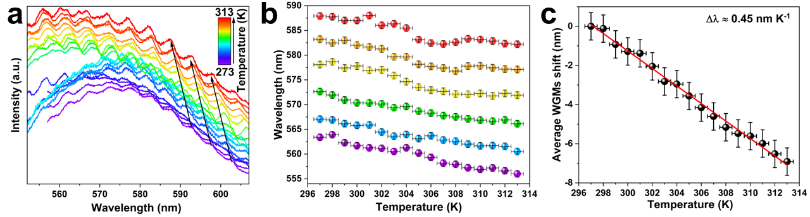
Figure. S2 Emission spectra measured at different temperature values with narrow WGMs and their thermal shift (a); the calculated position of the selected WGMs as a function of temperature for second cellulose fibers@Rhodamine B (b); average WGMs shift for second fiber (c).

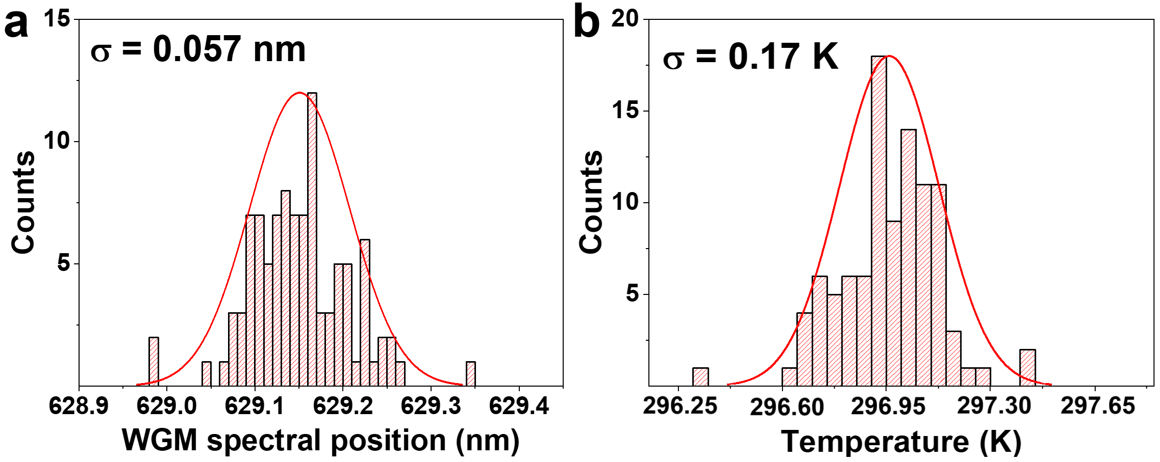
Figure. S3 Histograms obtained based on the recorded series of 100 emission spectra, showing spectral resolution of the WGM mode at ≈629 nm (a) and the corresponding temperature values (b), calculated using calibration curve from Eq. 5, with their respective standard deviation (σ) values; the σ represents the experimental temperature resolution of the system.

Table. S1 List of maximum relative and absolute sensitivities of different WGM-based sensors.
Max S_{r}  (% nm K⁻¹) |  | Max S_{a}  (nm K⁻¹) | Matrix | Ref.
8.4×10⁻² | 4.5×10⁻¹ |  | Cellulose fiber | This work
2.0×10⁻³ | 1.5×10⁻² |  | Silica microspheres | ¹
2.0×10⁻³ | 1.7×10⁻² |  | Oxyfluoride glass microsphere | ²
1.5×10⁻³ | 1.4×10⁻² |  | Nd³⁺ doped yttria–alumina–silica (YAS) microsphere | ³
8.1×10⁻⁴ | 5.3×10⁻³ |  | Ho³⁺ doped yttria–alumina–silica (YAS) microsphere | ⁴
6.0×10⁻⁴ | --- |  | Silica microcavity | ⁵
5.3×10⁻⁴ | 8.2×10⁻³ |  | Silica fiber | ⁶

References
1 K. Soler-Carracedo, A. Ruiz, I. R. Martín and F. Lahoz, J. Alloys Compd., 2019, 777, 198–203.
2 F. Paz-Buclatin, S. Ríos, I. R. Martín and L. L. Martin, Opt. Mater. Express, 2019, 9, 4126.
3 D. Walo-Martín, F. Paz-Buclatin, S. Ríos, I. R. Martín, L. L. Martin, A. Ródenas, V. N. Sigaev, V. I. Savinkov and G. Y. Shakhgildyan, Appl. Sci., 2021, 11, 1117.
4 L. de Sousa-Vieira, S. Ríos, I. R. Martín, L. García-Rodríguez, V. N. Sigaev, V. I. Savinkov and G. Yu Shakhgildyan, Opt. Mater. (Amst)., 2018, 83, 207–211.
5 T. Carmon, L. Yang and K. J. Vahala, in Integrated Photonics Research and Applications/Nanophotonics for Information Systems, OSA, Washington, D.C., 2005, vol. 12, p. IWE4.
6 E. Rivera-Perez, I. L. Villegas, A. Diez, M. V. Andres, J. L. Cruz and A. Rodriguez-Cobos, IEEE Photonics Technol. Lett., 2013, 25, 2498–2500.

