Supplementary Material for
Experimental Constraints on the Role of Carbonatitic Melts in Nb/Ta Fractionation at Subduction Zones
Wei Chen¹, Massimo Tiepolo², Guoliang Zhang^{1,}*
¹School of Marine Sciences, Sun Yat-sen University, Zhuhai, China.
²Dipartimento di Scienze della Terra “A. Desio”, Università degli Studi di Milano, Milano, Italy
Corresponding author: zhanggliang5@mail.sysu.edu.cn
Content of this file
Figure S1. Comparsion of Raman spectra between representative synthesized TiO₂ phases and rutile standard.
Figure S2. Frequency distribution of TiO₂ for global MORB and ocean sediment.
Figure S3. Nb and Ta partition coefficients between rutile-bearing eclogite and saline aqueous fluid and their ratios.
Table S1. Composition of starting material
Table S2. Major and minor element compositions of experimental phases
Table S3. Nb and Ta partition coefficients between rutile and perovskite and carbonatitic melt
Table S4. Calculated Nb and Ta concentration in carbonatitic melt and residual eclogite for carbonated basalts using newly obtained partition coefficients of Nb and Ta
Table S5. Calculated Nb and Ta concentration in carbonatitic melt and residual eclogite for carbonated sediments using newly obtained partition coefficients of Nb and Ta
Table S6. The calculated Nb and Ta characteristics of carbonatites that have mantle sources metasomatized by slab-derived carbonatitic melts
Notes: all supplementary Tables have been uploaded as a separate file.
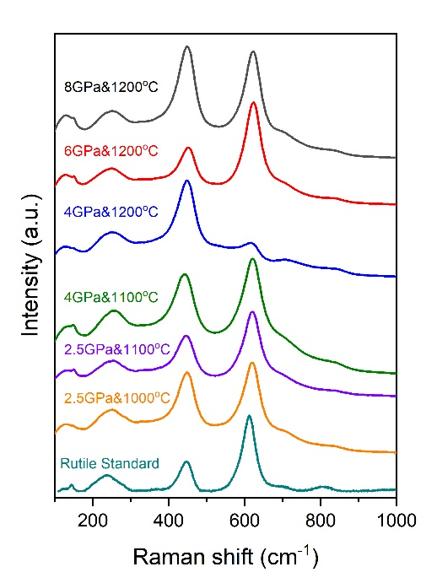
Figure S1. Comparsion of Raman spectra between representative synthesized TiO₂ phases and rutile standard. The Raman spectrum of rutile standard is selected from the RRUFF database (https://rruff.info/) with sample of R050417. Raman spectra of all synthesized TiO₂ phases as well as a standard rutile sample, all of which coincide in the peak positions. It suggests that all the TiO₂ phases synthesized under the investigated pressure-temperatures conditions are rutile.

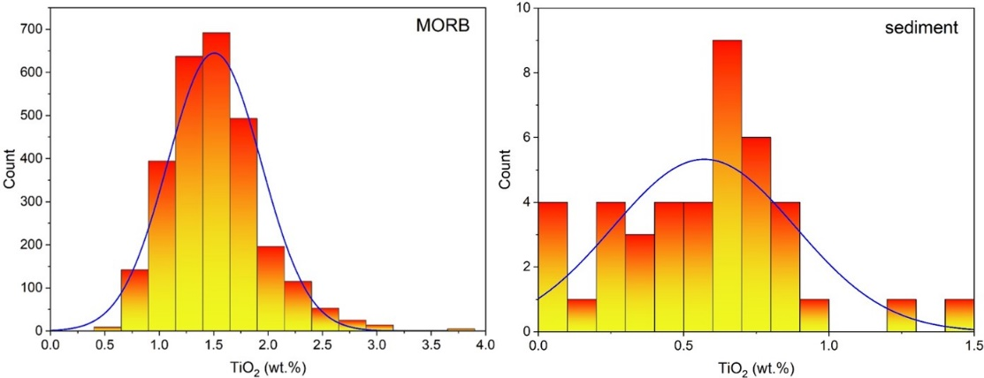
Figure S2. Frequency distribution of TiO₂ for global MORB and ocean sediment. Data sources for MORB: Jenner et al. (2012); Gale et al. (2013); Shimizu et al. (2016); Kamenetsky and Eggins (2012); Arevalo and McDonough (2010); Patten et al. (2013); Labidi et al. (2014); Eason and Sinton (2006); Nielsen et al. (2014); Yang et al. (2014, 2017); Yang et al. (2020). Data sources for ocean sediment: Plank and Langmuir (1998).

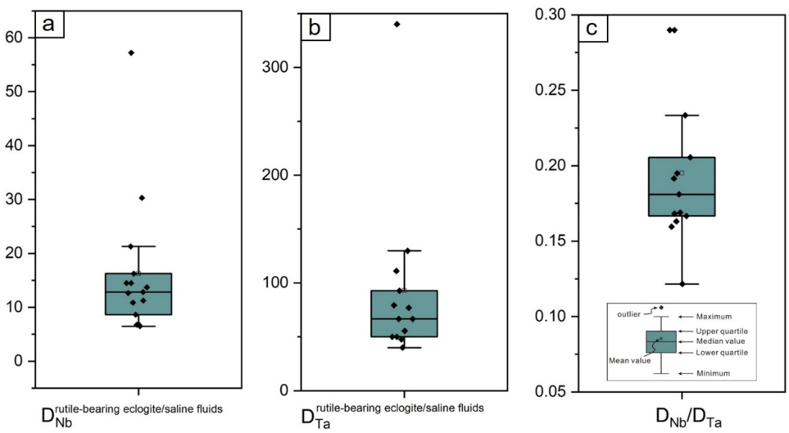
Figure S3. Box-and-whisker plots of rutile-bearing eclogite–saline fluids (a) Nb and (b) Ta partition coefficients (D_{Nb} and D_{Ta}), and the associated (c) partition coefficient ratios (D_{Nb/}D_{Ta}). Data sources: Rustioni et al. (2019).

Reference:
Arevalo, R., McDonough, W.F., 2010. Chemical variations and regional diversity observed in MORB. Chemical Geology 271, 70-85.
Chen, W., Keshav, S., Peng, W., Zhang, G., 2023. Coupled cycling of carbon and water in the form of hydrous carbonatitic liquids in the subarc region. Journal of Geophysical Research: Solid Earth n/a, e2023JB026681.
Eason, D., Sinton, J., 2006. Origin of high-Al N-MORB by fractional crystallization in the upper mantle beneath the Galápagos Spreading Center. Earth and Planetary Science Letters 252, 423-436.
Gale, A., Dalton, C.A., Langmuir, C.H., Su, Y., Schilling, J.-G., 2013. The mean composition of ocean ridge basalts. Geochemistry, Geophysics, Geosystems 14, 489-518.
Jenner, F.E., O'Neill, H.S.C., 2012. Analysis of 60 elements in 616 ocean floor basaltic glasses. Geochemistry, Geophysics, Geosystems 13.
Kamenetsky, V.S., Eggins, S.M., 2012. Systematics of metals, metalloids, and volatiles in MORB melts: Effects of partial melting, crystal fractionation and degassing (a case study of Macquarie Island glasses). Chemical Geology 302-303, 76-86.
Labidi, J., Cartigny, P., Hamelin, C., Moreira, M., Dosso, L., 2014. Sulfur isotope budget (32S, 33S, 34S and 36S) in Pacific–Antarctic ridge basalts: A record of mantle source heterogeneity and hydrothermal sulfide assimilation. Geochimica et Cosmochimica Acta 133, 47-67.
Nielsen, S.G., Shimizu, N., Lee, C.-T.A., Behn, M.D., 2014. Chalcophile behavior of thallium during MORB melting and implications for the sulfur content of the mantle. Geochemistry, Geophysics, Geosystems 15, 4905-4919.
Patten, C., Barnes, S.-J., Mathez, E.A., Jenner, F.E., 2013. Partition coefficients of chalcophile elements between sulfide and silicate melts and the early crystallization history of sulfide liquid: LA-ICP-MS analysis of MORB sulfide droplets. Chemical Geology 358, 170-188.
Plank, T., Langmuir, C.H., 1998. The chemical composition of subducting sediment and its consequences for the crust and mantle. Chemical Geology 145, 325-394.
Shimizu, K., Saal, A.E., Myers, C.E., Nagle, A.N., Hauri, E.H., Forsyth, D.W., Kamenetsky, V.S., Niu, Y., 2016. Two-component mantle melting-mixing model for the generation of mid-ocean ridge basalts: Implications for the volatile content of the Pacific upper mantle. Geochimica et Cosmochimica Acta 176, 44-80.
Yang, A.Y., Zhao, T.P., Zhou, M.F., Deng, X.G., 2017. Isotopically enriched N-MORB: A new geochemical signature of off-axis plume-ridge interaction—A case study at 50°28′E, Southwest Indian Ridge. Journal of Geophysical Research: Solid Earth 122, 191-213.
Yang, A.Y., Zhou, M.-F., Zhao, T.-P., Deng, X.-G., Qi, L., Xu, J.-F., 2014. Chalcophile elemental compositions of MORBs from the ultraslow-spreading Southwest Indian Ridge and controls of lithospheric structure on S-saturated differentiation. Chemical Geology 382, 1-13.
Yang, S., Humayun, M., Salters, V.J.M., Elemental constraints on the amount of recycled crust in the generation of mid-oceanic ridge basalts (MORBs). Science Advances 6, eaba2923.

