GC_Tester2
For optimal use of this program, please follow the guidelines below:
Right click, and then go to properties
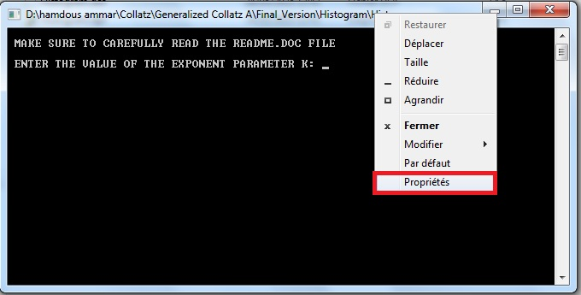

Check This option.
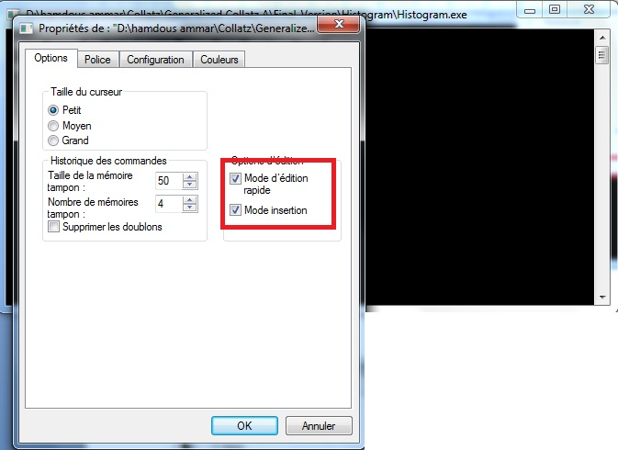
Select these settings, and then click OK

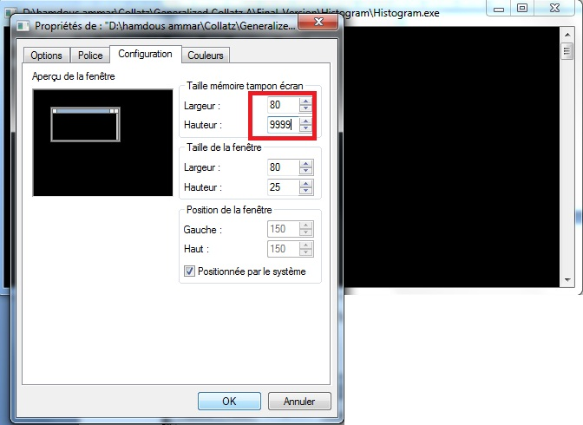
To pause the program, simply click on the window, and to resume it, just right-click
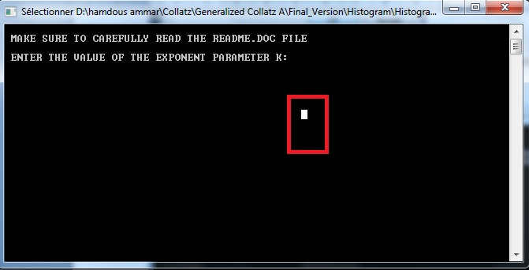

To copy data, simply highlight it with the mouse, then right-click
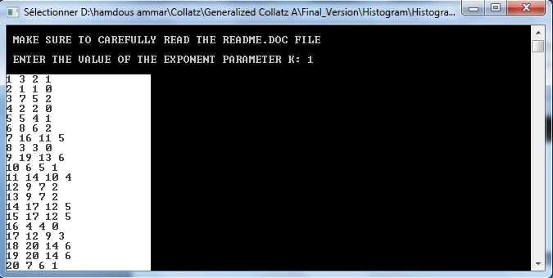

How this program works:
This auxiliary program is designed to generate and visualize an histogram over the first 100010001000 positive integers n∈[1,1000]n \in [1, 1000]n∈[1,1000], in order to analyze:
- the total number of iterations required to reach 1,
- the number of iterations performed using the generalized function fk,
- the number of iterations using f2.
The program is valid for exponent values k such that:
- 0 < k < 43 and k≠2.
The program doesn’t use these two main strategies:
1) It is sufficient to test only odd natural numbers.
2) For a natural number to be validated, it is enough for it to either converge to 1 or simply converge to a smaller natural number that has already been tested.
T program tests all natural numbers, both even and odd.

The program is developed with Borland Delphi 7 and does not require installation to run—just double-click on Histogram.exe.

The data extracted by this program are:
Each of the 1000 output lines produced by the program corresponds to a specific input n∈[1,1000] , and is composed of the following fields:
- The natural number being tested.
- The total number of iterations to reach 1 under the generalized Collatz sequence (combined odd and even steps).
- The number of iterations by f_{k} function.
- The number of iterations by f₂ function

