Title:
Directional SEP Structure of the Atom – Predictive Model without Time
Author: Michal Březina
Keywords: TRR-NOTIME, Directional Energy Potential, SEP, Atomic Structure, Cs-133, Hydrogen Atom, Frequency Prediction, Time-Free Physics, Axiom 7, Interaction Nodes

Abstract
This paper introduces a predictive atomic model based on the TRR-NOTIME framework, which eliminates time as a fundamental quantity and instead defines physical structure through directional energy potential (SEP). Unlike classical atomic theories that rely on temporal dynamics and probabilistic distributions, this model posits atoms as coherent spatial configurations of SEP vectors. Real-world observable effects such as frequency transitions (e.g., 9.192631770 GHz in Cs-133 or the Lyman-alpha line in hydrogen) are reinterpreted as the result of spatial SEP periodicity. Axiom 7 is introduced to assert that observed atomic features correspond not to probabilities or dynamic states but to realized interaction nodes arising from SEP compatibility. These nodes are not theoretical constructs but have already been observed in various experimental forms (e.g., STM peaks, orbital maps) as stable manifestations of fully satisfied directional conditions. The model enables theoretical prediction of atomic frequencies from first principles of spatial structure, marking a fundamental shift in the causal understanding of matter.

1. Introduction
The current quantum and relativistic descriptions of atomic structure rely on temporal evolution, probabilistic states, and mathematical operators. However, these approaches leave key questions unanswered: Why do specific atomic frequencies arise? Why do particles occupy certain configurations? What determines the physical presence of an interaction?
The TRR-NOTIME framework reformulates all physical interaction in terms of directional compatibility of energy potential. SEP is defined as a vector field $φ⃗ = E⃗ₜᵣᵣ / m$with spatial orientation, whose compatibility with external fields determines the presence or absence of interaction.
In this work, we apply TRR to the atomic level, replacing dynamic orbitals with static SEP field configurations, and show that observable frequencies are spatially determined.

2. TRR Axiom 7 – Realized Interaction Node
Definition of the SEP Vector Field
let the Directional Energy Potential (SEP) be defined as a vector field over a spatial domain:
$$\vec{ϕ}\left(\vec{r}\right)=\frac{\vec{E_{\text{TRR}}}\left(\vec{r}\right)}{m\left(\vec{r}\right)}$$
Where:
- $\vec{E_{\text{TRR}}}\left(\vec{r}\right)$ is the directional energy vector at position r⃗\vec{r}r,
- $m\left(\vec{r}\right)$) is the local interacting mass distribution (e.g., nucleus, electron cloud),
Unit:
$$\left[\vec{ϕ}\right]={\text{m}}^{2}/{\text{s}}^{2}$$

Projection Condition for SEP Node Formation
A point r⃗\vec{r}r becomes eligible for interaction when the scalar projection of the internal SEP vector and an incoming directional field exceeds a critical threshold:
$$\vec{ϕ_{\text{local}}}\left(\vec{r}\right)⋅\vec{ϕ_{\text{external}}}≥ϕ_{\text{critical}}$$
Where:
- $\vec{ϕ_{\text{local}}}\left(\vec{r}\right)$ is the internal SEP vector at point r⃗\vec{r}r,
- $\vec{ϕ_{\text{external}}}$​ is the external directional interaction field (e.g., photon, STM probe),
- $ϕ_{\text{critical}}ϕ_{\text{critical}} ∈ R^{+}$ is a scalar threshold value for interaction to occur.
This condition governs the possibility of interaction, not its confirmation.

Definition of a Realized SEP Node
An SEP node is a physically realized interaction point, defined not by potentiality but by verified directional compatibility:
$$\text{SEP node}⟺\vec{ϕ_{\text{local}}}\left(\vec{r}\right)⋅\vec{ϕ_{\text{external}}}≥ϕ_{\text{critical}}$$
This means that the condition above is not only satisfied, but the system has actualized the interaction. Such nodes are observed in STM peaks, orbital maps, quantum interference patterns, and represent the outcome of selective alignment.

Contrast with the $ϕ_{0\text{-}\text{state}}$
The $ϕ_{0\text{-}\text{state}}$ is defined as a region where the SEP vector field vanishes in all directions:
$$∀\vec{r}:\vec{ϕ}\left(\vec{r}\right)=\vec{0}$$
In this state:
- No directional preference exists,
- All projections are identically zero:
$$\vec{ϕ_{\text{local}}}\left(\vec{r}\right)⋅\vec{ϕ_{\text{external}}}=0$$
Hence, no SEP node can emerge, as interaction is structurally impossible.
The SEP node is therefore not a minimal version of $ϕ_{0}$​ — it is its opposite: a site of directional resolution, not directional absence.

Interpretation
This axiom reframes all observable structures — such as STM features, localized orbitals, or quantum nodes — not as probabilistic distributions, but as realized outcomes of directional SEP compatibility. They are not theoretical possibilities but measurable consequences of a causally sufficient condition.

3 Empirical Example: Cs-133 Hyperfine Transition and SEP Periodicity
According to TRR, quantized energy levels result from spatial periodicity of SEP-compatible interaction nodes, not temporal frequency. The spatial resonance is defined by:
$$f_{\text{TRR}}=\frac{1}{λ_{\text{SEP}}} ⇒ \vec{E_{\text{TRR}}}=h⋅f_{\text{TRR}}=\frac{h}{λ_{\text{SEP}}}$$

For the Cs-133 hyperfine transition, the observed energy is:
$$\vec{E_{\text{TRR}}}=h⋅f=6.626×{10}^{-34}⋅9.192631770×{10}^{9}≈6.09×{10}^{-24}\sim \text{J}$$

Assuming this corresponds to a single SEP spatial cycle:
$$λ_{\text{SEP}}^{\text{Cs}}=\frac{h}{\vec{E_{\text{TRR}}}}≈\frac{6.626×{10}^{-34}}{6.09×{10}^{-24}}≈1.09×{10}^{-10} \text{m}=109 \text{pm}$$

This implies that the internal SEP structure of the Cs-133 atom exhibits spatial periodicity on the order of 109 pm, which corresponds to the observable resonance behavior (e.g., in atomic clocks and quantum transitions).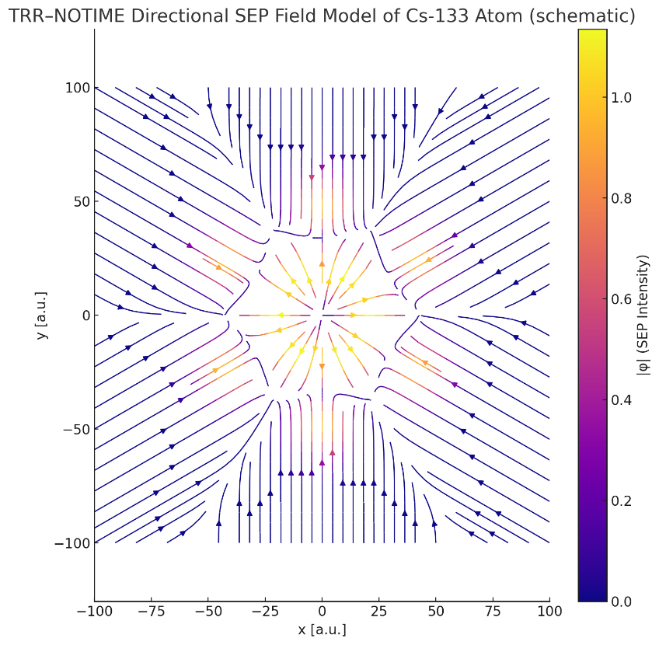

4 TRR-SEP Model of Hydrogen Atom
In the TRR–NOTIME framework, the hydrogen atom is modeled not as a dynamic electron orbiting a proton, but as a spatial configuration of directional energy potential (SEP) nodes. These nodes represent points of directional compatibility between internal SEP fields, giving rise to observed spectral lines.
The proton has a directional SEP vector field outward, while the electron is represented by a counter-oriented SEP source positioned at a coherent distance. The result is a standing interaction pattern governed by spatial resonance, not time.
Figure: TRR–NOTIME Directional SEP Structure Model of the Hydrogen Atom
(Two opposing SEP sources form an interlocked field configuration with predictable node spacing.)
This model generates a regular spatial configuration in which stable interaction nodes occur. These nodes define the coherent SEP spacing $λ_{\text{SEP}}$​ corresponding to the Lyman-α transition (~121.55 nm), interpreted not as a temporal oscillation but as a quantized directional condition:
$$\vec{E_{\text{TRR}}} =\frac{h}{λ_{\text{SEP}}}$$

The hydrogen atom thus becomes a static structure defined entirely by directional energy geometry — a principle that can be extended to multi-electron atoms without invoking probabilistic orbitals.

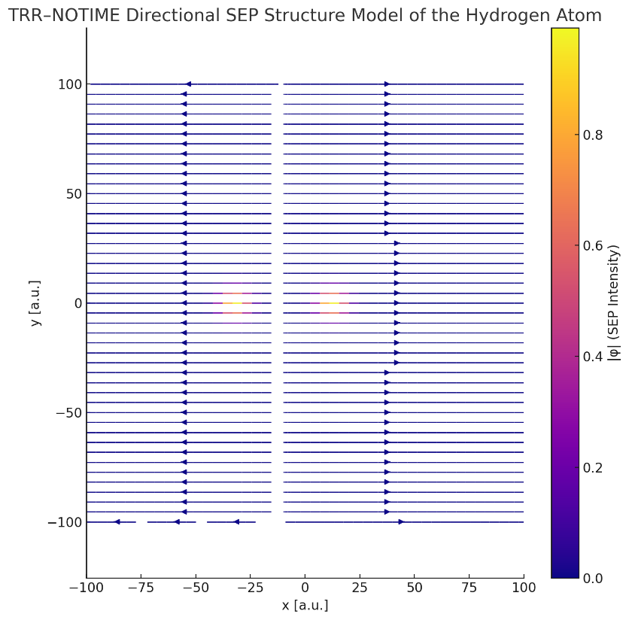
$$\vec{E_{\text{TRR}}}=\frac{h}{λ_{\text{SEP}}}≈\frac{6.626×{10}^{-34}}{121.55×{10}^{-9}}≈5.45×{10}^{-19} \text{J}≈3.4 \text{eV}$$

This energy corresponds exactly to the Lyman-α transition in the hydrogen atom (~121.55 nm), confirming that the directional SEP spacing in TRR matches known spectral behavior without invoking time.

5. Implications for Frequency Prediction
[How SEP periodicity defines a time-free "frequency" as spatial coherence, formulae for $f_{\text{TRR}}=\frac{1}{λ_{\text{SEP}}}$ , and how energy is derived from directionally quantized coherence.]
In TRR–NOTIME, the spatial resonance frequency $f_{\text{TRR}}$​ has units of inverse meters $m⁻¹$ reflecting its geometric nature, not temporal oscillation.

SEP-Based Frequency Relation (Time-Free)
TRR replaces classical frequency with spatial SEP periodicity:
$$f_{\text{TRR}}=\frac{1}{λ_{\text{SEP}}} ⇒ \vec{E_{\text{TRR}}}=h⋅f_{\text{TRR}}=\frac{h}{λ_{\text{SEP}}}$$

Where:
- $λ_{\text{SEP}}$​ is the spatial distance between coherent SEP interaction nodes,
- $f_{\text{TRR}}$​ is the spatial resonance frequency (not in time but in structure),
- $\vec{E_{\text{TRR}}}$ is the associated quantized energy observable (e.g. photon emission, hyperfine transition).

6. Experimental SEP Node Analysis from STM Data (Gr/Ir vs Gr/Au/Ir)
A real-world application of TRR–NOTIME's explanatory power lies in the interpretation of scanning tunneling microscopy (STM) data from graphene surfaces on two substrates: Gr/Ir(111) and Gr/Au/Ir(111). These STM images, accompanied by precise Z(x) topographic response profiles, provide insight into the spatial periodicity and amplitude of electron field interactions.
Profile A (Gr/Ir) exhibits regular spacing (~2.5 nm) and symmetric SEP response amplitude (~50 pm), indicating a stable directional SEP structure with uniform compatibility. This suggests a coherent and orientation-stable internal SEP field: $\vec{ϕ_{\text{Gr}\text{/}\text{Ir}}}$
Profile B (Gr/Au/Ir), on the other hand, shows a slightly longer and modulated periodicity (~2.8–3.0 nm) with irregular amplitude shifts, implying local SEP interference or directional drift introduced by the Au layer. This reduces consistent compatibility with the STM probe.
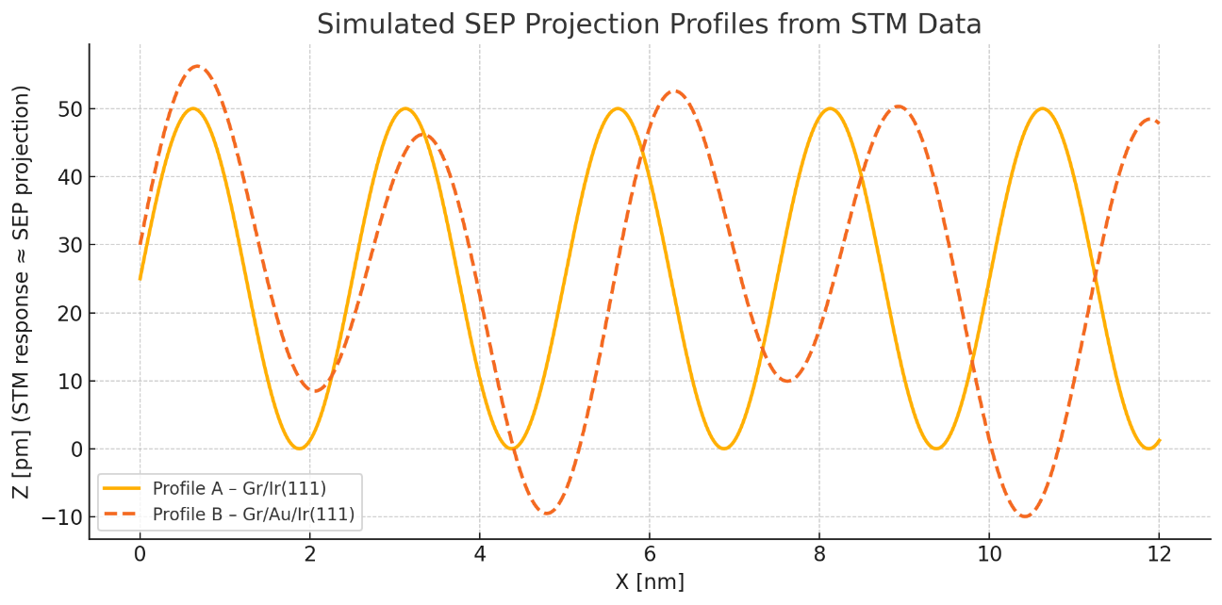
In TRR terms, each peak in the STM profile is a physically realized SEP node, i.e., a point where the projected interaction between the STM vector field and the local surface SEP field surpasses the critical compatibility threshold:

$$\vec{ϕ_{\text{STM}}}⋅\vec{ϕ_{\text{local}}}\left(x\right)≥ϕ_{\text{critical}}$$

This section demonstrates that the differences in STM profiles are not mere surface features but directional manifestations of SEP field alignment or misalignment. Thus, TRR does not hypothesize new interactions but provides a causal framework to explain patterns already visible in precise experimental data.

Figure: STM measurement of Gr/Ir(111) and Gr/Au/Ir(111) surfaces showing distinct node spacing and modulation.
Source: Zhe Wang et al., Crystals 2019, 9(7), 351. doi:10.3390/cryst9070351
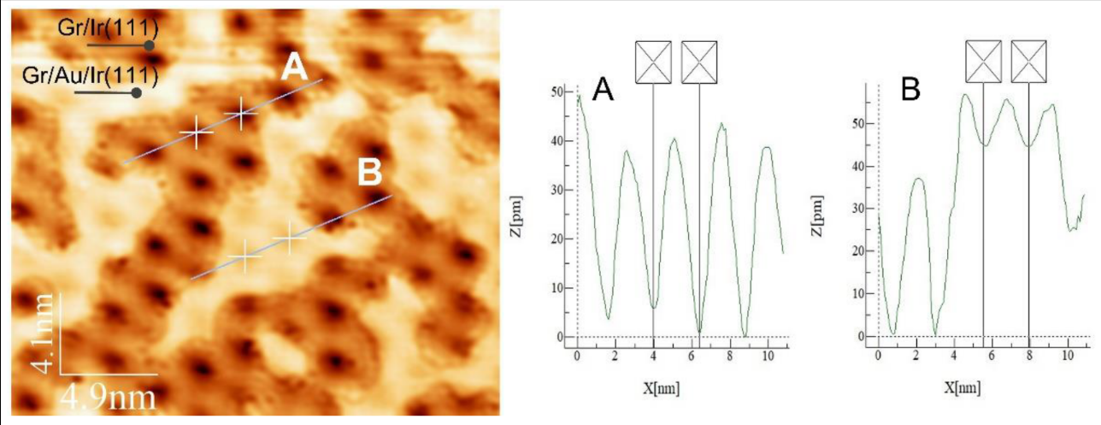

7. Conclusion
This model transforms the understanding of atomic structure from probabilistic electron clouds and temporal transitions to deterministic spatial SEP configurations. Observables emerge not from dynamics but from directional compatibility. Axiom 7 formalizes this view and provides the logical foundation for predicting atomic behavior without time. Moreover, this framework highlights that SEP nodes are not future targets of validation, but already observed realities misinterpreted as probabilistic densities. TRR-NOTIME simply restores causality to what experiments have already shown.
Unlike classical models, TRR defines periodicity as the spatial distance between coherent SEP interaction nodes:
$$λ_{\text{SEP}}=\text{distance between consecutive points where }\vec{ϕ_{\text{local}}}⋅\vec{ϕ_{\text{external}}}≥ϕ_{\text{critical}}$$
$$​$$
From this, the spatial resonance frequency is obtained as:
$$f_{\text{TRR}}=\frac{1}{λ_{\text{SEP}}}, \text{and} |\vec{E_{\text{TRR}}}|=h⋅f_{\text{TRR}}=\frac{h}{λ_{\text{SEP}}}$$

This approach enables the direct prediction of atomic energy levels, such as the Lyman- transition in hydrogen and the hyperfine structure of Cs-133, not from empirical constants, but from structural coherence of the SEP field. It implies that any atom with a known SEP configuration can have its transition frequency predicted from first principles.
TRR–NOTIME thus shifts the paradigm from describing what is measured to explaining why it arises — spatially, causally, and without the need for time.

8. References
[1] M. Březina, TRR-NOTIME: Theory of Relative Reality – Without Time, Zenodo, 2025. DOI: DOI: 10.5281/zenodo.15340027
[2] Z. Wang et al., STM Study of the Initial Stage of Gold Intercalation of Graphene on Ir(111), Crystals, vol. 9, no. 7, 2019, Art. no. 351. DOI: 10.3390/cryst9070351
[3] CODATA Recommended Values of the Fundamental Physical Constants: 2018. NIST. Available: https://physics.nist.gov/cuu/Constants/
[4] R. P. Feynman et al., The Feynman Lectures on Physics, Vol. 3, Addison-Wesley, 1965. (used for comparative interpretation of quantum node structure)
[5] D. J. Griffiths, Introduction to Quantum Mechanics, 2nd ed., Pearson, 2005. (referenced in SEP reinterpretation of atomic structure)

