Mapping EUNIS habitats in Europe
under current and future conditions

Sara Si-Moussi, Wilfried Thuiller
Laboratoire d’Ecologie Alpine (LECA)
Université Grenoble Alpes (UGA), Université de Savoie Mont-Blanc (USMB)
Project : NaturaConnect
Contents
Habitat distribution models 1
Context 2
Material and Methods 3
Habitat observations 3
Environmental predictors 3
Modeling framework 4
Data partitioning 5
Machine learning models 5
Generation of habitat maps 6
Ensemble forecasting 6
Habitat mapping workflow 6
Validation 7
Habitat mapping under current and future conditions 8
References 9

Summary

The EUNIS habitat classification is a key framework for categorising European habitats and supporting biodiversity policies, including the implementation of the nature restoration law. It organises habitat types into a hierarchical system, with over 200 distinct habitat classes at level 3, grouped into broader formations at level 1—such as saltmarshes (MA2), coastal habitats (N), wetlands (Q), grasslands (R), shrublands (S), forests (T), sparsely vegetated areas (U), and man-made habitats (V) (Chytrý et al., 2020).

To support growing demands for spatially explicit and forward-looking habitat data, we applied habitat distribution modelling (HDM) to produce projections of over 260 EUNIS level 3 habitats at 1 km resolution across Europe. These projections cover both current conditions and multiple future scenarios, including three Shared Socioeconomic Pathways (SSP1, SSP3, SSP5). For SSP1, we also include land use outcomes from the three Nature Futures Framework perspectives: Nature-for-Nature, Nature-for-Society, and Nature-as-Culture.

We used ensemble machine learning models that integrate climate projections, land use scenarios, and environmental variables such as topography and soil to estimate the most probable EUNIS habitat type at each grid cell. The dataset includes not only habitat predictions but also assessments of model uncertainty and the dominant habitat types within each EUNIS level 1 category.

These spatial outputs are valuable for informing long-term conservation and restoration strategies, and can be refined further with local or high-resolution land cover data for more detailed planning and implementation.

Material and Methods

Habitat observations
Training data
Vegetation observation plots² from the European Vegetation Archive (EVA, https://euroveg.org/eva-database) served as ground truth data for training and testing the model across Europe. Each observation plot was translated to the EUNIS typology at level 3 based on its species composition using the EUNIS-ESy expert system (Chytrý et al 2020). Plots that were reported with no cover-abundance information for individual species were excluded. Further, plots smaller than 1 m² or larger than 1000 m², without geographical coordinates and those with reported uncertainty of the coordinates larger than 1 km were also excluded. The plots with a missing indication of location uncertainty were retained, assuming most of them were within 1 km from the indicated coordinates. The resulting dataset contained a total of about 1,2 million georeferenced plots.
Validation data
To validate the HDM predictions, we gather independent habitat-annotated vegetation plot databases, including 80k plots from the Landelijke Vegetatie Database (NL) (Hennekens et al 2018) and 180k forest plots from the French Forest Inventory (IFN) (IGN 2018), as well as regional habitat maps of Austria (AT) (Umweltbundesamt et al 2021).

Environmental predictors
To train the models on the vegetation plots, we built a comprehensive database of ecologically meaningful environmental predictors at the highest resolution. Those variables had to be available across Europe at least at 1 km resolution. We selected a set of poorly correlated climatic variables, topography, hydrography, geology, and soil properties (Table 5). Additionally, we used land use maps to further refine habitat distribution maps.

Table 5. List of environmental predictors used for habitat distribution models
Type | Predictor | Data source
Climate | BIO1: Annual mean temperature (°C) | CHELSA V2.1  Resolution: 1km  Temporal range: 1981-2010  Spatial range: Europe  (Karger et al 2017)
Climate | BIO4: Temperature seasonality
Climate | GDD5: Growing degree days heat sum above 5°C (°C)
Climate | BIO12: Annual sum of precipitations (kg.m²/yr)
Climate | BIO15: Precipitation seasonality
Climate | SCD: Snow covered days (day count)
Climate | SWE: Snow water equivalent (kg.m²/yr)
Topography | EU DEM slope (degrees) | EU DEM v1.1  Resolution: 100m
Topography | EU DEM aspect (degrees) | EU DEM v1.1  Resolution: 100m
Topography | Landform classification based on the topographic position index.  (10 classes) | EU-DEM v.1.1., upscaled to 100m, on SAGA-GIS.  Resolution: 100m
Hydrography | Distance to inland water (m) | EU-Hydro river network  Resolution: 100m
Hydrography | Distance to sea coastline (m) | EU-Hydro coast-line  Resolution: 100m
Geology | Dominant parent material class  (27 classes) | European soil database (ESDB)  Resolution: 1km  (Panagos et al 2006)
Geology | Depth to rock (m)
Soil | Available Water Capacity (AWC) for the topsoil fine earth fraction | LUCAS topsoil physical properties  Resolution: 500m  (Ballabio et al 2016)
Soil | Bulk density of the topsoil (kg/dm³)
Soil | Coarse fragment (%) content in topsoil
Soil | Sand, silt, and clay proportions (%)
Soil | Soil acidity | LUCAS topsoil chemical properties  Resolution: 500m  (Ballabio et al 2019)
Soil | Organic carbon content (g/kg)
Soil | Nitrogen content (g/kg)
Soil | Calcium carbonates (g/kg)
Soil | Cation exchange capacity (cmol/kg)

Modeling framework
To handle the discrete nature of habitat classes, we employed a multi-class classification approach to accurately assign habitat types to specific locations based on the provided predictors (Figure 7). By jointly modelling all classes, multi-class models automatically consider associations between habitats and benefit rare habitats with limited observations. However, the co-occurrence of habitats from different formations (EUNIS level 1) can lead to habitat complexities or mosaics, making data ambiguous and potentially reducing the model's accuracy in predicting the correct habitat class.
To address the ambiguity, we leveraged the hierarchical structure of habitat classes by training separate multi-class models at level 3 for habitats within each EUNIS level 1 group. We employed an ensemble approach to address uncertainties arising from model choice and data sampling.
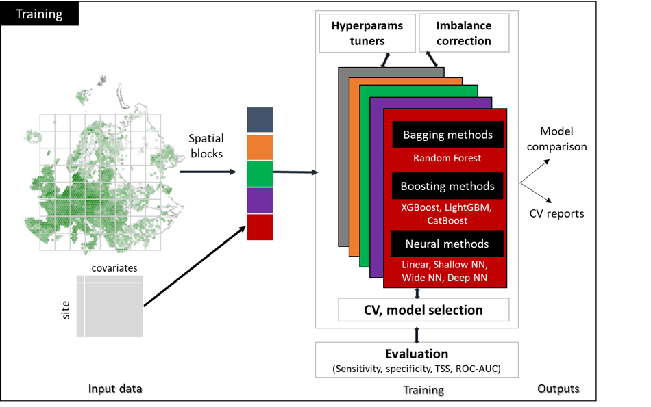
Figure 7. Habitat modeling framework overview for model training.

Data partitioning
We considered the uncertainty due to training data sampling. Employing 5-fold cross-validation, we trained each algorithm with 20% of the observations hidden from each iteration. This process generated an ensemble of 5 classifiers per algorithm with access to distinct samples, thus accounting for data sampling uncertainty. The 5-fold partition of observations was obtained through a spatial block strategy that avoids overestimation of model performances due to data leakage between training and validation sets while allowing the models to capture local variability between nearby observations.

Machine learning models
Algorithm choice
To encompass this diversity, we created an ensemble of algorithms from different families including bagging decision trees, boosted decision trees and neural networks.
In the bagging family, we evaluated the Random Forest (Breiman et al 2001) algorithm whereas in the boosting family we evaluated three algorithms: XGBoost (Chen and Guestrin, 2016), CatBoost (Prokhorenkova et al., 2018) and LightGBM (Ke et al 2017). In the neural networks (LeCun et al., 2015) family, we evaluated Multi-Layer Peceptrons (MLP) architectures with varying widths and depths from zero (linear models), to few (shallow neural networks) or many hidden layers (deep neural networks), as well as tabular attention networks (TabNet) (Arik et al 2021).
Training
We optimized the hyperparameters of each algorithm, and we applied appropriate imbalance correction techniques tailored to each algorithm to ensure optimal performances. Specifically, we used class weighted multi-class objectives for bagging and boosting trees whereas we trained neural networks with imbalance-aware optimization objectives: Focal Loss (Lin et al 2017) and Label Distribution Aware Margin loss (Cao et al 2019)).
Model selection criteria
We used macro-averaged class-wise precision, recall, and F1-score from cross-validation to select the best-performing model within each algorithm family. Precision measures how many predicted habitats were correct, recall assesses how well actual habitats were identified, and F1-score balances both metrics.

Generation of habitat maps
For a given scenario, the ensemble multi-class habitat models were used to predict the relative habitat probabilities given environmental layers. Habitat probabilities combined with a set of decision rules were then used to generate wall-to-wall habitat maps for Europe, following the workflow depicted in Figure 8.

Ensemble forecasting
After training, we obtained a set of models for each algorithm–data partition combination. By combining the relative habitat class probabilities predicted by each model, we generated two ensemble outputs:
- Ensemble mean: average habitat probability weighted by model quality (soft averaging);
- Consensus: the proportion of models voting (attributing highest probability) for each habitat class (committee averaging).

Habitat mapping workflow
The habitat mapping workflow generates three types of output maps at 1km resolution:
- Habitat probability maps: continuous maps of all EUNIS level 3 class probabilities (250+ maps).
- Dominant habitat maps: categorical maps of the most likely (highest mean probability) habitats at level 3 within each formation (9 maps).
- Wall-to-wall habitat map: categorical map of the top 3 EUNIS habitats at level 3 across all formations (previewed in Figure 9), namely wall-to-wall habitat map. To generate this map, we apply cross walk rules (EEA, ETC-BD ) to convert the land cover map into an EUNIS level 1 map. Afterwards, at each pixel, given its EUNIS 1 class, we map the dominant level 3 habitat class.

Dominant and wall-to-wall habitat maps are associated with confidence (ensemble mean probability of the most likely class) and consensus maps.
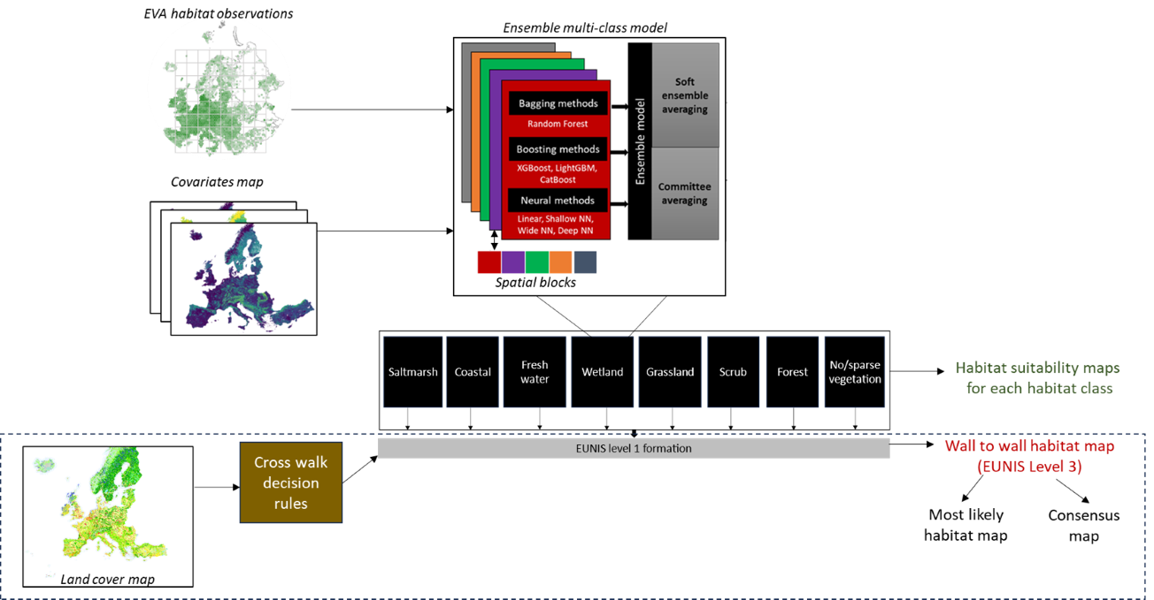
Figure 8. Workflow for the modeling and generation of habitat distribution maps.

Validation
The habitat maps showed strong predictive performance in cross-validation at the European scale (EVA), with most EUNIS level 3 classes achieving good F1-scores. Accuracy varied by habitat formation, with consistently high performance in abiotic-driven types like wetlands and coastal areas, and more variable results in structurally complex habitats like forests and grasslands. External validation in the Netherlands (NL), Austria (AT), Portugal (PT) and French forests (IFN) confirmed overall robustness, though performance dropped slightly, especially in Austria due to resolution mismatches. Trade-offs between precision and recall were observed across formations, and prediction improved when considering the top three habitat classes, especially for rare or narrowly distributed habitats.
Table . Evaluation scores for the habitat distribution modeling based on habitat formations.
Habitat formation | Dataset | F1-score | Precision | Recall
MA2 (Saltmarsh) | EVA | 0.87 ± 0.11 | 0.82 ± 0.18 | 0.95 ± 0.06
MA2 (Saltmarsh) | NL | 0.76 ± 0.34 | 0.74 ± 0.33 | 0.80 ± 0.36
N  (Coastal) | EVA | 0.81 ± 0.09 | 0.75 ± 0.15 | 0.92 ± 0.07
N  (Coastal) | NL | 0.82 ± 0.09 | 0.84 ± 0.06 | 0.83 ± 0.18
P  (Freshwater) | EVA | 0.87 ± 0.07 | 0.82 ± 0.12 | 0.94 ± 0.05
P  (Freshwater) | NL | 0.97 ± 0.02 | 0.96 ± 0.03 | 0.99 ± 0.01
Q  (Wetland) | EVA | 0.73 ± 0.13 | 0.67 ± 0.19 | 0.86 ± 0.09
Q  (Wetland) | NL | 0.95 ± 0.06 | 0.95 ± 0.08 | 0.96 ± 0.07
Q  (Wetland) | AT | 0.56 ± 0.46 | 0.55 ± 0.45 | 0.57 ± 0.46
R  (Grassland) | EVA | 0.66 ± 0.17 | 0.78 ± 0.15 | 0.59 ± 0.18
R  (Grassland) | NL | 0.40 ± 0.32 | 0.57 ± 0.42 | 0.37 ± 0.33
R  (Grassland) | AT | 0.37 ± 0.35 | 0.45 ± 0.39 | 0.37 ± 0.36
S  (Scrub and Tundra) | EVA | 0.83 ± 0.12 | 0.89 ± 0.06 | 0.79 ± 0.15
S  (Scrub and Tundra) | NL | 0.46 ± 0.39 | 0.49 ± 0.41 | 0.46 ± 0.41
S  (Scrub and Tundra) | AT | 0.31 ± 0.42 | 0.31 ± 0.42 | 0.31 ± 0.43
S  (Scrub and Tundra) | PT | 0.33 ± 0.39 | 0.41 ± 0.46 | 0.32 ± 0.41
T  (Forest) | EVA | 0.61 ± 0.20 | 0.77 ± 0.15 | 0.55 ± 0.23
T  (Forest) | IFN | 0.48 ± 0.32 | 0.78 ± 0.32 | 0.40 ± 0.33
T  (Forest) | NL | 0.38 ± 0.31 | 0.47 ± 0.36 | 0.37 ± 0.35
T  (Forest) | AT | 0.33 ± 0.39 | 0.34 ± 0.41 | 0.32 ± 0.39
T  (Forest) | PT | 0.39 ± 0.40 | 0.49 ± 0.41 | 0.36 ± 0.39
U  (Sparsely vegetated) | EVA | 0.94 ± 0.03 | 0.95 ± 0.03 | 0.94 ± 0.03
U  (Sparsely vegetated) | NL | 0.81 ± 0.22 | 0.96 ± 0.05 | 0.78 ± 0.31
U  (Sparsely vegetated) | AT | 0.35 ± 0.40 | 0.34 ± 0.39 | 0.36 ± 0.42

Habitat mapping under current and future conditions
Building on the previous workflow, we produced habitat probability and dominant habitat maps under current conditions using current climate (1990-2020) layers (Karger et al 2017) alongside other environmental layers. The current wall-to-wall map was then built using the land system map from (Dou et al 2021).
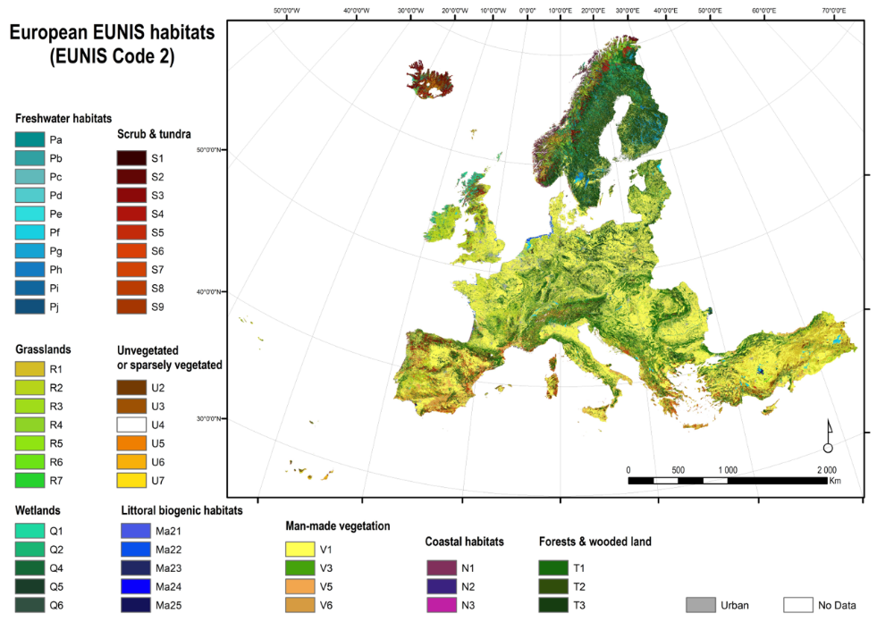
Figure 9. Wall-to-wall European map of EUNIS habitats. Each pixel represents the most likely EUNIS class at level 3. Due to the high number of classes, the color legend is provided at level 2.
To forecast future habitat distributions, we assumed all environmental predictors remained constant except for climate. Habitat probability and dominant habitat maps were forecasted under two future climate scenarios: SSP1 (RCP 2.6) and SSP3 (RCP 7.0) across 3 Global Circulation Models (GCMs).
Finally, we produced a series of future wall-to-wall maps under varying land-use trajectories, including baseline socioeconomic pathways (SSP1 and SSP3) and nature-positive scenarios aligned with the Nature Futures Framework (NFF): Nature for Nature (NfN), Nature for Society (NfS), and Nature as Culture (NaC).

References
Álvarez‐Martínez, J. M., Jiménez‐Alfaro, B., Barquín, J., Ondiviela, B., Recio, M., Silió‐Calzada, A., & Juanes, J. A. (2018). Modelling the area of occupancy of habitat types with remote sensing. Methods in Ecology and Evolution, 9(3), 580-593.
Ballabio, C., Panagos, P., & Monatanarella, L. (2016). Mapping topsoil physical properties at European scale using the LUCAS database. Geoderma, 261, 110-123.
Ballabio, C., Lugato, E., Fernández-Ugalde, O., Orgiazzi, A., Jones, A., Borrelli, P., ... & Panagos, P. (2019). Mapping LUCAS topsoil chemical properties at European scale using Gaussian process regression. Geoderma, 355, 113912.
Breiman, L. (2001). Random forests. Machine learning, 45, 5-32.
Cao, K., Wei, C., Gaidon, A., Arechiga, N., & Ma, T. (2019). Learning imbalanced datasets with label-distribution-aware margin loss. Advances in neural information processing systems, 32.
Chytrý, M., Tichý, L., Hennekens, S. M., Knollová, I., Janssen, J. A. M., Rodwell, J. S., Peterka, T., Marcenò, C., Landucci, F., Danihelka, J., Hájek, M., Dengler, J., Novák, P., Zukal, D., Jiménez-Alfaro, B., Mucina, L., Abdulhak, S., Abramova, L., Aćić, S., … Schaminée, J. H. J. (2021). EUNIS-ESy: Expert system for automatic classification of European vegetation plots to EUNIS habitats (v2021-06-01) [Data set]. Zenodo. https://doi.org/10.5281/zenodo.4812736
Chytrý M., Hennekens S.M., Jiménez-Alfaro B., Knollová I., Dengler J., Jansen F., Landucci F., Schaminée J.H.J., Aćić S., Agrillo E., Ambarlı D., Angelini P., Apostolova I., Attorre F., Berg C., Bergmeier E., Biurrun I., Botta-Dukát Z., Brisse H., Campos J.A., Carlón L., ... Yamalov S. 2016. European Vegetation Archive (EVA): an integrated database of European vegetation plots. Applied Vegetation Science 19: 173–180. https://doi.org/10.1111/avsc.12191
Copernicus Land Monitoring Service, European Environment Agency (EEA). (2016). EU-DEM v1.1.
Dou, Y., Cosentino, F., Malek, Z., Maiorano, L., Thuiller, W., & Verburg, P. H. (2021). A new European land systems representation accounting for landscape characteristics. Landscape Ecology, 36, 2215-2234.
European Environment Agency (EEA). (2019). EU-Hydro – River Network Database.
Hennekens, S. NDFF Dutch vegetation database. Dutch National Database of Flora and Fauna (NDFF) https://doi.org/10.15468/KSQXEP (2018).
IGN – Inventaire Forestier National Français. Données brutes, Campagnes annuelles 2005 et suivantes. (2022).
Karger, D. N., Conrad, O., Böhner, J., Kawohl, T., Kreft, H., Soria-Auza, R. W., ... & Kessler, M. (2017). Climatologies at high resolution for the earth’s land surface areas. Scientific data, 4(1), 1-20.
Ke, G., Meng, Q., Finley, T., Wang, T., Chen, W., Ma, W., ... & Liu, T. Y. (2017). Lightgbm: A highly efficient gradient boosting decision tree. Advances in neural information processing systems, 30.
LeCun, Y., Bengio, Y., & Hinton, G. (2015). Deep learning. nature, 521(7553), 436-444.
Lin, T. Y., Goyal, P., Girshick, R., He, K., & Dollár, P. (2017). Focal loss for dense object detection. In Proceedings of the IEEE international conference on computer vision (pp. 2980-2988).
Panagos, P. (2006). The European soil database. GEO: connexion, 5(7), 32-33.
Prokhorenkova, L., Gusev, G., Vorobev, A., Dorogush, A. V., & Gulin, A. (2018). CatBoost: unbiased boosting with categorical features. Advances in neural information processing systems, 31.
Umweltbundesamt. MAES/EUNIS habitat map Austria 10m. 56.1 MBytes PANGAEA https://doi.org/10.1594/PANGAEA.934147 (2021).

