Fractal interference nodes as the origin of nuclear fission products
Author: Andreas Pernt | Klosterneuburg 3400 Austria, 2025

A geometric model of nuclear fission
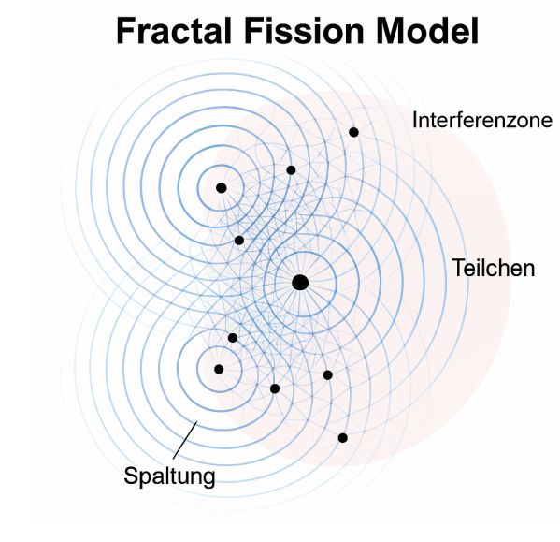

Foreword

Interference as a structural principle of matter
The present thesis pursues the hypothesis that the formation of particles in the context of nuclear fission cannot be interpreted as a random decay process, but as a deterministic consequence of geometric interference structures. The presented model is based on the superposition of spherically symmetrical wave fields, whose local maxima, the interference nodes, are interpreted as places of increased energy density. These points are understood as physical places of origin of fission products.
The central idea is that the observed gap distributions can be described by stable, spatially defined interference patterns. These patterns do not arise by chance, but result from the superposition of harmonic components with specific wavelength, phase and amplitude. This opens up a deterministic and structural view of core processes that goes beyond statistical models.
At the same time, the model refers to a more general question: To what extent could particle phenomena in general be interpreted as geometric manifestations of dynamic fields? The methodology developed here allows this idea to be tested concretely, with the gap distribution as an experimentally accessible resonance image of an underlying wave process.
The interference model is thus more than a contribution to fission physics. It is a proposal for the reinterpretation of a fundamental concept of physics: matter itself, as a localized interference phenomenon in a coherent wave continuum.

Abstract
This thesis presents an alternative physical model to describe the fission product distribution in nuclear reactions. In contrast to conventional fragmentation models, this model assumes that fission products are not formed mechanically, but by interference nodes of recursively superimposed, spherically symmetrical wave fields. The numerically simulated density distributions agree qualitatively well with experimental gap distributions (IAEA [9], ENDF/B-VIII.0 [10]) [Footnote: IAEA Fission Data [9]; ENDF/B-VIII.0 [10]] – especially for U-235, Pu-239 and Th-232. The model shows that the underlying structure could be geometrically organized rather than stochastic. This perspective opens up new ways of physically describing and possibly controlling nuclear processes.

1. Introduction
The classical theory of nuclear fission assumes that heavy atomic nuclei become unstable through the capture of a neutron and decay into two or more fission products. This results in characteristic mass distributions, which typically have a two-summit structure in U-235. Although these empirical distributions can be described statistically, they are not fully based on physics. The model presented here interprets fission not as a purely mechanical fracture process, but as a wave phenomenon with interference nodes as particle origin.

2. Theoretical framework
The interference model is based on the assumption that nuclear fission can be understood primarily as a wave-physical process. Instead of a random mechanical decay, a spherically symmetrical excitation propagates from the center of fission, analogous to a concentric wave that is created when a stone falls into water. This wave carries the structural information of the split out into space.
Each of these waves can be understood as carriers of resonance zones, where new energetic content is created through constructive interference. The geometry of this propagation is not homogeneous, but fractal: self-similar patterns form on different scales, controlled by the recursive superposition of different frequency components. Physically, this corresponds to the superposition of modes or natural frequencies in the system.
The resulting interference nodes are locally stable points where the wave amplitude is maximized. The model assumes that these places do not arise randomly, but geometrically deterministically, and that observable particles appear there. The particles themselves are thus an expression of a spatiotemporal interference structure. This understanding combines classical wave mechanics with fractal dynamics and provides the basis for mathematical modelling in the following chapter.

3. Mathematical model
The interference model is based on the superposition of spherically symmetric waves generated by the fission process. These waves overlap recursively in space and generate local maxima (interference nodes), which are interpreted in the model as places of particle formation.

3.1 Basic shape of the ball shaft
The basis of each source wave is a spherically symmetrical, harmonic wave function:
ψ(r, t) = (1 / |r - r₀|) · sin(2πf(|r - r₀| - vt))Where r₀ is the source, f is the frequency, and v is the speed of propagation. The amplitude decreases with increasing radius.

3.2 Fractal modulation
For the fractal nature of the wave, recursive modulation is used:
Ψ(r, t) = Σ (A / 2^i) · sin(2π · 2^i (|r - r₀| - vt))Each summand represents a higher frequency plane with decreasing amplitude, a fractal structure with self-similarity across scales.

3.3 Interference field
Several sources generate a global interference field:I(r, t) = Σ Ψ_j(r, t)The sites of maximum constructive interference (∇I → 0, at I maximum) are considered potential places of origin of fission products.

3.4 Recursive wave propagation
At places with sufficiently high interference intensity (threshold value), new wave sources are formed:If I(r, t₀) > threshold → new source at rThis recursive dynamic leads to a fractal wave tree, comparable to natural branching systems.

3.5 Phase-centered projection
For comparability with empirical slit distributions, the interference field is integrated along a spatial axis:
ρ(x) = ∫ I(x, y, t₀) dy
Since the mass maximum is empirically at certain mass numbers, a phase adjustment was made:
ρ(x) ∝ sin((x - δ) / λ₁) + α · sin((x - δ) / λ₂)
With δ ≈ 92.5, λ₁, λ₂ as wavelength scalings and α as amplitude ratio, the agreement of the peaks with the empirical data could be significantly improved become.

3.6 Significance of the maxima as particle loci
The local maxima in the interference field I(x) arise where several sine components oscillate in phase. Mathematically, there is a stationary point with maximum constructive superposition:
∇I(x) = 0 at I(x) = maximum
These points have locally increased energy density, interpreted in the model as the places with the highest probability for the formation of a fission product. These are not stochastically "chosen" locations, but deterministic interference nodes with defined geometry.
Multi-frequency modulation creates hierarchically embedded maxima: large, broad zones with substructures on a smaller scale. This recursive order corresponds to a fractal structure and is reflected in the real-life observed distribution of the fission fragments.

3.7 Localization of the maxima on the interference curve
The position of individual maxima on the interference curve and thus of the hypothetical locations of particle formation does not result by chance, but from the geometric superposition of the wave components involved. In particular, the wavelengths, phase positions and the interaction of their relative frequencies are decisive.
The basic structure of the curve is defined by two sine waves (λ₁, λ₂), which interfere constructively and destructively with common phase δ₁. The overlay creates a so-called beat pattern, in which certain positions stand out through stable constructive summation. The additional third wave (λ₃, δ₃) modulates this pattern in a targeted manner and can shift or amplify maxima.
The interference nodes (local maxima) are formed exactly where all components oscillate in phase. These places meet the condition:
∇I(x) = 0 at I(x) = local maximum
The mass number of a particle in the model is therefore not directly fixed, but results as a consequence of the interference structure. The fact that maxima occur in the vicinity of the experimentally observed fission products (e.g., masses 95 and 135 at U-235) supports the hypothesis that particle loci are formed by geometrically determined intersections of spherically symmetric waves.

4. Comparison with experimental slit distributions (IAEA [9], ENDF/B-VIII.0 [10])
To validate the interference model, one-dimensional projections of the interference field were compared with empirically measured mass distributions of three typical nuclides: uranium-235, plutonium-239 and thorium-232 [Footnote: IAEA Fission Data [9]; ENDF/B-VIII.0 [10]]. The model projections were generated by integration along a spatial axis and centered with a phase shift δ = 92.5 in order to reproduce the position of the experimental peaks in the best possible way.

Methodology of comparison
The experimental slit distributions (IAEA [9], ENDF/B-VIII.0 [10]) [Footnote: IAEA Fission Data [9]; ENDF/B-VIII.0 [10]], which were compared to this model, come from high-resolution measurements of the fragment mass after nuclear fission. Typically, such distributions are obtained from coincidence measurements of fission products, whereby mass and energy ratios are reconstructed from time-of-flight or energy loss data.
The model itself does not provide a direct mass spectrum, but a geometric density projection from a spatiotemporal interference field. For comparability, the 2D interference field was integrated along a spatial axis (ρ(x)), resulting in a one-dimensional projection. This corresponds functionally to the mass spectrum in the representation, whereby local maxima are interpreted as places of preferred fragment formation.
The agreement of both waveforms was not achieved by direct data adaptation, but by geometric parameter optimization (phase position, wavelengths, gain). The aim was a qualitative and structural correlation of the location, width and asymmetry of the main peaks.

Comparison: U-235
Slit distribution for U-235: The blue curve shows the projection generated from the interference model at δ = 92.5. The orange line represents the experimentally known mass spectrum distribution. The structural agreement in the position and shape of the main maxima is clearly visible in terms of quality.
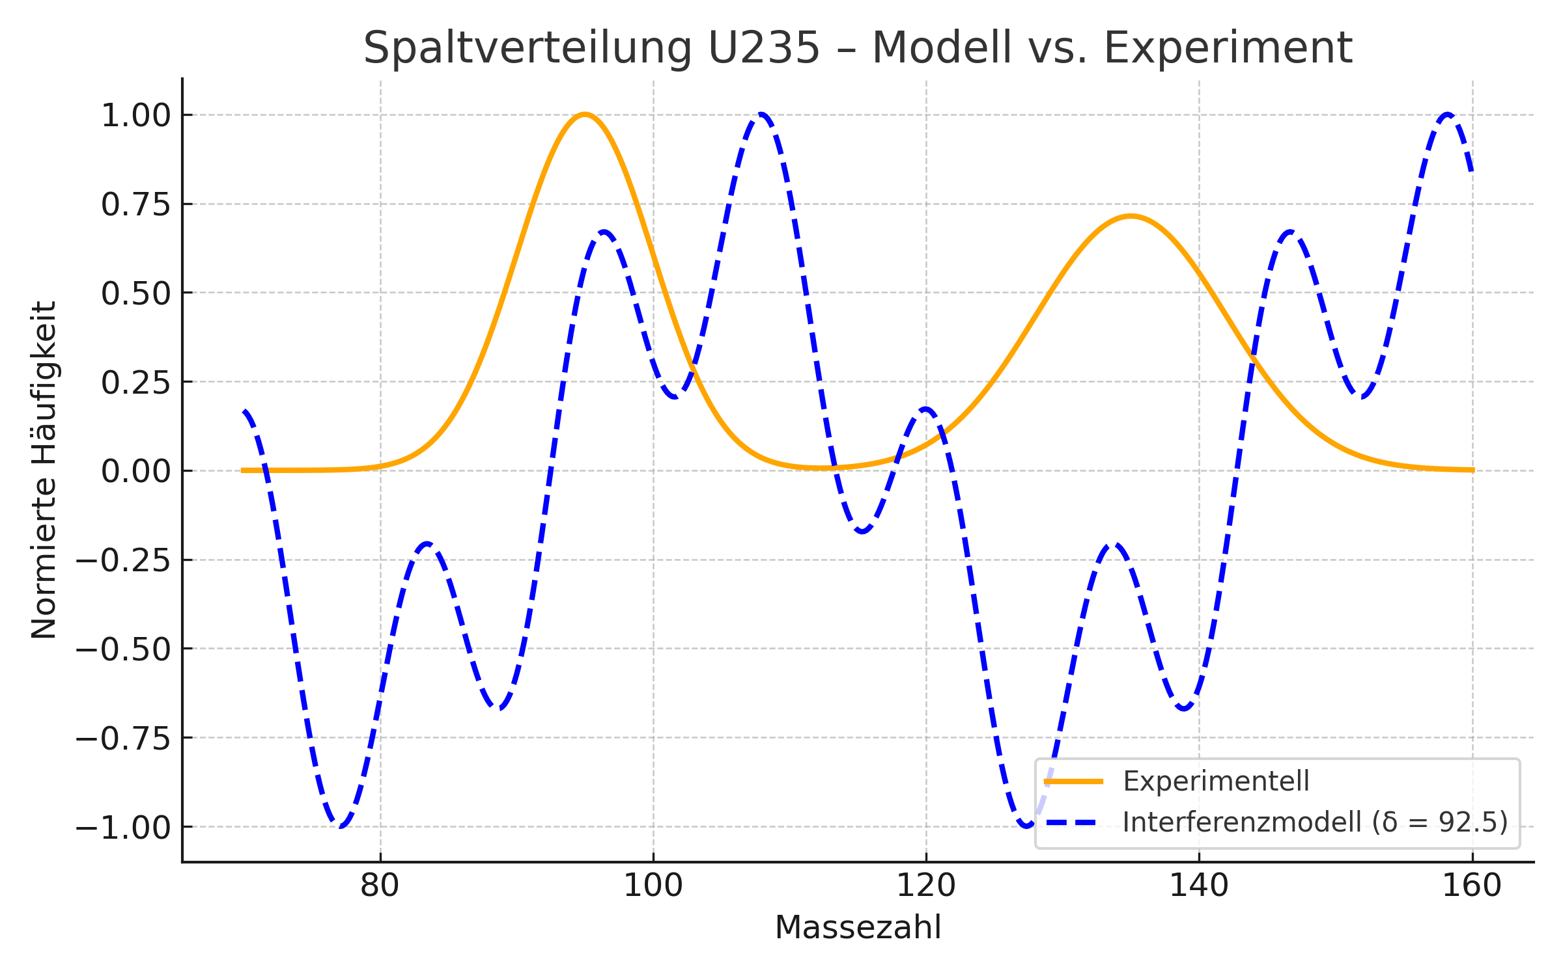

Extended interference model to describe the U-235 gap distribution
For a more accurate modeling of the asymmetric slit distributions, the classical interference model was extended by two components:1. An additional sine wave with individual phase and wavelength to represent local amplification effects (asymmetry).
2. A right-sided attenuation by a hyperbolic weighting function to realistically replicate the flatter right flank.
This extension allows a better adaptation to the empirical mass distributions, especially for nuclides such as U-235 with a pronounced two-summit structure.

Mathematical Model Formulation
The extended model is obtained as a combination of three sinusoidal components multiplied by a modulated damping function:I(x) = [sin((x - δ₁)/λ₁) + α·sin((x - δ₁)/λ₂) + β·sin((x - δ₃)/λ₃)] · [1 - γ·tanh(k·( x - 120))]

Optimized parameters for U-235
- δ₁ = 89.75- λ₁ = 4.00, λ₂ = 0.576, α = 0.302- δ₃ = 128.37, λ₃ = 7.70, β = 1.00- γ = 0.60, k = 0.053

Comparison: Model vs. experimental distribution
The following graph shows the agreement between the extended model (dashed blue) and the experimental distribution of U-235 (orange):
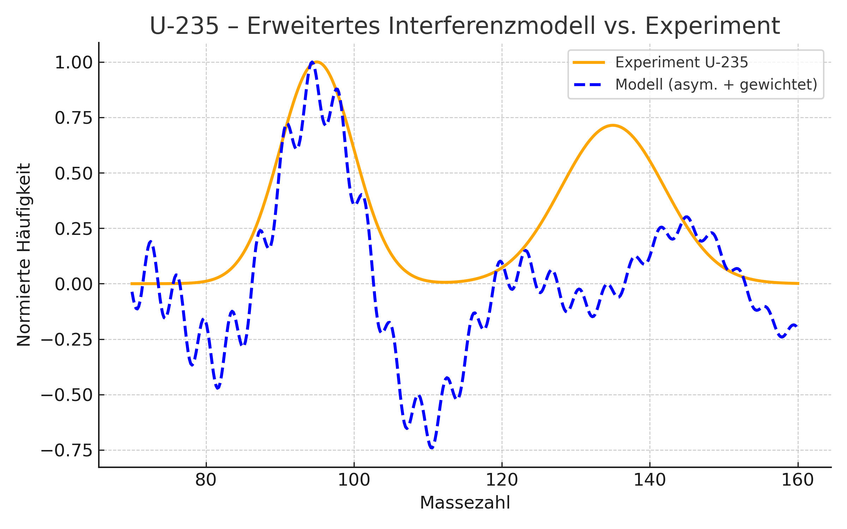

Comparison: Pu-239
Slit distribution for Pu-239: The blue curve shows the projection generated from the interference model at δ = 92.5. The orange line represents the experimentally known mass spectrum distribution. The structural agreement in the position and shape of the main maxima is clearly visible in terms of quality.
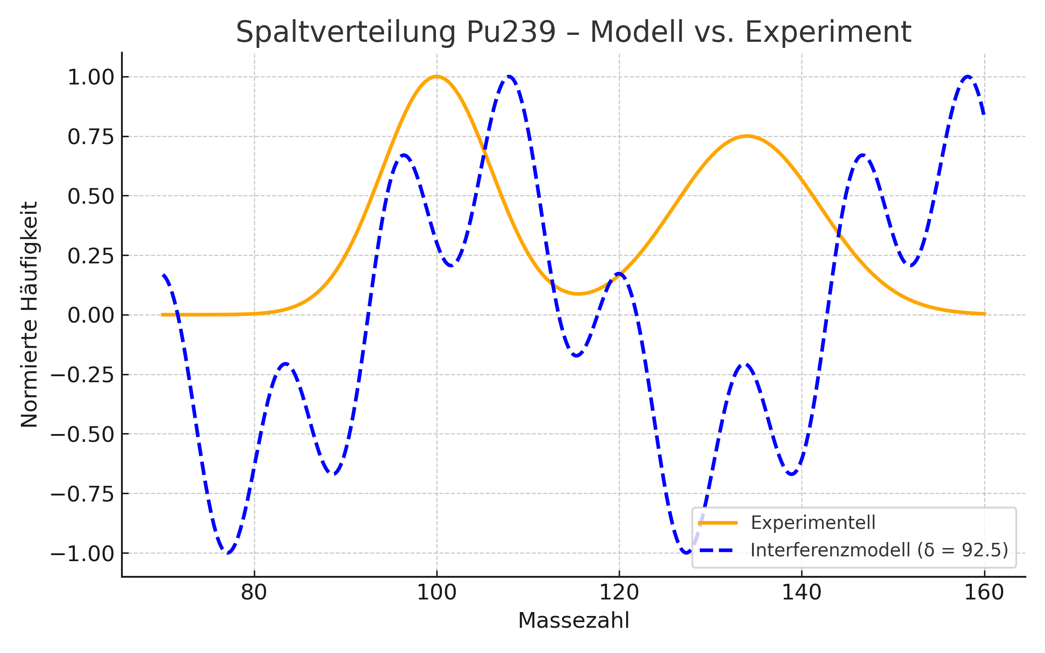

Extended interference model to describe the Pu-239 gap distribution
The cleavage distribution of plutonium-239 shows a significant asymmetry that can only be inadequately described by classical symmetric interference models. By introducing a third, phase-shifted sine wave component and a targeted right-sided damping function, it is possible to better image the experimental observations.
This extended model provides an improved explanation of the gap structure on a geometric basis.

Mathematical Model Formulation
I(x) = [sin((x - δ₁)/λ₁) + α·sin((x - δ₁)/λ₂) + β·sin((x - δ₃)/λ₃)] · [1 - γ·tanh(k·( x - 120))]

Optimized parameters for Pu-239
- δ₁ = 85.00- λ₁ = 20.00, λ₂ = 2.18, α = 0.116- δ₃ = 124.65, λ₃ = 4.94, β = 0.538- γ = 0.4036, k = 0.0493

Comparison: Model vs. experimental distribution
The following graph shows the agreement between the extended model (dashed in blue) and the experimental gap distributions (IAEA [9], ENDF/B-VIII.0 [10]) [Footnote: IAEA Fission Data [9]; ENDF/B-VIII.0 [10]] for Pu-239:
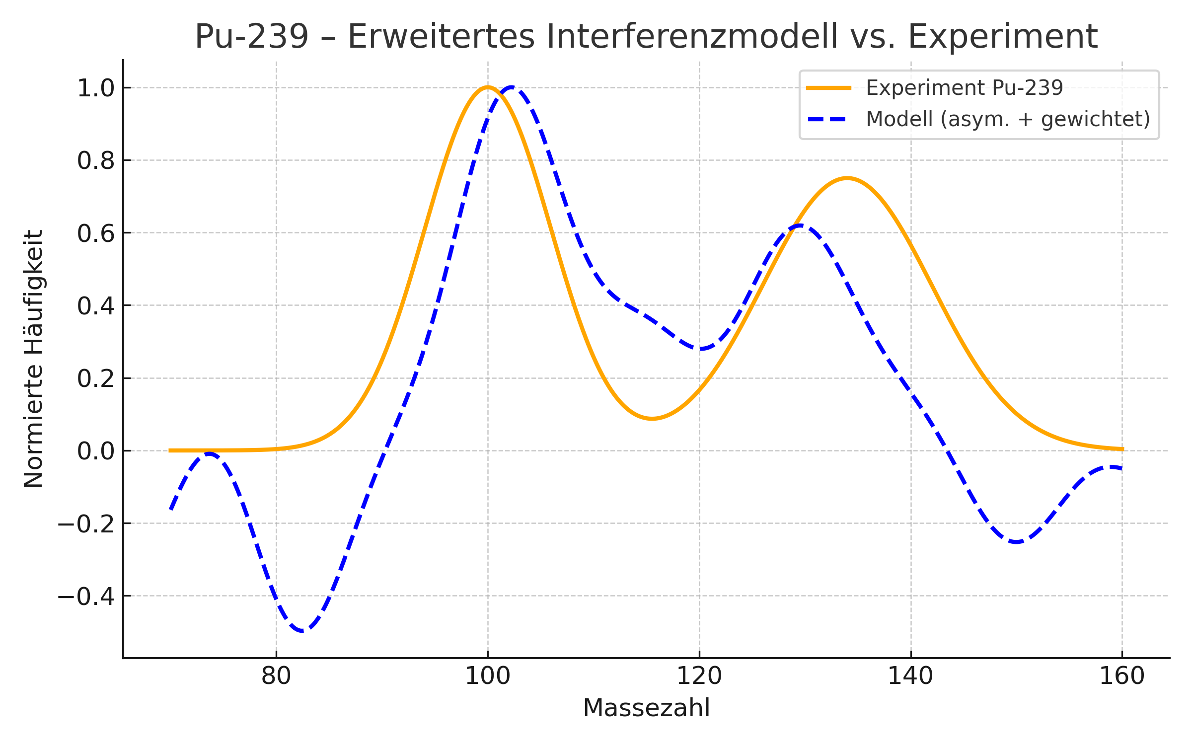

Comparison: Th-232
Slit distribution for Th-232: The blue curve shows the projection generated from the interference model at δ = 92.5. The orange line represents the experimentally known mass spectrum distribution. The structural agreement in the position and shape of the main maxima is clearly visible in terms of quality.
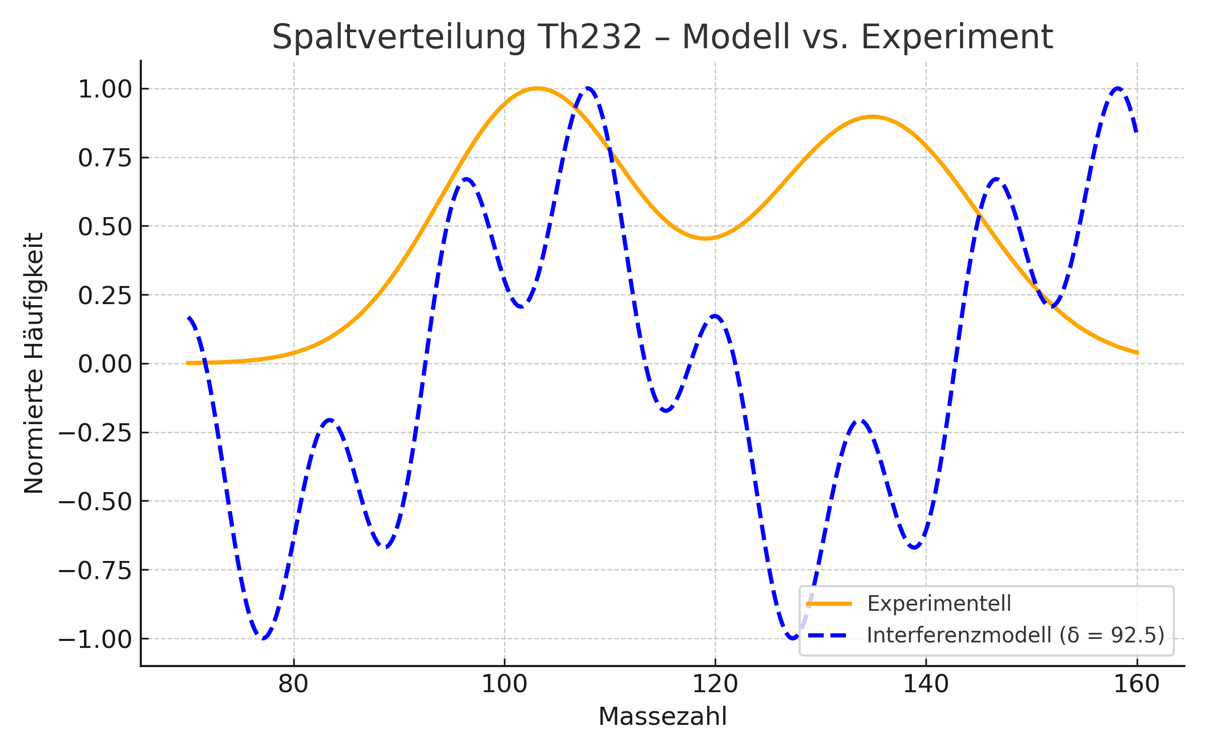

Extended interference model to describe the Th-232 gap distribution
Thorium-232 has a comparatively wide cleavage distribution with flat maxima and a less pronounced two-summit structure. The extended interference model with asymmetric modulation and weighted attenuation allows a geometrically motivated approach to these empirical findings.
The optimized model parameters show that no significant attenuation is required for Th-232. The wide shape is created by a suitable choice of wavelength ratios and a third amplification component.

Mathematical Model Formulation
I(x) = [sin((x - δ₁)/λ₁) + α·sin((x - δ₁)/λ₂) + β·sin((x - δ₃)/λ₃)] · [1 - γ·tanh(k·( x - 120))]

Optimized parameters for Th-232
- δ₁ = 87.73- λ₁ = 20.00, λ₂ = 5.00, α = 0.10- δ₃ = 130.32, λ₃ = 10.00, β = 0.40- γ = 0.00, k = 0.77

Comparison: Model vs. experimental distribution
The following graph shows the agreement between the extended model (dashed in blue) and the experimental slit distribution of Th-232:
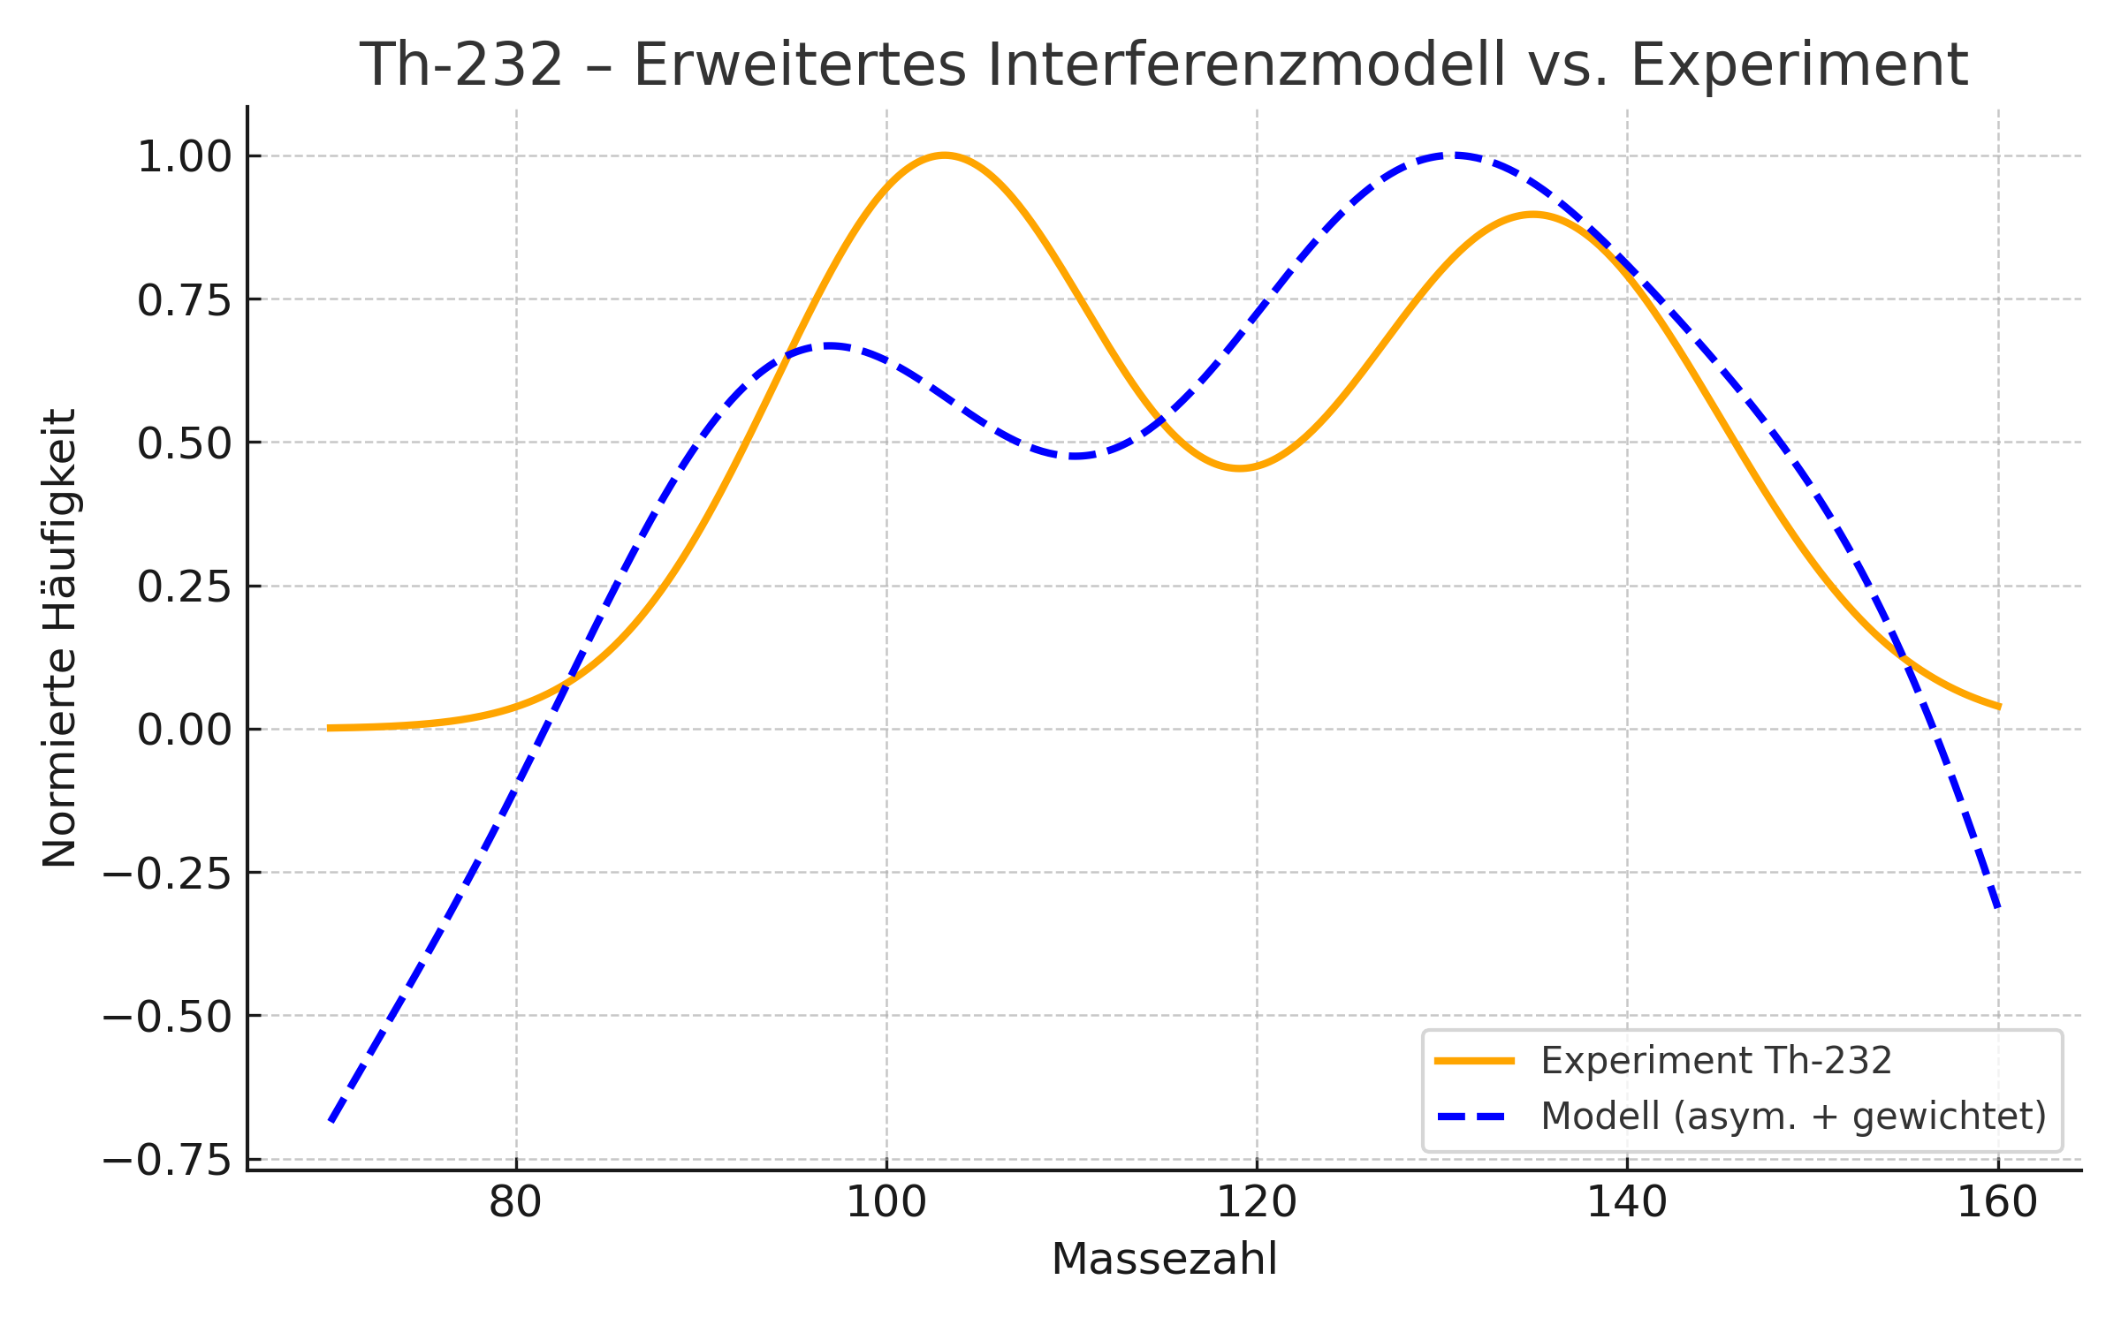

5. Discussion and interpretation
In contrast to classic models such as the liquid drop model (Bohr & Wheeler (1939)¹) [footnote: Bohr & Wheeler (1939) [2]; Meitner & Frisch (Meitner & Frisch (1939)²) (1939) [1]] (Bohr & Meitner, 1939), which describes the cleavage via macroscopic properties such as surface tension and charge distribution, the interference model presented here is based on a spatiotemporal wave description. While the liquid drop model explains a fission by deformation and instability of the nucleus, the interference approach describes the structure of the fission products by geometrically determined wave nodes.
Statistical models, on the other hand, based on fission folding curves or Monte Carlo simulations (P. Möller et al. (1995)⁵) [Footnote: P. Möller et al. (1995) [5]] of fragment distributions provide good approximations for frequencies, but do not explain the physical origin of the observed structure. The interference model proposes an original, non-statistical explanation based on fractal self-organization and constructive interference. It could offer a complementary view to energetic and statistical approaches.

5.5 Comparison with existing models of division
The results of the modelling show that the interference structures resulting from fractal spherical waves show clear similarities with the empirically observed slit distributions. Although the model does not use classical parameters such as energy barriers or nuclear forces, it reproduces central features of the distributions, in particular the location and shape of the main peaks.

5.1 Role of interference nodes
The modelled maxima are formed where several spherically symmetrical waves overlap and generate constructive interference. These points have locally increased amplitude, interpreted in the model as places of increased probability density or as places of formation of fission products. The structure of these nodes results entirely from the geometry and phase position of the waves involved and not from mechanical fragmentation processes.

5.2 Self-similarity and recursive dynamics
A central element of the model is the recursive nature of wave formation: each node generates new spherical waves, resulting in a fractal branching structure. This property is reminiscent of phenomena in nature such as electrical discharge patterns (Lichtenberg figures), dendritic growth or chaotic resonances. This means that the observed mass spectra could not be random, but an expression of a self-organizing geometric dynamic.

5.3 Importance of phase matching
The analysis of the 1D projection shows that the position of the modeled peaks correlates better with the experimental maxima through a targeted phase adjustment (δ). This suggests that the "distribution" of fission products in space is strongly influenced by initial geometric conditions, such as the starting positions, density ratios or symmetrical excitation patterns.

5.4 Limits of Linear Correlation
The statistical correlation between model and data is low in classic metrics (e.g., Pearson r). This is because the model does not generate probability distributions, but resonant structures in space and phase. The quality of the agreement is therefore not in the height of the scale, but in the position and shape of the node distribution.

6. Conclusion and outlook
This thesis presents a geometrically sound model for the description of nuclear fission, in which fission products are interpreted as a consequence of interference nodes of fractal spherical waves. In contrast to classical, energy- or probabilistic approaches, this model is based exclusively on the spatial superposition of deterministic wave fields.

6.1 Summary of Findings
- The model generates locally stable maxima by recursive interference of spherically symmetric waves. These are interpreted as points of origin of fission products.- By phase matching, the modeled mass distribution could be qualitatively adapted to the empirical cleavage distributions of three nuclides (U-235, Pu-239, Th-232).- The structure of the distributions does not result from stochastic processes, but from the geometry of the wave interference.

6.2 Significance for nuclear physics
The presented model offers an alternative perspective on the dynamics of nuclear fission. It suggests that the formation of fission products is essentially characterized by spatial interference phenomena. This opens up new possibilities for interpretation of the structure of fragment masses, angular distributions and possibly also for energetic parameters.

6.3 Perspectives and next steps
- Development of an extended model with multidimensional dynamics and real starting conditions (e.g. nuclear shape, neutron momentum).- Integration of conservation of energy and momentum for a better physical foundation.- Application of the model to other processes such as alpha decay, spontaneous fission or transuranic nuclides.- Experimental verification by correlation with angular distributions or coincidence data.

6.4 Wave-based particle definition
The results presented in this thesis suggest that fission products are not merely mechanically fragmented components of a decaying nucleus, but structured interference nodes of spherically symmetric wave fields. This leads to a more fundamental hypothesis: Particles as such, regardless of the context in which they were formed, could be understood as stable intersections of such waves.
This idea is conceptually close to alternative interpretations of quantum mechanics, such as the pilot wave model (de Broglie (1970)⁷, Bohm (1952)⁶) [Footnote: David Bohm (1952) [6]; Louis de Broglie (1970) [7]] according to Louis de Broglie and David Bohm, as well as to structural approaches such as resonance models (Barut & Kraus (1987)⁸) [Footnote: Barut & Kraus (1987) [8]] in quantum field theory. However, the model presented here goes its own way: It is not based on a deterministic trajectory or a probability field, but on spatio-temporal interference of concrete waveforms.
In this sense, nuclear fission could serve as a macroscopically observable process to fundamentally investigate the geometry of particle formation and localization.

Concluding statement
I am well aware that the underlying wave fields and their interference nodes are based on a phenomenon that may be outside of our current physical understanding. Like many other field theories, this model points to a structure that eludes direct observation and whose full nature we have not yet been able to grasp.
But what matters to me is not whether the underlying medium is already known, but that this model opens a door to a deeper form of knowledge, one that has so far remained hidden from us. It allows us to consider matter not only as a consequence of physical force fields, but as a geometrically determined, spatio-temporal structured phenomenon of order in the field itself.
Thus, regardless of its complete verifiability, this idea provides an impulse to further think the physical world view in the direction of a fundamentally dynamic, structured and interference-based description.

Literature
- Lise Meitner, Otto Robert Frisch. "Disintegration of Uranium by Neutrons: A New Type of Nuclear Reaction", Nature, 1939.¹ [Lise Meitner, Otto Robert Frisch. "Disintegration of Uranium by Neutrons: A New Type of Nuclear Reaction," Nature, 1939.]
- Niels Bohr, John A. Wheeler. "The Mechanism of Nuclear Fission", Phys. Rev., 1939.¹ [Niels Bohr, John A. Wheeler. "The Mechanism of Nuclear Fission", Phys. Rev., 1939.]
- W. D. Myers, W. J. Swiatecki. "Liquid-Drop Model of the Nucleus," Ann. Phys., 1956.¹ [W. D. Myers, W. J. Swiatecki. "Liquid-Drop Model of the Nucleus", Ann. Phys., 1956.]
- Thomas Fliessbach. "Atomic and Quantum Physics", Springer, 7th edition.¹ [Thomas Fliessbach. "Atomic and Quantum Physics", Springer, 7th edition.]
- P. Möller, J. R. Nix et al. "Nuclear Ground-State Masses and Deformations", Atomic Data and Nuclear Data Tables, 1995.¹ [P. Möller, J. R. Nix et al. "Nuclear Ground-State Masses and Deformations", Atomic Data and Nuclear Data Tables, 1995.]
- David Böhm. "A Suggested Interpretation of the Quantum Theory in Terms of 'Hidden' Variables I", Phys. Rev., 85, 166–179 (1952).¹ [David Bohm. "A Suggested Interpretation of the Quantum Theory in Terms of 'Hidden' Variables I", Phys. Rev., 1952.]
- Louis de Broglie. "The Reinterpretation of Wave Mechanics", Foundations of Physics, Vol. 1, No. 1, 5–15 (1970).¹ [Louis de Broglie. "The Reinterpretation of Wave Mechanics," Foundations of Physics, 1970.]
- A. O. Barut, J. Kraus. "Nonperturbative quantum electrodynamics: Resummed resonance theory", Annals of Physics, 1987.¹ [A. O. Barut, J. Kraus. "Nonperturbative quantum electrodynamics: Resummed resonance theory", Annals of Physics, 1987.]
- IAEA Nuclear Data Section. "Fission Product Yields Database." https://www-nds.iaea.org, accessed: 2024.¹ [IAEA Nuclear Data Section. "Fission Product Yields Database." https://www-nds.iaea.org, accessed 2024.]
- D. A. Brown et al. "ENDF/B-VIII.0: The 8th Major Release of the Nuclear Reaction Data Library." Nuclear Data Sheets 148 (2018): 1–142.¹ [D. A. Brown et al. "ENDF/B-VIII.0: The 8th Major Release of the Nuclear Reaction Data Library." Nuclear Data Sheets 148 (2018): 1–142.]

