Supplemental Information
Materials and Methods
All listed reagents were commercially available and used as derived without any further purification. Benzoyl chloride (Sigma-Aldrich, Merck), cesium fluoride (Apollo Scientific), 25-hydroxycholesterol (Angene), magnesium sulphate(VI) (Avantor Performance Materials Poland, formerly known as Polish Chemical Materials POCH), pyridinium chlorochromate (PCC, Alfa Aesar), potassium hydroxide (POCH) tetrabutylammonium fluoride 1M solution in THF (TBAF, Sigma Aldrich, Merck), trifluoromethyltrimethylsilane (TMSCF₃, Apollo Scientific). Used solvents were bought from POCH with reagent-grade purity, unless otherwise noted. Benzene anhydrous (Sigma-Aldrich, Merck), chloroform, 1,2-dimethoxyethane (Sigma-Aldrich, Merck) ethyl acetate (AcOEt), dichloromethane (DCM), methanol (MeOH), petroleum ether (PE), pyridine, tetrahydrofuran (THF). Anhydrous solvents were obtained by standard procedures described in the literature and were stored under 4Å molecular sieves¹. Laboratory glassware was cleaned and dried before use. An inert atmosphere was provided by technical argon (99,9%). Anhydrous conditions were acquired by drying laboratory glassware with a Bunsen burner and cooling under the flow of an argon. Preparative thin-layer chromatography (TLC) was carried out with aluminum-backed TLC Plates with F-254 fluorescent indicator (SiliCycle), using UV lamp or cerium-molybdenum solution followed by heat to visualize the results. Column chromatography was performed using irregular silica gel (230-400 mesh, 60Å, SiliCycle). Melting points were determined using Stuart Scientific SMP30 apparatus. ¹H NMR spectra were acquired on a Varian Inova 500 (500 MHz) spectrometer at a sample temperature of 25°C and were visualized using MestReNova v.14.0.0 (Mestrelab Research). NMR chemical shifts are reported in ppm and are referenced to DMSO-_{d6} at 2.50 ppm or CDCl₃ at 7.26 ppm and are noted as such. Coupling constants (J) are reported in Hertz. Multiplets are described as follows: s – singlet, d – doublet, t – triplet, m – multiplet.

Procedure for the preparation of cholest-5-ene-3β,25-diol 3β,25-dibenzoate (2)
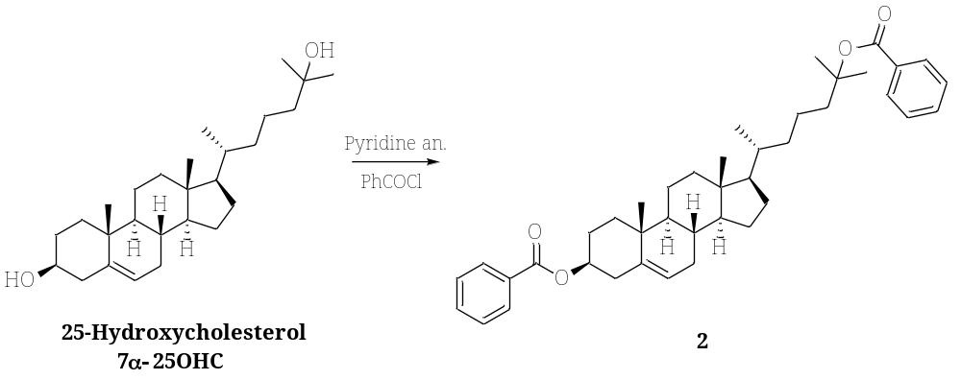
Scheme S1. Synthesis of cholest-5-ene-3β,25-diol 3β,25-dibenzoate (2)
In a Bunsen burner-dried 500 mL round bottom flask, under argon conditions, 25-hydroxycholesterol (1 eq, n = 0.0117 mol, m = 4.7 g) was dissolved in 180 mL of anhydrous pyridine. Subsequently, benzoyl chloride (20 eq, n = 0.233 mol, m = 32.816 g) was added to the reaction mixture in one portion, which was stirred under anhydrous conditions for 24 h. After that, 250 mL of MeOH was added and the reaction mixture was stirred for an additional 1 hour. Next, volatile solvents were evaporated using rotatory evaporator and the obtained solid was suspended in cold MeOH, which was further filtered off, washed with cold MeOH and dried under vacuum at 60℃. A pure product was obtained as a white powder (m = 7.012 g, n = 0.0115 mol) with 98% yield. Obtained results were consistent with those reported in the literature². Melting point: 101-103°C, ¹H NMR (500 MHz, CDCl₃, Figure S6) δ 8.09–8.04 (m, 2H, Ar-H), 8.04–7.99 (m, 2H, Ar-H), 7.60–7.52 (m, 2H, Ar-H), 7.49–7.41 (m, 4H, Ar-H), 5.45 (d, J = 5.1 Hz, 1H, =CH), 4.94–4.84 (m, 1H, CH–O), 2.49 (d, J = 8.2 Hz, 2H), 2.06–1.98 (m, 3H), 1.97–1.70 (m, 5H), 1.61 (s, 6H, 2x CH₃), 1.56–1.39 (m, 8H), 1.37–1.16 (m, 5H), 1.09 (s, 3H, CH₃), 1.15-1.02 (m, 4H), 0.95 (d, J = 6.4 Hz, 3H, CH₃), 0.71 (s, 3H, CH₃).

Procedure for the preparation of 7-oxocholest-5-ene-3β,25-diol 3β,25-dibenzoate (3)

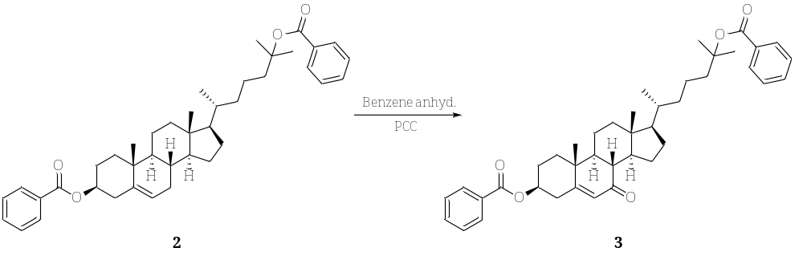
Scheme S2. Synthesis of 7-oxocholest-5-ene-3β,25-diol 3β,25-dibenzoate (3)

In Bunsen burner-dried 500 mL round bottom flask under argon atmosphere 2 (1 eq, n = 0.00323 mol, m = 1.975 g) was dissolved in 160 mL of anhydrous benzene. Subsequently, PCC (25 eq, n = 0.0808 mol, m = 17.423 g) was added and reaction mixture was refluxed for 24 hours. After that, the solution was cooled down and 300 mL of brine was added, followed by thrice extraction using chloroform. Organic phases were collected, dried over anhydrous MgSO₄, and evaporated. The crude product was purified with preparative column chromatography using PE:AcOEt as eluent (0% -> 10% AcOEt v/v). A pure product was obtained as a white, crystalline solid (m = 2.450 g, n = 0.00392 mol) with 61% yield. Obtained results were consistent with those reported in the literature². Melting point: 148-150°C, ¹H NMR (500 MHz, CDCl₃, Figure S7) δ 8.07–8.02 (m, 2H, Ar-H), 8.01–7.96 (m, 2H, Ar-H), 7.60–7.49 (m, 2H, Ar-H), 7.48–7.39 (m, 4H, Ar-H), 5.75 (s, 1H, =CH), 4.98 (tt, J = 11.0, 4.8 Hz, 1H, CH–O), 2.74–2.67 (m, 1H), 2.67–2.58 (m, 1H), 2.46–2.37 (m, 1H), 2.30–2.22 (m, 1H), 2.16–2.10 (m, 1H), 2.07–1.99 (m, 2H), 1.95–1.81 (m, 2H), 1.81–1.73 (m, 2H), 1.58 (s, 6H, 2x CH₃), 1.62–1.28 (m, 9H), 1.26 (s, 3H), 1.18–1.03 (m, 3H), 0.93 (d, J = 6.4 Hz, 3H, CH₃), 0.69 (s, 3H, CH₃).
Procedure for the preparation of cholet-5-ene-7β-trifluoromethyl-3β,7α,25-triol 3β,25-dibenzoate (4a) cholet-5-ene-7α-trifluoromethyl-3β,7β,25-triol 3β,25-dibenzoate (4b) 7-oxocholest-5-ene-3β,25-diol 3β,25-dibenzoate
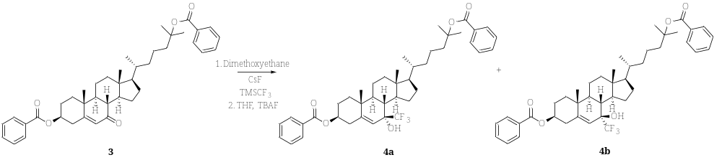
Scheme S3. Synthesis of cholet-5-ene-7β-trifluoromethyl-3β,7α,25-triol 3β,25-dibenzoate (4a) cholet-5-ene-7α-trifluoromethyl-3β,7β,25-triol 3β,25-dibenzoate (4b)

In Bunsen burner-dried 25 mL round bottom flask under anhydrous conditions 3 (1 eq, n = 0.000640 mol, m = 0.400 g) was dissolved in 8 mL of dimethoxyethane. Subsequently, TMSCF₃ (3.0 eq, n = 0.00192 mol, m = 0.274 g) was added followed by the addition of CsF (0.1 eq, n = 0.0000640 mol, m = 0.0097 g). The reaction was stirred at room temperature under anhydrous conditions until TLC analysis showed complete disappearance of the substrate (usually 48 hours). Next, the reaction mixture was filtered through a celite pad and concentrated under a vacuum using rotatory evaporator. The obtained residue was purified with column chromatography using PE:AcOEt as eluent (0% -> 5% AcOEt v/v). Both enantiomers were collected as a colorless sticky oil with 86% yield. Subsequently, silyl protected alcohols (1.0 eq, n = 0.000476 mol, m = 0.365 g) were dissolved in 5 mL of THF and treated with 1 M TBAF (1.1 eq, n = 0.000523 mol, C_{M} = 1 M, V = 0.523 mL). After 5 minutes of stirring at room temperature, the mixture was concentrated under a vacuum using rotatory evaporator and treated with water. The obtained suspension was extracted thrice with DCM, the organic layers were collected, dried with MgSO₄ and evaporated to dryness. Diastereoizomers were separated with column chromatography using PE:DCM as eluent (1:1 v/v). The desired product cholest-5-ene-7β-trifluoromethyl-3β,7α,25-triol 3β,25-dibenzoate (4a), was obtained as white powder (m = 0.096 g, n = 0.000138 mol) with 29% yield. ¹H NMR (500 MHz, CDCl₃, Figure S8) δ 8.06–8.01 (m, 2H, Ar-H), 8.01–7.96 (m, 2H, Ar-H), 7.59–7.49 (m, 2H, Ar-H), 7.47–7.40 (m, 4H, Ar-H), 5.39 (s, 1H, =CH), 4.89 (tt, J = 11.6, 4.6 Hz, 1H, CH–O), 2.66–2.58 (m, 1H), 2.55–2.46 (m, 1H), 2.11–1.62 (m, 9H), 1.58 (s, 6H, 2x CH₃), 1.52–1.35 (m, 6H), 1.33–1.04 (m, 6H), 1.03 (s, 3H, CH₃), 0.94 (d, J = 6.5 Hz, 3H, CH₃), 0.91–0.81 (m, 2H) 0.75 (s, 3H, CH₃).

Procedure for the preparation of cholet-5-ene-7β-trifluoromethyl-3β,7α,25-triol (5, CF₃-7α-25OHC)
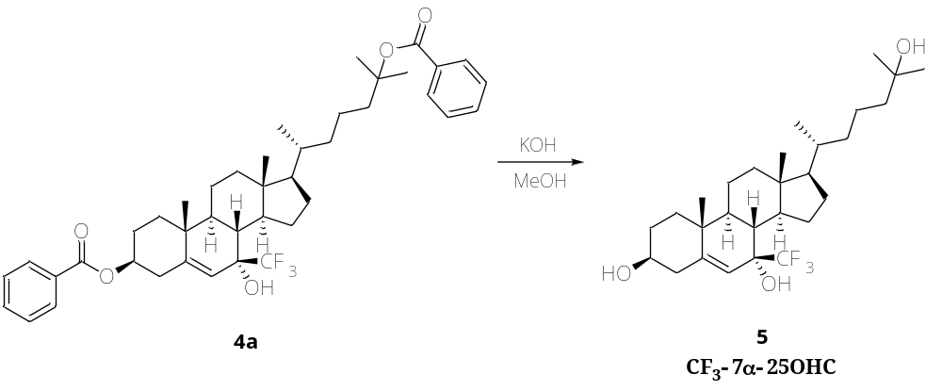
Scheme S4. Synthesis of cholet-5-ene-7β-trifluoromethyl-3β,7α,25-triol (5, CF3-7α-25OHC)

In a 50 mL round bottom flask, 4a (1 eq, n = 0.00122 mol, m = 0.850 g) was dissolved in 12 mL of MeOH. Subsequently, KOH (12 eq, n = 0.0147 mol, m = 0.824 g) was added and the mixture was left to stir at room temperature until the reaction was completed based on TLC analysis (usually it took 72 h). After that, the reaction mixture was treated with distilled water (around 2 mL) under stirring, to precipitate the product, which was further filtered, washed with water, and recrystallized from H₂O:MeOH to give pure compound. A product was obtained as a white crystalline solid (m = 0.430 g, n = 0.000884 mol) with 72% yield. Obtained results were consistent in full with those reported in the literature³. Melting point: 198-199°C, ¹H NMR (500 MHz, CDCl₃, Figure S9) δ 5.32 (s, 1H, =CH), 3.58 (tt, J = 11.3, 4.4 Hz, 1H, CH–O), 2.48–2.40 (m, 1H), 2.31–2.22 (m, 1H), 2.07–1.98 (m, 1H), 1.99–1.79 (m, 5H), 1.69–1.61 (m, 1H), 1.55–1.34 (m, 9H), 1.31–1.23 (m, 2H), 1.21 (s, 6H, 2x CH₃), 1.17–1.01 (m, 4H), 0.97 (s, 3H, CH₃), 0.95 (d, J = 6.5 Hz, 3H, CH₃), 0.90–0.79 (m, 2H), 0.74 (s, 3H, CH₃).
REFERENCES
1. Armarego, W.L.F., and Cha, C. (2009). Purification of Laboratory Chemicals, 6th Edition | W.L.F. Armarego, Christina Chai | ISBN 9780080878249. 760.
2. Li, D., and Spencer, T.A. (2000). Synthesis of 7α-hydroxy derivatives of regulatory oxysterols. Steroids 65, 529–535. https://doi.org/10.1016/S0039-128X(00)00131-8.
3. Deng, X., Sun, S., Wu, J., Kuei, C., Joseph, V., Liu, C., and Mani, N.S. (2016). Fluoro analogs of bioactive oxy-sterols: Synthesis of an EBI2 agonist with enhanced metabolic stability. Bioorg. Med. Chem. Lett. 26, 4888–4891. https://doi.org/10.1016/j.bmcl.2016.09.029.

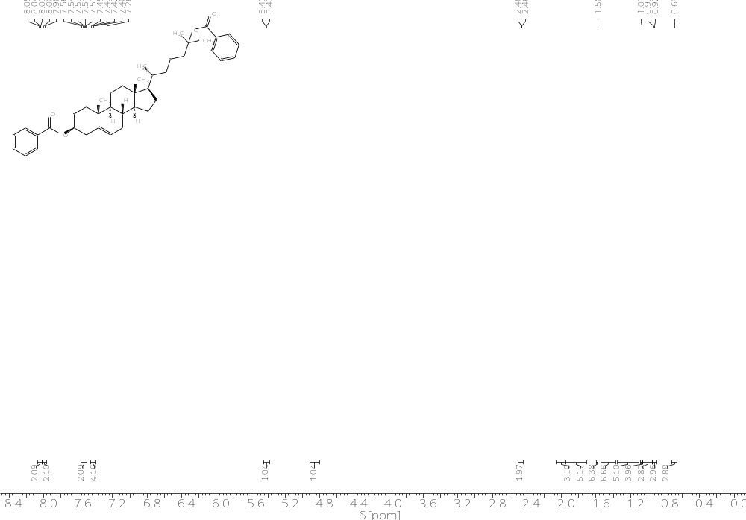
Figure S6. ¹H NMR spectra of 2 (for better readability, not all signals were peak picked)
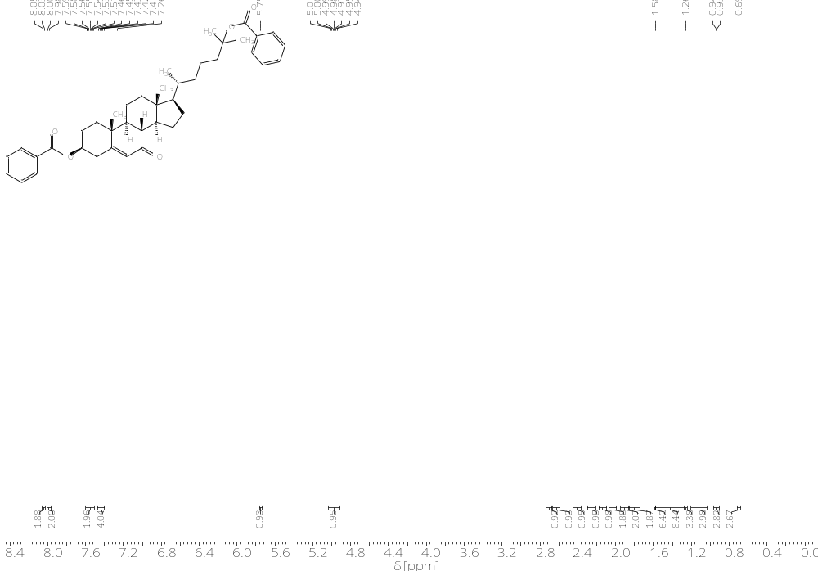
Figure S7. ¹H NMR spectra of 3 (for better readability, not all signals were peak picked)
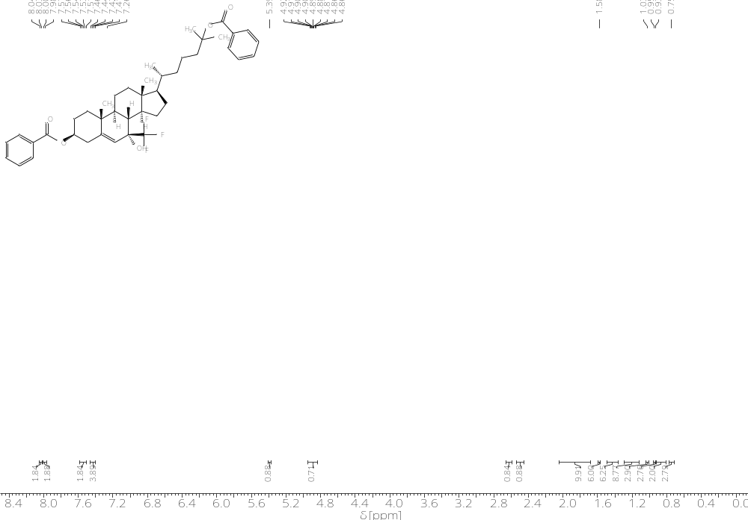
Figure S8. ¹H NMR spectra of 4a (for better readability, not all signals were peak picked)
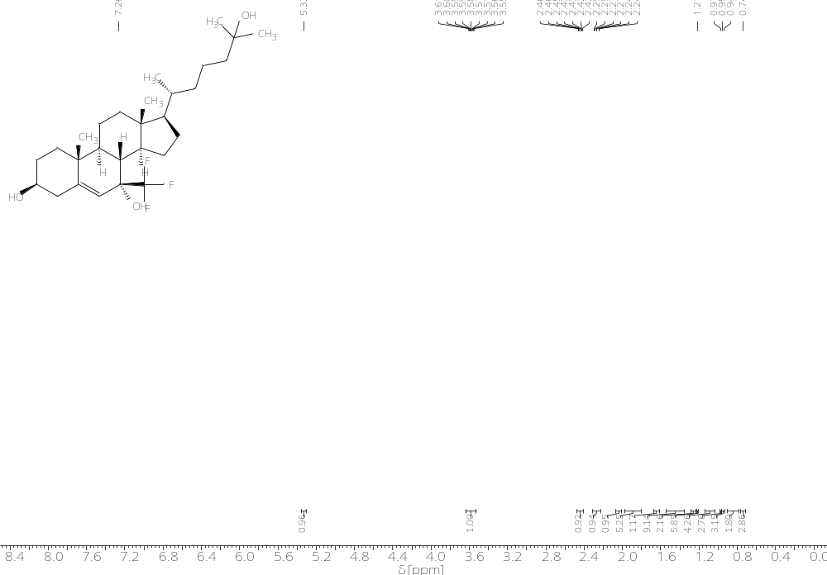
Figure S9. ¹H NMR spectra of 5, CF₃-7α-25OHC (for better readability, not all signals were peak picked)

