User Stories – How to create and use them in your project
Created by Susanna Kuper & Jana Plomin | Last updated Mar 25th^{th} 2025

Purpose
 | This guide explains what user stories are, how to use them effectively, and key considerations when creating them. It also provides a practical template for crafting user stories, including those embedded within epics.

This guide can be employed during the requirements analysis phase to enhance user-centeredness within your service.
User Stories – Definition and Typical Structure
User stories are short, text-based descriptions of functionality from the user's perspective. They focus on what the user wants to achieve while deliberately leaving the solution open. The classic structure of a user story is:
As a [user], I want [function], so that I can [take action].
This concise format encourages team discussion, validates assumptions, and allows for refinement through clear acceptance criteria.
Improved User Story
User stories should help those involved in the process to understand not only what is to be implemented, but also why and with what impact on the user. Answering the following questions can help you to write better user stories.
WHY does the user need it? | WHAT needs the user to be able to do with it? | HOW does the user benefit from having it?
The following user story structure provides more detail on the three questions, supporting discussions on suitable solutions:
The [user] wants [function] to achieve the goal of [user goal]. The current inability to do this is causing negative effect. Enabling user to do this would deliver specific measurable value to the user/organization.

Differentiating User Stories from Requirements, Use Cases, and Epics
In agile requirement management, various methods are associated with user stories, making it important to understand their differences and relationships.
User Story vs. Requirements

User stories are informal descriptions of functionality, leaving the specific implementation open for discussion. Because user stories remain rather flexible and solution-agnostic, they can be subject to frequent changes throughout the redesign process. In contrast, requirements are formal, detailed descriptions of the features a product must provide, typically more stable and broken down into specific tasks for different iterations or releases. The focus also differs: user stories center on the user experience—what the person wants to achieve—whereas requirements emphasize functionality—what the product must do.
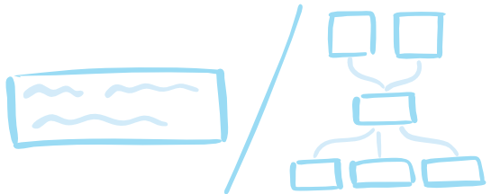
User Story vs. Use Cases
Use cases document all possible steps and scenarios (normal, alternative, and error cases) that a user follows to achieve a goal. They can appear as text, tables, or diagrams and provide a comprehensive description of system functionalities. User stories, however, offer a succinct view emphasizing the "what" and "why," while leaving the implementation details open for team discussion.
User Story vs. Epic
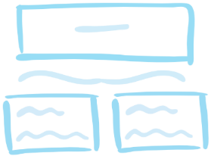
Epics are larger in scope and complexity, and can be broken down into a number of different user stories. They outline broad objectives that may take months to achieve and are often based on a roadmap. Epics provide a broad overview, serving as a way to organize the work of an agile project team and outline the overall roadmap.
Process for Creating a User Story
To craft a successful user story, consider the following steps:
- Identify Target User Groups:
Determine the different user groups for your service.
- Choose a Focus:
Select a specific group to concentrate on.
- Understand Context and Needs:
Analyze the context, goals, and needs of the chosen user group. Use personas if available, and address the three questions (WHY, WHAT, HOW).
- Collaboratively Draft User Stories:
Work together with user representatives to draft initial user stories and identify both the needs and the conditions for accepting or rejecting functionality, recorded as acceptance criteria. User stories are only fulfilled when these quality criteria are met.

Common Mistakes and How to Avoid Them
Frequent Mistakes:
- Focusing on Functionality Instead of the User Benefit:
In practice, user stories often fail to reflect genuine user needs, instead masking functional descriptions as motivations (e.g., “As a user, I can enter my user credentials so that I can login”).
- Providing Overly Specific Solutions:
Specifying a concrete solution too early restricts the team's flexibility.
- Unclear Acceptance Criteria:
Vague or missing criteria can lead to misunderstandings about when the feature is complete.
How to Avoid These Mistakes:
- Emphasize User Needs:
A well-crafted user story defines what a user must be able to do within the interactive system to satisfy a user need. The user goal should be clearly articulated, with context and function described in a neutral manner (e.g., “As a manager, I can print the meeting agenda, so that I know what’s coming up without using the device.”).
- Keep Solutions Open:
Encourage team discussion to explore different implementation approaches instead of fixing a single solution upfront.
- Define Clear Acceptance Criteria:
Collaboratively establish specific conditions that must be met for a user story to be considered complete.
Get started!
You will find two templates that you can fill in and copy on the following pages.

User Story Template
User story name:
Priority | Choose: High, medium, low
User Story | Choose a variant and fill out:  As a [user] I want [function], so that I can [take action].  The user wants [function] to achieve the goal of [user goal].  The current inability to do this is causing [negative effect].  Enabling user to do this would deliver [specific measurable value] to the user/organization.
Acceptance criteria | Fill out:  Given that [some context] when [some action is carried out] then [a set of observable outcomes] should occur.

Epic and User Story Template
Epic | User Story |  | Acceptance Criteria | Priority
Epic one | User Story one | Choose a variant and fill out:  As a [user] I want [function], so that I can [take action].  The user wants [function] to achieve the goal of [user goal].  The current inability to do this is causing [negative effect].  Enabling user to do this would deliver [specific measurable value] to the user/organization. | Fill out:  Given that [some context] when [some action is carried out] then [a set of observable outcomes] should occur. | Choose:  Hight, medium, low
Epic one | User Story two | … | … | …
Epic one | User Story three | … | … | …

