Augmented allometric scaling: Predicting drug clearance in farm animals with machine learning using body weight
D Inauen^{1*}, LS Lautz², AJ Hendriks³, R Gehring¹
¹ Utrecht University, Faculty for Veterinary Medicine, Institute for Risk Assessment Sciences, One Health Pharmacology, Yalelaan 104-106, 3584 CM Utrecht, the Netherlands
² ESQlabs GmbH, Am Sportplatz 7, Saterland 26683, Germany
³ Radboud University Nijmegen, Department of Environmental Science, Heyendaalseweg 135, 6525 AJ Nijmegen, the Netherlands

*Main/corresponding author: David Inauen, d.inauen@uu.nl, https://orcid.org/0009-0002-1569-7739
Co-authors: Leonie Sophie Lautz, leonie.lautz@esqlabs.com; Aalbert Jan Hendriks, jan.hendriks@ru.nl; Ronette Gehring, r.gehring@uu.nl

Supplementary Material 1

Principal component analysis (PCA)
As the dataset was reused for each target species, the chemicals spaces were similar for each iteration. Differences between PCA plots arose from the fact that different molecular descriptors were used in every target species iteration. 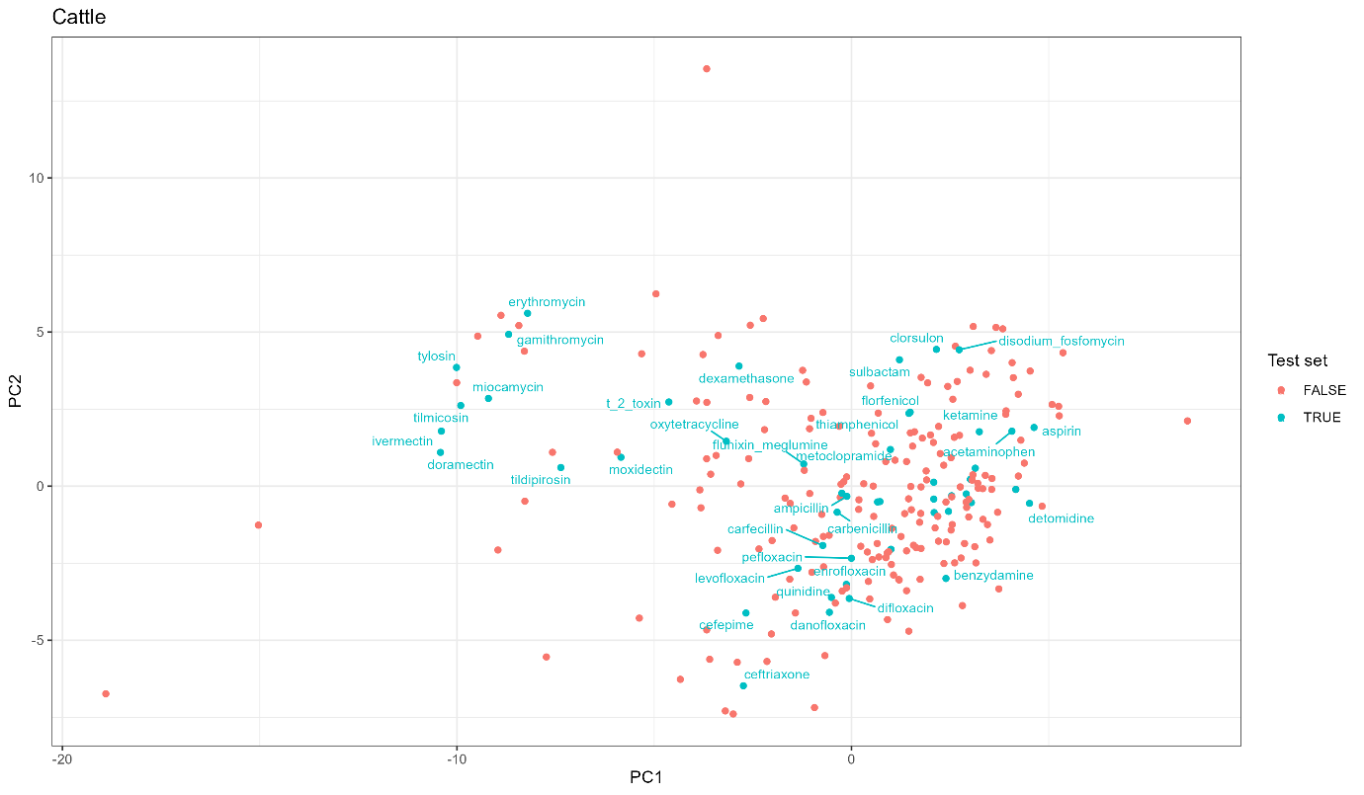
Figure 1 PCA of molecular descriptors of the training (red) and test (blue) sets of cattle in the extrapolative model. Select chemicals are labelled.
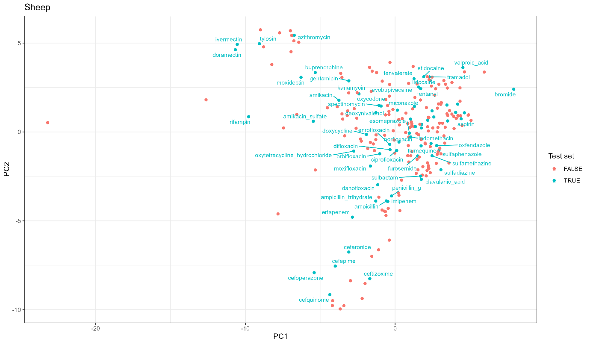
Figure 2 PCA of molecular descriptors of the training (red) and test (blue) sets of sheep in the extrapolative model. Select chemicals are labelled.
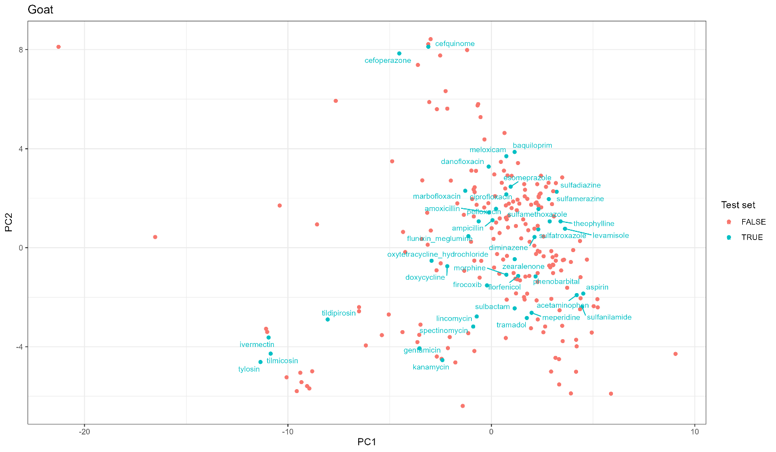
Figure 3 PCA of molecular descriptors of the training (red) and test (blue) sets of goat in the extrapolative model. Select chemicals are labelled.
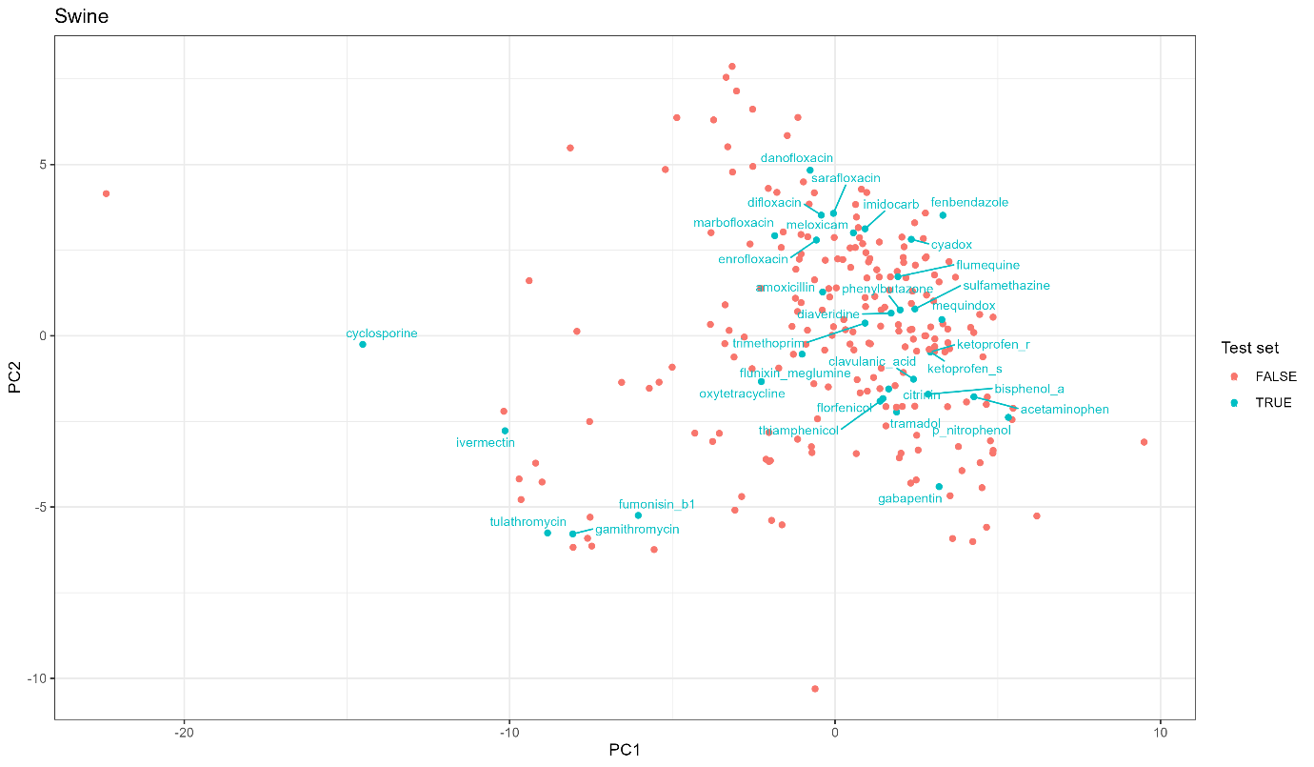
Figure 4 PCA of molecular descriptors of the training (red) and test (blue) sets of swine in the extrapolative model. Select chemicals are labelled.
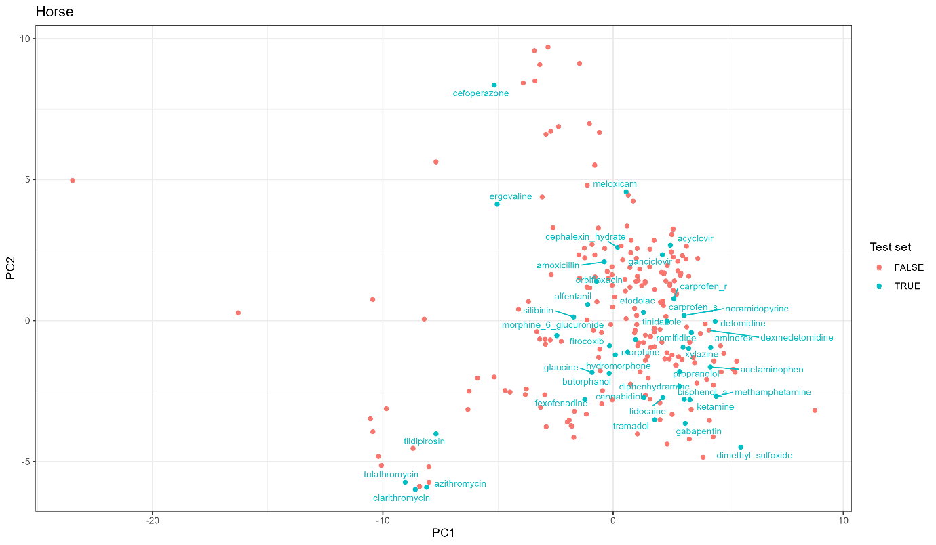
Figure 5 PCA of molecular descriptors of the training (red) and test (blue) sets of horse in the extrapolative model. Select chemicals are labelled.
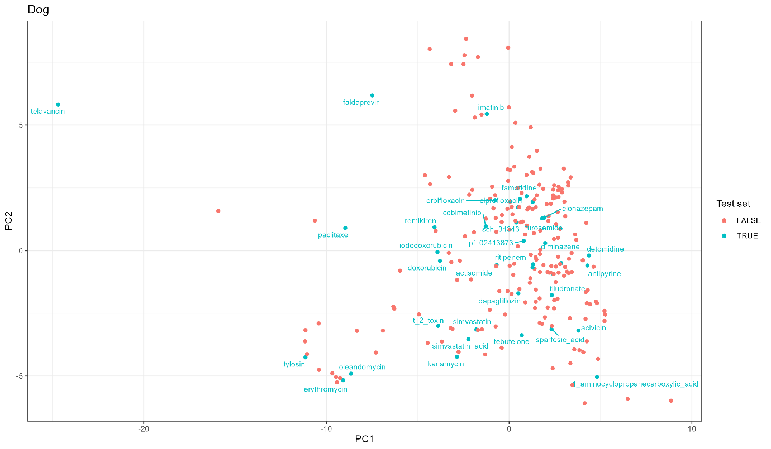
Figure 6 PCA of molecular descriptors of the training (red) and test (blue) sets of dog in the extrapolative model. Select chemicals are labelled.
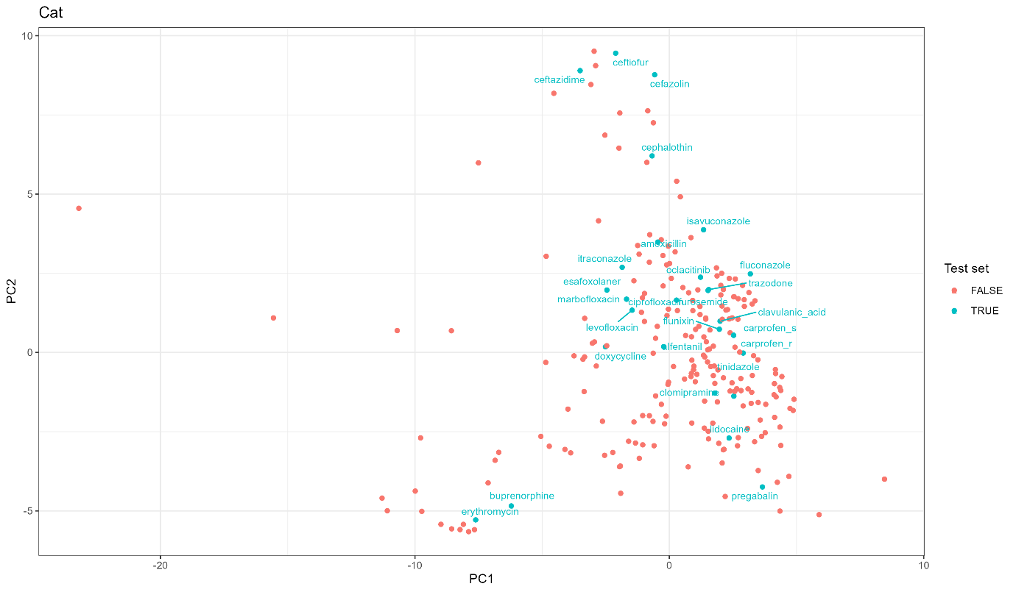
Figure 7 PCA of molecular descriptors of the training (red) and test (blue) sets of cat in the extrapolative model. Select chemicals are labelled.
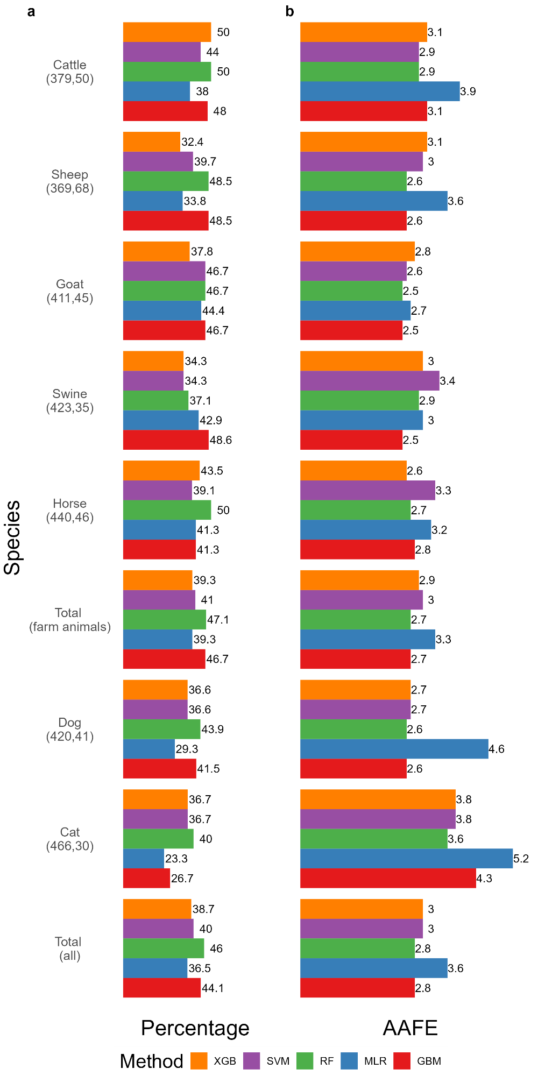
Figure 8 Extrapolative model: a) Percentage of chemicals with FE < 2 and b) AAFE on test set for the ML methods XGBTREE, SVMPOLY, RF, MLR, and GBM, in all target species. Total is the farm animal weighted mean. The values below each species name indicate the sizes of the training, resp. test set.
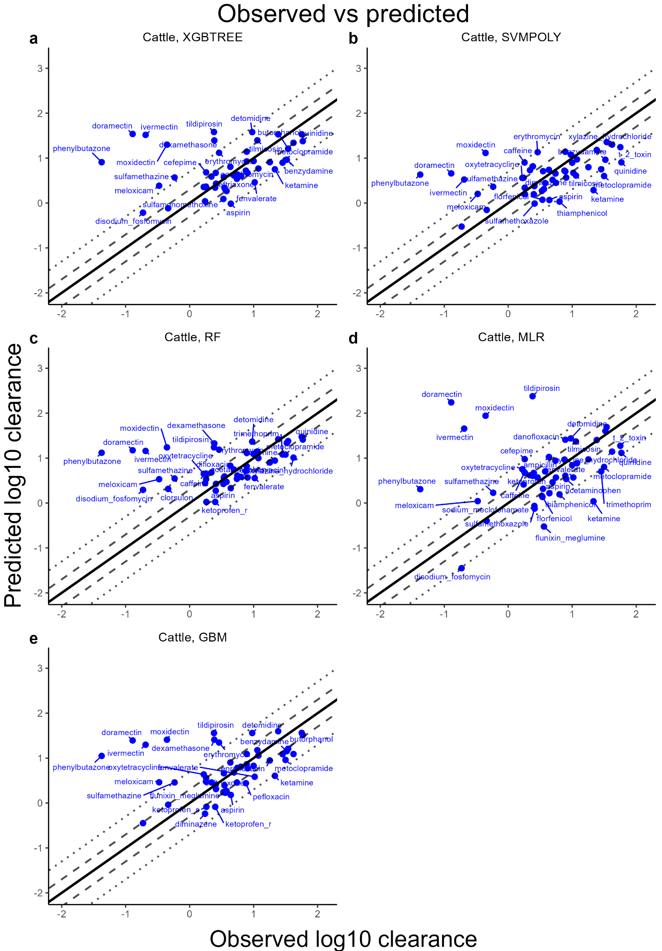Figure 9 Observations vs predictions: Extrapolative model for cattle. The solid line depicts unity and the dashed and dotted lines the 2-fold resp. 5-fold error. All chemicals outside of the 2-fold error are labelled. Units of clearance are ml/min/kg.
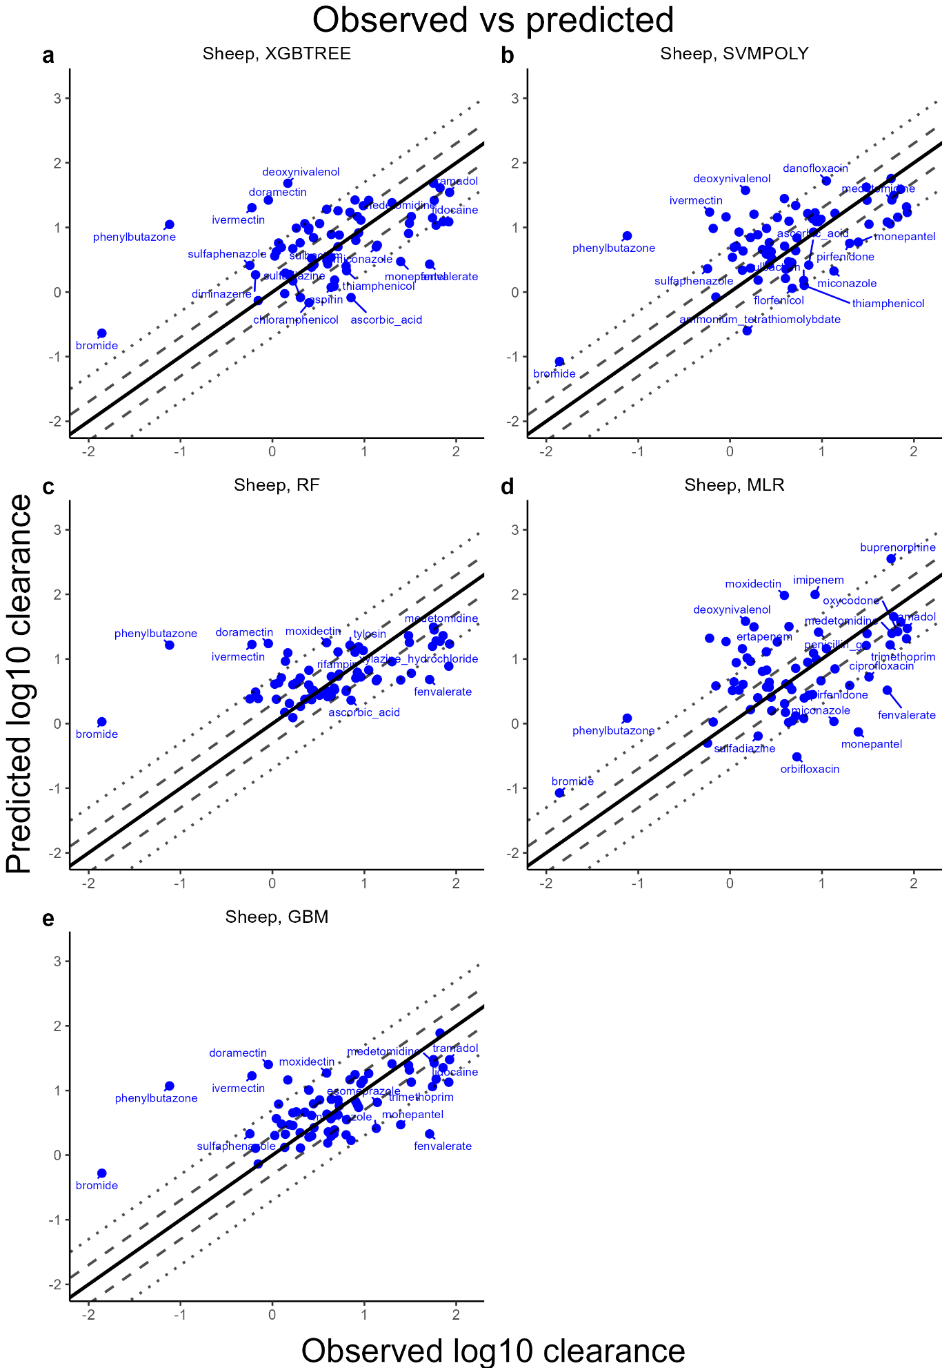Figure 10 Observations vs predictions: Extrapolative model for sheep. The solid line depicts unity and the dashed and dotted lines the 2-fold resp. 5-fold error. All chemicals outside of the 2-fold error are labelled. Units of clearance are ml/min/kg.
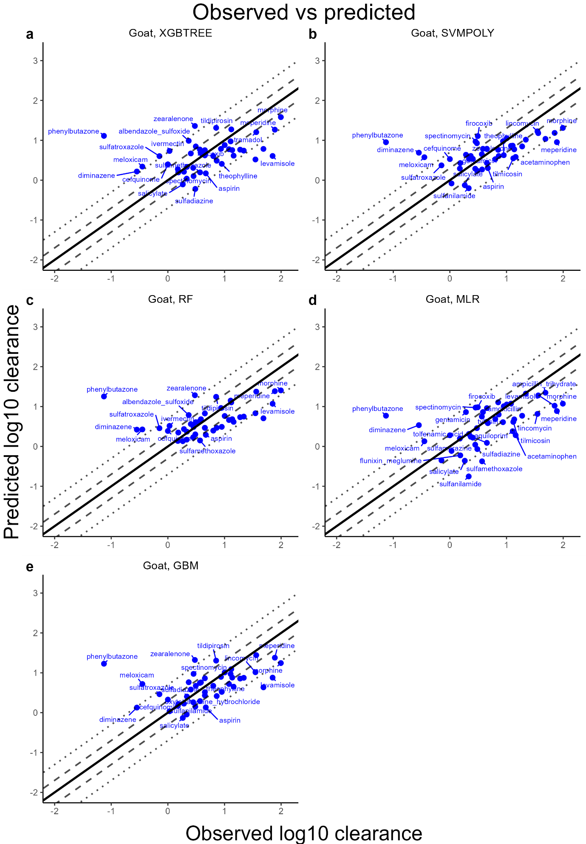Figure 11 Observations vs predictions: Extrapolative model for goat. The solid line depicts unity and the dashed and dotted lines the 2-fold resp. 5-fold error. All chemicals outside of the 2-fold error are labelled. Units of clearance are ml/min/kg.
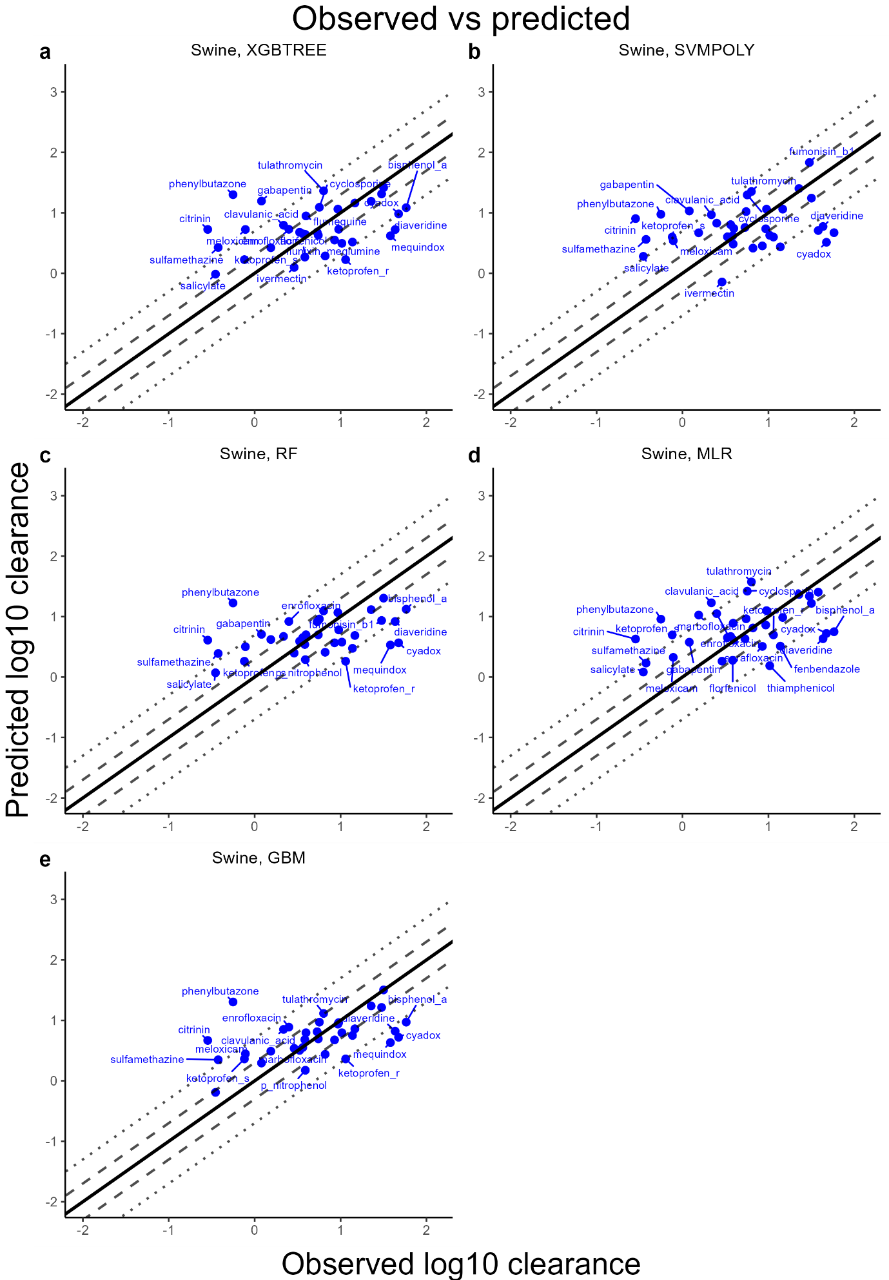Figure 12 Observations vs predictions: Extrapolative model for swine. The solid line depicts unity and the dashed and dotted lines the 2-fold resp. 5-fold error. All chemicals outside of the 2-fold error are labelled. Units of clearance are ml/min/kg.
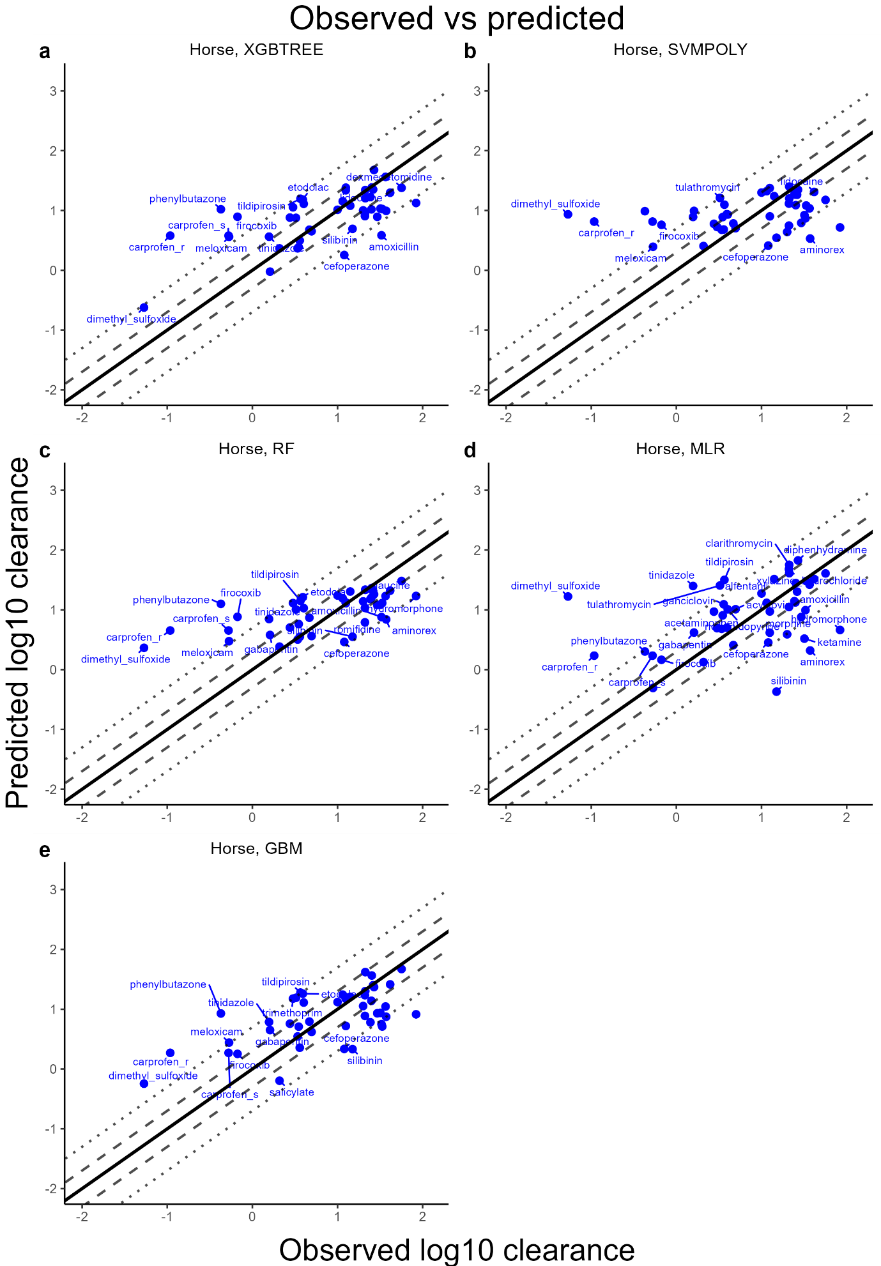Figure 13 Observations vs predictions: Extrapolative model for horse. The solid line depicts unity and the dashed and dotted lines the 2-fold resp. 5-fold error. All chemicals outside of the 2-fold error are labelled. Units of clearance are ml/min/kg.
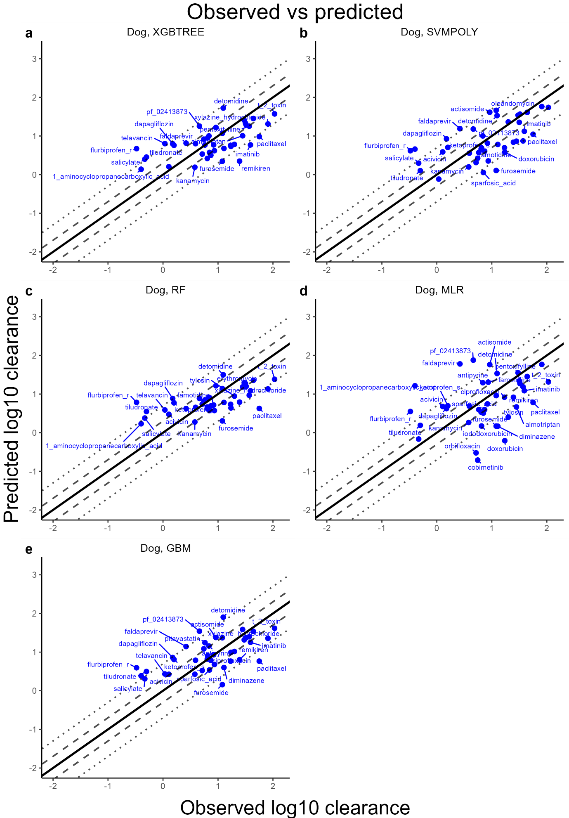Figure 14 Observations vs predictions: Extrapolative model for dog. The solid line depicts unity and the dashed and dotted lines the 2-fold resp. 5-fold error. All chemicals outside of the 2-fold error are labelled. Units of clearance are ml/min/kg.
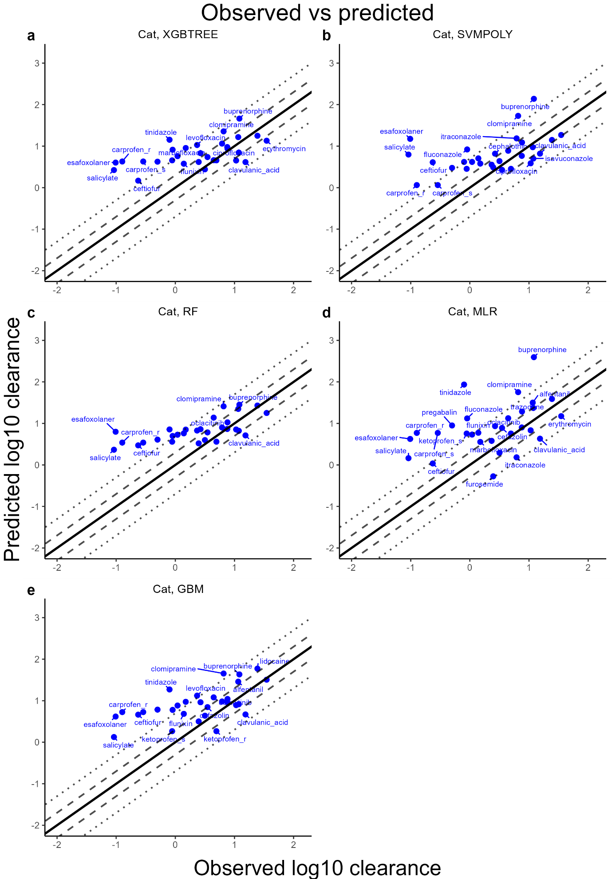Figure 15 Observations vs predictions: Extrapolative model for cat. The solid line depicts unity and the dashed and dotted lines the 2-fold resp. 5-fold error. All chemicals outside of the 2-fold error are labelled. Units of clearance are ml/min/kg.

Additional results augmented AS model
Table 1 Augmented AS model: Results for target species on allometrically predicted chemicals. Column “Features” indicates the number of features after the Boruta procedure, including BW and the species identifier. Root mean squared error (RMSE) and coefficient of determination (R2) on training and test sets are given. *N test refers to the number of chemicals for which simple AS predictions were conducted, those form a subset of the test sets obtained from the extrapolative approach.
Method | Features | N train | RMSE train | R2  train | N test* | RMSE test | R2 test
Cattle
XGBTREE | 83 | 527 | 0.23 | 0.89 | 24 | 0.44 | 0.59
SVMPOLY | 83 | 527 | 0.35 | 0.74 | 24 | 0.41 | 0.64
RF | 83 | 527 | 0.2 | 0.92 | 24 | 0.42 | 0.63
LR | 83 | 527 | 0.43 | 0.62 | 24 | 0.43 | 0.61
GBM | 83 | 527 | 0.32 | 0.79 | 24 | 0.39 | 0.67
Sheep
XGBTREE | 85 | 509 | 0.24 | 0.89 | 23 | 0.39 | 0.73
SVMPOLY | 85 | 509 | 0.3 | 0.82 | 23 | 0.42 | 0.68
RF | 85 | 509 | 0.19 | 0.93 | 23 | 0.39 | 0.73
LR | 85 | 509 | 0.41 | 0.66 | 23 | 0.41 | 0.7
GBM | 85 | 509 | 0.31 | 0.8 | 23 | 0.39 | 0.72
Goat
XGBTREE | 84 | 532 | 0.26 | 0.86 | 20 | 0.37 | 0.68
SVMPOLY | 84 | 532 | 0.35 | 0.76 | 20 | 0.43 | 0.56
RF | 84 | 532 | 0.19 | 0.93 | 20 | 0.33 | 0.74
LR | 84 | 532 | 0.43 | 0.63 | 20 | 0.35 | 0.71
GBM | 84 | 532 | 0.31 | 0.81 | 20 | 0.36 | 0.7
Swine
XGBTREE | 85 | 542 | 0.25 | 0.88 | 21 | 0.35 | 0.65
SVMPOLY | 85 | 542 | 0.29 | 0.83 | 21 | 0.35 | 0.64
RF | 85 | 542 | 0.19 | 0.93 | 21 | 0.34 | 0.66
LR | 85 | 542 | 0.43 | 0.64 | 21 | 0.41 | 0.5
GBM | 85 | 542 | 0.31 | 0.8 | 21 | 0.37 | 0.61
Horse
XGBTREE | 85 | 531 | 0.24 | 0.88 | 15 | 0.37 | 0.76
SVMPOLY | 85 | 531 | 0.35 | 0.75 | 15 | 0.49 | 0.57
RF | 85 | 531 | 0.19 | 0.93 | 15 | 0.39 | 0.73
LR | 85 | 531 | 0.41 | 0.66 | 15 | 0.42 | 0.7
GBM | 85 | 531 | 0.31 | 0.8 | 15 | 0.39 | 0.73
Dog
XGBTREE | 85 | 536 | 0.23 | 0.9 | 21 | 0.39 | 0.53
SVMPOLY | 85 | 536 | 0.35 | 0.76 | 21 | 0.43 | 0.43
RF | 85 | 536 | 0.19 | 0.93 | 21 | 0.38 | 0.56
LR | 85 | 536 | 0.42 | 0.64 | 21 | 0.45 | 0.39
GBM | 85 | 536 | 0.31 | 0.81 | 21 | 0.38 | 0.56
Cat
XGBTREE | 85 | 547 | 0.24 | 0.88 | 14 | 0.48 | 0.62
SVMPOLY | 85 | 547 | 0.3 | 0.82 | 14 | 0.49 | 0.6
RF | 85 | 547 | 0.18 | 0.93 | 14 | 0.48 | 0.62
LR | 85 | 547 | 0.42 | 0.63 | 14 | 0.47 | 0.65
GBM | 85 | 547 | 0.42 | 0.63 | 14 | 0.49 | 0.62

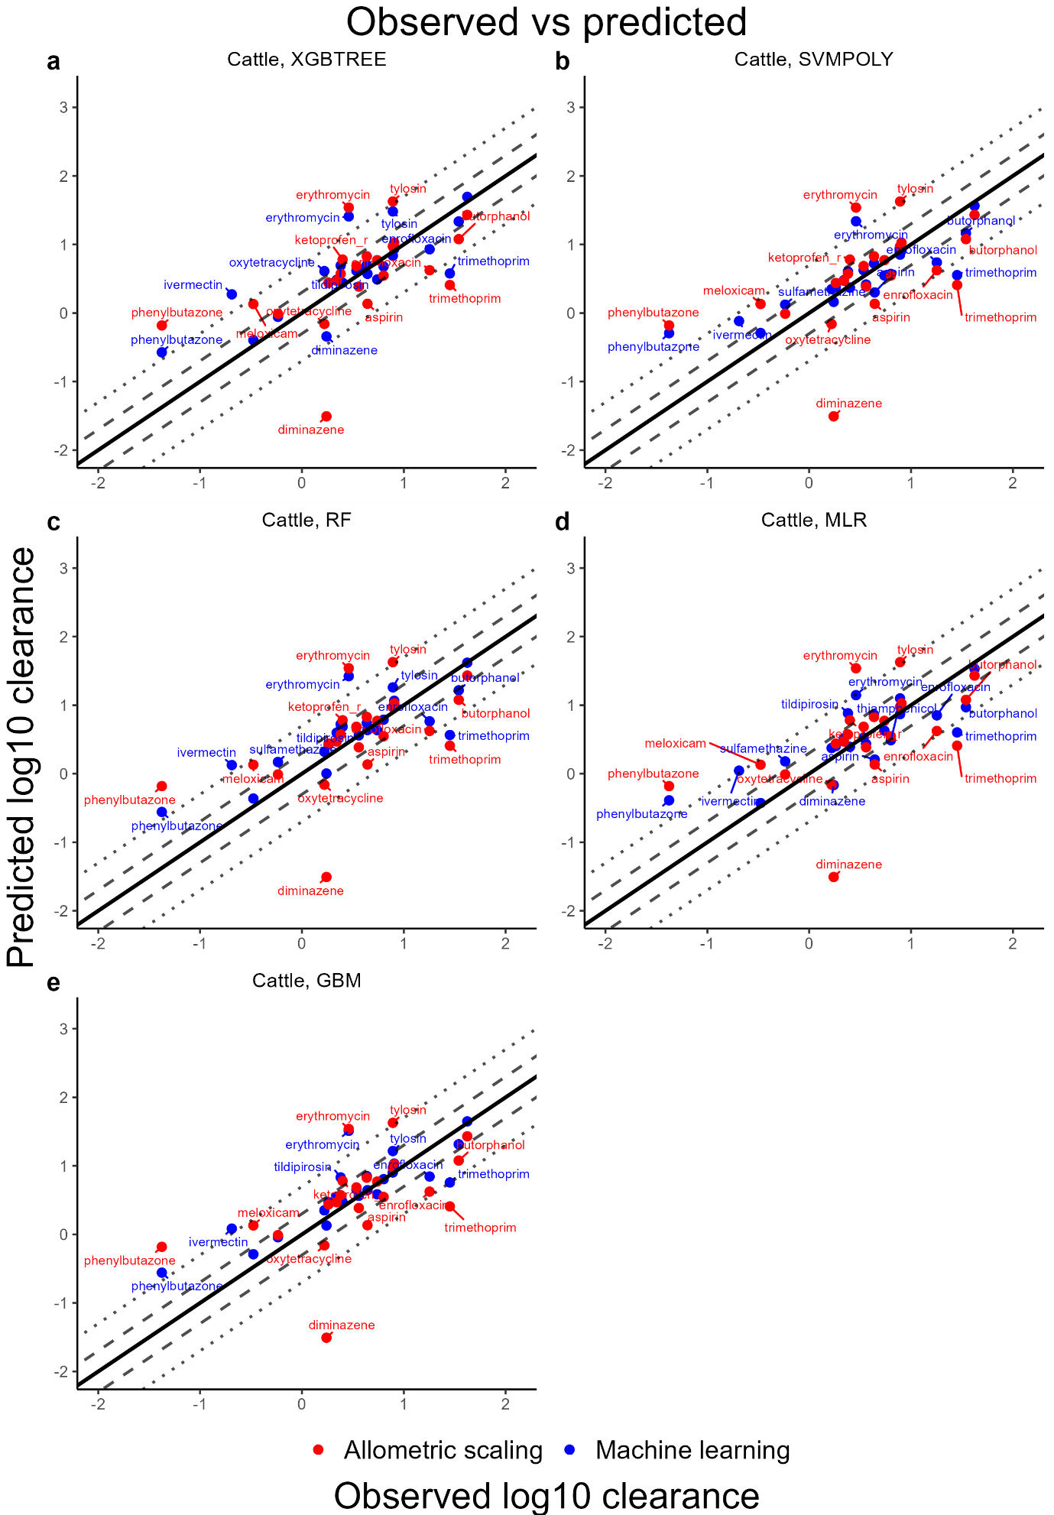Figure 16 Observations vs predictions: Simple and augmented AS with the ML methods for cattle. The solid line depicts unity and the dashed and dotted lines the 2-fold resp. 5-fold error. All chemicals outside of the 2-fold error are labelled. Units of clearance are ml/min/kg.
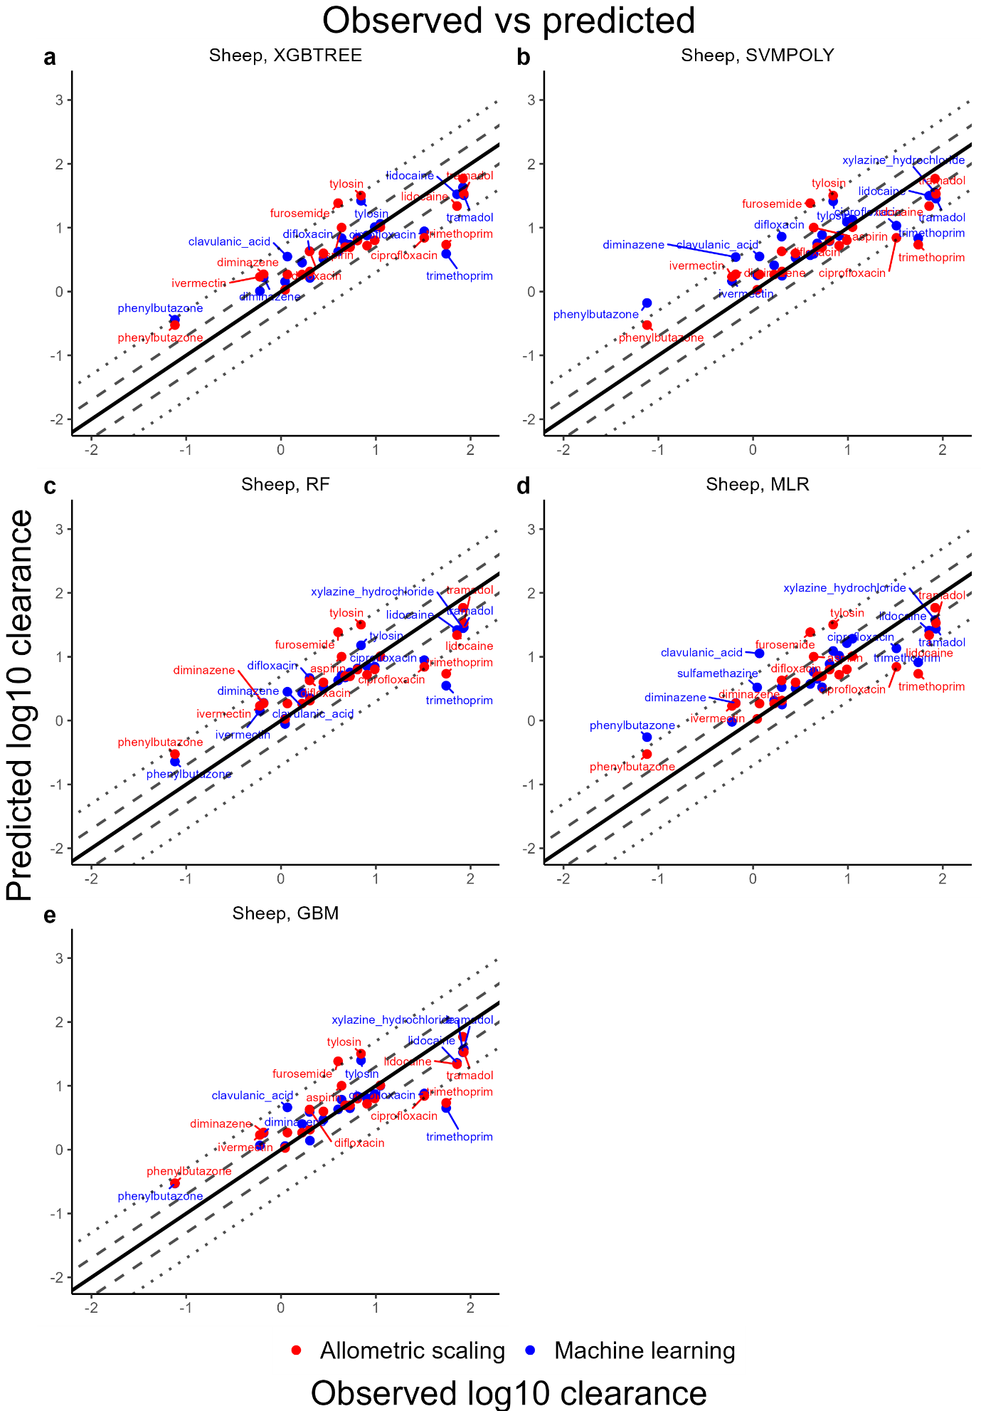
Figure 17 Observations vs predictions: Simple and augmented AS with the ML methods for sheep. The solid line depicts unity and the dashed and dotted lines the 2-fold resp. 5-fold error. All chemicals outside of the 2-fold error are labelled. Units of clearance are ml/min/kg.
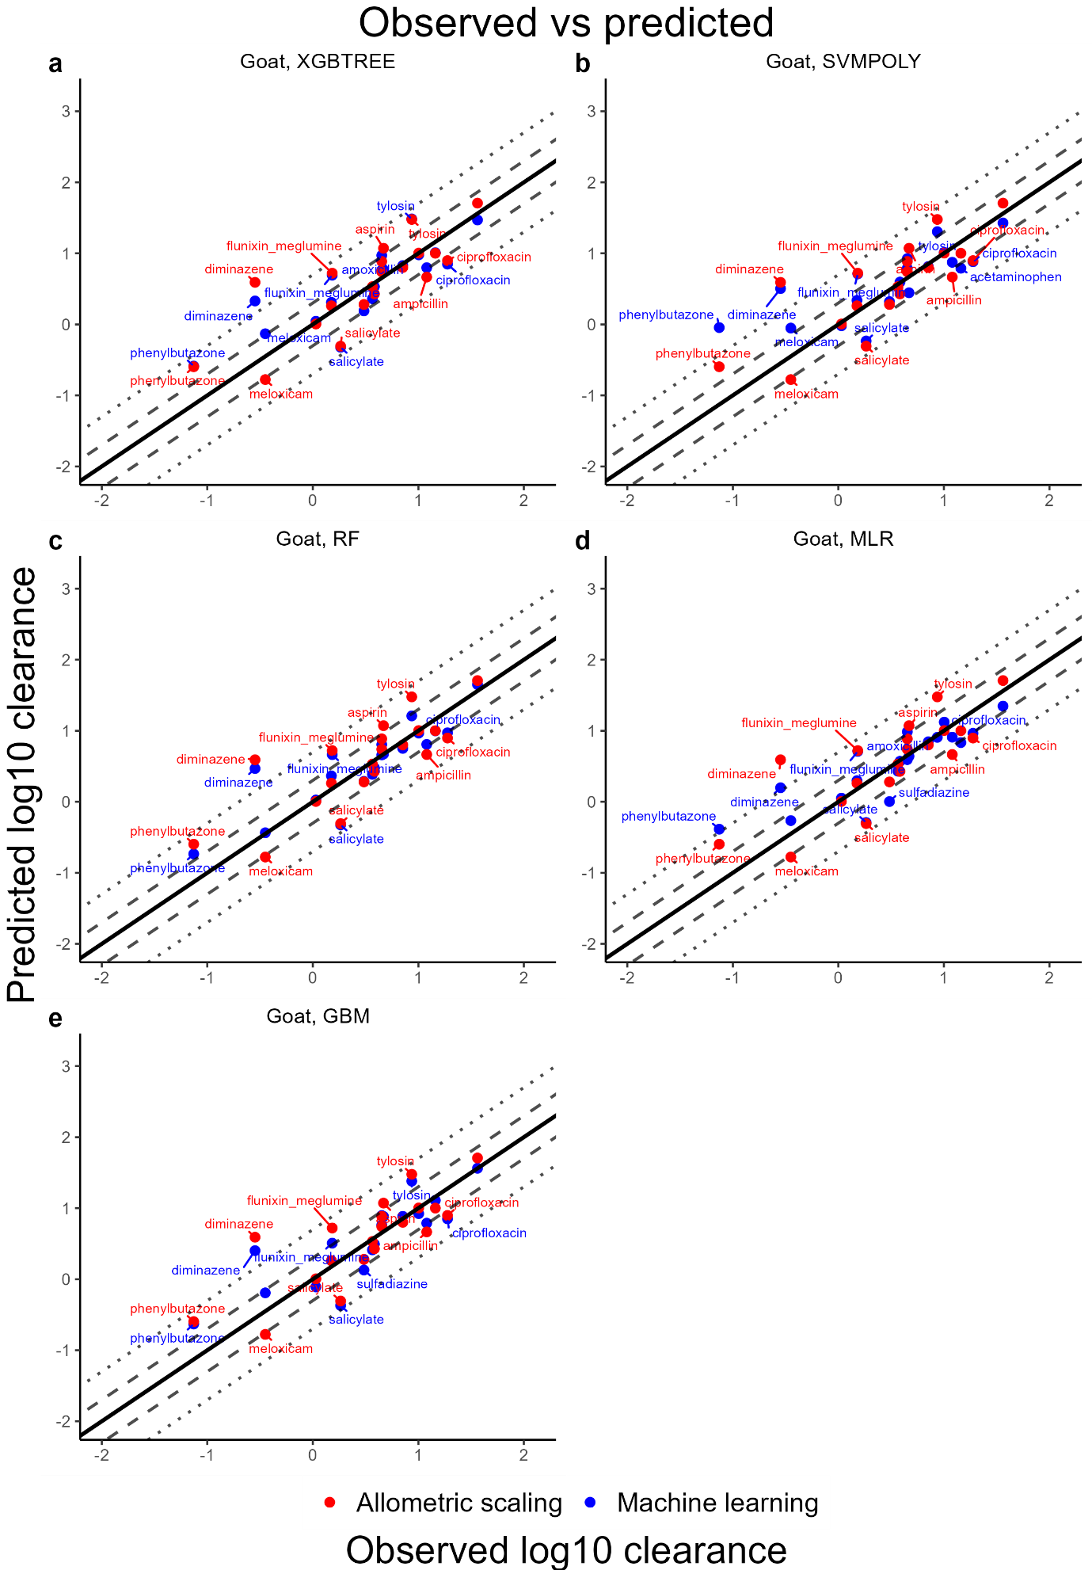
Figure 18 Observations vs predictions: Simple and augmented AS with the ML methods for goat. The solid line depicts unity and the dashed and dotted lines the 2-fold resp. 5-fold error. All chemicals outside of the 2-fold error are labelled. Units of clearance are ml/min/kg.
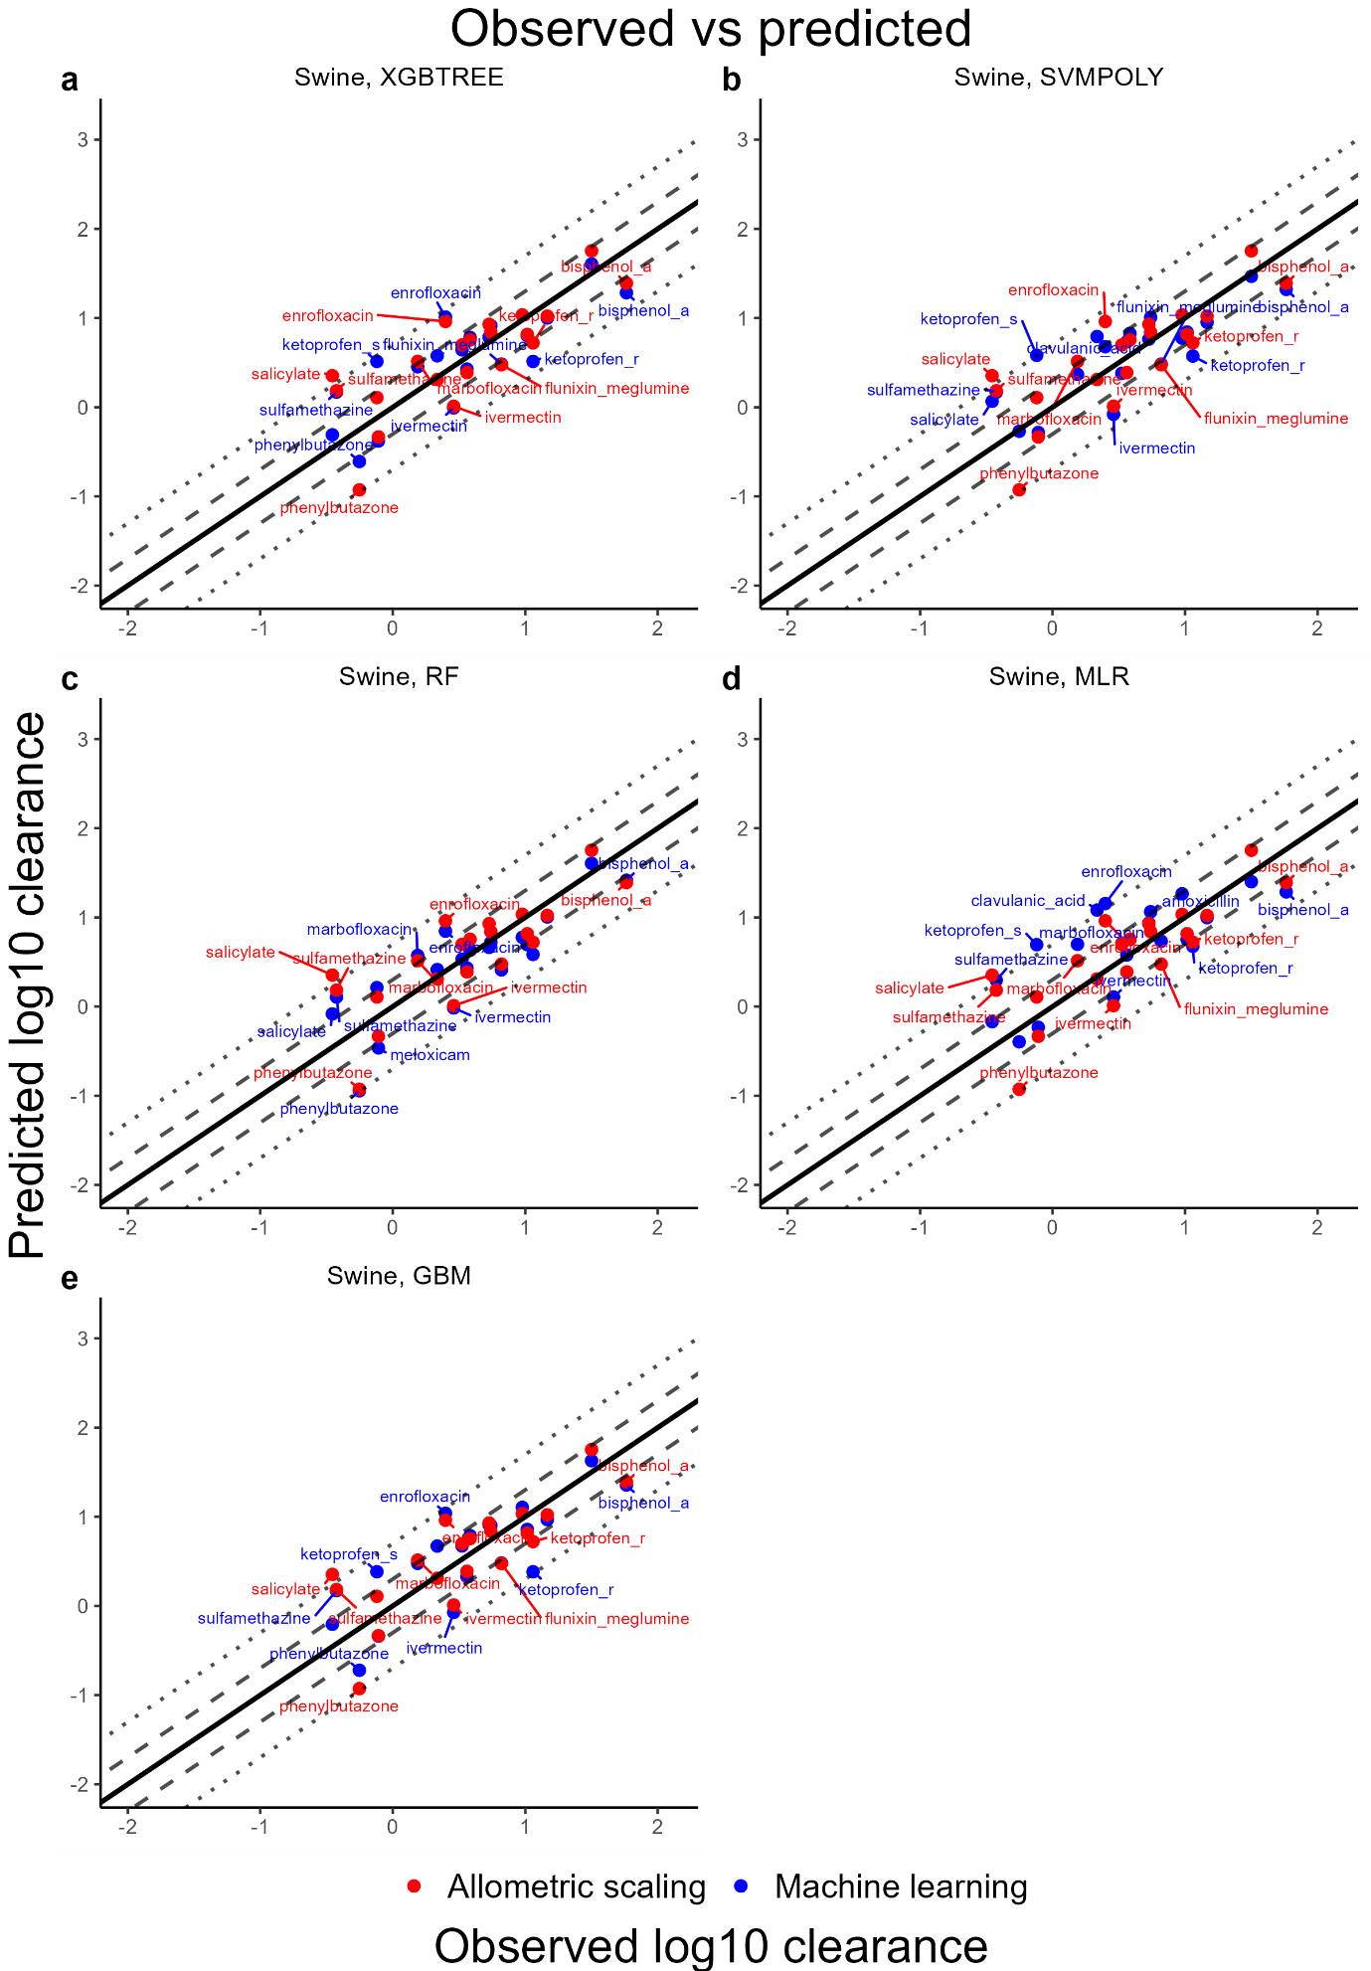
Figure 19 Observations vs predictions: Simple and augmented AS with the ML methods for swine. The solid line depicts unity and the dashed and dotted lines the 2-fold resp. 5-fold error. All chemicals outside of the 2-fold error are labelled. Units of clearance are ml/min/kg.
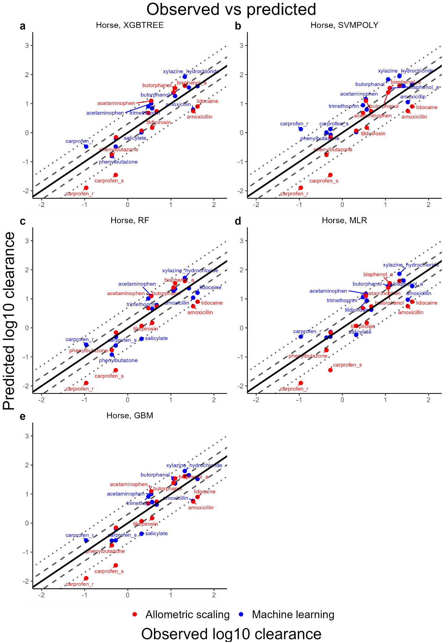
Figure 20 Observations vs predictions: Simple and augmented AS with the ML methods for horse. The solid line depicts unity and the dashed and dotted lines the 2-fold resp. 5-fold error. All chemicals outside of the 2-fold error are labelled. Units of clearance are ml/min/kg. Tramadol is not included.
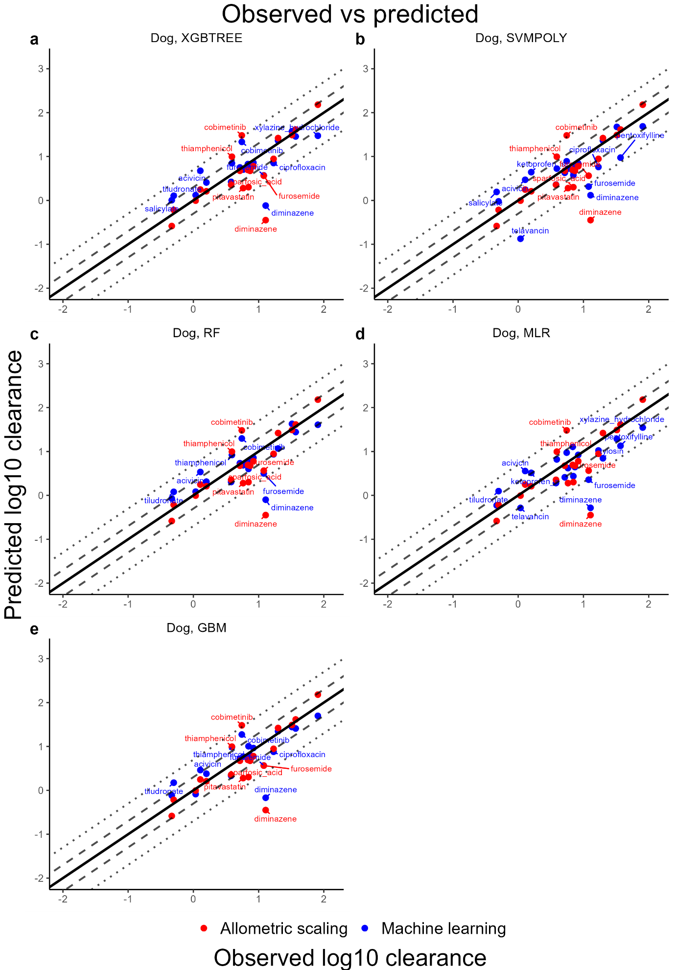
Figure 21 Observations vs predictions: Simple and augmented AS with the ML methods for dog. The solid line depicts unity and the dashed and dotted lines the 2-fold resp. 5-fold error. All chemicals outside of the 2-fold error are labelled. Units of clearance are ml/min/kg.
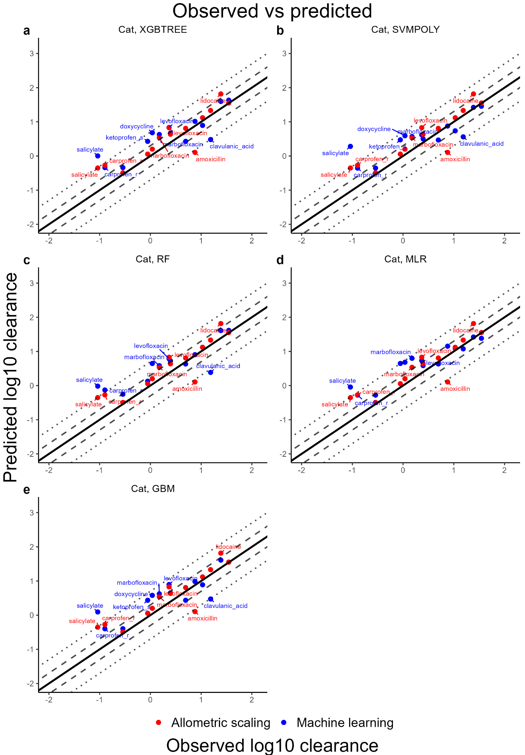
Figure 22 Observations vs predictions: Simple and augmented AS with the ML methods for cat. The solid line depicts unity and the dashed and dotted lines the 2-fold resp. 5-fold error. All chemicals outside of the 2-fold error are labelled. Units of clearance are ml/min/kg.
Table 2 FEs of the simple AS and augmented AS approaches for cattle, sheep and goat. R2 of the individual simple AS regressions are given, and n is the number of species used for the regression.
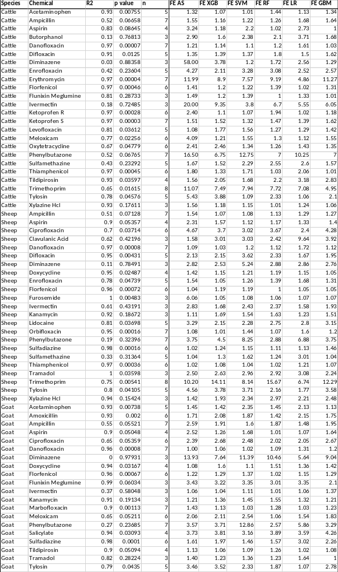
Table 3 FEs of the simple AS and augmented AS approaches for swine, horse, dog and cat. R2 of the individual simple AS regressions are given, and n is the number of species used for the regression. *Tramadol AS regression in horse was conducted on species with similar BWs, leading to a steep regression slope.
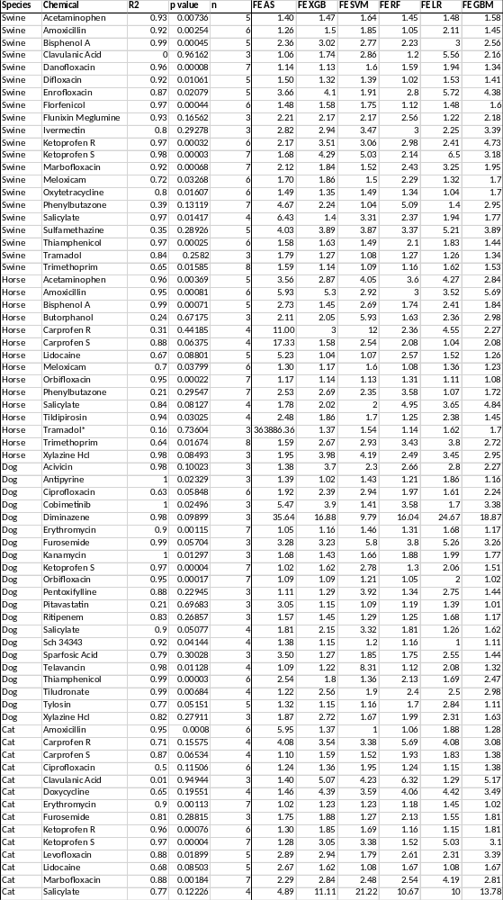
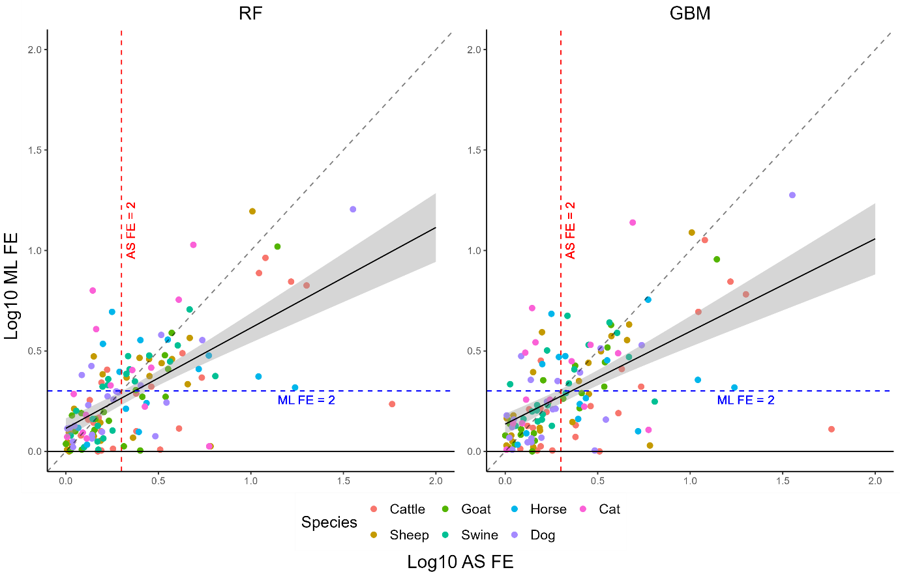
Figure 23 Simple AS FE vs augmented AS FE, logarithmic scale, depicted for ML methods RF and GBM. The dashed diagonal line indicates parity; points below parity indicate better performance by the augmented AS model using ML. The red and blue dashed lines indicate FE 2. A linear regression line with 95% confidence interval indicates the trend.

Table 4 Twenty most important RF features on the extrapolative model, target species: Cattle
Feature | Importance | Description (Mordred)
Mm | 27.915 | mean of constitutional weighted by mass
logBW | 20.004 | Log10 of bodyweight
Mi | 15.100 | mean of constitutional weighted by ionization potential
FCSP3 | 12.961 | the fraction of C atoms that are SP3 hybridized
CIC4 | 12.326 | 4-ordered complementary information content
EState_VSA5 | 10.947 | EState VSA Descriptor 5 ( 1.17 <= x < 1.54)
SdssC | 10.396 | sum of dssC
JGI6 | 10.369 | 6-ordered mean topological charge
nBondsM | 10.255 | number of multiple bonds in non-kekulized structure
FilterItLogS | 9.765 | Filter-it™ LogS
EState_VSA8 | 9.551 | EState VSA Descriptor 8 ( 2.05 <= x < 4.69)
SlogP_VSA4 | 9.313 | MOE logP VSA Descriptor 4 ( 0.00 <= x < 0.10)
JGI4 | 9.275 | 4-ordered mean topological charge
JGI7 | 8.928 | 7-ordered mean topological charge
JGI8 | 8.734 | 8-ordered mean topological charge
JGI3 | 8.509 | 3-ordered mean topological charge
IC1 | 8.468 | 1-ordered neighborhood information content
SlogP_VSA3 | 8.416 | MOE logP VSA Descriptor 3 (-0.20 <= x < 0.00)
ZMIC3 | 8.361 | 3-ordered Z-modified information content
VSA_EState2 | 8.130 | VSA EState Descriptor 2 ( 4.78 <= x < 5.00)

Table 5 Twenty most important RF features on the extrapolative model, target species: Sheep
Feature | Importance | Description (Mordred)
Mm | 38.347 | mean of constitutional weighted by mass
logBW | 22.531 | Log10 of bodyweight
Mi | 15.886 | mean of constitutional weighted by ionization potential
CIC3 | 14.733 | 3-ordered complementary information content
JGI8 | 10.730 | 8-ordered mean topological charge
VSA_EState8 | 10.024 | VSA EState Descriptor 8 ( 6.45 <= x < 7.00)
EState_VSA2 | 9.988 | EState VSA Descriptor 2 ( -0.39 <= x < 0.29)
JGI3 | 9.981 | 3-ordered mean topological charge
PEOE_VSA10 | 9.868 | MOE Charge VSA Descriptor 10 ( 0.10 <= x < 0.15)
SlogP_VSA3 | 9.717 | MOE logP VSA Descriptor 3 (-0.20 <= x < 0.00)
NssCH2 | 9.650 | number of ssCH2
JGI6 | 9.606 | 6-ordered mean topological charge
JGT10 | 9.597 | 10-ordered global topological charge
FilterItLogS | 9.224 | Filter-it™ LogS
PEOE_VSA8 | 9.101 | MOE Charge VSA Descriptor 8 ( 0.00 <= x < 0.05)
JGI2 | 8.748 | 2-ordered mean topological charge
JGI7 | 8.701 | 7-ordered mean topological charge
JGI5 | 8.584 | 5-ordered mean topological charge
EState_VSA8 | 8.567 | EState VSA Descriptor 8 ( 2.05 <= x < 4.69)
fMF | 8.547 | molecular framework ratio

Table 6 Twenty most important RF features on the extrapolative model, target species: Goat
Feature | Importance | Description (Mordred)
Mm | 28.202 | mean of constitutional weighted by mass
logBW | 26.083 | Log10 of bodyweight
FCSP3 | 14.196 | the fraction of C atoms that are SP3 hybridized
FilterItLogS | 13.754 | Filter-it™ LogS
Mi | 12.727 | mean of constitutional weighted by ionization potential
JGI6 | 11.775 | 6-ordered mean topological charge
JGI7 | 11.429 | 7-ordered mean topological charge
JGI8 | 11.256 | 8-ordered mean topological charge
EState_VSA5 | 11.220 | EState VSA Descriptor 5 ( 1.17 <= x < 1.54)
JGI3 | 11.216 | 3-ordered mean topological charge
SdssC | 10.816 | sum of dssC
nBondsM | 9.778 | number of multiple bonds in non-kekulized structure
EState_VSA1 | 9.684 | EState VSA Descriptor 1 (-inf < x < -0.39)
nHBAcc | 9.386 | number of hydrogen bond acceptor
SlogP_VSA4 | 9.314 | MOE logP VSA Descriptor 4 ( 0.00 <= x < 0.10)
IC1 | 9.215 | 1-ordered neighborhood information content
CIC4 | 8.788 | 4-ordered complementary information content
VSA_EState7 | 8.788 | VSA EState Descriptor 7 ( 6.07 <= x < 6.45)
JGI5 | 8.548 | 5-ordered mean topological charge
EState_VSA8 | 8.407 | EState VSA Descriptor 8 ( 2.05 <= x < 4.69)

Table 7 Twenty most important RF features on the extrapolative model, target species: Horse
Feature | Importance | Description (Mordred)
MZ | 28.926 | mean of constitutional weighted by atomic number
logBW | 24.443 | Log10 of bodyweight
FCSP3 | 14.443 | the fraction of C atoms that are SP3 hybridized
SdssC | 13.558 | sum of dssC
JGI6 | 12.755 | 6-ordered mean topological charge
FilterItLogS | 12.467 | Filter-it™ LogS
JGI3 | 12.191 | 3-ordered mean topological charge
Mi | 12.141 | mean of constitutional weighted by ionization potential
JGI7 | 11.667 | 7-ordered mean topological charge
CIC3 | 11.072 | 3-ordered complementary information content
EState_VSA3 | 10.469 | EState VSA Descriptor 3 ( 0.29 <= x < 0.72)
VSA_EState8 | 10.098 | VSA EState Descriptor 8 ( 6.45 <= x < 7.00)
VSA_EState7 | 9.626 | VSA EState Descriptor 7 ( 6.07 <= x < 6.45)
JGI8 | 9.579 | 8-ordered mean topological charge
nBondsM | 9.484 | number of multiple bonds in non-kekulized structure
JGI4 | 9.312 | 4-ordered mean topological charge
EState_VSA8 | 8.696 | EState VSA Descriptor 8 ( 2.05 <= x < 4.69)
JGI2 | 8.649 | 2-ordered mean topological charge
VSA_EState6 | 8.181 | VSA EState Descriptor 6 ( 6.00 <= x < 6.07)
SlogP_VSA3 | 8.155 | MOE logP VSA Descriptor 3 (-0.20 <= x < 0.00)

Table 8 Twenty most important RF features on the extrapolative model, target species: Swine
Feature | Importance | Description (Mordred)
logBW | 26.166 | Log10 of bodyweight
MZ | 22.633 | mean of constitutional weighted by atomic number
JGI6 | 15.399 | 6-ordered mean topological charge
SlogP_VSA4 | 13.688 | MOE logP VSA Descriptor 4 ( 0.00 <= x < 0.10)
EState_VSA7 | 12.480 | EState VSA Descriptor 7 ( 1.81 <= x < 2.05)
SdssC | 11.346 | sum of dssC
FCSP3 | 11.049 | the fraction of C atoms that are SP3 hybridized
Mi | 10.757 | mean of constitutional weighted by ionization potential
VSA_EState4 | 10.582 | VSA EState Descriptor 4 ( 5.41 <= x < 5.74)
EState_VSA3 | 10.450 | EState VSA Descriptor 3 ( 0.29 <= x < 0.72)
FilterItLogS | 10.407 | Filter-it™ LogS
EState_VSA8 | 10.261 | EState VSA Descriptor 8 ( 2.05 <= x < 4.69)
EState_VSA5 | 10.043 | EState VSA Descriptor 5 ( 1.17 <= x < 1.54)
SlogP_VSA3 | 9.903 | MOE logP VSA Descriptor 3 (-0.20 <= x < 0.00)
VSA_EState7 | 9.431 | VSA EState Descriptor 7 ( 6.07 <= x < 6.45)
JGI2 | 9.152 | 2-ordered mean topological charge
JGI3 | 8.962 | 3-ordered mean topological charge
EState_VSA2 | 8.908 | EState VSA Descriptor 2 ( -0.39 <= x < 0.29)
EState_VSA9 | 8.829 | EState VSA Descriptor 9 ( 4.69 <= x < 9.17)
CIC4 | 8.771 | 4-ordered complementary information content

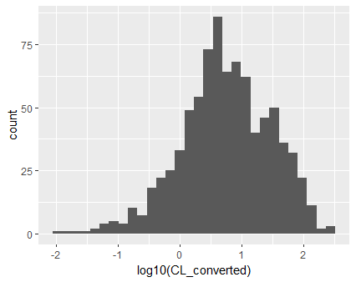
Figure 24 Histogram of log10 CL of the full data.
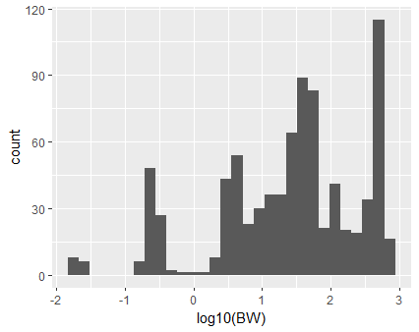
Figure 25 Histogram of log10 BW of the full data.

https://mordred-descriptor.github.io/documentation/master/descriptors.html

