Global Journal of Engineering Science and Researches
REVIEW ON ELECTROSTATIC WIND ENERGY CONVERTER
Mr. Pavan S. Kejdiwal^{*1} , Mr. Gaurav S. Daberao², Prof. D. P. Patil³, Mr. Mahesh R. Pandao⁴ & Mr. Mohammad Atique⁵
^{*1,2,3,4&5}UG Student Electrical Engineering. MGI-COET Shegaon

ABSTRACT
Wind energy is converted to electrical energy by letting the wind move charged particles against the direction of an electric field. The advantage of this type of conversion is that no rotational movement, which occurs in conventional wind turbines, is required. An electrostatic wind energy converter (EWICON) has been developed. Charged particles have been created using two spraying methods, electro hydrodynamic atomization and high pressure monodisperse spraying. Using both methods, wind energy has been converted to electric energy and delivered to an electrical load with positive efficiency.
On EWICON charged droplets are moved by the wind. Due to charge movement, a current is generated which can be converted to be connected to the power grid. Apart from the positive impact on maintenance costs, it would also mean that this type of energy converter would produce less noise than a wind turbine, making it a candidate for placement on tall buildings

- INTRODUCTION

Energy needs of the country is growing at a very fast pace to meet high GDP growth rate. Present peak electricity demand of the country is 135 GW which is expected to grow to about 200 GW and 283 GW by the end of 2016-17 and 2021-22 respectively. To meet energy growing demand and to reduce supply-demand gap, there is a need of large capacity addition through conventional as well as from renewable sources. Considering the depleting domestic fossil fuel reserves in the country as well as increasing demand for energy consumption along with environmental concern. There is a need to harness alternate sources of energy. Abundant renewable potential in the country, presents excellent solution to meet above challenges i.e. attaining energy security. Access and delivery at affordable price along with addressing climate change contents [3].

Currently, wind-based electricity is generated by means of wind turbines. The advantages of wind turbines are that they have high conversion efficiencies, are reliable with proper maintenance, and are continuously improved with ongoing research. However, there are also a number of fundamental disadvantages that either lead to technical challenges for large-scale, offshore deployment, public resistance for construction on land in or near populated areas, or both [1].

First, wind turbines require regular maintenance, which in the case of offshore wind farms, increases the operating costs. The need for maintenance arises from the fact that the conversion from wind energy to electrical energy comes from the rotational movement. This movement significantly contributes to the wear andtear of the turbine. Second, complaints fuelled by noise and visual disturbances have effectively decreased the number of potential areas to build wind turbines, such as remote farming lands [1].

1.1 A new concept, ewicon:
As stated before, in all of the methods, that are used to convert wind energy into electrical energy, some form of mechanical movement occurs, which is the primary reason for maintenance and usually the primary cause of failure. Therefore, a concept in which there is very little mechanical movement would be ideal with respect to system complexity and maintenance costs [5].

The EWICON method (Electrostatic WInd energy CONverter) is a method which is based on the principle that the wind transports electrically charged particles or charge carriers in an electric field.
In this, we will discuss a device called EWICON, in which charged droplets are moved by the wind. As a result of this charge movement, a current is generated which can be converted to be connected to the power grid. This method, in principle, does not have the need for moving mechanical parts. Apart from the positive impact on maintenance costs, it would also mean that this type of energy converter would produce less noise than a wind turbine, making it a candidate for placement on tall buildings. Another advantage is that this method does not have a cut-out speed, the maximum speed at which a wind turbine can be used [2].

Fig 1.1 Artist’s sketch of a sea-based EWICON wind farm

- LITERATURE REVIEW

Dhiradj Djairam, et al. [1],describes the working principle of the EWICON, including various implementations, showing how the intermediate conversion via mechanical rotation of conventional wind turbines is no longer required. Subsequently the methods of creating charged particles. Then, the overall EWICON system design has been explained. This article shows that it is possible to convert wind energy to electrical energy requiring less energy for the operation, which has not been achieved with water before. Thus, the proof of principle has been shown in this paper.

D. Djairam, et al. [2],presents a method of directly converting wind energy into electrical energy is proposed, called an Electrostatic Wind Energy Converter (EWICON). The method is based on transporting electrically charged particles against the direction of an electric field by the wind and accumulating them at a collector. The electro-spray method is used to create the charged particles. Two implementations of the EWICON and their properties are discussed, one with a separate collector and one with the system itself as a collector. Based on practical considerations, a choice has been made for the latter implementation.

This method of producing energy from wind, in principle, does not have the need for moving mechanical parts. Apart from the positive impact on maintenance costs, it would also mean that this type of energy converter would produce less noise than a wind turbine.

Rahul T. Dhanore, et al. [3], presents an alternative method of utilizing wind energy for generate electricity to reduce supply-demand gap. The increasing global demand for energy has rekindled the interest for various forms of renewable energy production, including wind energy. One of these methods is the electrostatic wind energy converter in which wind energy is converted to electrical energy by letting the wind move charged particles against the direction of an electric field. Also, we discussed here about two possible implementation of EWICON principle of which one is chosen.

The theoretical foundation was provided on which, in the subsequent topics, the practical aspects could be built, such as droplet creation and charging methods or the choice of spraying liquids. In general, the EWICON concept has been proven to be able to achieve a net gain in terms of output power depending on the used methods and more importantly, the used spraying liquid.

Dhiradj DJAIRAM, et al. [5],this Ph.D. thesis summarizes the research on EWICON system, which utilizing wind energy for generate electricity to reduce supply-demand gap. In this thesis, the working principle of the EWICON, including various implementations, is showing how the intermediate conversion via mechanical rotation of conventional wind turbines is no longer required. Subsequently, we will discuss the methods of creating charged particles. Then, the overall EWICON system design will be given as well as the experimental results.

- EWICON WORKING PRINCIPLE

First, we will look at the theoretical foundation of the movement of charged particles by wind in an electric field. Subsequently, we will discuss two possible ways in which the EWICON system can be implemented and choose the most practically feasible implementation type. Last, with the theory and the implementation type, we will present simulation results to show that this conversion principle can deliver electrical energy.

3.1 Theoretical basis
When a force acts on a body that undergoes a displacement, that force does work on the body. In the EWICON system, the body is a charged particle with charge q, and there is electric force on the charged particle due to an electric field E, given by

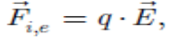
…………... (3.1)
This force is combined with the force of the wind, which is schematically depicted in Figure 3.1.

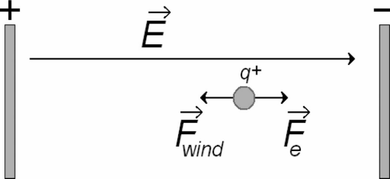
Fig 3.1 Charged particle in an electric field with wind force

These particles with increased energy can then be collected. In theory, any charged object that can be wind driven can function in EWICON. Experiments have actually been carried out to show that the principle also works with ping pong balls. However, the recycling of these balls for recharging renders this particular choice of charge carriers unpractical. There are several forces acting on the droplets, starting with gravity with works on droplet i:
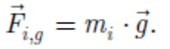

……………… (3.2)

These droplets fall in air, therefore, there is also an upwards force acting on the droplets, the buoyancy (an upward force exerted by a fluid that opposes the weight),
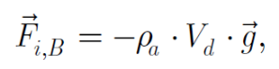

…………… (3.3)
in which V_{d} is the volume of the droplet and ρ_{a} is the air density. Moving in the wind, there will also be a drag force that initially causes the droplets to move,
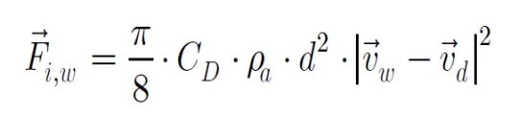
……..……. (3.4)

in which C_{D} is the drag coefficient, d is the droplet diameter, v_{w} is the wind speed, and v_{d} is the speed of the droplet. This drag force will be zero when the droplet moves with the same speed as the wind. When the air flow is laminar, i.e., the Reynolds number is lower than one, the process is said to be in the Stokes region, and Stokes’ law can be used for the drag force, in which η_{a} is the dynamic viscosity of air and C_{c} is the slip
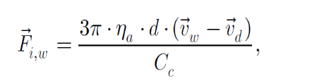

……………... (3.5)
correction factor by Cunningham, which becomes relevant for particles smaller than 15 μm. For droplets with d >>1 μm, we can assume Cc = 1.

The electric forces acting on the droplets can be divided into two parts. The first part is the electric force due to the external electric field, E_{ext}, as indicated in Figure 3..1,

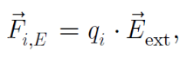

………………. (3.6)

in which q_{i} is the charge present on the i^{th} droplet. This charge will depend on the method by which the droplets are created. This external field obviously depends on the exact configuration of the electrode(s) in an actual EWICON system. The second part is the electric force due to the electric fields created by the other charged droplets surrounding the ith droplet.
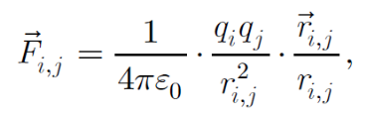

................. (3.7)

in which r_{i,j} is the distance between droplet i and droplet j. It should be noted that all the created charged droplets have charge with the same polarity and, thus, will repel each other. Summing all contributing forces, we find for the law of motion
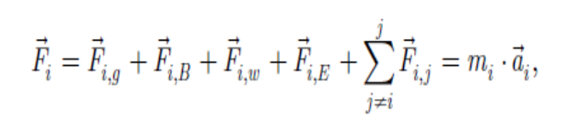
…………. (3.8)

In which F_{i} is the total force of the i^{th} droplet and a_{i} is the acceleration of the charged droplet. In this equation, if we look at the orders of magnitude, the total force is mainly dominated by the drag force and the electric force. We can solve this equation, giving us the velocity and position of every droplet at each point in time. Using (3.8), the work done on the i^{th} droplet, W_{i}, by the wind is
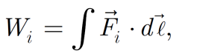
…………. (3.9)

in which dℓ is the displacement, which follows the path of the droplet. From this, the total energy gained from the wind can be calculated.

It is important to note that there is a limit to the power that can be extracted from the wind. Betz and Lanchester have derived an expression for the power surface density,
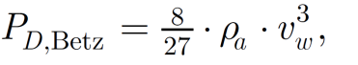
in which ρ_{a} is the air density and v_{w} is the wind speed.
…………… (3.10)

- EWICON CONSTRUCTION

There are two implementations by which the EWICON system can be designed. The first one, called Type A, is more intuitive but carries several practical problems. The second one, called Type B, is electrically more challenging but will result in a EWICON system with higher applicability.

4.1 Type A: the patent of alvin marks
As we can see in Figure 4.1, in this implementation of the EWICON system, the charged particles are created by a charging system, which usually consists of a number of nozzles and electrodes, which is grounded. A stream of charged particles, which can be considered as an electric current, is then transported by the wind to a separate insulated collector, which is initially neutral. When the charged particles touch the collector, they will deliver their charge to the collector. This causes the potential of the collector to rise.

This potential will have the same polarity as the charged particles cloud, thereby creating an electric field. Due to this field, an electric force will push the charged particles away from the collector. Initially, the wind force will be larger than the electric force and therefore the charged particles will still arrive at the collector. As long as this process occurs, however, the electric field
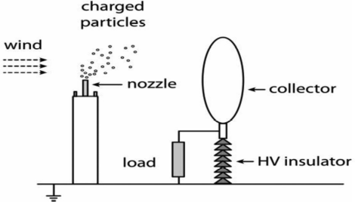

Fig 4.1 Type A EWICON system with a separate collector.

generated by the collector will continue to increase, causing the charged particles cloud to either move back against the wind or around the collector. When the charged particles come in contact with the charging system or earth, the charge is lost and the net current decreases.

Therefore, the wind has to overcome this repelling electric force and depending on the speed of the wind, the size of the collector and the load, the collector potential attains a maximum that further depends on possible leakage currents to earth via the insulator surface. If all produced charged particles are captured by the collector, then the maximum power of the EWICON has been attained [5].

In this configuration, shown in Fig. 4.1, the charging system (electrodes + nozzles) responsible for the charged particles is connected to earth. After the charging system has produced the charged particles, the wind blows these charged particles away towards an initially neutral collector that is electrically isolated from earth. Consequently, the electric potential of this collector will rise and have the same polarity as the polarity of the charged droplets. Therefore, the collector will start to repel the droplets and depending on the power of the wind, which is related to the wind speed, the voltage of the collector will reach a maximum. An electrical load can be attached to this collector.

4.2 Type B: the collector-less ewicon system:
The main principle can be seen in Figure 4.2. In this figure, we can see that, now, the charging system is electrically isolated from earth. The charging system is in fact the EWICON system. Since the system is initially neutral and because charged droplets with one polarity will be created and moved away by the wind, the electrical potential of the system will rise with a polarity opposite to that of the droplets. Again, the maximum potential to which the system can be charged depends on the wind speed.

One significant advantage in Type B is that an external collector is no longer required. The earth acts as the collector, and it is only necessary to remove the charged droplets from the charging system, removing the requirement for wind alignment.

The challenge with Type B will be the design of an electrically isolated charging system. Moreover, the fact that the earth, i.e., the environment, acts as the collector for the droplet puts restrictions on the type of liquids. For example, certain oils that have been shown to produce good results in terms of electric charge production cannot be used [1].
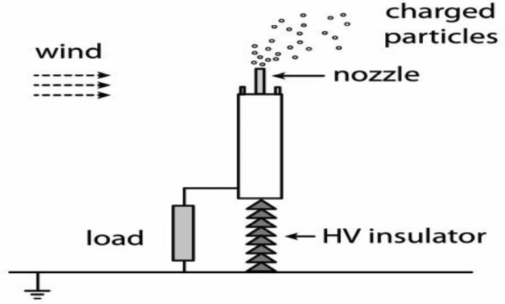

Fig 4.2 Type B EWICON system without a collector

In this configuration, shown in Fig. 4.2, the charging system is electrically isolated from earth. In this case, after the charging system has produced the charged particles, the wind blows the particles away from the charging system. Due to this charge movement away from the set-up the electric potential of the charging system rises, but with a polarity opposite to the polarity of the charged particles. Therefore, there will be an attractive force between the charging system and the charged particles, which would decrease the stream of charged droplets being removed from the set-up, thus decreasing the net current. Again, the maximum voltage of the set-up that can be reached is dependent on the wind power. Similarly, an electrical load can be attached to the set-up.

4.3 Choice of setup
It is useful to note again the significance of the wind in these set-ups. Without the work of the wind, the charged particles would either be repelled by the collector (Type A) or be attracted by the charging system (Type B). In both cases, this would mean the current created by the spraying process would be nullified. This means the system cannot feed a load.

Type A's main advantage is that it is conceptually simple. However, it requires a separate isolated collector, which means extra building material and effort. Also, due to the inherent chaotic character of the wind, a relatively large collector needs to be built to ensure that most of the charged droplets are caught and even then, there is no guarantee that all of the particles will be collected.

Type B's main disadvantage is that the charging system needs to be isolated from earth. This means the charging system is more complicated than the one used in a Type A setup. However, there is no need for a separate collector which simplifies the construction of the set-up. The fact that the charged particles are not collected does mean, however, that the particles are dispersed into the surroundings. Therefore, from an environmental point of view, the particles cannot be harmful or toxic.

Since the intended spraying medium for the EWICON is water, this condition has been met. Also, during the feasibility testing period, it was found that using a Type B set-up resulted in very stable voltages compared to voltages achieved with a Type A set-up.

Therefore, the Type B set-up is more favourable as a starting-point for further EWICON research.

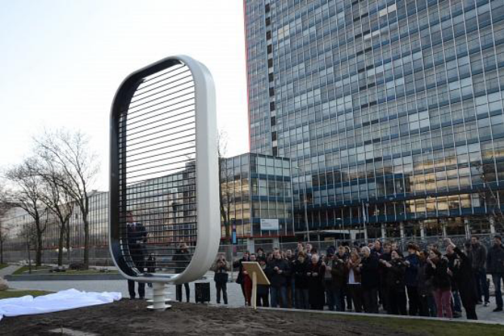
Fig 4.3 EWICON System in Delft University, Netherlands

- DESIGN OF CHARGING SYSTEM

5.1 Charge and liquid droplets
Regardless of the charging method, there will always be a maximum charge q_{max} that can be applied on a liquid droplet. This is called the Rayleigh limit and is governed by the surface tension,
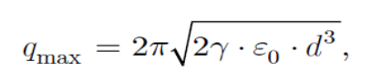
…………….. (5.1)

in which γ is the surface tension of the liquid of the droplet, ε₀ is the vacuum permittivity, and d is the droplet diameter. If the charge on a droplet exceeds q_{max}, the droplet will break up due to the electrical stresses, which the surface tension is unable to withstand. Going solved by (5.1), a high surface tension and large droplet diameter seem to be more favourable for the EWICON system. However, a high surface tension also complicates droplet production.
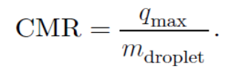
Moreover, while a single droplet might hold more charge with larger diameter, the important parameter to take into account is the charge per mass ratio,
………………… (5.2)
This indicates that the relative charge per droplet actually increases with decreasing droplet diameter. In short, with a constant liquid flow rate, more charge will be produced per time unit with smaller droplet diameters. The last issue is the electric and mechanical mobility of the droplets. A charged droplet released in an electric field will accelerate until it reaches a terminal velocity due to drag force of the surrounding air. In the EWICON situation, this terminal velocity is the minimum wind speed that should be present in order for the EWICON to successfully operate.

Calculations have shown that
• the electric field must not exceed 106 V/m as the EWICON then requires wind speeds over 30 m/s and
• the produced droplets should have a droplet diameter between 0.1 and 100 μm.

5.2 High-pressure monodispersed spraying
This method is based on the principle that a liquid is forced through a device fitted with micron-sized pores of equal size creating liquid jets of equal diameter. The pressure is in the order of 10 to 15 MPa, resulting in an exit velocity of 10 to 20 m/s.

The liquid jets break up into droplets under the Rayleigh break up principle, with the droplet diameter proportional to the jet diameter. Charging the droplet is achieved by induction using a ring electrode, as shown in Figure 5.1.

This spraying technique is mostly used in ink-jet printers and medicine applications where saline water is commonly used. Furthermore, the charge on the droplets can be controlled by varying the potential of the electrode. The main disadvantage of this method is the power required to achieve the high pressure. This will negatively contribute to the overall efficiency of the EWICON system.
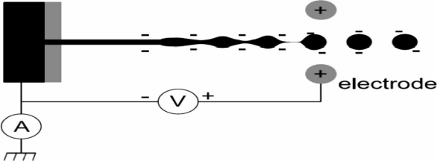

Fig5.1 High-pressure monodispersed spraying; the liquid breaks up into monodispersed droplets, and the droplets are charged using a ring electrode.

5.3 Electro-hydrodynamic atomization
Electro-hydrodynamic atomization (EHDA) is a spraying and charging method that is used for coating or administering medicine. Its main advantage is that very little energy is required for the creation of charged droplets. The method is based on the principle that a strong electric field will deform the meniscus of a liquid leaving a spraying nozzle to a conical shape, a Taylor cone, see Figure 5.2. From this conical shape, a liquid jet is created that breaks into droplets with a high charge density.

Depending on the liquid flow rate, density, viscosity, surface tension, conductivity, and electric field, this spraying process can take place in various modes.

Of these modes, the so-called cone-jet mode is desired for mainly two reasons:
1) highest charge per droplet and
2) monodispersity.

The main challenge with the cone-jet mode is that the surface tension of the spraying liquid should be relatively low, in the order of 20 to 40 mN/m. Since water has a relatively high surface tension (72 mN/m), the spraying conditions have to be carefully set to prevent disrupting discharges.

If the cone-jet mode is not achieved, then the next best mode is the micro-dripping mode. In this mode, droplets have a wider range of diameter and the charge on each droplet is lower than during the cone-jet mode. Experiments will have to show whether these produced charged droplets in the micro-dripping will be sufficient for an efficient energy conversion process.

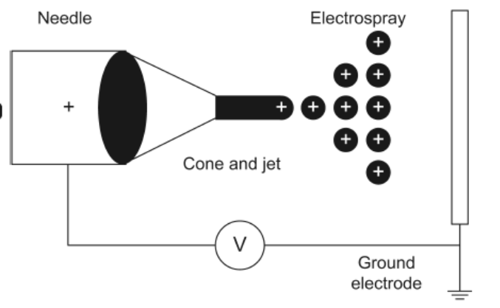
Fig 5.2 (a) Cone shape, droplet size, and electric current depend on the forces acting on liquid and dissolved ions: gravity, electric field and surface tension. (b) Ethanol spraying in the cone-jet.

- ADVANTAGES AND DRAWBACKS OF EWICON

6.1 Advantages
One of the disadvantages of the mechanical conversion method is the wear and tear of the moving parts. Therefore, these components are more subjective to failure and have high maintenance costs. Another drawback is the noise and intermittent shadow caused by the rotational movement of the blades. Also visual pollution of the landscape is mentioned as a negative property of a wind turbine.

A new concept, which converts the wind energy directly into electrical energy, is the Electrostatic Wind energy Converter or EWICON. The EWICON directly converts wind energy into electrical energy, by displacement of charged particles by the wind in the opposite direction of an electric field. With this method the moving mechanical part, and its disadvantages, is no longer present. Another advantage is, that the size of this converter i.e. the wind surface area, can be scaled in two directions. In a conventional converter this area can only be increased by increasing the rotor diameter, see figure.
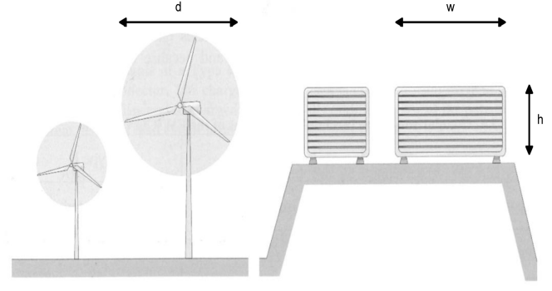
Fig 6.1 Wind surface area of both wind energy converters. At a wind turbine, the area is increased by increasing the rotor diameter (d). An EWICON system can be scaled up by increasing the height (h) or the width (w), or both

Summarizing, the advantages of the EWICON system are:
- No mechanical wear and tear, thereby lower maintenance costs.
- No intermittent shadows and lower noise because the absence moving and rotating parts.
- Area can be increased in both dimensions.
- Can be constructed in various shapes.

6.2 Drawbacks of ewicon
Despite the advantages, there will be also some restrictions by implementing an EWICON system. The charged particles will be represented by charged droplets. As a consequence, a liquid will be released in the environment, which has to be environmentally friendly. Also corrosion and clogging of the liquid supply should be taken into account.

However the EWICON system can be scaled in two dimensions, the size will still be in the order of a conventional wind turbine. The visual pollution problem will not be solved. The complete system as well as the creation of charged droplets operates at high voltage. This requires attention to safety and insulation aspects. Other disadvantages at the present stage arecompared to the maximum convertible power in the wind; the net power output is in the order of a few percent.

- CONCLUSION AND FUTURE WORK

It is possible to convert wind energy to electrical energy requiring less energy for the operation, which has not been achieved with water before. However, the power coefficients are still small compared with conventional wind turbines. Part of these lower efficiencies and power coefficients is due to the fact that the droplet-charging process produces a lower-than-expected output current. In the case of EHDA, water is not spraying in the cone-jet, causing polydispersity in the charged droplets. Therefore, a significant part of the charged droplets are attracted back to EWICON system. It is very important that all droplets have the same size. In the case of HPMS, the charging process by induction is not as efficient as predicted by charging models. Also, the mechanical power required to achieve the high pressure negatively affects the efficiency significantly.

The experiments show that the EWICON system in the current configuration is capable of generating electrical energy from wind energy with an efficiency of at least 7%. The efficiency of conventional wind turbines, like e.g. a Siemens 1.3 MW wind turbine, is roughly 45% which still is six to seven times higher compared to the efficiency of the current EWICON.

If we take the power coefficient of the current EHDA laboratory system and apply that to a scaled-up system with a wind surface area comparable to the aforementioned Siemens wind turbine, an output power of 360 kW would be generated at 13 m/s. While this is still significantly lower than 6 MW, it is important to bear in mind that it is not solely output power but “cost per kWh” that will determine the economic feasibility of the EWICON.
With additional research, in 5 to 10 years, the power coefficient of the EWICON might only need to be improved to 20 to 30% after which savings in construction and maintenance will tip the scale towards the EWICON. If that is achieved, electrostatic wind energy converters such the ones sketched in figure 1 might be placed both in sea and in urban environments.

REFERENCES
- Dhiradj Djairam, Peter H. F. Morshuis, and Johan J. Smit,” A Novel Method of Wind Energy Generation—The Electrostatic Wind Energy Converter”, IEEE Electrical Insulation Magazine, July/August, in 2014 — Vol. 30, No. 4
- D. Djairam, A.N. Hubacz, P.H.F. Morshuis, J.C.M. Marijnissen, J.J. Smit,” The development of an Electrostatic Wind Energy Converter (EWICON)”,High Voltage Technology and Management group, Delft University of Technology.
- Rahul T. Dhanore, Yeshwant M. Jibhakate,” A Review Paper on Electrostatic Wind Energy Converter (EWICON) Method of Utilizing Wind Energy”, IJTARME V-5 No.2 ISSN (Print): 2319-3182, February 2016.
- Alvin M. Marks,” Charged Aerosol Generator with Un-Electrode Source”, US Patent No. 4.206.396, Jun. 3, 1980.
- Dhiradj DJAIRAM,” The Electrostatic Wind Energy Converter”, Ph.D. Thesis, Economy, Ecology and Technology, Delft University of Technology, Netherland, EETK02005, ISBN: 978-90-8559-482-6.
- T. J. Price, “James Blyth—Britain’s first modern wind power pioneer,” Wind Eng., vol. 29, no. 3, pp. 101–200, 2005.
- Williams, P., Lansdorp, B., and Ockels, W., “Flexible Tethered Kite with Moveable Attachment Points, Part II: State and Wind Estimation,” AIAA Atmospheric Flight Mechanics Conference, 2007.
- Keith, D.W., DeCarolis, J.F., Denkenberger, D.C., Lenschow, D.H., Malyshev, S.L., Pascala, S., Rasch, P.J., “ The influence of large-scale wind power on global climate”, PNAS, volume 101, no. 46, 2006.
- M. Cloupeau, “Research on wind conversion by electro fluid dynamic processes,” Arch. Mech., vol. 5, no. 6, pp.529–538, 1986.

