Time-Frequency Fingerprint Analysis in SEEG Source-Space to Identify the Epileptogenic Zone

Yash Shashank Vakilna, ${MS}^{1*\#}$, Deniz Atilgan, ${MD}^{1\#}$, Johnson Hampson, ${MS}^{1}$, Takfarinas Medani, ${PhD}^{2}$, Richard M. Leahy, ${PhD}^{2}$, Nuria Lacuey, ${MD PhD}^{1}$, Samden D. Lhatoo, ${MD}^{1}$, Sandipan Pati, ${MD}^{3}$, John C. Mosher, ${MD}^{1}$, and Jay R. Gavvala, ${MD}^{1}$

1. Texas Institute for Restorative Neurotechnologies (TIRN), Department of Neurology,
McGovern Medical School, University of Texas Health Science Center at Houston,
Houston, TX 77054, United States
2. Ming Hsieh Department of Electrical and Computer Engineering, University of
Southern California, Los Angeles, CA 90089, United States
3. Department of Neurology, University of Minnesota Medical School

# Equal Contribution

Running title: Seizure Fingerprint on source-space
Number of characters in the title and running head: 91and 35
Number of words in the abstract: 99
Number of words in the body of the manuscript: 1498
Number of figures, color figures, and tables: 2, 2, 0

# Corresponding Author:

Yash Shashank Vakilna, MS
Texas Institute of Restorative Neurotechnologies
Room 440C, 1133 John Freeman Blvd, Houston, TX 77030.
P: 713-500-7925
E-mail: yash.shashank.vakilna@uth.tmc.edu

Abstract

This case study highlights the application of seizure fingerprint analysis in the source-space of SEEG data to accurately localize the epileptogenic zone (EZ) in patients with complex cortical malformations. A 25-year-old female with extensive bilateral perisylvian polymicrogyria presented with intractable focal seizures. The source-level analysis performed in Brainstorm using the sLORETA imaging algorithm subsequently showed EZ fingerprint analysis. The patient underwent MR-guided laser interstitial thermal therapy, targeting the identified EZ, resulting in postoperative seizure freedom with minimal complications. Extending the analysis from the sensor-space to the source-space could further enhance surgical planning and improve outcomes in complex epilepsy cases.

Introduction
The primary aim of a surgical epilepsy evaluation is to delineate the epileptogenic zone (EZ), defined as “the minimum amount of cortex that must be removed for seizure freedom” (1). Determination of this area is a complex process and requires a comprehensive evaluation. Intracranial EEG recording such as stereo-EEG (SEEG) is often required in MRI-negative cases, widespread epilepsies, and epilepsies in close proximity to eloquent areas (2).
In a majority of cases, the seizure onset pattern plays a prominent role in guiding the therapeutic decision-making. Low voltage fast activity (LVFA) is the most common seizure onset pattern described in SEEG recordings (3–5). Removal of the areas generating LVFA has been associated with improved post-surgical outcomes (5–11). LVFA, however, may occur in multiple areas simultaneously, and visual discrimination may lead to subjective interpretations, particularly in neocortical epilepsies and malformations of cortical developments (12,13). Despite several attempts to objectively delineate the extent of the EZ (14–17), most common EZ identification methodologies rely on fast activity alone, which has been shown to be inadequate (18,19). Additionally, varying methodologies may provide conflicting results depending on the particular ictal pattern (14,17,18,20,21).
Grinenko et al. 2018 identified a distinct time-frequency pattern (named “fingerprint”) to define EZ. This pattern has been found to be homogeneous across patients regardless of the etiology, and the regions involved (22). The description of the EZ fingerprint, however, was limited to sensor-level analysis, which is dependent on electrode proximity to the EZ. An inherent limitation of the SEEG approach is insufficient sampling, where electrical sources of interest could lie between the electrodes and may be missed (23). Utilizing SEEG source-level analysis can overcome this sampling problem by shedding light onto the regions left uncovered by electrodes.
In this study, we present a novel approach that utilizes the EZ fingerprint proposed to determine the EZ in the source-space constructed using sLORETA. We applied this approach in a case of complex bilateral malformations, including Perisylvian polymicrogyria (PMG) and right temporal periventricular nodular heterotopia (PVNH).

Case Study
A 25-year-old right-handed woman with known drug-resistant epilepsy since the age of six and right parietal opercular corticectomy at age fifteen presented with episodes of focal aware seizures (FAS) with left hand somatosensory aura (tingling) and focal impaired awareness seizures (FIAS) characterized by staring and ictal pouting occurring one to two per week on average. Her evaluation in the epilepsy monitoring unit (EMU) showed intermittent right parietal slowing and ten habitual seizures, all with right parieto-central (C4-P4) onset. Magnetic resonance imaging showed evidence of bilateral perisylvian PMG and pachygyria as well as periventricular nodular heterotopia in the right posterior temporal lobe in addition to post-surgical changes in the right parietal opercular region. Magnetoencephalography (MEG) showed discharges in the right superior parietal region superior to the prior resection cavity. Based on the non-invasive evaluation, she underwent SEEG lead implantation predominantly targeting the anatomical abnormality over the right hemisphere.
The visual analysis of SEEG demonstrated two seizure onset patterns corresponding to the two semiologically distinct events. Focal aware seizures with left-hand somatosensory aura were characterized by a slow polarizing potential and low voltage fast activity in the PMG in the right superior parietal region (SPS 7-10 followed by PLON 6-16 and PLAT 6-8). Focal impaired awareness seizures were characterized by repetitive spiking onset in the posterior insula within the PMG (PIN 1-6).
After a detailed analysis of the SEEG data and discussion in the surgical conference, MR-guided laser interstitial thermal therapy (LITT) of the right superior parietal polymicrogyria (including the right post-central cortex identified above) via a right parietal trajectory and right posterior insular polymicrogyria via right parieto-occipital trajectory was performed without any complications. She reported being seizure-free at one-year postoperative follow-up.

Methods

SEEG recording
The patient was implanted with 16 SEEG (electrode model PMT2102-14-091/2102-16-101) with 238 contact leads out of which 222 contact leads were used for the analysis in total. SEEG was recorded as a part of the routine clinical phase 2 evaluation workflow. SEEG signals were recorded on a Nihon Kohden (Irvine, CA) EEG machine with a 2kHz sampling rate. The coordinates of the SEEG electrode contacts were estimated by co-registering the post-implant CT with the pre-implant MRI using the FSL software package (24). The electrode coordinates were then exported as an ASCII file.

Epileptogenic Zone (EZ) fingerprint identification
SEEG recordings were visually checked for bad channels, which were excluded from the analysis. As demonstrated in Figure 1, the entire EZ fingerprint identification pipeline was implemented in Brainstorm (25). The power-line contamination was removed using a band-stop notch IIR filter.
During the initial analysis, fingerprint analysis on the sensor level defined in (12) and characterized by a combination of “pre-ictal spikes” and “narrow-band fast activity” concurrent with “suppression of lower frequencies” was performed and several electrodes were identified meeting criteria (Supplementary Figure S1). To further clarify the EZ, source-level fingerprint analysis was subsequently performed. Forward modeling was performed using symmetric BEM (26) with a three-layer realistic head model (scalp, inner skull, outer skull). The inverse modeling was performed using sLORETA Min-Norm Imaging (27). Afterward, the Desikan-Killiany atlas was then used to define multiple regions of interest (ROIs), which were further subdivided to maintain a consistent area of 5 cm² for each ROI. Principal Component Analysis (PCA) was applied to extract the main time series for each ROI (using only the first PCA component). The Morlet wavelet transform (with a wavenumber of 6) was then used to compute the time-frequency maps of the extracted time series, which were subsequently screened for the presence of EZ fingerprints.

Results
As shown in Figure 2, we can identify the patch of the cortex with an EZ fingerprint indicative of the EZ. The right post-central region demonstrated all the properties of the seizure fingerprint. Conversely, other parcellated regions including the right supramarginal region did not show the seizure fingerprint.

Discussion
In this case study, we utilize advanced ictal signal processing techniques to further understand the EZ in a challenging case of lesional epilepsy. After traditional visual analysis of the intracranial ictal patterns, we performed time-frequency analysis at the sensor level and found the typical fingerprint features characterized by “pre-ictal spikes,” “narrow-band fast activity” concurrent with “suppression of lower frequencies.” While these findings were well correlated with the conventional visual analysis, they were found in multiple-depth electrode contacts, limiting the ability to translate to clinical management. Using sLORETA-based modeling and time-frequency analysis, we identified the critical brain areas responsible for seizures. This led to a successful surgical outcome using MR-guided laser interstitial thermal therapy (LITT), with the patient experiencing seizure freedom after the procedure. The result highlights the value of this method for guiding surgical decisions, especially in challenging cases where cortical abnormalities are widespread or difficult to assess. Our findings suggest that incorporating source-level analysis into routine SEEG evaluations can enhance the accuracy of epilepsy surgery planning. Our findings demonstrate the feasibility of utilizing ictal fingerprint analysis in source-space constructed with SEEG’s current density model while using the sLORETA.
SEEG is increasingly being adopted worldwide for pre-surgical evaluation, and with it, there has been a recognition of the steep learning curve transitioning from a subdural-based methodology (28). One of the most challenging problems is knowing when an SEEG electrode represents a true ictal onset pattern versus propagation (29). While many automated approaches have been developed, many are sensor-level analyses that either may provide conflicting results or rely on the presence of fast activity, which has shown to be inadequate in some cases. (12) identified a specific time-frequency pattern (fingerprint) to define EZ. This pattern has been found to be homogeneous across patients regardless of the etiology and the regions involved (12,20).
SEEG source localization techniques can theoretically overcome the spatial undersampling problem, which is an inherent problem associated with the recording modality. However, only a handful of studies have been published on using interictal(23,30,31)and ictal(31) source localization techniques in SEEG datasets. There is only one study in the SEEG field that analyzed seizure onset with source localization techniques (31). They analyzed the dominant frequency at seizure onset with both dipole models and current density models. However, they only utilized “fast activity” to delineate EZ rather than the more robust fingerprint analysis.

Limitations
In this case, the patient had two seizure types and two corresponding seizure onset patterns. We used the sLORETA algorithm to create a current density model of both seizure patterns. However, we only used our novel method for the first seizure type arising from the superior parietal region since there was a clear LVFA onset.

Conclusion
In this case study, we successfully used EZ fingerprint analysis in the source-space of SEEG data to localize the EZ in a patient with complex cortical malformations. By extending our analysis to the source-space, we gained a more precise understanding of the epileptogenic region, which traditional sensor-level approaches may have missed due to limited spatial coverage. This technique holds the potential for improving surgical outcomes in patients with complex epilepsy and should be explored further in future studies.

Conflict of Interest Statement
None.

Author Contributions
Conception and design: JCM, JRG, SDL, SP.
Acquisition and data analysis: YSV, DA, JH.
Drafting the manuscript: all authors.

Funding
Research reported in this publication was supported in part by the National Institute of Biomedical Imaging and Bioengineering of the National Institutes of Health under award number R01EB026299. The content is solely the responsibility of the authors and does not necessarily represent the official views of the National Institutes of Health.

Data Availability Statement
The datasets generated and analyzed during the current study are publicly available in the Zenodo repository at DOI: 10.5281/zenodo.14807262. Additional data and materials supporting the findings of this study are available from the corresponding author upon reasonable request.

References
1. Rosenow F, Lüders H. Presurgical evaluation of epilepsy. Brain. 2001;124.

2. Isnard J, Taussig D, Bartolomei F, Bourdillon P, Catenoix H, Chassoux F, et al. French guidelines on stereoelectroencephalography (SEEG). Neurophysiologie Clinique. 2018;48.

3. Perucca P, Dubeau F, Gotman J. Intracranial electroencephalographic seizure-onset patterns: Effect of underlying pathology. Brain. 2014;137.

4. Singh S, Sandy S, Wiebe S. Ictal onset on intracranial EEG: Do we know it when we see it? State of the evidence. Epilepsia. 2015;56.

5. Lagarde S, Buzori S, Trebuchon A, Carron R, Scavarda D, Milh M, et al. The repertoire of seizure onset patterns in human focal epilepsies: Determinants and prognostic values. Epilepsia. 2019;60.

6. Lee SA, Spencer DD, Spencer SS. Intracranial EEG seizure-onset patterns in neocortical epilepsy. Epilepsia. 2000;41.

7. Jung WY, Pacia SV, Devinsky O. Neocortical temporal lobe epilepsy: Intracranial EEG features and surgical outcome. Journal of Clinical Neurophysiology. 1999;16.

8. Wennberg R, Arruda F, Quesney LF, Olivier A. Preeminence of extrahippocampal structures in the generation of mesial temporal seizures: Evidence from human depth electrode recordings. Epilepsia. 2002;43.

9. Doležalová I, Brázdil M, Hermanová M, Horáková I, Rektor I, Kuba R. Intracranial EEG seizure onset patterns in unilateral temporal lobe epilepsy and their relationship to other variables. Clinical Neurophysiology. 2013;124.

10. Holtkamp M, Sharan A, Sperling MR. Intracranial EEG in predicting surgical outcome in frontal lobe epilepsy. Epilepsia. 2012;53.

11. Kim DW, Kim HK, Lee SK, Chu K, Chung CK. Extent of neocortical resection and surgical outcome of epilepsy: Intracranial EEG analysis. Epilepsia. 2010;51.

12. Grinenko O, Li J, Mosher JC, Wang IZ, Bulacio JC, Gonzalez-Martinez J, et al. A fingerprint of the epileptogenic zone in human epilepsies. Brain. 2018;141.

13. Aubert S, Wendling F, Regis J, McGonigal A, Figarella-Branger D, Peragut JC, et al. Local and remote epileptogenicity in focal cortical dysplasias and neurodevelopmental tumours. Brain. 2009;132.

14. Bartolomei F, Chauvel P, Wendling F. Epileptogenicity of brain structures in human temporal lobe epilepsy: A quantified study from intracerebral EEG. Brain. 2008;131.

15. Weiss SA, Lemesiou A, Connors R, Banks GP, McKhann GM, Goodman RR, et al. Seizure localization using ictal phase-locked high gamma: A retrospective surgical outcome study. Neurology. 2015;84.

16. David O, Blauwblomme T, Job AS, Chabards S, Hoffmann D, Minotti L, et al. Imaging the seizure onset zone with stereo-electroencephalography. Brain. 2011;134.

17. Gnatkovsky V, Francione S, Cardinale F, Mai R, Tassi L, Russo GL, et al. Identification of reproducible ictal patterns based on quantified frequency analysis of intracranial EEG signals. Epilepsia. 2011;52.

18. Gnatkovsky V, Curtis MD, Pastori C, Cardinale F, Russo GL, Mai R, et al. Biomarkers of epileptogenic zone defined by quantified stereo-EEG analysis. Epilepsia. 2014;55.

19. Worrell G, Gotman J. High-frequency oscillations and other electrophysiological biomarkers of epilepsy: Clinical studies. Biomarkers in Medicine. 2011;5.

20. Andrzejak RG, Schindler K, Rummel C. Nonrandomness, nonlinear dependence, and nonstationarity of electroencephalographic recordings from epilepsy patients. Physical Review E - Statistical, Nonlinear, and Soft Matter Physics. 2012;86.

21. Andrzejak RG, David O, Gnatkovsky V, Wendling F, Bartolomei F, Francione S, et al. Localization of epileptogenic zone on pre-surgical intracranial EEG recordings: Toward a validation of quantitative signal analysis approaches. Brain Topography. 2015;28.

22. Li J, Grinenko O, Mosher JC, Gonzalez-Martinez J, Leahy RM, Chauvel P. Learning to define an electrical biomarker of the epileptogenic zone. Human Brain Mapping. 2020;41.

23. Gonzalez-Martinez JA. The stereo-electroencephalography: The epileptogenic zone. Journal of Clinical Neurophysiology. 2016;33.

24. Smith SM, Jenkinson M, Woolrich MW, Beckmann CF, Behrens TE, Johansen-Berg H, et al. Advances in functional and structural MR image analysis and implementation as FSL. Neuroimage. 2004;23:S208–19.

25. Tadel F, Baillet S, Mosher JC, Pantazis D, Leahy RM. Brainstorm: A user-friendly application for MEG/EEG analysis. Computational intelligence and neuroscience. 2011;2011(1):879716.

26. Gramfort A, Papadopoulo T, Olivi E, Clerc M. OpenMEEG: Opensource software for quasistatic bioelectromagnetics. Biomedical engineering online. 2010;9:1–20.

27. Pascual-Marqui RD, others. Standardized low-resolution brain electromagnetic tomography (sLORETA): Technical details. Methods Find Exp Clin Pharmacol. 2002;24(Suppl D):5–12.

28. Gavvala J, Zafar M, Sinha SR, Kalamangalam G, Schuele S, Consortium AS, et al. Stereotactic EEG practices: A survey of united states tertiary referral epilepsy centers. Journal of Clinical Neurophysiology. 2022;39(6):474–80.

29. Frauscher B, Mansilla D, Abdallah C, Astner-Rohracher A, Beniczky S, Brázdil M, et al. Learn how to interpret and use intracranial EEG findings. Epileptic disorders: international epilepsy journal with videotape. 2024;26(1):1–59.

30. Hosseini SAH, Sohrabpour A, He B. Electromagnetic source imaging using simultaneous scalp EEG and intracranial EEG: An emerging tool for interacting with pathological brain networks. Clinical Neurophysiology. 2018;129.

31. Satzer D, Esengul YT, Warnke PC, Issa NP, Nordli DR. Source localization of ictal SEEG to predict postoperative seizure outcome. Clinical Neurophysiology. 2022;144.

Figures

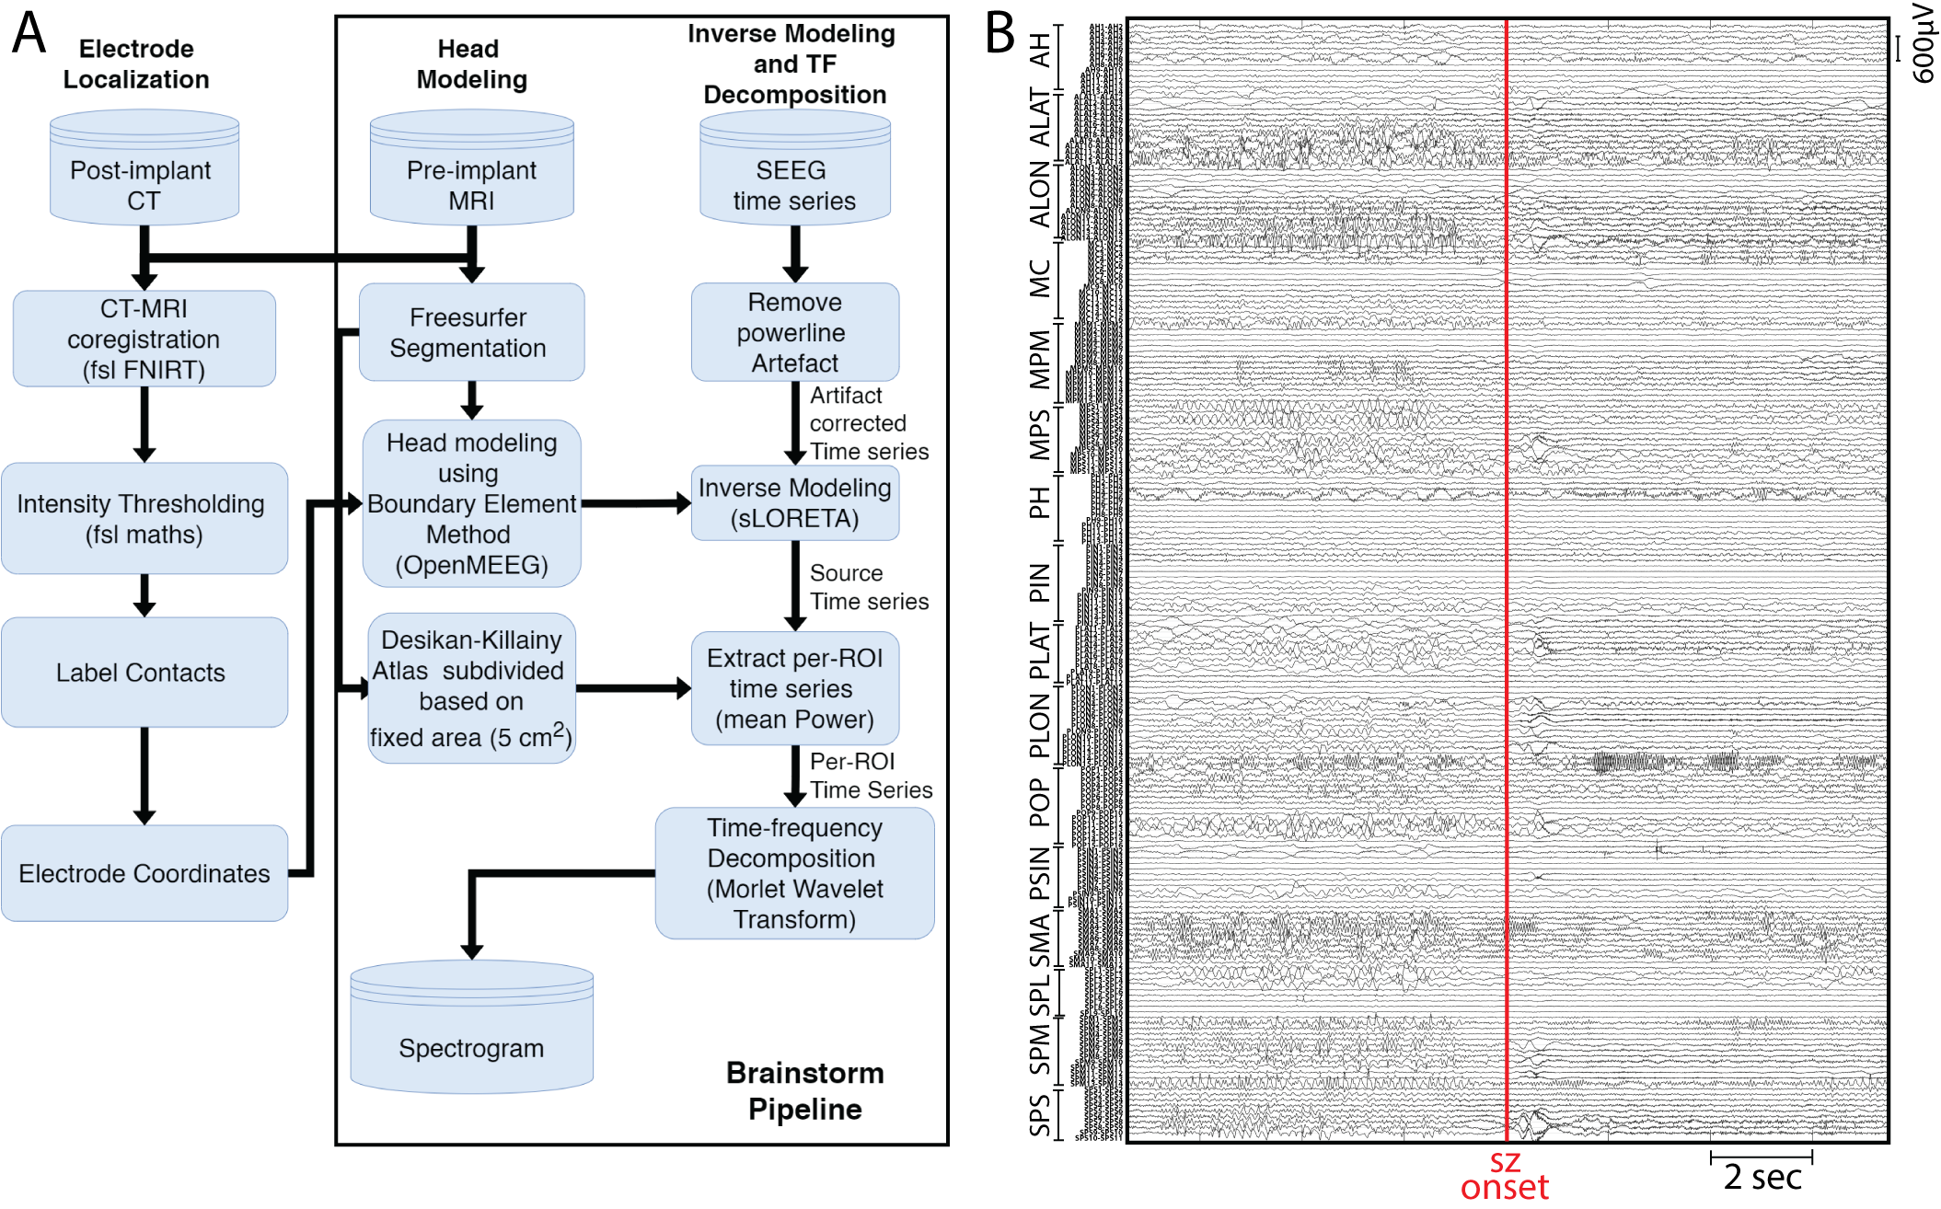
Figure 1. A. Flowchart illustrating the data-processing steps involved in computing spectrogram to identify epileptogenic zone fingerprints on the source-space. B. SEEG time series of all the sampled channels in bipolar montage.

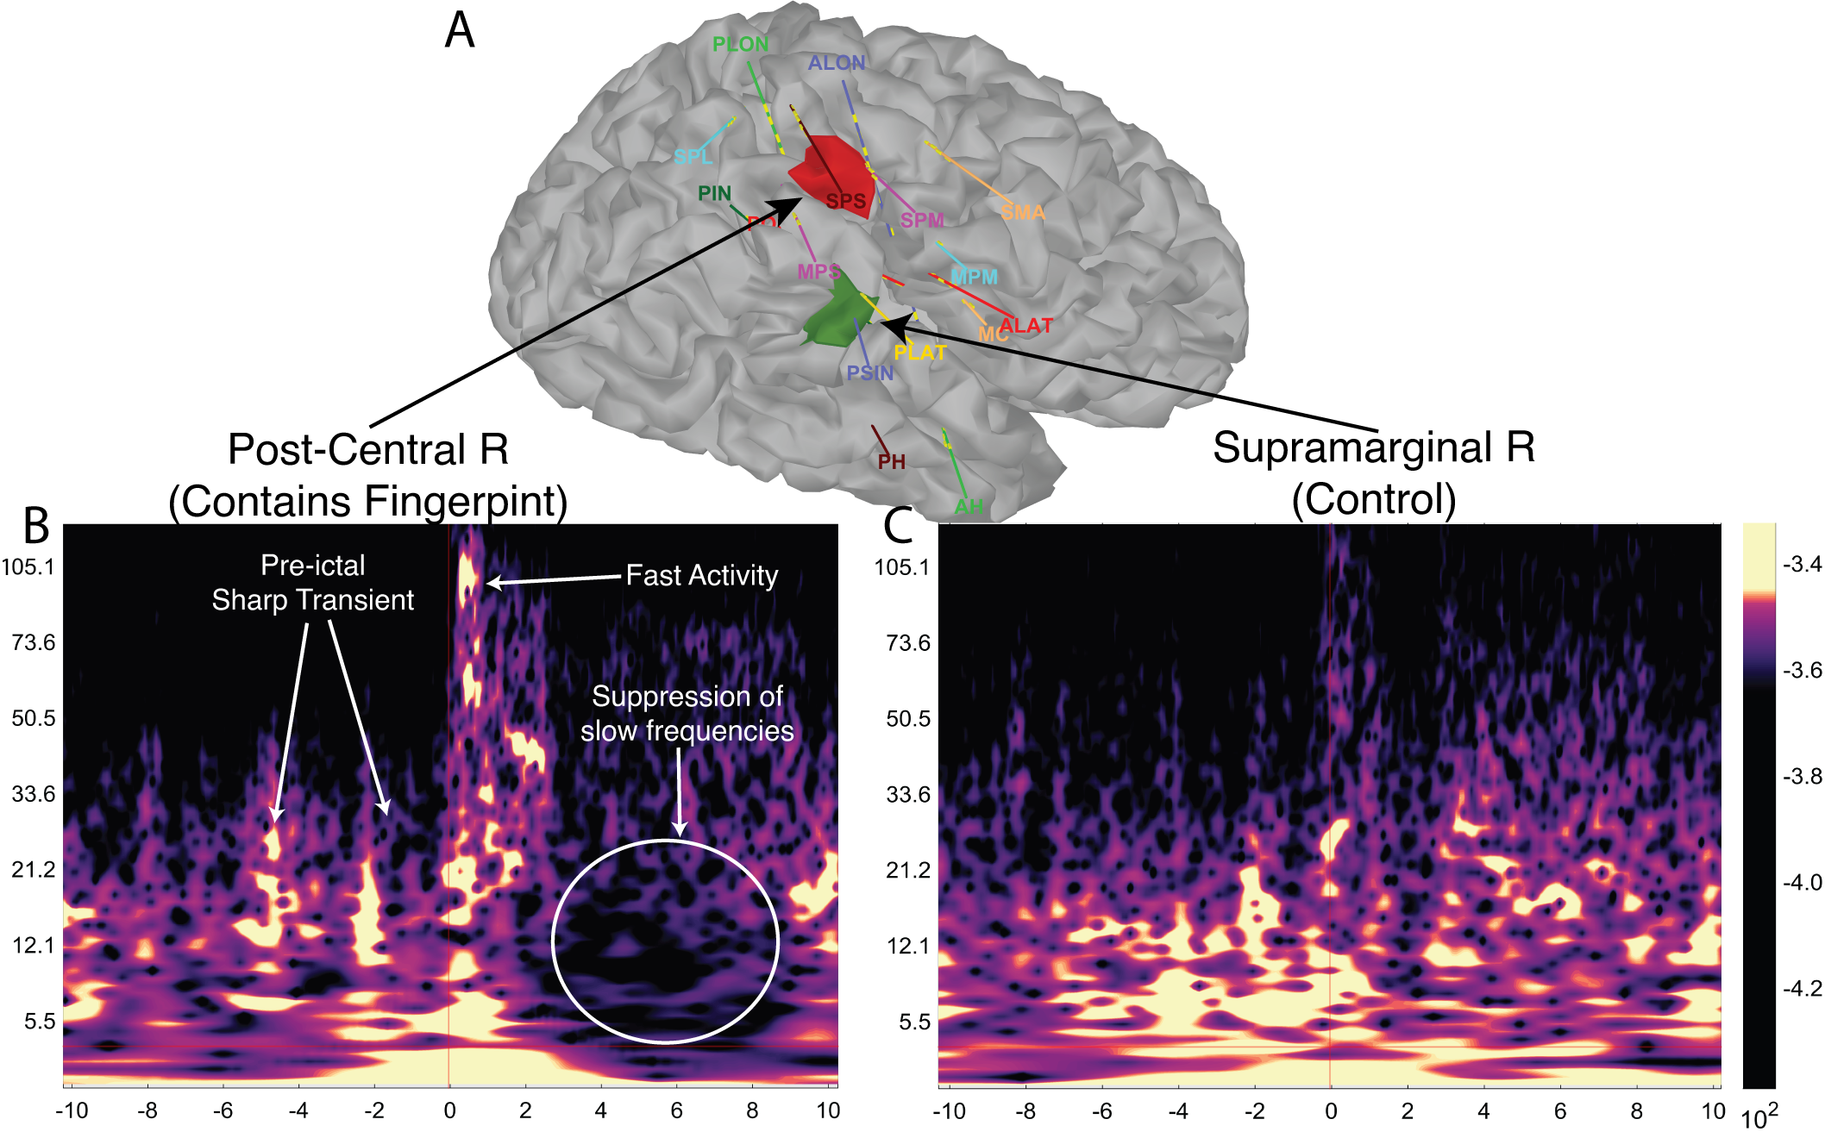
Figure 2. A. Cortex extracted from pre-implant MRI showing the SEEG implants. B. Post-Central R region showing the seizure fingerprint. C. Supramarginal R region acting as a control.

