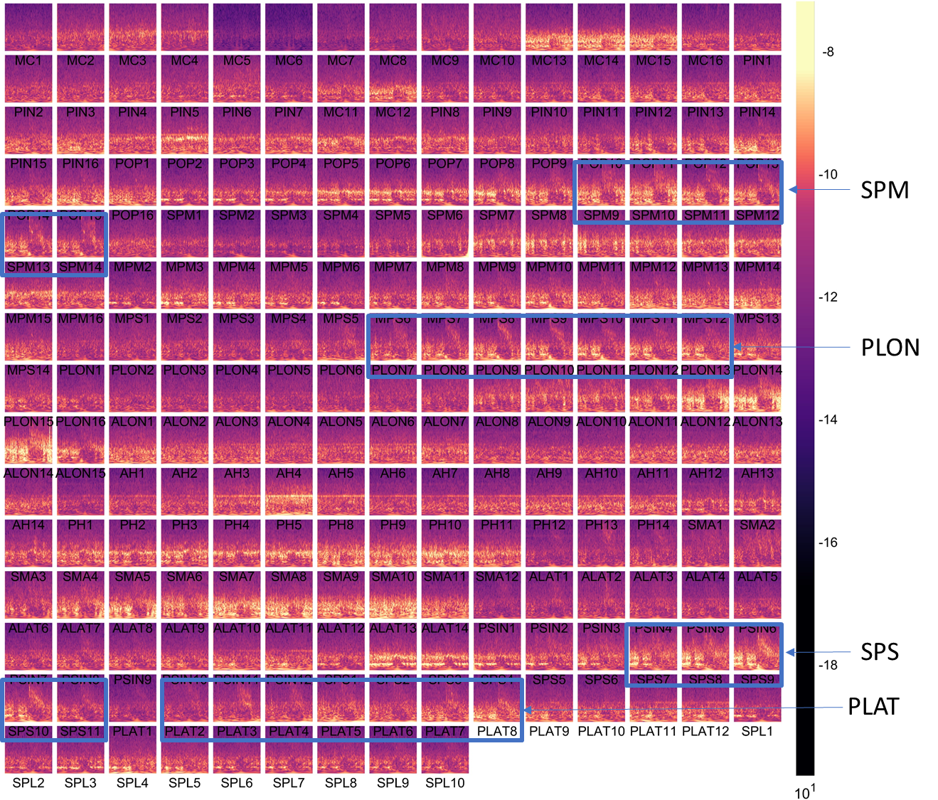
Supplementary Figure

Supplementary Figure 1: Seizure Fingerprint – sensor level

