Tutorial for SWAT+ MODFLOW

Dr. Ryan Bailey
Dept. of Civil and Environmental Engineering
Colorado State University
January 2025
Email: rtbailey@colostate.edu

Introduction
This tutorial guides the user through the preparation and simulation of a coupled SWAT+ MODFLOW hydrologic model. SWAT+ simulates land surface, soil, and channel hydro-chemical processes, whereas MODFLOW simulates aquifer hydrological processes. This tutorial has the following sections:

- Overview of SWAT+ MODFLOW (p. 4)

- Geographic linkage between SWAT+ objects and MODFLOW grid
2.1 Recharge to water table and Groundwater Soil transfer (p. 5-9)
2.2 Groundwater ET (p. 10)
2.3 Groundwater-channel exchange (p. 11-13)
2.3 Groundwater pumping for irrigation and municipal demand (p. 14-15)
2.5 Groundwater-canal exchange (p. 16-18)
2.6 Groundwater-drain outflow (p. 19-20)
2.7 Groundwater-reservoir exchange (p. 21)

- Preparing and modifying SWAT+ and MODFLOW input files
3.1 Modification to SWAT+ files (p. 22)
3.2 Modification to MODFLOW files (p. 23-28)

- SWAT+MODFLOW code structure (p. 29)

- Running a SWAT+ MODFLOW simulation
5.1 Assemble model input files (p. 30)
5.2 Run SWAT+MODFLOW simulation (p. 31-32)
5.3 Troubleshooting (p. 33)

- Viewing SWAT+ MODFLOW simulation results
6.1 SMRT output files (p. 34)
6.2 Groundwater fluxes (p. 35-40)
6.3 Groundwater head (p. 41)

- Model calibration using PEST (p. 42-44)

- Global sensitivity analysis for SWAT+MODFLOW (p. 45-46)

To use this tutorial, the user must have the following:
- Working SWAT+ model, with shape files for HRUs, channels, and subbasins.
- Working MODFLOW, with shape file for the grid.
The steps for linking, preparing all necessary input files, viewing results are provided using existing SWAT+ and MODFLOW models for the John Martin Reservoir (JMR) watershed, a 9,990 km² irrigated watershed within the Arkansas River Valley of southeastern Colorado. See maps on the next page. The JMR watershed has been irrigated for over 140 years, with irrigation being drawn from 1) the Arkansas River through an extensive network of earthen irrigation canals and 2) the underlying alluvial aquifer. There are 5,100 fields, the majority of which are irrigated. Both flood irrigation and sprinkler irrigation are practiced in the watershed. The following major hydrologic processes and fluxes occur in the watershed, and will be simulated using SWAT+ MODFLOW:
- Surface runoff from rainfall and irrigation
- Infiltration, deep percolation, and recharge
- Crop Evapotranspiration
- Streamflow in the Arkansas River and its tributaries
- Canal diversions from the Arkansas River
- Seepage from canals to the aquifer
- Groundwater pumping
- Subsurface tile drainage
- Groundwater-channel exchange along the Arkansas River and its tributaries
- Groundwater-reservoir exchange

John Martin Reservoir (JMR) watershed:

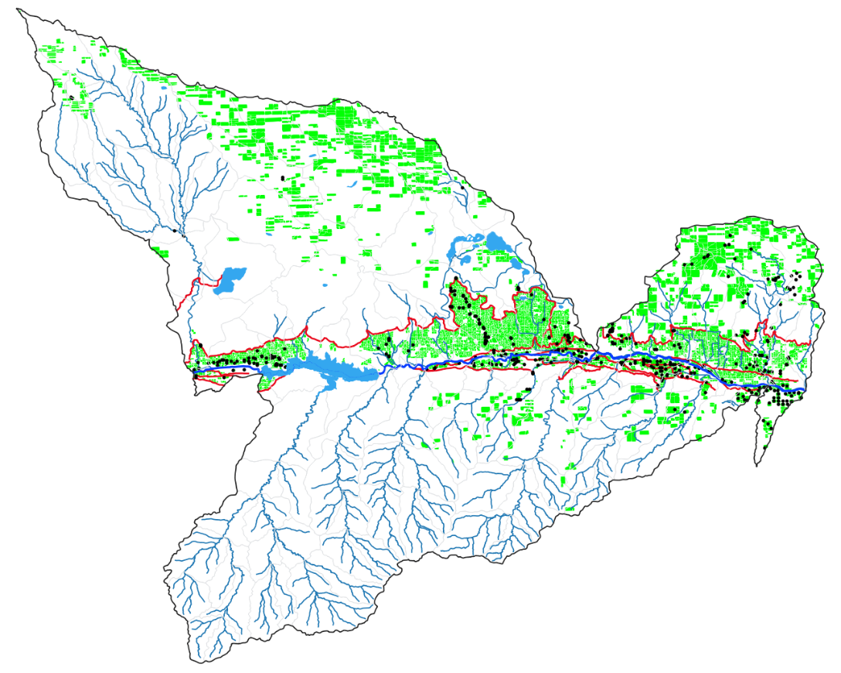
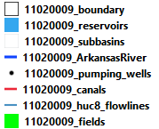

Geographic context for the JMR watershed:
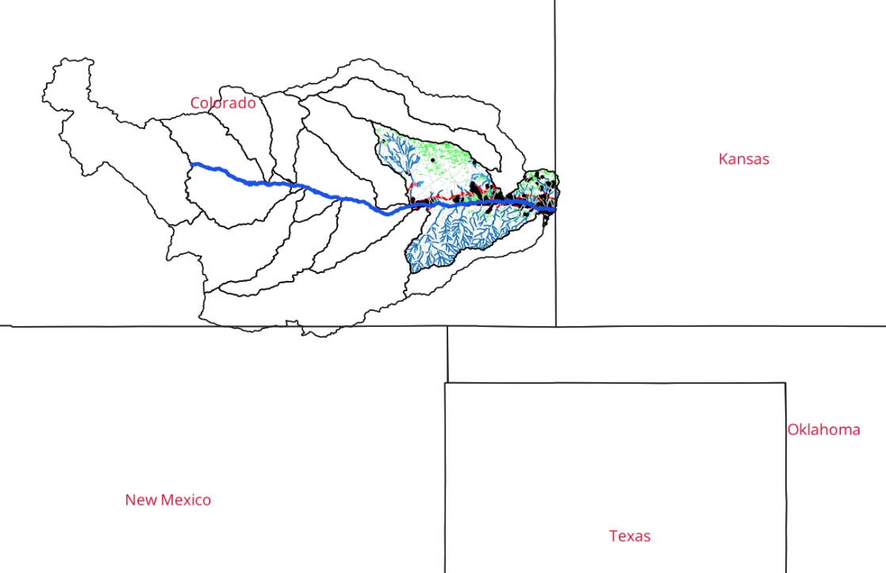

The JMR SWAT+ model has the following features:
- 10,611 HRU objects
- 135 Reservoir objects
- 110 point sources
- 101 routing units and outlets
- 1,324 channels

The JMR MODFLOW model has the following features:
- 500 m grid cells, resulting in 311 rows and 280 columns
- Recharge package (deep percolation from HRUs)
- Evapotranspiration package (ET from shallow groundwater in the plant root zone)
- River package (stream channels and canals)
- Well package (pumping for irrigation)
- Drain package (tile drainage outflow to channels)
- Reservoir package (groundwater-reservoir exchange)

This tutorial will use the following GIS shape files to perform the linkage between SWAT+ and MODFLOW. These are contained in the “gis” folder of the tutorial.
- SWAT+ HRU shape file: 1102009_fields.shp
- SWAT+ channel shape file: 11020009_huc8_flowlines.shp
- SWAT+ boundary: 11020009_boundary.shp
- SWAT+ reservoirs: 11020009_reservoirs.shp
- MODFLOW grid: modflow_grid.shp

1. Overview of SWAT+ MODFLOW

SWAT+MODFLOW is a single Fortran code that integrates MODFLOW-NWT (Niswonger et al., 2011) into the SWAT+ code (version 61.0). There are 13 subroutines written to link SWAT+ objects to MODFLOW grid cells, perform hydrologic flux calculations, and write out results to output files.

The following diagram summarizes the hydrologic fluxes and nutrient loads simulated by SWAT+ (black text) and MODFLOW (blue text).

Within the SWAT+MODFLOW code, the subroutines used to link SWAT+ and MODFLOW are given the prefix “smrt” (swat-modflow-rt3d). The linkage input files and the output files specific to MODFLOW are also given the prefix “smrt”. This term is used throughout this manuscript to indicate the new parts of the code. “RT3D” refers to an add-on module for nutrient transport in the aquifer system, and will be included in a second version of this tutorial.

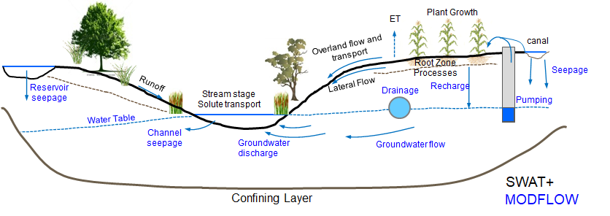
Figure 1. Cross-section of watershed, showing fluxes simulated by SWAT+ and MODFLOW.

The groundwater fluxes, the SWAT+ objects to which they are linked, the corresponding MODFLOW package that simulates the flux, the input file that contains the linkage information, and the flux abbreviation used in inputs and outputs, is summarized as follows. More details for each flux are provided in Section 2.

Groundwater flux SWAT+ object MODFLOW Input file Abbreviation for
Package input/output

Recharge to water table HRUs Recharge smrt.hrucells rech
GW to soil profile HRUs Recharge smrt.hrucells soil
GW-channel exchange Channels River smrt.chancells gwsw
GW pumping for irrigation HRUs Well water_allocation.wro pump
GW-canal exchange Channels River smrt.canalcells canl
GW-drain outflow Channels Drain smrt.drngcells drng
GW-reservoir exchange Reservoirs Reservoir smrt.resvcells resv

2. Geographic linkage between SWAT+ objects and MODFLOW grid

This section provides details for linking SWAT+ objects to MODFLOW grid cells, to allow for correct simulation of all major hydrologic fluxes in the watershed-aquifer system. All geographic connections are performed using GIS.

2.1 Recharge to water table and GroundwaterSoil transfer

Overview: Recharge
Recharge to the water table originates from deep percolation that exits the bottom of the soil profile. Deep percolation and recharge are first calculated for each HRU, and then transferred to the MODFLOW grid for the Recharge package.

The following figure (A) shows an example soil profile of an HRU, with 4 layers. Deep percolation water exits the bottom of the soil profile and is routed through the vadose zone to the water table, to simulate recharge to the saturated zone.
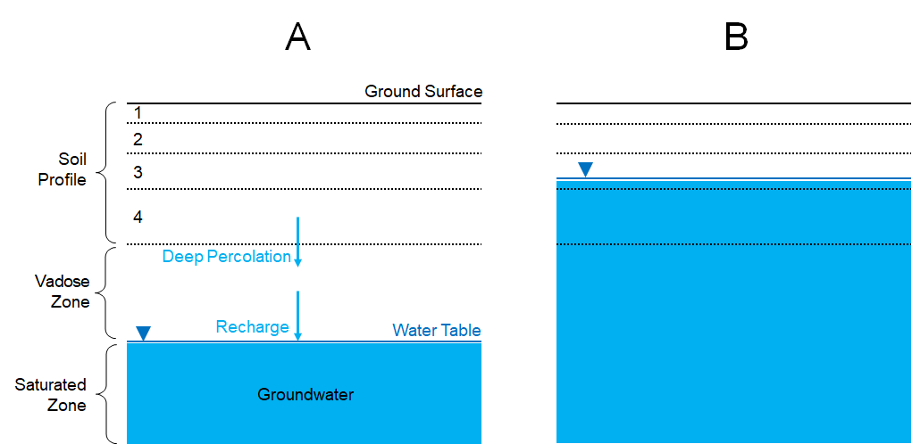

Figure 2. (A) process of deep percolation and recharge in a coupled soil-aquifer system; (B) condition of water table within the HRU soil layers.

Routing through the vadose zone is not simulated in a physically based manner, but rather using the following transfer function:

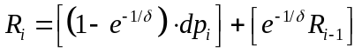

where dp_{i} is the depth (mm) of deep percolation for the current day i, R is the recharge from the previous day (i-1) and the current day i, and δ is the recharge delay term (days). The term on the left is the recharge from the current day’s deep percolation, and the term on the right is the recharge from the previous day’s deep percolation. The transfer function spreads out the recharge temporally, so that portions of the deep percolation water reach the water table at different times. The following figure shows two deep percolation events (5 mm, 8 mm), and the resulting recharge to the water table using a delay term of 5 days. The total recharge over the 30-day period is equal to total deep percolation (13 mm) but is spread out temporally.

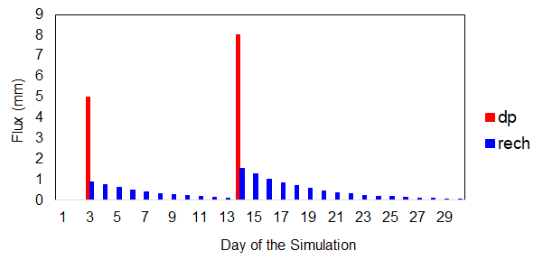

Once daily recharge is calculated for each HRU, the amount of recharge (m³/day) to each MODFLOW individual grid cell R_{cell} is calculated by summing the contribution from all intersecting HRUs:

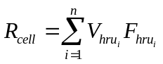

where V_{hru} is the daily volumetric flow rate of recharge (m³/day) for the i^{th} HRU connected to the grid cell, and F_{hru} is the fraction of the i^{th} HRU that is occupied by the cell.

For example, the following figure shows the geographic intersection between cell 49174 and 3 HRUs, highlighted in yellow (6908, 7011, 7012). The area of each HRU is 412,200 m², 85,500 m², and 234,900 m², respectively. The overlapping area between the cell and each HRU is 134,080 m², 39,275 m², and 31,211 m², respectively, resulting in HRU fractions of 0.325, 0.460, and 0.133, respectively.

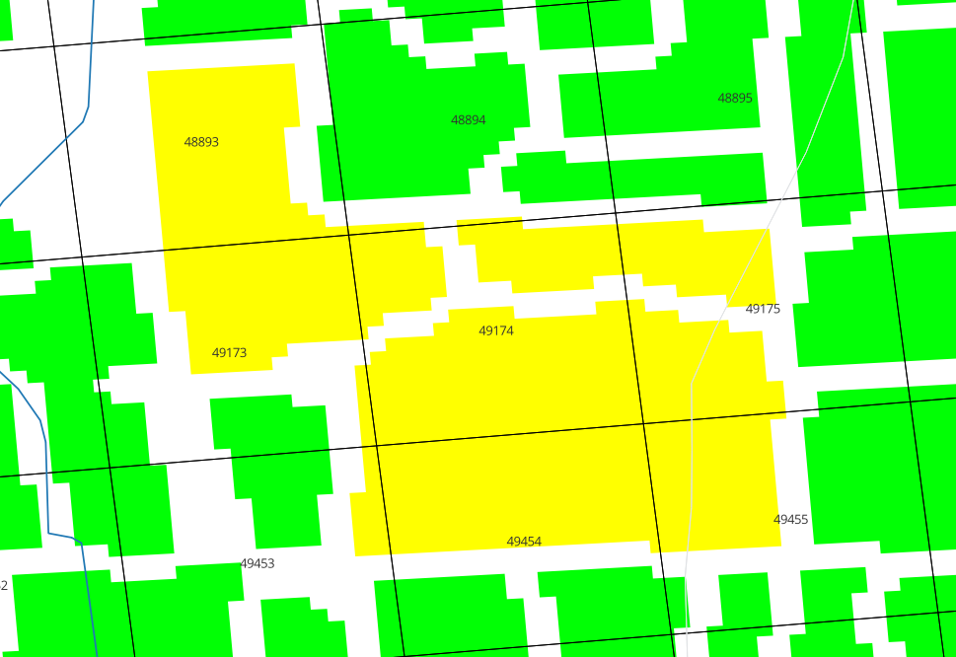
6908
7011
7012
Figure 3. Geographic connection with MODFLOW grid cells and SWAT+ HRUS.

Therefore, if 5 mm of recharge is simulated for each HRU on a given day during the simulation, then the recharge to cell 49174 is calculated as:

Recharge volume for HRU 6908 = (5 mm/1000) * 412,200 m² = 2,061 m³
Recharge volume for HRU 7011 = (5 mm/1000) * 85,500 m² = 428 m³
Recharge volume for HRU 6908 = (5 mm/1000) * 234,900 m² = 1,175 m³

R_{cell} = (2,061 m³ * 0.325) + (428 m³ * 0.460) + (1,175 m³ * 0.133) = 1,023 m³

Therefore, for this day, the recharge to cell 49174 is 1,023 m³. This same process is repeated for each cell of the MODFLOW grid.

Overview: GroundwaterSoil Transfer
In some environments and hydrologic conditions, the water table can rise into the soil profile (see Figure 2B). This can occur during high-intensity storm events, or irrigation events in areas with inadequate drainage. Groundwater transfer to the soil profile can lead to increased soil lateral flow, tile drainage, saturation excess flow, and plant ET. The water can also recharge back to the water table. We would like the soil water routing routines of SWAT+ to handle this additional soil water. To do so, the code tracks, for each grid cell, the location of the water table in relation to the soil profile. If the water table is within the soil profile, then the groundwater (and associated nutrient mass) within the soil profile is removed from the grid cell and transferred to the HRU soil profile. The volume of groundwater (m³) is added to the soil water within the soil layers below the water table.

If the water table (i.e., groundwater head) is within the HRU soil profile, then the volume of groundwater V_{gw} to transfer to the soil profile is:

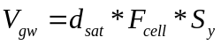

where d_{sat} is the depth of soil profile saturated by the water table (m) (i.e., the vertical distance from the water table to the base of the soil profile), F_{cell} is the area of the cell the resides spatially in the HRU (m²), and S_{y} is the aquifer specific yield. This volume is then added to the soil storage array of the soil layers based on the fraction of the layer that is saturated.

Input file
To simulate the mapping of HRU deep percolation and recharge MODFLOW grid cells and the transfer of groundwater to the HRU soil profile, the geographic intersection information between HRUs and grid cells must be performed in a GIS and then stored in the input file smrt.hrucells. The example file for the JMR model is in the JMR_TxtInOut folder.

The first section of the file is the specification of the groundwater delay term δ. The term can be specified for each HRU (as a single-column list), or as a single value that is then applied to each HRU in the model. For the JMR model, a single value (flag = 0) of 5.0 is specified. If the flag = 1, then a list of HRU values is needed.

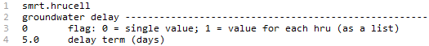

The second section of the file is the specification of groundwater-soil interaction. The user can specify if the groundwater-soil transfer feature is active or inactive, by changing the flag in the second section of the smrt.hrucells file:

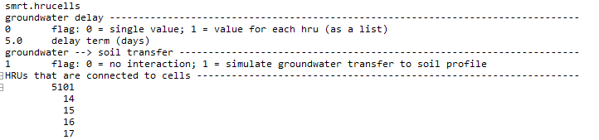

The third section of the file lists the HRUs that are in connection with MODFLOW grid cells. This is provided, as some HRUs may not be in geographical connection with the grid. For the JMR model, 5,101 of the 10,611 HRUs are in connection with grid cells. Typically, if the grid overlays the entire watershed, each HRU will be in connection with grid cells. The fraction is lower for the JMR model because only cultivated fields are considered as HRUs that are in connection with grid cells.

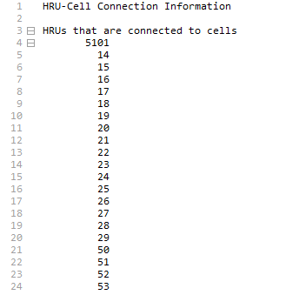
List of HRU IDs
Number of HRUs
The fourth section of the file lists, for each HRU in connection with grid cells, the connected grid cells and their overlapping area (m²). For example, HRU 14 is connected to 6 grid cells (13175, 13176, 13455, 13456, 13457, 13458). The total HRU area is 427,500 m², and the overlapping areas are provided, ranging from 9,480 m² to 139,332 m². This information is needed to calculate recharge to the grid cells, as described above.

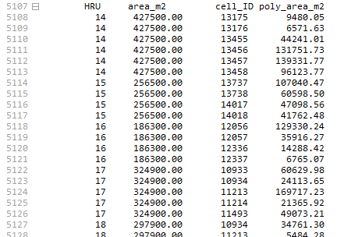

Continues for all 5,101 connected HRUs…

2.2 Groundwater ET
ET from the saturated zone is simulated using the EVT package of MODFLOW. Groundwater ET is calculated only if the water table in a grid cell is above a specified elevation z_{bot} (m), calculated by subtracting a specified ET extinction depth EXDP (m) (i.e. the depth below which ET cannot occur) from the ground surface z_{surf} (Figure 4). The maximum depth of ET that can be removed from the saturated zone is equal to the unsatisfied ET ET_{remain} (mm), set equal to the difference between the potential ET (mm) and the actual ET (mm) simulated for each HRU for the day. The connection between HRUs and grid cells for mapping unsatisfied ET is the same as for mapping soil percolation to grid cell recharge.

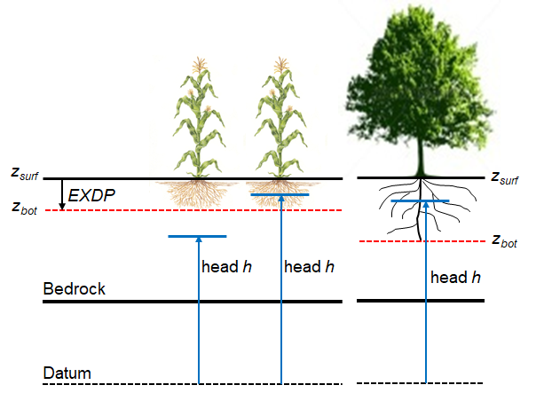
Figure 4. Schematic showing calculation of groundwater ET within the extinction depth EXDP.

The depth of groundwater ET (mm) removed from the cell is calculated using the following linear relationship:
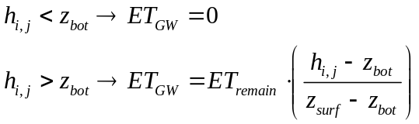

The depth of groundwater ET is multiplied by the horizontal spatial area of the HRU to provide a volumetric flow rate in m³/day, and then divided amongst the cells connected to the HRU. This groundwater volume is removed from the grid cell. Figure 4 shows the scenario of the ET equations within the context of the variables. For the row crop (corn as an example), the condition on the left results in no groundwater ET, whereas the condition on the right would result in groundwater ET equal to approximately half of ET_{remain}. For the tree, the condition would result in groundwater ET equal to more than half of ET_{remain}. Groundwater ET can be significant for areas with high water tables and deep-reaching vegetation roots, such as in riparian areas of streams.

Simulating groundwater ET occurs if the EVT package of MODFLOW is activated. This is described in Section 3.2.

2.3 Groundwater-channel exchange
Exchange of water between the aquifer and stream channels is simulated using the River package of MODFLOW. Within the River package, Darcy’s Law is used to calculate the daily volumetric flow rate Q (m³/day) of exchange by comparing the groundwater head (h_{gw}) in the grid cell to the stream stage (h_{stream}) in the channel. If the groundwater head is higher than the stream stage, then groundwater discharges through the channel bed into the channel. If, however, the groundwater head is lower than the stream stage, then stream water seeps through the channel bed into the aquifer. There are three conditions that might occur:

h_{gw} > h_{stream}: 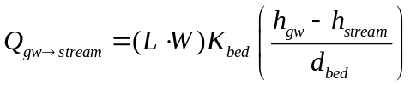

h_{stream} > h_{gw} (h_{gw} above channel bottom) 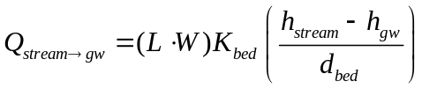

h_{stream} > h_{gw} (h_{gw} below channel bottom bot_{bed}) 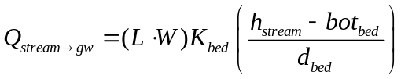

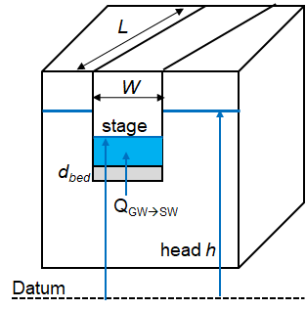
Figure 5. Schematic showing relation between channel water and groundwater within a MODFLOW grid cell. W = channel width; L = length of channel within the MODFLOW grid cell; d_{bed} = channel bed thickness.

For these calculations:

- W is provided by daily simulated width of the corresponding SWAT+ channel
- h_{stream} is provided by daily simulated depth of the corresponding SWAT+ channel
- h_{gw} is provided by daily simulated groundwater head of the corresponding MODFLOW grid cell
- K_{bed} is provided by MODFLOW inputs
- d_{bed} is provided by MODFLOW inputs
- bot_{bed} is provided by MODFLOW inputs
- L is provided by a geographic intersection between SWAT+ channels and MODFLOW grid cells

The geographic intersection between SWAT+ channels and MODFLOW grid cells is shown by the following figure, where yellow cells are those in connection with SWAT+ channels.

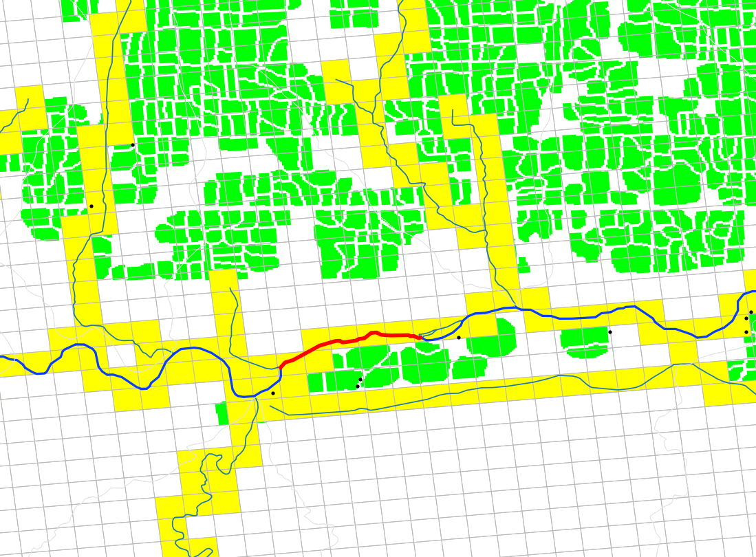
Figure 6. MODFLOW grid cells (yellow) in connection with SWAT+ channels.

The channel highlighted in red (channel #497) is along the Arkansas River and is in connection with 7 grid cells. Through an intersection routine within GIS, the length L of the channel within each of the grid cells is 428 m, 532 m, 562 m, 513 m, 131 m, 525 m, and 119 m. The length of the channel within the grid cell is directly proportional to the area of channel bed in connection with the aquifer, and therefore is a strong control on the amount of water that can be transferred between the aquifer and the channel (see Darcy’s Law equations on previous page). The same intersection must be performed for all channels within the SWAT+ model. This can be performed by intersecting the SWAT+ channel shape file with the MODFLOW grid shape file. Then, the length of each channel segment must be calculated within GIS.

Note: if SWAT+ is linked with MODFLOW, then the regular channel seepage calculation with the channel control subroutine is not used. Therefore, the hydraulic conductivity of channel bed sediments as listed in the SWAT+ input files is not used.

The geographic connections between SWAT+ channels and MODFLOW grid cells are listed in the file smrt.chancells. Channel bed properties for Darcy’s Law are also listed in this file.

For the JMR model, the beginning of the file is shown below. For each MODFLOW grid cell in connection with a SWAT+ channel, the cell layer is specified, followed by channel bed elevation (m), the connected SWAT+ channel, the length of the channel within the cell, and the channel bed zone. The list of zones is shown at the beginning of the file, with the estimated channel bed hydraulic conductivity (m/day) and thickness (m) for each zone. When the model simulation begins, these parameter values are assigned to grid cells based on the zone specified for each cell. Channel bed zones are used to reduce the number of channel bed parameters included in model calibration. Rather than using one parameter value for each grid cell, values are specified only for zones.

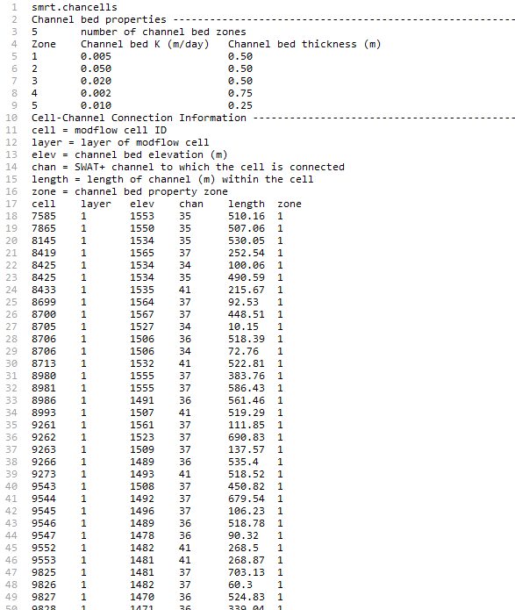

The number of grid cells listed in this file (7,934 for the JMR model) is specified in the object.cnt input file, as the number of MODFLOW objects. This is described further in Section 3.1.

2.4 Groundwater pumping for irrigation and municipal demand
For a standard SWAT+ model, the water allocation module can be used to control water transfer between SWAT+ objects for water demand conditions. Water demand can include irrigation for HRUs or municipal demand. Sources of water for these demands can include channels, reservoirs, aquifers, or unlimited. For the JMR model, HRUs receive irrigation water from channels (via canal diversions), groundwater, and unlimited (canals that divert water upstream of the watershed boundary).

Irrigation Demand
If SWAT+MODFLOW is being used, and the irrigation source is specified to be “aquifer”, then MODFLOW will simulate groundwater pumping to satisfy the irrigation demand. Irrigation will only occur if sufficient groundwater is available in the grid cell. If the irrigation demand is greater than the available groundwater in the cell, then all groundwater is removed to satisfy a portion of the demand.

There are two options for specifying the grid cells that provide the pumped irrigation water: 1) a single cell is specified; 2) all grid cells connected to the demand HRU (using connections in smrt.hrucells) are used to satisfy the demand.

There are three files that are used to simulate irrigation: water_allocation.wro, lum.dtl, and irr.ops. These are provided in the JMR model folder, and the following shows examples from this model.

Within the water_allocation.wro file, there are 6 source objects (unlimited, aquifer, canal diversions) and 3,920 demand objects (HRUs for irrigation). Each demand object has 1 source object (SRCS). For HRU 16, the source object (SCRC1) is listed as “2”, which corresponds to the 2nd source object, which is “aqu”. If MODFLOW is active, then “aqu” indicates a groundwater source, and pumping will occur from MODFLOW grid cells. If the OB_NUM value for “aqu” is equal to 0 (as in this case), then all grid cells connected to HRU 16 will undergo pumping, with the HRU irrigation demand volume divided equally among the grid cells. If, however, the OB_NUM value was given a value > 0, then this value is the ID of the grid cell from which pumping should occur. In this second case, pumping will occur only from a single cell, and the cell-HRU connections in smrt.hrucells are not used.

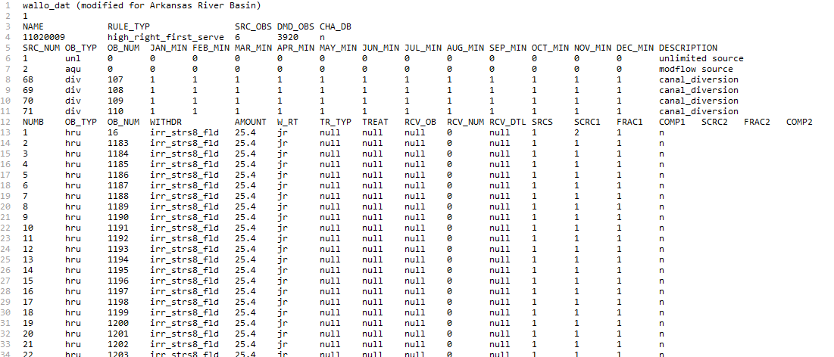

Irrigation demand (depth = AMOUNT = 25.4 mm for this model) occurs based on the decision table(s) listed under the “WITHDR” column. In this model, the decision tables are irr_strs8_fld (flood irrigation) and irr_strs8_spk (sprinkler irrigation), depending on the HRU. These decision tables are listed in the file lum.dtl, which contains all land use decision tables. The decision tables irr_strs8_fld and irr_strs8_spk have the following form:

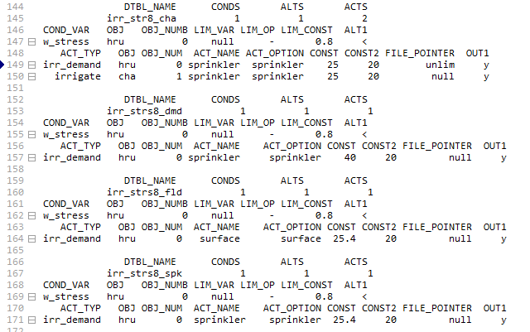

For both decision tables, the conditional variables (COND_VAR) is “w_stress”, which represents soil water stress. The test condition (LIM_CONST) is 0.8, indicating that irrigation will occur if water stress is less than 0.8. If irrigation is triggered, then the irrigation runoff ratios from the file irr.ops are used:

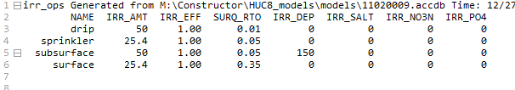

Because the irr_strs8_fld table has the ACT_OPTION = “surface”, then the runoff ratio SURQ_RTO applied to each irrigation event is 0.35, typical of flood irrigation. Because the irr_strs8_spk table has the ACT_OPTION = “sprinkler”, the runoff ratio is 0.05, typical of sprinkler irrigation.

Municipal Demand
For municipal demand (OB_TYP = “muni”), the same two options are available

- Pumping from single cell: if the “aqu” source is used, then groundwater pumping will occur from a single cell if the OB_NUM value for “aqu” is provided with the MODFLOW cell ID.

- Pumping from multiple cells: this will occur if “aqu” source is used, OB_NUM for “aqu” is set to 0, and the OB_NUM for “muni” is set to an HRU number. In this case, groundwater pumping to satisfy the municipal demand will occur in all cells connected to the specified HRU.

2.5 Groundwater-canal exchange
Earthen irrigation canals often seep water to the underlying unconfined aquifer. They can also receive groundwater if the water table is higher than the canal stage. In SWAT+MODFLOW, this exchange is simulated using MODFLOW’s River package. The exchange rate (m³/day) is calculated using Darcy’s Law, for each MODFLOW grid cell in geographic connection with an irrigation canal:

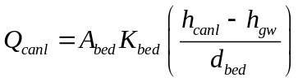

where:
- A_{bed} = the area of the canal bed in contact with the aquifer, within the grid cell (m²) = the width of the canal (m) * the length of the canal in the grid cell (m)
- K_{bed} = the hydraulic conductivity of the canal bed material (m/day)
- h_{canl} = the head (stage) of the canal water (m)
- h_{gw} = the head of groundwater in the grid cell (m)
- d_{bed} = the thickness of the canal bed material (m)

These values must be determined for each grid cell in connection with an irrigation canal. For the JMR model, there are 17 canals (red lines in map below). When intersected with the MODFLOW grid, there are 1,277 grid cells that are designated as “canal cells” (green cells in map), and for which the exchange rate is calculated. The length of the canal in the grid cell can be found from the intersection results. The exchange rate should be calculated only when there is water in the irrigation canal. For the JMR model, this is between April 1 and October 15 of each year.

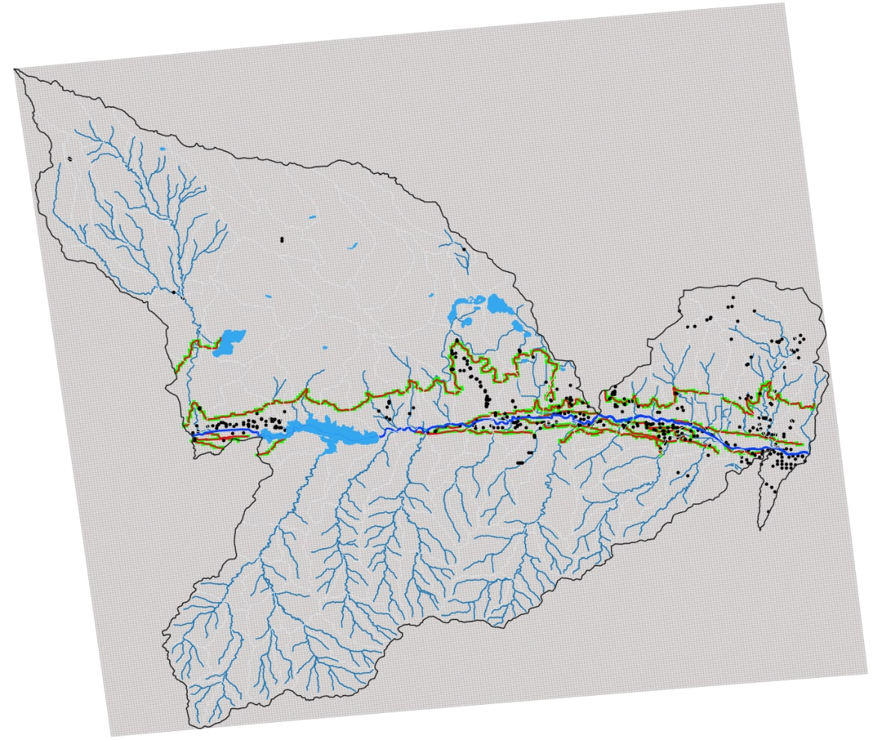

This map shows a close-up of several of the irrigation canals (red lines), intersected with the MODFLOW grid. The “canal cells” are highlighted in green.

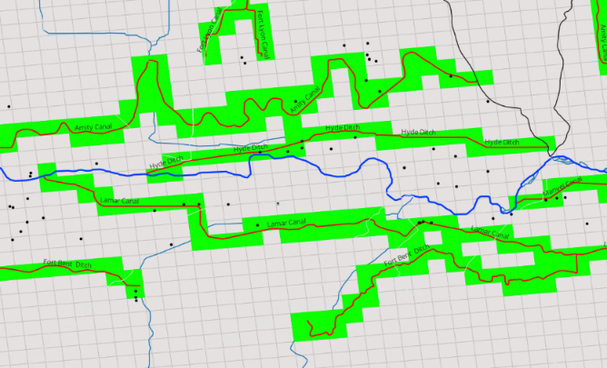

To simulate canal-groundwater exchange in SWAT+MODFLOW, the River package must be active. The specified maximum number of River Cells in the modflow.riv file must be equal to the River Cells from the channel intersection + River Cells from the canal intersection. For the JMR model, this is 7,934 + 1,277 = 9,211.

The smrt.canalcells input file contains information for canals and the geographic connection between canals and grid cells. The information for each canal is listed first, followed by the canal-cell connections. The parameters canal information table (width, depth, thickness, bed_K) can be used as calibration parameters.

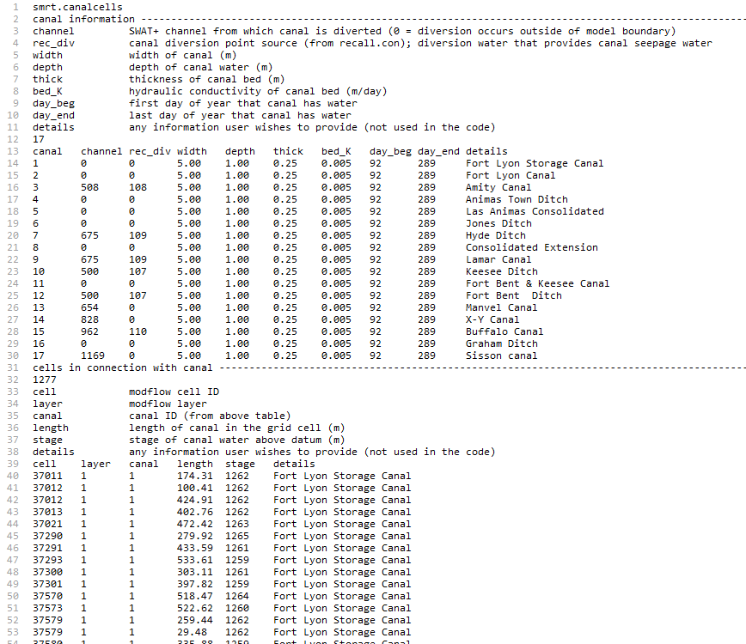

The rec_div column in the first table indicates the point source (if any) of the canal diversion. If there is a point source (negative, for flow out of the channel) in the model associated with this canal diversion, then the “rec_div” number is the point source ID listed in the recall.con file. When canal seepage is simulated, then this seepage volume will be provided by the water already diverted to the canal from the channel source. For example, canal 3 (Amity Canal) has “rec_div” = 108. This corresponds to the point source ID 108, listed in recall.con, as see in the following image of the bottom of the recall.con file:

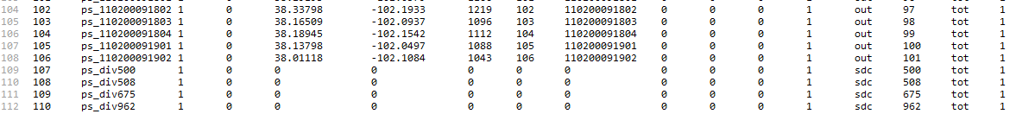

Point source 108 (ps_div500) diverts water from channel (sdc) 500. In the recall.rec file, this point source has an associated input file div_500_ps.dat, which contains the daily diversions (negative values; m³) from channel 500. This water is used for irrigation, using the water allocation module. When using the groundwater-canal exchange option, i.e., using the input file smrt.canalcells as shown in this section, then seepage to the aquifer will be taken from the volume of water diverted into the canal. If groundwater discharges water to the canal, then this volume will be added to the volume of water diverted into the canal, which can then be used for irrigation in downstream areas.

2.6 Groundwater-drain outflow
Subsurface drains (“tiles”) are often placed in agricultural landscapes to drain excess soil water and groundwater. SWAT+ has a tile drainage routine. While this routine removes excess soil water, drainage should also occur if groundwater rises to the level of the drains. This can be simulated in SWAT+MODFLOW using MODFLOW’s drain package. Within the package, groundwater head is compared to the drain elevation; if the head is higher than the drain, then groundwater is removed via the drain. With new SWAT+MODFLOW linkage routines, this removed groundwater is transferred to SWAT+ channels for channel routing.

The groundwater-drain feature for SWAT+MODFLOW is activated using the Drain package of MODFLOW. The modflow.drn file is included, which specifies the number Drain cells. For the JMR model, there are 814 Drain cells. These are shown in the figure below.

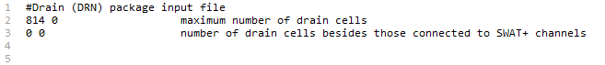

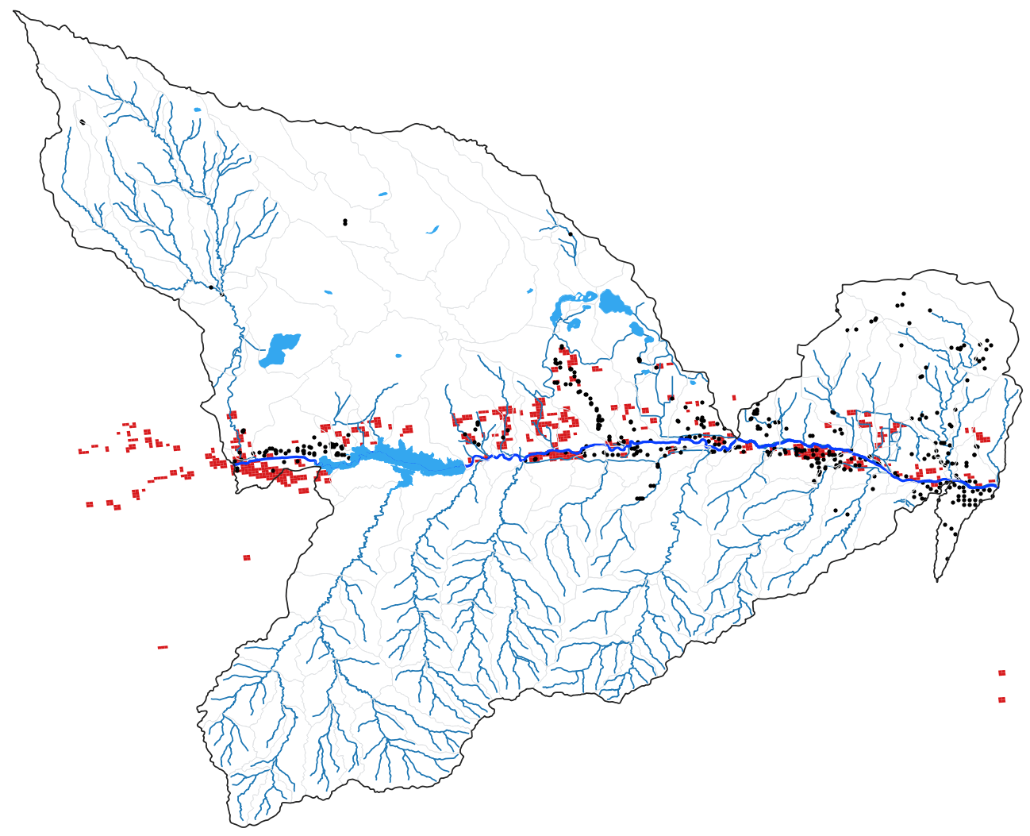

In the normal application of the Drain package for a MODFLOW simulation, the Drain package input file also includes Drain elevation and Drain material conductance for each Drain cell. However, in SWAT+MODFLOW, these inputs are included in the file smrt.drngcells along with cell-channel connections.

The first section of the file lists the conductance zones. The second section of the file lists the Drain cell, the layer of the cell, the depth (m) of the drain from the ground surface, the SWAT+ channel to which drainage water is transferred, and the conductance zone. For the JMR model, the channel was determined by proximity to the Drain cell.

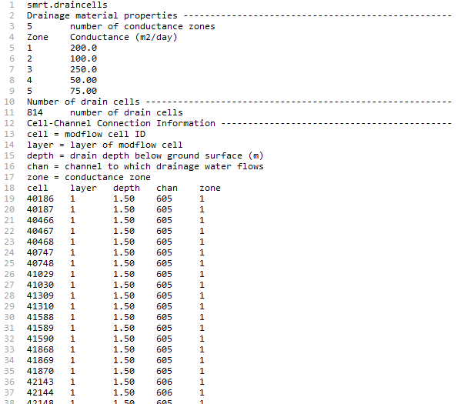

2.7 Groundwater-reservoir exchange
Water can be exchanged between reservoirs and an underlying unconfined aquifer. Within SWAT+MODFLOW, this exchange can occur between reservoirs objects and MODFLOW grid cells, using MODFLOW’s Reservoir package. The MODFLOW reservoir package input file is not needed. Instead, reservoir information and MODFLOW cell connections are provided in the file smrt.resvcells. The reservoir package uses Darcy’s Law to calculate the transfer of water from the aquifer to the reservoir, or from the reservoir to the aquifer, depending on their relative position. For each daily time step of the simulation, the reservoir stage is updated using the simulated reservoir depth of the reservoir object. If MODFLOW is active, then the original seepage calculation in the reservoir control subroutine is not used.

In the JMR model there are 302 MODFLOW grid cells that are connected to reservoir objects. For each cell, the connected reservoir object, stage (m), depth (m), hydraulic conductivity (m/day), and bed thickness (m) are listed.

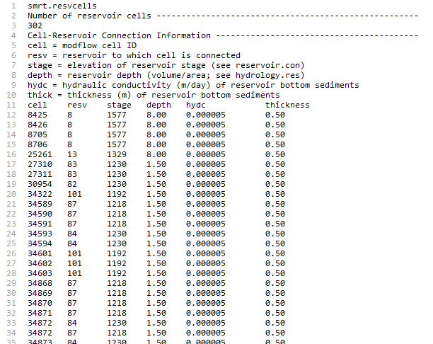

3. Preparing and modifying SWAT+ and MODFLOW input files

Besides the smrt linkage files described in Section 2, there are several changes that must be made to the original SWAT+ files and MODFLOW files.

3.1 Modification to SWAT+ files
Three files need modification when running SWAT+MODFLOW:

codes.bsn: this file contains flags to turn on/off certain features in SWAT+. The last column is “modflow”. Set the value to 1 to turn on SWAT+MODFLOW.

object.cnt: this file specified the number of objects for each object type. The “modflow” number should be set to the number of River cells listed in the smrt.chancells file. For the JMR model, this is 7,934. Notice that the number of aquifer objects (AQU) is set to 0, since the original aquifer module is not active when MODFLOW is being used.

file.cio: this file specifies all files used in the SWAT+ model. For a typical SWAT+ simulation, the aquifer module is active, and therefore the file “aquifer.con” is listed in the 6th column of the “CONNECT” line. However, for SWAT+MODFLOW, a new placeholder for the MODFLOW connect file (modflow.con) is included on this line. Since the original aquifer module is not active, the name in the 6th column is set to “null”, and instead “modflow.con” is written in the 5th column. With this set-up, the SWAT+ code knows to look for the modflow.con., which is written to file when the smrt_chancells file is read. Therefore, the user does not need to create a modflow.con file but can view it in the model folder once the model is running.

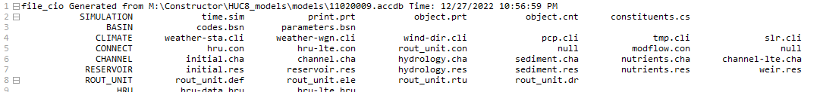

Note about rout_unit.con: The routing unit connect file contains connection information between routing units and other SWAT+ objects. For a typical SWAT+ model (e.g., created using QSWAT+), aquifer recharge is connected routing units, using “aqu” for the object type and “rhg” for the hydrograph type. For SWAT+MODFLOW, however, the original aquifer module is not used, and this “aqu” connection in rout_unit.con should be removed. However, the SWAT+ code has been modified to eliminate this connection if MODFLOW is active. Therefore, no changes to the rout_unit.con are needed.

3.2 Modification to MODFLOW files
MODFLOW uses one input file for each active package: the river package has one input file, the drain package has one input file, and so on. The MODFLOW files are listed in the “name file” called modflow.nam. As such, this functions in the same way as the file.cio file for SWAT+. You can see this file in the JMR model folder.

Several of the MODFLOW files are used in the same manner as in original MODFLOW simulations. Other files are modified for use in SWAT+MODFLOW. This section provides details for all necessary files.

Name file (modflow.nam)
The name file lists all files used in a MODFLOW simulation. For stand-alone MODFLOW simulations, the user can provide any file name for the name file. However, for SWAT+MODFLOW simulations, the code has been modified so that the file name modflow.nam must be used. Below is the modflow.nam file for the JMR model, with red text provided only as description in the figure and is not in the actual file. The user decides the name for each input file.
The boxed files are those required for SWAT+MODFLOW simulations. The output files are:
- modflow.out: main MODFLOW output, containing solver progress and water balance summaries. If the SWAT+MODFLOW simulation stalls or stops, this file should be checked to see if there is a convergence issue with MODFLOW. There will be a message at the bottom of the file stating that convergence is not achieved.
- modflow.hed: simulated groundwater head for each grid cell for time steps specified in the output control *.oc file.
- modflow.ccf: binary file containing flow rate and head data for each grid cell; typically only used for post-processing MODFLOW software such as GMS, Groundwater Vistas, or VisualMODFLOW.

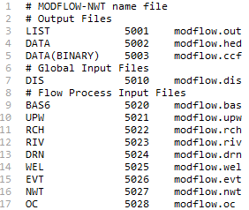
Output control
Newton solver
Evapotranspiration package
Well package (groundwater pumping/injection)
Drain package
River package
Recharge package
Upstream Weighting package (aquifer properties)
Basic package (active cell array; initial head values)
Discretization (grid, timesteps)

The integers next to each package (e.g., 5022 for the Recharge package) are file index identifiers used by the MODFLOW code. These numbers are often below 100 for stand-alone MODFLOW simulations. However, as each input/output file in the SWAT+MODFLOW simulation must have a unique number, the MODFLOW input and output files are given numbers > 5000 so as not to coincide with numbers already provided to the SWAT+ input files. Therefore: always check the numbers in the modflow.nam file to make sure they are above 5000.

Discretization package
The Discretization file (modflow.dis for the JMR model) contains all information for spatial (grid cell size and layering) and temporal (time steps, stress periods) discretization. Instructions for preparing the Discretization input file is found at https://water.usgs.gov/ogw/modflow-nwt/MODFLOW-NWT-Guide/.

The first section of the file specifies the number of layers, rows, and columns, and the cell size (m).

The second section lists the top elevation (m) (e.g., ground surface elevation) for each grid cell, in 2D array format, followed by the array for the bottom elevation (m) of each grid cell; this is repeated for the number of layers in the MODFLOW grid. The JMR model has a single layer representing the unconfined aquifer. Top elevation for each grid cell was determined in GIS using a digital elevation model, spatial joined to the grid cell shape file. Bottom elevation was determine using an aquifer thickness data (https://data.isric.org/; search “Absolute depth to bedrock”).

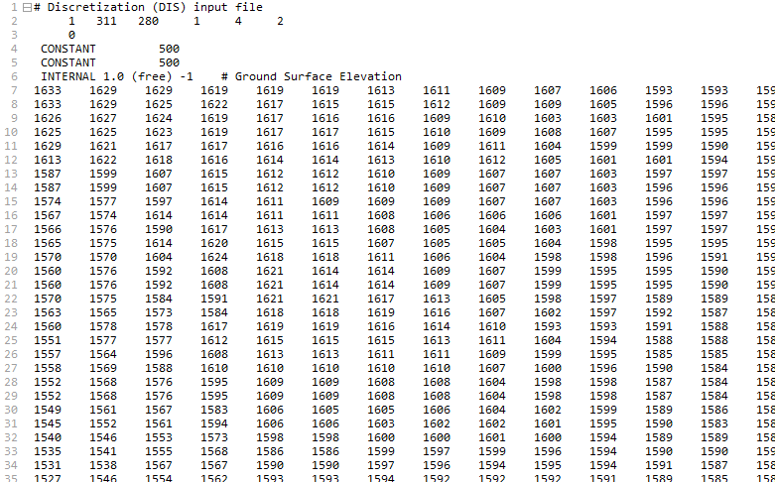
#layers, #rows, #columns, #stress periods, days, meters

The third section lists time step information. MODFLOW can be run in two settings: “steady-state” (SS) and “transient” (TR) (i.e., unsteady flow). For SWAT+MODFLOW, the “transient” option must be specified. This option is found at the bottom of the file, as shown in the diagram below. For SWAT+MODFLOW simulations, set the length of the stress period to at least the number of days in the SWAT+ simulation. This will result in daily time steps, to match the SWAT+ time step length.

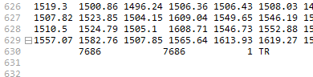
Length (days) of stress period; # of time steps in the stress period.

Output control
The output control input file (modflow.oc) contains instructions for MODFLOW to print groundwater head and water balance at specified times of the simulation. The groundwater head is written to the *.hed file specified in the modflow.nam file (modflow.hed) and the water balance data is written to the *.out file (modflow.out). Instructions for preparing the Output Control file is found at https://water.usgs.gov/ogw/modflow-nwt/MODFLOW-NWT-Guide/. Note: monthly and yearly averaged head values are written to other output files as part of the SWAT+MODFLOW code. See Section 6.

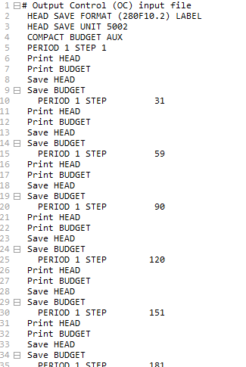
Head and water balance written on day 31 of the simulation
Head and water balance written on day 1 of the simulation
Integer must match the integer provided to modflow.hed in modflow.nam
Writes head values in a table with 280 columns; 10 spaces, with 2 decimal points

River package
For typical MODFLOW simulations, the properties (stage, bed conductance, bed elevation) of each River cell must be written in the river package file (modflow.riv), for each stress period of the simulation. In SWAT+MODFLOW simulations, however, these properties are specified in smrt.chancells. The only item needed in modflow.riv is the maximum number of river cells in the simulation, so that river package arrays can be sized properly. The number of river cells is the summation of cells intersected with SWAT+ channels and cells intersected with irrigation canals. For the JMR model, is 7,934 + 1,277 = 9,211.

The file structure is:

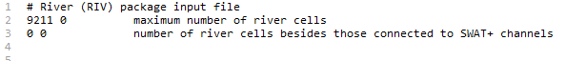

Recharge package
The Recharge package must be activated to enable recharge from SWAT+ HRUs to be mapped to the MODFLOW grid cells. Instructions for preparing the Recharge package input file is found at https://water.usgs.gov/ogw/modflow-nwt/MODFLOW-NWT-Guide/. In this example, the file is named modflow.rch. The file structure is:

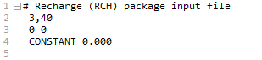

The “CONSTANT” signifies the rate (m/day) applied to each MODFLOW grid cell. This value is over-written by HRU recharge for each day of the simulation.

EVT package
Groundwater ET simulation is described in Section 2.2. The EVT package must be activated to enable ET from shallow groundwater. This ET is in addition to the ET from the soil profile as calculated for SWAT+ HRUs. Instructions for preparing the EVT package input file is found at https://water.usgs.gov/ogw/modflow-nwt/MODFLOW-NWT-Guide/. The file structure is:

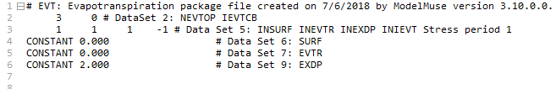
Extinction depth (m); depth below which no ET occurs.

Notice that the SURF and EVTR array values are set to 0.000. Within the SWAT+MODFLOW code, the SURF cell values (ground surface elevation) are given the elevation of the cells in the top layer, and the EVTR values (potential ET) are given the difference between potential ET and actual ET simulated by each SWAT HRU, with the HRU values mapped to the MODFLOW grid cells:

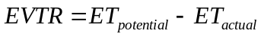

This residual ET can be removed from the saturated zone of the aquifer if the water table is above the extinction depth EXDP. The user can modify the value for EXDP. For this example, EXDP is set to 2.0 m below the ground surface, i.e., ET from groundwater cannot occur when the water table drops to below 2.0 m from the ground surface. If ET from shallow groundwater is not desired in the simulation, then the user should set EXDP to 0.00.

Well package
Groundwater pumping for irrigation and municipal water supply is described in Section 2.4. To active the option of groundwater pumping, the Well package for MODFLOW must be active, and the maximum number of Well cells (i.e., cells for which groundwater pumping occurs) must be specified in modflow.wel so that the Well package arrays can be sized properly. The layer from which pumping occurs must also be specified. Do not include any leading lines that begin with “#”.

The file structure is:

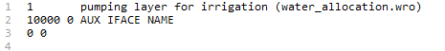
Maximum number of Well cells for any day during the simulation.

Drain package
Subsurface drainage from the aquifer to SWAT+ channels is described in Section 2.6. The groundwater-drain feature for SWAT+MODFLOW is activated using the Drain package of MODFLOW. The modflow.drn file is included, which specifies the number Drain cells. For the JMR model, there are 814 Drain cells. These are shown in the figure below.

Reservoir package
Reservoir-aquifer exchange is described in Section 2.7 and is simulated using the Reservoir package of MODFLOW. This feature is activated if the smrt.resvcells file is present, and does not require a companion MODFLOW input file.

Observation file
Daily groundwater head values can be output for selected MODFLOW grid cells, termed “observation cells”. These values can then be plotted as a groundwater well hydrograph time series and compared to groundwater level data from monitoring wells. The modflow.obs file lists these cells. For the JMR model, there are 111 observation cells, each corresponding to a monitoring well from the US Geological Survey (USGS). The third column is an identifier for user convenience, but is not read in. For the JMR model, this identifier is the USGS monitoring well ID.

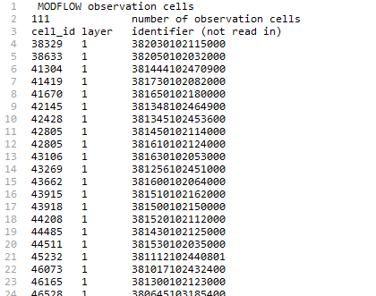

Note: this file is not required to run a SWAT+MODFLOW simulation. The code searches for this file to active this option.

4. SWAT+MODFLOW code structure

Users may wish to make changes to the SWAT+MODFLOW code, or to debug a model to learn about the code or determine why a model simulation crashes. This section shows the main code structure of SWAT+MODFLOW. Subroutines created for SWAT+MODFLOW linkage and running are highlighted in maroon text. The SWAT+MODFLOW source code is available in the folder “SourceCode”.

For each daily time step (within the time_control loop), the subroutine smrt_run is called, which maps SWAT+ information to MODFLOW arrays, calls MODFLOW to solve the groundwater flow equation for each grid cell, and then uses the MODFLOW groundwater head and flow results to populate SWAT+ variables (i.e., update streamflow based on aquifer-channel exchange, aquifer-drain exchange, and aquifer-canal exchange).

main

proc_bsn
basin_read_cc (read modflow flag in codes.bsn)
basin_read_objs (read modflow number in object.cnt)
readcio_read (read modflow.con in file.cio)

hyd_connect
smrt_initialize
mf_read (read MODFLOW input files)
smrt_hrucell (read smrt_hrucells)
smrt_canl_read (read smrt_canalcells)
smrt_drng_read (read smrt_drngcells)
smrt_resv_read (read smrt_resvcells)
prepare groundwater balance and flux files
rt_read (read RT3D input files)
prepare concentration and load files
smrt_chan_read (read smrt_chancells; write modflow.con)

time_control: day loop
wallo_control
wallo_withdraw
smrt_well (determine pumping rate for each cell; irrigation or municipal)
command
smrt_run
smrt_conversion2mf (map SWAT+ information to MODFLOW: recharge; ET;
soil transfer; river stage and bed conductance; canal bed
conductance; reservoir stage)
mf_run (run MODFLOW run RT3D: smrt_conversion2rt3d; rt_run)
smrt_conversion2swat (map MODFLOW information to SWAT+: aquifer-
channel exchange; aquifer-canal exchange; aquifer- drain exchange; aquifer-reservoir exchange)
smrt_output (output model-wide groundwater fluxes; output monthly and yearly
groundwater head and fluxes for each cell; groundwater concentrations
and loads for each cell)

5. Running a SWAT+ MODFLOW simulation

5.1 Assemble model input files
The files necessary to run SWAT+MODFLOW are:

MODFLOW files
- modflow.nam
- modflow.nwt
- modflow.bas
- modflow.dis
- modflow.oc
- modflow.upw
- modflow.rch
- modflow.riv
- modflow.evt
- modflow.wel (optional)
- modflow.drn (optional)

Linkage files
- smrt.hrucells
- smrt.chancells
- smrt.canalcells (optional)
- smrt.drngcells (optional)
- smrt.resvcells (optional)

Modified SWAT+ files
- codes.bsn
- object.cnt
- file.cio

These files are all placed in the SWAT+ model folder that contains all input files. For the JMR model example, all files are in the folder “JMR_TxtInOut”. You can open up each file inside a text editor (e.g., Notepad++, EditPlus) to view the contents.

5.2 Run SWAT+MODFLOW simulation
Once all files are ready, the SWAT+MODFLOW simulation can be run by double-clicking the SWAT+MODFLOW.exe executable, as shown in the following figure that shows a portion of the model folder contents.

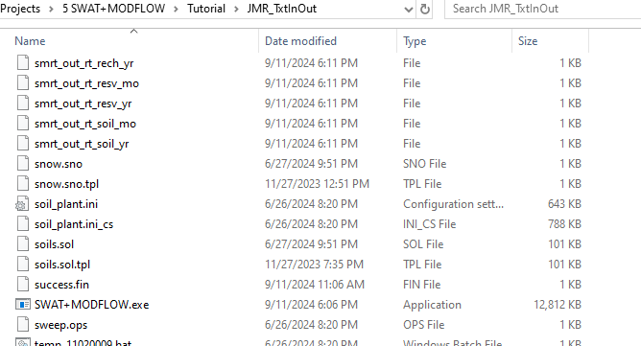

The start of the simulation looks as follows. Notice the message “SWAT+/modflow: modflow is being used”. The model is run for 9 years, as specified in the input file time.sim.

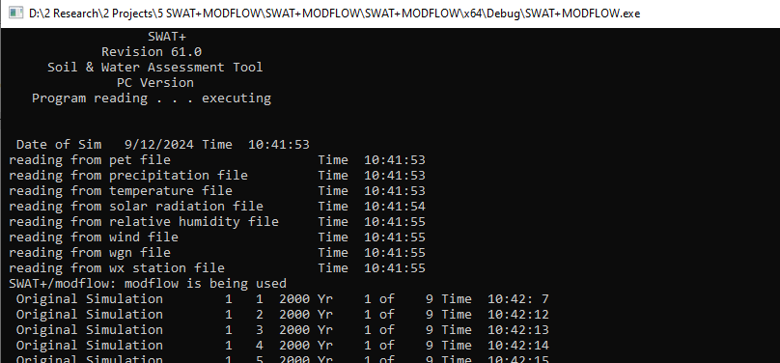

During the simulation, messages are written to the file smrt_log to track the reading of smrt files and the calling of subroutines. The file has the following structure:

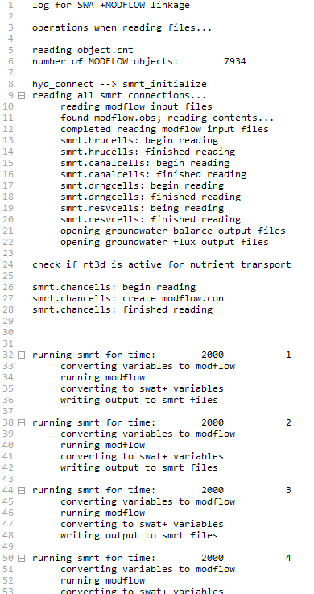

5.3 Troubleshooting
The SWAT+MODFLOW can crash for the following main reasons:

#1: Input files (smrt, modflow) are prepared incorrectly.

#2: MODFLOW does not converge during a given time step.

For #1: There are many mistakes that can be made when creating the smrt and modflow input files. If the model crashes at the beginning of the simulation (during the read subroutines), you can use the contents of smrt_log to see what the issue might be. The file contents as listed on the previous page can be used as a guide.

For example: if the model crashes and the smrt_log contents are as follows, then there is a problem with the smrt.hrucells input file because the message “smrt.hrucells: finished reading” has not been written.

Another example: if the model crashes and the smrt_log contents are as follows, then there is a problem with the MODFLOW input files. In this case, open the main MODFLOW output file (modflow.out) and scroll to the bottom of the file. The file will have a message indicating the last procedure performed before crashing. For example, it may read “Reading Recharge file” on the last line, indicating that there is a problem with the Recharge input file.

For #2: Sometimes the MODFLOW subroutines are not able to solve the groundwater flow equations for the grid cells. This often occurs if inflow/output fluxes are too high, or if model parameters have extreme values. In this case, the model will stop due to convergence issues. In this case, there will be a message in modflow.out stating “Stopped due to model convergence error”. To address model convergence, you may need to decrease the grid cell size or relax solver convergence criteria in the Newton solver file modflow.nwt (see https://water.usgs.gov/ogw/modflow-nwt/MODFLOW-NWT-Guide/ for details regarding this file).

6. Viewing SWAT+ MODFLOW simulation results

6.1 SMRT output files
During the simulation, the model produces a set of output files to view simulated results. SWAT+ output control is handled in the input file print.prt. I recommend outputting daily, monthly, yearly, and average annual values for “basin_wb” (model-wide water balance fluxes), and monthly values for “channel_sd” (streamflow for each channel).

The following output files are provided by smrt. The subsequent sections show example results using these files.

Groundwater head

- smrt_out_mf_gwhead_mo monthly average groundwater head (m) for each MODFLOW cell
- smrt_out_mf_gwhead_yr yearly average groundwater head (m) for each MODFLOW cell
- smrt_out_mf_head_obs daily groundwater head (m) for each observation cell listed in modflow.obs

Groundwater fluxes:

- Model domain totals (mm)
  - smrt_out_mf_balance_day daily flux (mm) for each groundwater term
  - smrt_out_mf_balance_mo monthly average flux (mm) for each groundwater term
  - smrt_out_mf_balance_yr yearly average flux (mm) for each groundwater term
  - smrt_out_mf_balance_aa average annual flux (mm) for each groundwater term

- Cell values (m³/day): written for each month and year of the simulation
  - Recharge
    - smrt_out_mf_rech_mo monthly average recharge flux for each MODFLOW cell
    - smrt_out_mf_rech_yr yearly average recharge flux for each MODFLOW cell
  - Soil Transfer
    - smrt_out_mf_soil_mo
    - smrt_out_mf_soil_yr
  - Groundwater ET
    - smrt_out_mf_gwet_mo
    - smrt_out_mf_gwet_yr
  - Groundwater-channel exchange
    - smrt_out_mf_gwsw_mo
    - smrt_out_mf_gwsw_yr
  - Groundwater pumping for irrigation (based on water allocation module)
    - smrt_out_mf_wlag_mo
    - smrt_out_mf_wlag_yr
  - Groundwater pumping (specified rates in Well package)
    - smrt_out_mf_wlwl_mo
    - smrt_out_mf_wlwl_yr
  - Groundwater pumping (specified rates in MNW2 package)
    - smrt_out_mf_mnw2_mo
    - smrt_out_mf_mnw2_yr
  - Groundwater-canal exchange
    - smrt_out_mf_canl_mo
    - smrt_out_mf_canl_yr
  - Groundwater-drain exchange
    - smrt_out_mf_drng_mo
    - smrt_out_mf_drng_yr
  - Groundwater-reservoir exchange
    - smrt_out_mf_resv_mo
    - smrt_out_mf_resv_yr
6.2 Groundwater fluxes

Domain-wide fluxes
The following figure is a bar chart of groundwater fluxes for each day of the 9-year simulation, as written in the file smrt_out_mf_balance_day. The chart was prepared in Excel. Notice that canal seepage occurs only during the days 92-289, as specified in the smrt.canalcells file (see Section 2.5 for explanation). Also notice that groundwater pumping occurs only during the growing season of each month, to satisfy the irrigation demand of the crops grown in this study region.

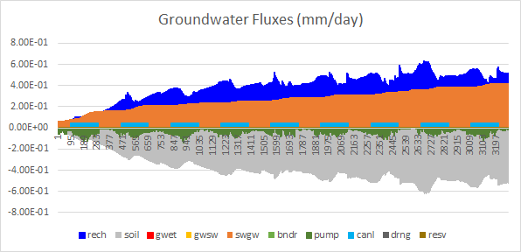

These fluxes can also be tracked in the modflow.out file. The groundwater budget (inputs, outputs, storage) is printed for each time step list in the modflow.oc input file. For example, for time step (day) 151:

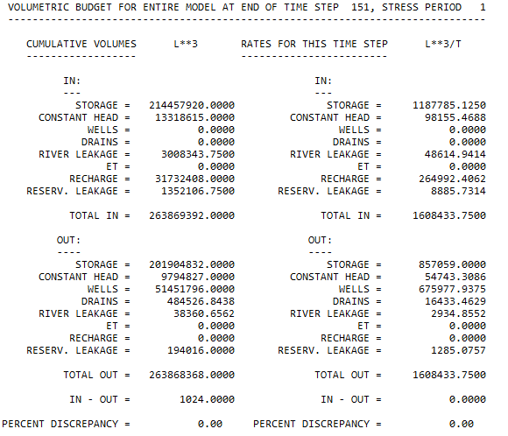

Inputs include channel seepage, recharge, reservoir seepage, and boundary inflow; outputs include well pumping, drains, discharge to channels, discharge to reservoirs, and boundary outflow.
If the groundwatersoil transfer option is turned off (see Section 2.1 and input file smrt.hrucells, line 6), then the daily groundwater fluxes are as follows:

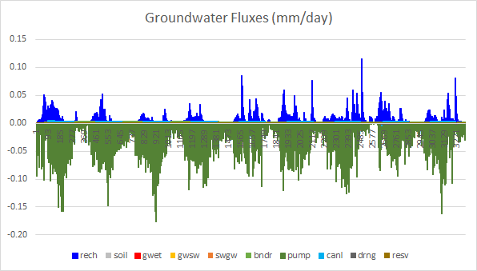

Notice that the recharge fluxes are much lower than in the case where the option is turned on (see chart on previous page). When the groundwatersoil transfer option is turned on, water is transferred to the soil profile, which then often returns to the aquifer via soil deep percolation; and the cycling can repeat. When the option is turned off, flow is only in the direction from the soil profile to the water table.

Cell fluxes

Recharge
The following figure shows monthly average recharge flux (m³/day) for each MODFLOW cell for July 2008, as written in the file smrt_out_mf_rech_mo. The map was created using an ASCII file, read into QGIS as a raster. The example file rech_2008_07.txt is available in the folder “Maps”. The maximum cell value is 57,512 m³/day, shown in red.

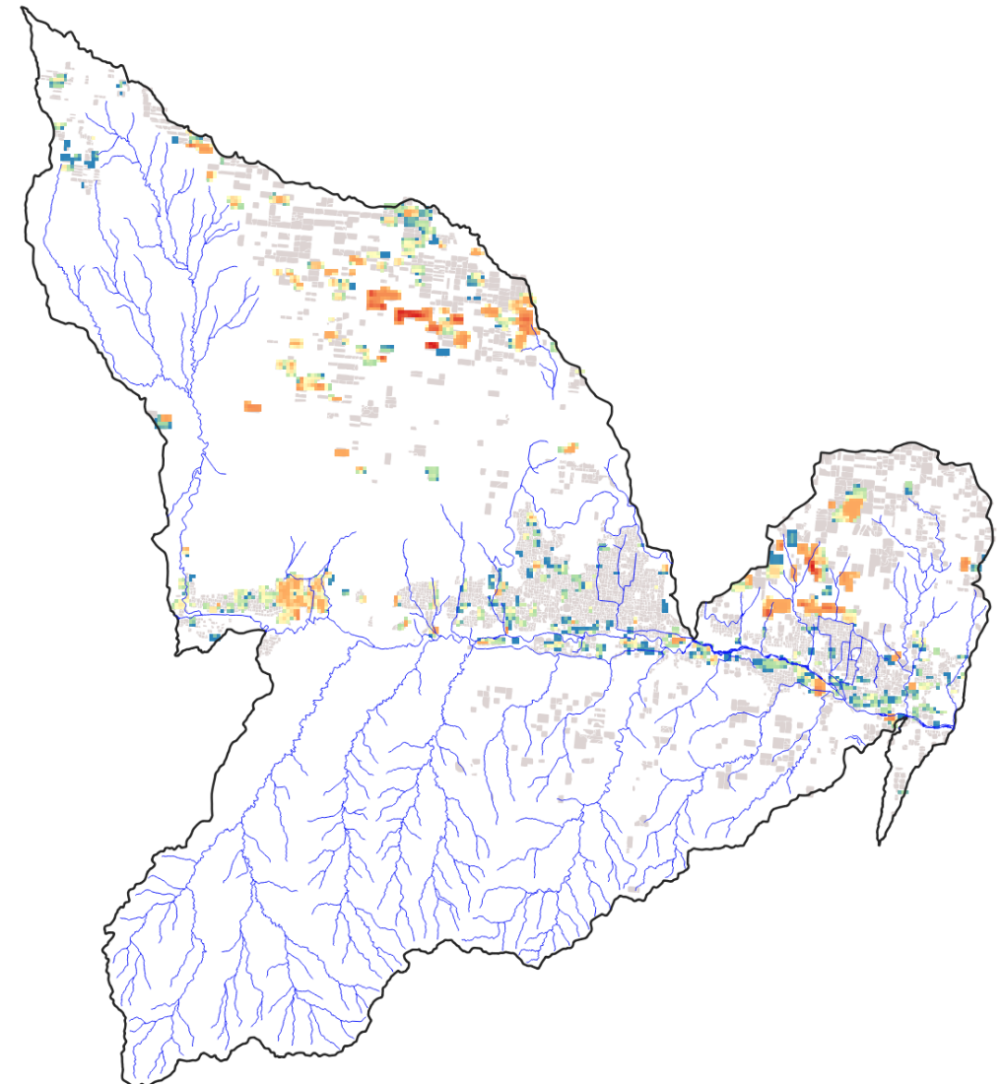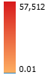

When the groundwatersoil transfer option is turned off, then recharge only happens where soil deep percolation occurs (and not in areas of high water table where groundwater is transferred to the soil profile, and then returned to the water table via percolation).

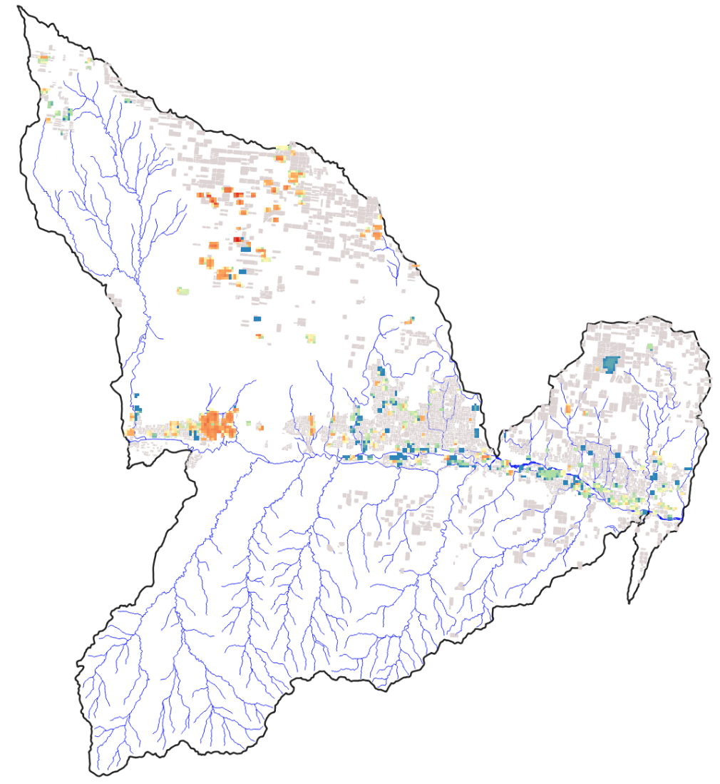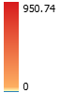

Pumping for Irrigation
The following figure shows monthly average pumping flux (m³/day) for each MODFLOW cell for July 2008, as written in the file smrt_out_mf_pump_mo. The map was created using an ASCII file, read into QGIS as a raster. The example file pump_2008_07.txt is available in the folder “Maps”. Notice that pumping occurs on the east side of the region, where the majority of groundwater-irrigated fields reside. The maximum cell value is -4,054 m³/day (negative because groundwater is being removed from the aquifer), shown in red.

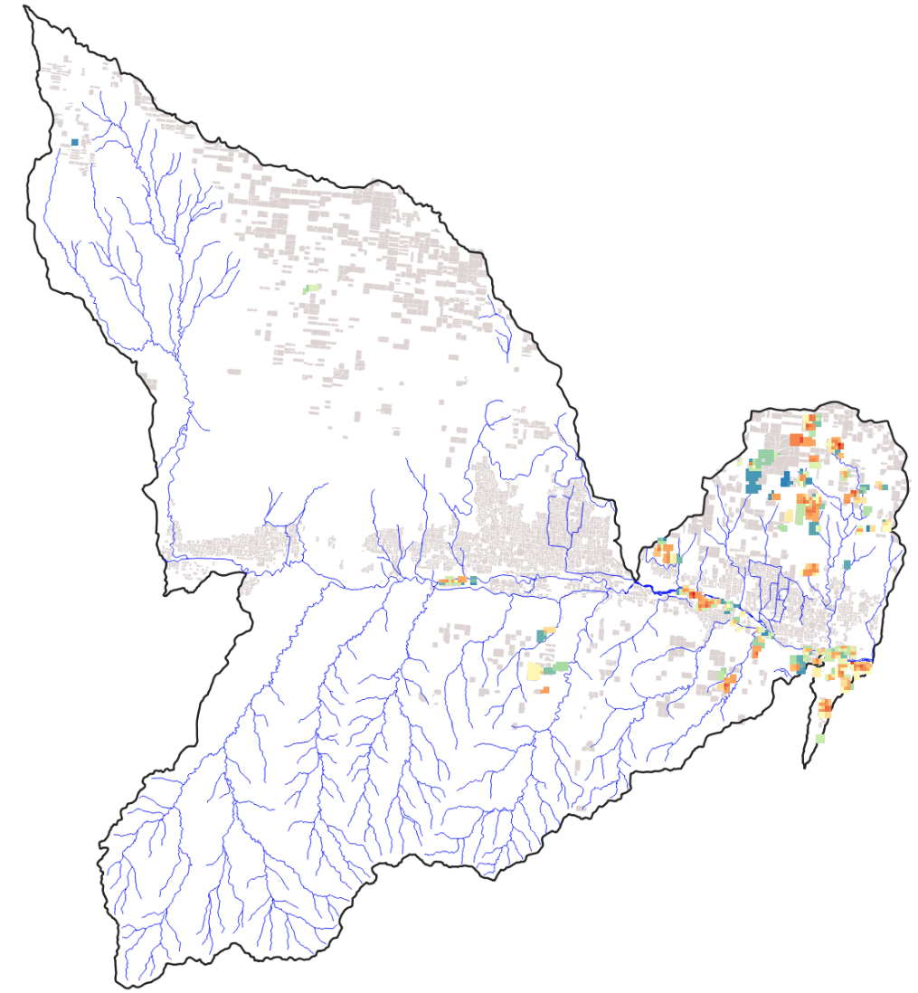

Groundwater-canal exchange
Monthly average groundwater-canal flux (positive value = canal seepage) (m³/day) for each MODFLOW cell for July 2008, as written in the file smrt_out_mf_canl_mo. The map was created using an ASCII file, read into QGIS as a raster. Red-orange colors indicate locations of canal seepage (inflow to aquifer); blue-green colors indicate groundwater discharge to canals (outflow from aquifer). The example file canal_2008_07.txt is available in the folder “Maps”.

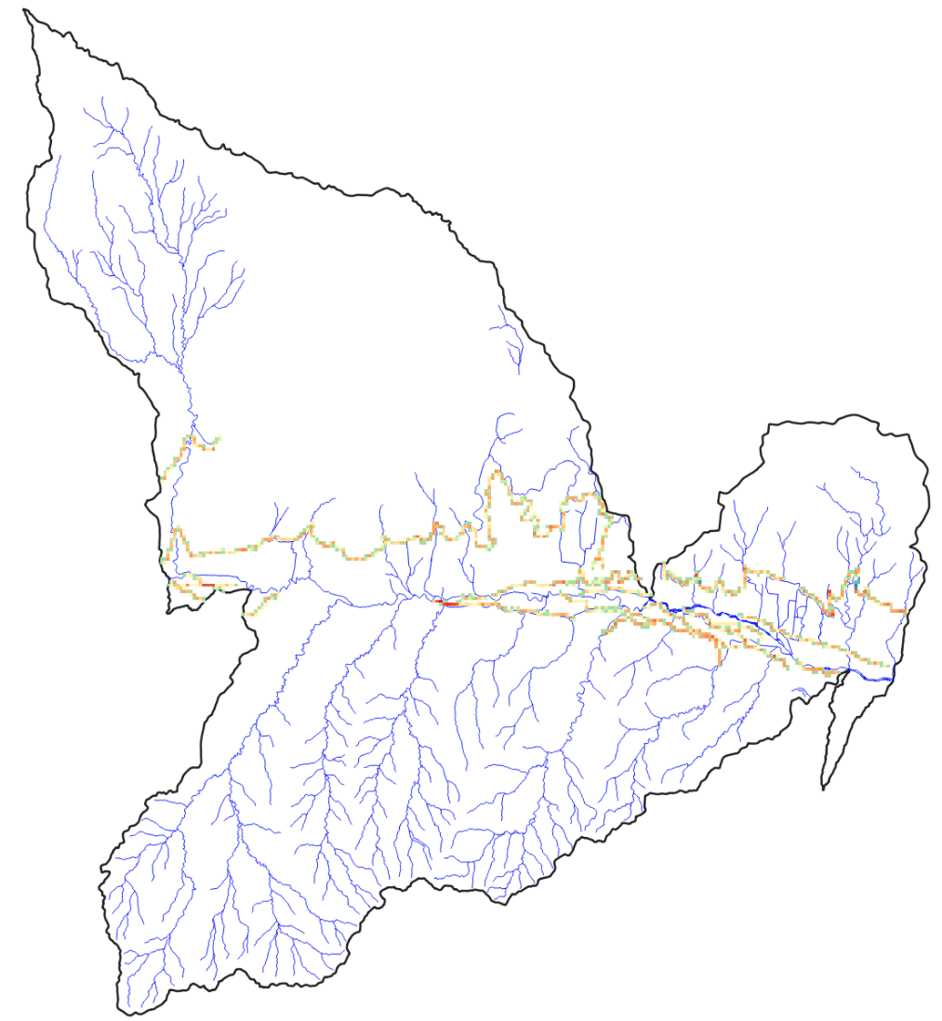

6.3 Groundwater head
Maps of cell-by-cell groundwater head (m) can be plotted using the output in modflow.hed (for days specified in modflow.oc), smrt_out_mf_gwhead_mo, and smrt_out_mf_gwhead_yr. The following map shows average groundwater head for each grid cell for July 2008. The map was created using an ASCII file, read into QGIS as a raster. The example file gwhead_2008_07.txt is available in the folder “Maps”.

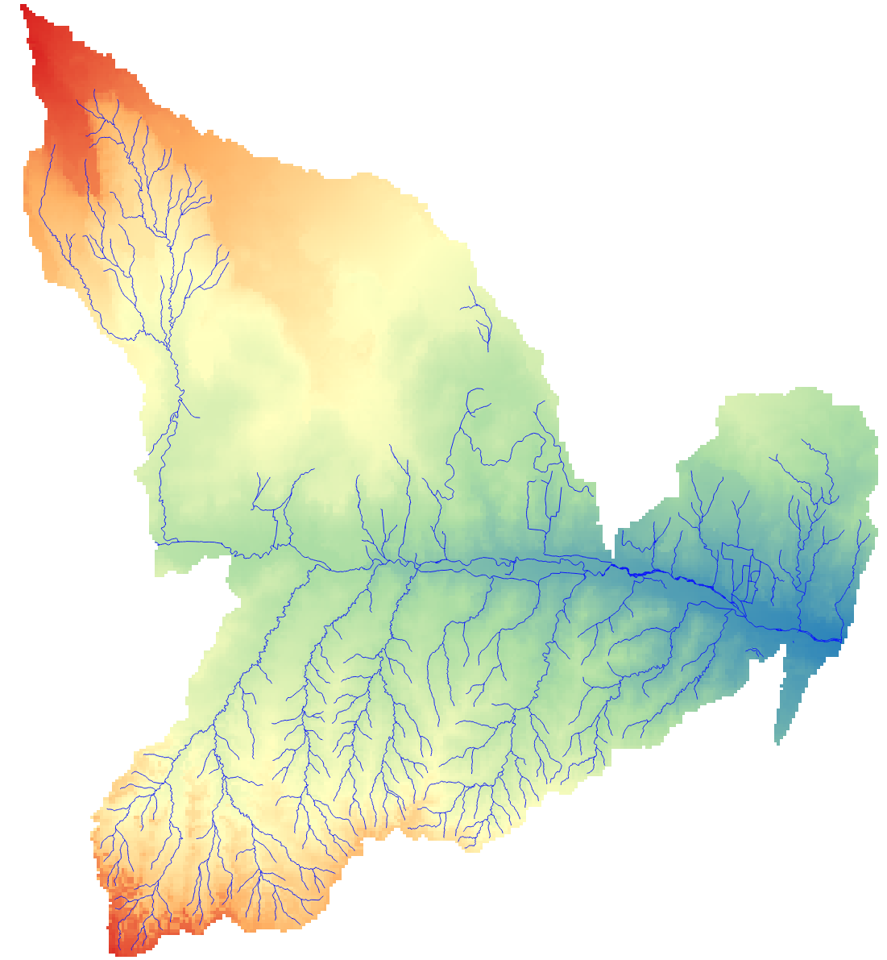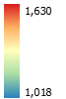

7. Model calibration using PEST
Model calibration (i.e. parameter estimation) can be performed for the SWAT+ model using the PEST (Parameter Estimation) (Doherty, 2020) software. PEST is model-independent and has been used in hundreds of hydrologic and environmental modeling studies to provide optimal estimates of parameter values. PEST uses nonlinear techniques to minimize the residual between observed and simulated values.

The following diagram shows the overall workflow of a PEST simulation. PEST starts with an initial set of parameter values, and then during each iteration is run n times (n = number of targeted parameters) to populate the Jacobian matrix, which contains derivatives of each simulated value, i.e., the change in the simulated value with respect to the model parameter value, an indication of the relative influence of each parameter on model output. The matrix values are then used to provide an improved set of parameter values during the next iteration, with this process continuing until the sum of the residuals between observed and simulated values is minimized.

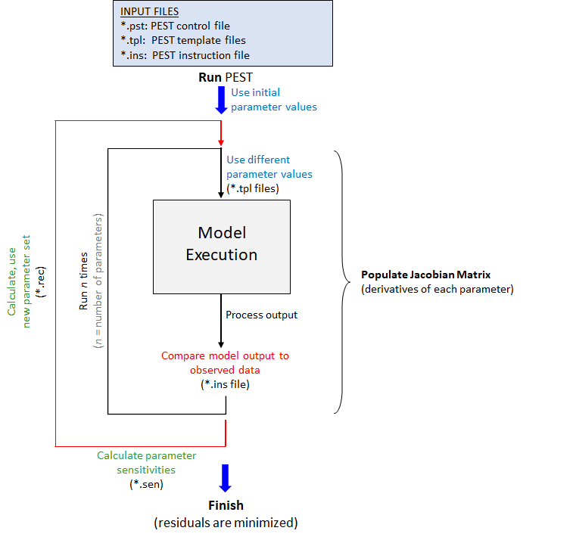

For the JMR model, all PEST files are contained in the folder PEST\Results\Regular. These are referenced on the next page. For details on how to set up PEST for a hydrologic model, please view the tutorial videos and PEST manuals available in the folder PEST\Video tutorials. These videos were prepared for a different SWAT+ model, but the steps and set-up to run PEST are the same. You should start by viewing Videos 1-9.

There are three main types of files that need to be created to run a PEST simulation:
- *.pst file. This is the “control” files that lists targeted model parameters, parameter ranges, measurement data, and PEST calibration parameters. For the JMR model, the file is called pest_control.pst. For this model, there are 67 parameters included in the model calibration. There are 241 measured data: 84 monthly streamflow measurements from an upstream river gage; 84 monthly streamflow measurements from a downstream river gage; and 73 annual groundwater head measurements from 10 monitoring wells.
- *.tpl files. These are the “template” files. There is one template file for each SWAT+ input file that contains one or more targeted parameters. These files contain placeholders for targeted parameters, which will be filled in by PEST during model executions. For the JMR model, the 67 parameters are contained within 10 input file (hydrology, snow, soil, curve number, aquifer properties, groundwater delay, channel bed conductivity, and canal bed conductivity).
- *.ins file: This is the “instruction” file that informs PEST how to read model output, for comparison with measurement data.

Basic procedure:
- Create template files for the required input files (e.g., cntable.lum, hydrology.hyd, modflow.upw)
- Create the control file for PEST (e.g., pest_control.pst); use the file pest_control.explanation as a guide to create the control file. For our example watershed, we have 67 parameters (these will be varied during the calibration) and 241 measured values. For our example watershed, the calibration period 2002-2008.
- When PEST runs, it will compare model output with the observed values listed in the PEST control file.
  - Model output values will be stored in a file called “pest_sim_output”, as specified at the bottom of the PEST control file (the user decides what this file is called). The pest_sim_output file must be accompanied by an instruction file (pest_sim_output.ins), so that PEST knows how to interpret the values listed in pest_sim_output.
  - After SWAT+MODFLOW finishes the simulation, a post-processing code must be run that retrieves the simulated values from output files and writes them to the file pest_sim_output. For the JMR model, this post-processing step is performed by the Fortran program pest_sim_output.exe. (Note: any post-processing program could be created for this purpose; this Fortran program is one option; the Fortran code (create_sim_output.f) is available in the folder PEST)
  - The 2 steps of 1) running SWAT+MODFLOW; 2) running pest_ sim_output.exe to create the pest_sim_output file, are contained in the batch file run.bat. This batch file is listed in the PEST control file, under “model command line”, so that PEST will run both the SWAT+MODFLOW executable and the post-processing program for each simulation run.
  - The program pest_sim_output.exe needs to know the channel to target for output, the number of months for output, and the list of monitoring wells. For our example with the JMR model, this information is provided in the input file pest_targets. This file is specific to the post-processing code, and can change based on the format of your own post-processing code.
- When all PEST files are ready, we will run a check program (pestchek.exe) to verify that all input files are correctly written. Using the Command Prompt, navigate to the folder, and type pestchek, followed by the name of the PEST control file (in our example, pest_control.pst):
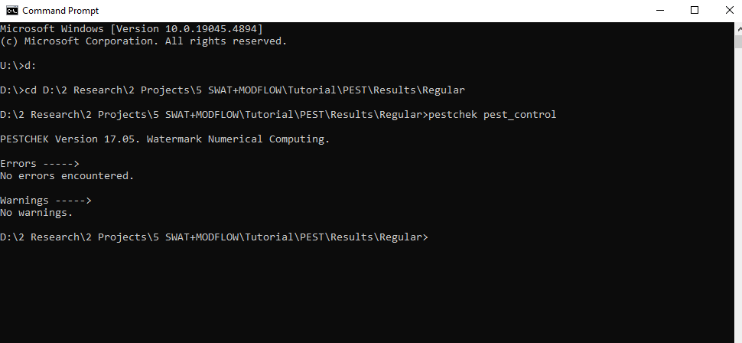
For our example, with the provided files, there should be no errors.

- Run PEST from the Command Prompt, by typing pest, followed by the name of the PEST control file. PEST will then begin its iterations. For each iteration, PEST will run SWAT+MODLFOW (and the post-processing code pest_sim_output.exe) one time for each parameter. At the conclusion of each iteration, PEST modifieds the parameter values to minimize the residual between observed and simulated values.
  - To monitor progress, view the contents of pest_control.rec. This file contains updates of the total residual (“phi”) between the observed values and the simulated values. This value should decrease with each iteration, as parameter values are modified.
  - The sensitivity of model output to each parameter is contained in the output file pest_control.sen. This provides a local sensitivity analysis of each parameter in regard to the model output.

8. Global sensitivity analysis for SWAT+MODFLOW
SWAT+MODFLOW models can be used in conjunction with the PEST++ software program to perform global sensitivity analysis (GSA) using the Morris Method. This requires the use of PEST++ (executable: pestpp-sen.exe), which is provided in the folder PEST\Results\1 Morris Simulation (Q+GW)\GSA SWAT+MOD\GSA SWAT+MOD.

The PEST files and post-processing code are the same as for regular model calibration (see Section 8). When running PEST++, use the executable pestpp-sen.exe in the command window. For our JMR model, this will run the SWAT+MODFLOW model 271 times [(number of parameters = 67 * 4) + 4]. Once the runs are complete, PEST++ writes out several files containing sensitivity information:

*.sen.par.csv: List of parameter values for each simulation.

*.mio: Sensitivity values (absolute value of mean; standard deviation) of each model output to each parameter. For the JMR model, this results in sensitivity values for each parameter, for each of the 241 simulated values that correspond to the measured values. These results can be used to identify the controlling parameters on each individual model output. This can be helpful to identify controlling parameters for different seasons of the year, or for different locations within the watershed.

*.mos: Same as the results in *.mio but sorted by parameter.

*.msn: Overall sensitivity of model output to parameters. This provides a single sensitivity value for each parameter, therefore combining the effect on all measured values.

*.group.msn: Overall sensitivity of model output to parameters for each model output type. For the JMR model, this results in parameter sensitivity values for the first streamflow gage (flow 1), the second streamflow gage (flow 2), and groundwater head (gw head).

For example, the following is a bar chart showing the absolute value of mean sensitivity for the 67 parameters, in relation to flow 1, as provided in *.group.msn:

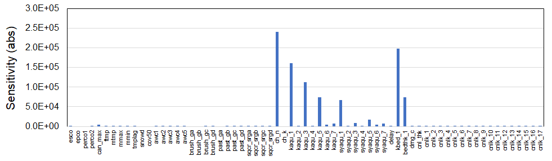

From these results, we conclude that stream channel Manning’s roughness (ch_n), aquifer hydraulic conductivity in geologic zones 1, 3, and 5 (kaqu_1, kaqu_3, kaqu_5), specific yield in zone 1 (syaqu_1), channel bed conductivity (kbed_1), and channel bed thickness (bedthk_1) control streamflow in the downstream region of the model. This is an expected result, as groundwater discharge to the Arkansas River is a significant component of streamflow in the JMR watershed.

These results, along with the results for flow 2 and gw_head, are shown in the following table, with red colors denoting strong parameter control, and green indicating weak parameter control. The results for flow 2 and gw_head are similar to those for flow 1, with Manning’s roughness, aquifer hydraulic conductivity in zones 1, 3, 5, specific yield in zone 1, and channel bed conductivity and thickness controlling streamflow and groundwater head.

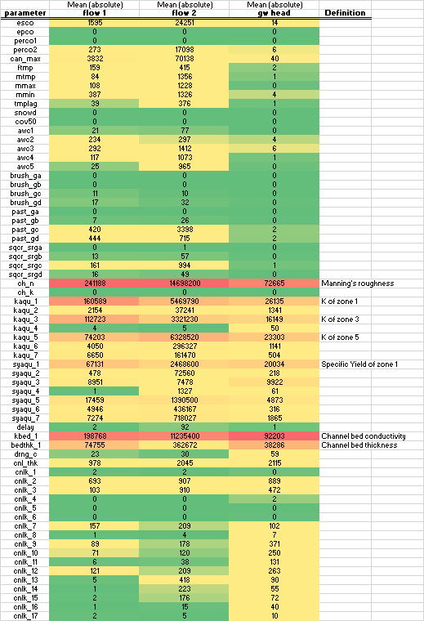

References
Doherty, J.: PEST, Model-independent Parameter Estimation: User Manual (seventh ed.). Watermark Numerical Computing, Brisbane, Australia, 3338, 3349, 2020.
Niswonger, R.G., Panday, S. and Ibaraki, M., 2011. MODFLOW-NWT, a Newton formulation for MODFLOW-2005. US Geological Survey Techniques and Methods, 6(A37), p.44.

