Research Data Management Lifecycle Checklist

Research Data Management
Research data management (RDM) concerns the organization of data, from its entry to the research cycle through the dissemination and archiving of valuable results. RDM is an iterative and continuous process. In general, it is most efficient to properly manage your data as you go, rather than trying to reconstruct everything at the end. The data lifecycle illustrates the stages of data management and describes how data flow through a research project.
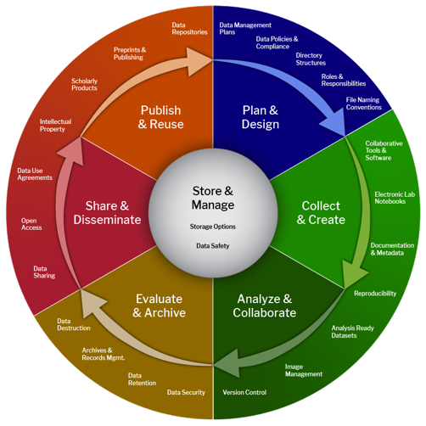

Harvard Research Data Management Lifecycle Checklist
The checklist serves as a reference to keep track of the elements that make up good research data management throughout the data lifecycle. Using the section prompts, you can identify gaps and communicate elements of data management to members of your research team. The checklist was last updated on October 2, 2024.
Please note that this resource does not cover every single aspect of RDM, and it is likely that certain data management practices specific to your research, your type(s) of data, and your needs are not covered. Find out more about data management on the Harvard Biomedical Research Data Management Website.

Research Data Management Lifecycle Checklist Contents

Planning: Plan ahead

Plan & Design
- Capture Key Project Information
- Review Relevant Policies for Data Management
- Write or Review a DMSP
- Budget for Data Management and Sharing
- Define Roles and Responsibilities
- Establish Data Organization
- Keep Up to Date with Data Management Resources and Policies

Active Research: Document

Collect & Create
- List Data Types, Formats, and Size
- Outline Data Collection Methods
- Utilize Metadata Standards
- Create Data Documentation

Analyze & Collaborate
- Facilitate Data Analysis
- Maintain Code Documentation
- Document Data Analysis Protocols
- Document Image Management and Processing

Operational Storage: Think short and long term

Store & Manage
- Secure Active Data
- Determine Appropriate Data Storage Locations
- Create a Data Backup Plan
- Resolve Access Permissions

Evaluate & Archive
- Assess Data Retention
- Appraise Data for Archiving
- Appropriately Dispose Data

Dissemination: Share confidently

Share & Disseminate
- Determine Data Ownership and IP
- Review or Create Data Use Agreement(s)
- Fulfill Data Sharing Requirement(s)
- Apply Open Science Practices

Publish & Reuse
- Connect Scholarly Products
- Select Appropriate Data Repository(ies)
- Confirm FAIR Data Principles

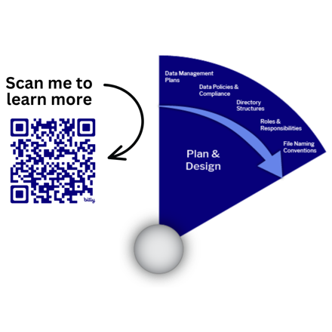
Planning: Plan ahead

Plan & Design

€ Capture Key Project Information
Tracking project information helps understand applicable policies to align with the end of a research project or activity. Capture project details in DMPTool, lab/project notebooks, Harvard compliance systems, or other documentation (e.g., README File). A project may be formally defined by a funder or collaboration, however, sometimes projects are informally defined between a researcher and the PI.
- Project ID: Determined by the funder and/or institution (e.g., NIH grant number)
- Project Name: As it appears on the grant or the understood name of an informal collaboration
- Project PI: Name and ORCID of Principal Investigator(s) or main researcher(s) on the project
- Project Description/Abstract: Provide background and rationale about the project
- Administrative Data: Contact details, project dates, data management plan versions, etc.
- Create and connect your ORCID account with Harvard University
Open Researcher and Contributor ID (ORCID) is an alphanumeric code to uniquely identify scientific and other academic authors and contributors. Connecting your ORCID to Harvard authorizes the university to read your public data and authenticates the Harvard-based activities listed in your ORCID record.

€ Review Relevant Policies for Data Management
Universities, funders, and publishers all have expectations and requirements for research data related to security, sharing and retention.
- Harvard Research Data Security Policy (HRDSP): Focuses on proper management and stewardship of research data, inclusive of human subjects’ research, data exchanged pursuant to a data use agreement (DUA), and other data subject to foreign, federal, or state regulations, sponsor requirements or intellectual property protections.
- Harvard DUA Guidance and Policy: A Data Use Agreement (DUA) is a binding contract between organizations that governs the transfer and use of data. It is an agreement between the data producer and secondary data user(s) and may impose rules for reuse, storage, re-dissemination, and disposal or termination. DUA terms and conditions vary depending on the specific type of data. DUAs are considered research-related agreements and must be reviewed and signed by an appropriate Negotiating Office at Harvard.

- Harvard Research Records Retention: Researchers have certain obligations to record, maintain and retain research records, and to make those records available for grant monitoring and auditing purposes. In general, essential research records should be retained for a period of no fewer than seven (7) years after the end of a research project or activity.
- Data Management and Sharing Policies: Requirements for researchers to make their data available to others when they complete a study. Most commonly to be compliant with funding organizations (e.g., NIH/NSF) and journals (e.g., Nature/Science) that require the reporting of research data.

€ Write or Review a Data Management and Sharing Plan
A data management and sharing plan (DMSP or DMS Plan) is a formal document that outlines what you will do with your data during and after a research project. A DMS Plan is now commonly required as a condition of funding for top funders, such as NIH and NSF. You may be tasked with writing this DMS Plan, or if one has already been developed for your project, you should review the Plan in collaboration with the PI.
- Collaboratively write and track your DMS Plan in DMPTool
DMPTool is an online tool available to help you write your data management and sharing plans according to funder requirements and Harvard policies for managing your data. Login with HarvardKey and request help through Harvard Library’s Data Management Plan Review Service.

€ Budget for Data Management and Sharing
PIs might want to be aware of associated costs for data management resources, including understanding where costs will be accrued, who pays those costs, and who has managerial responsibility for them will inform management activities throughout the project. For example, NIH allows investigators to request funds toward data management and sharing in the budget sections of their applications. Harvard University has guidance for budgeting data management and sharing costs for PIs.

€ Define Roles and Responsibilities
It is recommended that PIs select a dedicated individual responsible for research data to ensure the ongoing data management practices on each project. Data management responsibilities extend beyond just the PI or researcher who created or collected the data. Various parties are involved in the research process and may play a role in ensuring good quality data stewardship. The roles and responsibilities of data management should be clearly defined.
- Department, Lab, or Project Data Manager: Responsible for ensuring the accurate collection, documentation, storage, and reporting of data throughout the department, lab, or project. Explore resources to get started with and support ongoing data management practices.

€ Establish Data Organization
Describe locations where your data are stored and your file naming and folder structure conventions. Research data files and folders need to be labeled and organized in a systematic way agreed upon by the entire research team, so they're both identifiable and accessible for current and future users. It is important that access to research data is shared with the PI and, as appropriate, other project collaborators. Research data should always be stored in School-approved storage locations and not on personal laptop or desktop devices.
- File Naming: A file naming convention is a framework for naming your files in a way that describes what they contain and how they relate to other files. Everyone on the team needs to be consistent.
- File Structure: Create folders according to file naming conventions, document their purpose, and ensure files are stored in correct folders.

€ Keep Up to Date with Data Management Resources and Policies
Many relevant training courses are offered at Harvard University; another resource is lab data managers. There may be required training for specific roles, for example working with sensitive data.
- Research Data Management Seminars: Regular classes and workshops on a variety of topics related to the management of research data.
- Harvard Research Data Security Training: We recommend that researchers handling secure data complete the Harvard University developed training on the information security policy.
- CITI Human Research Training: Harvard institutional policies require all individuals who are involved in human subjects’ research to complete training in the ethical conduct of human research.
- Utilize the RDM Onboarding Checklist to onboard new employees or trainees to a lab or new project
The RDM Onboarding Checklist outlines the important steps for new employees or trainees to understand the data management practices of the lab or project, ensuring accurate communication throughout the lifecycle.

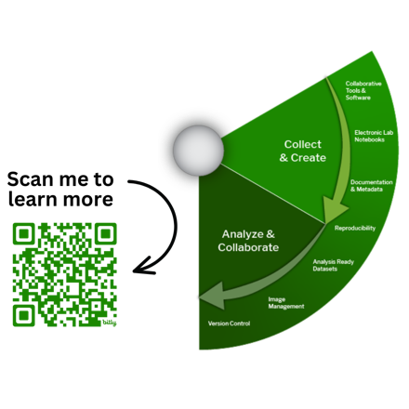
Active Research: Document

Collect & Create

€ List Data Types, Formats, and Size
Understand the data you are working with and the implications for data security, data storage, and data sharing. This information should be captured in your project README File, lab notebook, and/or DMS Plan.
- Types: List the data you will collect or create, e.g., tabular data, survey data, experimental measurements, models, software, audiovisual data, physical samples, etc.
- Formats: Note what format(s) your data will be in, e.g., plain text (.txt), comma-separated values (.csv), geo-referenced TIFF (.tif, .tfw). Using open formats ensures the long-term usability of data and are recommended for sharing and archiving. If you need to convert or migrate your data files, be aware of potential data loss or corruption and take appropriate steps to avoid or minimize it.
- Amount/Size: Estimate how much data will be produced throughout the project and if the production rate will change. This helps determine data storage requirements both during and after the project.

€ Outline Data Collection Methods
Explain how data will be collected and/or describe any existing data being used (including outlining any Data Use Agreement terms). Determine how you will document data collection methods. This information should be captured in your project README File, with links to the appropriate locations.
- Electronic Lab Notebook (ELN): Allow users to enter protocols, observations, notes, and other data using a computer or mobile device. Find ELN guidance across the Longwood Medical Area.
- Lab Protocols: Describe reusable methodologies in all fields of study. Consider using a publishing platform to collaboratively write and publish interactive and dynamic protocols.
- Inventory: Track data files, physical samples, and/or materials using a simple spreadsheet, database, or collaborative tool. Some ELNs have a built-in inventory tracking system.
- Data Management Tools: There are many other places to capture information for specific aspects of project management (e.g., OSF, GitHub), or specific data workflows (e.g., DataJoint, OMERO, REDCap).
- protocols.io is a collaborative platform for publishing step-by-step methodologies
The Countway Library offers protocols.io Premium for the HMS/HSDM/HSPH research community. Premium accounts expand access to private and secure workspaces, increased storage capacity, and dedicated support.

€ Utilize Metadata Standards
Metadata is structured information that describes, explains, locates, or otherwise makes it easier to retrieve, use, or manage research data. Whenever possible, it is best to consult community standards. Metadata can be tracked in lab notebooks, lab databases, and/or data repositories.
- Metadata Schemas: Labeling, tagging, or coding system used for recording cataloging information or structuring descriptive records (e.g., MIBBI, ISA-Tab, Darwin Core).
- Controlled Vocabularies: Predefined terms by a community or research group (e.g., CMS coding).
- Ontologies: Variety of controlled vocabulary that defines components and describes relationships among components (e.g., MeSH, MGED, Gene Ontology).
- Technical Standards: Established norm or requirement for a repeatable technical task establishing uniform criteria, methods, processes, and practices (e.g. ISO-8601 date and time format YYYYMMDD)

€ Create Data Documentation
Good documentation allows you to understand, use, and share your data and helps other researchers discover, access, use, repurpose, and cite your data. In addition to lab notebooks, documentation can be maintained in a variety of forms and will be utilized when depositing data in a repository:
- README: Text file located in a project-related folder that describes the contents and structure of the folder and/or a dataset so that a researcher can locate the information they need.
- Data Dictionary: Defines and describes the elements of a dataset so that it can be understood and used later (also known as a codebook).

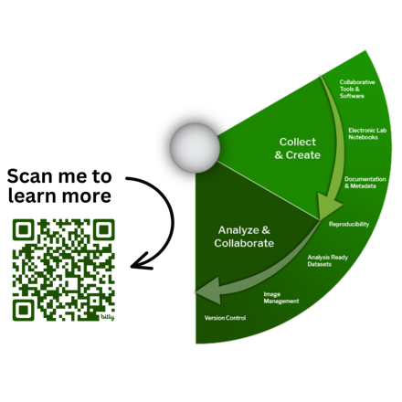
Active Research: Document

Analyze & Collaborate

€ Facilitate Data Analysis
Analysis-ready datasets have been responsibly collected and reviewed so that analysis of the data yields clear, consistent, and error-free results to the greatest extent possible. Since raw data are often unstructured, data cleaning is part of the analysis process. Always keep a read-only copy of original raw data, and then document further processing and analysis.
- Tidy Data Principles: Each variable is in its own column, each observation in its own row, and each value in its own cell. This format facilitates data visualization and analysis using software languages.

€ Maintain Code Documentation
Establish documentation for code, scripts, and software. Version control is used to track changes to your files so you can collaborate with team members or go back and retrieve specific versions of your files later.
- Utilize GitHub to store, track, and collaborate on software projects
GitHub is a web-based service for Git repositories (i.e., groups of tracked files). GitHub is good for code development; however, it is not a robust platform for sharing. Consider capturing an instance of your GitHub Repository in an established repository, e.g. Zenodo or Harvard Dataverse, to facilitate long-term preservation.

€ Document Data Analysis Protocols
Interpretation or analysis of data requires proper documentation. The type of analysis you perform depends on the type of data you’re using and what the goal of your research project is. There are several strategies to enhance your analysis and fully capture your process:
- Jupyter Notebook is an interactive computing environment to create documents that include code, plots, text, images, and more. This streamlines analysis and provides a platform to rerun your work.
- High-Performance Computing (HPC) helps make your analysis more efficient and faster. HPC environments are connected to storage clusters where you can store the data being processed.
  - HMS Research Computing offers the O2 cluster, bioinformatics consultative services, and other assistance to support needs, analysis methods, documentation, and data transfer.
  - FAS Research Computing offers the Cannon Cluster, FASSE Cluster, consultative services, and other assistance to support needs, analysis methods, documentation, and data transfer.
- HMS Research Core Facilities provide specialized services, equipment, and staff for data analysis support
HMS Research Core Facilities provide access to highly specialized services, equipment, and staff and can provide advice on documenting data analysis relating to the technology in their specific Core.

€ Document Image Management and Processing
Documenting the manipulation and analysis of images can help with processing and provide greater transparency of techniques. Additionally, sharing images in open formats (when possible) supports long-term access.
- Recommended Open Formats:
  - Still images: TIFF, JPEG 2000, PDF, PNG, GIF, BMP
  - Moving images: MOV, MPEG, AVI, MXF
- Image Management Resources:
  - OMERO: Software for management, visualization, and analysis of microscope images
  - Adobe Bridge: Free software for locally organizing images
  - ImageJ: Free open-source, Java-based image processing and display tool
  - Tropy: Free, open-source software to organize and describe photographs of research materials

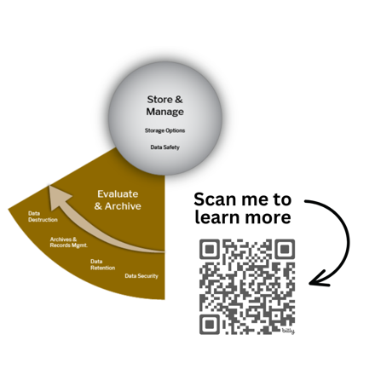
Operational Storage: Think short and long term

Store & Manage

€ Secure Active Data
Every stage of the data lifecycle centers around data storage. Proper storage maintenance throughout the lifecycle is imperative to ensure data remains secure and adheres to recommended safety protocols.
- Data Safety: Protect the welfare of research participants and confirm the integrity of research data. Harvard's Data Safety system supports the submission, review, and management of data use.
- Data Security: Ensure confidential and sensitive data is maintained. Harvard maintains five Data Security Levels. Review the Research Data Security Levels with Examples to determine your risk level.
- Software: Protect your software systems using strategies like anti-virus software, updating applications and OS, firewall, and anti-intrusion software. Digital access should be limited to those that need it.
- Hardware: Ensure appropriate security controls for the physical location(s) where your computers, servers, and data storage reside. Physical access should be restricted to those that need access.

€ Determine Appropriate Data Storage Locations
Review institutional storage options to better understand where to store data based on behavior, performance, and means of access. The type of data you are working with, or the Data Security Level, will dictate where and how that data needs to be stored or handled.
- Harvard University Collaborative Matrix: Aligns Harvard’s Data Security Levels with storage platforms
- HMS IT Research Data Storage Offerings: HMS offers three primary storage types with distinct behaviors, performance, and means of access
- FAS Data Storage Offerings: FASRC offers three different software applications with variety of performance characteristics

€ Create a Data Backup Plan
Having at least one backup can help prevent data mishaps. Harvard systems automatically provide secure backup in geographically distributed locations.
- CrashPlan (Code42): Ensures critical data is recoverable in the event of a loss or compromise or data. CrashPlan is available to HMS and HSDM quad-based personnel for free. CrashPlan is also available for FAS departments, Central Administration, and other schools through Harvard University IT (HUIT).
  - Backs up continually over almost any network on or off-campus
  - Recovers documents from any computer via a web browser
  - Stores document copies for a minimum of 60 days
Research data that is temporarily not in Harvard systems benefits from following the 3-2-1 Rule.
- 3-2-1 Rule: General fail-proof backup strategy:
  - Three copies of the data (e.g., original + external/local + external/remote)
  - Two types of storage formats (e.g., external hard drive + cloud location)
  - One storage type is offsite (e.g. geographically distributed location)

€ Resolve Access Permissions
Ensure data is always shared with the PI and always resides in a shared location with more than one owner to help support the longevity and sustainability of research. Individual data should be moved to a shared location prior to completion of a project or departure from a lab. Access permissions also apply to a variety of storage locations including Electronic Lab Notebooks and website content.
- Utilize the RDM Offboarding Checklist to offboard employees or team members from the lab or project
When employees leave, they take their skills and institutional knowledge with them. It is important to record essential informative information related to projects and datasets to ensure the success of future users. Use the RDM Offboarding Checklist and Knowledge Transfer File Template to guide the knowledge transfer process.

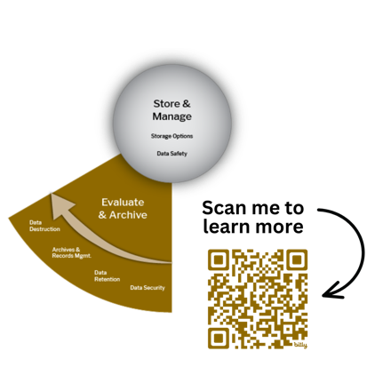
Operational Storage: Think short and long term

Evaluate & Archive

€ Assess Data Retention
Determine what data must be retained or destroyed for contractual, legal, or regulatory purposes, and how long the data will be retained and preserved. Additionally, data and related records might be identified for permanent storage as a part of the historical record of a discipline or institution, or as intellectual property.
- Harvard Research Records Retention: Researchers have certain obligations to record, maintain and retain research records, and to make those records available for grant monitoring and auditing purposes. In general, essential research records should be retained for a period of no fewer than seven (7) years after the end of a research project or activity.
- Essential Research Records:
  - substantiating grant applications or demonstrating compliance with contractual terms
  - substantiating published research and patents, whether the research is sponsored or not
  - substantiating research described in grant proposals and other funding requests
  - records considered for permanent preservation and access by the Archives and Records Management Program at the Center for the History of Medicine

€ Appraise Data for Archiving
A small percentage of data and related records may be identified for permanent storage as a part of the historical record of a discipline, institution, or as intellectual property. Harvard takes on all costs and security for archived data and records after appraisal and acquisition.
- Records eligible for permanent retention maybe those that:
  - document a breakthrough
  - are generated by a lab or individual who had a great impact on the field
  - are highly reusable in a particular area of research
- Understand the difference between “archiving” and “long-term storage”
Permanent retention or archiving is the ongoing migration of electronic formats and storage costs, as well as care, maintenance, and access services for the records in perpetuity. Long-term storage and preservation seek to ensure data will be available in a persistent and accessible format for the specific period outlined by your funder and institution.

€ Appropriately Dispose Data
Once the research has concluded, determine which data and records are safe to dispose of, including how you will permanently remove sensitive data or project data.
- Retention & Maintenance of Research Records & Data Frequently Asked Questions (FAQ): Guides the retention and maintenance of research records by Harvard faculty and staff.
- General Records Schedule (GRS) and Research Records: Details how long to retain different types of records and whether to send records to an archive or destroy them when they are no longer required.
- In-Office Destruction Documentation Form: Used to document in-office destruction of records whose retention period has expired.
- Consult the Center for the History of Medicine Archives and Records Management Program
The ARM program can assist you with appraising your research for long-term historical value, and help managing and disposing of data or records associated with your research.

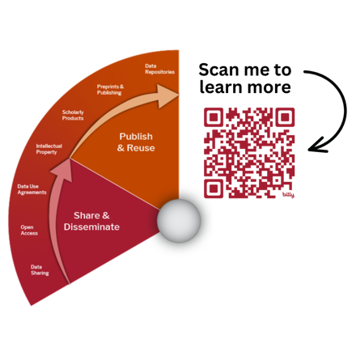
Dissemination: Share confidently

Share & Disseminate

€ Determine Data Ownership and Intellectual Property
To effectively share data, researchers should first resolve any data ownership issues to confirm that they have approval to share the data. If researchers have questions, they should consult their PI, members of their department administration, or, if needed, the Office of Technology Development.
- Intellectual Property Policy: The rights, those responsibilities, and principles that determine how research data should be handled ultimately belongs to the University.
- Research Data Ownership Policy: The University asserts ownership over research data for projects conducted at the University, under the auspices of the University, or with University resources. The University delegates stewardship of the data to PIs, therefore the PI has full responsibility for data management. Data ownership policies are available from the Office of the Vice Provost for Research.

€ Review or Create Data Use Agreement(s)
A Data Use Agreement (DUA) is a binding contract between organizations that governs the transfer and use of data. It is an agreement between the data producer and secondary data user(s) and may impose rules for reuse, storage, re-dissemination, and disposal or termination. Find out more information about initiating and processing DUAs.
- Incoming Data: When obtaining data from any third party (e.g., dbGaP, ICPRS). The appropriate Harvard office will help identify any additional special requirements that must be completed prior to accessing the data, as well as conditions for what to do with the data at the end of the project.
- Outgoing Data: When providing Harvard data to a third party, the Harvard sending party must prepare a DUA with input from appropriate Harvard offices. Data may be transmitted to the Data Recipient in accordance with the DUA terms and conditions.

€ Fulfill Data Sharing Requirement(s)
There may be requirements from funders and publishers to provide access to research data.
- Funder Data Sharing Policies: SPARC resource of current federal funding agency data sharing policies.
- Journal Data Sharing Policies: CHORUS resources indexing publisher data sharing policies.
  - Publishers have Data Availability Policies at the publisher level or at the journal level. Typically, authors must provide a Data Availability Statement published as part of the accepted article.

€ Apply Open Science Practices
Sharing all aspects of your research data and protocols is important for open and reproducible science. Here are some helpful resources to get started and practice open science:
- Open Access Publishing: The free unrestricted online access to scientific and scholarly research
  - Publish in an open access peer-reviewed journals (e.g., Directory of Open Access Journals)
  - Deposit in an open access repository (e.g., Digital Access to Scholarship at Harvard; Preprint repositories)
- Open Materials and Methods: Open methods, protocols, and materials facilitate replication and reuse
  - Protocols: Sharing experimental methods and step-by-step protocols supports reproducibility
  - Reagents: Reagent repositories help support validating and sharing reagents
- protocols.io is a collaborative platform for publishing step-by-step methodologies
The Countway Library offers protocols.io Premium for the HMS/HSDM/HSPH research community. Premium accounts expand access to private and secure workspaces, increased storage capacity, and dedicated support.

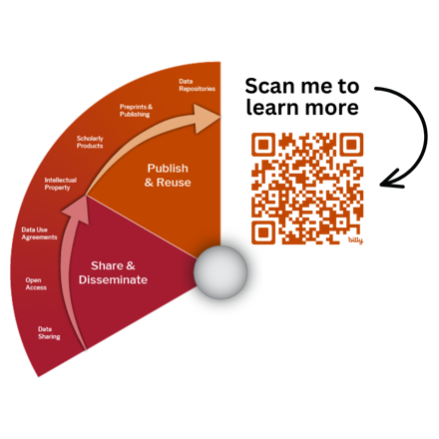
Dissemination: Share confidently

Publish & Reuse

€ Connect Scholarly Products
Consider ways to link access of your research outputs with persistent identifiers (PIDs). A PID is a long-lasting digital reference to a contributor, organization, or object.
- People: Open Researcher and Contributor ID (ORCID) is an alphanumeric code to uniquely identify scientific and other academic authors and contributors. ORCIDs can be linked to many other profiles.
- Organizations: Research Organization Registry (ROR) aims to provide a persistent identifier for every research organization in the world.
- Works: Digital Object Identifier (DOI) is a persistent identifier or handle used to uniquely identify various objects, including articles, conference proceedings, datasets, research materials, etc.
- Resources: Research Resource Identifiers (RRID) help researchers cite key resources, including antibodies, model organisms, cell lines, plasmids, software tools, and databases.

€ Select Appropriate Data Repository(ies)
Data repositories are the preferred method for sharing because they support the discovery, access, and long-term availability of data. Choose the appropriate repository(ies) for all your data types.
- Domain-Specific Repository: Have a specific focus, either by data type or by biomedical research discipline. These are good first choices for your data. Examples: NCBI Gene Expression Omnibus (GEO), NCBI Database of Genotypes and Phenotypes (dbGaP), NIMH Data Archive (NDA).
- Generalist Repository: Accept data regardless of data type, discipline, or affiliation. These may be used when there isn't an established repository for your data, or you need to share more general data or materials. Examples: Open Science Framework, figshare, Zenodo, Vivli.
- Institutional Repository: Focused on preserving and disseminating the scholarship produced by the institution’s faculty and students. Example: Harvard Dataverse
- Follow the Generalist Repository Ecosystem Initiative (GREI)
GREI brings together seven NIH-recognized platforms for sharing NIH-funded research data. Harvard provides support for three of these recognized platforms: Harvard Dataverse, Open Science Framework, and Vivli. Utilize the comparison and flow charts to determine the best generalist repository for your research data.

€ Confirm FAIR Data Principles
To advance science efficiently and ensure reproducibility, follow the FAIR Data Principles:
- Findable: Make sure your data can be found – by both humans and search engines.
  - Use repositories to make data searchable and discoverable online, provide structured metadata descriptions, and assign a unique and persistent identifier (e.g., DOI).
- Accessible: Tell – both humans and machines – how they can get access to your data.
  - Most published research data is open and available for immediate download. If data cannot be open (e.g., because it contains sensitive information), describe the restrictions and how to request access.
- Interoperable: Ensure your data can be integrated with other data and utilized by applications.
  - Avoid sharing proprietary files, using open formats to facilitate easy access and reuse. Use controlled vocabularies and well-defined models to ensure data are well-structured.
- Reusable: Make sure data – and related metadata – are well-described.
  - Provide documentation at both the study level and file level. Remove ambiguity about what others can and can't do with your data by assigning a license (e.g., Creative Commons Zero), and provide a citation to make it easier for others to cite your work.

Research Data Management Lifecycle Checklist
Project Title: _________________________________________________________________________

Planning: Plan ahead

Plan & Design
- Capture Key Project Information
- Review Relevant Policies for Data Management
- Write or Review a DMSP
- Budget for Data Management and Sharing
- Define Roles and Responsibilities
- Establish Data Organization
- Keep Up to Date with Data Management Resources and Policies

Active Research: Document

Collect & Create
- List Data Types, Formats, and Size
- Outline Data Collection Methods
- Utilize Metadata Standards
- Create Data Documentation

Analyze & Collaborate
- Facilitate Data Analysis
- Maintain Code Documentation
- Document Data Analysis Protocols
- Document Image Management and Processing

Operational Storage: Think short and long term

Store & Manage
- Secure Active Data
- Determine Appropriate Data Storage Locations
- Create a Data Backup Plan
- Resolve Access Permissions

Evaluate & Archive
- Assess Data Retention
- Appraise Data for Archiving
- Appropriately Dispose Data

Dissemination: Share confidently

Share & Disseminate
- Determine Data Ownership and IP
- Review or Create Data Use Agreement(s)
- Fulfill Data Sharing Requirement(s)
- Apply Open Science Practices

Publish & Reuse
- Connect Scholarly Products
- Select Appropriate Data Repository(ies)
- Confirm FAIR Data Principles
Checklist Completed by:
Name: [First-Last]
Date: [YYYY-MM-DD]
Checklist Reviewed by:
Name: [First-Last]
Date: [YYYY-MM-DD]

