Phytoplankton list of the Albufera Coastal Lagoon (Valencia, Spain) during 2023
Juan Víctor Molner, Isabel Mellinas, Clara Canós, María D. Sendra, Juan M. Soria*
Cavanilles Institute of Biodiversity and Evolutionary Biology (ICBiBE), University of Valencia, 46980 Valencia, Spain; molpo@alumni.uv.es (J.V.M.); mecoi@alumni.uv.es (I.M.); clacalo4@alumni.uv.es (C.C.); sendrac@uv.es (M.D.S.)
* Correspondence: juan.soria@uv.es

The Albufera of Valencia is a hypereutrophic, oligohaline lagoon that has experienced significant changes in phytoplankton composition and state in recent decades due to human activities. These activities affect phytoplankton biomass and community structure, which are key indicators of ecosystem health. In this study, phytoplankton samples from the lagoon were analysed to identify dominant groups and genera, and their seasonal cycles were determined using biovolume measurements with the Utermöhl method. Various environmental variables were also measured. A species that exhibits seasonal abundance, resulting in a change in the lagoon's colour from green to brown, was identified. The lagoon is in poor condition and hypereutrophic. Cyanobacteria were the most dominant group, peaking in November, contrary to previous studies, followed by Chlorophyceae and Bacillariophyceae. Phytoplankton are vital bioindicators for assessing ecosystem health, underscoring the need for further research in this area.
We present the list of phytoplankton identified in the samples from February 2023 to January 2024 taken in a center point:
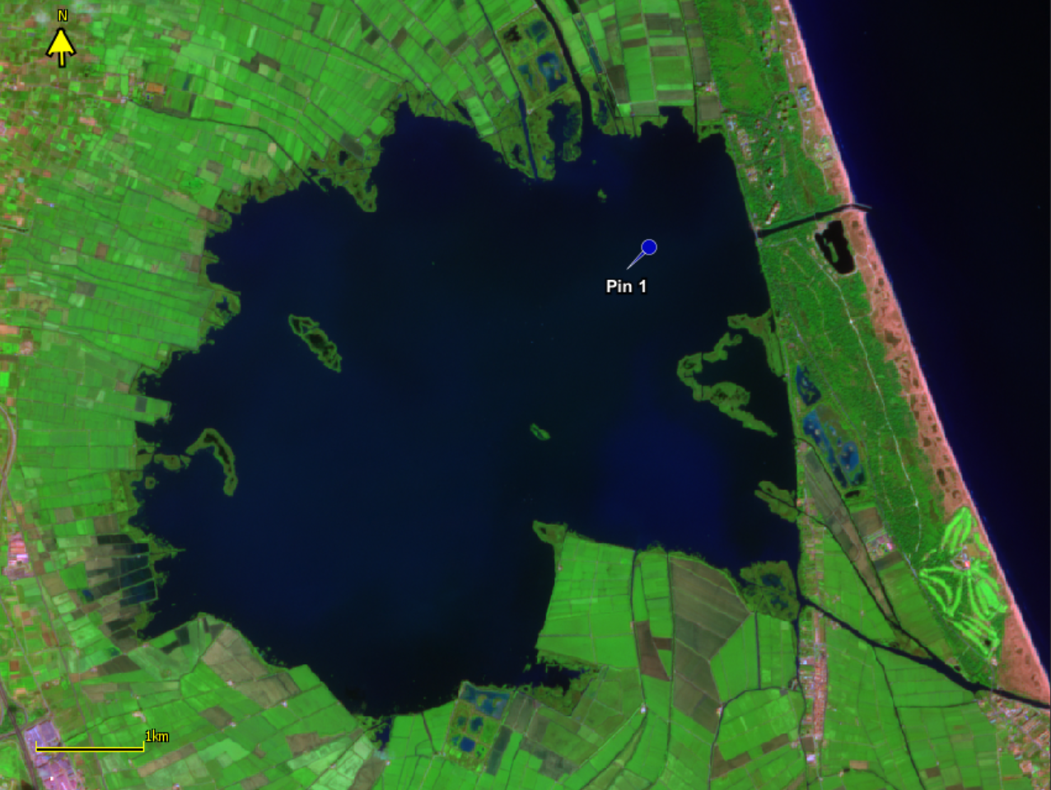
Location of sampling point in Albufera lagoon on 17/09/2023 as seen by Sentinel-2 in enhanced vegetation colour mode. Pin 1 is the sampling point location at geographical coordinates 39.34600 N & -0.33660 W.
 Copyright: © 2024 by the authors.
Open access publication under the terms and conditions of the Creative Commons Attribution (CC BY) license (https://creativecommons.org/licenses/by/4.0/).
DOI: 10.5281/zenodo.14558067

