COMPARISON OF THE HARDNESS AND ELASTIC MODULUS OF DIFFERENT ORTHODONTIC ALIGNERS' MATERIALS
Hussein Shakir Saleh Al Noor^{*1} & Sami Kadhum. Al-Joubori²
^{*1}Department of Orthodontics, College of Dentistry, University of Baghdad
²Department of Orthodontics, College of Dentistry, University of Baghdad

 | Abstract
Keywords: hardness, elastic modulus, thermoplastic, aligners, mechanical properties | Aims: This study was aimed to investigate mechanical properties (Hardness and Elastic Modulus) of three thermoplastic materials used in the fabrication of orthodontic aligners.  Methods: Shore D hardness test was used to measure the hardness of three companies of hard thermoplastic materials (ISO7619-1:2010). Dimensions of the test specimens and testing procedure were done according to (ASTM D 2240-05). Ten samples were tested for each of the three materials using Shore hardness apparatus. For elastic modulus test, thermoplastic sheets that are less than 1mm in thickness are measured according to the ASTM D 882-02 and those that are 1mm or more are measured according to the ASTM D 638-02a. Ten samples were tested for each of the three materials and the elastic modulus was calculated using tensile test in the Universal testing machine.  Results: Hardness test for the three brands showed no significant differences among them. Leone 0.8mm was less than Duran 1mm and Clear aligner 0.5mm in the elastic modulus.  In conclusion: There is no significant difference in hardness among all the three materials used in this study. The elastic modulus of Duran 1mm and Clear aligner 0.5mm showed no significant difference and both are significantly higher than Leone 0.8mm
Introduction
Clear aligner is one of the most interesting appliances to the patient due to the fact that it is removable and nearly invisible and consequently it will cause less damage to the teeth whether by caries, calculus or white spots that usually accompanied the fixed appliance. Understanding the properties of the aligner materials and designs can help to produce more accurate results of the aligners and provide more data for orthodontist who are currently using or intending to use this technology ⁽¹⁾ . Unlike the traditional appliances, orthodontic force quality produced by orthodontic aligners depends mainly on the mechanical properties in the manufacturing process of the material itself⁾²⁽. Thermoplastic materials are polymers arranged in linear and slightly branched configuration with strong covalent and weak Van der Waals bonds. With heating the molecular chains move which make the plastic to be flexible and bendable on any shape. When cooled, the molecular chains solidify in to the new shape⁽³⁾. Thermoplastic materials should have the ability to generate force and retain it by material deflection in order to produce tooth movement. The amount of displacement or deflection of the aligner is dependent on the internal material stiffness and can be identified by the stress strain curve of the material. Different properties can be calculated from the stress strain curve like force levels, yield strength, deformation and elasticity (stiffness)⁽⁴⁾. The elastic modulus (Young’s modulus) is the most important feature of the thermoplastic material. Elastic modulus is an indicator of the material stiffness. Higher elastic modulus means higher stiffness and the slope is steeper. Stiffness of the thermoplastic material is responsible for aligner retention and forces^{(4).} Therefore, a higher elastic modulus will lead to more precise tooth movement and increased retention of the aligner which in turn will increase the difficulty of wearing and removal of the appliance by the patient. In contrast, low modulus material will make the removal and placement of the appliance easier, but with no enough forces to produce the desired tooth movement⁽⁴⁾. On the other hand, Hardness cannot be defined specifically as it is affected by multiple factors such as proportional limit, strength, ductility, etc. However, measurement of the resistance to indentation is taken as an indicator of hardness measurement. Measuring the hardness is important as it provides information that is significant together with the structural, quality control, failure analysis in determining the capabilities of the material being used. In addition, measuring the hardness is useful in predicting the amount of forces applied by the aligner as the orthodontic forces and hardness are greatly correlated ⁽²⁾. Ryu et al in 2018 studied the effect of thermoforming on the mechanical properties of four orthodontic aligners and concluded that "the physical and mechanical properties of thermoplastic materials used for the fabrication of orthodontic aligners should be evaluated after thermoforming in order to characterize their properties for clinical application"⁽⁵⁾

Durometer hardness test is used to measure the resistance to indentation of the thermoplastic materials, vulcanized rubber, elastomeric materials, and gel-like materials. The indentation hardness is related inversely to the penetration and directly dependent on the elastic modulus of the material⁽⁶⁾.

Materials and methods
Hardness test Shore D hardness test was used to measure the hardness of three companies of hard thermoplastic materials (ISO7619-1:2010).According to the American society for testing materials (ASTM D 2240-05) the minimum thickness allowed for a test specimen was 6 mm and in order to reach the required thickness, each material was thermoformed over a round disk of cold cure acrylic resin with diameter of 15mm and as follow:^{(7,8)}
Duran 1mm: 6 sheets thermoformed over each other
Leone 0.8mm: 8 sheets thermoformed over each other
Clear aligner 0.5mm 12 sheets thermoformed over each other

The procedure was to press the indenter over the material on a flat surface and to record the result after 15 seconds (ASTM D 2240-05). Ten samples were tested for each of the three materials (Figure 1). The Shore hardness apparatus (HT- 5610 D) consists of a spring-loaded indenter whoseflexible indentation depth is a measure of the material’s Shore hardness; the hardness is measured on a scale from 0 to 100. A reading of 0 Shore describes the maximum possible indentation of the rod into the specimen, and 100 Shore indicates almost no indentation at all or a very high resistance to indentation. Shore D is specified for harder elastomer measurements using a needle that ends with a 30° point angle and 0.8mm diameter tip. The procedure was to press the indenter over the material on a flat surface and to record the result after 15 seconds (ASTM D 2240-05). Ten samples were tested for each of the three materials.

Elastic modulus; the elastic modulus of the thermoplastic materials was measured using the tensile test. According to the American society for testing materials (ASTM), thermoplastic sheets that are less than 1mm in thickness are measured according to the ASTM D 882-02 and those that are 1mm or more are measured according to the ASTM D 638-02a. Rectangular specimens made from cold cure acrylic 8 mm in width and 150 mm in length were used as a mould for tensile testspecimenaccording to the ASTM D 882-02 for Leone and Clear aligner sheets. These thermoplastic sheets were thermoformed over the acrylic moulds according to the manufacturer's instructions and then the samples were cut from the mould using a scissor. The test was done using Universal Testing Machine (Laryee Technology Co, China). The tests were done at 23$±$2°C with initial grip separation of 100mm and a rate of grip separation 50mm/minute ⁽⁹⁾. Each material had ten samples and each sample was stretched along its axis until it raptured. Elastic modulus for Duran sheets were measured According to the ASTM D 638-02a in which the test specimen should be type V specimen which is used for sheets of thickness range from 4mm to 1mm. the sample is dumbbell shaped and itsdimensions are illustrated in the figure 2. The tests were done at 23$±$2°C using Universal Testing Machine (Laryee Technology Co, China) with initial grip separation of 25.4 mm and a rate of grip separation 10mm/minute ⁾¹⁰⁾. Duran material had ten samples and the elastic modulus was obtained by the software of the universal testing machine that calculates the elastic modulus automatically from the stress strain data that appear at the end of each test. (Figure 3) The data were analysed using SPSS (Statistical Package of Social Scienceversion 24, IBM Co., New York, USA). One-way ANOVA test followed by post hoc Tukey's test were used for comparing hardness and elastic modulus among different groups. In the statistical evaluation, the following levels of significance were used:
P > 0.05 | Non-significant
0.05 ≥ P > 0.01 | Significant
P ≤ 0.01 | Highly significant

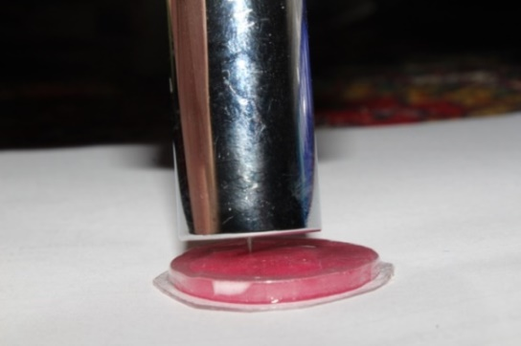
Figure 2 sample geometry and dimensions according to ASTM D 638-02a

Figure 2 sample geometry and dimensions according to ASTM D 638-02a

Figure 1 hardness measurement using Shore hardness apparatus (HT- 5610 D)

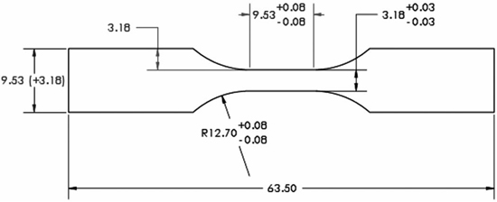

Figure 3 elastic modulus measurements using universal testing machine

Figure 2 sample geometry and dimensions according to ASTM D 638-02a

Results and discussion
Descriptive statistics for hardness and elastic modulus
Means and standard deviation (SD) of the hardness and elastic modulus of clear aligners from three companies are listed in table 1. The mean hardness recorded for the Clear aligner 0.5mm ranged between 75.26 to 80.096, from 74.88 to 78.588 for Leone 0.8mm and ranged from 76.74 to 80.46 for Duran 1mm. The mean Elastic modulus obtained for the Clear aligner 0.5mm ranged between 2050 to 2250 MPa, from 1120 to 1500 MPa for Leone 0.8mm and ranged from 2100 to 2500 MPa for Duran 1mm (table 1).Significant difference among the tested groups for when comparing the elastic modulus results (table 2). Tukey honestly significant difference (HSD) test was used after ANOVA to compare among the aligners to find means that are significantly different from each other (Table 3) and as follow:

There was significant difference between clear aligner 0.5mm and Leone 0.8 mm with higher elastic modulus means for clear aligner 0.5mm. There was no significant difference between clear aligner 0.5mm and Duran 1 mm.

There was significant difference between Leone 0.8 mm and Duran 1 mm with higher elastic modulus means for Duran 1mm.

Discussion
Thermoplastic materials are excellent in aesthetic appearance, easy to be formable and simple to use. However, investigations and researches on aligners are very limited and their scientific features are not well studied. In order to produce accurate and predictable tooth movement, practitioner should know the limitation of aligner treatments. Therefore, researches on the aligner materials properties will provide the necessary information that can address some of the problems and limitations that accompany the aligner orthodontic treatment. For this reason, this study compares the mechanical properties of aligner materials from three brands to find the suitable properties for best aligner action. It is worth to mention that this study is first study that uses Shore D hardness test to measure the hardness of orthodontic aligner, the first study that uses Leone 0.8mm sheets for research purposes.

The mechanical properties of thermoplastic materials are affected by their molecular structure and environmental condition⁾⁽¹¹⁾. All materials were tested under the same conditions and in the exact testing environment. Despite the fact that all the three aligners brands were made from the same material (PET-G), Leone 0.8mm was less than Duran 1mm and Clear aligner 0.5mm in the elastic modulus. This could be explained by the presence of additive materials in the structure of Leone thermoplastic sheets which could affect their elasticity as described by the materials data sheets. Elastic modulus of Duran and Clear aligner obtained from this study coincide with those provided by their data sheets.

Hardness test for the three brands showed no significant differences among them. This can be explained by the fact that all materials were made from the same material (PET-G), thermoformed under the same conditions and made in equal sample geometry.
These finding agree with the hardness specified by the Duran and Clear aligner data sheets. Data sheets of Leone 0.8mm do not contain information about hardness and there was no previous research on this material to compare with.

Table 1 Descriptive statistics of the hardness and elastic modulus tests of different aligners
Property | Types of aligners | Mean | S.D. | Min. | Max.
Hardness | Clear aligner 0.5 mm | 77.984 | 1.702 | 75.26 | 80.096
Hardness | Leone 0.8 mm | 77.269 | 1.212 | 74.88 | 78.588
Hardness | Duran 1 mm | 78.717 | 1.411 | 76.74 | 80.46
Elastic  modulus  (MPa) | Clear aligner 0.5 mm | 2128 | 58.271 | 2050 | 2250
Elastic  modulus  (MPa) | Leone 0.8 mm | 1239.500 | 117.295 | 1120 | 1500
Elastic  modulus  (MPa) | Duran 1 mm | 2227 | 129.362 | 2100 | 2500

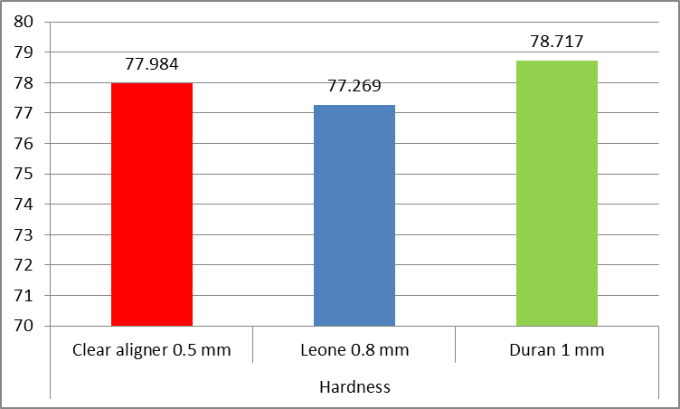
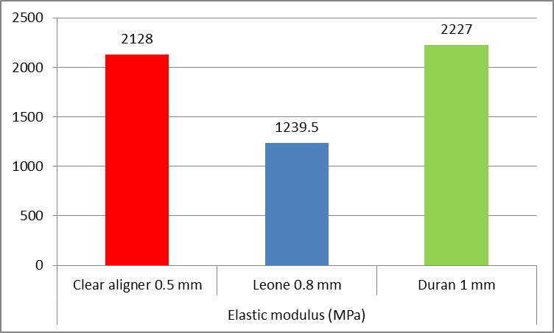
Figure 5 Elastic modulus of different aligners

Figure 4 hardness tests of different aligners

Property | ANOVA | Sum of Squares | d.f. | Mean Square | F-test | p-value
Hardness | Between Groups | 10.490 | 2 | 5.245 | 2.475 | 0.103
Hardness | Within Groups | 57.228 | 27 | 2.120 | 2.475 | 0.103
Hardness | Total | 67.718 | 29 |  | 2.475 | 0.103
Elastic  modulus  (MPa) | Between Groups | 5914631.667 | 2 | 2957315.833 | 261.802 | 0.000
Elastic  modulus  (MPa) | Within Groups | 304992.500 | 27 | 11296.019 | 261.802 | 0.000
Elastic  modulus  (MPa) | Total | 6219624.167 | 29 |  | 261.802 | 0.000

Table 2 Comparing the hardness and elastic modulus tests among aligners

Types of aligners |  | Mean  Difference | p-value
Clear aligner  0.5 mm | Leone 0.8 mm | 888.500 | 0.000
Clear aligner  0.5 mm | Duran 1 mm | -99.000 | 0.112
Leone 0.8 mm | Duran 1 mm | -987.500 | 0.000
Table 3 Tukey HSD after ANOVA for Elastic modulus

Conclusion
There is no significant difference in hardness among all the three materials used in this study. The elastic modulus of Duran 1mm and Clear aligner 0.5mm showed no significant difference and both are significantly higher than Leone 0.8mm.further studies could be conducted to Measure the hardness and elastic modulus of the aligner materials after clinical use.

Acknowledgements
I would like to express my appreciation, respect, and gratitude to my supervisor Assist. Prof. Dr. Sami K. Al-Joubori. Unlimited gratitude goes to Assist. Prof. Dr. Mohammed Nahidhfor his continuous assistance starting from clinical works to theoretical advices and his help in performing the statistical works.

I must express my very profound gratitude to my parents and to my wife for providing me with unfailing support and continuous encouragement throughout my years of study and through the process of researching.This accomplishment would not have been possible without them. Thank you

References

Dasy H, Dasy A, Asatrian G, Rózsa N, Lee H-F, Kwak JH. Effects of variable attachment shapes and aligner material on aligner retention. The Angle Orthodontist. 2015;85(6):934-40.

Kohda N, Iijima M, Muguruma T, Brantley WA, Ahluwalia KS, Mizoguchi I. Effects of mechanical properties of thermoplastic materials on the initial force of thermoplastic appliances. Angle Orthod. 2013;83(3):476-83.

Tuncay OC. The invisalign system. London: Quintessence; 2006.

Cowley DP, Mah J, O'Toole B. The effect ofgingival-margin design on the retention of thermoformed aligners. J Clin Orthod. 2012;46(11):697-702; quiz 5.

Ryu J-H, Kwon J-S, Jiang HB, Cha J-Y, Kim K-M. Effects of thermoforming on the physical and mechanical properties of thermoplastic materials for transparent orthodontic aligners. Korean Journal of Orthodontics. 2018;48(5):316-25.

American Society for T, Materials, Rubber ACDo, Subcommittee DoPT. Standard test method for rubber property : durometer hardness2016.

Rola WA-R. The effect of two types of disinfectant on shear bond strength, hardness, roughness of two types of soft liners. Journal of baghdad college of dentistry. 2012;24(2):27-31.

Ahn H-W, Kim KA, Kim S-H. A new type of clear orthodontic retainer incorporating multi-layer hybrid materials. Korean Journal of Orthodontics. 2015;45(5):268-72.

Astm. Standard test method for tensile properties of thin plastic sheeting. West Conshohocken, PA: ASTM; 2002.

Materials ASfT. Standard test method for tensile properties of plastics. West Conshohocken, Pa.: The Society; 2004.

Buchdahl R. Mechanical properties of polymers and composites – Vols. I and II, Lawrence E. Nielsen, Marcel Dekker, Inc., New York, 1974, Vol. I 255 pp. Vol. II 301 pp. Vol. I $24.50, Vol. II $28.75. Journalof Polymer Science: Polymer Letters Edition. 1975;13(2):120-1.

Author Biblography

 | Hussein Shakir Saleh Al Noor  Post graduate student in orthodontic department-college of dentistry/university of Baghdad  Email: Hussein.alnoor@yahoo.com
 | Sami Kadhum. Al-Joubori  Assist. Prof., Department of Orthodontics, College of Dentistry, University of Baghdad  Master degree in orthodontics  Email: samikadhum76@gmail.com

