Activity
Do it yourself: Metadata for FAIR cultural heritage put into practice

Part 1 (15 minutes):
- Form a group (of up to 4 people)
- Have a look at the example dataset below in your group (10 minutes).
- Using the Handout with links, decide:
- What are the data?
- How would you describe this data set in terms of generic metadata? (5 minutes)
- What domain specific metadata would it contain? (5 minutes)
- What vocabulary/vocabularies would you use to standardise your terminology and make it understandable to anyone? (5 minutes)
- Make sure to write key findings on the flip-over boards during the exercise.

Part 2 (15 minutes):
With a DOI provided by the instructors, you can then look at the dataset and its accompanying metadata in the repository and read the detailed metadata to find out more about what metadata standards and vocabularies have been used.

This exercise, and the accompanying resources, have been adapted from an original exercise created by Cees Hof, Pascal Flohr, and Tamara van Zwol.

Example Dataset:

Ordnance Survey Memoir Drawings
About the collection:
Scans of drawings made as part of the Ordnance Survey (OS) Memoirs scheme (Ireland) [more info about Ordnance Survey here]. Originally, the OS Memoirs were meant to accompany the first edition maps and include information about the populations, landscape, and society that inhabited the mapped regions. The scheme was abandoned due to costs in 1839-1840 before the project was completed.

About the project/deposit:
The collection was deposited in the Digital Repository of Ireland by the Royal Irish Academy. The project is called OS200: Digitally Re-Mapping Ireland’s Ordnance Survey Heritage. The project aims to gather historic Ordnance Survey (OS) maps and texts to form a single freely accessible online resource for academic and public use. This digital platform will reconnect the First Edition Six-Inch Maps with the OS Memoirs, Letters and Name Books and in doing so will enable a team of researchers from across Ireland - north and south - to uncover otherwise hidden and forgotten aspects of the life and work of those employed by the OS as they mapped and recorded landscapes and localities.

About the data:
This collection contains both cropped images of the drawings as well as the full page scan(s) of the manuscript page or pages referring to the drawing.

An example of one of the photographs in the collection:

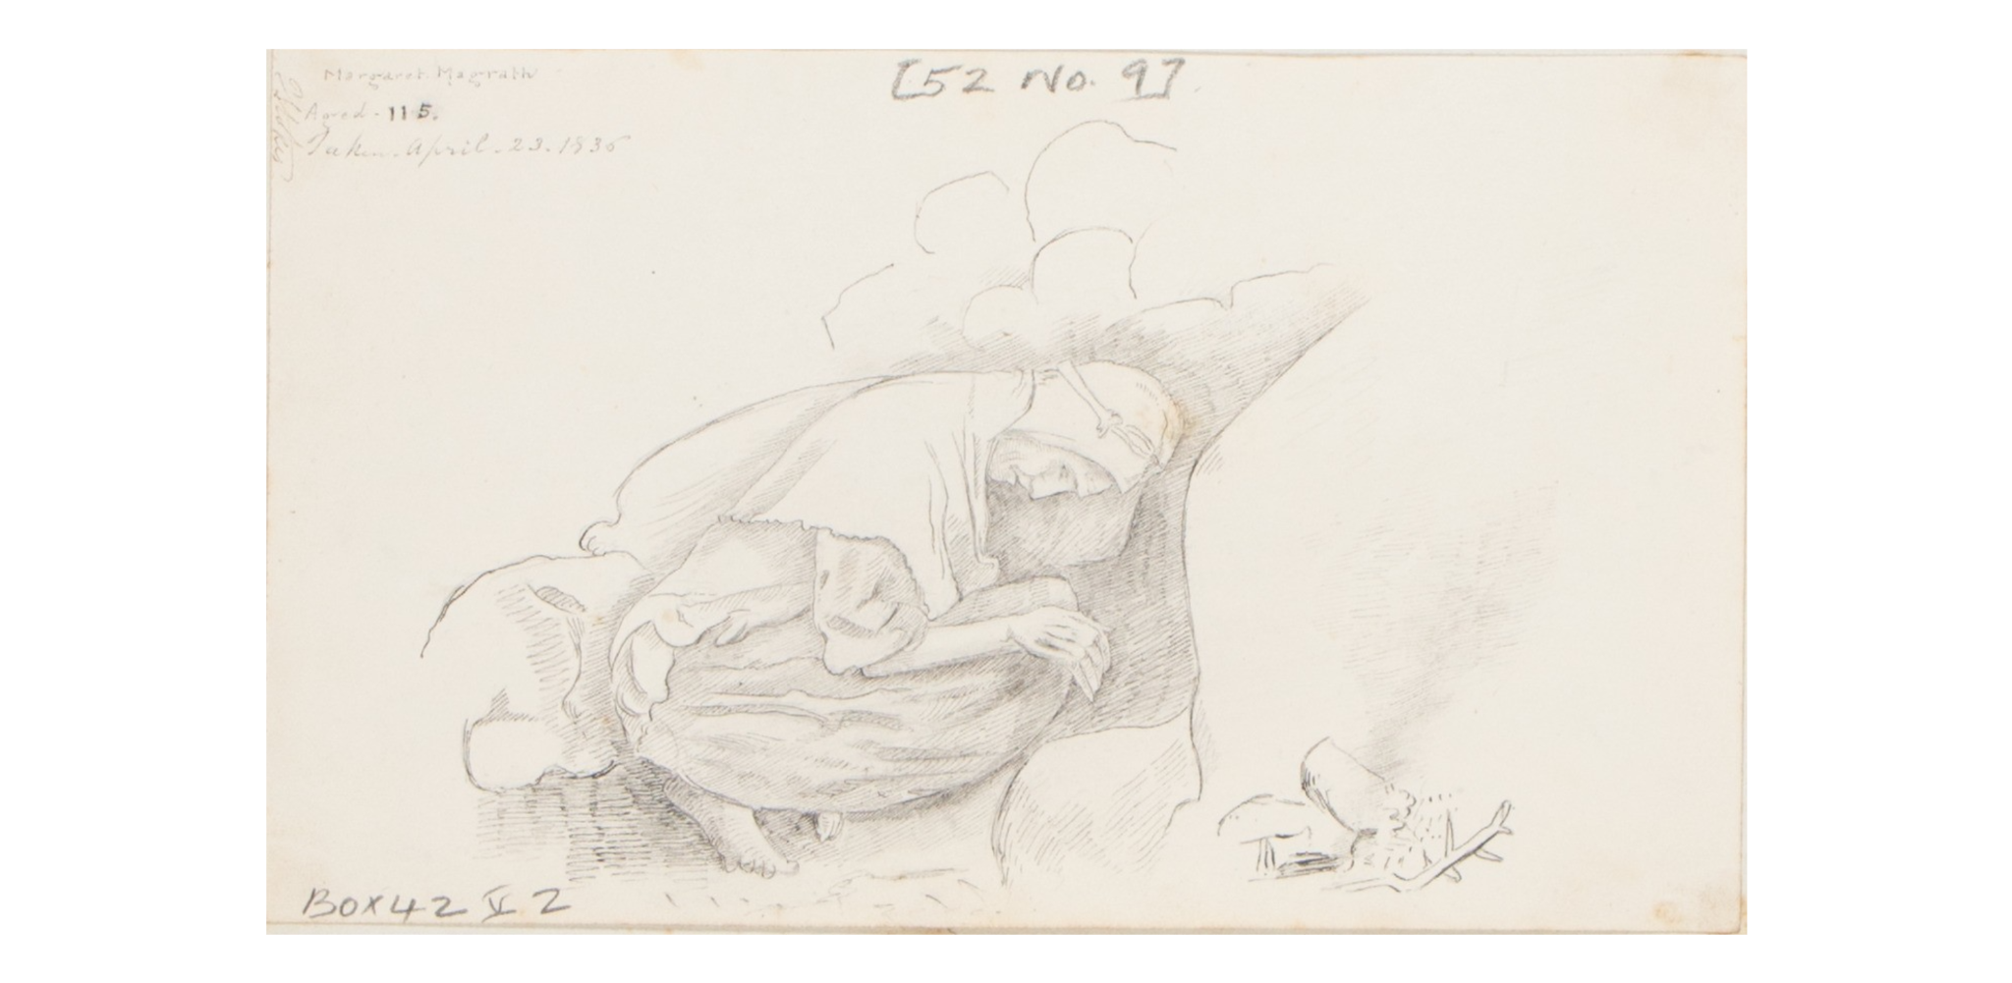
Brief description: Drawing of an elderly woman from Moneygran townland with stones and other object beside her, shown crouched in a foetal position.|See Ordnance Survey Memoirs of Ireland, v.27, 1994, pp.117-118

Questions:

What is the data?

How would you describe this data set in terms of generic metadata?

What domain specific metadata would it contain?

What vocabulary/vocabularies would you use to standardise your terminology and make it understandable to anyone?

Part 2:

Let’s take a look at the dataset together, in the Digital Repository of Ireland (DRI)

Ordnance Survey Memoir Drawings

DOI:

10.7486/DRI.w376h139n
Title
Ordnance Survey Memoir Drawings
Description
Scans of drawings made as part of the Ordnance Survey Memoirs scheme. Originally, the OS Memoirs were meant to accompany the first edition maps and include information about the populations, landscape, and society that inhabited the mapped regions. The scheme was abandoned due to costs in 1839-1840 before the project was completed. This collection contains both cropped images of the drawings as well as the full page scan(s) of the manuscript page or pages referring to the drawing.
Creators
OS200 Royal Irish Academy
Creation Date
2024 June 21
Published by Digital Repository of Ireland
19/06/2024
Full reference:

OS200, Royal Irish Academy. Ordnance Survey Memoir Drawings. Collection [Type]. Digital Repository of Ireland (2024) [Publisher]. Royal Irish Academy [Depositor]. https://doi.org/10.7486/DRI.w376h139n (Accessed: 2024/10/15)

