Global Journal of Engineering Science and Researches
ANALYSIS OF CHANGE IN SHAPE OF SUCTION MANIFOLD TO IMPROVE PERFORMANCE OF POLTPROPYLENE CENTRIFUGAL PUMP USING CFD
Amandeep Singh^{*1}, Parveer Kumar² & Kedar Mainali³

ABSTRACT
Centrifugal pumps are broadly used for irrigation, water supply plants, steam power plants, sewage, because of their suitability in practical service. Hence it is crucial to find out the design parameters and working conditions that result optimal output and maximum efficiency with lowest power consumption. Study shows that CFD (Computational fluid dynamics) analysis is being increasingly applied in the design of centrifugal pumps. The suction side of the pump typically consists of a single pipe of a nominal bore same as or greater than the delivery pipe. This arrangement may not be effective for higher capacity pumps used in the industry or public distribution system. The effort of this dissertation work would be to identify suitable configuration for the suction side of the Centrifugal Pump to enhance the utilization of the power. ANSYS Fluent would be used to evaluate the variants for the intake manifold for determining the discharge and the pattern of flow of water through the manifold. Minimal pressure drop combined with a high value of discharge would be the criteria for assessment of the variants.

Keywords: Computational fluid dynamics, Centrifugal pump, ANSYS fluent, Power consumption

- INTRODUCTION

The centrifugal pump is a member of family referred to as rotary system pump consisting of fundamental components including impeller (rotary element) and volute (casing) or stationary element. A centrifugal pump delivers beneficial energy to the fluid in pump largely via pace modifications that occur as this fluid flows thru the impeller and the associated fixed passage ways of the pump. It is conversion of mechanical energy to hydraulic energy for dealing with fluid to get it to a required height or place by using the centrifugal force of the impeller blade. The input to the centrifugal pump is the mechanical energy such as provided by electrical motor however; the output power is hydraulic lift to the fluid. In a centrifugal pump, the liquid is forced by atmospheric or other pressure into fixed rotating vanes. A centrifugal pump consists of a set of rotating vanes enclosed inside a housing or casing that is used to impart power to a fluid thru centrifugal pressure. A pump transforms mechanical energy from some external supply and imparts it to the liquid flowing via it in addition some losses occur in power conversion. The power transferred is anticipated with the aid of the Euler Equation.
The performance of pumps depends upon variety of hydraulic concerns which include net positive suction head, suction glide situations and running range in terms of flow and head. Although net high quality suction head are properly understood and properly addressed in the layout of pumping stations, the sizing and arrangements of suction manifold is based on top enterprise practice recommendations. Poor go with the flow situations in suction manifolds can cause non-uniform distribution of flow throughout the pipe, causing pump vibration. Due emphasis needs to be paid at the bends, tees and configuration of manifolds for flow imbalance and swirling. For a normal pumping station with more than one pump, the suction pipe work accommodates a manifold located either inside or outside the pumping station. From which individual suction lines run to the pump. The individual suction lines encompass an isolation valve. The inclination of the suction line to the manifold should range among 90⁰ for small pumping stations to 45⁰ for large pumping stations. All of the tees, bends, tapers and valves influence the stream as it travels to the pumps.

“Each unit of energy saved by the application contributes to conservation for the environment and in the direction of green Earth. Each inch of enhancement inside the `head' on the output side adds to the efficacy of the pumping system. These work objectives at enhancing the overall performance of the device with a focal point at the suction side while contributing to the worldwide effort in upgrading the overall performance. This work is applicable within the context of reducing power consumption or enhancing the net suction head of the pumping system".

- MATERIALS AND METHODS

- Material
This paper work deals with the Polypropylene Centrifugal pumps that are used to transport fluids by the conversion of rotational kinetic energy to the hydraulic energy.
- Methodology

- Mathematical model: In mathematical version, the empirical formulae of the Engineering area can be implemented to get the preferred answer for the problem. There are techniques to calculate the pressure drop, specifically; the Bisection technique and the modified Newton Raphson technique. In our case we can use the modified Newton Raphson technique. Inside the modified Newton-Raphson technique we approximate the Jacobian (which is altered in every iteration, via a fixed matrix. Now, we don’t have to re-compute the Jacobian in every generation, nor will we need to resolve the linear equation (invert the Jacobian) in each new iteration.

- Analytical Method: This is nothing but the computational approach. This approach offers the simplicity and facilitates us to solve the problem with robustness. The software programs used can be in Finite element analysis (FEA) domain. The analytical model is then further divided in three parts particularly; Preprocessing, solving, post processing. The preprocessing may be achieved in modeling software which includes CATIA after which followed via solver GAMBIT/ANSYS and post processing may be in ANSYS FLUENT. Right here the end result of the mathematical model will be compared with the result obtained from the computer process is performed in these steps. The methodology of CFD analysis has been shown by flow chart given below in figure
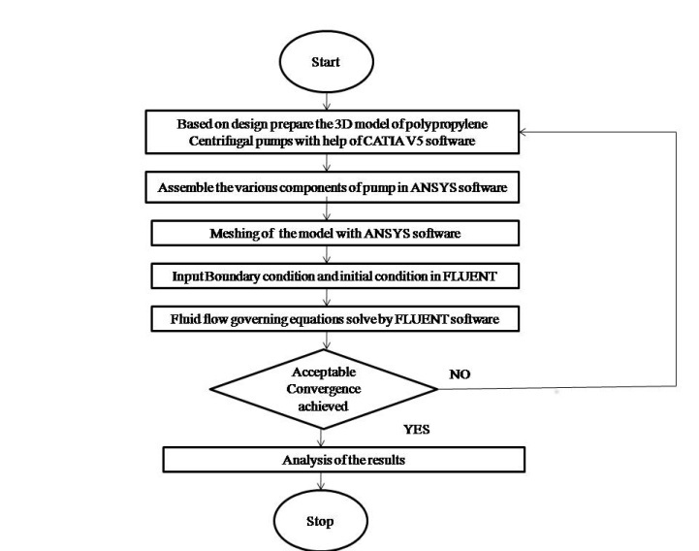
Figure 1 Flow chart for methodology

- 3D Modeling

- 3D Modeling of pump component
3D modeling of pump is the first step of CFD analysis. For the present study CATIA V5 software has been used for creating 3D model of casing and impellor. CATIA V5 is most user friendly software though which complicated geometry easily can be created.

- Creating 3D model for casing part and impeller

Table 1 Parameter type
Parameters | Type
Component type | Polypropylene Centrifugal pumps
Configuration Type | Axial
Rotation type | Negative
Model units | meter

Table 2 Suction pipe parameter
Sr. No. | Diameter | Length | Velocity
1 | 76.2 | 3 | 0.548201
2 | 76.2 | 1 | 0.548201
2 | 63.5 | 1 | 0.394705
2 | 63.5 | 1 | 0.394705
3 | 76.2 | 1 | 0.657842
3 | 44 | 1 | 0548201
3 | 44 | 1 | 0.548054
3 | 44 | 1 | 0.548054

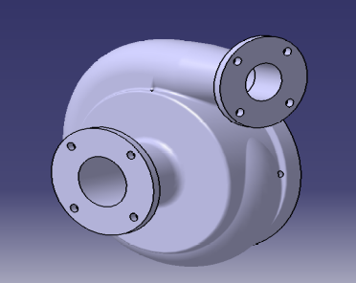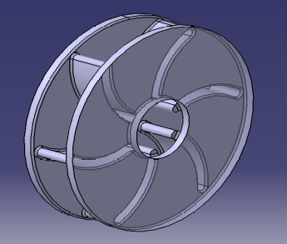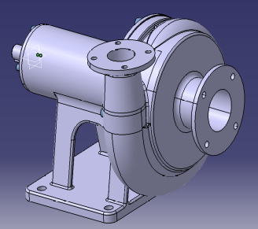
Figure 2 Casing Part Figure 3 3D model of impeller Figure 4 Polypropylene Centrifugal pumps in CATIA V5 software

- MESHING IN ANSYS

The goal of meshing in ANSYS Workbench is to provide robust, easy to use meshing tools that will simplify the mesh generation process. These tools have the benefit of being highly automated along with having a moderate to high degree of user control.

Overview of the Meshing Application Interface
The meshing application interface is shown in figure below

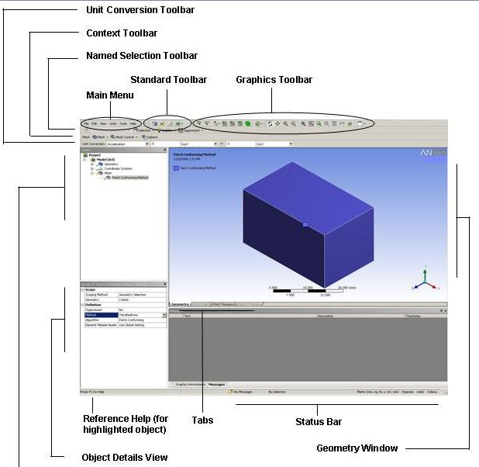
Figure 5 Meshing Application Interface

Generate Mesh

When you are ready to compute the mesh, you can do so by using either the Update feature or the Generate Mesh feature. Either feature computes the entire mesh. The surface mesh and the volume mesh are generated at one time. The mesh for all parts/bodies is also generated at one time. For help in understanding the difference between the Update and Generate Mesh features, see Updating the Mesh Cell State. For information on how to generate the mesh for selected parts only, refer to Generating Mesh. The Previewing Surface Mesh and Previewing Inflation features are also available if you do not want to generate the entire mesh at one time

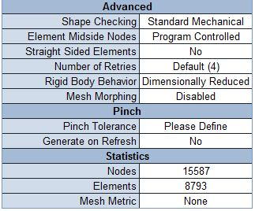
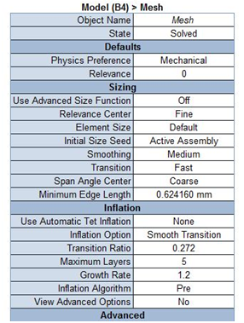
Figure 6 Meshing parameters of the crankshaft using ANSYS
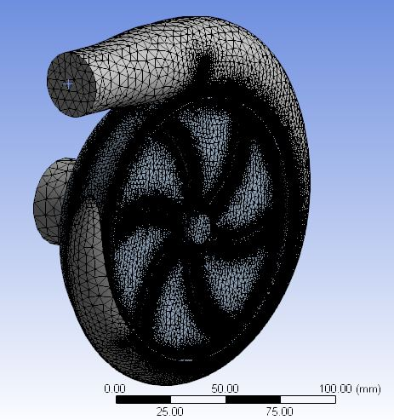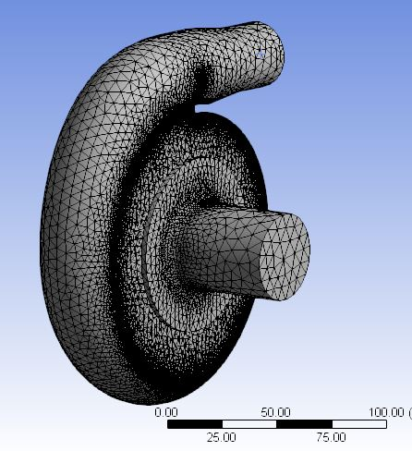

Once the mesh is generated, you can view it by selecting the Mesh object in the Tree Outline. You can define Section Planes to visualize the mesh characteristics, and you can use the Show Worst Elements Show Worst Elements feature to view the worst quality element based on the quality criterion for a selected mesh metric.

- RESULTS AND DISCUSSION

The result shows that how to design the suction side. The efficiency of the centrifugal pump can be increased by number of ways such as modifying the geometry of the sump, increasing the diameter of the suction pump, having multiple pumps working in series, etc. This results in better suction of the working fluid and as a result of it the mass flow rate of the fluid increases which directly increases the efficiency of the pump by reducing the motor HP and hence reducing the operational cost of the centrifugal pump.

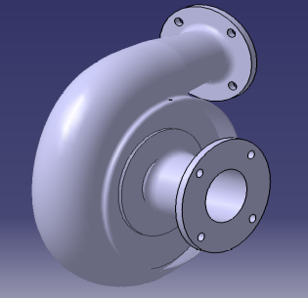
Figure 7 Suction shape

In the similar way we can create all the models in CATIA for analysis. The following Figure shows a model of variants shape of manifold. The model which is prepared in CATIA V5 is imported to new pre-processing software called ANSYS for entering the boundary conditions and for tetrahedral meshing of the given geometry. Element Size of meshing is 5. The more fine mesh you perform the more accurate the result you will get in ANSYS FLUENT, but the fines mesh also increases the duration of the result along with the size of the file.
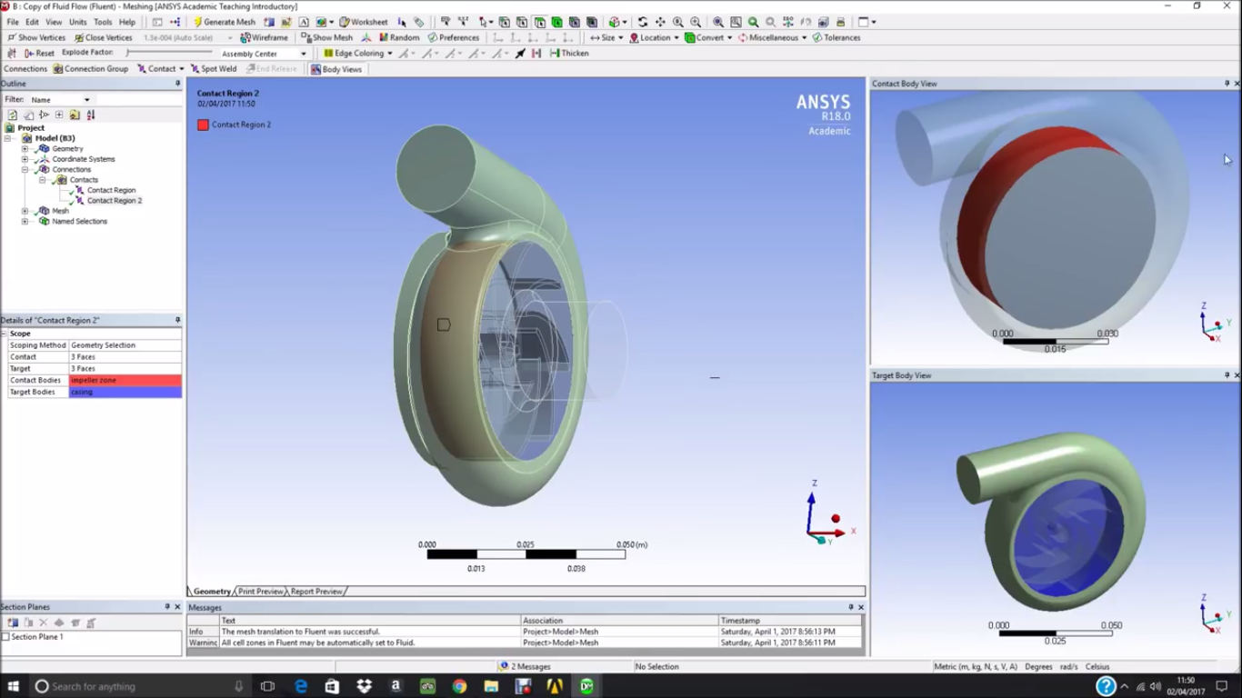
Solving: For solving we are using ANSYS Fluent Solver. In this interface following parameters used:

Table 3 Parameters
System type | Analysis type | Model | Fluid Used | Mass flow rate at inlet | Temperature
Pressure based system | Steady state condition | k-epsilon with realizable model | Water | 2.5 kg/s | 27⁰C

Contours for design condition
The total pressure variation in the pump components obtained though the numerical simulation is come in the form of pressure contours are shown below in the figure 6.1, 6.2 & 6.3. The runner is the most critical part of pump for the simulation. The total pressure varies from hub to tip of the impeller. It has been found maximum pressure obtained at the tip of the runner as shown in figure 6.1. The variation of pressure in the impeller is shown below in figure 7.2.

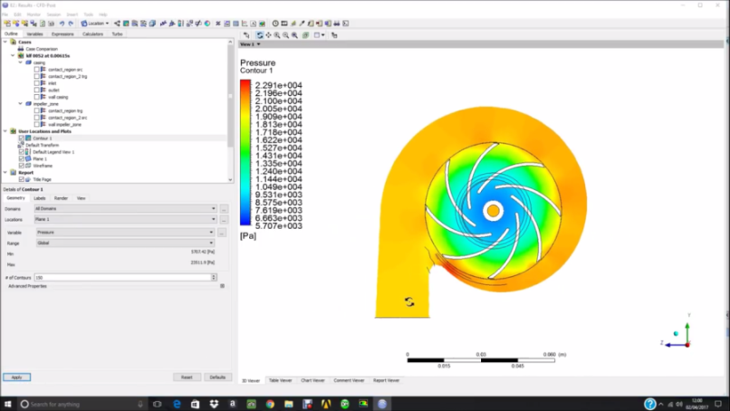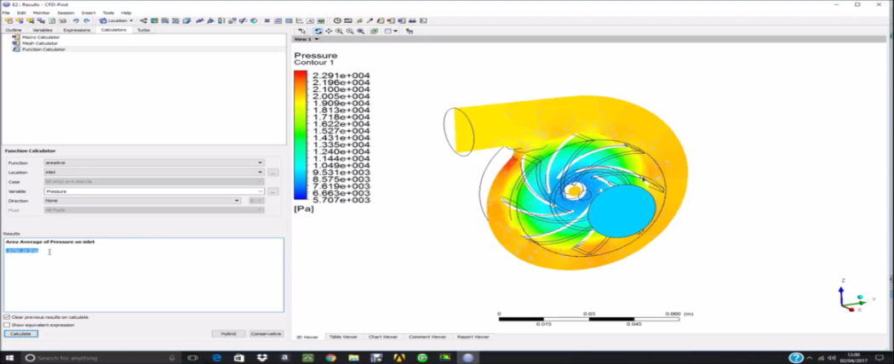
Figure 8 Maximum total pressure 137.7397 Pa. on impeller

Fig shows that pressure plot in Pascal. At inlet is more and decreases as gradually along the length. Color strip shows indicate the different pressure level. Blue color indicates the minimum pressure level and red color indicate the max pressure level. The variation of total pressure in tubular casing with draft tube is shown below in figure 7.3. It has been found maximum value of pressure obtained at inlet of the casing and the total pressure has minimum value at the inlet of draft tube.

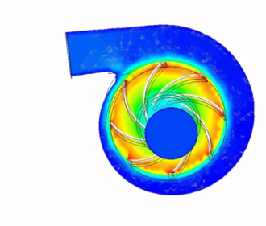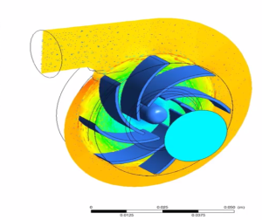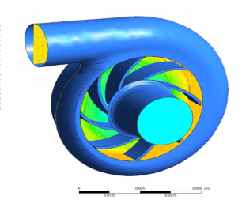
(A) (B) (C)

Figure 9 (A) Velocity contour in pump 0.548054 m/s (B) Velocity vector in pump o.548054 m/s (C) Velocity vector at impeller 0.548054 m/s with casing
Velocity Plot:
Velocity plot shown in fig. color strip shows the different velocity levels in geometry. At wall on pipe velocity is minimal and at the centre of pipe velocity is max. Velocity vector shows the flow pattern of fluid. Vertices can be seen using this plot.

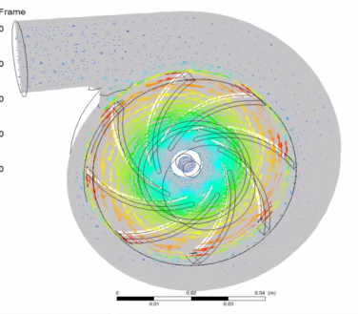

Figure 10 Velocity vector at Pump plane 0.548054 m/s

Graph Plot:
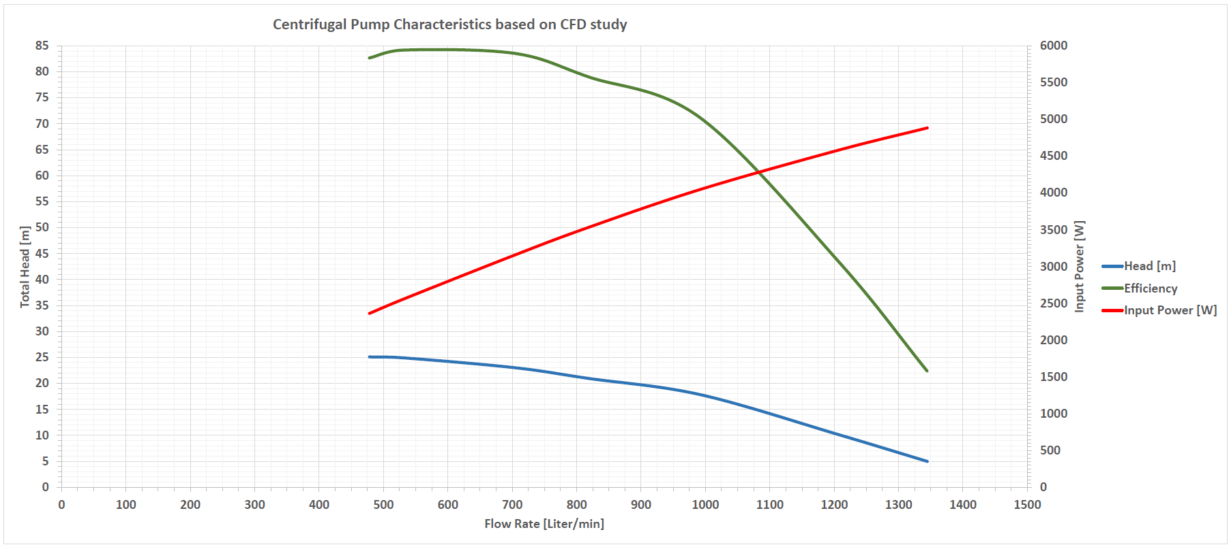
Figure 11 Graph shown in fig. centrifugal pump characteristics based on CFD.

Pressure generated due to change in diameter size
The pressure will increase due to change in diameter size. The Chart 7.2 shows the variation of the pressure with respect to diameter change.

Figure 12 pressure v/s diameter

Power generated due to change in dia. Size with respect to length
The power will increase due to change in diameter size. The figure shows the variation of the power with respect to diameter change. The power will be 0.43043 KW for the diameter of 44mm.

Figure 13 Diameter v/s Power v/s Length

- SUMMARY

The comparison between single and modified model of suction pipe proposed in our thesis can be very well represented in a tabular format, as shown below. From below table pressure drop is minimum in 2 pipe configuration. Also minimum power required for this configuration. Pressure developed in three pipe configuration is more as compared to other two variants. By changing the geometry of the three suction pipes, pressure drop and vortices get minimized.

Efficiency of this configuration is more as compared to other variants.

Table 4 Pressure developed for different diameter
Sr. No. | Diameter | Length | Velocity | Pressure Developed in Pascal | Power
1 | 76.2 | 3 | 0.548201 | 117.3169 | 0.36974
2 | 76.2 | 1 | 0.548201 | 77.55235 | 0.248601
2 | 63.5 | 1 | 0.394705 | 77.55235 | 0.248601
2 | 63.5 | 1 | 0.394705 | 77.55235 | 0.248601
3 | 44 | 1 | 0.548054 | 137.7397 | 0.430437
3 | 44 | 1 | 0.548054 | 137.7397 | 0.430437

Table shows the pressure developed (in Pascal) in polypropylene centrifugal pump at different section diameter.

- CONCLUSIONS

CFD model used to study the effect of various parameters which reduces time as well as cost and hence could become an important tool for optimization of pump sump geometry. Redesign of the suction side of the pump facilitated the flow of water and improves the discharge and consequently the performance of the centrifugal pump. .The pressure increased in the pump is very high as compared to the increase in the power consumption which is very small

- RECOMMENDATIONS

In present analysis, flow is assumed to be steady state. Instead, in future unsteady flow analysis can be carried out. Also, 3D model can be created by other CAD software such as CATIA, SOLIDWORKS etc. compare which model provide good accuracy of result. Meshing can be generated by different meshing module such ICEM-CFD and TURBO-mesh. For post processing in analysis CFX module of ANSYS-14 software can be used.

REFERENCES
- Bin Cheng, Yonghai Yu, CFD Simulation and Optimization for Lateral Diversion and Intake Pumping Stations, 2012 International Conference on Modern Hydraulic Engineering, Procedia Engineering 28 (2012), 27-32
- Honggeng Zhu, Rentian Zhang, Guoqiang Luo, Bin Zhang, Investigation of Hydraulic Characteristics of a Volute-type Discharge Passage based on CFD, 2012 International Conference on Modern Hydraulic Engineering, Procedia Engineering 28 (2012), 122 – 127
- LI Yao-jun, WANG Fu-jun, Numerical Investigation Of Performance Of An Axial-Flow Pump With Inducer,Journal of Hydrodynamics, Ser.B, 2007,19(6):705-711
- CHEN Hong-xun, GUO Jia-hong, Numerical Simulation Of 3-D Turbulent Flow In The Multiintakes Sump Of The Pump Station, Journal of Hydrodynamics Ser.B, 2007,19(1):42-47
- S.P. Asok, K. Sankaranarayanasamy, T. Sundararajan, G. Vaidyanathan, K. Udhaya Kumar, Pressure drop and cavitation investigations on static helical-grooved square,triangular and curved cavity liquid labyrinth seals, Nuclear Engineering and Design 241 (2011) 843–853

