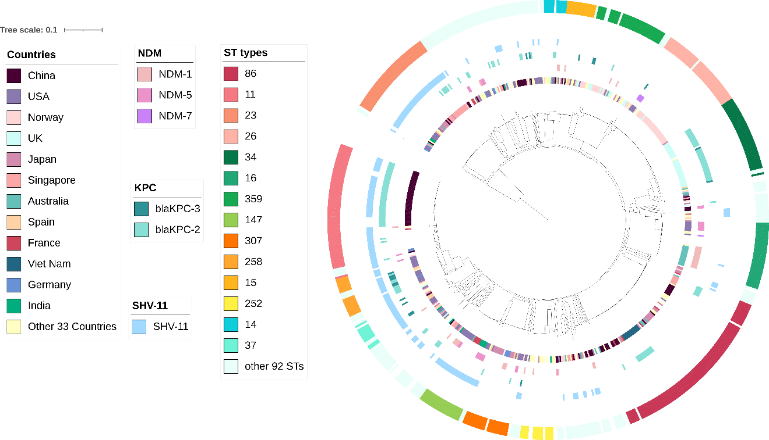

Fig S6. Distribution of β-lactamase genes that may related to decreased cefiderocol resistance in 633 Klebsiella pneumoniae strains with incomplete CirA. This phylogenetic tree, from the inner ring to the outer ring, consists of countries, NDM, KPC, SHV-11, and ST types, respectively.

