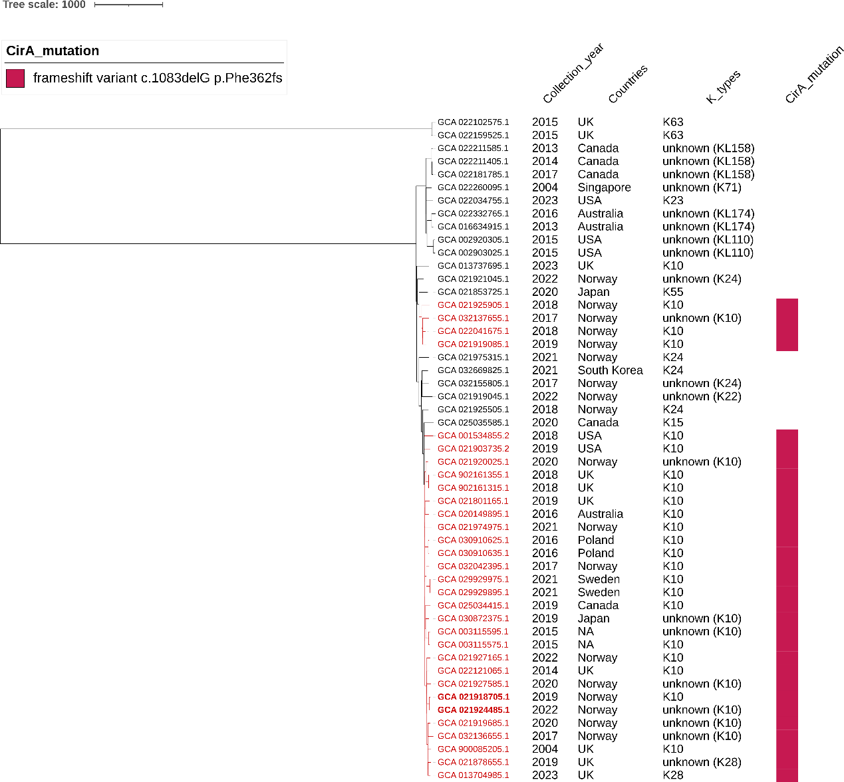

Fig S4. Phylogenomic tree of all ST359 strains from the 49,947 K. pneumoniae genomes. The annotation information of this tree from left to right are collection years, countries, K_types and CirA frameshift mutation caused by a deletion at nucleotide position 1083.

