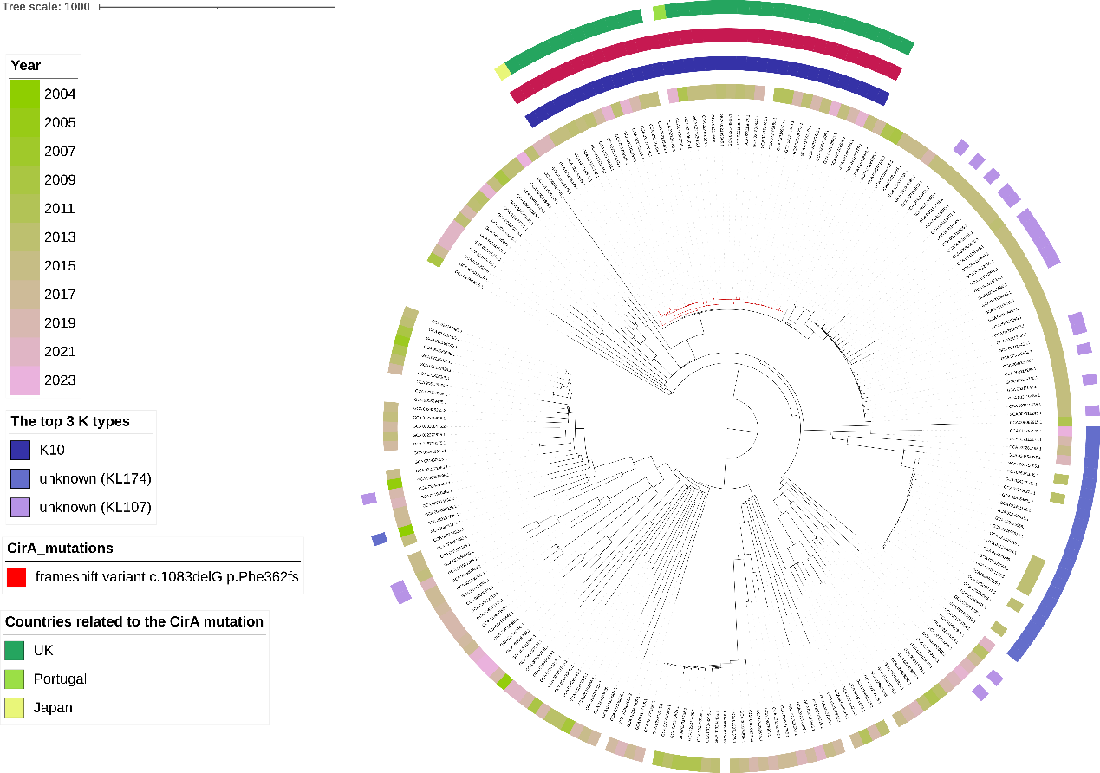
Fig S3. Phylogenomic tree of all ST34 strains from the 49,947 K. pneumoniae genomes. The annotation information of this tree from the inner circle to the outer circle are collection years, the top three K types, CirA frameshift mutation caused by a deletion at nucleotide position 1083 and countries related to this variant.

