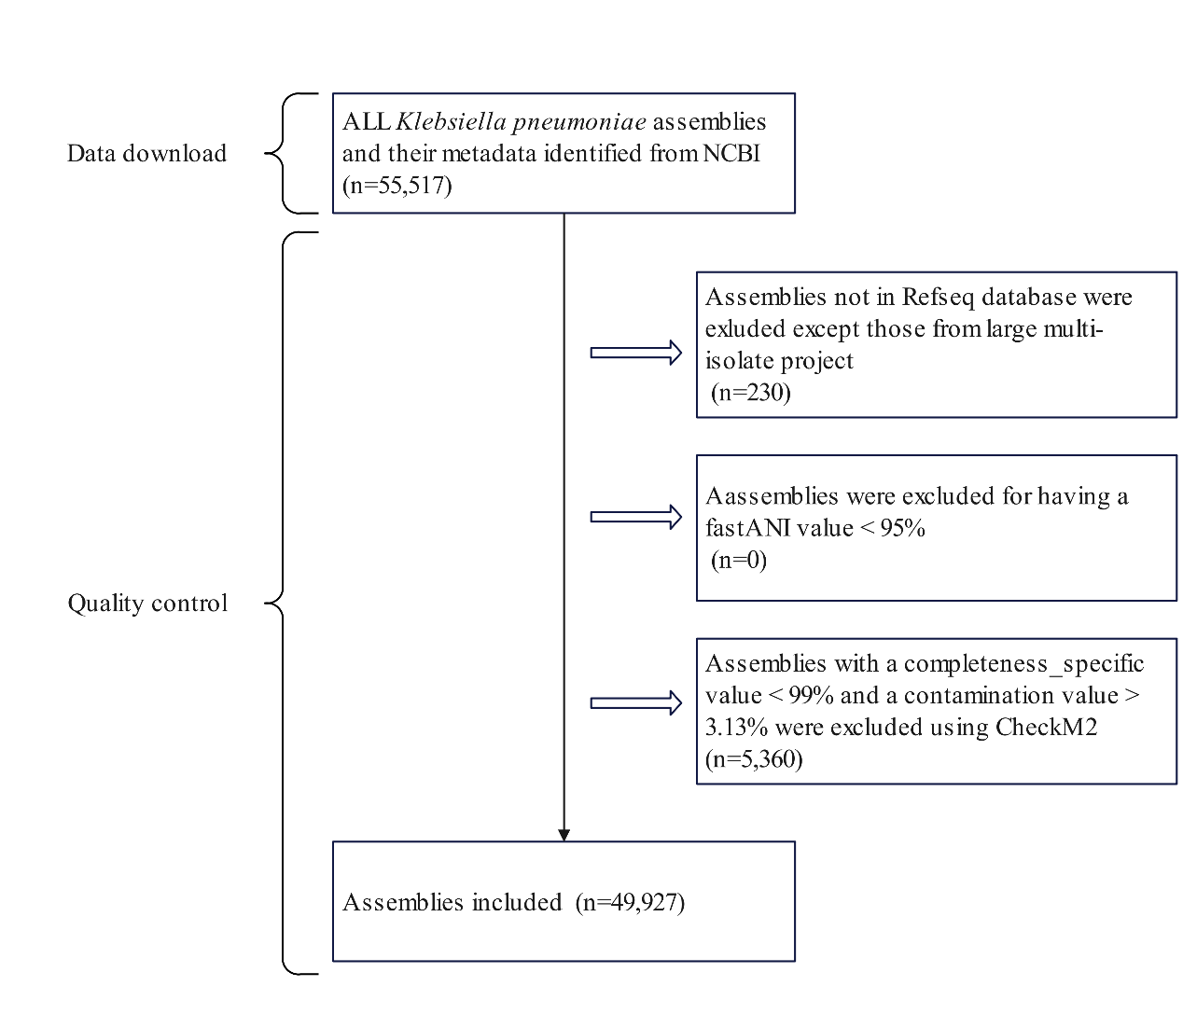

Figure S1. Flowchart of retrieving and quality control of K. pneumoniae genome assemblies

