30 m Normalized Difference Vegetation Index Maps of Pure Pixels over China for Estimation of Fractional Vegetation Cover (2014)
Tian Zhao^{1,2}, Wanjuan Song³, Xihan Mu^{1,2*}
(muxihan@bnu.edu.cn)
¹State Key Laboratory of Remote Sensing Science, Faculty of Geographical Science, Beijing Normal University, Beijing 100875, China
²Beijing Engineering Research Center for Global Land Remote Sensing Products, Faculty of Geographical Science, Beijing Normal University, Beijing 100875, China
³State Key Laboratory of Remote Sensing Science, Aerospace Information Research Institute, Chinese Academy of Sciences, Beijing 100101, China
- Introduction
Fractional Vegetation Cover (FVC) quantitatively characterizes the horizontal density of photosynthetically active vegetation. There is a high demand for accurate FVC products with high resolution in fields such as agriculture, forestry, and ecology. Due to its simplicity, the vegetation index (VI)-based mixture model is one of the most widely used methods for calculating FVC.
The accuracy and efficiency of FVC estimation using the VI-based mixture model depend on the precise calculation of two key parameters: the normalized difference vegetation index (NDVI) for fully-covered vegetation (Vv) and bare soil (Vs). Traditional statistical approaches for determining Vv and Vs often exhibit considerable errors when pure pixels are unavailable for analysis in many areas. Additionally, these approaches tend to overlook the spatial variation inherent in Vv and Vs. Using multi-angle remote sensing data, we generated 30-m maps for the NDVI of Vv and Vs across China. These pixel-wise Vv and Vs maps can be used for the accurate estimation of FVC at moderate to high resolutions.
The Vv and Vs maps were generated using the MultiVI algorithm, which integrates a directional VI-based mixture model with a gap fractional model to formulate equations for retrieving Vv and Vs. The primary data for calculating the 500 m Vv and Vs were derived from the MODIS Bidirectional Reflectance Distribution Function (BRDF) products. Subsequently, the 500 m Vv and Vs were downscaled to 30 m using spectral unmixing theory and the Globeland30 land type products. The estimated FVC using the MultiVI Vv and Vs demonstrated a root mean square deviation (RMSD) of approximately 0.1 when evaluated against field-measured FVC across different experimental sites.
- Data description
1. File description
The Vv and Vs data are stored in GeoTIFF files using the WGS-84 (World Geodetic System - 1984 Coordinate System) coordinate system with UTM (Universal Transverse Mercator Grid System) projection. The data are categorized into tiles based on a latitude size of 5° and a longitude size of 6°. The specific grids are presented below.
The file name consists of 18-bit characters with the following rules:
North-South latitude abbreviation (1 digit) + 6-degree zone number (2 digits) + "_" + Start latitude (2 digits) + "_" + Product time (4 digits) + "_ " + Resolution (3 digits) + "_ " + Data attribute (2 digits). The components are as follows:
- North-South latitude abbreviation: 'N' denotes north latitude, while 'S' signifies south latitude.
- 6-degree zone number: The UTM system divides the Earth into 60 zones, each 6° of longitude in width. Zone 1 covers longitude 180°W to 174° W; Zone numbering increases eastward to zone 60, which covers longitude 174°E to 180°E.
- Start latitude: The latitude value corresponding to the lower edge of the tile.
- Product time: Date of the product (YYYY).
- Resolution: The spatial resolution of the product.
- Data attribute: Vv represents the NDVI of fully-covered vegetation, while Vs denotes the NDVI of bare soil.
2. Data properties
Label | Value
Valid value range | 0 ~ 100
Scale factor | 0.01
Water/permanent snow | 0
- Spatial distribution
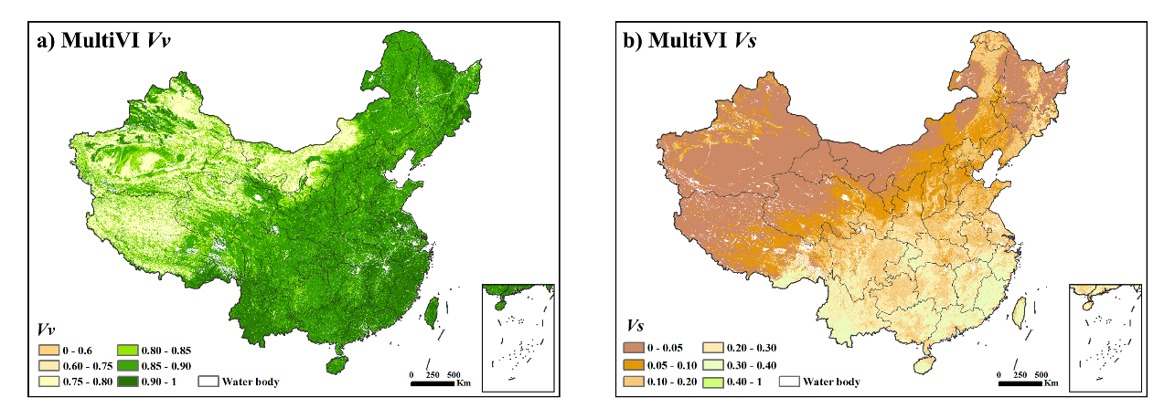
The spatial distributions of generated Vv and Vs.
- References
The data are copyrighted by the Radiation Modeling and Measurement Research Group (RAMM) at the State Key Laboratory of Remote Sensing Science, Faculty of Geographical Science, Beijing Normal University.
When using this dataset, please cite the following literature in your article:
[1] Mu, X., Song, W., Gao, Z., McVicar, T. R., Donohue, R. J., & Yan, G. (2018). Fractional vegetation cover estimation by using multi-angle vegetation index. Remote sensing of environment, 216, 44-56.
[2] Song, W., Zhao, T., Mu, X., Zhong, B., Zhao, J., Yan, G., ... & Niu, Z. (2022). Using a vegetation index-based mixture model to estimate fractional vegetation cover products by jointly using multiple satellite data: Method and feasibility analysis. Forests, 13(5), 691.
[3] Zhao, T., Mu, X., Song, W., Liu, Y., Xie, Y., Zhong, B., ... & Yan, G. (2023). Mapping Spatially Seamless Fractional Vegetation Cover over China at a 30-m Resolution and Semimonthly Intervals in 2010–2020 Based on Google Earth Engine. Journal of Remote Sensing, 3, 0101.
[4] Song, W., Mu, X., McVicar, T. R., Knyazikhin, Y., Liu, X., Wang, L., ... & Yan, G. (2022). Global quasi-daily fractional vegetation cover estimated from the DSCOVR EPIC directional hotspot dataset. Remote Sensing of Environment, 269, 112835.

