IJESRT
International Journal of Engineering Sciences & Research Technology
POWER QUALITY IMPROVEMENT ON 14 BUS IEEE SYSTEM USING UPQC
Hilal Ahmad Bhat^{*1} & Er. Ravinder Kaur²
^{*1&2}Power Engineering, Guru Nanak Dev Engineering College, India

DOI: 10.5281/zenodo.1402447
ABSTRACT
Power quality has now turned into the most important issue for equally transmitters and domestic users. People are doing efforts to enhance power quality. The custom power devices which are used for power quality enhancement are basically made from power electronic devices for example the state transfer switch (STS) and active filters. In this present work single – phase UPQC with minimum voltage angle injection control is used for 14 bus system and the result has been compared with and excluding power electronic custom power device. The required model is developed in Simulink/MATLAB and both types of loads has been applied either steady state or dynamic. The resistance and inductive loads has been inserted at the center of simulation model by turning on and off of circuit breaker, which is placed at bus 2. The output is compared in terms of real and reactive power. The system with UPQC has enhanced values of real power, voltage and current and also posse’s only minimum harmonics when load is ON and OFF. However, arrangement without UPQC is not constant and has excess harmonics in current and voltage waveforms and also high values of Total Harmonic Distortion

Keywords: IEEE 14 bus system, total harmonic reduction (THD), active power, reactive power, UPQC etc.

- INRTODUCTION
Electric power is the most important form of energy that is being used in daily life. Electricity is available almost in everywhere; the need of hour is that the power quality must be up to the mark. A perfect power supply would be one that is every time available, always remains within voltage and frequency limits, should be noise free. Power quality can be stated as“deviations from normal voltage or current”. Another way of defining power quality is that “loads ability to function properly”. Without good power quality the load may overheat, malfunction, and require high maintenance. Power quality has direct impact on electrical consumption and electrical demand. Poor electrical power increases the amps required in electrical network and vice versa. The bad power quality has a demagnetizing impact on electrical and mechanical equipment’s and it also has an impact on electricity bills. Also the main goal of power system function is to fulfill the demand at all the places inside power network reliably as possible. The electric power generation systems use the available natural resources for power generation e.g. coal, water, sunlight etc. The method of operation of these generation system is based on usefulness of centralized generators. The power coming out from these generation systems is distributed in particular areas by transmission and distribution system. In these days the power coming out from central power plants is reduced due to conventional resources are getting extinguished day by day. And at the same time cost of power transmission is increased.

- Custom power devices
Custom power devices are the electronics devices which are manufactured only for mitigation of the problems that are usually created by poor power qualities in customer and industries, so that their performance may not get affected. These devices are usually used in distribution system to sustain the constant voltage profile (power quality)

Customer power quality are classified into two types

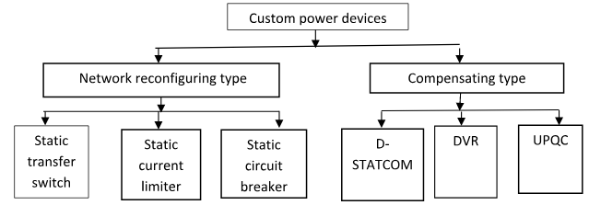
Fig 1: Custom power devices
- UPQC (Unified Power Quality Conditioner)

Each custom device has own benefits and demerits, and efficiency every custom devices depends on where it is applied. UPQC is always considered best device for the power quality problems, the reason is that the above devices which has been discussed only mitigate only one problem voltage or current harmonics. UPQC is considerably better than others, because it is only unique device which can compensate both problems at a time either supply or load harmonics.

UPQC is an important custom device usually called (line or power conditioner) is equipment used to increase the power supply quality on both sides like supply side and load side [1]. It maintains the power at desired level and the devices are not get affected due to harmonics. It comprises of shunt filter usually used for mitigation of current problems and on supply side series filter which mitigates the voltage problems. The combination of these two is called UPQC.

The UPQC is used in distribution and transmission system to maintain the power quality at desired level otherwise substation loads gets badly affected. It is nothing but only combination of filters series, and shunt. Among all the power system custom devices it is the only device which is able to mitigate the all problems occurring in power systems like current and voltage harmonics, distortion, transients, voltage fluctuations. Fig2shown below:
- Basic Components of UPQC
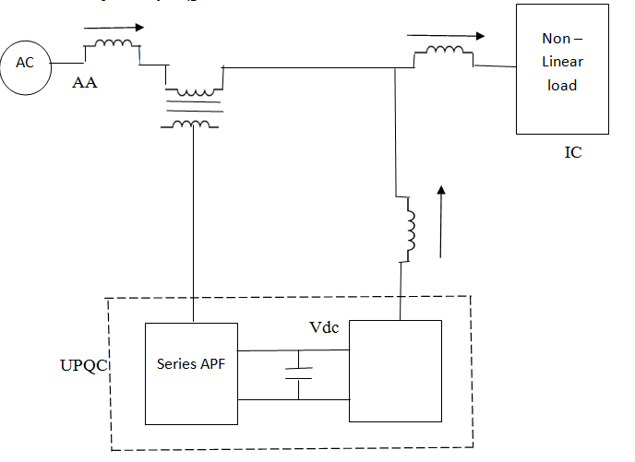
Fig2: Components of UPQC[2].
The series and shunt filters are made by IGBT. series filter is attached in supply side and shunt filter is connected in load side. Both these filters are connected on each other by a DC link sharing a common capacitor.
  - Applications of UPQC
- Voltage control in power system network.
- Medicines and semiconductor manufacturing industry
- Reactive power requirement purposes.
- Railway or other places where huge load variations occur.

  - Superiority of UPQC on other devices
Each of the devices has its own merits and demerits, and efficiency every custom devices depends on where it is applied. UPQC is always considered best device for the power quality problems, the reason is that the above devices which I have discussed only mitigate only one problem either voltage or current harmonics. UPQC is much flexible than others, because it is only unique device which can compensate both problems at a time either supply or load harmonics[2].

- LITERATURE REVIEW
M.T.L Gayatri et al. (2015) micro grids are constructed in every place, but the maintaining power quality is also challenging factor of micro grid due to distributed generation (DG) where various types of loads are connected which causes power quality issues. When micro-grid is connected isolated reactive power problem is increasing, so Var’s are increased .in this paper DVR and UPQC is used for the power factor problems and also power quality issues[3].

Janardhankotturu et al. (2016)presented construction of UPQC is stated and after that implementation of UPQC is done by using (UVT) unit vector template control strategy for getting the UPQC.in this paper after the implantation of UPQC current and voltage related problems has been resolved in non-linear loads and real power transfer is increased[4].
Chiang, HD. et al. (2016) performed investigation of divergence difficulties related with the Contained Z-bus system. They show the calculated analytical outputs to be used on divergence analysis on the IEEE 13- bus, and a practical 1101-node distribution networks. They have used combined analytical and numerical results to confirm our observations that implicit Z-bus method is suitable for a distribution network with many P-Q specified nodes or P-Q(V) nodes and only one P-V bus (at the substation), it however suffers from the divergence problem with several DGs modeled as P-V nodes[5].

SachinDevassy et al. (2016)presented the photo voltaic UPQC (PV-UPQC). shunt filter performs the dual function, it takes the supply from PV array and also mitigate the load side harmonics and distortion. The series filter mitigates the grid voltage and also supply side transients. The paper presents the dual advantage i-e clean energy generation and also improved power.it maintains the voltage and also reduces THD[2].

Mehdi Nafar et al. (2017) proposed controlling current in distribution system (3 phase,4 wire) weather load is balanced or unbalanced. UPQC is the latest custom devices used in distribution network for power quality enhancement. After UPQC is installed in 3 phase 4 wire distribution system near the nonlinear loads the benefits obtained are, currents are balanced (either load or source, Reduction in THD, voltage is available at desired level[6].

Marian Ciontn et al. (2017)proposed the series filter is controlled for improvement of power factor and reduction in THD using a very good technique phase locked loop (PLL). After the application of above technique best results have been calculated I-e power factor has been better than before and reduction in harmonics takes place[7].

Henry Shu-Hung (2018) UPQC is presented which is without transformer, UPQC is made of two inverters shunt and series controller.in this paper shunt controller is controlled by hysteresis current controller for obtaining desirable current waveform on load side. In series inverter control strategy used is boundary controller used to maintaining voltage sag during supply side. After implementation current and voltage problems are removed completely and it has the ability of fast responding of voltage variation[8].

- PRESENT WORK

- (UPQC) Unified Power Quality Conditioner
The structure of the UPQC is shown in Fig3. The UPQC comprises of basically two single-phase PWM converters which are connected back to back through a mutual dc-link capacitor and also a low-impedance transformer.
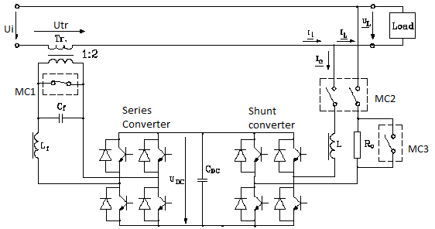
Fig3: Unified Power Quality Conditioner system

The converter which is connected in series is basically a DVR, which usually injects or extracts the required voltage component to mitigate the sag, swell etc. The converter connected in parallel is called STATCOM. The main function of STATCOM is to take the supply current to neutralize the reactive power demanded by the load for the reduction of harmonics and for controlling the voltage of dc link at a particular level. The shunt converter which is used in UPQC does not work only as active filter but also provides active power for the series converters also. The shunt converter is normally operated in hysteresis current control method so as to make the supply current and the input current at a same phase, the benefit of this is that the input power factor of the system remains at unity level.

The mode of operation of series inverters is unipolar PWM technique. When voltage problems like sag/swell occurs on input side the DVR controls the voltage at desired value by injecting or removing a part of voltage level from it to maintain the voltage at specific magnitude. [1] Basically there are two most important methods for voltage compensation at load side. When voltage disturbance takes place on supply side the DVR supply’s voltage in quadrature to make supply side sinusoidal voltage which is the basic requirement for loads to work in better condition. And the second method is that adjustment of required voltage in same phase which usually depends on supply voltage. In this method the UPQC has capacity of mitigating both voltage problems sag and swell, harmonics.

Table 1: System Rating and Circuit Parameters
System Quantities | Standards
Transformer turn ratio | 1:2
Shunt-converter inductance | 300 mH
dc-link capacitors
Shunt-converter capacitor
Pulse generator amplitude | 2
Period | .1 sec
Pulse width | 50% of period

The most important advantage of the shunt-series controller is that it does not require any energy storage. It is designed to mitigate any supply-voltage variation of a certain magnitude, independent of its duration.

The main objective is to study the variations in active power of the system which comprises load and output at various places using UPQC and without UPQC when a load being non-linear is added in a line. The better way is to solve the difficulties of consumer load effects which are getting increased and at the same time to equalize the active and reactive power of loads is to add fact devices in power systems Some systems i.e. SSSC and STATCOM has internal battery sources which can provide further energy to system but in this UPQC FACT device is explored which does not require any energy storage method. In this study, 14 bus system has been used to study the result of transmission and generation structure with and without UPQC.

- UPQC Simulink model

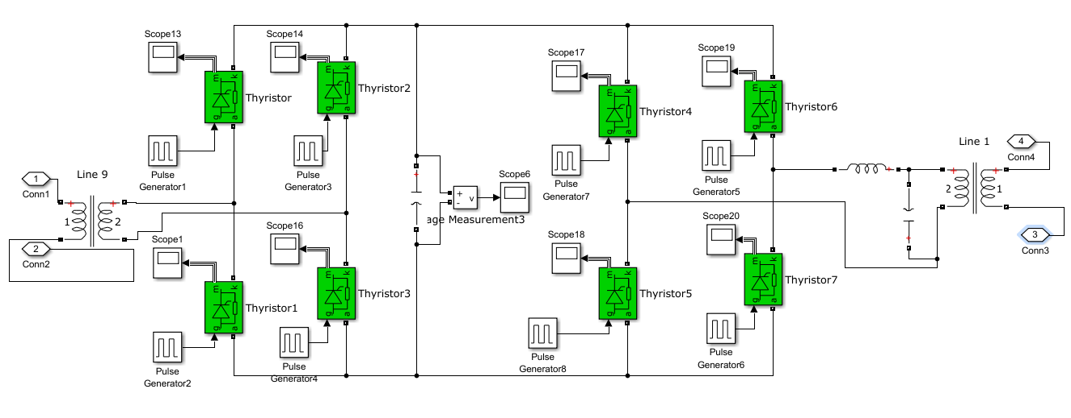
Fig4: UPQC model designed in Simulink

UPQC block has been shown above which uses series and shunt converters. Eight thyristors has been used which are triggered by pulse width generators having time period of .1 sec and on time of 50% of the time period.
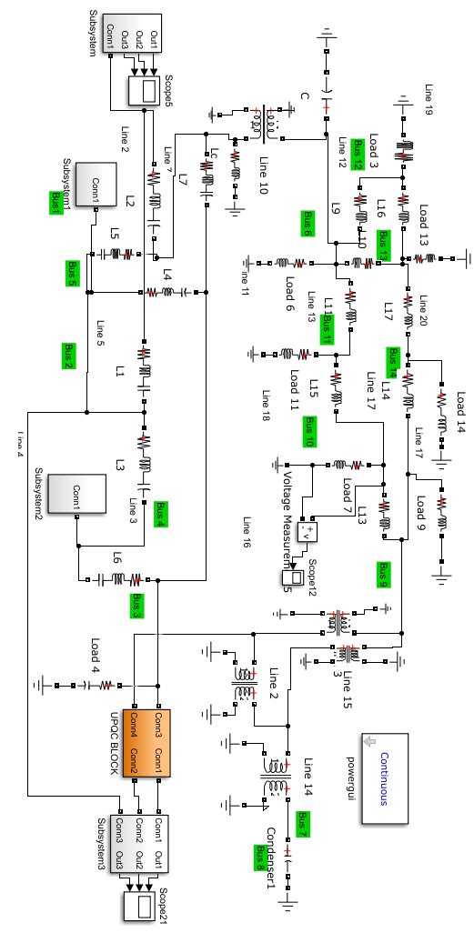
Fig 5: The Bus and line data designed in Simulink
Fig4 shows the model in which line data and bus data are given, from this data loads and impedances are made.

- RESULTS AND DISCUSSION
The result of the 14 bus model is compared with the model with UPQC and compares the results Non-linear inductive load (Load 2) has been introduced at line 3 bus 3 at time 0.1667 sec of the simulation time and keeps on with circuit breaker up to 0.5 sec. It has .8 (in pu) resistive load and (.2) inductive load. One megawatt is selected as per unit value for the power according to base power rating of the 14 bus system. It has another resistive load (Load 1) of .94 (pu) and inductive load of .19 (pu) which keeps on whole time of the simulation. The required model of fourteen bus system is constructed with the help of MATLAB and SIMULINK. The outcome of simulation of both with and without is presented in this section. The real and reactive power is being measured by PQ blocks which are used for the measurement of power quantity. The output waveforms of generators are shown in Fig6, 7 and 8. Voltage through load-1 and also load-2. The voltage reduces at time of 0.2 sec when second load is added. Total harmonic distortions in the currents has been shown in Fig12, 13, 14, 15 for generator two, load 12 and generator one respectively.

Fig 6 shows the generator voltage waveform with and without using UPQC. Voltage has fewer harmonic however current waveform has more harmonics when no UPQC is used

  - Generator output voltage.

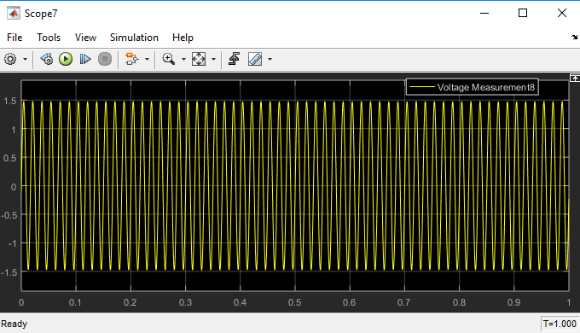
Fig 6: Output Voltage waveforms of Distributed Generator one and two

  - Voltage comparison with UPQC shown in fig 5

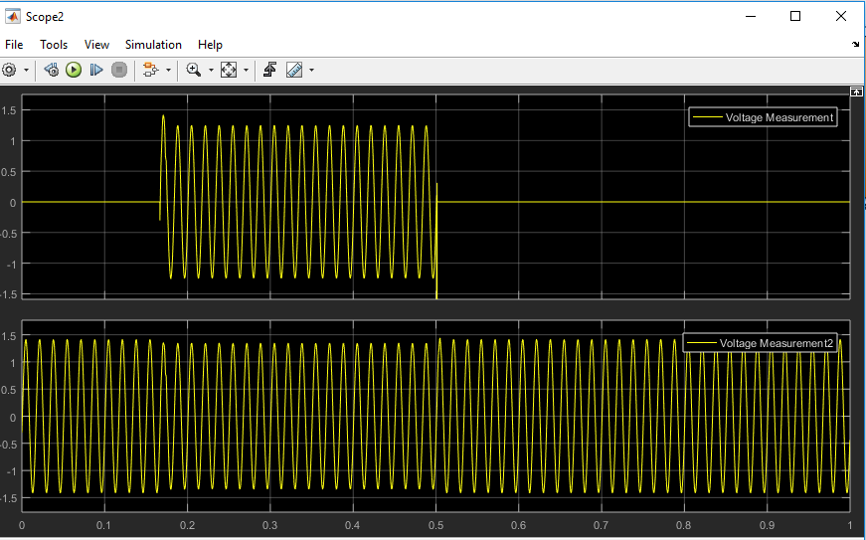
Fig7: Voltages across non-linear inductive load (load2) and Load one at Bus 3 with UPQC

Fig7 indicates the load voltage for linear and non-linear loads. The harmonics that were present in the voltage waveform have been eliminated, and a pure required sinusoidal waveform is obtained.
  - Active and reactive power, voltage and current comparison
Fig8 Shows harmonics in the waveform as no FACT device was used in the system

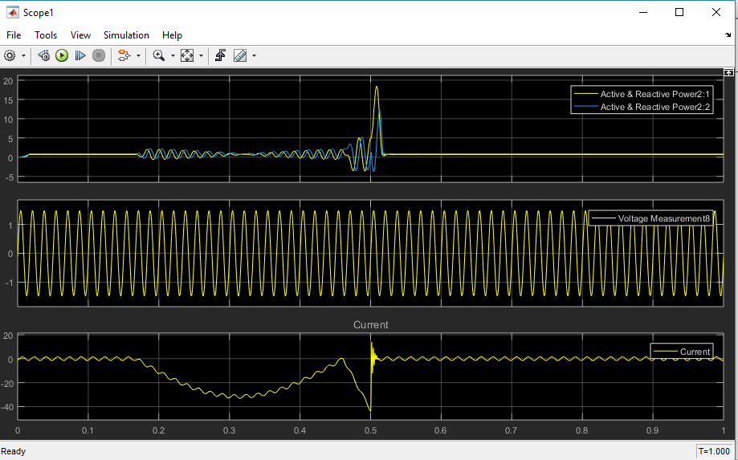
Fig8: Power (active and reactive), Voltage and also current waveforms across Generator two situated at Bus 2 without UPQC

  - Power, voltage and current comparison with UPQC
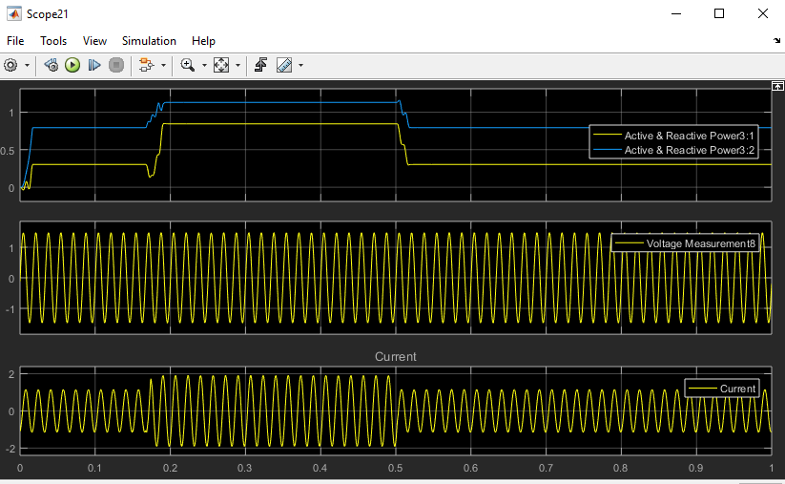
Fig9: Power (active and reactive), Voltage and current waveforms across Generator two situated at Bus 2 with UPQC
As shown in Fig9, Inductive load introduced extra inductive reactance and due to added reactance large magnetizing current would be drained from supply. As a result, the load current will lag behind the load voltage and hence we can say reactive power decreases, reducing power factor when UPQC is used in the system. System without UPQC gives harmonics.

  - Current and THD with UPQC
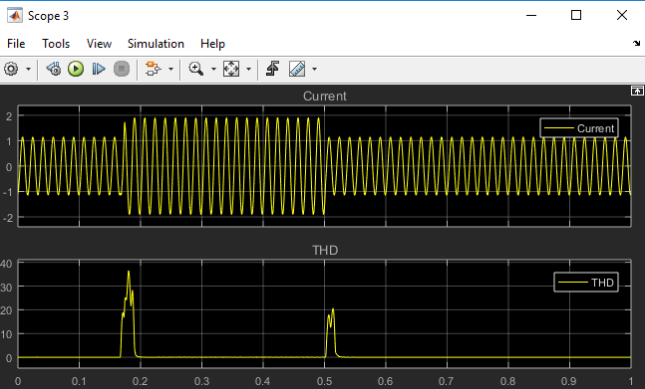
Fig10: Current waveform and THD across Generator two with UPQC

As seen in Fig10 UPQC based system has THD only when the load is switched on and off and it regains the original ideal condition shortly after the switching operation. System without UPQC shows poor performance in terms of THD and has very high values when load switch is on and off. THD values are shown as a percentage of original signals.

  - Power, voltage and current output comparison with UPQC

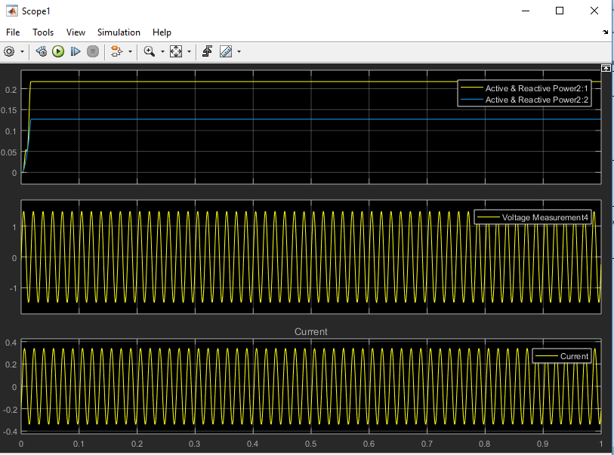

Fig11: Power (active and reactive), Voltage and current waveforms across Load 12 situated at Bus 2 with UPQC
The result of current and voltage is completely sinusoidal after the application of UPQC. The out waveform is improved which is the main requirement.

  - Current and THD across load 12

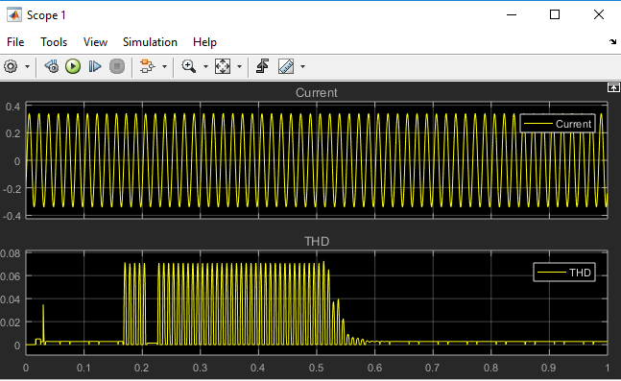
Fig12: Current waveform and THD across Load 12 with UPQC

The current and THD is shown Fig12 the THD is only present in on and off of UPQC after the system becomes stable ie no harmonic distortion is present in output and also current waveform is sinusoidal.

  - Power, current and voltage waveform output with UPQC

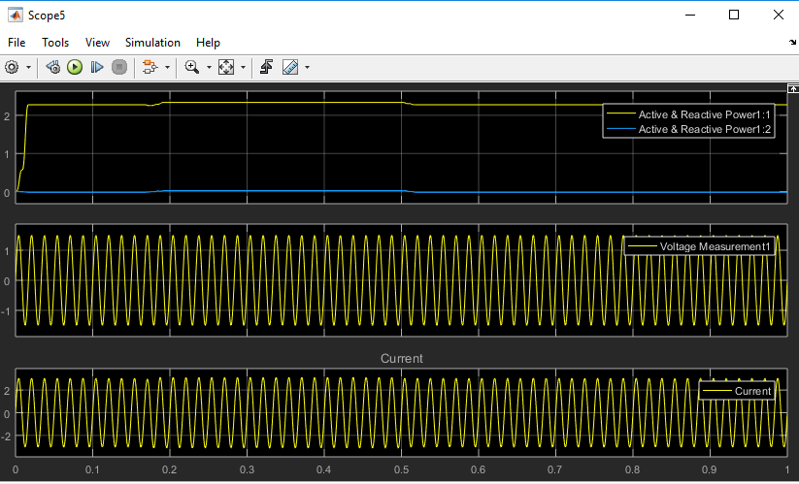
Fig13: Power (active and reactive), Voltage and current waveforms across Generator one situated at Bus 1 with UPQC

The output is shown in Fig13 the active and reactive power is stable after the application of UPQC very little harmonic is present. The current and voltage harmonics are also sinusoidal.
  - Current and THD across generator 1 shown in fig 5

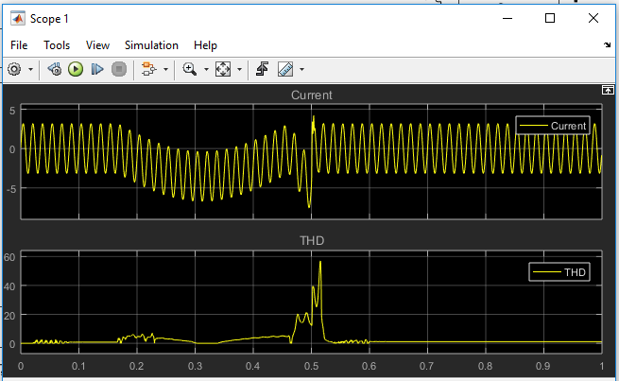
Fig14: Current and THD across Generator one situated at Bus 1 without UPQC

The current and THD waveform is shown in fig 14. The current is not stable it possess harmonics. The THD is also high. the output is shown without the application of UPQC.

  - Current and THD across Generator one situated at Bus 1 with UPQC

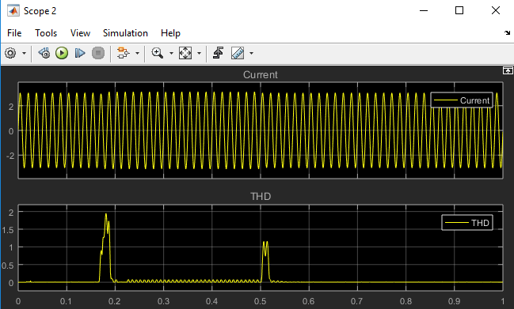
Fig15: Current and THD across Generator one situated at Bus 1 with UPQC

It is seen that there is harmonics in the generator waveforms when no UPQC is used but no harmonics when UPQC fact device is used in the system. After comparing the above parameters in generation unit it is noticed that system with UPQC provides more stability in terms of output power which in turns depends upon type of loads i.e. resistive, reactive or capacitive. It is seen that the reactive power is more than active power when inductive load is used and opposite happens when load changes to capacitive one.

Table 2: Total harmonic distortion evaluated at different nodes of 14 Bus system usingUPQC fact device and without UPQC.
Location | Generator one | Generator two | Load 12
Without UPQC | 4.29905 | 37.784 | 0.55456
With UPQC | 0.039123 | 0.5395 | 0.010539

The table shows the comparison of THD in current waveform. It is shown that the THD is reduced after the application of UPQC. Without the UPQC the THD value is high, the THD value at generator two is very large due to coupling effect at generator two.

  - THD calculation without using UPQC Fact device in 14 Bus system

Fig16: THD calculation without using UPQC fact device in 14 bus system

The THD in current waveform is shown in Fig16. The THD percentage of generator one is 4.299% and generator two is 37.78% and load 12 is 0.5545%. The THD calculation is without UPQC.
Fig17 THD calculation using UPQC Fact device in 14 Bus systems

Fig17: THD calculation without using UPQC Fact device in 14 Bus IEEE Systems

After the application of UPQC the change in percentage calculation of THD in current waveform are generator one 0.039123%, THD in generator two is 0.5396% and in load 12 is 0.010529%. It is seen that the THD is reduced after the application of UOQC.

- CONCLUSION
There is a growing need for renewable energy systems with ancillary features particularly in low-voltage distribution systems. This is happening mainly due to increased penetration of nonlinear power-electronic-based loads and renewable-energy-based systems. These power electronic loads, though energy efficient, inject harmonic currents into the grid, which cause distortion at common coupling (PCC) mostly in some very weak grid systems. Furthermore, these power electronic loads are sensitive to disturbances in voltages. In weak distribution systems, there are usually voltage and current variations which are usually depending on power generation and demand. These voltage oscillations affect the delicate power electronic loads such as speed drives, illumination systems, etc., which can cause repeated tripping, mal operation, and thus leading to increased maintenance costs. To improve the superiority of output power, current and voltage waveforms and to reduce harmonics in supply systems, optimum voltage angle injection based UPQC fact device is introduced. Voltage phase angle of -4.98 degree is provided to the generator where coupling with the non-linear Load buses is applied by the use of UPQC. The system has improved waveforms with reduction total harmonic distortion in the current waveforms in which generator two has reduced THD value from 37.784% to 0.5396% when UPQC is used with comparison to system without UPQC. Similar effects have been noticed at other load locations of the system.

REFERENCES
- D. O. Kisck, V. Navrapescu and M. Kisck, (2007). “Single-Phase Unified Power Quality Conditioner with Optimum Voltage Angle Injection for Minimum VA requirement," IEEE Power Electronics Specialists Conference, Orlando, FL, Pages 574-579
- J. Kotturu and P. Agarwal, "Performance analysis of Open UPQC using three level diode clamped multilevel inverter," 2016 IEEE 6th International Conference on Power Systems (ICPS), New Delhi, 2016, pp. 1-6
- S. Devassy and B. Singh, "PLL-less d-q control of solar PV integrated UPQC," 2016 IEEE International Conference on Power Electronics, Drives and Energy Systems (PEDES), Trivandrum, 2016, pp. 1-6.
- SeyedMajidKeshavarz , Mehdi Nafar," Using UPQC to control the fourth-wire current in four-wire three-phase distribution networks under unbalanced load conditions" Scinzer Journal of Engineering, Vol 3, Issue 2, (2017): 55-64
- V. S. Cheung, R. S. Yeung, H. S. Chung, A. W. Lo and W. Wu, "A Transformer-Less Unified Power Quality Conditioner with Fast Dynamic Control," in IEEE Transactions on Power Electronics, vol. 33, no. 5, pp. 3926-3937, May 2018.
- T. Q. Zhao, H. D. Chiang, and K. Koyanagi, “Convergence analysis of implicit Z-bus power flow method for general distribution networks with distributed generators,” IET Generation, Transmission & Distribution, vol. 10, no. 2, pp. 412–420, Feb. 2016.
- M. T. L. Gayatri, A. M. Parimi and A. V. P. Kumar, "Reactive power compensation in microgrids using custom power devices," 2015 IEEE IAS Joint Industrial and Commercial Power Systems / Petroleum and Chemical Industry Conference (ICPSPCIC), Hyderabad, 2015, pp. 96-104
- S. Ivanov, M. Ciontu, D. Sacerdotianu and A. Radu, "Simple control strategies of the active filters within a unified power quality conditioner (UPQC)," 2017 International Conference on Modern Power Systems (MPS), Cluj-Napoca, 2017, pp. 1-4

CITE AN ARTICLE
Bhat, H. A., & Kaur, R., Er. (2018). POWER QUALITY IMPROVEMENT ON 14 BUS IEEE SYSTEM USING UPQC. INTERNATIONAL JOURNAL OF ENGINEERING SCIENCES & RESEARCH TECHNOLOGY, 7(8), 526-537.

