Supplementary Table S1. Detailed description of each exercise session
Supplementary Table S2. Descriptive statistics across weeks
Supplementary Figure S1. Self-reported physical activity by week
Supplementary Material 1. Detailed description of the implicit association test
Supplementary Material 2. Additional measures
Supplementary Material 3. Additional analyses testing the impact of the intervention on the
evaluation of the exercise sessions.

Supplementary Table S1. Detailed description of each exercise session
Exercises | Instructions | Scheme and material | Situational variables
Warm-up  Cardiovascular / joint / muscles  15min | - Turing in circle in the room (one way and then the other): unroll the step, one foot in front of the other, big steps/high steps (5min).  - Range of motion: head forward/backward; turn arms one way, then the other; turn wrists one way, then the other; turn pelvis one way, then the other; same for knees and ankles (5min). | 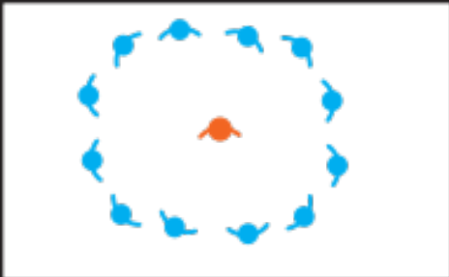 | Range of motion: walking (if feasible) or static (if too difficult to walk).
1.Motor course | The participant takes a racket in one hand and puts a ball on it. The goal is to go over the blocks and back again. |   Racket + ball (heavy) + round blocks (≥5) | If too easy: take a lighter ball.  For lower intensity (i.e., experimental condition): Without the block or the racket, just the ball in the hand.
2. Kneeling up/down | Start standing, then go down on your knees one knee at a time, then go back up by unfolding one knee at a time, and so on. | 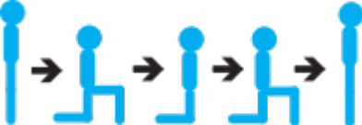  Use a chair if necessary | If too easy: do not use your hand to get up.  If too hard: help yourself by leaning on a chair.  For low intensity (i.e., experimental condition): only sitting/standing on the chair.
 |  |  | Continued

Supplementary Table S1. (continued)
Exercises | Instructions | Scheme and material | Situational variables
3.Elastic unilateral row | In front of the espalier, knees slightly bent, pelvis in retroversion, bring the shoulder then the elbow backwards; the 2 arms at the same time.  Caution: remain quite straight and do not release the arm towards the front too quickly. | 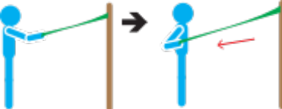  Elastic band + espalier | If too easy: shorten the elastic band (take the elastic higher) or take a stronger elastic.  For low intensity (i.e., experimental condition): Take a less resistant elastic band or use the bars to do the exercise: hang backwards with the arms, then scapular retropulsion to come back against the bar.
4. Cushion balance + squat | Standing with both feet on an air cushion, perform squats while holding on to the bar.  Pay attention to the balance of the practitioner. | 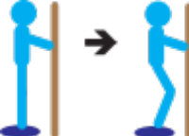  Air cushion + espalier | If too easy: do not stand on the bar or go lower while squatting.  For low intensity (i.e., experimental condition): without the squat, only balance on the cushion.
 |  |  | Continued

Supplementary Table S1. (continued)
Exercises | Instructions | Scheme and material | Situational variables
5.Elastic arm curl | One elastic band under each foot and the other end in each hand, knees slightly bent, pelvis in retroversion, perform an arm flexion.  Caution: do not completely stretch the arms at the bottom of the movement, do not roll the shoulders forward. | 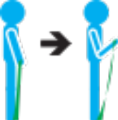  Elastic band | If too easy: shorten the elastic (take the elastic higher) or take a stronger elastic.  For low intensity (i.e., experimental condition): take an elastic band with less resistance or take a 0.5 kg dumbbell.
6.Moving the box | Take the box on the ground while keeping your back straight, knees bent, abs tight.  Stand up then go towards the block in front of you, rest and take back the box, and return towards the block in front of you, and so on. |   Box + dumbbells + round blocks | If too easy: put more weight (dumbbells) in the box.  For low intensity (i.e., experimental condition): Remove the weights (dumbbells) out the box and/or do not bend the knees (only walking with the box).

Supplementary Table S2. Descriptive statistics across weeks
 | Mean | SD | Range
Evaluation of each exercise session
Perceived effort
Week 1 | 4 | 1.0 | 3-5
Week 2 | 4 | 0.9 | 3-5
Week 3 | 3.8 | 1.2 | 3/6
Week 4 | 3.3 | 0.5 | 3-4
Week 5 | 3.7 | 0.8 | 3-5
Week 6 | 3.4 | 0.5 | 3-4
Week 7 | 3.6 | 0.5 | 3-4
Week 8 | 3.6 | 0.8 | 3-5
Affective evaluation
Week 1 | 6.1 | 2.9 | 3-10
Week 2 | 7.8 | 1.6 | 5-10
Week 3 | 6 | 3.1 | 0-8
Week 4 | 6.7 | 1.6 | 4-9
Week 5 | 5.4 | 3.1 | 0-8
Week 6 | 7.4 | 1.4 | 6-9
Week 7 | 7 | 3.6 | 0-10
Week 8 | 7.3 | 2.1 | 4-10
Self-efficacy
Week 1 | 5.9 | 1.3 | 4-7
Week 2 | 5.8 | 1.2 | 4-7
Week 3 | 5.8 | 1.0 | 5-7
Week 4 | 6 | 1.3 | 4-7
Week 5 | 5.6 | 1.4 | 4-7
Week 6 | 5.9 | 0.9 | 5-7
Week 7 | 5.7 | 0.9 | 5-7
Week 8 | 5.7 | 1.1 | 4-7
 |  |  | Continued

Supplementary Table S2. (continued)
 | Mean | SD | Range
Evaluation of each exercise session
Future intention
Week 1 | 5.9 | 1.6 | 3-7
Week 2 | 5.7 | 1.2 | 4-7
Week 3 | 5.8 | 1.3 | 4-7
Week 4 | 5.4 | 1.4 | 3-7
Week 5 | 5.6 | 1.5 | 3-7
Week 6 | 6.1 | 1.2 | 4-7
Week 7 | 6 | 1.4 | 4-7
Week 8 | 5.9 | 1.7 | 3-7
PA behaviors
Self-reported measure (in min per day)
Week 1 | 136.2 | 68.2 | 55.7-246.4
Week 2 | 147.7 | 74.6 | 62.1-263.6
Week 3 | 172.9 | 111.9 | 53.6-323.6
Week 4 | 183.5 | 99.6 | 55.7-337.1
Week 5 | 210.3 | 113.1 | 85.1-398.6
Week 6 | 201.3 | 112.9 | 68.6-352.9
Week 7 | 199.7 | 112.2 | 47.1-333.6
Week 8 | 185.7 | 114.3 | 45.6-305.1
Accelerometer-based measure (in min/day)
Week 1 | 126.3 | 120.5 | 35.5-361.5
Week 2 | 84.7 | 104.5 | 18-269
Week 3 | 66.5 | 81.9 | 15.5-210.5
Week 4 | 87.2 | 102.1 | 14.5-237.5
Week 5 | 137.3 | 126.2 | 6.5-356.5
Week 6 | 158.8 | 203.9 | 12-553.5
Week 7 | 57.7 | 55.9 | 8.5-118.5
Week 8 | 146.5 | 158.8 | 25-413.5
Note. SD = standard deviation; min = minutes; PA = physical activity.
Supplementary Figure S1. Self-reported physical activity by week
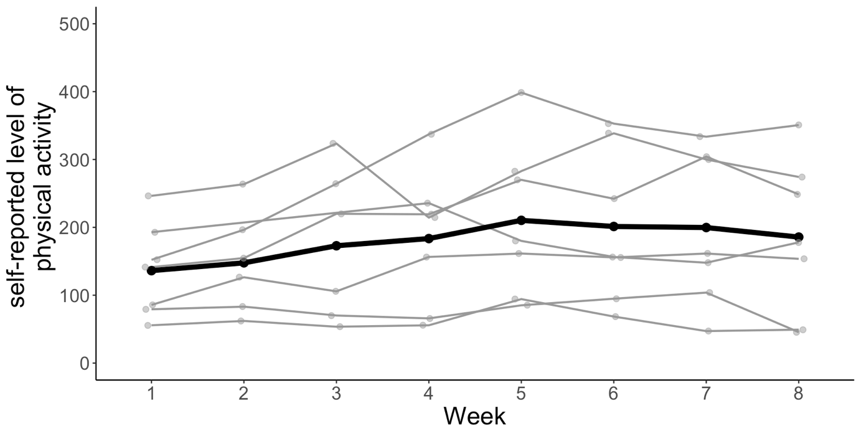
Note. Dots represent the observations for each participant. Grey lines represent each participants evolution of the self-reported physical activity across weeks. The black line represents the averaged evolution of the self-reported physical activity across weeks.

Supplementary Material 1. Detailed description of the implicit association test
Implicit attitudes toward PA were assessed using an implicit association test (Greenwald, McGhee, & Schwartz, 1998). In this computerized task, participants were asked to quickly sort four types of words [physical activity, sedentary behaviors, positive attributes (i.e., good), negative attributes (i.e., bad)], by pressing a key on a keyboard. Following previous recommendations (Greenwald, Nosek, & Banaji, 2003), this test consisted of seven blocks. In the first block, categories related to PA and sedentary behaviors were presented in green in the upper-left and upper-right corners of the black screen and the stimuli (i.e., words related to either PA or sedentary behaviors) appeared in random order on the center of the screen in white. Participants categorized the stimuli by pressing the letter « E » or « I » for the left and right side, respectively. Following an incorrect answer, a red cross appeared on the screen and participants were asked to correct their response. The intertrial interval was 400 ms for words correctly categorized. The response latency from onset of the word to pressing a response key was recorded. In the second block, participants were asked to sort stimuli related to the good and bad categories, following the same procedure than in the first block. Then, in the third (i.e., practice trials) and fourth (i.e., test trials) blocks, participants were asked to sort the words into one of the two categories: physical activity/good (e.g., on the left side) and sedentary behaviors/bad (e.g., on the right side). The fifth block was identical to block 1, but the position of the categories was inverted (e.g., whether PA was presented on the left side, it was now moved on the right side). Finally, the sixth (i.e., practice trials) and seventh (i.e., test trials) blocks were similar to the third and fourth blocks, but the categories were inverted (e.g., whether participants were asked to sort PA/good [e.g., on the left side] and sedentary behaviors/bad [e.g., on the right side], they were now asked to sort sedentary behaviors/good [e.g., on the left side] and PA/bad [e.g., on the right side]). The practice trials (i.e., third and sixth blocks) consisted of 20 trials and the test trials (i.e., fourth and seventh blocks) of 40 trials, as recommended (Greenwald et al., 2003). The side on which the categories appeared was counterbalanced across participants. The eight physical activity- (i.e., active, move, run, effort, walk, sport, stairs, bike) and sedentary- (i.e., sofa, sitting, armchair, rest, television, lying down, chair, reading) related words, and the eight positive (i.e., vigor, euphoria, vitality, exhilarating, pleasant, joyful, satisfying, fun) and negative (i.e., distress, exhaustion, fatigue, suffering, sad, painful, boring, disappointing) attributes were selected based on previous studies (Cheval, Sarrazin, Boisgontier, & Radel, 2017; Chevance, Héraud, Guerrieri, Rebar, & Boiché, 2017; Conroy, Hyde, Doerksen, & Ribeiro, 2010; Hyde, Elavsky, Doerksen, & Conroy, 2012; Rebar, Ram, & Conroy, 2015).
For each participant. the D-score was calculated by subtracting the mean response time in the so-called compatible test block (i.e., physical activity/good and sedentary/bad) from the mean response time in the incompatible test block (i.e., physical activity/bad and sedentary/good) and then by dividing this mean difference by the pooled standard deviation across both blocks (Greenwald et al., 2003). The D-score range from -2 to +2, indicating negative and positive implicit attitudes toward PA (vs. sedentary behaviors), respectively. Values of .15, .35, and .64 were considered as a slight, moderate, and strong, respectively (Blanton, Jaccard, & Burrows, 2015).

Supplementary Material 2. Additional measures
Evaluation of each exercise session
These variables were assessed 5-min after the end of each exercise session.
Affective evaluation of the exercise session. The affective evaluation of the exercise session was assessed using the following item (Hargreaves & Stych, 2013): « How pleasant or unpleasant did you find the exercise session? » Participants answered on a 21-point scale from -10 (Very unpleasant) through 0 (Neutral) to +10 (Very pleasant).
Self-efficacy toward the exercise session. The self-efficacy toward the exercise session was measured using the following item adapted from the Needs Satisfaction-Thwarting Scale (Cheval, Chalabaev, Quested, Courvoisier, & Sarrazin, 2017): The stem prior the item was « To what extent do you feel capable to carry out the exercises requested by the exercise session. Participants answered on a 7-point bipolar scale with 1 (Not capable at all) to 7 (Very capable).
Perceived effort toward the exercise session. The rate of global perceived effort toward the exercise session was assessed using a modified version of the Borg CR-10 scale proposed to be particularly adapted to exercise in patients (Kern & Fautrelle, 2018). This one-item scale started with the stem « How did you perceive the level of effort (intensity) of the exercise session? » Participants answered on a 12-point scale ranging from 0 (Nothing) through 5 (Somewhat hard) to 10 (Very, very hard). In line with the recommendations (Borg, 1998), the research assistant gave standard instruction on how to use the scale. This scale was also used by the participant to monitor the effort intensity during the exercise session (see procedure).
Intentions to be physically during the next week. Intentions to be physically active during the next week were measured using the following item (Cheval, Sarrazin, Isoard-Gautheur, Radel, & Friese, 2015): « Over the next seven days, I intend to carry out at least 30 minutes moderate-to-vigorous physical activity per day on five or more days of the week during my free time or my transportation ». Respondents answered on a scale ranging from 1 (Not at all agree) to 7 (Strongly agree).
Global evaluation of physical activity
These variables were assessed at baseline, at the end of the control condition (i.e., four weeks), and at the end of the experimental condition (i.e., eight weeks).
Instrumental attitudes toward physical activity. Instrumental attitudes toward physical activity were assessed using two items (Rhodes & Courneya, 2003). The stem prior to each item was « Would you say that being physically activity is something… ». Participants answered on a seven-point bipolar scale with 1 (useless) to 7 (useful) and from 1 (harmful) to 7 (beneficial). Items were averaged to create an overall measure of instrumental attitudes toward to be physically active.
Intentions to be physically active. Intentions to be physically active were measured using the following two items (Cheval et al., 2015): « Usually, I intend to carry out at least 30 minutes moderate-to-vigorous physical activity per day on five or more days of the week during my free time or my transportation »; « I am determined to carry out at least 30 minutes moderate-to-vigorous physical activity per day on five or more days of the week during my free time or my transportation ». Respondents answered each item on a scale ranging from 1 (Not at all agree) to 7 (Strongly agree). The items were averaged to create an overall measure of intention to be physically active.
Self-efficacy toward physical activity. Self-efficacy toward physical activity was assessed using one item of the Needs Satisfaction-Thwarting Scale (Cheval, Chalabaev, et al., 2017). The stem prior the item was « To what extent do you feel capable to carry out at least 30 minutes moderate-to-vigorous physical activity per day on five or more days of the week during your free time or your transportation ». Participants answered on a 7-point bipolar scale with 1 (Not capable at all) to 7 (Very capable).

Supplementary Material 3. Additional analyses testing the impact of the intervention on the
evaluation of the exercise sessions.
Statistical analysis
For the outcomes related to the evaluation of the exercise sessions, we used a linear MEM that included the two conditions (control condition vs. experimental condition) as fixed factor. These models specified participants as a random factor and included random effects for the conditions. The models were adjusted for usual physical activity.
Affective evaluation of the exercise session
No significant differences in the affective evaluation of the exercise sessions were observed between the control condition and the experimental condition (b = .04, 95%CI = -1.44 to 1.51, p = .963).
Perceived effort
No significant differences in the perceived effort associated to the exercise sessions were observed between the control condition and the experimental condition (b = -.25, 95%CI = -.61 to .11, p = .235).
Self-efficacy
No significant differences in the self-efficacy toward the exercise sessions were observed
between the control condition and the experimental condition (b = -.14, 95%CI = -.74 to .46, p
= .657).

References
Blanton, H., Jaccard, J., & Burrows, C. N. (2015). Implications of the implicit association test D-transformation for psychological assessment. Assessment, 22(4), 429–440. https://doi.org/10.1177/1073191114551382
Borg, G. (1998). Borg's perceived exertion and pain scales. Human kinetics.
Cheval, B., Chalabaev, A., Quested, E., Courvoisier, D. S., & Sarrazin, P. (2017). How perceived autonomy support and controlling coach behaviors are related to well-and ill-being in elite soccer players: A within-person changes and between-person differences analysis. Psychology of Sport and Exercise, 28, 68–77.
Cheval, B., Sarrazin, P., Boisgontier, M. P., & Radel, R. (2017). Temptations toward behaviors minimizing energetic costs (BMEC) automatically activate physical activity goals in successful exercisers. Psychology of Sport and Exercise, 30, 110–117. https://doi.org/10.1016/j.psychsport.2017.02.006
Cheval, B., Sarrazin, P., Isoard-Gautheur, S., Radel, R., & Friese, M. (2015). Reflective and impulsive processes explain (in)effectiveness of messages promoting physical activity: a randomized controlled trial. Health Psychology, 34(1), https://doi.org/10–19. 10.1037/hea0000102
Chevance, G., Héraud, N., Guerrieri, A., Rebar, A., & Boiché, J. (2017). Measuring implicit attitudes toward physical activity and sedentary behaviors: Test-retest reliability of three scoring algorithms of the Implicit Association Test and Single Category-Implicit Association Test. Psychology of Sport and Exercise, 31, 70–78. https://doi.org/10.1016/j.psychsport.2017.04.007
Conroy, D. E., Hyde, A. L., Doerksen, S. E., & Ribeiro, N. F. (2010). Implicit attitudes and explicit motivation prospectively predict physical activity. Annals of Behavioral Medicine, 39(2), 112– https://doi.org/118. 10.1007/s12160-010-9161-0
Greenwald, A. G., McGhee, D. E., & Schwartz, J. L. (1998). Measuring individual differences in implicit cognition: the implicit association test. Journal of Personality and Social Psychology, 74(6), 1464-1480. https://doi.org/10.1037//0022-3514.74.6.1464
Greenwald, A. G., Nosek, B. A., & Banaji, M. R. (2003). Understanding and using the implicit association test: I. An improved scoring algorithm. Journal of Personality and Social Psychology, 85(2), 197–216. https://doi.org/10.1037/0022-3514.85.2.197
Hargreaves, E. A., & Stych, K. (2013). Exploring the peak and end rule of past affective episodes within the exercise context. Psychology of Sport and Exercise, 14(2), 169–178. https://doi.org/10.1016/j.psychsport.2012.10.003
Hyde, A. L., Elavsky, S., Doerksen, S. E., & Conroy, D. E. (2012). The stability of automatic evaluations of physical activity and their relations with physical activity. Journal of Sport and Exercise Psychology, 34(6), 715–736. https://doi.org/10.1123/jsep.34.6.715
Kern, L., & Fautrelle, L. (2018). Activites physiques adaptees : le livret des bonnes pratiques pour des personnes avec schizo- phrénie à destination des patients et des équipes thérapeutiques. Licence CC-BY-SA.
Rebar, A. L., Ram, N., & Conroy, D. E. (2015). Using the EZ-diffusion model to score a single-category implicit association test of physical activity. Psychology of Sport and Exercise, 16(3), 96–105. https://doi.org/10.1016/j.psychsport.2014.09.008
Rhodes, R. E., & Courneya, K. S. (2003). Investigating multiple components of attitude, subjective norm, and perceived control: An examination of the theory of planned behaviour in the exercise domain. British Journal of Social Psychology, 42(1), 129–146. https://doi.org/10.1348/014466603763276162

