BERT-based Symptom Extraction NER Pipeline
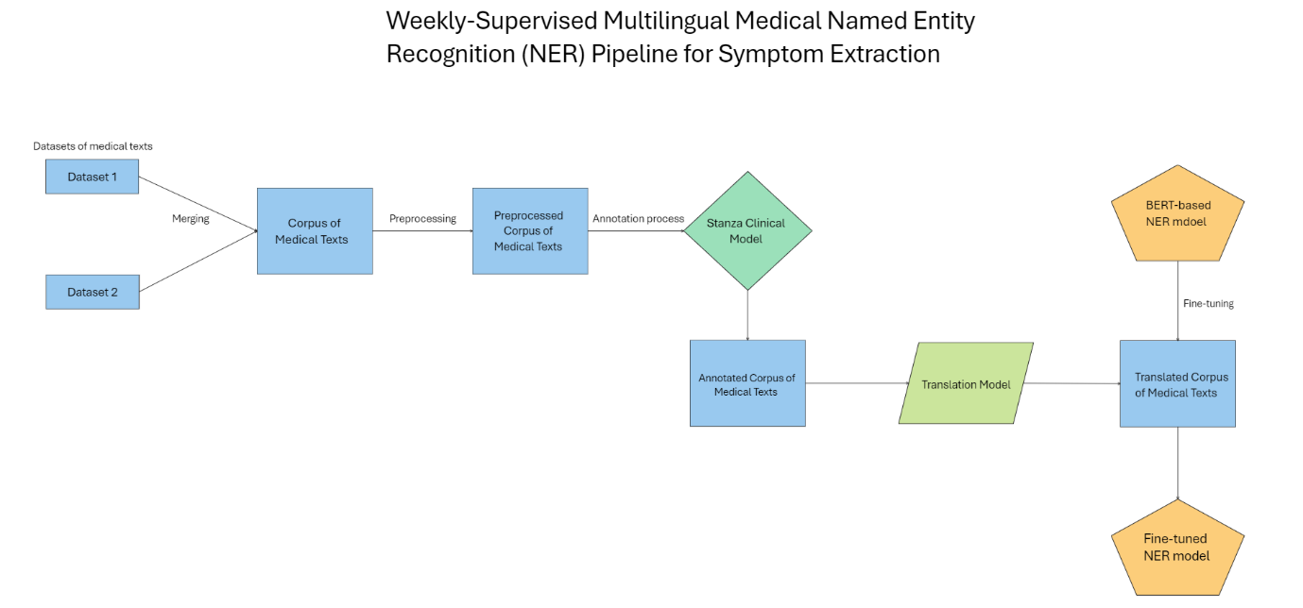
dr. Izidor Mlakar, Rigona Sallauka, dr. Umut Arioz, dr. Matej Rojc

Explanation of Diagram:
To address the challenges of multilingual medical text processing, we developed a comprehensive pipeline designed to extract key clinical entities—PROBLEM, TEST, and TREATMENT—from medical texts in multiple languages. The pipeline consists of several key steps:
1. Data Integration and Preprocessing:
We begin by merging two distinct datasets of English medical texts. This step ensures a robust and diverse corpus, combining the strengths of both datasets. Following the integration, we preprocess the texts to clean the data, which includes removal of strings that do not contain relevant information. This preprocessing step is crucial to ensure the texts are in an optimal format for subsequent annotation.
2. Annotation with Stanza's i2b2 Clinical Model:
The preprocessed English texts are then annotated using the i2b2 clinical model from the Stanza Library. This model is specifically designed for clinical text processing and annotates each text with three labels: PROBLEM (e.g., diseases, symptoms), TEST (e.g., diagnostic procedures), and TREATMENT (e.g., medications, therapies). This annotation step is fundamental to creating a labeled dataset that can be used for training and evaluating Named Entity Recognition (NER) models.
3. Translation of Annotated Corpus:
To extend the utility of the annotated corpus beyond English, we translate the annotated texts into multiple languages. This translation process is carefully managed to maintain the integrity of the annotations, ensuring that the PROBLEM, TEST, and TREATMENT labels are accurately reflected in the target languages. As a result, we generate multilingual annotated datasets that are crucial for developing NER models capable of processing medical texts in different languages.
4. Fine-tuning BERT for Multilingual NER:
The final step in the pipeline involves fine-tuning a BERT-based NER model using the newly created multilingual annotated datasets. BERT (Bidirectional Encoder Representations from Transformers) is a state-of-the-art model for NER tasks, and by fine-tuning it with our multilingual datasets, we create specialized NER models that can accurately extract PROBLEM, TEST, and TREATMENT entities from medical texts in various languages.

Datasets used for training:
Dataset 1: Kabatubare/autotrain-data-1w6s-u4vt-i7yo
dataset_info:
features:
- name: autotrain_text
dtype: string
splits:
- name: train
num_bytes: 19109937
num_examples: 23437

Link: https://huggingface.co/datasets/Kabatubare/autotrain-data-1w6s-u4vt-i7yo
Example row: ### Human:\nmy 5 1/2-year-old son displays adhd symptoms for 20 days then for 10 days he has none. is it adhd or another condition?\n\n### Assistant: adhd and bipolar mood disorder (bmd) can coexist or be mistaken for one another. bmd usually is not diagnosed until young adulthood. however studies have shown that the earlier a person is diagnosed with bmd the more likely he is to have been diagnosed with adhd previously. in this case i would just like to reiterate that there is not enough information to discuss either possibility for your son. you mentioned that he becomes hyperactive for 3 weeks but not what his behaviors are like during those 10 days. you also do not mention irritability or mood swings just adhd symptoms. keep documenting the symptoms you are concerned about including what goes on in the home and at school when you see changes in behavior (do you work those weeks does he visit a relative or have a different aide in the classroom). you also mentioned that this began 7 months ago. i would also urge you to think about what also might have changed in your son's life about that time. consulting your pediatrician or a child psychiatrist should help you unravel the mystery of your son's behavior.

Dataset 2: s200862/medical_qa_meds
dataset_info:
features:
- name: text
dtype: string
splits:
- name: train
num_bytes: 1,638,400
num_examples: 5942 -

Link: https://huggingface.co/datasets/s200862/medical_qa_meds
It includes questions and answers.
Example row: <s>[INST] What are the symptoms of Allergy? [/INST] Allergy symptoms vary, but may include: Breathing problems (coughing, shortness of breath) Burning, tearing, or itchy eyes Conjunctivitis (red, swollen eyes) Coughing Diarrhea Headache Hives Itching of the nose, mouth, throat, skin, or any other area Runny nose Skin rashes Stomach cramps Vomiting Wheezing What part of the body is contacted by the allergen plays a role in the symptoms you develop. For example: Allergens that are breathed in often cause a stuffy nose, itchy nose and throat, mucus production, cough, or wheezing. Allergens that touch the eyes may cause itchy, watery, red, swollen eyes. Eating something you are allergic to can cause nausea, vomiting, abdominal pain, cramping, diarrhea, or a severe, life-threatening reaction. Allergens that touch the skin can cause a skin rash, hives, itching, blisters, or even skin peeling. Drug allergies usually involve the whole body and can lead to a variety of symptoms. </s>

Preprocessing Steps: (rigon)
The data underwent a preprocessing process. First, the data was cleaned. Since our data consisted of question-answer pairs between a user and an assistant, data contained text that could be removed, without losing the relevant information. In Kabatubare/autotrain-data-1w6s-u4vt-i7yo dataset we removed the following strings: “Human:”, “Assistant:”, “\\n”, \\t, and hyphens between the words (“-“) were replaced by a single space. Whereas in s200862/medical_qa_meds we removed: “[INST]”, “[/INST]”, “<s>”, “</s>”, “\n”, and “\t”. Then, all the punctuations were removed. Finally, the data was lowercase.

Symptom Extraction in EN: (umut)
We used Stanza clinical-domain NER system contains a general-purpose NER model trained on the 2010 i2b2/VA dataset that extracts problem, test, and treatment entities from various types of clinical notes.
Model | Dataset | Entity Types | Number of Tokens (train/dev/test) | F1-score
Clinical | i2b2 | Problem, Test, Treatment | 106,597/44,672/269,954 | 88.13

Translation Models: (umut)
English to German - Greek – Spanish – Italian – Polish – Portuguese:
Model was developed by Language Technology Research Group at the University of Helsinki. Model Type is Translation.
Source Language: English
Target Language: German, Greek, Spanish, Italian, Polish
License: CC-BY-4.0
Links:
- German - https://huggingface.co/Helsinki-NLP/opus-mt-en-de
- Greek - https://huggingface.co/Helsinki-NLP/opus-mt-en-el
- Spanish - https://huggingface.co/Helsinki-NLP/opus-mt-tc-big-en-es
- Italian - https://huggingface.co/Helsinki-NLP/opus-mt-tc-big-en-it
- Polish - https://huggingface.co/gsarti/opus-mt-tc-en-pl
- Portuguese - https://huggingface.co/Helsinki-NLP/opus-mt-tc-big-en-pt
English to Slovenian:
Model name: facebook/mbart-large-50-many-to-many-mmt
This model is a fine-tuned checkpoint of mBART-large-50. mbart-large-50-many-to-many-mmt is fine-tuned for multilingual machine translation. The model can translate directly between any pair of 50 languages. To translate into a target language, the target language id is forced as the first generated token. To force the target language id as the first generated token, pass the forced_bos_token_id parameter to the generate method.
Link: https://huggingface.co/facebook/mbart-large-50-many-to-many-mmt

Word Alignment:
Model: aneuraz/awesome-align-with-co
This method is for extracting alignments between words in parallel sentences using contextual word embeddings from models like BERT. Main processing steps:
- Contextual Word Embeddings: Powerful models like BERT capture the meaning of words based on their context in a sentence. These models can be used to generate numerical representations (embeddings) for each word in a sentence.
- Alignment Scores: The method calculates alignment scores between words in two parallel sentences (sentences in different languages that mean the same thing). Two approaches are used:
  - Probability Thresholding: This method uses a similarity matrix based on the dot product of word embeddings. It then applies a function (like softmax) to turn similarities into probabilities and identifies high-probability pairs as aligned.
  - Optimal Transport: This approach views alignment as a transportation problem, where the goal is to move "probability mass" between words in a way that minimizes cost (distance between word embeddings). The resulting matrix shows likely alignments.
- Bidirectional Alignments: The method considers alignments in both directions (source to target and target to source). The final alignment is obtained by finding the intersection of alignments in both directions.
- Subword Handling: Since some models work with subwords (parts of words), the method considers two words aligned if any of their subwords are aligned.
Overall, this approach leverages contextual word embeddings and different techniques to find corresponding words between sentences in different languages.

Training: (rigon)
To develop a robust NER model capable of extracting medical entities across different languages, we implemented the training process explained below. This process encompasses data augmentation, dataset splitting, model configuration, and training.
1. Data Augmentation:
Before splitting the dataset, we performed data augmentation to enhance the diversity and robustness of the training data. The augmentation process involved two main strategies:
- Sentence Reordering: Words within each sentence were reordered to create new variations of the same sentence structure. This method increases the variability of the dataset, enabling the model to generalize better to different sentence formations.
- Entity Extraction: All words within each sentence that were annotated with non-"O" labels (i.e., labeled as PROBLEM, TEST, or TREATMENT) were extracted and used to generate new sentences. These sentences were then added back into the dataset, ensuring that the model would encounter more examples of key medical entities during training.
2. Dataset Splitting:
Following augmentation, the dataset was split into three distinct sets:
- Training Set (80%): The largest portion of the dataset was allocated for training the model. This set was used to fine-tune the model's weights based on the annotated examples.
- Validation Set (10%): A smaller portion was reserved for validation during training. This set enabled the model to be evaluated periodically, allowing us to monitor its performance and apply early stopping if necessary.
- Test Set (10%): The final portion was held out as a test set. This set was used for evaluating the model's performance after training, providing an unbiased measure of its ability to generalize to unseen data.
3. Model Configuration:
We configured a BERT-based NER model with specific parameters to optimize its performance:
- Architecture: The BERT-base-cased model was selected for its strong performance on NER tasks, particularly in handling multilingual text.
- Labels: Custom labels were defined for the entities of interest, including various tags for PROBLEM, TEST, and TREATMENT entities.
- Training Parameters: The model was set to train for 200 epochs with a batch size of 64. An AdamW optimizer was used, with a learning rate of 3e-5 and a weight decay of 0.01 to prevent overfitting.
- Loss Function: A focal loss function was employed to address class imbalance by focusing more on harder-to-classify examples.
4. Training with Early Stopping:
The model was trained on the augmented and split datasets using early stopping to prevent overfitting. The training process was monitored by evaluating the model on the validation set at regular intervals (every 2000 steps). If the model's performance did not improve for 200 evaluation steps, the training process was halted.
5. Evaluation and Logging:
After training, the model was evaluated on the test set to assess its accuracy and overall performance. The results of this evaluation, including metrics such as training loss, evaluation loss, accuracy, precision, recall, and f1-score, were logged using Weights & Biases (wandb) to track and compare different runs.

https://stanfordnlp.github.io/stanza/available_biomed_models.html
Yuhao Zhang, Yuhui Zhang, Peng Qi, Christopher D Manning, Curtis P Langlotz, Biomedical and clinical English model packages for the Stanza Python NLP library, Journal of the American Medical Informatics Association, Volume 28, Issue 9, September 2021, Pages 1892–1899, https://doi.org/10.1093/jamia/ocab090
Uzuner O, South BR, Shen S, € et al. 2010 i2b2/VA challenge on concepts, assertions, and relations in clinical text. J Am Med Inform Assoc 2011; 18 (5): 552–6
Jörg Tiedemann and Santhosh Thottingal. 2020. OPUS-MT – Building open translation services for the World. In Proceedings of the 22nd Annual Conference of the European Association for Machine Translation, pages 479–480, Lisboa, Portugal. European Association for Machine Translation.
https://doi.org/10.48550/arXiv.2008.00401
https://arxiv.org/abs/2101.08231

