Supplementary file 1 – Study instrument

INTRODUCTION

The European and International Standardization Organizations developed a new health app certification and quality label aimed at assisting citizens and healthcare professionals in making informed choices about health apps.

The label visually displays the scores of an app on 4 aspects based on a health app quality report consisting of 81 questions:
1-Healthy and safe (items focused on health requirements, health risks, ethics, health benefit and societal benefit)
2-Easy to use (items focused on accessibility and usability)
3-Secure data (items focused on privacy and security)
4-Robust build (items focused on technical robustness and interoperability)

These scores range from a green A (indicating the highest score) to a red E (indicating the lowest score). The weighed scores result in an overall score.

Details of the health app quality report will be available in addition to the quality label.

(page break)

This is what the quality label looks like:

Example 1: Example 2: Example 3:
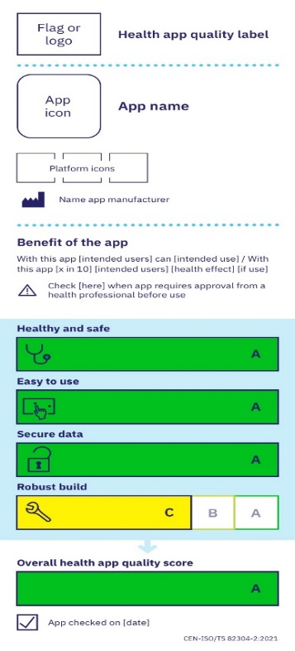
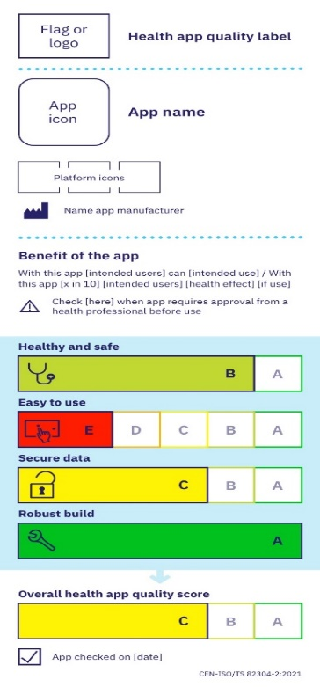
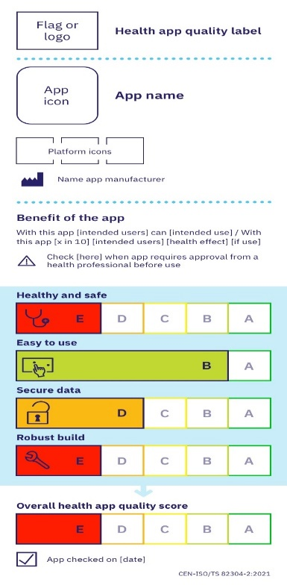

<<page break>>

INSTRUCTIONS
Imagine, that at the present moment the quality label is available and that each app has a label assigned to show its quality.

So, when you look for a specific app, you can see the quality label at a glance, and you can click on a link to access the quality report, if you wish to.

As there are all kinds of different apps available, we want you to focus only on self-management apps of high quality (high quality - as indicated by the quality label).

Self-management apps are apps that can help patients to take care of a health issue or specific symptoms themselves.

An example for a self-management focused app is an app for type 2 diabetes patients for monitoring blood sugar levels, physical activity and dietary intake.

<<page break>>

INSTRUCTIONS continued

Below, we will provide you with 37 short statements about using the quality label to recommend patients high-quality self-management apps.

Please answer these items imagining that:
-Each app has a quality label
-Quality label shows self-management apps to have high quality
-Statements relate to the period of the upcoming 3 months

It is fine if you are not sure about some of these items, and there are no true or false answers. Please try to imagine what your expectation would be regarding each of the statements.

<<page break>>

 | ITEM | ANSWER OPTIONS
0 | I will recommend high quality apps to my patients in the upcoming three months | 1-Strongly disagree  7-Strongly agree

<<page break>>

 | ITEM | ANSWER OPTIONS
1 | I have sufficient knowledge to recommend high quality apps to my patients | 1-Strongly disagree  7-Strongly agree
2 | I have sufficient skills to recommend high quality apps to my patients
3 | I think that as a healthcare professional, it is my job to recommend high quality apps to my patients
4 | I am confident that I can recommend high quality apps to my patients
5 | I am confident that I can recommend high quality apps to my patients, even if I were to encounter barriers (e.g., lack of time, patients’ beliefs or concerns)
 | PAGE BREAK
6 | Recommending high quality apps to my patients will lead to:  Improved patient experience | 1-Strongly disagree  7-Strongly agree
7 | Improved population health
8 | Reduced healthcare costs
9 | Improved work life of healthcare professionals (e.g., reduced workload, improved professional competencies or work satisfaction)
 | PAGE BREAK
10 | I am motivated to recommend high quality apps to my patients | 1-Strongly disagree  7-Strongly agree
11 | Other work-related tasks or things I need to do interfere with recommending high quality apps to my patients
12 | I can easily remember what I need to do to recommend high quality apps to my patients
13 | The quality label for health apps is well constructed
 | PAGE BREAK
14 | Recommending high quality apps to my patients is compatible with my usual way of working | 1-Strongly disagree  7-Strongly agree
15 | The quality label for health apps offers all information and materials that I need to be able to recommend high quality apps to my patients
16 | I have sufficient time for recommending high quality apps to my patients
17 | Recommending high quality apps to my patients is a free choice for me (i.e., not imposed by others)
18 | In my organization, formal arrangements are made (i.e., policy, training) with regard to recommending high quality apps to my patients
 | PAGE BREAK
19 | Other changes in my organization (e.g., reorganizations, cutbacks, the introduction of other innovations or work duties) interfere with recommending high quality apps to my patients | 1-Strongly disagree  7-Strongly agree
20 | In my organization there are enough patients for whom I can recommend high quality apps
21 | Most patients appreciate it when I recommend them high quality apps
22 | Most patients are motivated to use high quality apps that I have recommended for them
23 | I need to have (more) information to be able to recommend high quality apps to my patients
 | PAGE BREAK
24 | I need to have (more) training to be able to recommend high quality apps to my patients | 1-Strongly disagree  7-Strongly agree
25 | I need to have (more) assistance to be able to recommend high quality apps to my patients
26 | I need to get informed regularly about further developments of the quality label to be able to recommend high quality apps to my patients
27 | I need to be financially rewarded for recommending high quality apps to my patients
28 | I need to get sufficient appreciation (e.g., from colleagues, patients, management) for recommending high quality apps to my patients
 | PAGE BREAK
29 | It is expected from me that I recommend high quality apps to my patients (e.g., by colleagues, management, others) | 1-Strongly disagree  7-Strongly agree
30 | I get sufficient support when I need it (e.g., from colleagues, management or others) to recommend high quality apps to my patients
31 | It feels good to recommend high quality apps to my patients
32 | It feels unpleasant to recommend high quality apps to my patients
 | PAGE BREAK
33 | I have clear plans about how to recommend high quality apps to my patients | 1-Strongly disagree  7-Strongly agree
34 | I have clear plans about how to recommend high quality apps to my patients when I encounter barriers (e.g., lack of time, participants are not motivated)
35 | I check regularly whether I am doing everything necessary to recommend high quality apps to my patients
36 | Recommending high quality apps to my patients is a habit for me

<<page break>>
REMAINING BARRIERS
Do you expect to experience obstacles in recommending high quality apps to your patients? Please share them in the box below.

<<page break>>

DEMOGRAPHIC ITEMS AND E-HEALTH AFFINITY
- What is your gender?
  - Female
  - Male
  - Other
  - Prefer not to disclose
- What is your age?
(Enter)
- Where do you live (primarily)?
  - Catalonia
  - Other
- How would you characterize the location where you practice as a healthcare professional?
  - Rural
  - Urban
- What is your occupation?
  - Nurse (senior, junior, or nurse in training)
  - Physician (senior, junior, or physician in training)
    - Anatomical Pathology
    - Anesthesiology
    - Cardiology
    - Cardiovascular & Thoracic Surgery
    - Clinical Immunology/Allergy
    - Critical Care Medicine
    - Dermatology
    - Diagnostic Radiology
    - Emergency Medicine
    - Endocrinology and Metabolism
    - Family Medicine
    - Internal medicine
    - Gastroenterology
    - General Surgery
    - General/Clinical Pathology
    - Geriatric Medicine
    - Hematology
    - Medical Biochemistry
    - Medical Genetics
    - Medical Microbiology and Infectious Diseases
    - Medical Oncology
    - Nephrology
    - Neurology
    - Neurosurgery
    - Nuclear Medicine
    - Obstetrics/Gynecology
    - Occupational Medicine
    - Ophthalmology
    - Orthopedic Surgery
    - Otolaryngology
    - Pediatrics
    - Physical Medicine and Rehabilitation
    - Plastic Surgery
    - Psychiatry
    - Public Health and Preventive Medicine
    - Radiation Oncology
    - Respirology
    - Rheumatology
    - Urology
    - Other
  - Dentist
  - Mental health professional (psychologists, counselors or therapists)
  - Midwife
  - Occupational therapist
  - Optometrist
  - Pharmacist or pharmacy technician
  - Physical therapist
  - Registered dietitian
  - Other
- For how many years have you been practicing as a healthcare professional?
  - (Enter)
- What is your current practice setting?
  - Private practice
  - Private publicly funded practice
  - Primary healthcare practice
  - Community health center
  - Hospital: Inpatient
  - Hospital: Outpatient
  - Research-Academic center
  - Other
- Have you ever recommended a health app to a patient?
  - Yes
  - No
  - I am not sure

- How often do you have patients asking for recommendations on health apps?
- Never
- Less than once per month
- Monthly
- Weekly
- Daily

