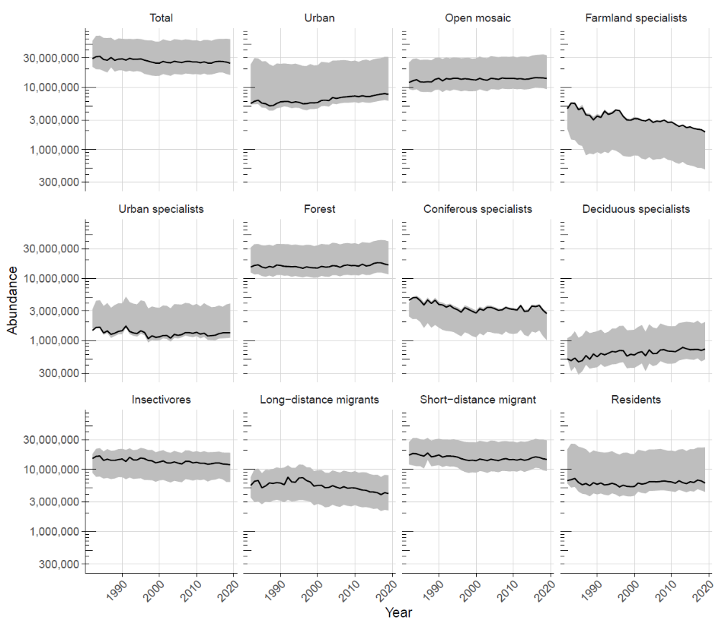
Figure S2.1. Trends of composite abundances (including the estimates of confidence intervals, CIs, grey area) of species groups delimited by selected (categorical) characteristics. Solid lines are estimates based on point counts (see the Main text). In this case, abundance estimates of each species for year 2004 were extrapolated forward and backward using trend indices for each year produced by the Breeding Bird Monitoring Programme. Minimum and maximum abundance for each year, delimiting the grey areas (CIs), were calculated using the confidence intervals of trend indices for each year and the estimates of regional abundances taken from the Breeding Bird Atlas of the Czech Republic (Šťastný et al., 2006). Maximum out of all three available estimates of species abundances for the year 2004 (i.e. out of the point count-based estimate, minimum and maximum atlas estimate) was taken as a baseline, and the maxima of all the trend indices (based on index confidence intervals) were then used for extrapolation of maximum species abundances in all the remaining years, backward and forward. Similarly, when calculating minimum abundances, minima of all abundance estimates were used for the year 2004, and minimum index values were then used for extrapolating minimum abundances across all years. The grey areas thus represent the range within which we expect the real total abundance with high confidence. Y-axis uses log₁₀ scale.

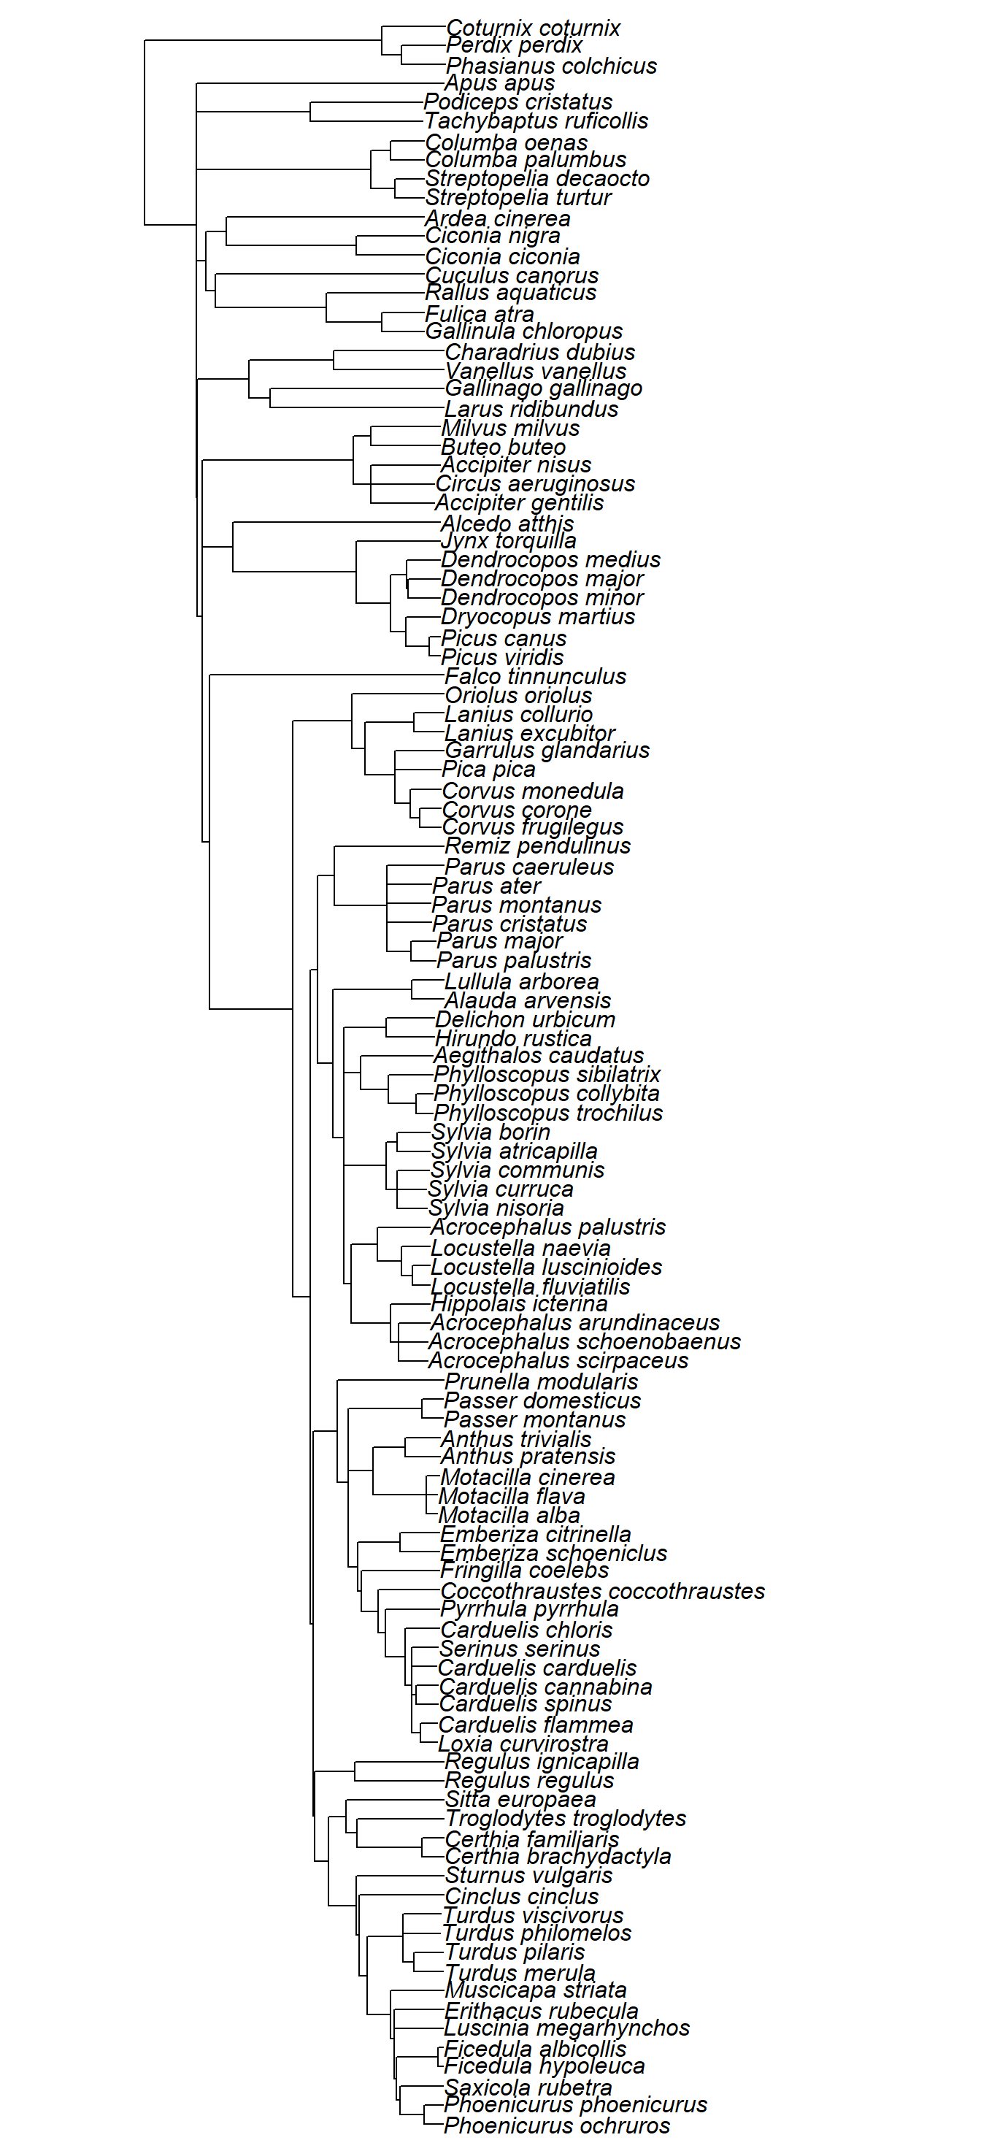
Figure S2.2. Phylogenetic tree of the 111 studied bird species, which we used in the phylogenetic linear model (PGLS; Freckleton et al., 2002). The tree is a consensus tree of 500 trees (“Hackett trees” based on 9993 OTUs each) from BirdTree.org (Jetz et al., 2012). We calculated a strict consensus using function consensus in R package ‘ape‘ (Popescu et al. 2012) and function consensus.edges in R package ‘phytools‘ (Revell et al., 2012).

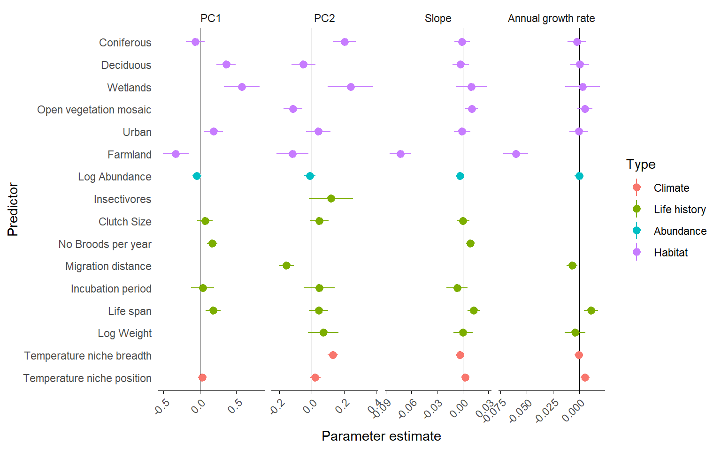
Figure S2.3. Estimated standardized coefficients (parameters) from phylogenetic linear model (PGLS; Freckleton et al., 2002) with PC1, PC2, Slope, and Annual growth rate as response variables, with adjusted R2 values of 0.24, 0.45, 0.32, and 0.26, respectively. We used exactly the same predictors as in Fig. 3 in the main text, and all predictors were included as simple linear terms. All continuous predictors were standardized to 0 mean and variance of 1. The points are mean estimates, bars are standard errors.

Table S2.1. The model-averaged coefficients (including 95% CI) based on the Akaike information criteria corrected for small sample sizes (AICc) of the most supported (ΔAICc < 2) linear models assessing the relationships between the measures of the trajectories of population changes (PC1–4, slope of population trend and growth rate) and individual explanatory variables in 111 common bird species breeding in the Czech Republic in 1982–2019. Those terms whose 95% confidence intervals (CIs) did not overlap zero are printed in bold. The model-averaged CIs are based on unconditional standard errors. Relative importance (RI) represents the sum of weights of all models where a given variable appeared.

 | PC1 | CI | RI | PC2 | CI | RI | PC3 | CI | RI | PC4 | CI | RI | Slope | CI | RI | Growth rate | CI | RI
Temperature niche position | 0.139 | ±0.113 | 1.00 | 0.001 | ±0.016 | 0.04 | 0.000 | ±0.009 | 0.03 | <0.001 | ±0.005 | 0.01 | 0.011 | ±0.009 | 1.00 | 0.012 | ±0.007 | 1.00
Temperature niche breadth |  |  |  | 0.106 | ±0.058 | 1.00 |  |  |  | -0.002 | ±0.015 | 0.10 | -0.001 | ±0.005 | 0.16 | -0.001 | ±0.004 | 0.13
Migration distance |  |  |  | -0.150 | ±0.057 | 1.00 | 0.001 | ±0.014 | 0.07 | 0.007 | ±0.030 | 0.27 |  |  |  | <0.001 | ±0.002 | 0.04
Log Weight |  |  |  | -0.061 | ±0.097 | 0.78 | 0.001 | ±0.014 | 0.07 | -0.024 | ±0.047 | 0.63 | 0.001 | ±0.007 | 0.16 | 0.001 | ±0.006 | 0.15
Log Abundance | -0.100 | ±0.140 | 0.86 | -0.044 | ±0.080 | 0.68 |  |  |  | -0.014 | ±0.042 | 0.42 | -0.006 | ±0.010 | 0.79 | <0.001 | ±0.003 | 0.10
Life span | 0.154 | ±0.124 | 1.00 | 0.041 | ±0.095 | 0.54 | 0.001 | ±0.015 | 0.07 | -0.007 | ±0.034 | 0.21 | 0.010 | ±0.010 | 0.93 | 0.008 | ±0.009 | 0.90
Clutch Size | 0.003 | ±0.040 | 0.08 | 0.001 | ±0.015 | 0.04 | -0.001 | ±0.017 | 0.08 | -0.001 | ±0.013 | 0.06 | 0.000 | ±0.002 | 0.06
No Broods per year | 0.003 | ±0.039 | 0.08 |  |  |  | -0.001 | ±0.014 | 0.07 | -0.063 | ±0.039 | 1.00 | 0.000 | ±0.002 | 0.03
Incubation period | -0.012 | ±0.085 | 0.18 | 0.002 | ±0.024 | 0.03 | 0.004 | ±0.028 | 0.15 | -0.001 | ±0.012 | 0.03 | 0.000 | ±0.003 | 0.03
Farmland | -0.130 | ±0.118 | 1.00 | -0.001 | ±0.012 | 0.03 | -0.016 | ±0.048 | 0.45 | -0.001 | ±0.014 | 0.07 | -0.011 | ±0.008 | 1.00 | -0.011 | ±0.007 | 1.00
Open vegetation mosaic |  |  |  | -0.081 | ±0.056 | 1.00 |  |  |  |  |  |  | 0.001 | ±0.006 | 0.24 | 0.002 | ±0.006 | 0.35
Deciduous | 0.145 | ±0.118 | 1.00 | -0.001 | ±0.014 | 0.03 | 0.001 | ±0.011 | 0.04 | -0.005 | ±0.025 | 0.18 | 0.000 | ±0.004 | 0.11 | <0.001 | ±0.002 | 0.05
Coniferous | 0.004 | ±0.047 | 0.08 | 0.071 | ±0.059 | 1.00 | 0.000 | ±0.009 | 0.03 | -0.009 | ±0.034 | 0.32 | 0.003 | ±0.009 | 0.42 | <0.001 | ±0.002 | 0.05
Urban | 0.049 | ±0.126 | 0.52 | 0.023 | ±0.061 | 0.49 | -0.002 | ±0.020 | 0.10 | 0.003 | ±0.021 | 0.14 | 0.000 | ±0.003 | 0.09 | -0.001 | ±0.005 | 0.22
Wetlands | 0.004 | ±0.047 | 0.08 | 0.042 | ±0.080 | 0.67 | <0.001 | ±0.009 | 0.03 | 0.014 | ±0.041 | 0.42 | 0.000 | ±0.003 | 0.07 | <0.001 | ±0.003 | 0.10
Insectivores |  |  |  | -0.009 | ±0.048 | 0.20 | 0.002 | ±0.018 | 0.10

Table S2.2. The results of linear models assessing the relationships between the trajectories of population trends and individual explanatory variables in 111 common bird species breeding in the Czech Republic, 1982–2019. The models for each measure of population trajectories (PC1-4, Slope) are ranked according to their weights using the Akaike information criterion corrected for small sample sizes (AICc). Only the best performing models (ΔAICc < 2) are shown. Note that the codes of the terms (individual explanatory variables, i.e.species traits) are different for each explored variable (the measures of population trajectories, PC1-4, Slope).
Results for PC1

lm(formula = PC1 ~ <9 unique rhs>, na.action = na.fail)
Component models:
df logLik AICc delta weight
1/3/6/8/9/10 8 -90.21 197.83 0.00 0.20
1/3/6/8/9 7 -91.54 198.17 0.34 0.17
1/3/6/8 6 -92.88 198.56 0.73 0.14
1/3/6/7/8/9 8 -90.99 199.38 1.56 0.09
1/3/6/7/8/9/10 9 -89.92 199.62 1.79 0.08
1/3/4/6/8/9/10 9 -89.95 199.69 1.86 0.08
1/3/6/8/9/10/11 9 -89.97 199.72 1.90 0.08
1/3/5/6/8/9/10 9 -89.98 199.74 1.91 0.08
1/2/3/6/8/9 8 -91.20 199.81 1.98 0.08
Term codes:
1 Agriculture
2 Broods_per_year
3 Clim_pos
4 ClutchSize
5 Coniferous
6 Deciduous
7 Incubation period
8 Life_span
9 Log_Abundance
10 Urban
11 Wetlands

Results for PC2

lm(formula = PC2 ~ <21 unique rhs>, na.action = na.fail)
Component models:
df logLik AICc delta weight
2/5/9/10/11/12/13 9 -8.01 35.79 0.00 0.09
2/5/12/13/14/15 8 -9.31 36.03 0.23 0.08
2/5/9/10/11/12/13/14/15 11 -5.84 36.35 0.56 0.06
2/5/9/10/11/12/13/15 10 -7.10 36.41 0.61 0.06
2/5/9/10/11/12/13/14 10 -7.16 36.51 0.72 0.06
2/5/12/13/15 7 -10.78 36.65 0.85 0.06
2/5/10/12/13/14/15 9 -8.45 36.69 0.89 0.05
2/5/10/11/12/13/14/15 10 -7.27 36.73 0.94 0.05
2/5/8/9/10/11/12/13 10 -7.39 36.99 1.19 0.05
2/5/9/11/12/13/15 9 -8.65 37.07 1.28 0.05
2/5/8/10/11/12/13/14/15 11 -6.21 37.09 1.29 0.04
2/5/11/12/13/14/15 9 -8.73 37.25 1.45 0.04
2/4/5/9/10/11/12/13 10 -7.58 37.36 1.56 0.04
2/5/8/10/11/12/13/15 10 -7.58 37.37 1.57 0.04
2/3/5/9/10/11/12/13 10 -7.66 37.53 1.73 0.04
2/5/9/11/12/13/14/15 10 -7.72 37.64 1.85 0.03
2/5/8/9/10/11/12/13/15 11 -6.52 37.72 1.92 0.03
2/5/8/10/11/12/13 9 -8.97 37.72 1.92 0.03
2/5/6/12/13/14/15 9 -8.97 37.72 1.93 0.03
1/2/5/9/10/11/12/13 10 -7.77 37.73 1.94 0.03
2/5/7/11/12/13/14/15 10 -7.77 37.74 1.95 0.03
Term codes:

1 Agriculture
2 Clim_br
3 Clim_pos
4 ClutchSize
5 Coniferous
6 Deciduous
7 Incubation_period
8 InsectFood
9 Life_span
10 LogAbundance
11 LogWeight
12 Migr_dist
13 Mosaic
14 Urban
15 Wetlands

Results for PC3

lm(formula = PC3 ~ <23 unique rhs>, na.action = na.fail)
Component models:
df logLik AICc delta weight
(Null) 2 -3.92 11.96 0.00 0.09
1 3 -2.91 12.05 0.09 0.09
1/7 4 -2.14 12.66 0.70 0.06
1/12 4 -2.33 13.04 1.09 0.05
7 3 -3.45 13.12 1.16 0.05
12 3 -3.53 13.29 1.34 0.05
4 3 -3.63 13.49 1.54 0.04
1/4 4 -2.62 13.62 1.66 0.04
6 3 -3.71 13.64 1.69 0.04
1/9 4 -2.69 13.75 1.79 0.04
2 3 -3.78 13.78 1.82 0.04
1/10 4 -2.70 13.78 1.83 0.04
8 3 -3.80 13.83 1.87 0.04
9 3 -3.80 13.83 1.87 0.04
11 3 -3.81 13.85 1.89 0.04
1/11 4 -2.74 13.86 1.90 0.03
10 3 -3.82 13.86 1.91 0.03
1/8 4 -2.77 13.91 1.96 0.03
1/2 4 -2.77 13.92 1.96 0.03
13 3 -3.85 13.92 1.97 0.03
5 3 -3.86 13.94 1.98 0.03
1/7/8 5 -1.68 13.94 1.98 0.03
3 3 -3.86 13.94 1.99 0.03
Term codes:

1 Agriculture
2 Broods_per_year
3 Clim_pos
4 ClutchSize
5 Coniferous
6 Deciduous
7 Incubation_period
8 InsectFood
9 Life_span
10 LogWeight
11 Migr_dist
12 Urban
13 Wetlands

Results for PC4

lm(formula = PC4 ~ <59 unique rhs>, na.action = na.fail)
Component models:
df logLik AICc delta weight
2/6/10/11 6 31.11 -49.41 0.00 0.03
2/10/11 5 29.98 -49.38 0.03 0.03
2/11/14 5 29.86 -49.15 0.26 0.03
2/6/11/14 6 30.91 -49.02 0.39 0.03
2/10/11/12 6 30.88 -48.95 0.46 0.03
2/6/11 5 29.66 -48.74 0.67 0.02
2/7/10/11 6 30.74 -48.68 0.73 0.02
2/9/14 5 29.63 -48.68 0.73 0.02
2/10/11/14 6 30.70 -48.60 0.81 0.02
2/9/13/14 6 30.58 -48.35 1.06 0.02
2/7/11/14 6 30.51 -48.21 1.20 0.02
2/10/11/13 6 30.50 -48.19 1.22 0.02
2/7/9/14 6 30.47 -48.13 1.28 0.02
2/6/10/11/12 7 31.60 -48.12 1.29 0.02
2/7/11 5 29.33 -48.09 1.32 0.02
2/6/9/14 6 30.44 -48.07 1.34 0.02
2/6/10/11/14 7 31.58 -48.06 1.35 0.02
2/11/12/14 6 30.43 -48.06 1.36 0.02
2/9/12/14 6 30.40 -47.99 1.42 0.02
2/3/11/14 6 30.38 -47.96 1.45 0.02
2/7/9 5 29.26 -47.95 1.46 0.02
2/12 4 28.14 -47.91 1.51 0.02
2/5/9/14 6 30.35 -47.88 1.53 0.02
2/6 4 28.13 -47.88 1.53 0.02
1/2/6/10/11 7 31.48 -47.87 1.54 0.02
2/11/13/14 6 30.33 -47.84 1.57 0.02
1/2/6/11 6 30.32 -47.83 1.58 0.02
2/6/10/11/13 7 31.45 -47.82 1.60 0.02
2/5/9/13/14 7 31.43 -47.77 1.64 0.02
2/3/10/11 6 30.29 -47.77 1.64 0.02
2/10/11/12/13 7 31.42 -47.75 1.67 0.01
2/7 4 28.04 -47.71 1.70 0.01
2/10/11/13/14 7 31.39 -47.70 1.71 0.01
2/4/10/11 6 30.25 -47.69 1.72 0.01
2/10/12 5 29.13 -47.69 1.72 0.01
2/6/9 5 29.12 -47.66 1.75 0.01
2/7/9/13/14 7 31.37 -47.66 1.75 0.01
2/7/10/11/12 7 31.35 -47.62 1.79 0.01
2/6/12 5 29.08 -47.59 1.83 0.01
2/10/11/12/14 7 31.33 -47.57 1.85 0.01
2/3/6/11 6 30.18 -47.55 1.87 0.01
2/8/10/12 6 30.18 -47.54 1.87 0.01
2/6/11/12 6 30.17 -47.53 1.88 0.01
2/7/12 5 29.05 -47.53 1.88 0.01
2/6/7/10/11 7 31.31 -47.53 1.89 0.01
2/3/6/10/11 7 31.29 -47.50 1.92 0.01
2/9/11/14 6 30.15 -47.49 1.92 0.01
1/2/6/11/14 7 31.28 -47.48 1.93 0.01
2/12/14 5 29.02 -47.48 1.94 0.01
1/2/6 5 29.02 -47.48 1.94 0.01
2/9/12/13/14 7 31.28 -47.47 1.94 0.01
2/5/11/14 6 30.14 -47.47 1.94 0.01
2/9/10/12 6 30.13 -47.46 1.95 0.01
2/5/10/11 6 30.12 -47.44 1.97 0.01
2/3/10/11/12 7 31.26 -47.44 1.98 0.01
2/3/12 5 29.00 -47.43 1.99 0.01
2/8/10 5 29.00 -47.43 1.99 0.01
2/3/6/11/14 7 31.25 -47.42 2.00 0.01
1/2/7 5 28.99 -47.41 2.00 0.01
Term codes:
1 Agriculture
2 Broods_per_year
3 Clim_br
4 Clim_pos
5 ClutchSize
6 Coniferous
7 Deciduous
8 Incubation_period
9 Life_span
10 LogAbundance
11 LogWeight
12 Migr_dist
13 Urban
14 Wetlands

Results for the slope

lm(formula = Slope ~ <27 unique rhs>, na.action = na.fail)
Component models:
df logLik AICc delta weight
1/4/6/9/10 7 207.76 -400.42 0.00 0.07
1/4/6/9/10/12 8 208.87 -400.34 0.09 0.07
1/4/9/10 6 206.46 -400.10 0.32 0.06
1/4/9/10/12 7 207.36 -399.63 0.79 0.05
1/4/7/9/10 7 207.35 -399.61 0.81 0.05
1/4/11 5 204.87 -399.16 1.26 0.04
1/4/9 5 204.83 -399.09 1.34 0.04
1/3/4/6/9/10/12 9 209.36 -398.95 1.48 0.04
1/3/4/9 6 205.84 -398.88 1.55 0.03
1/4/9/11 6 205.84 -398.88 1.55 0.03
1/4/9/10/14 7 206.97 -398.85 1.57 0.03
1/4/6/9/10/14 8 208.09 -398.77 1.65 0.03
1/3/4/6/9/10 8 208.09 -398.77 1.66 0.03
1/4/9/13 6 205.78 -398.76 1.66 0.03
1/4/8/9 6 205.76 -398.71 1.71 0.03
1/3/4/9/10 7 206.89 -398.69 1.73 0.03
1/4/5/9/10 7 206.87 -398.65 1.77 0.03
1/4/9/10/11 7 206.85 -398.61 1.81 0.03
1/4/6/9/10/11 8 208.01 -398.61 1.81 0.03
1/4/7/9/10/12 8 207.99 -398.58 1.85 0.03
1/4/9/10/13 7 206.83 -398.56 1.86 0.03
1/4/6/7/9/10 8 207.99 -398.56 1.86 0.03
1/4/5/6/9/10 8 207.98 -398.54 1.88 0.03
1/3/4/9/10/12 8 207.96 -398.52 1.91 0.03
1/4/6/9/10/13 8 207.94 -398.47 1.95 0.03
1/2/4/6/9/10/12 9 209.12 -398.46 1.96 0.03
1/4/6/10/11 7 206.76 -398.42 2.00 0.03
Term codes:
1 Agriculture
2 Broods_per_year
3 Clim_br
4 Clim_pos
5 ClutchSize
6 Coniferous
7 Deciduous
8 Incubation_period
9 Life_span
10 LogAbundance
11 LogWeight
12 Mosaic
13 Urban
14 Wetlands

