Myzus persicae O EIv2.1 annotation data package

- Overview of EI annotation pipeline

Gene models are annotated by workflow incorporating repeat identification, PacBio and RNA-Seq mapping and assembly and alignment of protein sequences from related species. Alternative assembly approaches are employed to assemble sets of transcripts for each available sample. From these a filtered set of non-redundant transcripts are derived using Mikado https://mikado.readthedocs.io/en/latest/. Mikado transcripts are classified based on alignment to available proteins to identify likely full-length transcripts, Mikado models together with aligned proteins and repeat annotation are provided as hints to Augustus http://bioinf.uni-greifswald.de/augustus/. Multiple Augustus gene builds are created from alternative evidence inputs or weightings. These are supplemented with gene models derived directly from protein alignments and high confidence models from the Mikado transcript selection stage. Metrics are generated to assess how well supported each gene model is by available evidence and an integrated set of models produced by Mikado.

EI annotation stages:
- RNA-Seq mapping and transcript assembly
- Repeat Identification
- Protein alignments
- Integration of transcript assemblies (Mikado)
- Classification of Mikado models (to determine full length transcripts)
- Reformatting of evidence files for genebuild
- Augustus genebuild/s (multiple runs with alternative input/weightings)
- Generation of external evidence metrics (used in the Mikado gene model integration and for generating the confidence classification)
- Integration of gene models with Mikado (using Augustus models, the Mikado full length transcripts and models derived from protein alignment)
- Final filtering of models excluding those we class as entirely unsupported.
- Assignment of confidence classes
- Assignment of gene/transcript IDs
- Functional annotation
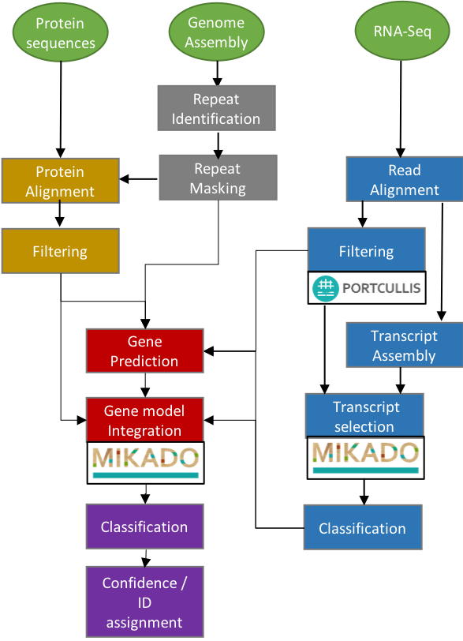

- Assignment of biotypes

Genes are assigned into one of three biotypes:

protein_coding_gene = genes with supported ORFs or high coding potential

predicted_gene = genes with limited homology support (< 30%) and with low coding potential

transposable_element_gene = genes with > 40% overlap with interspersed repeats

ncRNA = [NEED INFORMATION]

- Gene confidence classification

Genes are also flagged as either “High” or “Low” confidence

High = >80% coverage to reference proteins OR >60% protein coverage and with at least 40% of the structure supported by transcriptome data.

Low = genes with transcripts falling outside the high confidence threshold.

Note the annotation does not specifically attempt to identify pseudogenes, or other smRNAs although these may be annotated as protein coding or predicted genes (usually marked as low confidence)

The table below indicates the number of genes in each biotype/confidence category.

Biotype | Confidence | Gene | Transcript
protein_coding_gene | High | 21,279 | 38,819
transposable_element_gene | High | 5,842 | 6,005
ncRNA | Low | 7,990 | 11,101
predicted_gene | Low | 492 | 501
protein_coding_gene | Low | 1,517 | 1,579
transposable_element_gene | Low | 600 | 604
 | Total | 37,720 | 58,609

- Files provided with the data package

Assembly
------------
# Myzus persicae O genome:
assembly/Myzus_persicae_O_v2.0.scaffolds.fa

Annotation
--------------
# Myzus persicae O GFF3 file:
annotation/MYZPE13164_O_EIv2.1.annotation.gff3

# Myzus persicae O cDNA fasta file:
annotation/MYZPE13164_O_EIv2.1.annotation.gff3.cdna.fasta

# Myzus persicae O CDS fasta file:
annotation/MYZPE13164_O_EIv2.1.annotation.gff3.cds.fasta

# Myzus persicae O peptide fasta file:
annotation/MYZPE13164_O_EIv2.1.annotation.gff3.pep.fasta

# Myzus persicae O individual transcript details:
annotation/MYZPE13164_O_EIv2.1.annotation.gff3.transcript-stats.txt

# Myzus persicae O classification metrics information:
annotation/MYZPE13164_O_EIv2.1.annotation.gff3.metrics.txt

Brief description of the above metrics columns is below:

Column | Comment
#trans | Transcript identifier
#gene | Gene identifier
#confidence | Gene confidence assignment * as explained under 'Section: Gene confidence classification'
#biotype | Gene biotype assignment * as explained under 'Section: Assignment of biotypes'
#region | Transcript loci region in the format chromosome:transcript_start..transcript_end

- Gene Stats

Number of genes | 37,720
Number of Transcripts | 58,609
Transcripts per gene | 1.55
Number of monoexonic genes | 7,589
Monoexonic transcripts | 7,753
Transcript mean size cDNA (bp) | 1,980.65
Transcript median size cDNA (bp) | 1,669
Min cDNA | 70
Max cDNA | 45,208
Total exons | 353,349
Exons per transcript | 6.03
Exon mean size (bp) | 328.52
CDS mean size (bp) | 232.51
Transcript mean size CDS (bp) | 1,184.68
Transcript median size CDS (bp) | 882
Min CDS | 0
Max CDS | 43,491
Intron mean size (bp) | 1,210.87
5UTR mean size (bp) | 319.04
3UTR mean size (bp) | 428.9

- BUSCO Assessment results

BUSCO (v3.0; https://busco.ezlab.org/) results against the genome (i.e. based on BUSCO own Augustus predictions) and proteins (based on the annotation) are below:

