Advancing Android Privacy Assessments with Automation
Examples of different views proposed in the Assessor View
Example 1:

Real-world Android app Stellarium [1] collects UUID and logs it.

1. Jimple program slice 2. View 1: Java program slice
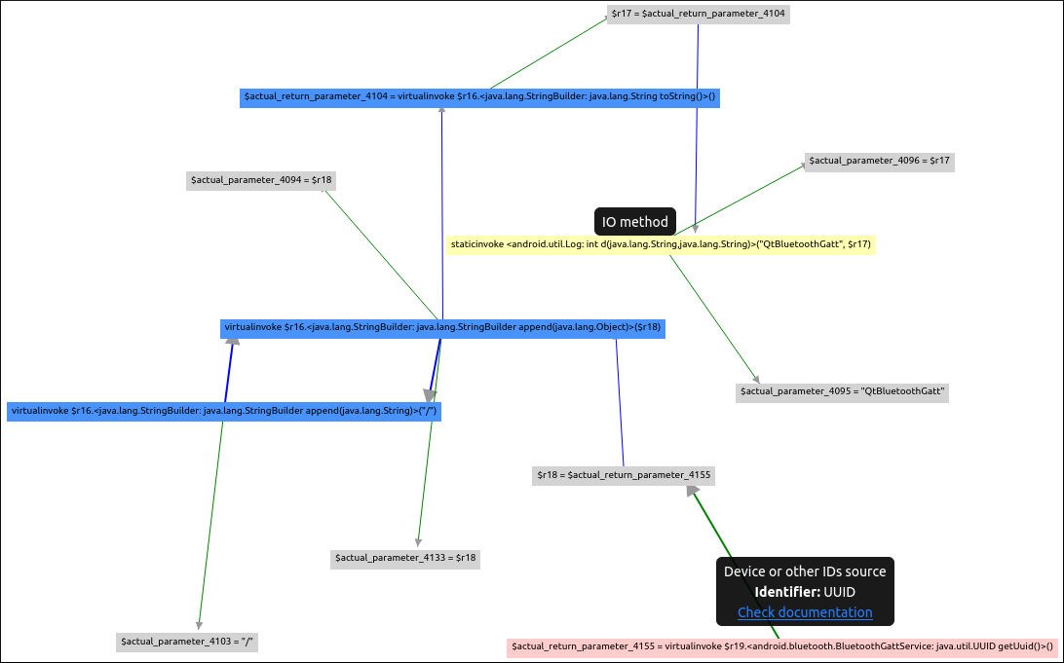
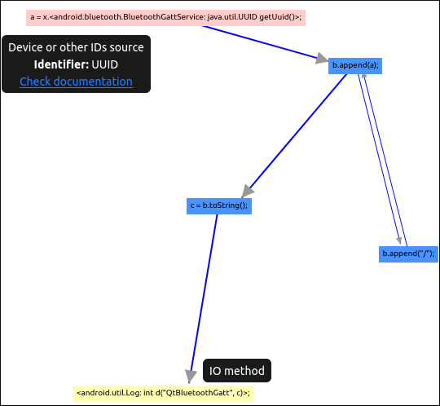

3. View 2: DPV [2] model 4. View 3: DPV diagram
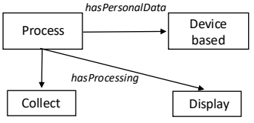
1 ex:Stellarium dpv:Process ;
2 dpv:hasPersonalData pd:DeviceBased ;
3 dpv:hasProcessing 1.dpv:Collect, 2.dpv:Display .

Example 2:

Real-world Android app Stellarium collects UUID and reads it.

1. Jimple program slice 2. View 1: Java program slice

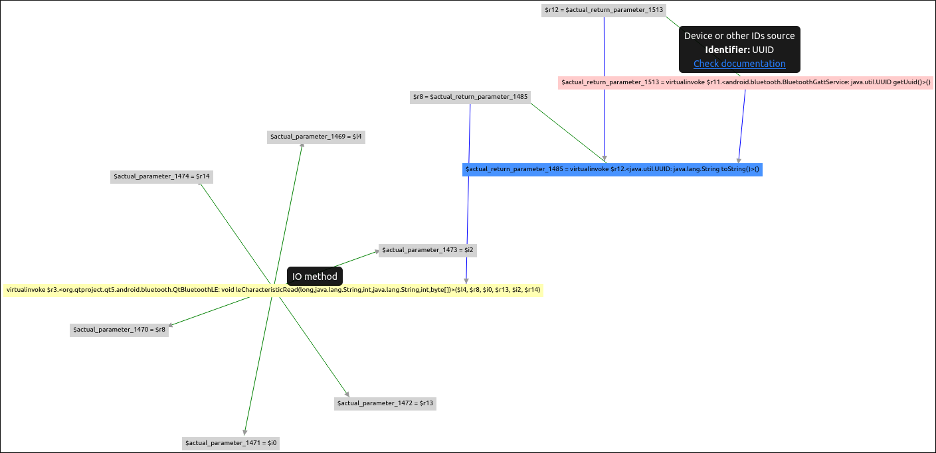

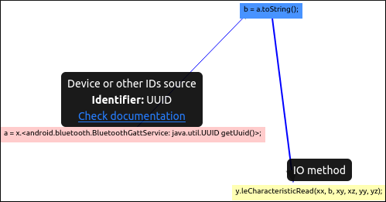

3. View 2: DPV model 4. View 3: DPV diagram
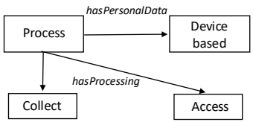
1 ex:Stellarium dpv:Process ;
2 dpv:hasPersonalData pd:DeviceBased ;
3 dpv:hasProcessing 1.dpv:Collect, 2.dpv:Access .

Example 3:

TaintBench app Sms_send_locker_qqmagic[11] collects SMS message contents and logs it via Android.

This is a complex case which illustrates the difference between View 2 and View 3. In this case, the following operations are found in the program slice.

SMS body is collected and then data (variable a) derived from it. Hence the derived data is variable a.
Then the following operations take place:
b = b.append(a)
a = b
c = c.append(a)
a = c
d = d.append(a)
a = d

Finally, variable a is logged by Android.

View 2: DPV model View 3: DPV diagram

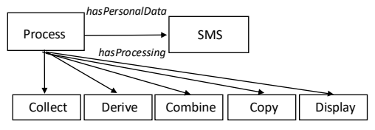
1 ex:Sms_send_locker_qqmagic dpv:Process ;
2 dpv:hasPersonalData pd:SMS ;
3 dpv:hasProcessing 1.dpv:Collect, 2.dpv:Derive //variable a
3.dpv:Combine, 4.dpv:Copy //b = a
5.dpv:Combine, 6.dpv:Copy //c = a
7.dpv:Combine, 7.dpv:Copy //d = a
9.dpv: Display .

More examples follow..

App | Program Slice Property | View 2: DPV model | View 3: DPV diagram | Privacy implication
Steam [3] | User agent transferred to Android bundle. | ex:Steam dpv:Process ;  dpv:hasPersonalData pd:DeviceBased ;  dpv:hasProcessing 1.dpv:Collect, 2.dpv:Transfer . | 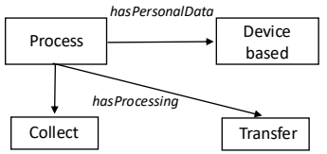 | Transfer without pseudonymization. Violation of GDPR Article 25 [5].
  1 ex:Stellarium dpv:Process ;
  2 dpv:hasPersonalData dpv:DeviceBased ;
  3 dpv:hasProcessing dpv:Collect, dpv:Access .
Steam | Google session ID collected and written to Google storage. | ex:Steam dpv:Process ;  dpv:hasPersonalData pd:DeviceBased ;  dpv:hasDataSource dpv:ThirdParty ;  dpv:hasProcessing 1.dpv:Collect, 2.dpv:Store . | 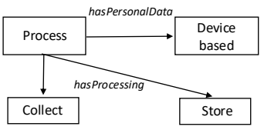 | Storage without pseudonymization. Violation of GDPR Article 25 [5].
  1 ex:Stellarium dpv:Process ;
  2 dpv:hasPersonalData dpv:DeviceBased ;
  3 dpv:hasProcessing dpv:Collect, dpv:Access .
LocationLeak1 [4] | Latitude logged/recorded. | ex:LocationLeak1 dpv:Process ;  dpv:hasPersonalData pd:Locaton ;  dpv:hasProcessing 1.dpv:Collect, 2.dpv:Record . | 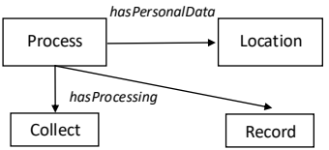 | Recording data without pseudonymization. Violation of GDPR Article 25 [5].
  1 ex:Stellarium dpv:Process ;
  2 dpv:hasPersonalData dpv:DeviceBased ;
  3 dpv:hasProcessing dpv:Collect, dpv:Access .
Jollyserv  [10] | Country name collected and then appended to a new variable. | ex:LocationLeak1 dpv:Process ;  dpv:hasPersonalData pd:Country ;  dpv:hasProcessing 1.dpv:Collect, 2.dpv:Combine . | 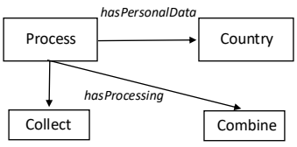 | Personal data is combined but not used later. Possible data minimization according to GDPR Article 5 [9]
  1 ex:Stellarium dpv:Process ;
  2 dpv:hasPersonalData dpv:DeviceBased ;
  3 dpv:hasProcessing dpv:Collect, dpv:Access .
Hummingbad_android_samp [7] | MoPub [8] device ID collected,  and stored in advertisement report. | ex:Hummingbad_android_samp dpv:Process ;  dpv:hasPersonalData pd:DeviceBased ;  dpv:hasDataSource dpv:ThirdParty ;  dpv:hasPurpose dpv:PersonalizedAdvertising ;  dpv:hasProcessing 1.dpv:Collect, 2dpv:Store . | 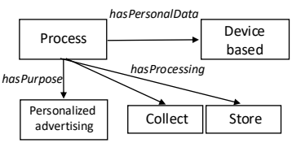 | Recording data without pseudonymization. Violation of GDPR Article 25 [5].
  1 ex:Stellarium dpv:Process ;
  2 dpv:hasPersonalData dpv:DeviceBased ;
  3 dpv:hasProcessing dpv:Collect, dpv:Access .

References:

[1] Stellarium: https://play.google.com/store/apps/details?id=com.noctuasoftware.stellarium_free&hl=en

[2] Data Privacy Vocabulary (DPV): https://arxiv.org/abs/2404.13426

[3] Steam: https://play.google.com/store/apps/details?id=com.valvesoftware.android.steam.community&hl=en

[4] LocationLeak1: https://github.com/secure-software-engineering/DroidBench/tree/master

[5] GDPR Article 25: https://gdpr-info.eu/art-25-gdpr/

[6] GDPR Chapter 5: https://gdpr-info.eu/chapter-5/

[7] Hummingbad_android_samp: https://github.com/TaintBench/hummingbad_android_samp

[8] MoPub: https://www.applovin.com/max/

[9] GDPR Article 5: https://gdpr-info.eu/art-5-gdpr/

[10] Jollyserv: https://github.com/TaintBench/jollyserv

[11] Sms_send_locker_qqmagic: https://github.com/TaintBench/sms_send_locker_qqmagic

