Supplementary Text 1: 3D-LAKES Quality Flags
- Background
Three quality (QA) flags are provided for each lake in the 3D-LAKES dataset. The QA flags indicate the level of uncertainty associated with the estimated bathymetry values. Additionally, we provide the corresponding input variables used to generate these flags. The input variables are for users to better understand and evaluate the quality of the predictions. A summary of this information is presented in Supplementary Table 1. Detailed explanations on the uncertainties associated with each flag, along with the corresponding confidence intervals (Supplementary Figure 1), are provided in the subsequent Methods and Results sections. All quality flags and associated Input data for each lake can be downloaded from Zenodo (https://doi.org/10.5281/zenodo.13107867).
Supplementary Table 1: Attribute table of quality flags and associated input data.
QA Flags
Variable | Value and meaning | Usage
QA_RMSE | 0 = good  1 = suspect  2 = degraded | Representing the uncertainty of the overall bathymetry values by RMSE values, incorporating all known contributing factors (e.g., Model_RMSE, Lake_area, Slope_100).
QA_NRMSE | 0 = good  1 = suspect  2 = degraded | Assessing the uncertainty of the A-E relationships by NRMSE values, including all known factors (i.e., Model_RMSE, Lake_area, Slope_100).
QA_Extrapolation  (Level 2 product) | 0 = good  1 = suspect  2 = degraded  3 = bad | Investigating potential extrapolation errors in Level 2 A-E relationships.
Input Data
Variable | Meaning | Source
Lake_area | The lake surface area (i.e., polygon area), in square kilometers. | HydroLAKES (Messager et al., 2016).
Slope_100 | The average slope within a 100-meter buffer around the lake polygon, in degrees. | HydroLAKES (Messager et al., 2016).
Model_NRMSE | NRMSE values between the input data and the predicted value from the machine learning method. | The procedure of RANSAC and Isotonic Regression.

- Methods
  - Generation of “QA_RMSE” and “QA_NRMSE”
To estimate the uncertainty of bathymetry values for each lake, two (each for RMSE and NRMSE) Random forest models (Breiman, 2001) were trained using validation results. The 214 validation samples were categorized based on their RMSE/NRMSE values, which indicate the performance of the 3D-LAKES dataset relative to in-situ measurements. Specifically, the 214 samples were ranked from lowest to highest RMSE/NRMSE values and divided into three groups: the top 40% (indicating the highest accuracy) were labeled as “0”, the middle 30% (40–70%) as “1”, and the bottom 30% (70–100%) as “2”, representing decreasing levels of model performance.
We evaluated the importance of various input variables in determining the performance of the 3D-LAKES dataset against validation data. Among the candidate variables, Lake_area, Slope_100, and Model_NRMSE emerged as the most influential factors. Based on this finding, we selected these variables to train two Random Forest models. To implement this, the dataset of 214 reservoirs was split into a training set (80%) and a testing set (20%).
Finally, we used both trained Random Forest models to estimate RMSE and NRMSE for each water body in the 3D-LAKES dataset.
  - Estimation of “QA_Extrapolation” for Level 2 Product
Potential linear extrapolation errors in the Level 2 A–E relationships were analyzed for each water body in the 3D-LAKES dataset. We calculated the ratio between the range of water dynamic elevation (i.e., the difference between historical maximum and minimum water elevation) in the Level 2 A–E relationships and the average lake depth obtained from HydroLAKES (Messager et al., 2016). Ideally, the water dynamic elevation should be similar to the average lake depth. Therefore, this ratio should fall between 0–2, unless the water body experiences significant expansion or contraction.
In this study, we categorized this ratio into four groups to generate the “QA_Extrapolation” flag:
- 0 if the ratio is less than 1 (good).
- 1 if the ratio is between 1 and 2 (suspect).
- 2 if the ratio is between 2 and 3 (degraded).
- 3 if the ratio exceeds 3 (bad).
QA_Extrapolation is a quality flag used to indicate the extrapolation errors of the Level 2 A-E relationships. If the QA_Extrapolation flag may indicate large errors (e.g., flag = 3), users are advised not to use the Level 2 A–E relationships and only use the Level 1 A–E relationships for a more accurate representation.
- Results
  - The Random Forest Performance on “QA_RMSE”, “QA_NRMSE”
In this study, we developed two predictive models: one for the NRMSE flag and another for the RMSE flag. A total of 43 validation samples were randomly selected as the testing dataset. The predicted flags generated by the models were compared with the ground truth labels described in Section 2.1.
The performance of these models is summarized in Supplementary Table 2 and Supplementary Table 3, respectively. Overall, the model predicting the RMSE flag achieved better accuracy, reaching 0.65, whereas the NRMSE model performed less effectively, with an accuracy of 0.51. Misclassifications primarily occurred for Flag 1 in both models. However, this issue was more pronounced in the NRMSE model, likely due to the similarity in NRMSE values between Flag 0 and Flag 1. For both Flag 0 and Flag 2, the F1-scores exceeded 0.55, indicating strong classification performance for these categories.
Supplementary Table 2: Random Forest performance for QA_RMSE flag.
Flag | Precision | Recall | F1-score | Support
0 | 0.63 | 0.71 | 0.67 | 17
1 | 0.46 | 0.46 | 0.46 | 13
2 | 0.91 | 0.77 | 0.83 | 13
Accuracy |  |  |  | 0.65

Supplementary Table 3: Random Forest performance for QA_NRMSE flags.
Flag | Precision | Recall | F1-score | Support
0 | 0.52 | 0.65 | 0.58 | 17
1 | 0.4 | 0.31 | 0.35 | 13
2 | 0.58 | 0.54 | 0.56 | 13
Accuracy |  |  |  | 0.51

  - Uncertainty in Bathymetric Values Across Predicted Quality Flags
To provide a confidence interval for bathymetric values for water bodies in 3D-LAKES, we further analyzed the uncertainty across various quality flags using the previously mentioned 43 testing samples (Supplementary Figure 1). An increasing trend in NRMSE/RMSE values is observed from Flag 0 to Flag 2, indicating that the Random Forest models can predict uncertainty reliably. Therefore, users can identify the statistical error ranges of the RMSE and NRMSE according to their associated QA flags at each lake (Supplementary Figure 1). For instance, if the flag value of QA_RMSE is 0, it means the RMSE is within the range of 0.3m (25th percentile) to 0.5m (75th percentile).
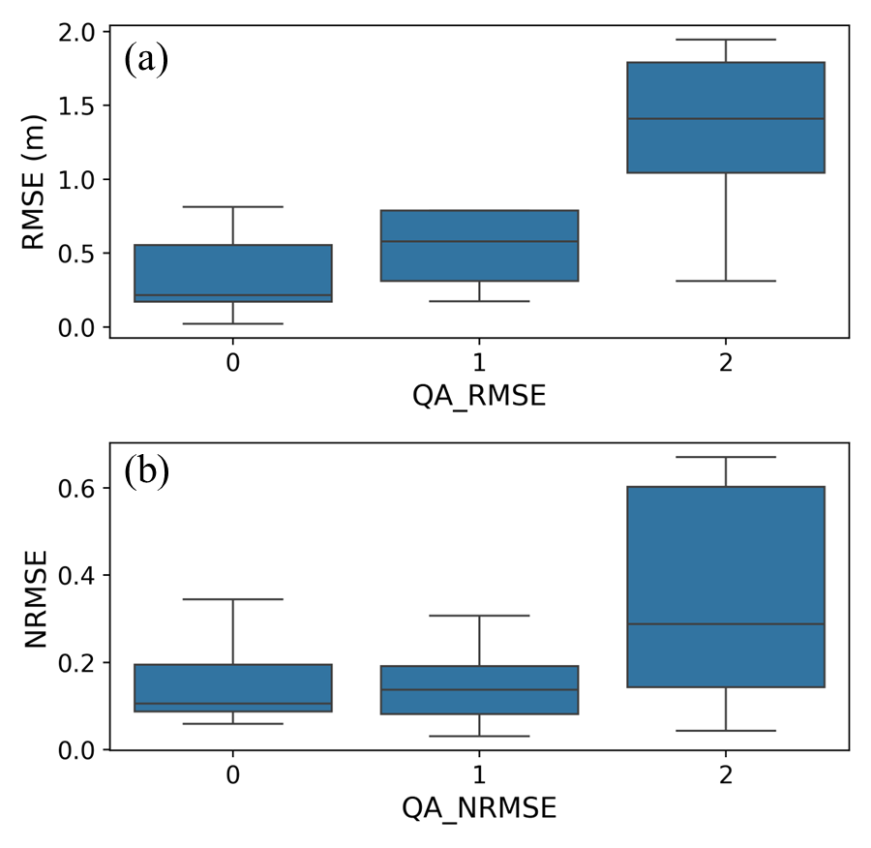
Supplementary Figure 1: The boxplots of the (a) RMSE (m) and (b) NRMSE (%) values (based on results over the 43 testing locations) across different quality flags.
  - The Spatial Distribution of “QA_RMSE”, “QA_NRMSE” Flags
For each lake, we apply the two previously trained Random Forest models to estimate the uncertainty in the 3D-LAKES dataset. The global spatial distribution of QA_RMSE and QA_NRMSE flags is demonstrated in Supplementary Figure 2. In the case of QA_RMSE, most water bodies (about 55%) are classified as “good” (i.e., flag = 0). However, some lakes (about 11%)—such as those in parts of Japan—are found “degraded” (i.e., flag = 2), likely due to their high average surrounding terrain slope. For QA_NRMSE, about 58% of all water bodies are flagged as “degraded”. Most of these are shallow, small water bodies.
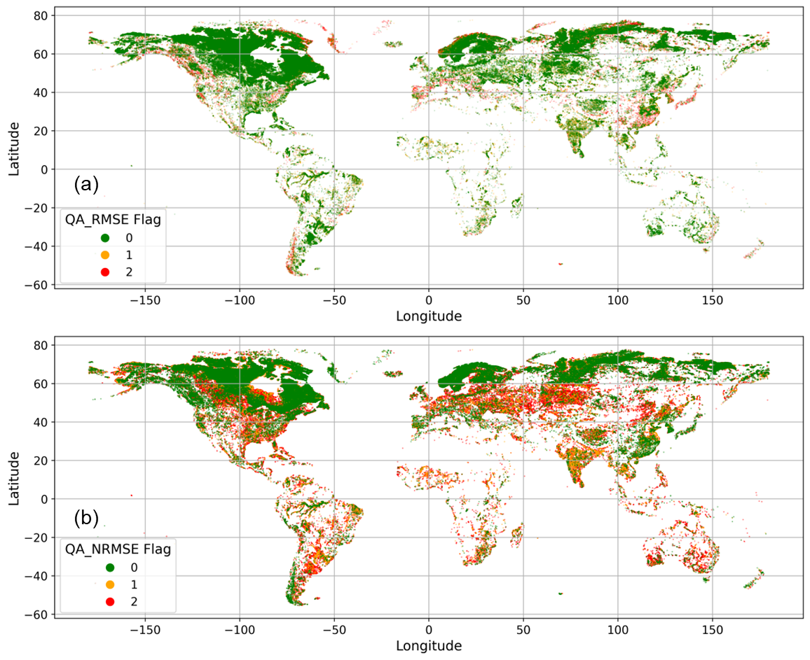
Supplementary Figure 2: The global spatial distribution of the (a) QA_RMSE and (b) QA_NRMSE flags.
- Limitation
Due to the limited availability of validation data, the predicted quality flag may be subject to bias. The 214 validation samples were collected from the U.S. Bureau of Reclamation (USBR: https://www.usbr.gov/lc/region/g4000/hourly/mead-elv.html), the U.S. Army Corps of Engineers (USACE: http://www.nwdmr.usace.army.mil/rcc/projdata/projdata.html), and the Texas Water Development Board (TWDB: https://www.twdb.texas.gov/surfacewater/surveys/completed/list/index.asp). However, these sources may not adequately represent the uncertainty associated with bathymetry estimates on a global scale.
Furthermore, due to the inherent complexity of the bathymetry generation process, the three selected features—Lake_area, Slope_100, and Model_NRMSE—may not capture all contributing factors. Therefore, we provide the complete set of input variables as a reference for users to better understand and evaluate the quality of the predictions. All quality flags and associated input data for each lake can be downloaded from Zenodo (https://doi.org/10.5281/zenodo.13107867).

References:
Breiman, L. (2001). Random forests. Machine learning, 45, 5-32.
Messager, M. L., Lehner, B., Grill, G., Nedeva, I., & Schmitt, O. (2016). Estimating the volume and age of water stored in global lakes using a geo-statistical approach. Nat Commun, 7, 13603. https://doi.org/10.1038/ncomms13603

