Modeling the Glacial Lake Outburst Flood (GLOF) Process Chain Using BASEMENT
  - Jonathan M. Lala
  - Center for Water and the Environment
  - University of Texas at Austin

1. Introduction
The increasing risks of climate change are especially apparent in high mountain regions, where the local hydrology is dominated by glaciers and perennial snow. Glacial outburst floods (GLOFs) are of particular note in these regions, since they are often unpredictable and can cause significant damage to downstream communities in a short amount of time. One of the most common cause of a GLOF is an avalanche entering a glacial lake, which creates an impulse wave that may overtop the lake’s terminal moraine or otherwise create a chain reaction of erosion and subsequent flooding (Figure 1). Whereas previous modeling approaches toward GLOFs relied on assumptions that cannot be guaranteed in an avalanche scenario, technological improvements in free and/or open source software have allowed for the simulation of a GLOF under a variety of scenarios. This tutorial is intended to expand upon the method used in Lala et al. (2018), which simulates the GLOF process in BASEMENT, a free environmental flow software developed by the Lab of Hydraulics, Hydrology & Glaciology at ETH Zürich. The software allows for the simultaneous modeling of both hydraulic and morphodynamic processes, fully capturing both the flow of water and debris resulting from erosion of the terminal moraine.
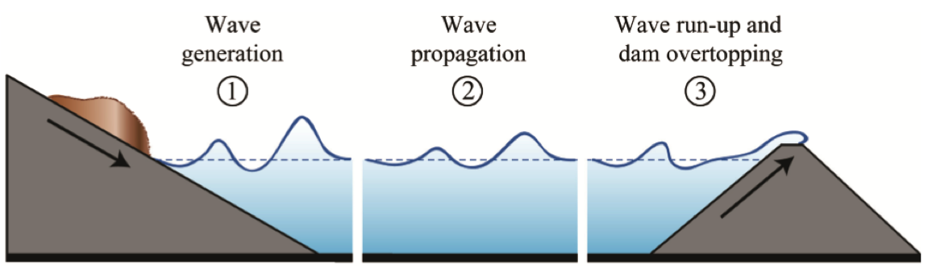
Figure 1: Schematic of the three main processes of an avalanche-induced GLOF. The avalanche enters the lake (1), which generates an impulse wave modeled by BASEMENT and the Heller-Hager equations (described in Section 5). The flood wave then flows through the terminal moraine (3), in which erosion and downstream inundation is simulated by BASEMENT. (Source: Heller et al., 2009)
This tutorial, as an expansion of Lala et al. (2018), uses the case study of a potential avalanche-induced GLOF Imja Tsho in the Nepal Himalaya. The avalanche scenarios were run using RAMMS::Debris Flow (http://ramms.slf.ch/ramms/index.php). Regardless of the software used for modeling an avalanche, this tutorial requires an inflow “hydrograph” quantifying the rate of avalanche debris entry into the lake. Instructions on how to translate this mass rate entry into the parameters required by BASEMENT are given below, in Sections 4 and 5.
The BASEMENT wave simulations are validated by the Heller-Hager equations (Heller et al., 2009), a set of empirical and analytical equations that quantify various characteristics of the avalanche-induced wave using parameters gained from the avalanche simulations and from the bathymetry of the lake. A spreadsheet of the equations is attached as an appendix to this tutorial. The basic method for validation is given in Figure 2, and explained in detail in Section 5.
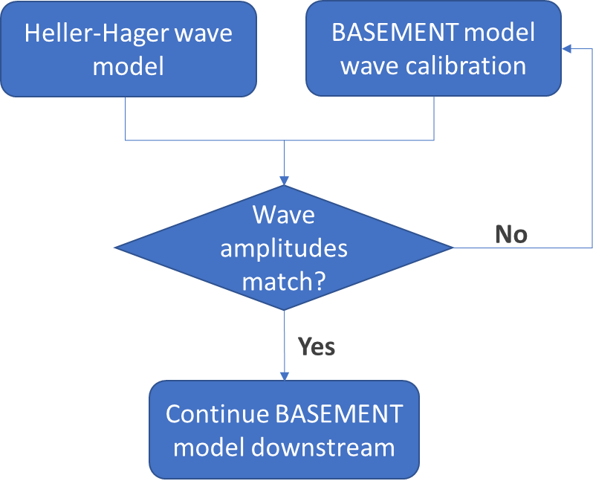
Figure 2: GLOF simulation process

2. First Steps
BASEMENT is downloadable via http://www.basement.ethz.ch/download/software-download.html (this tutorial uses version 2.7). All geographic data is processed via QGIS, a free and open source GIS software downloadable at https://qgis.org/en/site/. In order to create and edit meshes in QGIS, the BASEmesh plugin must be installed. After launching QGIS, click Manage and Install Plugins under the Plugins dropdown menu.

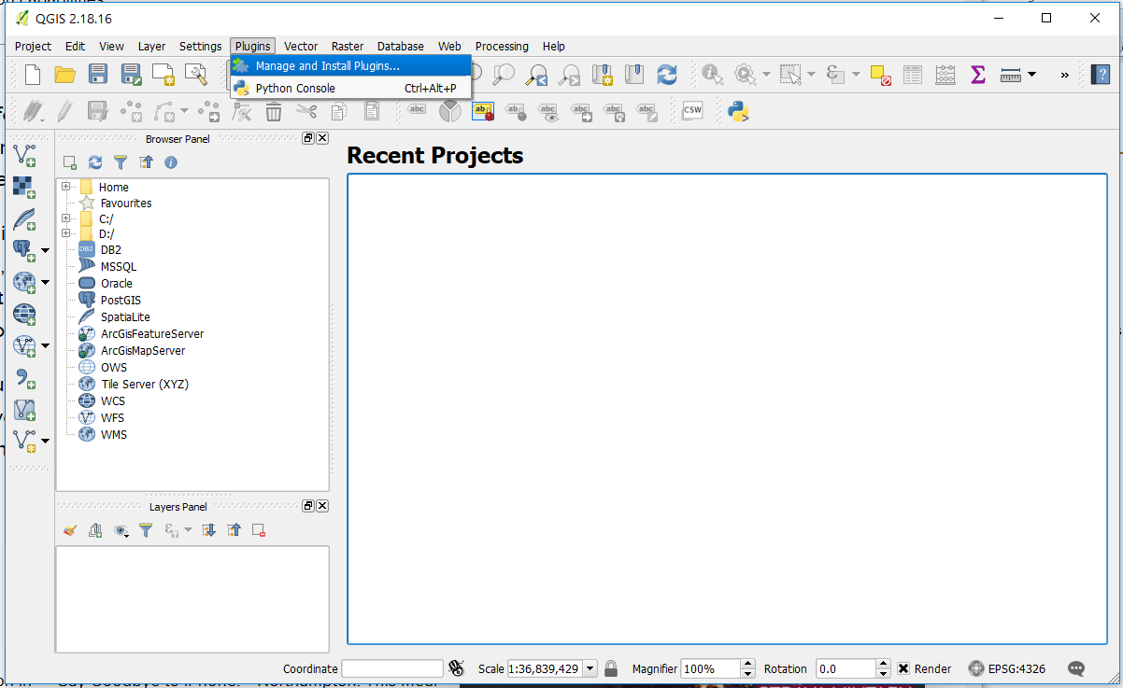
Next, select Settings, then Add…, and create a new repository using the URL http://people.ee.ethz.ch/~basement/qgis_plugins/qgis_plugins.xml.

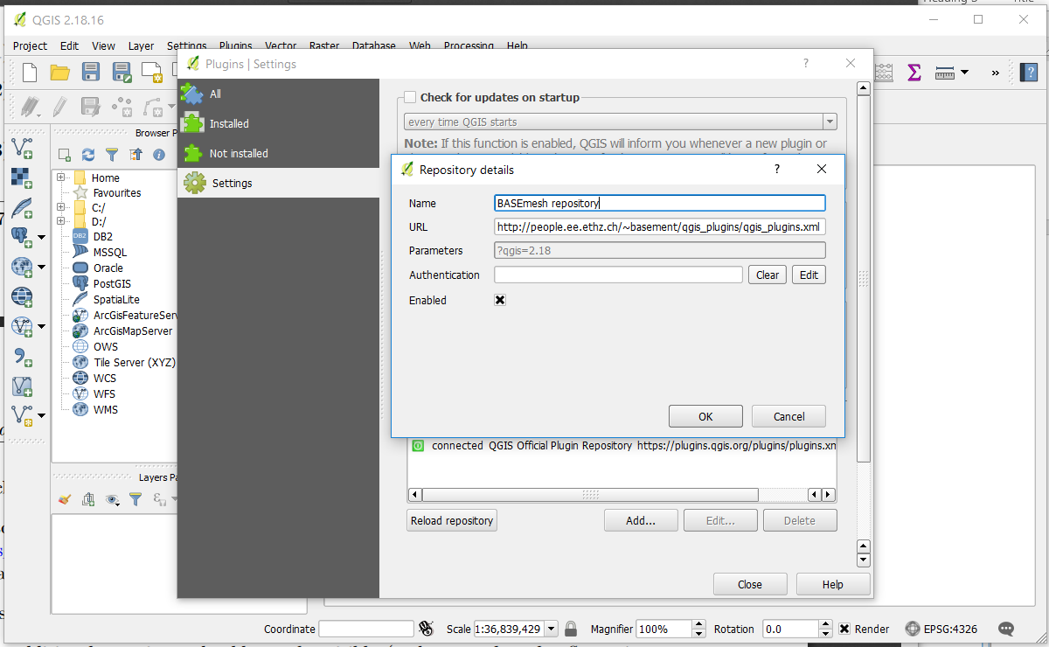
Finally, select the All tab, then BASEmesh, and finally Install plugin.

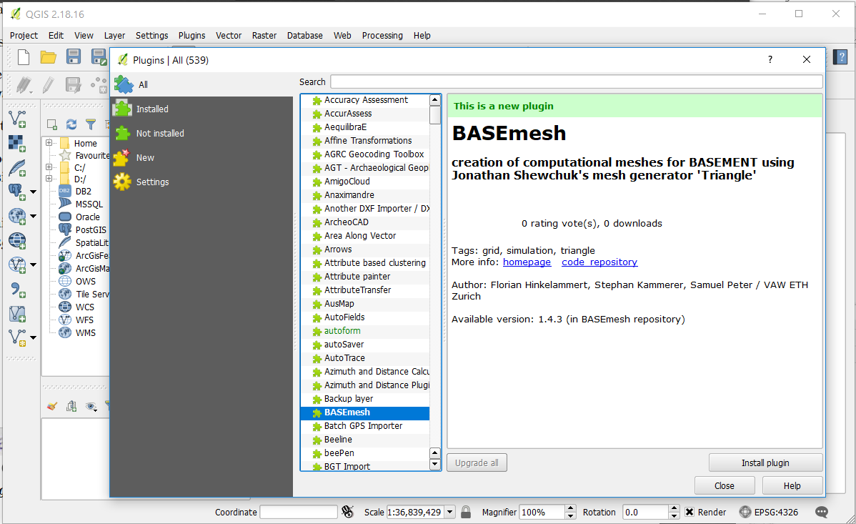
You should now see the options for BASEmesh within your toolbar.

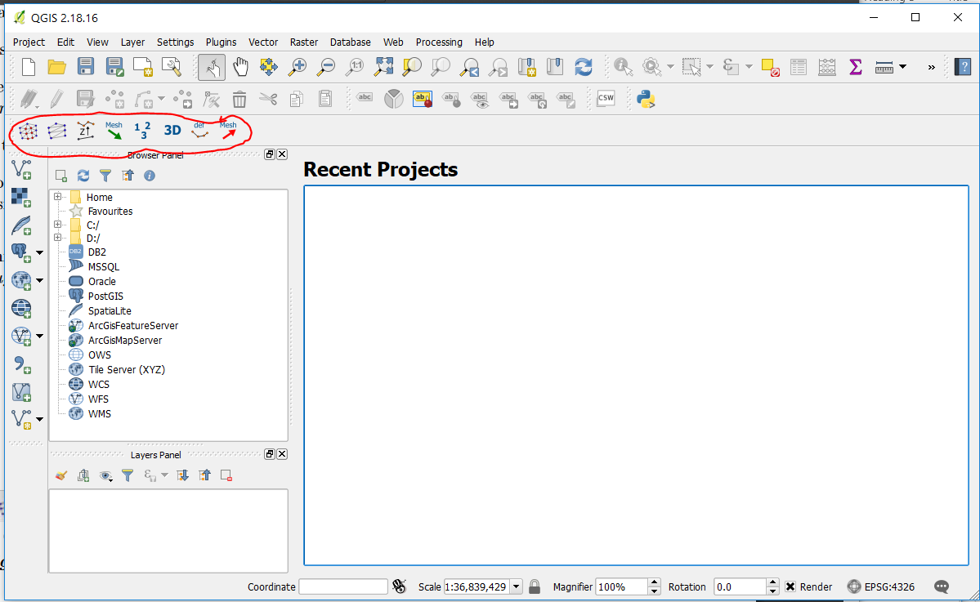
Before proceeding further, it is highly recommended that you complete Tutorials 1 and 2 from the BASEMENT website (http://www.basement.ethz.ch/download/tutorials.html), which introduce you to the basics of the software as well as its interactions with QGIS via the BASEmesh plugin. This GLOF tutorial will assume a basic familiarity with BASEMENT and BASEmesh as taught in the online tutorials.

3. Building a Mesh of the Simulation Area
What you need: QGIS with BASEmesh plugin, DEM (including lake bathymetry) in .tif format
BASEMENT, as a primarily hydrodynamic software, uses a triangulated irregular network (TIN) mesh rather than a raster for elevation data and finite element delineation. A basic “quality mesh” is generated in QGIS from user-defined parameters (e.g. model boundary, maximum element area) and then coupled with elevation data either from an elevation mesh or with a raster DEM, the latter of which is used in this tutorial. The resulting mesh is then given material indices, such as delineation of water or dry land, and then exported as a .2dm file readable by BASEMENT. For a step-by-step procedure on how to generate a .2dm mesh, see BASEMENT Tutorials 1 and 2.
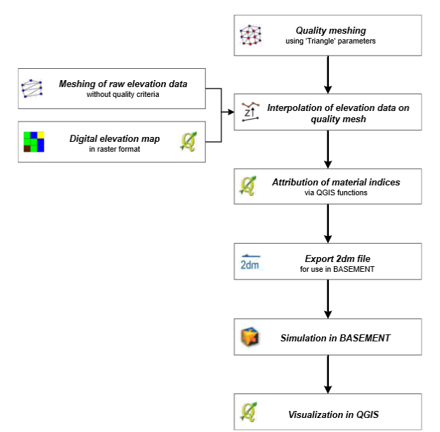
Source: BASEMENT User Manual
Because of the amount of computational power (and time) required to run a GLOF simulation in BASEMENT, it is recommended that the simulation area be as small as possible. Before creating the model boundary polygon, delineate the lake area. If you do not have a shapefile of the lake area, create a contour map using your DEM, and then use the Lines to polygons tool:

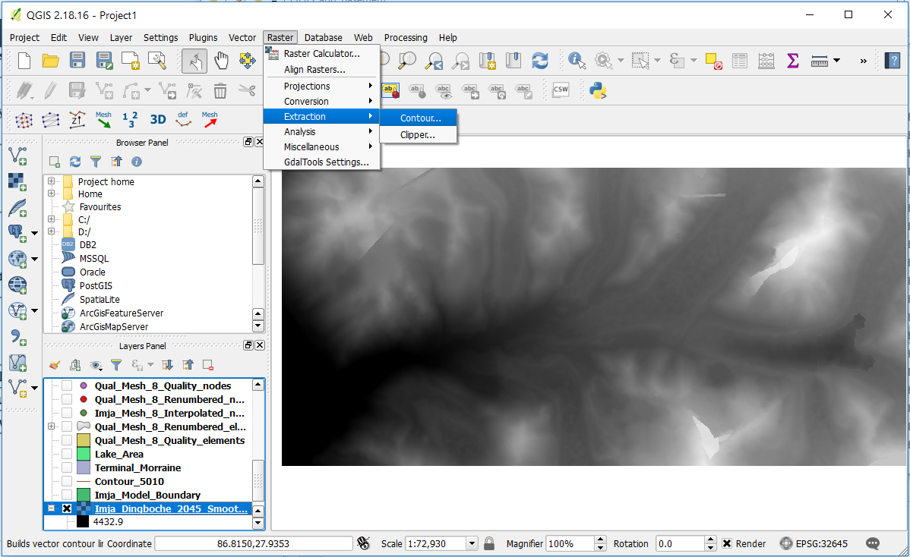

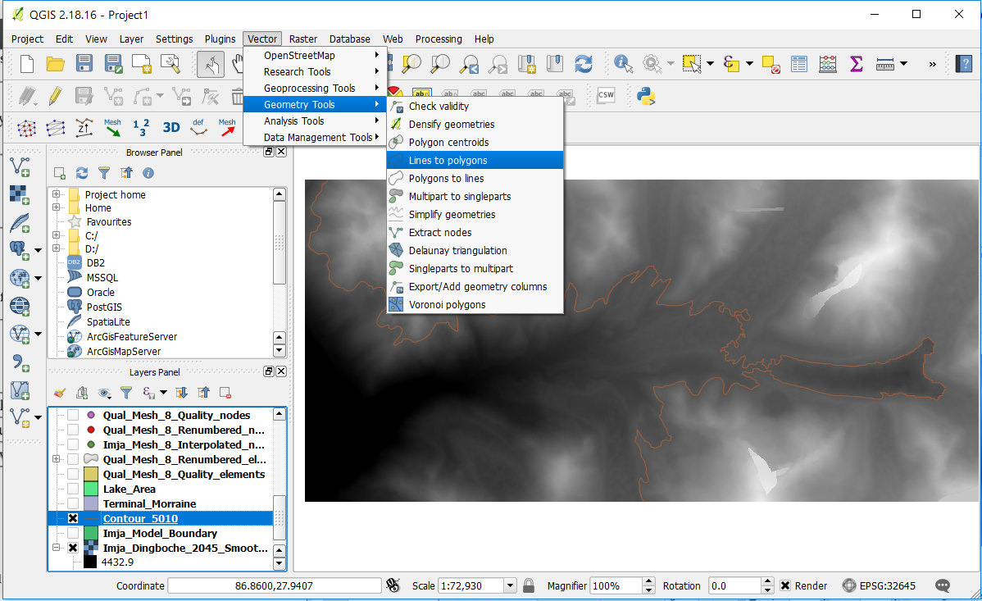

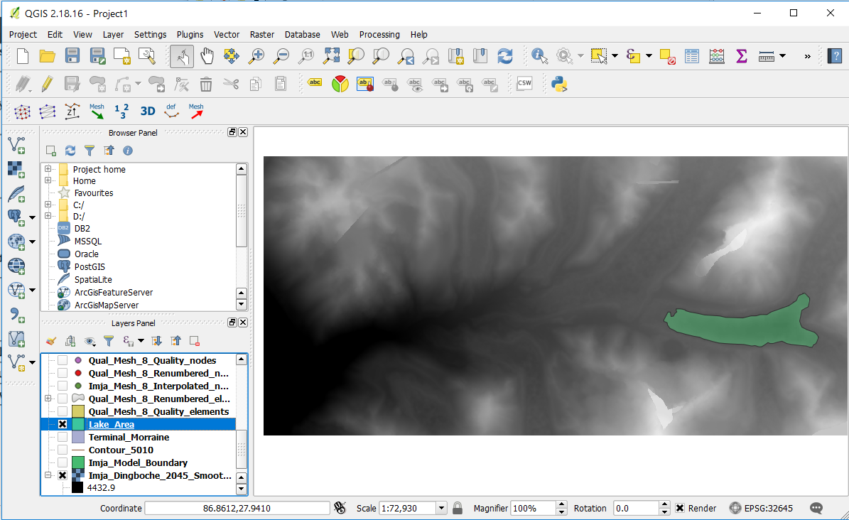
Next, the model boundary can be created (using contours, or simply freehand). Be sure that the model boundary lines up with the edge of the lake where the avalanche enters (in this case, from the northeast or southeast arms of the lake).

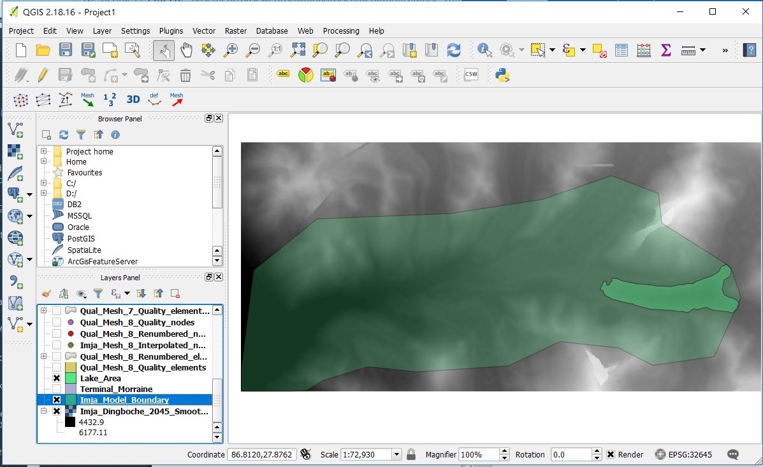
Next, create breaklines to delineate the lake and potential flood areas—in which smaller element sizes are desirable—from the rest of the model area, in which larger elements are acceptable. Note that with the exception of the lake area, these lines are arbitrarily drawn and can be adjusted once the BASEMENT simulation is run and potentially flooded areas are identified. A final breakline, Outflow, is created at the most downstream part of the model area (in this case, the lower left-hand corner) to allow for outflow when the model is run. BASEMENT also requires a definition of an inflow boundary, but this must be adjusted manually during the validation process with the Heller-Hager equations, and is thus not considered here (see Section 5 for more details on the validation procedure). In this example, four breaklines were created: one for each side of the potentially flooded areas (NorthSide and SouthSide), one for the lake (same extents as the Lake_Area polygon we delineated earlier), and one for the outflow (southwest corner of the simulation area):

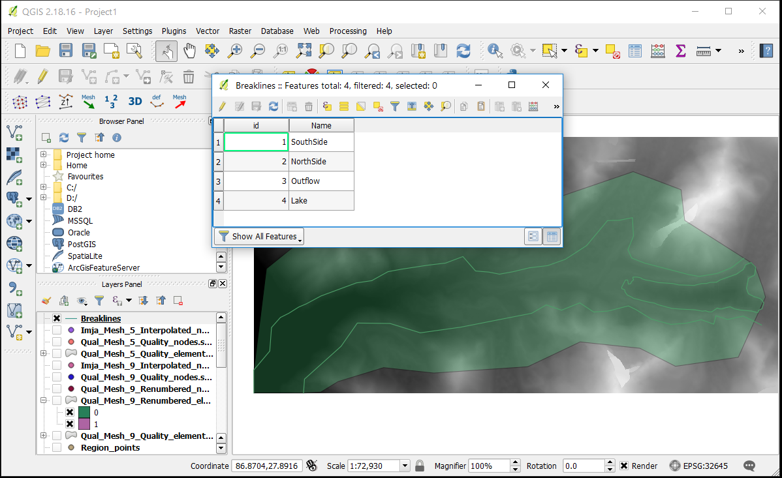
To identify the areas delineated by the breaklines, create a new point shapefile and add a point within each area (Region_points in this example). QGIS automatically designates these points with an id number; additional fields for maximum element area (max_area), material ID (MATID), holes in the mesh (hole), and a string identifier (type). It is recommended that you set the downstream, potentially flooded areas (river_bed in the figure below) to have a smaller maximum area, since hazard analysis is confined to these areas. For hole, a positive value tells BASEmesh to create a hole in the mesh, reducing the number of elements and therefore the computation time. A value of 0 tells the system not to create a hole, and a positive value tells the system to create a hole. Finally, set the MATID to 1 for the lake and 0 for dry land.

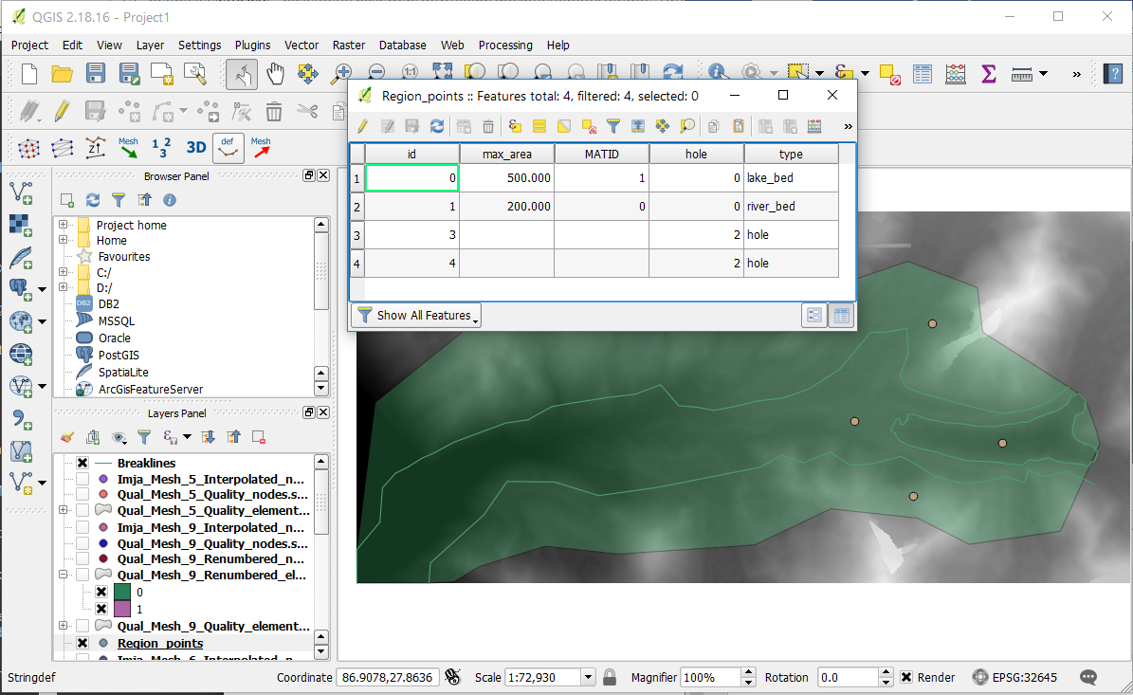
Now that the parameters for the mesh are created, the quality mesh can be generated. Select Quality meshing…

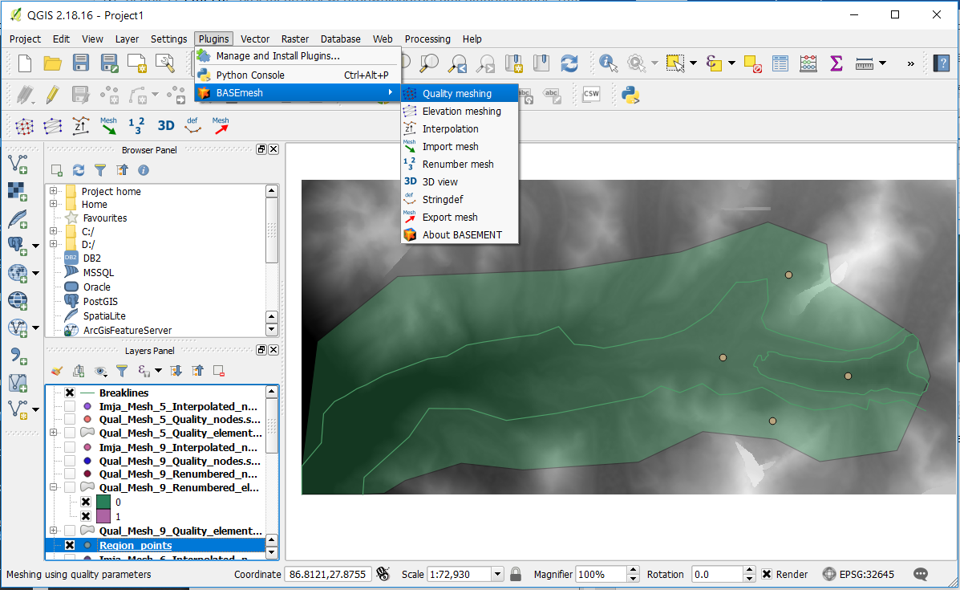
…and fill out the information as follows:

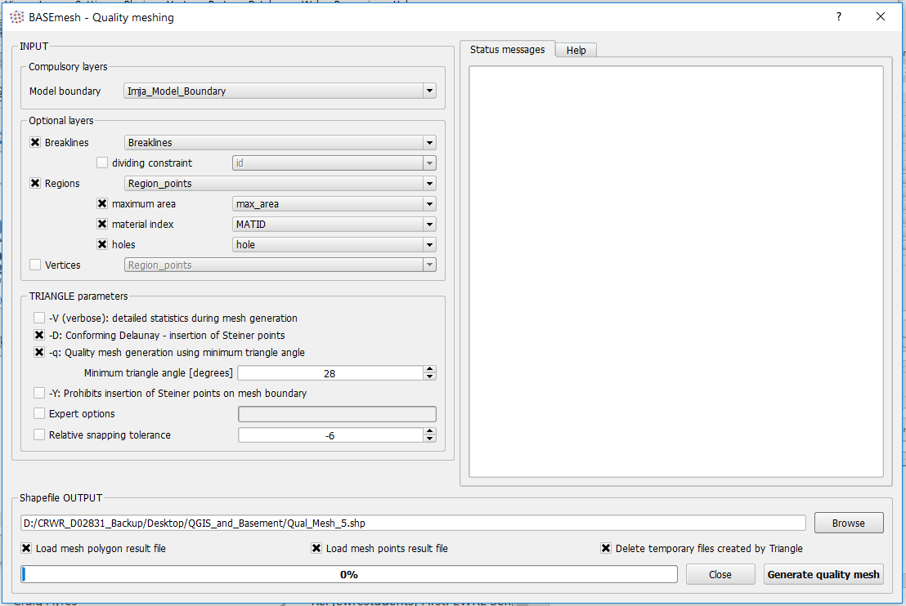
Choose an output location and then select Generate quality mesh. Now, you have a mesh consisting of two shapefiles: one with the elements and one with the nodes. Note how areas marked as holes have no elements, whereas the area marked river_bed has smaller elements than that of lake_bed.

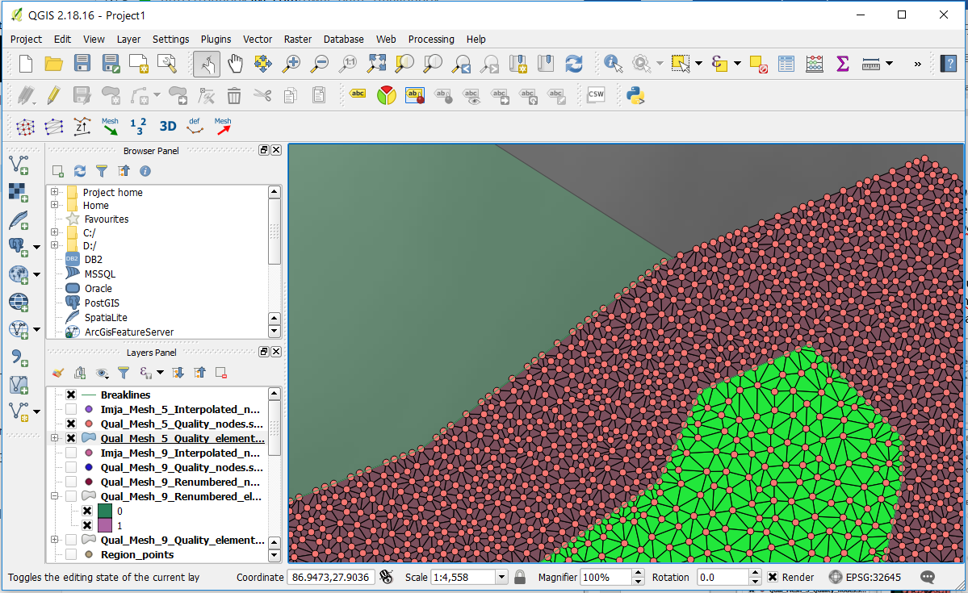
Once the quality mesh is created, elevation values can be interpolated from the DEM and added to the mesh. Select Interpolation from the BASEmesh dropdown menu or from the toolbar (circled in red) and choose digital elevation map for elevation data.

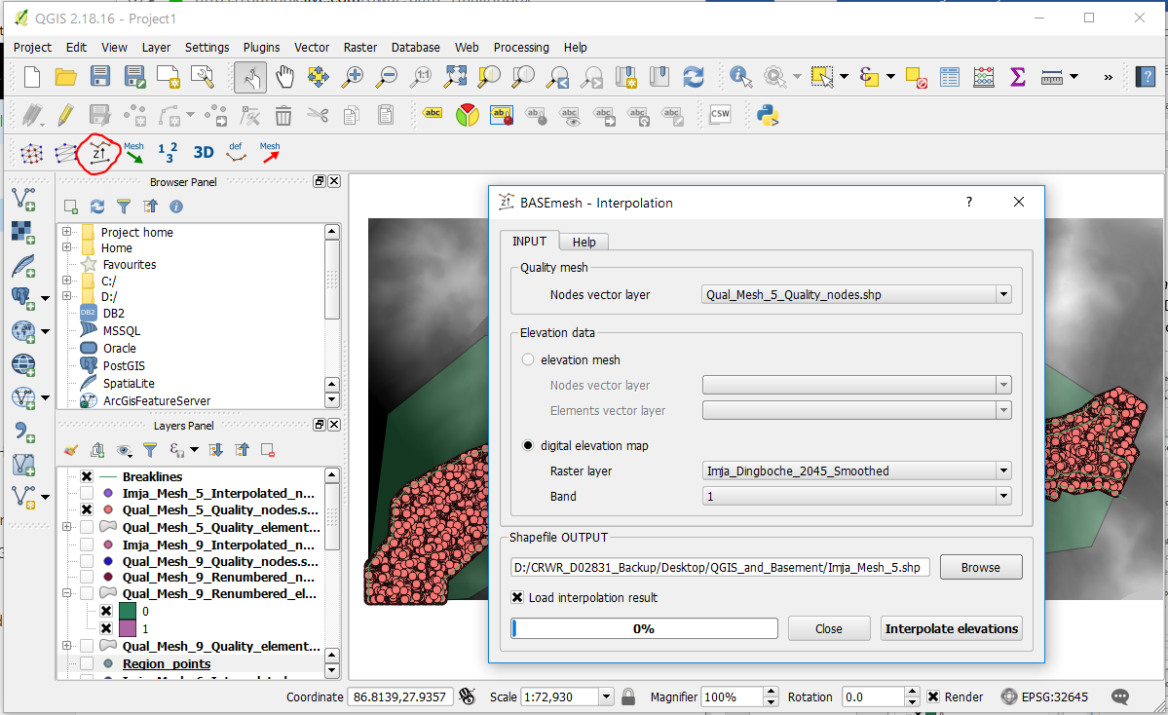
The result is a new shapefile of the nodes (in this case, Imja_Mesh_5_Interpolated_nodes_Raster.shp). Finally, export the mesh to .2dm format so that it can be read in BASEMENT, being sure to use the Z field as the elevation field.

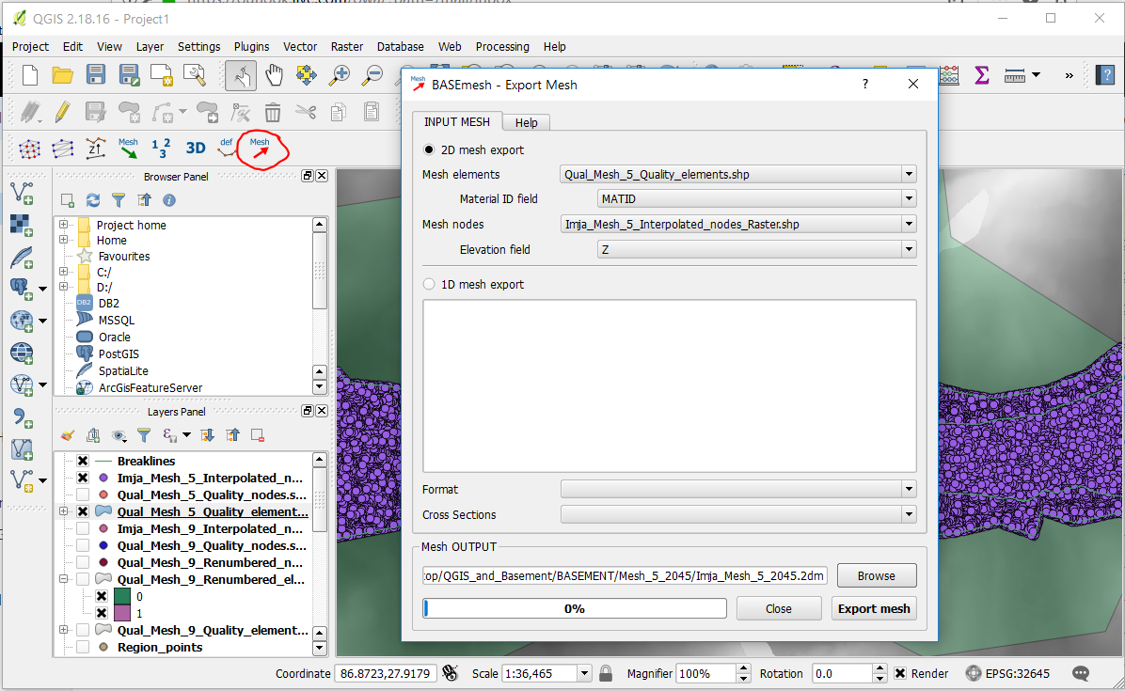
The mesh is now complete, but there are still two tasks left so that BASEMENT can interpret your mesh. First, define the nodes of your breaklines so that they can also be read in BASEMENT. Select Stringdef from the BASEmesh dropdown menu or toolbar (circled), fill out the selections as follows, and select Find node IDs. This will create a text file enumerating all of the nodes that make up your breaklines.

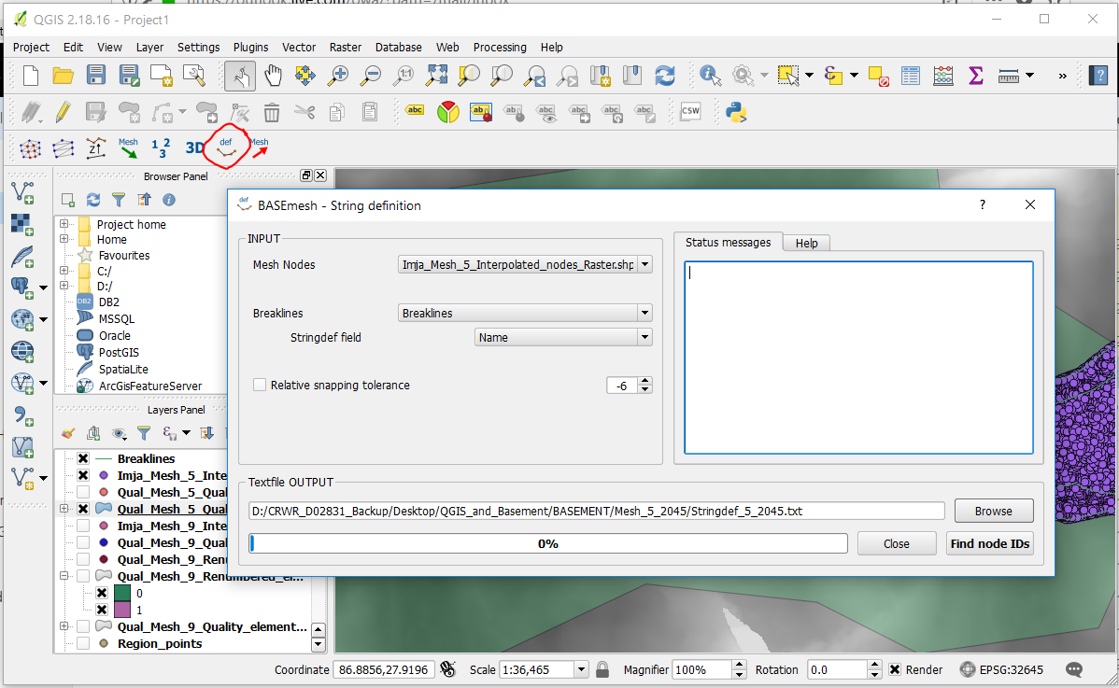
Finally, BASEMENT will need to know the initial state of the lake before the GLOF. You should have done this when creating the quality mesh, when you were creating the Region_points shapefile to identify the areas between breaklines. In case you didn’t, or in case you decide to change the MATID of some area, you can follow these steps to manually enter MATID’s into mesh elements:
Select all the elements within the lake area using the Select by location tool.

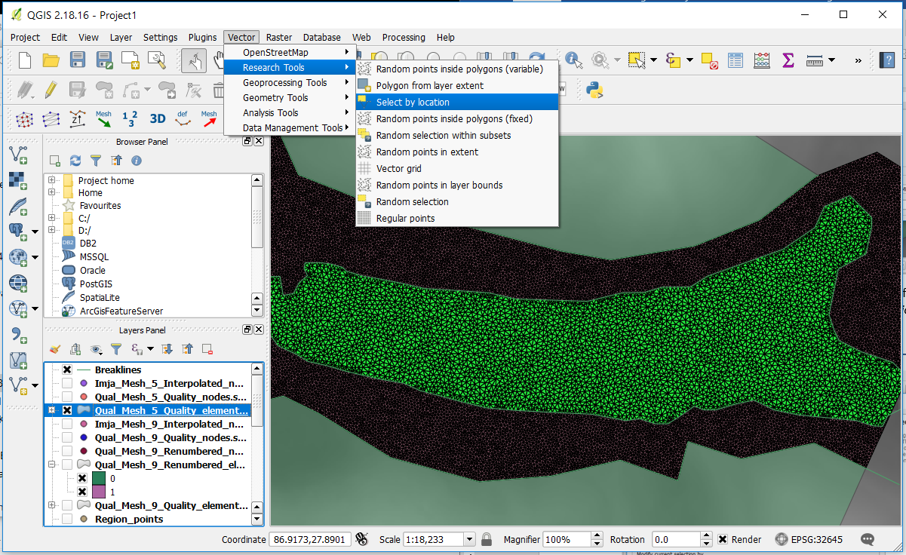

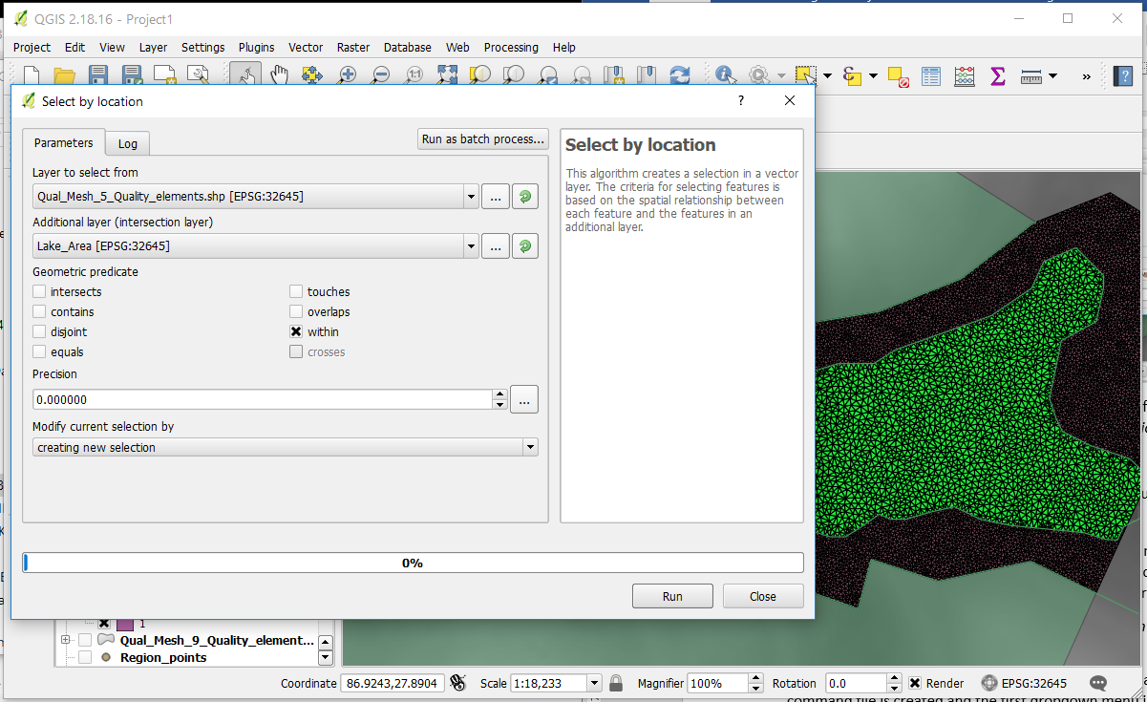
Once the elements are selected, right-click the elements layer and click Open attribute table. Click the Toggle Editing button at the top left, then set MATID to 1 for the selected elements by clicking Update Selected. Now, all elements within the lake should have a MATID of 1 and all other elements should have a MATID of 0.

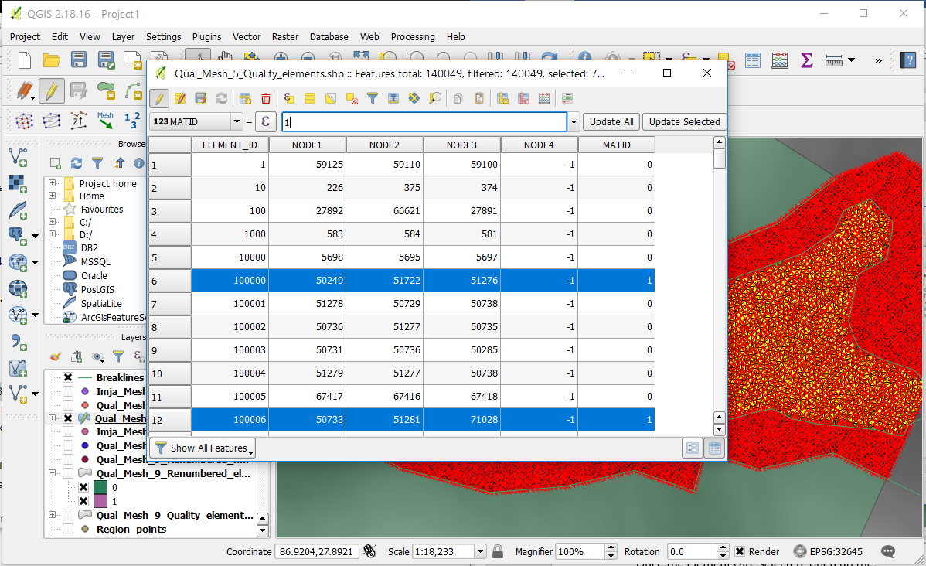
You now have a completed mesh and are ready to set up your first BASEMENT simulation.

4. Setting Up the BASEMENT Model
What you need: BASEMENT installed on your computer (this tutorial uses version 2.7), a .2dm mesh of the simulation area from QGIS, and all the info you have about the hydraulics and geomorphology of your study area
BASEMENT has a wide range of modeling capabilities and a relatively simple interface in which to set them up. Although the instructions for the simulation can be written manually, this tutorial will utilize the drop-down menus presented in the main user interface.
Note: the files used for a BASEMENT simulation at Imja Tsho are included with this tutorial and can be used as a reference
Start by launching BASEMENT, clicking Edit Command, and then selecting New under the File tab. A new command file is created and the first dropdown menu is now visible. Select PROJECT from the dropdown and then click Add Block.

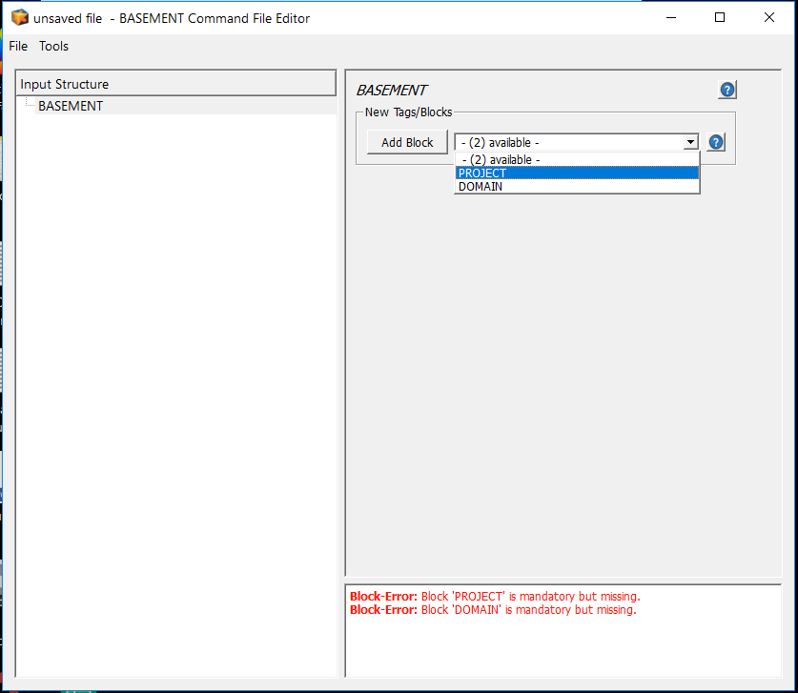
A new block is added under BASEMENT within the Input Structure sidebar. Select the PROJECT block, then add tags for title, author, and date using the dropdown menu. These fields are simply for your own records and are not required to run a simulation, but they are helpful for logging your runs.

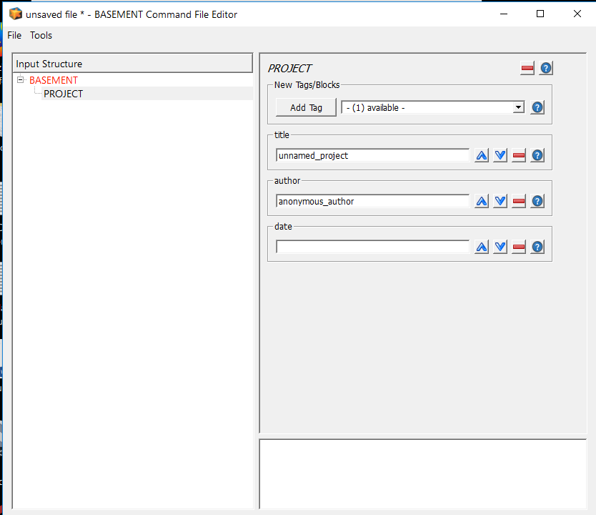
Now, select BASEMENT under the Input Structure sidebar again and add the DOMAIN block. From DOMAIN, add blocks for PHYSICAL_PROPERTIES and BASEPLANE_2D. You may also add the tag multiregion as an optional note for naming your simulation area. Proceed to add all sub-blocks and tags from these main blocks to the Input Structure.

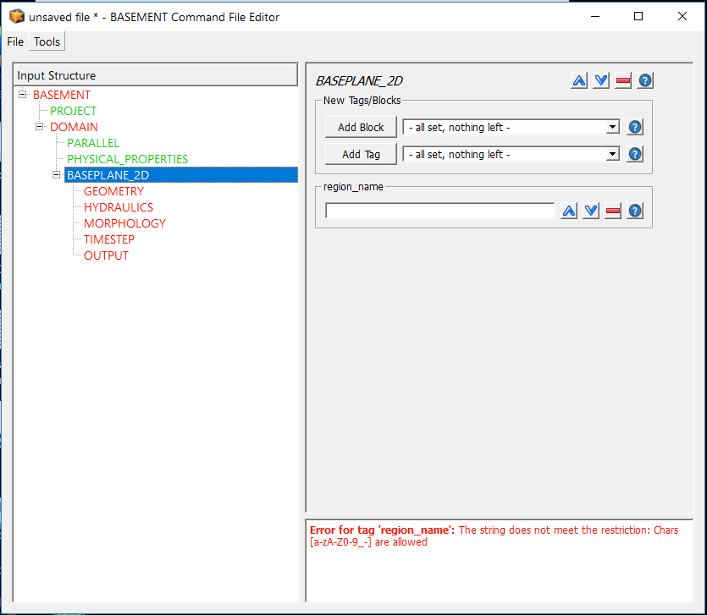
Note that PHYSICAL_PROPERTIES automatically sets gravity, viscosity, and rho to default values. Also note the differences in color within the Input Structure sidebar: red text indicates an incomplete block or error, whereas green indicates that the block is executable for a simulation.
Now you can add the geometric characteristics of your simulation area that you defined in QGIS. Under GEOMETRY, add tags for type and file, using your .2dm mesh file created in QGIS…

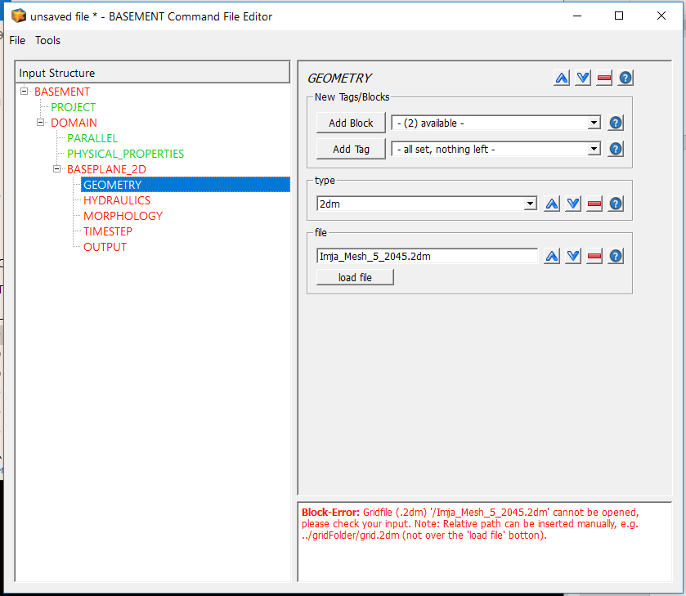
…and also add a block STRINGDEF. Using the stringdef file you created in QGIS, fill in the data as shown within the tags for name, node_ids, and upstream_direction:

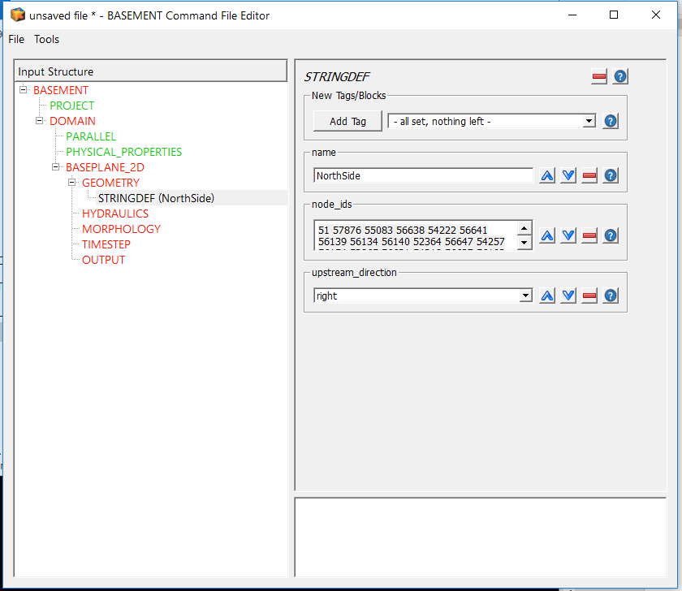
For the Imja Tsho simulation, there were 4 breaklines, corresponding to the first 4 stringdefs: the north side of the simulation area, the south side, an outflow, and a delineation of the lake itself. The fifth stringdef, inflow, will need to be adjusted as part of the calibration measure (seen in the next section). For now, just pick a few nodes along the edge of the mesh, close to the center of mass of the avalanche where it reaches the lake. Add as many other breaklines as needed for your own mesh.
Continue adding blocks, subblocks, and tags until the Input Structure sidebar looks like this:

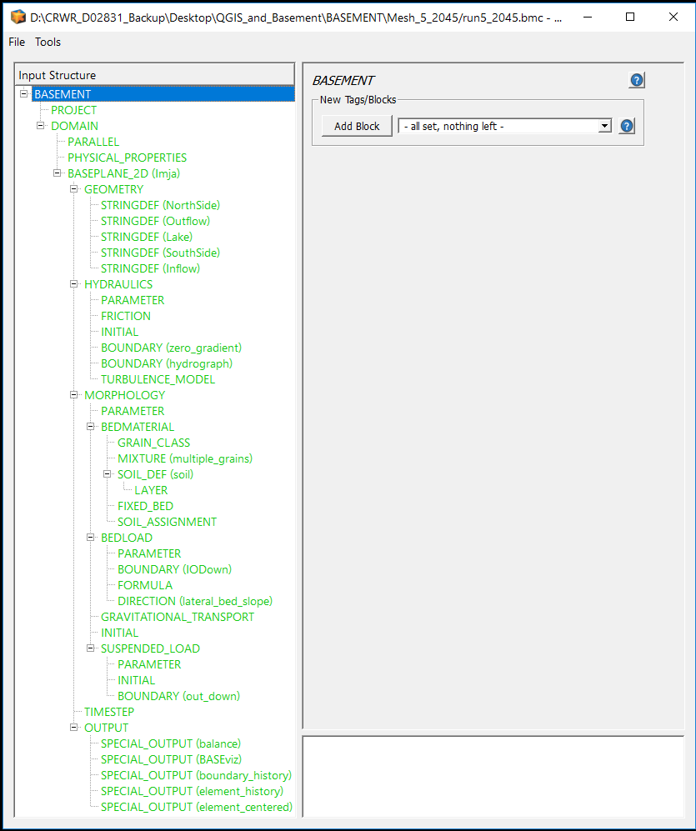
Fill in all relevant information for your simulation. Remember that the files for the simulation at Imja Tsho are included as an appendix to this tutorial, in case you get lost or are unsure of what to enter. The question mark boxes to the right of all blocks and tags can also provide guidance by explaining the function of each option.
A few blocks to note are as follows:
HYDRAULICS – INITIAL

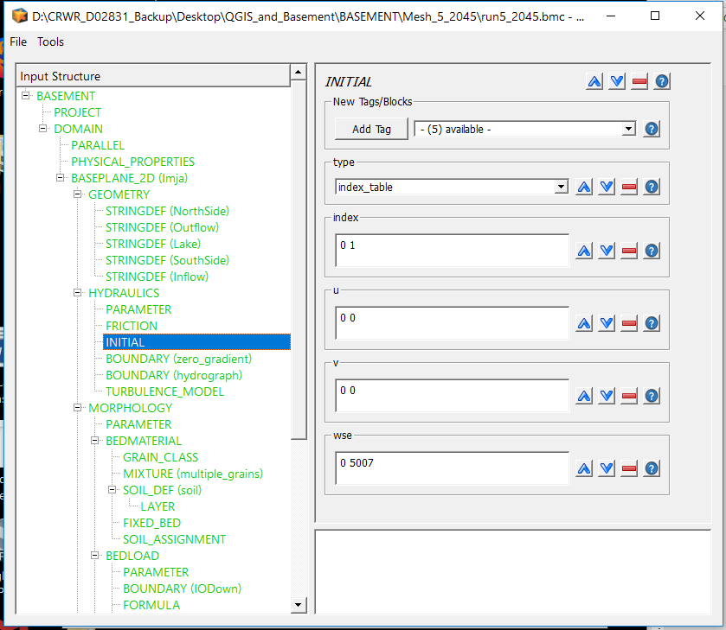
The indices shown here are the MATIDs you set after creating the mesh. Recall that 0 refers to dry land and 1 to the lake. We can define this by giving the left index (0) a water surface elevation (wse) of 0, whereas the lake is located at 5007 m above mean sea level and hence the right index 1 receives a wse of 5007. In both cases, we assume there is no velocity (u and v) for any standing water at the initial period, since the lake has not yet been hit with an avalanche.
HYDRAULICS – BOUNDARY
In this simulation there are two hydraulic boundaries (inflow and outflow). The outflow must be designated a zero-gradient boundary:

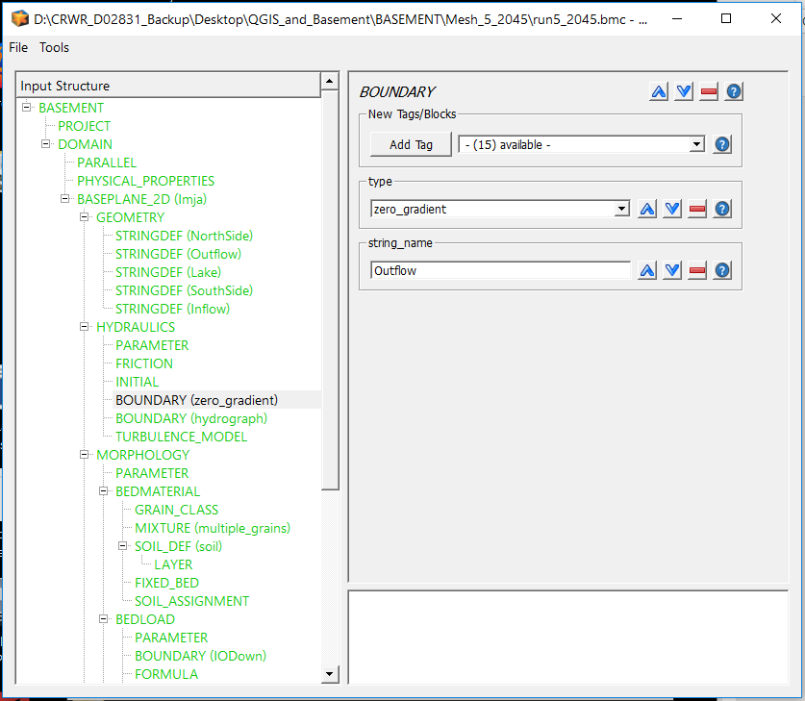
The inflow is defined by the “hydrograph” of avalanche material entering the lake. This is an important calibration measure, as you will see, but for now just enter the hydrograph as it stands in the format shown below, in a .txt file. Because the avalanche material at Imja Tsho was assumed to have a density of 1000 kg/m³—equal to that of water—the avalanche time series was converted to a hydrograph using a 1:1 ratio (e.g. 1 m³ of avalanche material entering the lake corresponds to 1 m³ of water in the inflow hydrograph). You may adjust this ratio proportionally if you assume a different avalanche material density, although the calibration measures described below may require further adjustment of the hydrograph.

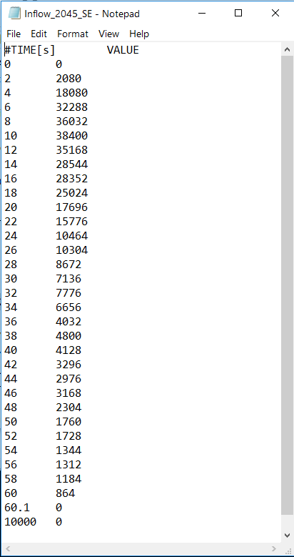

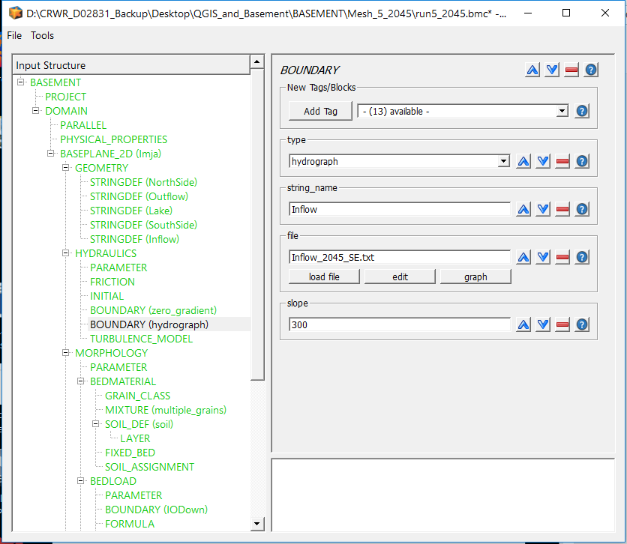
Note the high slope. As BASEMENT explains, the slope here does not have to be reflective of reality, since we are already defining the mass and velocity through the inflow boundary. Instead, this tutorial chooses a very high slope to capture the supercritical conditions that would occur when the avalanche material enters the lake from a steep slope.
MORPHOLOGY – BEDMATERIAL
The simulations at Imja Tsho detailed in Lala et al. (2018) consisted of two separate models: one representing the soil of the area as a single grain size (using the MPM model) and one based on a grain size distribution gathered near the outlet of the lake (using the MPM-multi model). As detailed in the paper, the MPM-Multi model is a more conservative model, since it simulates hiding and armoring and hence results in less erosion. Within BASEMENT, it is easy to choose which you prefer. For grain class, you may choose a single diameter (left), or multiple diameters (right), both in mm…

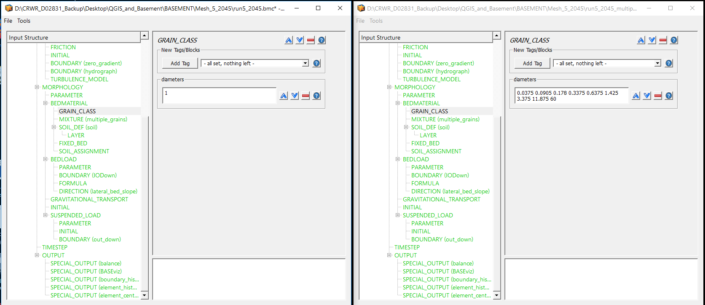
…and the corresponding volume fraction for each grain diameter.

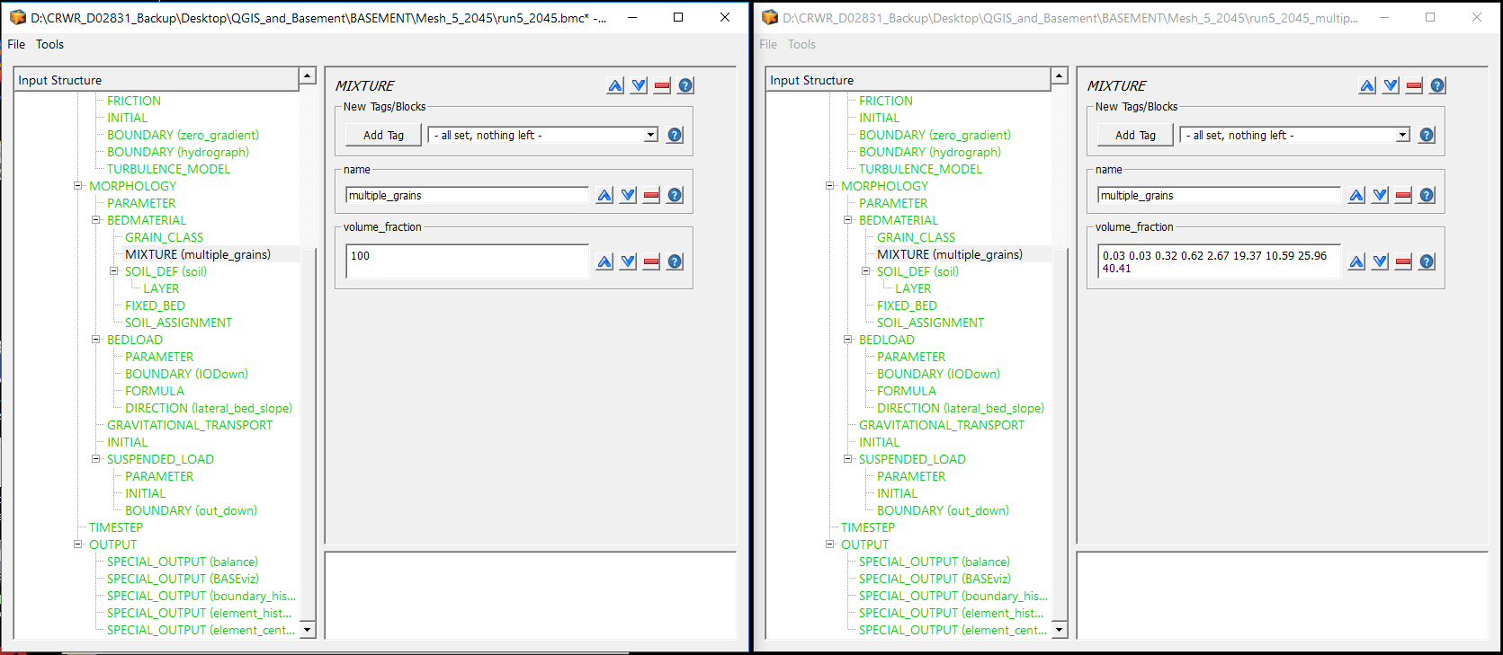
Another useful tool is the FIXED_BED assignment. This prevents erosion from occurring within selected nodes in the mesh once a certain elevation value is reached. This is useful if the bedrock in a given area is shallow and may be uncovered by erosion. In the case of Imja Tsho, the lake bottom was determined to be bedrock. Select the nodes using QGIS and then set zb_fix to -100, which tells BASEMENT to keep the bed elevation to that of the initial elevation of the node (i.e. no erosion will occur at all).

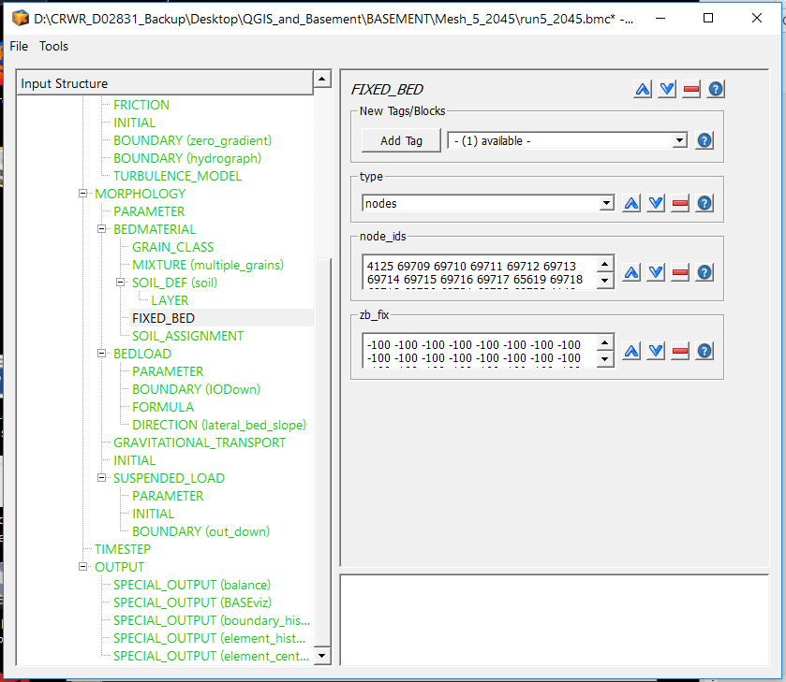
MORPHOLOGY – BEDLOAD – FORMULA
BASEMENT offers a wide variety of bedload transport formulas. As explained above, Lala et al. (2018) uses two: MPM for a single-grain simulation, and MPM-Multi for the multiple-grain simulation. Additionally, to provide a conservative estimate of erosion, the bedload factor can be increased to artificially increase erosion. For the Imja Tsho simulation, in both cases, the bedload factor was set to 2, which corresponds to double the transport capacity for the selected transport formula.

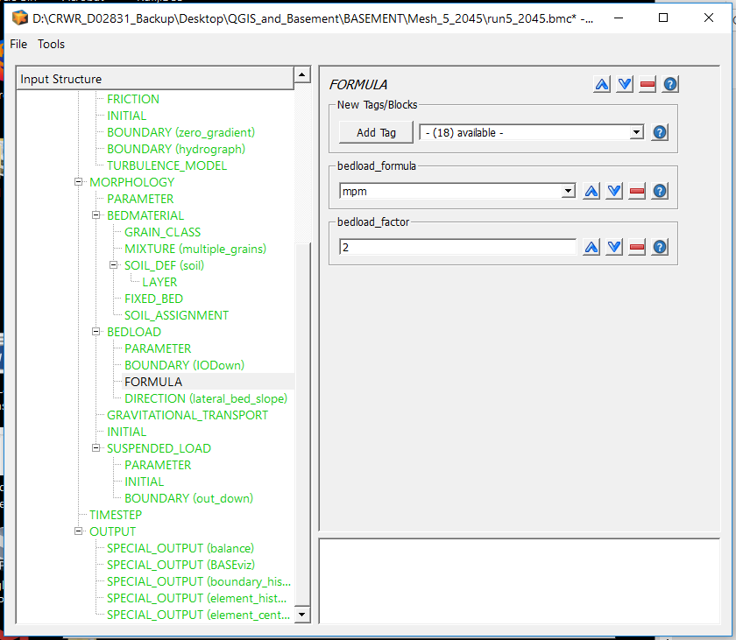
OUTPUT
Finally, we consider three particularly important output blocks. The first is BASEviz, which creates a dynamic visualization of the simulation as it is running (shown here depicting velocity over the entire Imja Tsho simulation area 2000s into the run time):
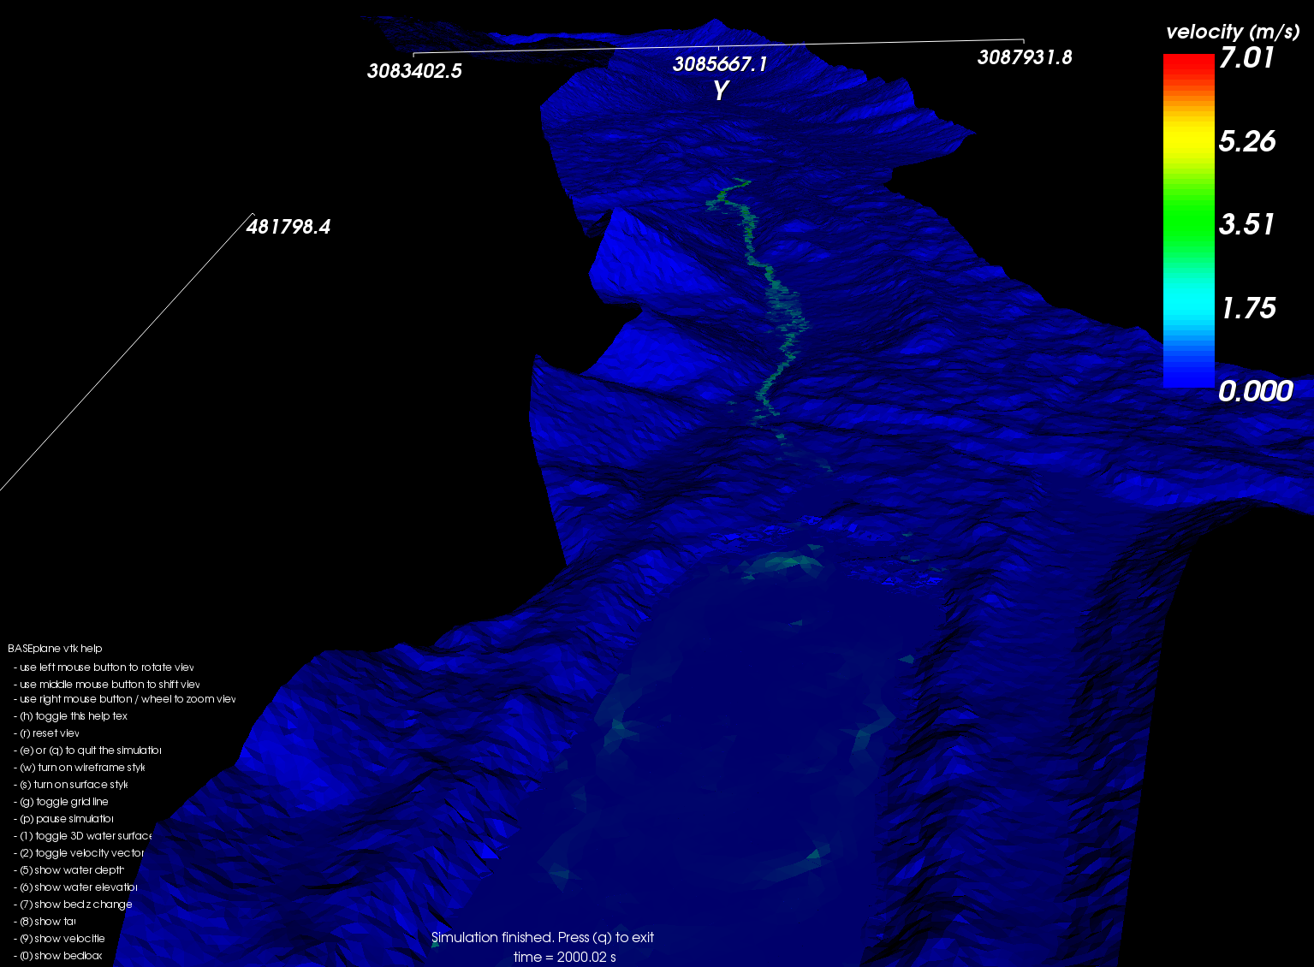
The second output block is element_history, in which you can select particular elements, determine relevant parameters, and a time step, from which BASEMENT will produce a text file at each time step throughout the whole simulation. This is useful for specific areas you wish to study, such as the terminal moraine (to analyze discharge and erosion). For example, the selections shown below will result in 4 text files—one for each element listed—depicting specific discharge, depth, and element elevation at 5-second intervals throughout the simulation.

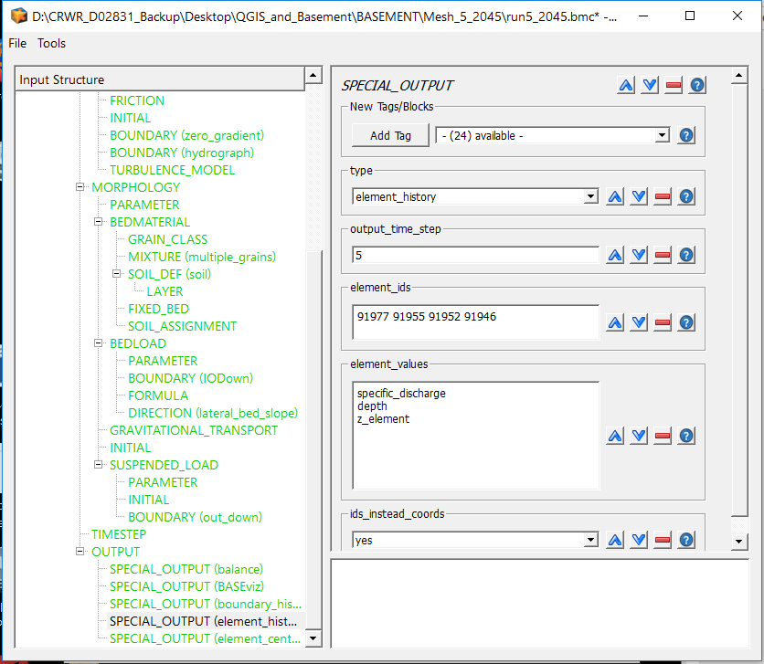
Finally, if you want a summary of all the elements in the mesh—for example, if you want to create a map of inundation at a specific point in time—use the element_centered output block. Again, you can choose which parameters and timestep you want; you can also choose the format in which the output is given (in this case, as an ascii file).

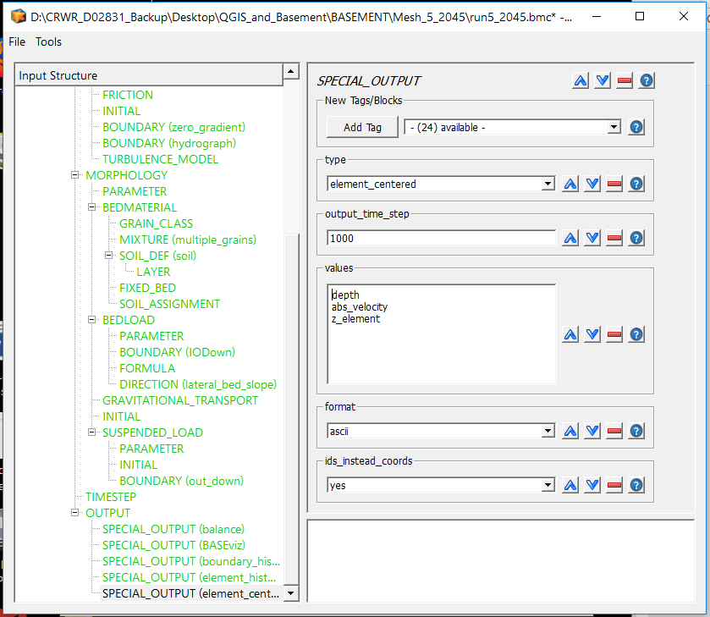
So far, we have only considered some of the more important blocks used for GLOF modeling. BASEMENT has a variety of other functions that may be useful for your specific case, so be sure to experiment and see what may be useful to you.

5. Running BASEMENT and Calibrating with the Heller-Hager Equations
With the model set up and all relevant parameters set, it is time to run your first BASEMENT simulation. Before beginning, determine a string of elements stretching from the area where the avalanche enters the lake to where the resulting impulse wave will reach the terminal moraine. These elements will help you analyze wave height as the impulse wave traverses the lake. Enter these elements into the element_history output block and select a relatively small timestep (2 seconds for the example below).

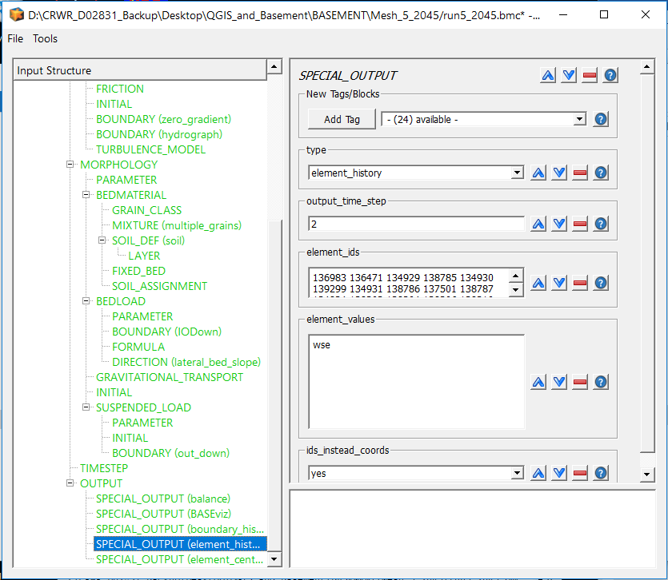
Close the Edit Command window, then click Run on the main BASEMENT window. Run the simulation until it is clear that the impulse wave has traversed the lake, then stop the simulation. Plot the maximum water surface elevations as a function of time using the resulting output files. A MATLAB script is included as an appendix to this tutorial that will extract the maximum water surface elevation value and corresponding time for all output files and combine them into a new text file.
The Heller-Hager equations, described in Heller et al. (2009), are a set of analytical and empirical equations that characterize impulse waves generated by mass movement into a lake. For the purposes of this tutorial, they are used simply as a measure of validating the height of the impulse wave height, since the model relies on simplified assumptions that can be more accurately addressed in BASEMENT. A spreadsheet of the equations is included as an appendix to this tutorial. Enter the data needed to determine the maximum wave amplitude (a_m) and the amplitude at various points along the wave trajectory (a(x)), and compare it to the results of BASEMENT. Most importantly, compare a(x) near the terminal moraine (but while the lakebed slope is still relatively flat) for both models, since the wave height near the moraine is the most important factor in determining the risk of overtopping or erosion of the moraine.
If the results of BASEMENT do not agree with the results from the Heller-Hager equations, it will be necessary to alter the inflow boundary and/or inflow hydrograph in BASEMENT. Because there is a limited number of nodes in the mesh from which to define the inflow boundary, it is best to start there, then fine-tune the hydrograph if additional calibration is needed.
Assume, for example, that your initial inflow boundary in BASEMENT consisted of all the yellow nodes highlighted here, since the avalanche model showed all of those areas covered once the avalanche reached the lake:

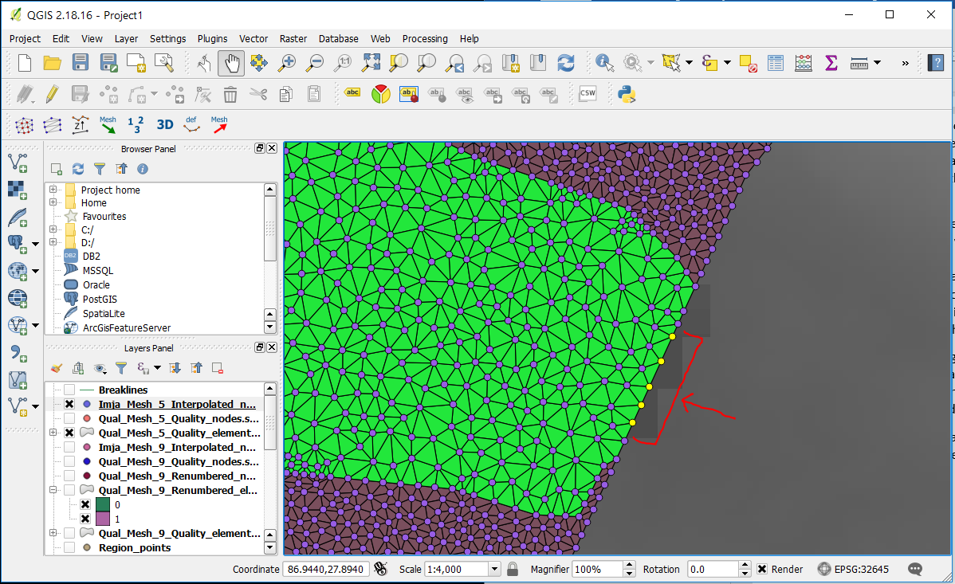
Quite likely, the wave heights in BASEMENT will be lower than that of the Heller-Hager equations, especially in the far-field (near the terminal moraine), since attenuation is one problem of BASEMENT’s fundamental physical model (the 2-D shallow water equations). In this case, you need to reduce the length of the inflow boundary by removing one or more nodes from the inflow string.

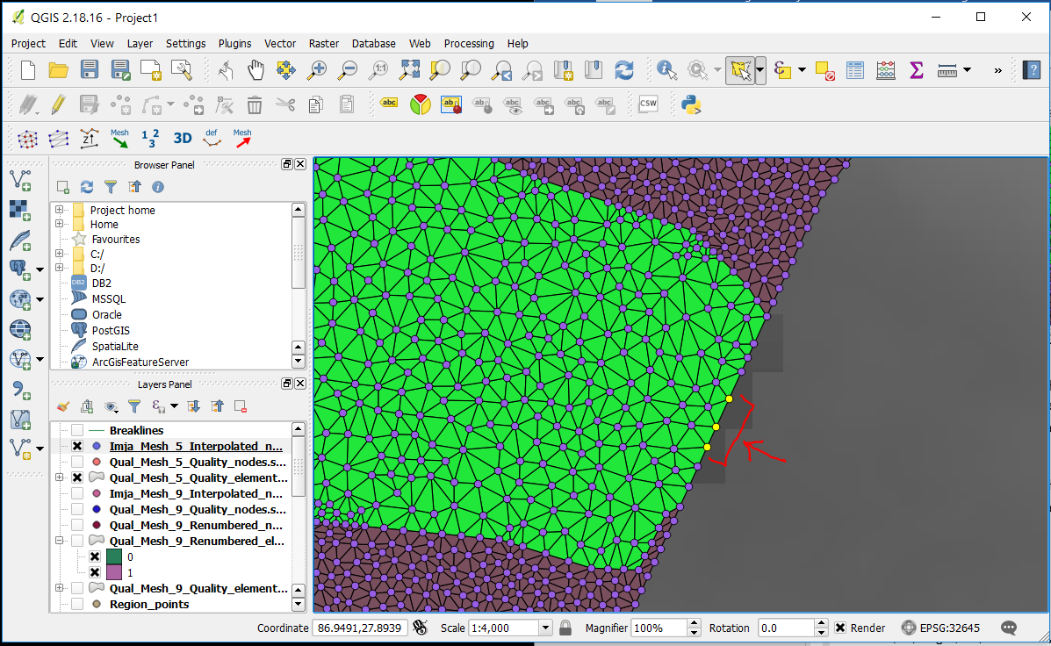
Because the inflow hydrograph has a fixed discharge and time, shortening the inflow boundary will in effect increase the entry velocity—and hence momentum—of the avalanche as it enters the lake, resulting in a greater impulse and a higher wave.
If wave heights near the terminal moraine still do not match, the hydrograph itself must be altered. The procedure is simple: to maintain the same amount of mass while altering the momentum, scale each discharge value by a given number, and scale the time values by its inverse. For example, the simulation at Imja Tsho altered the hydrograph by doubling the discharge values and halving the time values, so that the momentum was increased without changing the total amount of mass entering the lake. Below are the original hydrograph from the RAMMS results (left) and the scaled hydrograph (right) for this simulation.

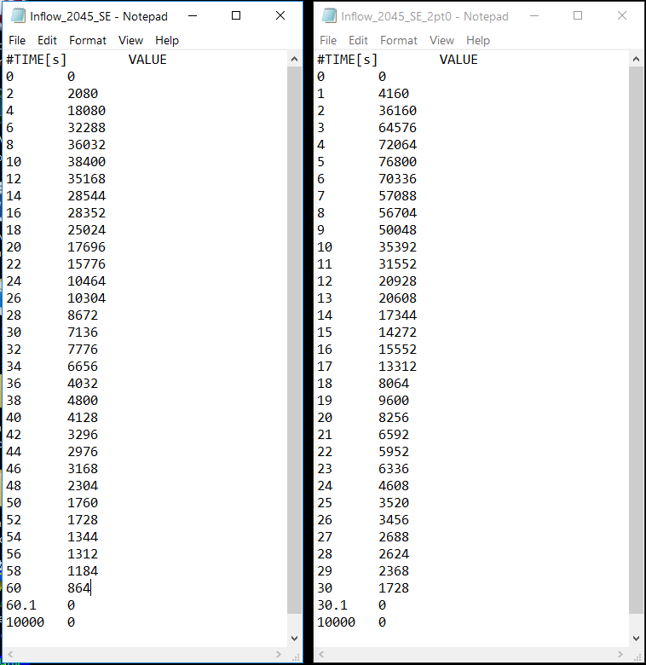
It should be noted that mismatched wave heights are not the only reason to calibrate the inflow parameters. BASEMENT does not allow for inflows that exceed 200 m/s, which would require either a widening of the inflow boundary or a decrease in the hydrograph’s discharge rate. Conversely, if the inflow discharge rate is too low or the inflow boundary is too wide, the minimum water depth set in GEOMETRY—HYDRAULICS—PARAMETER may not be met. It is up to you to determine the best combination of calibration measures to ensure the wave characteristics between the two models properly match.

Acknowledgements
This tutorial functions as a supplement to Lala et al. (2018), for which funding was provided by the National Science Foundation under the Dynamics of Coupled Natural and Human Systems program (award no. 1516912). Many thanks to all those who made the project possible. The author would specifically like to thank Denny Rivas, who introduced him to BASEMENT modeling, and Rachel Chisolm, who provided insight into the underlying physics and helped to create the attached spreadsheet for the Heller-Hager model.

References
Lala, J. M., Rounce, D. R., and McKinney, D. C.: Modeling the glacial lake outburst flood process chain in the Nepal Himalaya: Reassessing Imja Tsho’s Hazard. Hydrology and Earth System Sciences, 2018. [In review at time of writing]
Heller, V., Hager, W., and Minor, H. E.: Landslide generated impulse waves in reservoirs: Basics and computation. Laboratory of Hydraulics, Hydrology, and Glaciology, ETH Zürich, Switzerland, 172pp, 2009.
Vetsch, D., Siviglia, A., Ehrbar, D., Facchini, M., Kammerer, S., Koch, A., Peter, S., Vonwiller, L., Gerber, M., Volz, C., Farshi, D., Mueller, R., Rousselot, P., Veprek, R., and Faeh, R.: System Manuals of BASEMENT, Version 2.7. Laboratory of Hydraulics, Glaciology and Hydrology (VAW). ETH Zurich, 2017. http://www.basement.ethz.ch.

