Supporting information 4: for “Moment tensor inversion and uncertainty analysis of earthquakes in Uttarakhand Himalayas”
Rinku Mahanta¹, Vipul Silwal^{1*}, M. L. Sharma², Sudheer Kumar Tiwari¹, Himanshu Mittal³

¹Department of Earth Sciences, IIT Roorkee, India
²Department of Earthquake Engineering, IIT Roorkee, India
³National Center of Seismology, New Delhi, India
*email: vipul.silwal@es.iitr.ac.in

Contents:
Figures (S3.1 to S3.40): Random search for best fitting depth corresponds to minimum misfit value. The variation of confidence value (⍴_{av}) at each depth is also illustrated in the figures.
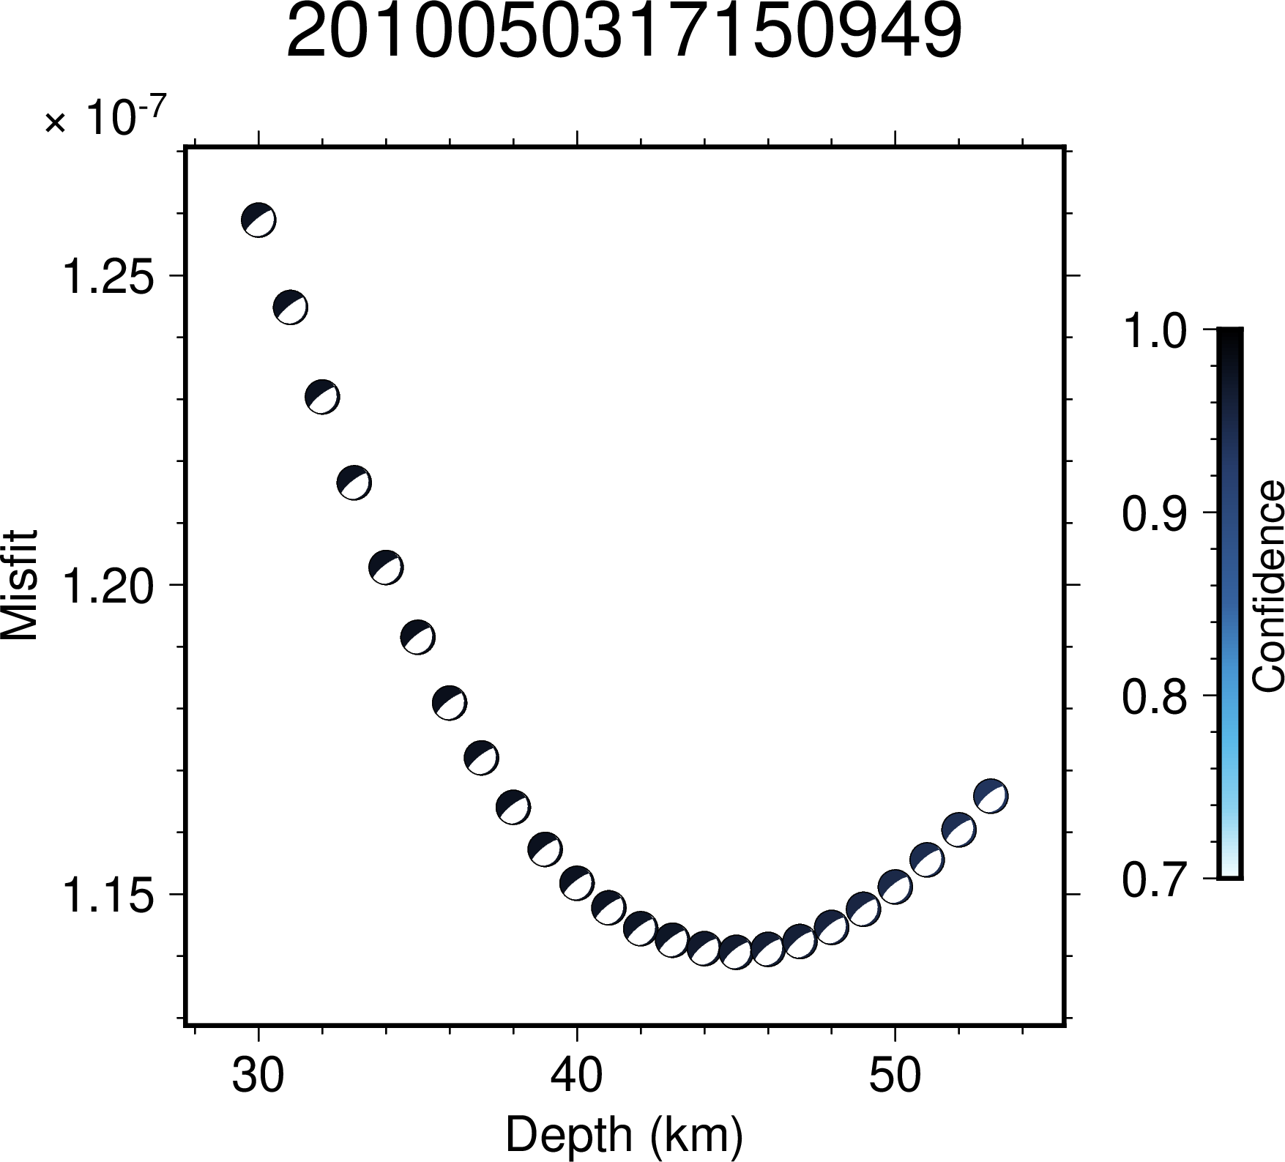
Figure S3.1: Illustration of variation in confidence values across depth for the event 2010050317150949. The minimum value of misfit lies at the depth of 45 km.

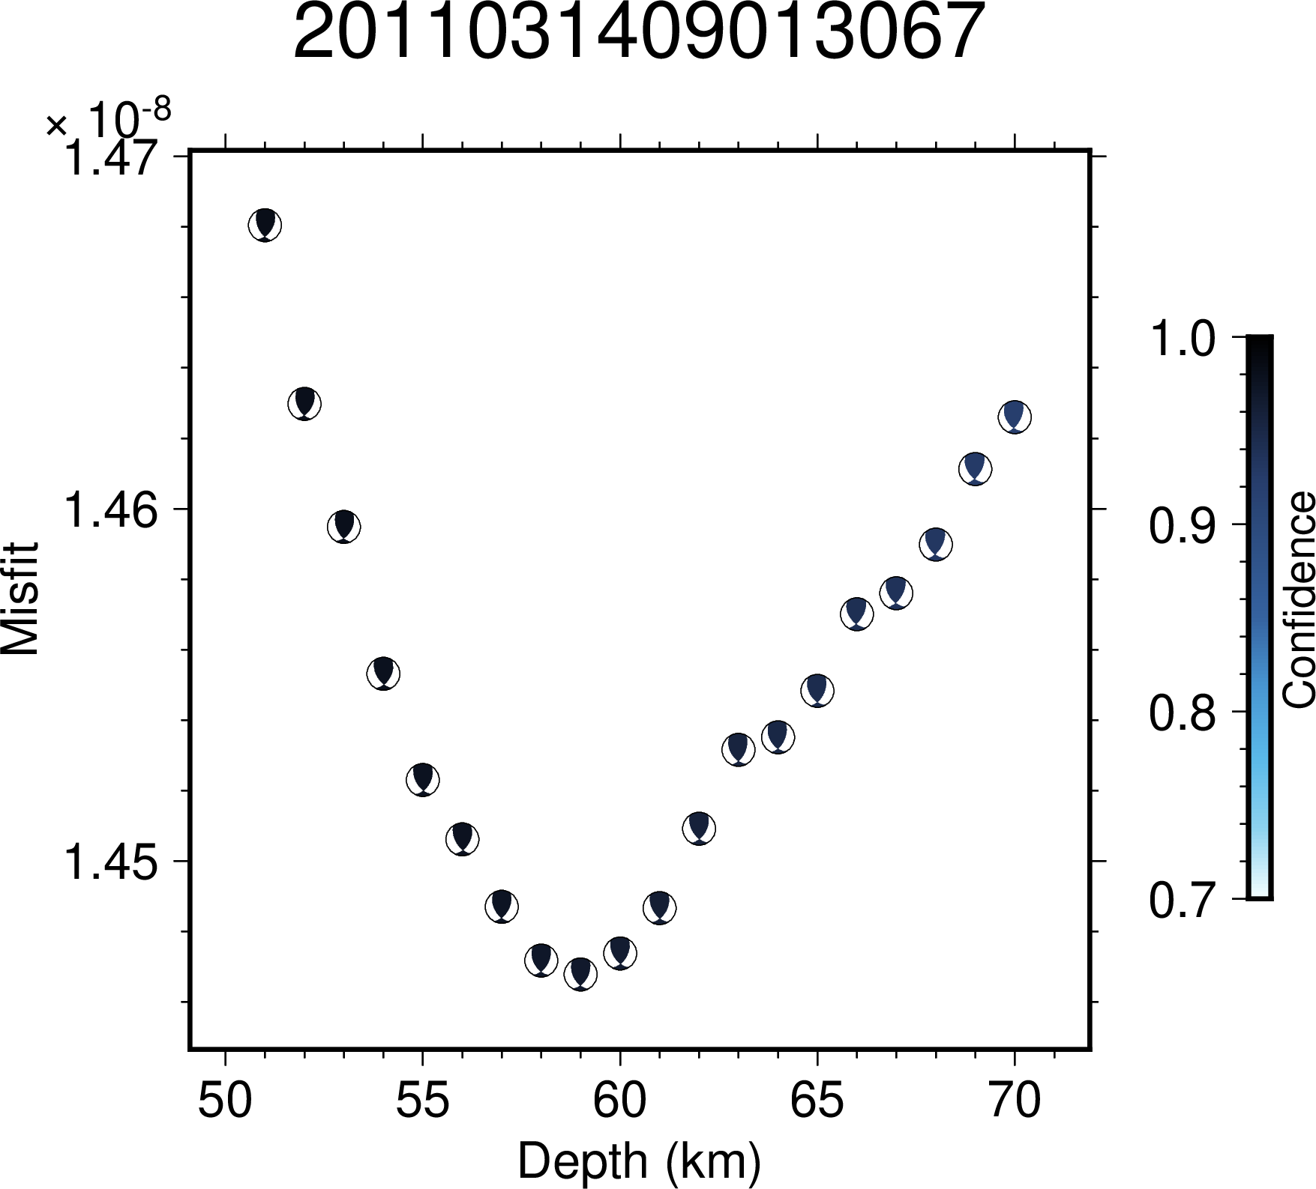
Figure S3.2: Illustration of variation in confidence values across depth for the event 2011031409013067. The minimum value of misfit lies at the depth of 59 km.
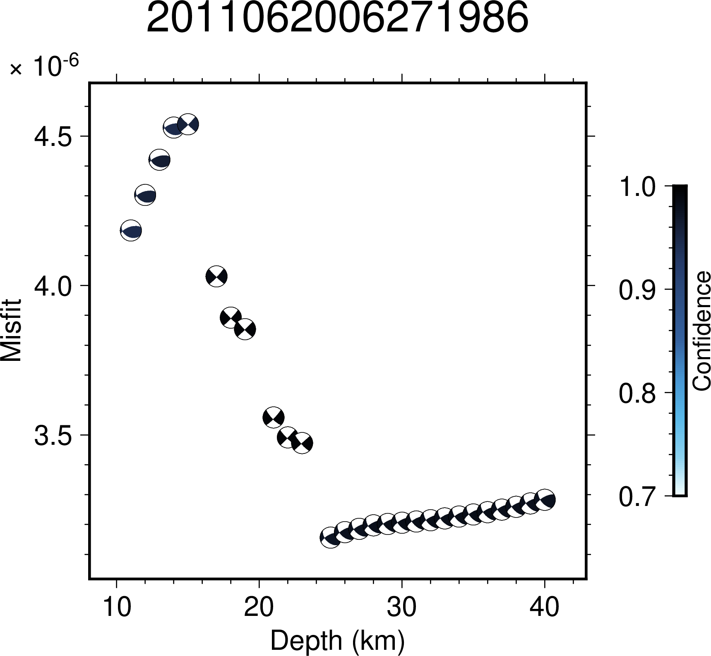
Figure S3.3: Illustration of variation in confidence values across depth for the event 2011062006271986. The minimum value of misfit lies at the depth of 25 km.
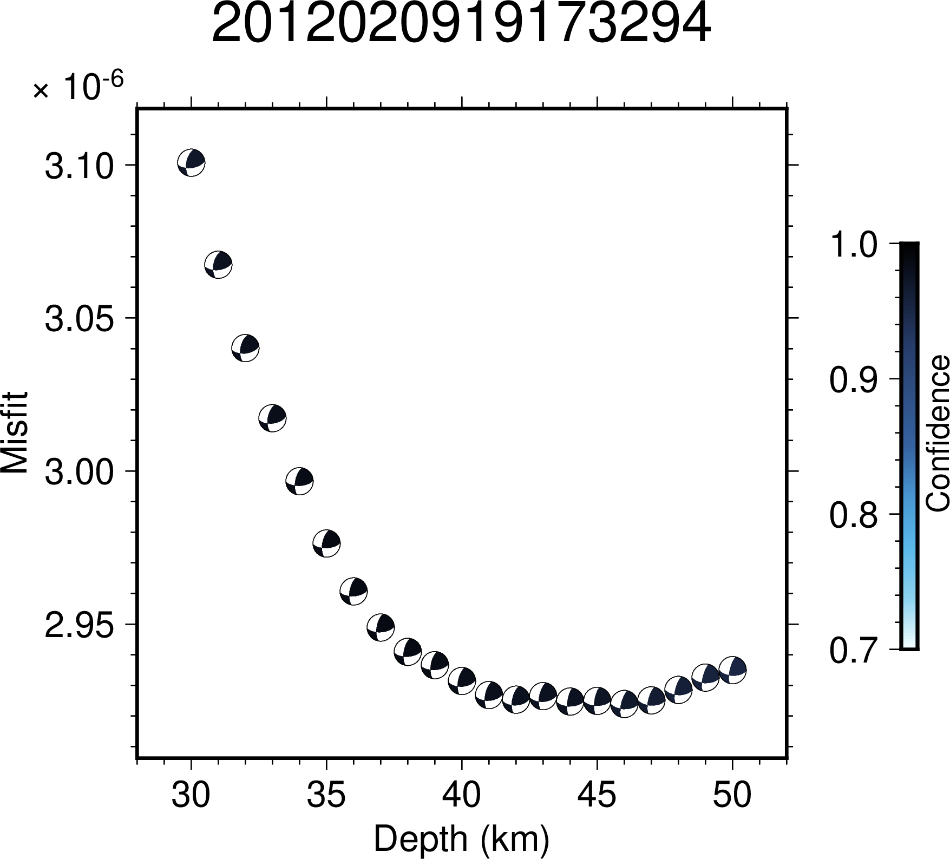
Figure S3.4: Illustration of variation in confidence values across depth for the event 2012020919173294. The minimum value of misfit lies at the depth of 43 km.
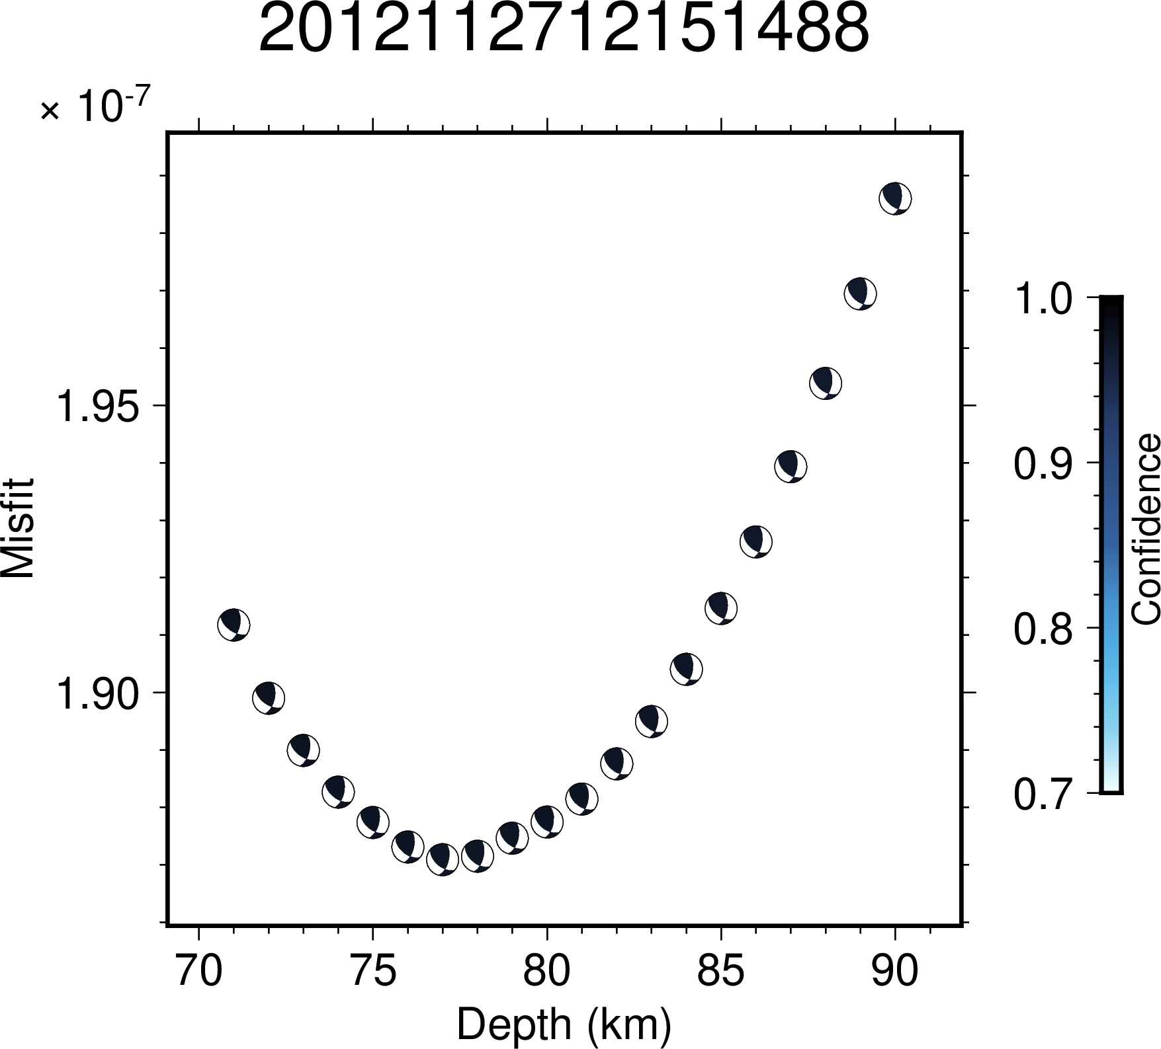

Figure S3.5: Illustration of variation in confidence values across depth for the event 2012112712151488. The minimum value of misfit lies at the depth of 79 km.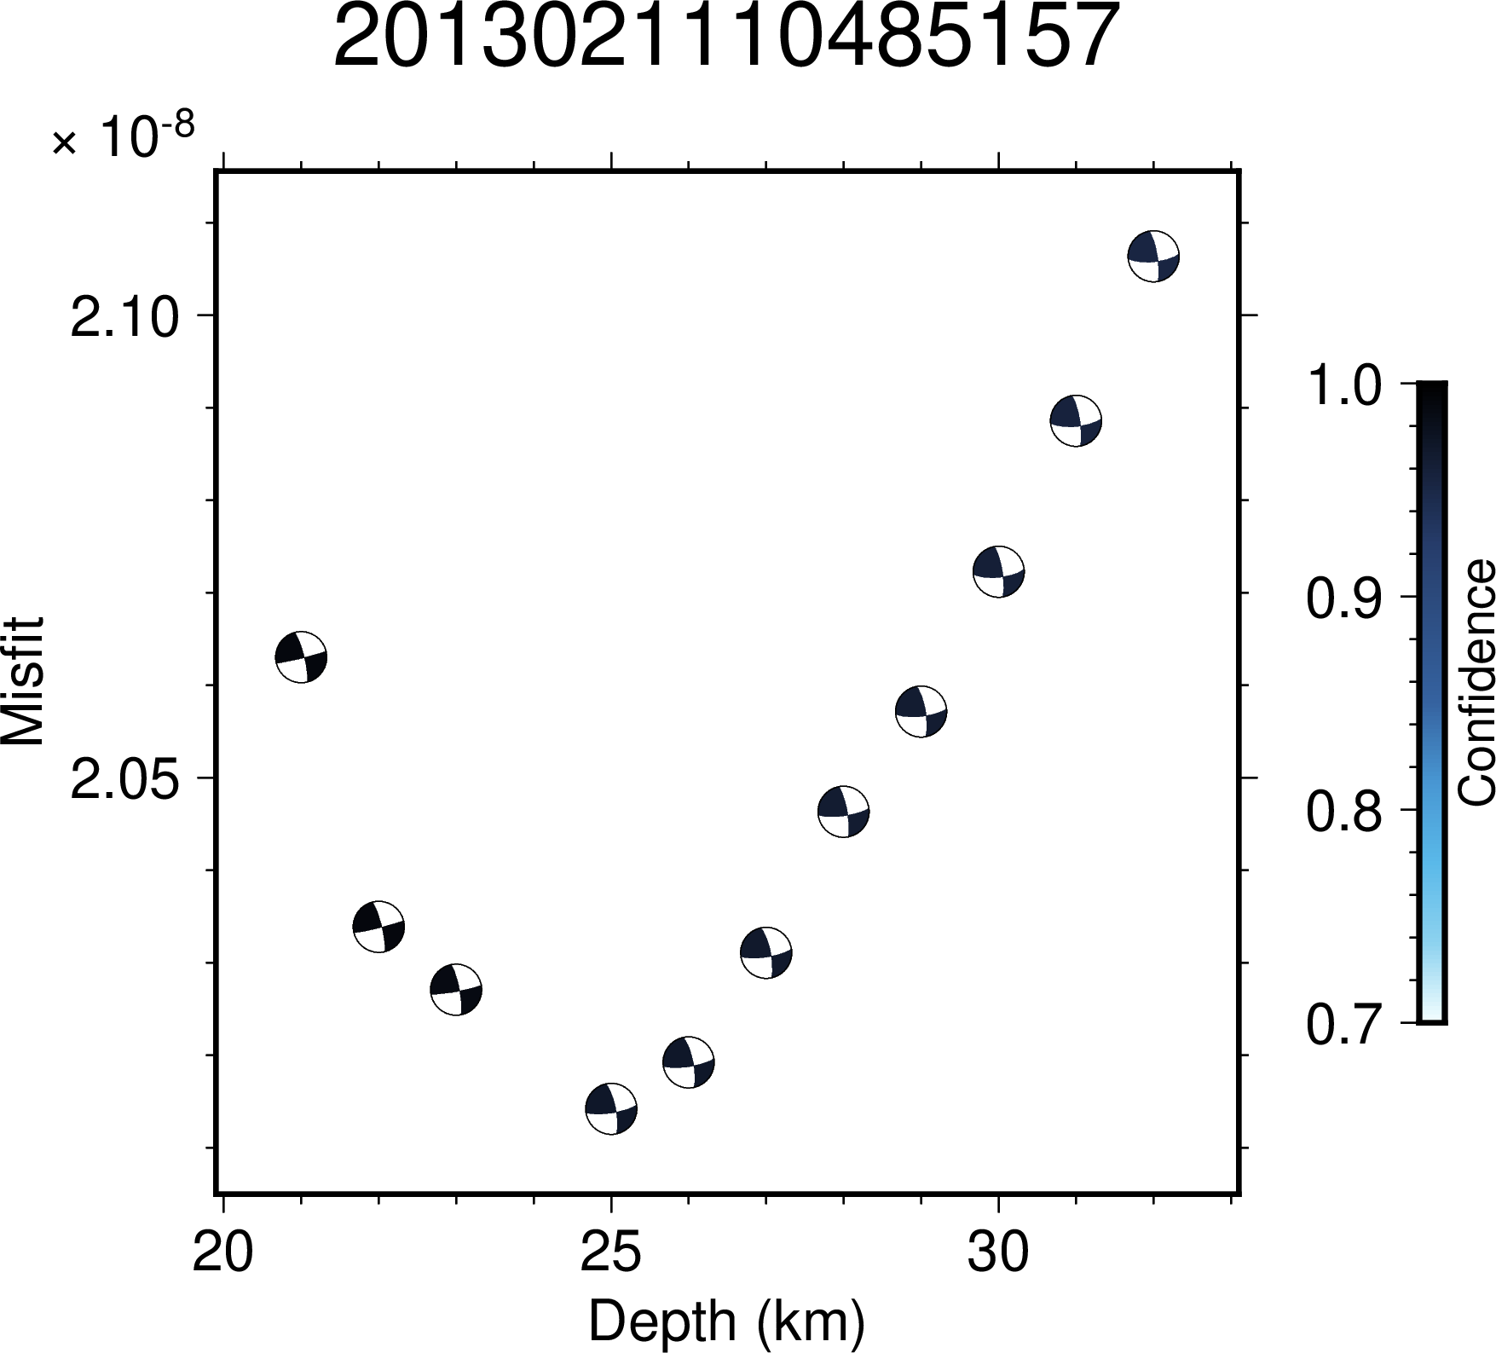Figure S3.6: Illustration of variation in confidence values across depth for the event 2013021110485157. The minimum value of misfit lies at the depth of 25 km.
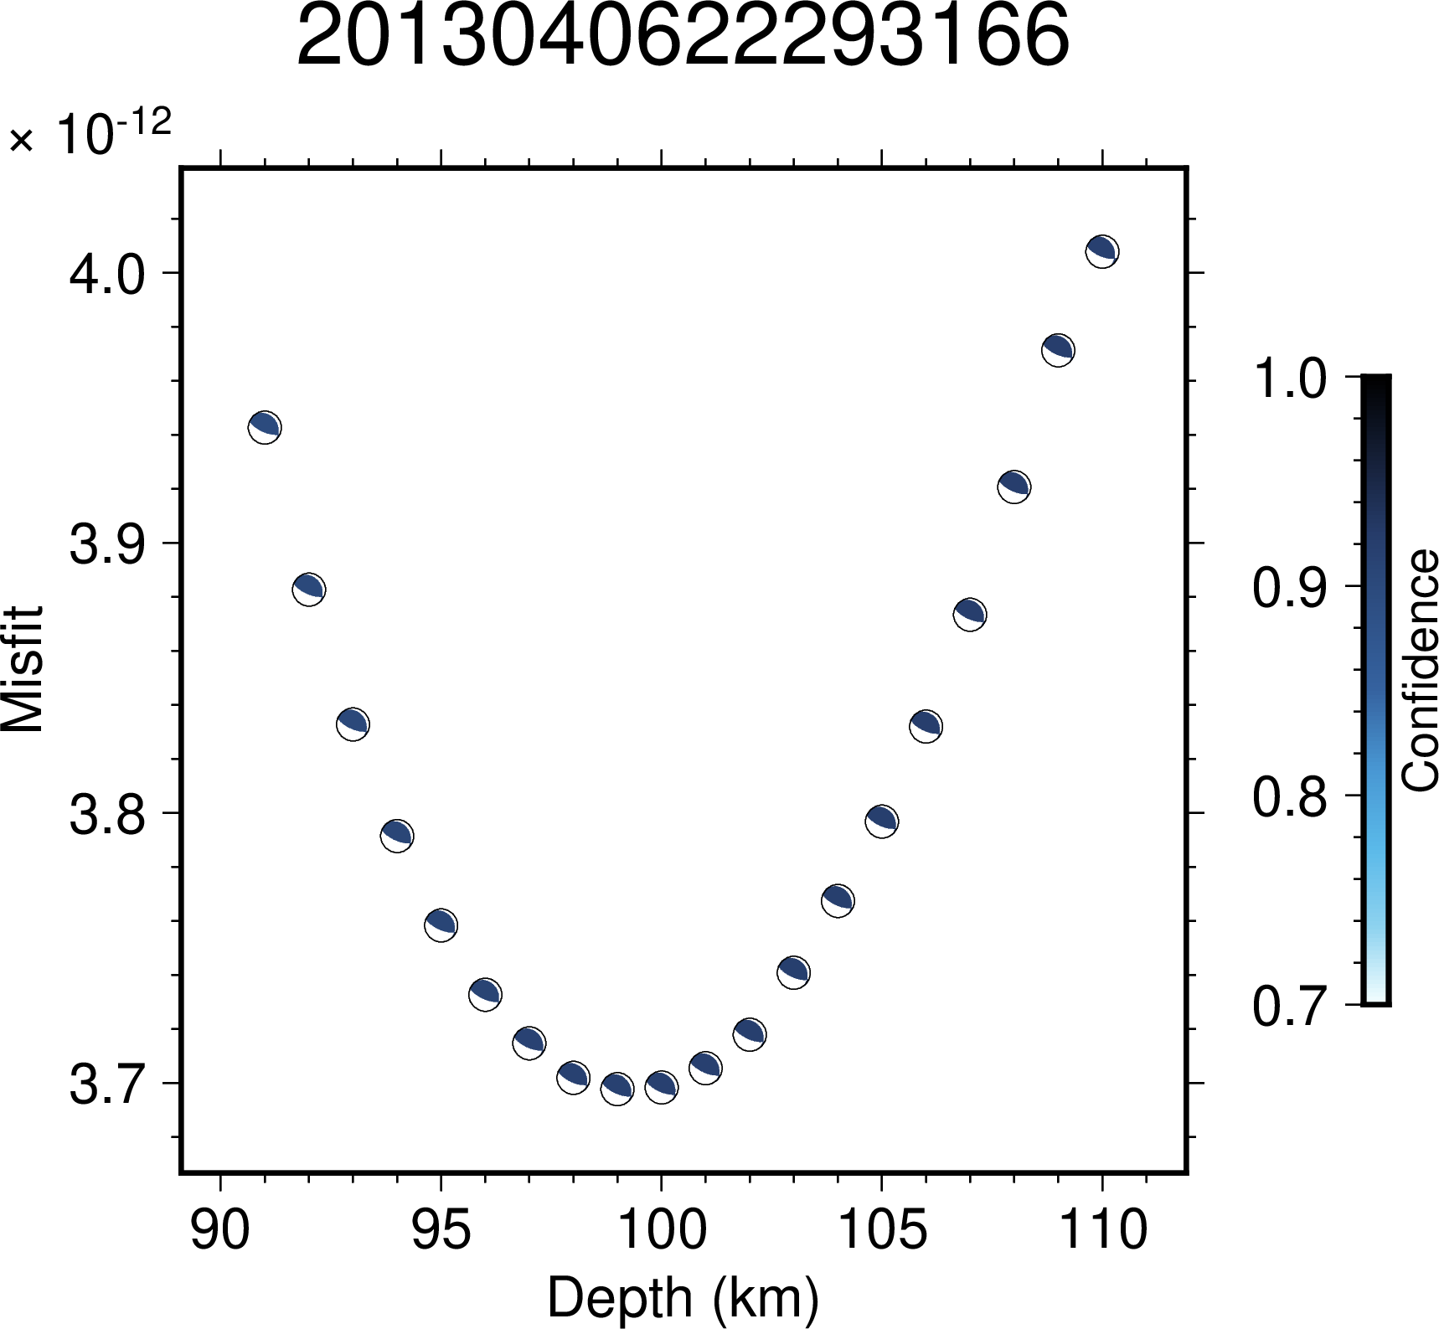Figure S3.7: Illustration of variation in confidence values across depth for the event 2013040622293166. The minimum value of misfit lies at the depth of 100 km.
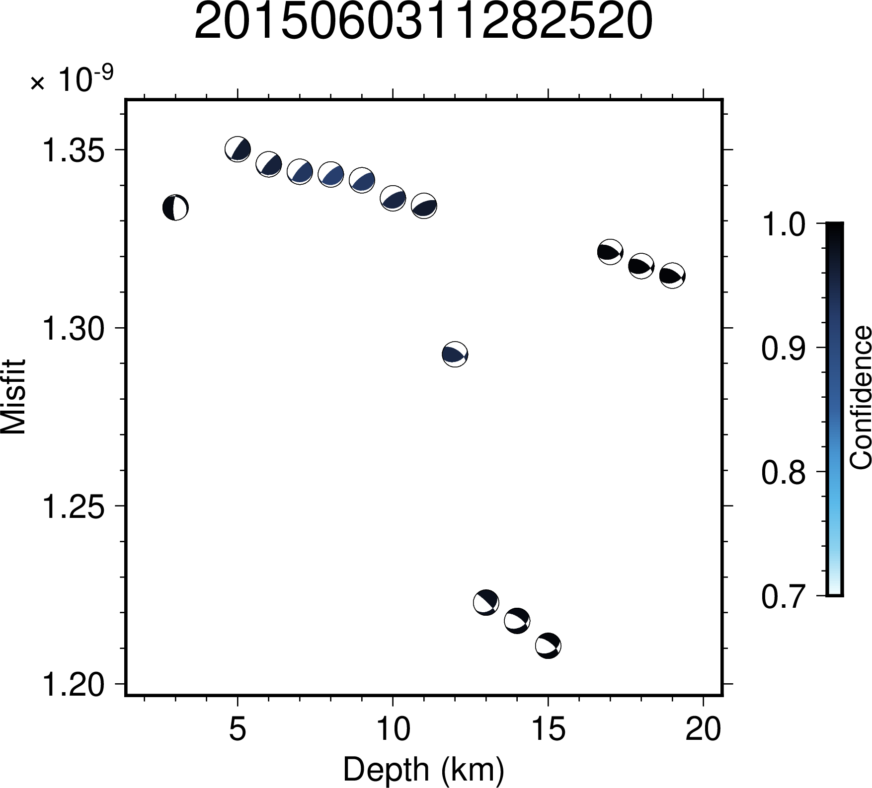Figure S3.8: Illustration of variation in confidence values across depth for the event 2015060311282520. The minimum value of misfit lies at the depth of 15 km.
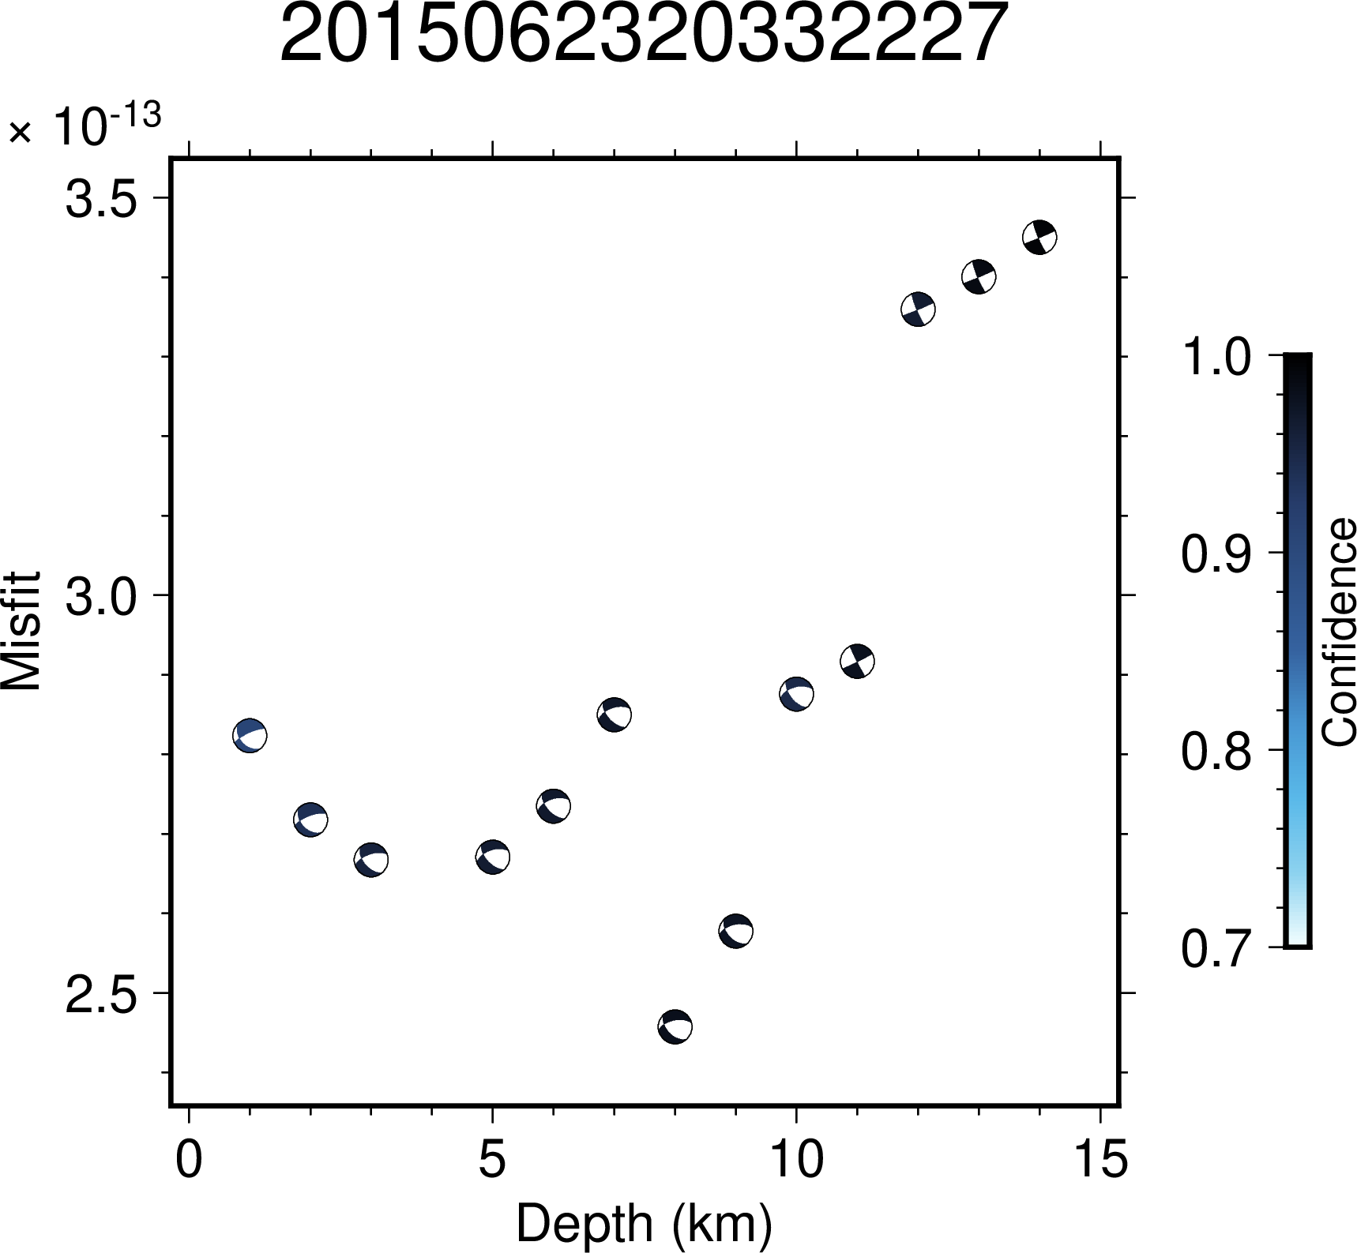Figure S3.9: Illustration of variation in confidence values across depth for the event 2015062320332227. The minimum value of misfit lies at the depth of 8 km.
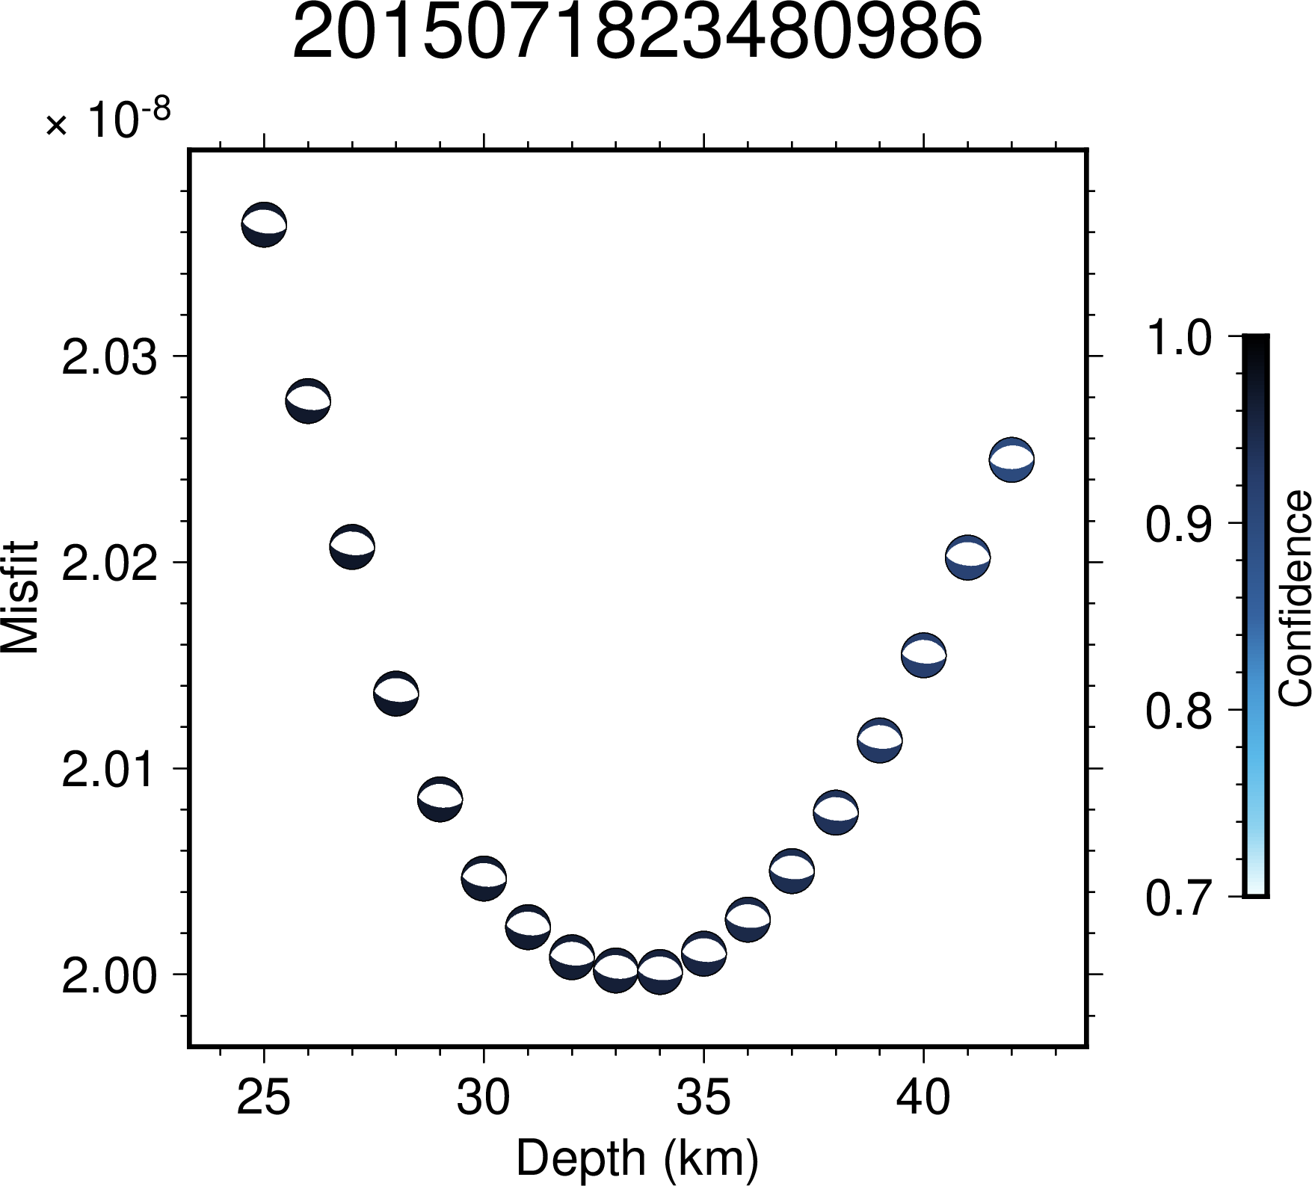Figure S3.10: Illustration of variation in confidence values across depth for the event 2015071823480986. The minimum value of misfit lies at the depth of 33 km.
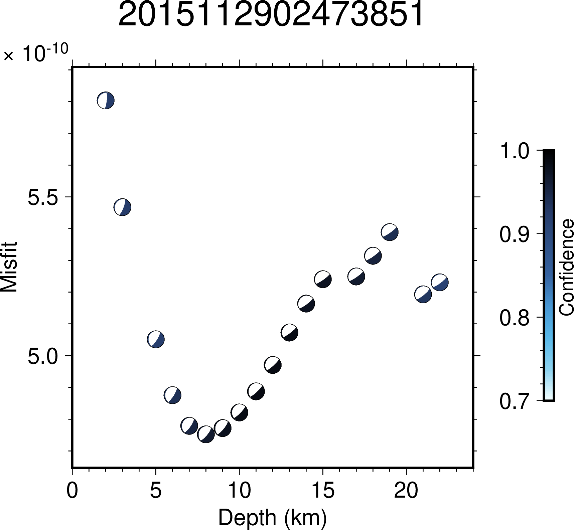Figure S3.11: Illustration of variation in confidence values across depth for the event 2015112902473851. The minimum value of misfit lies at the depth of 9 km.
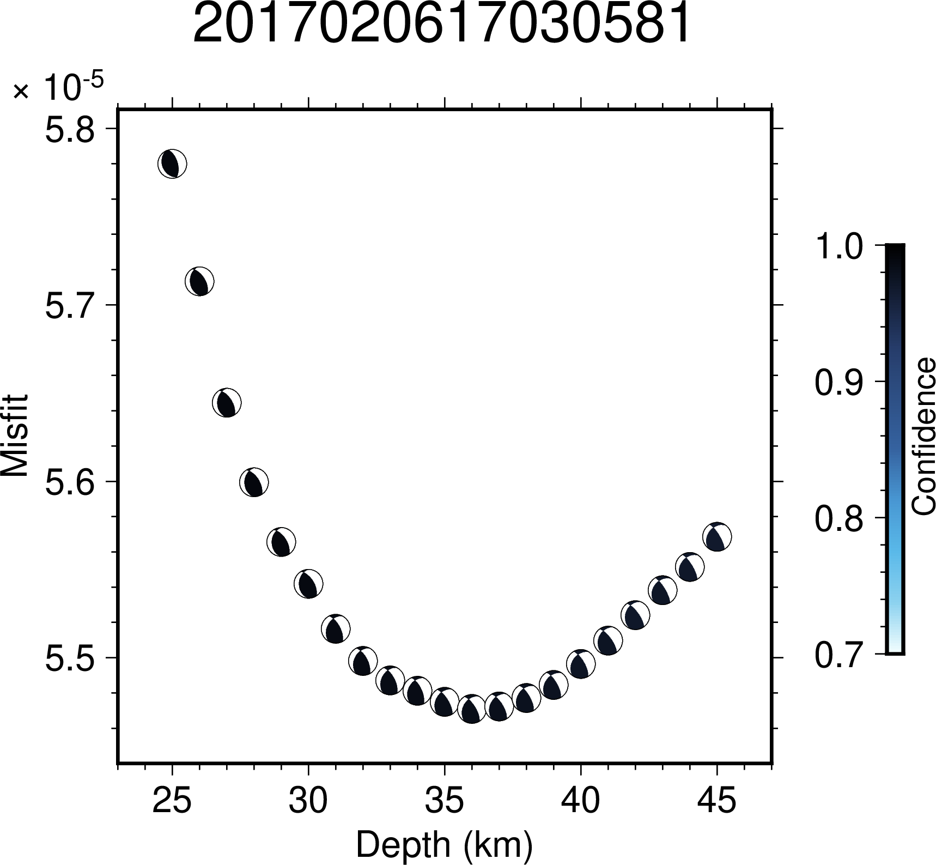Figure S3.12: Illustration of variation in confidence values across depth for the event 2017020617030581. The minimum value of misfit lies at the depth of 36 km.
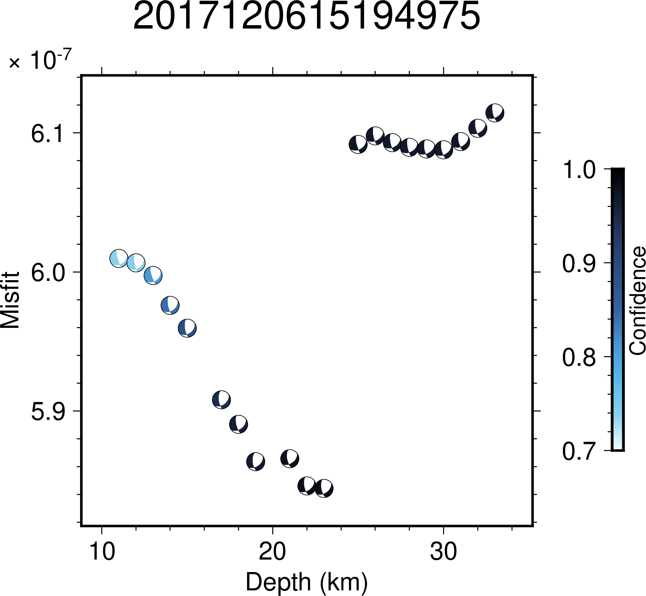Figure S3.13: Illustration of variation in confidence values across depth for the event 2017120615194975. The minimum value of misfit lies at the depth of 23 km.
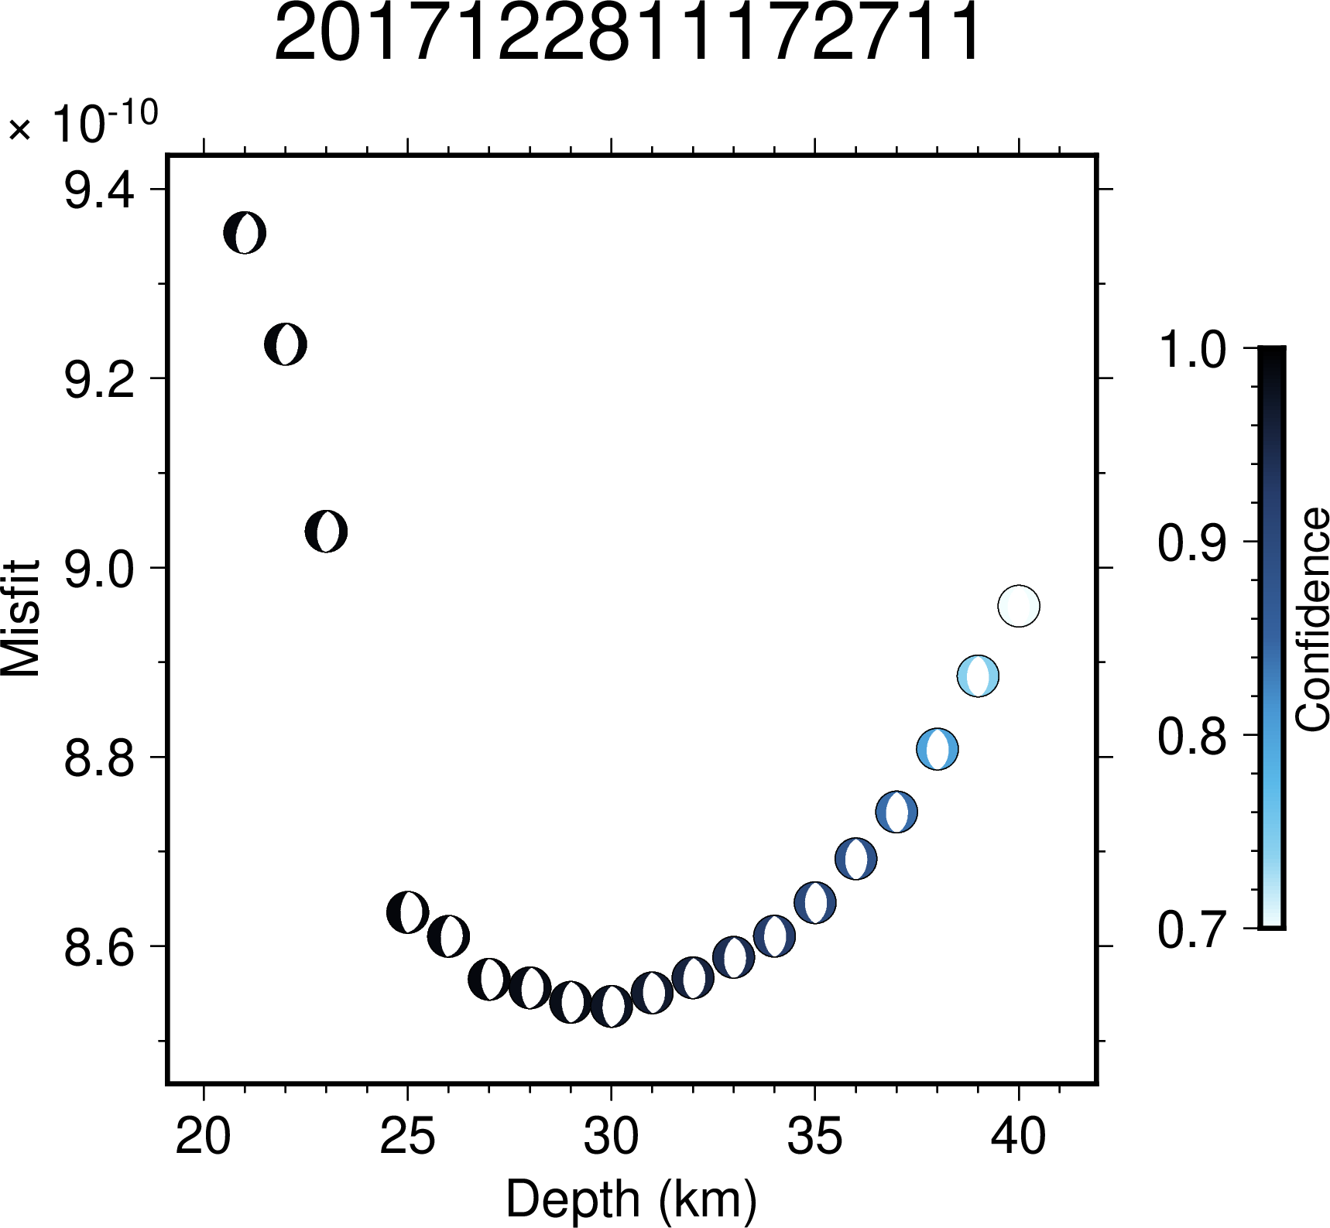Figure S3.14: Illustration of variation in confidence values across depth for the event 2017122811172711. The minimum value of misfit lies at the depth of 29 km.
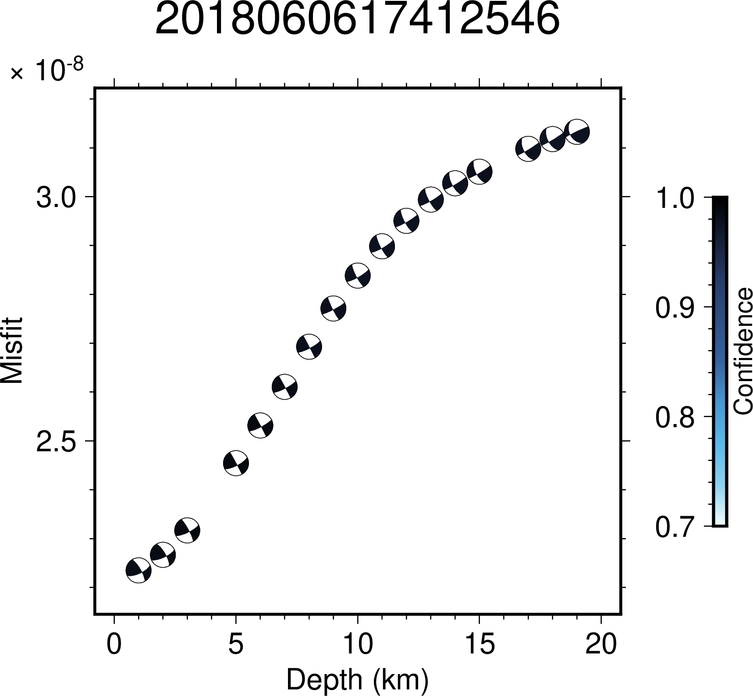Figure S3.15: Illustration of variation in confidence values across depth for the event 2018060617412546. The minimum value of misfit lies at the depth of 1 km.
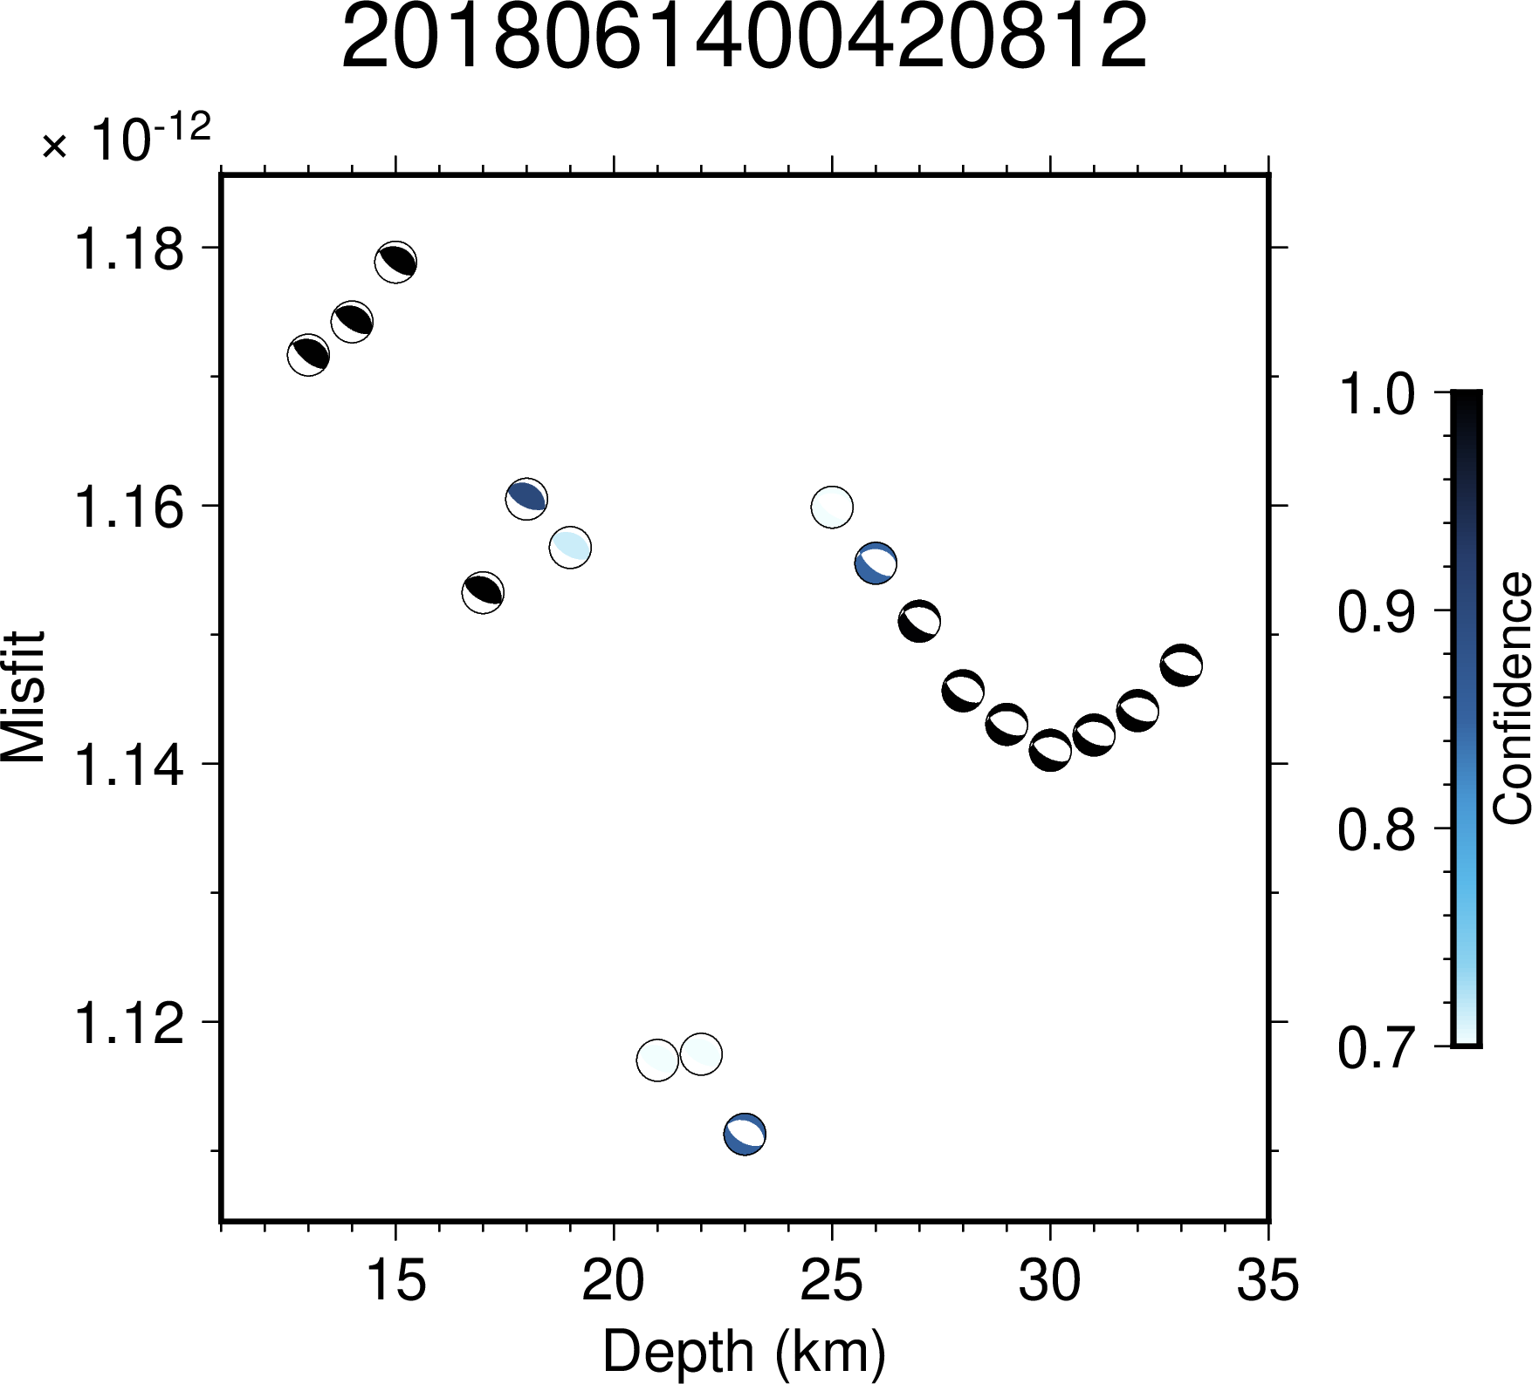Figure S3.16: Illustration of variation in confidence values across depth for the event 2018061400420812. The minimum value of misfit lies at the depth of 23 km.
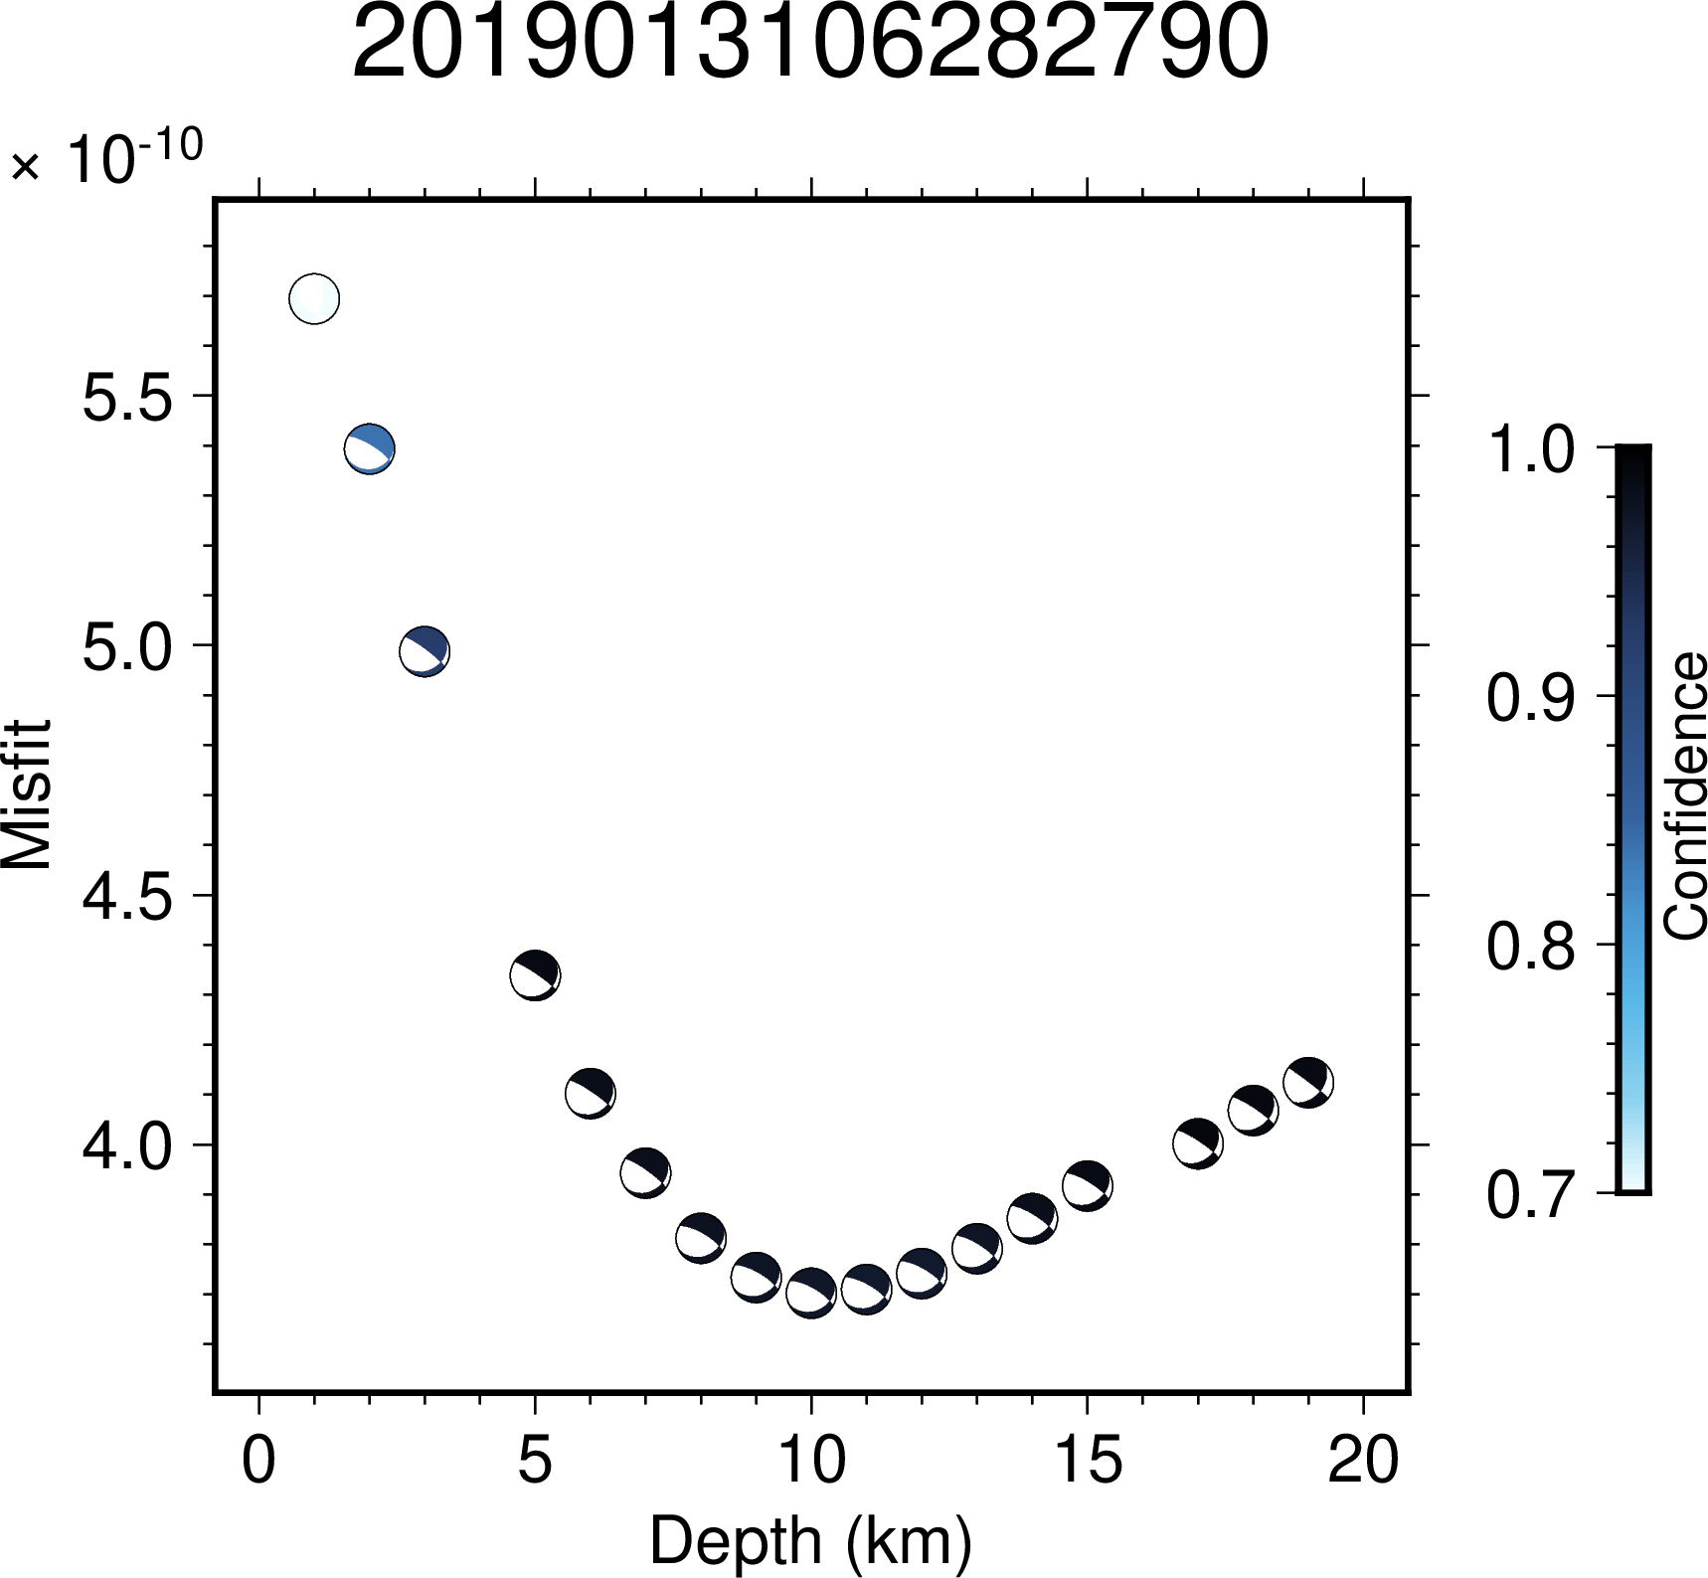Figure S3.17: Illustration of variation in confidence values across depth for the event 2019013106282790. The minimum value of misfit lies at the depth of 10 km.
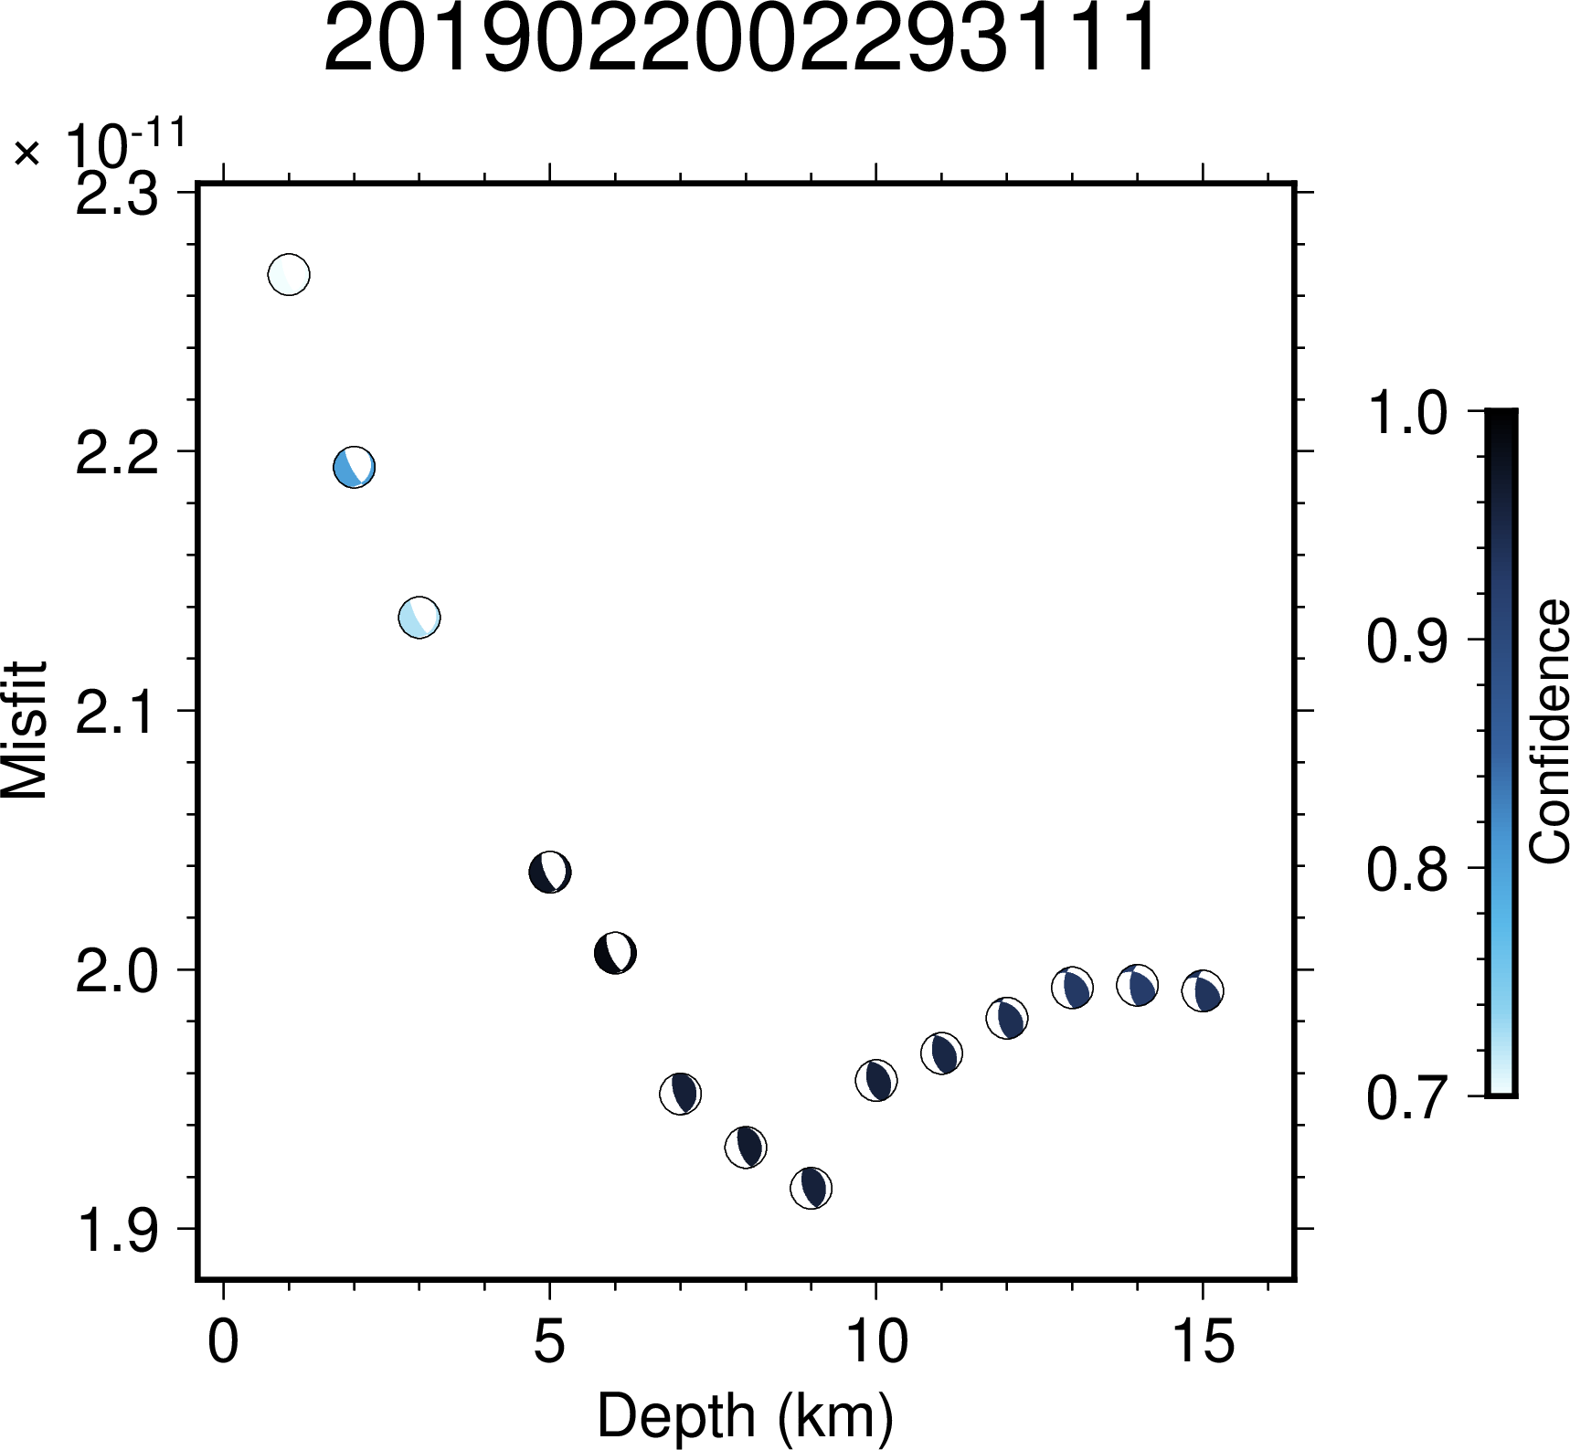Figure S3.18: Illustration of variation in confidence values across depth for the event 2019022002293111. The minimum value of misfit lies at the depth of 9 km.
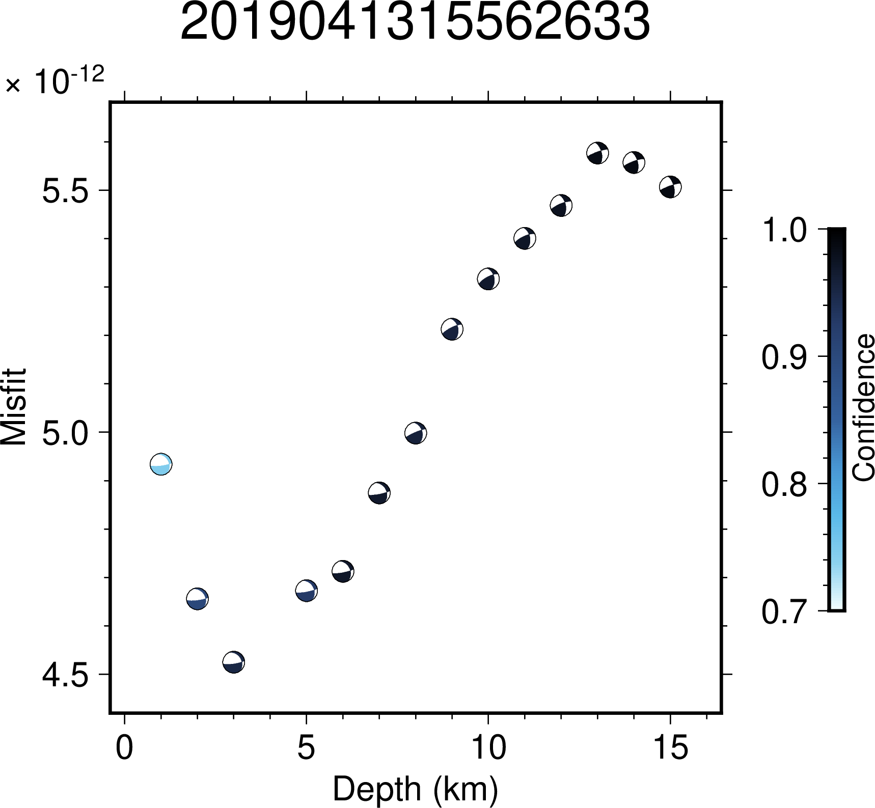Figure S3.19: Illustration of variation in confidence values across depth for the event 2019041315562633. The minimum value of misfit lies at the depth of 3 km.
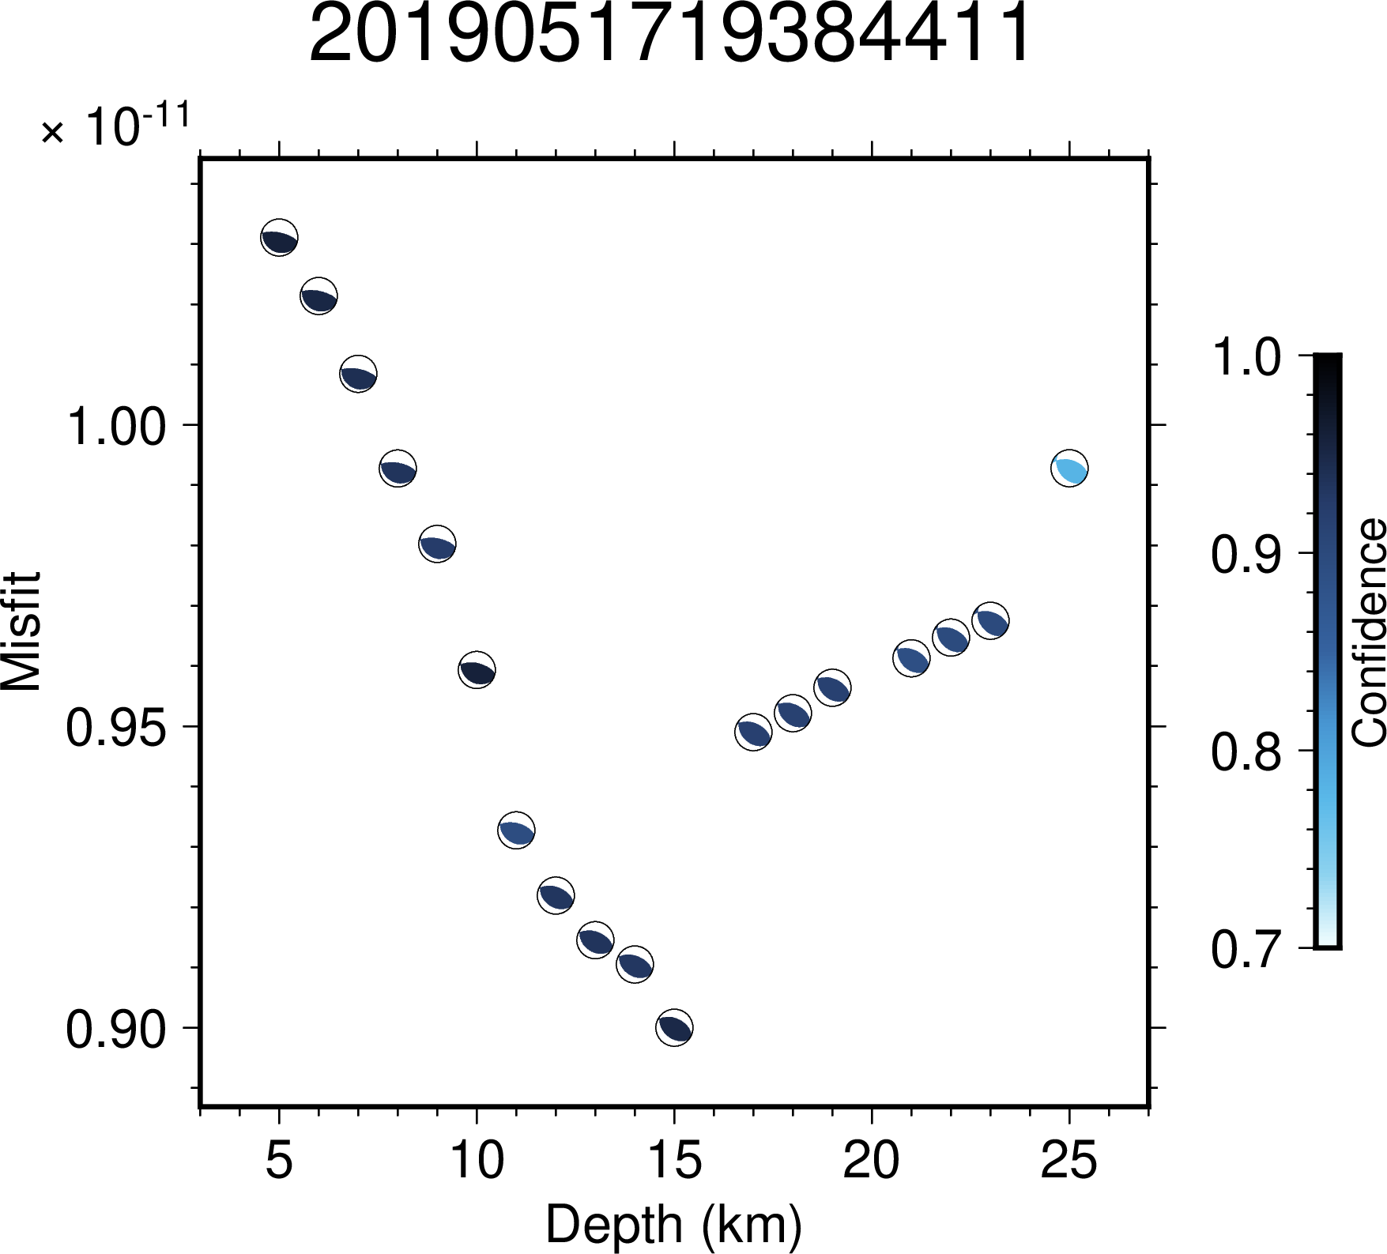Figure S3.20: Illustration of variation in confidence values across depth for the event 2019051719384411. The minimum value of misfit lies at the depth of 15 km.
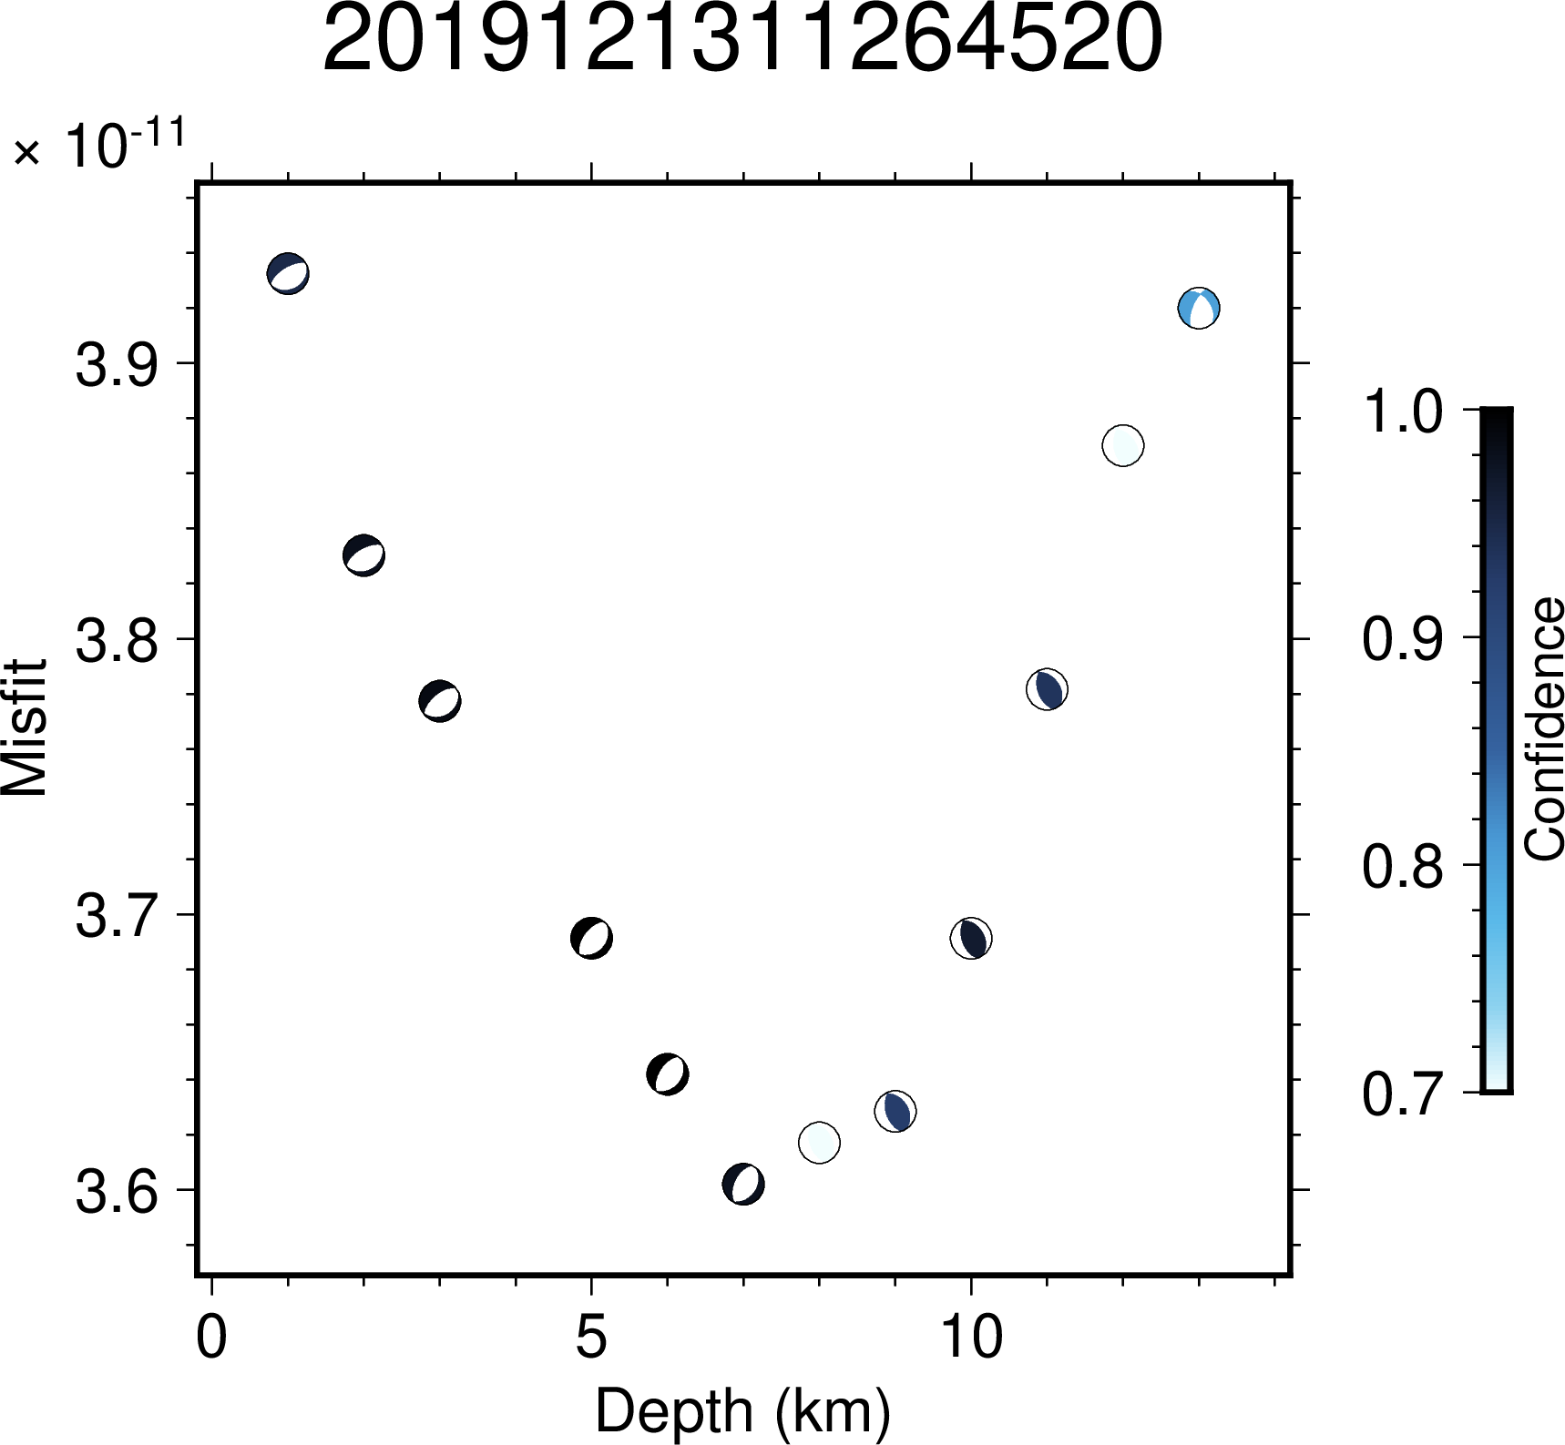Figure S3.21: Illustration of variation in confidence values across depth for the event 2019121311264520. The minimum value of misfit lies at the depth of 8 km.
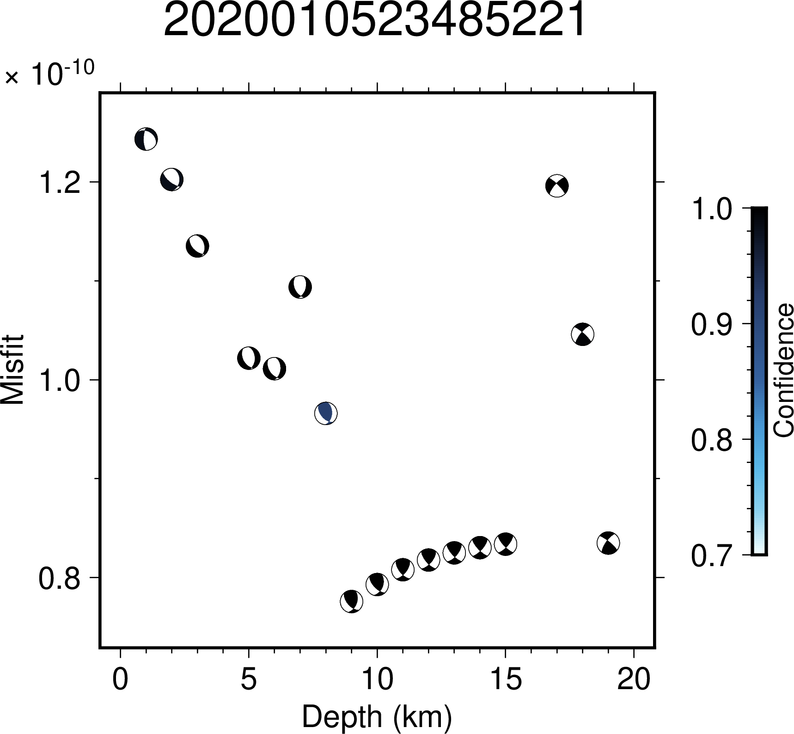Figure S3.22: Illustration of variation in confidence values across depth for the event 2020010523485221. The minimum value of misfit lies at the depth of 9 km.
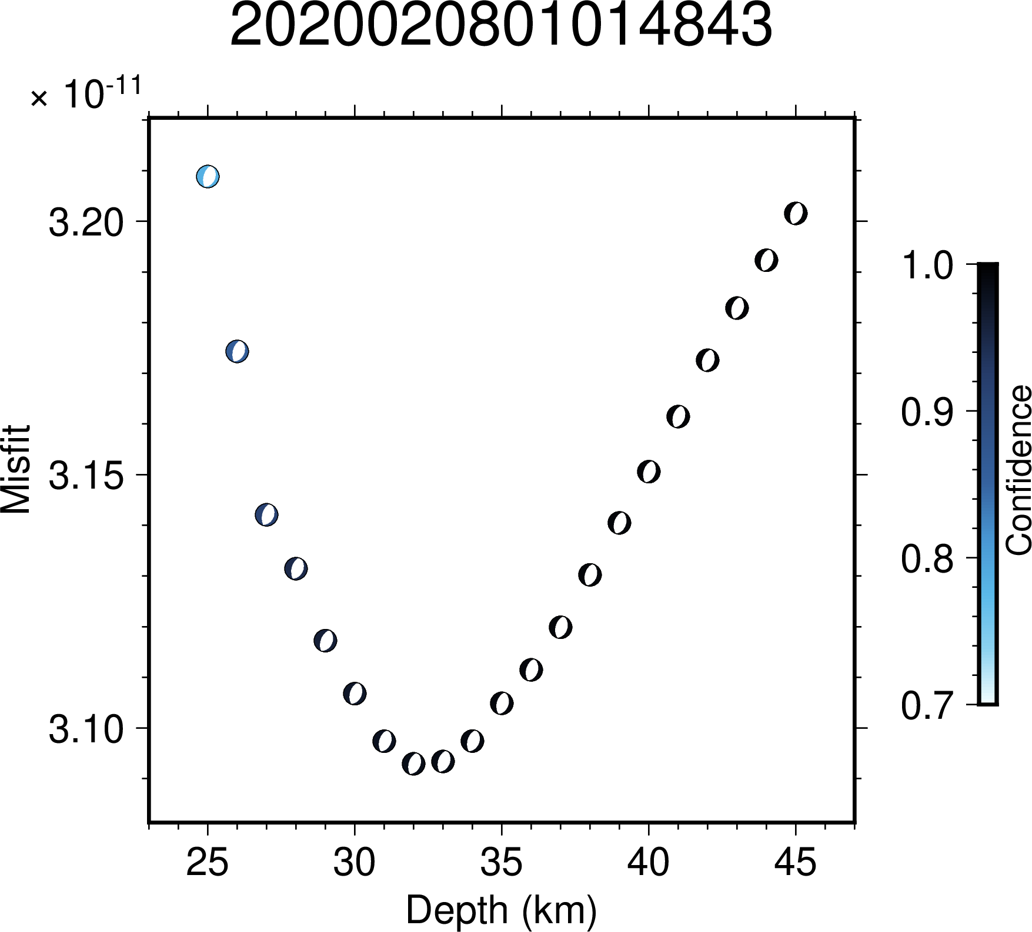Figure S3.23: Illustration of variation in confidence values across depth for the event 2020020801014843. The minimum value of misfit lies at the depth of 34 km.
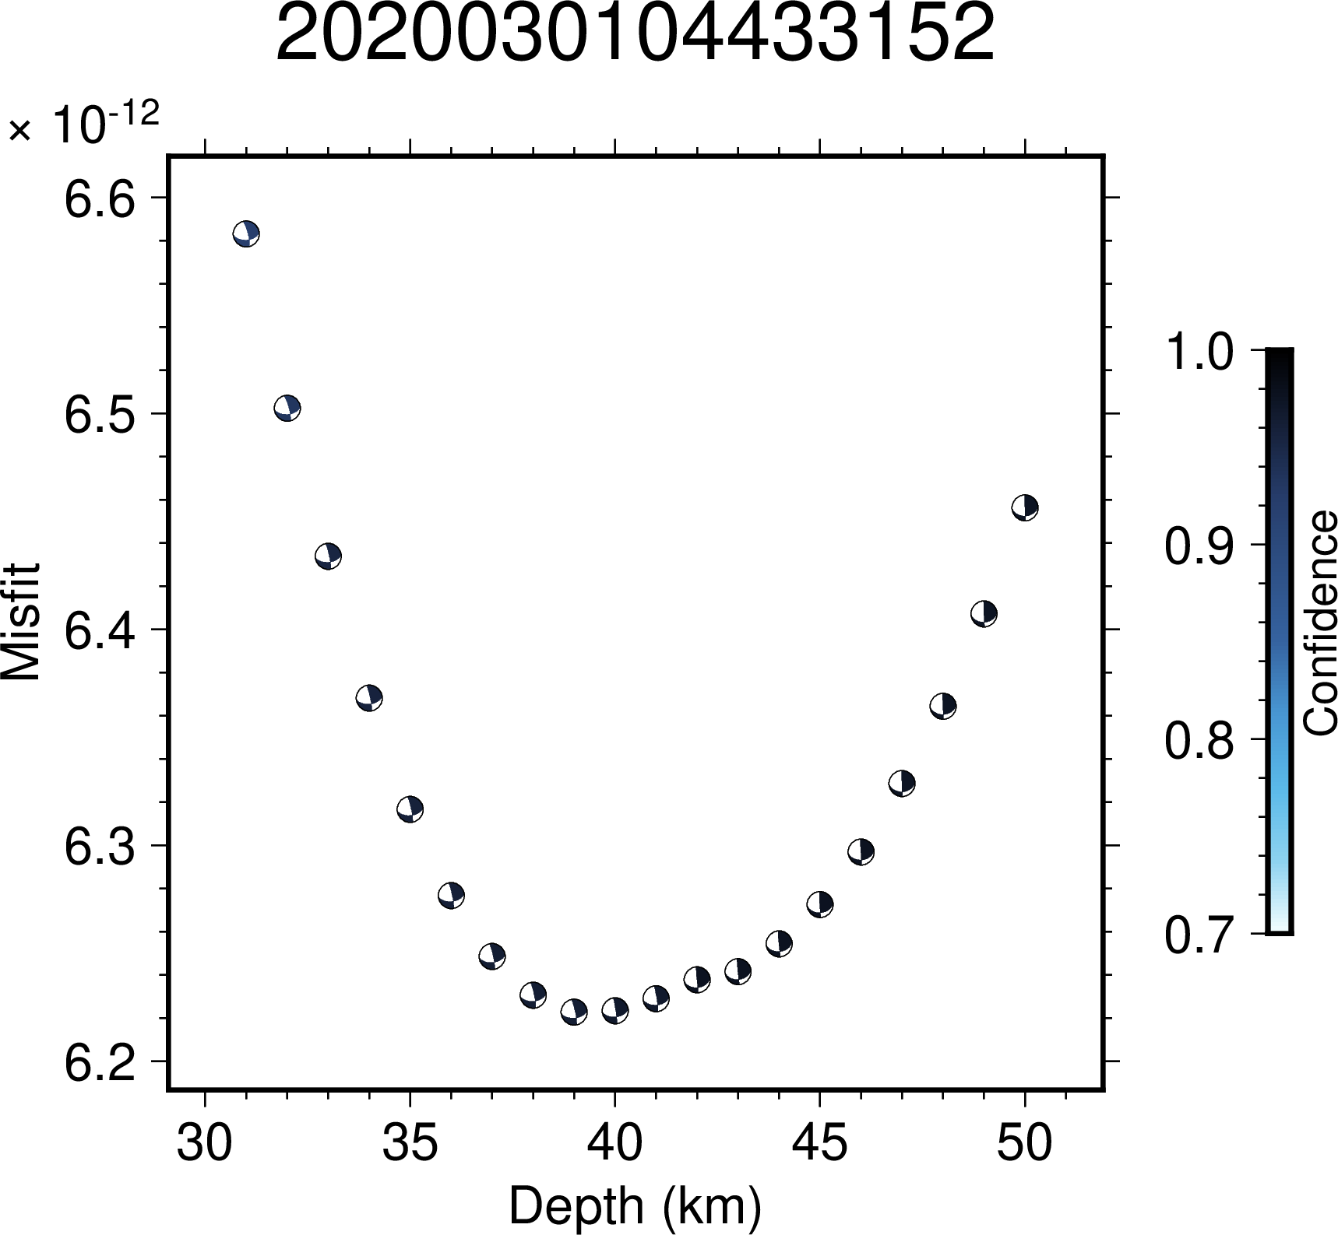Figure S3.24: Illustration of variation in confidence values across depth for the event 2020030104433152. The minimum value of misfit lies at the depth of 40 km.
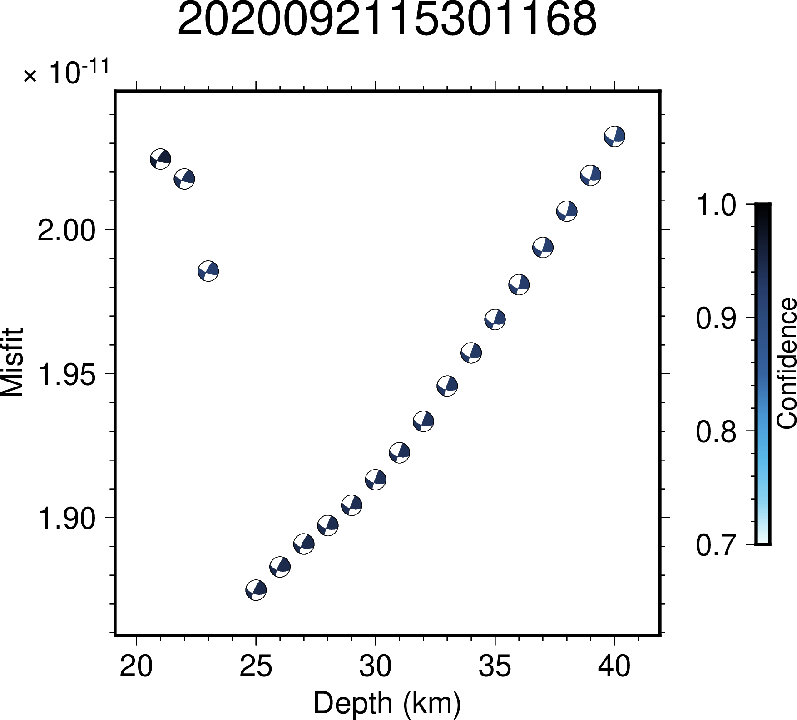Figure S3.25: Illustration of variation in confidence values across depth for the event 2020092115301168. The minimum value of misfit lies at the depth of 25 km.
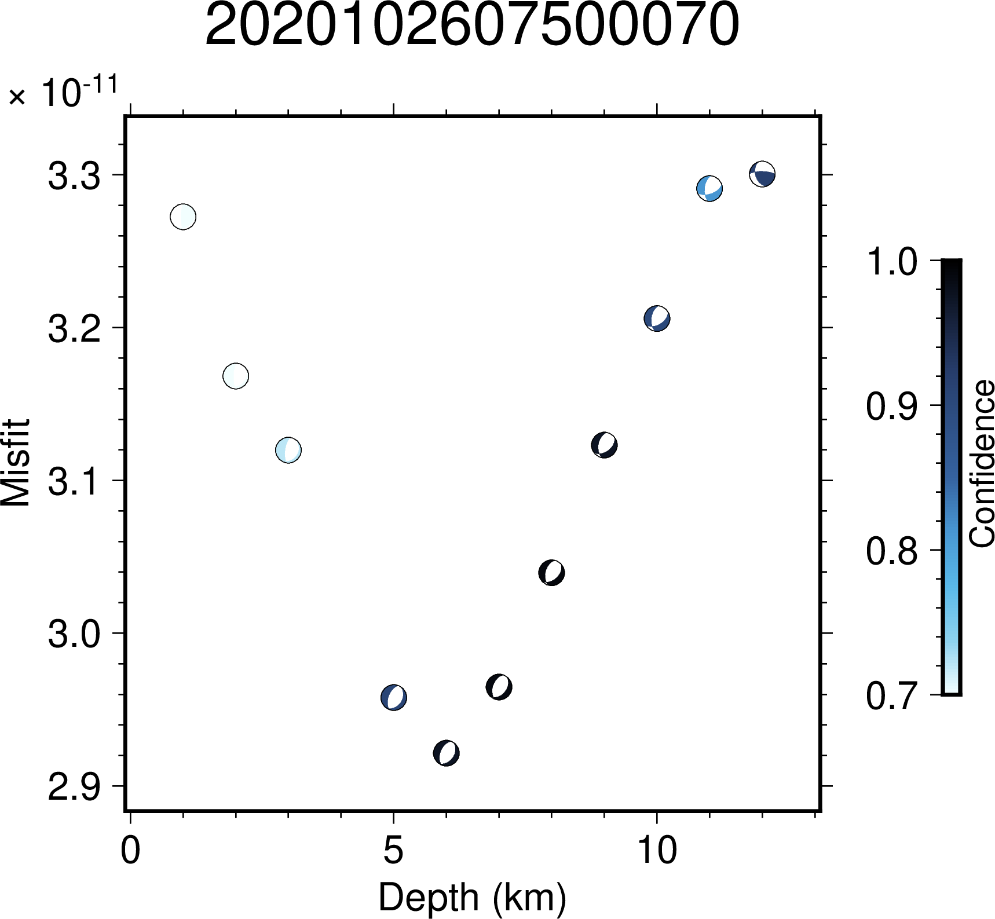Figure S3.26: Illustration of variation in confidence values across depth for the event 2020102607500070. The minimum value of misfit lies at the depth of 6 km.
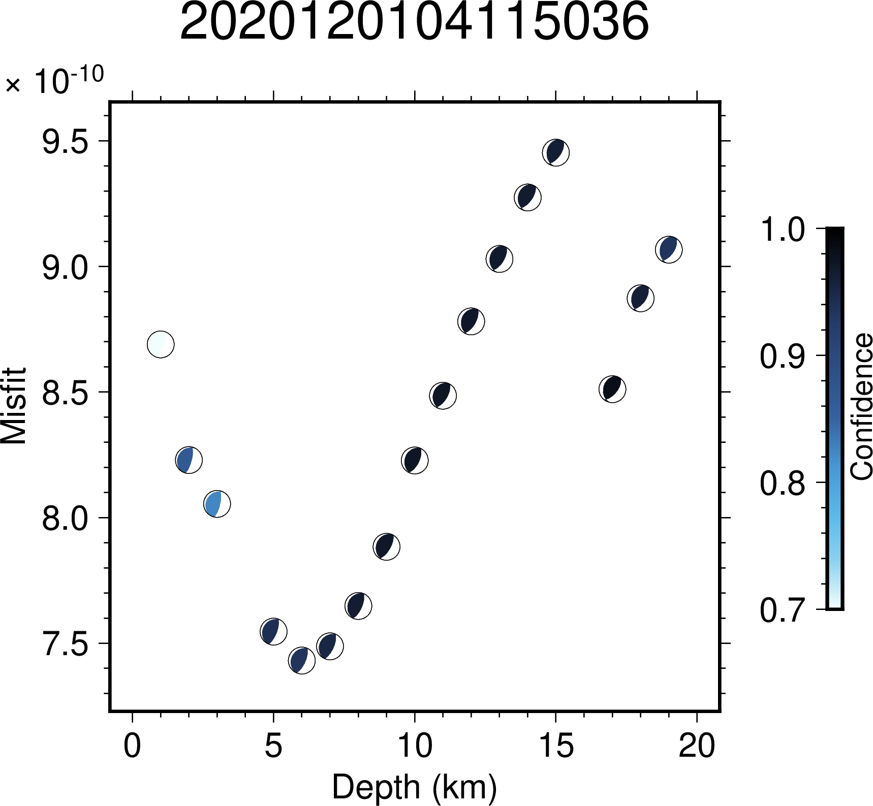Figure S3.27: Illustration of variation in confidence values across depth for the event 2020120104115036. The minimum value of misfit lies at the depth of 7 km.
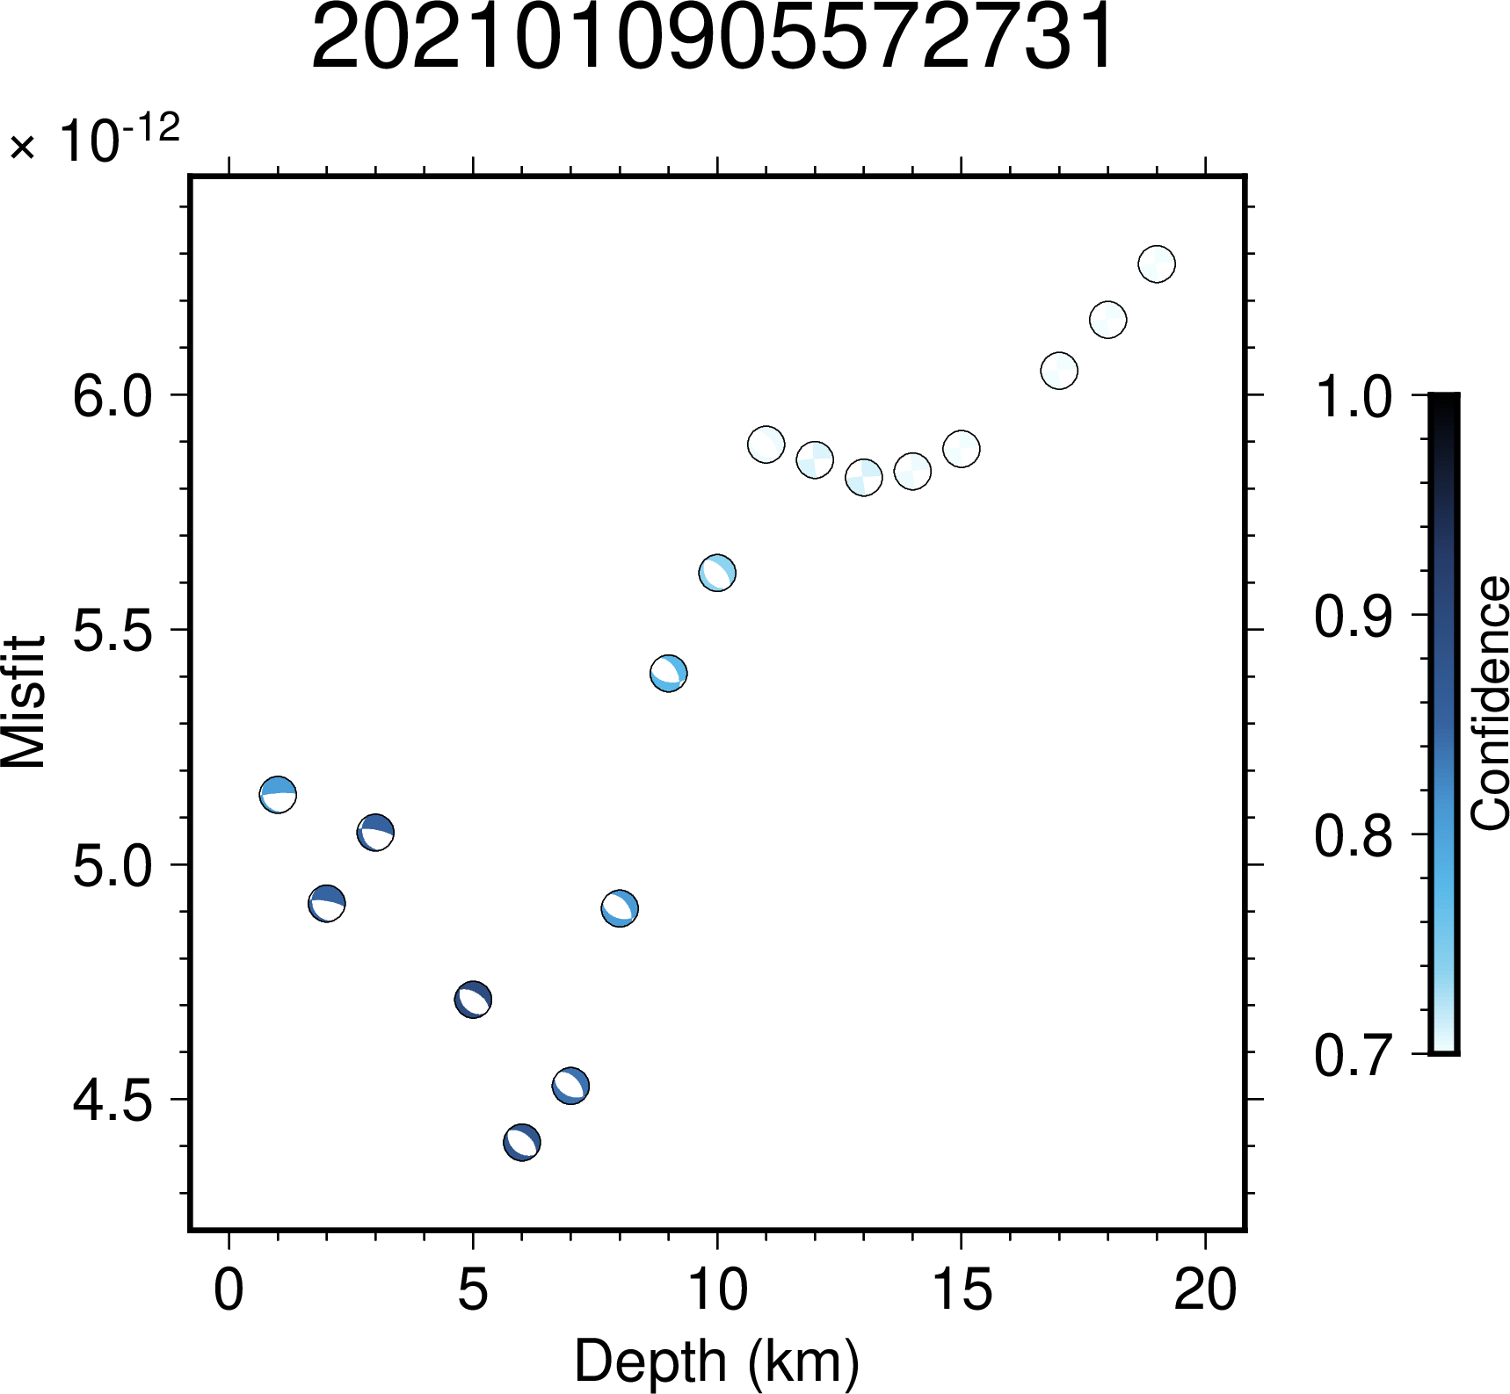
Figure S3.28: Illustration of variation in confidence values across depth for the event 2021010905572731. The minimum value of misfit lies at the depth of 6 km.
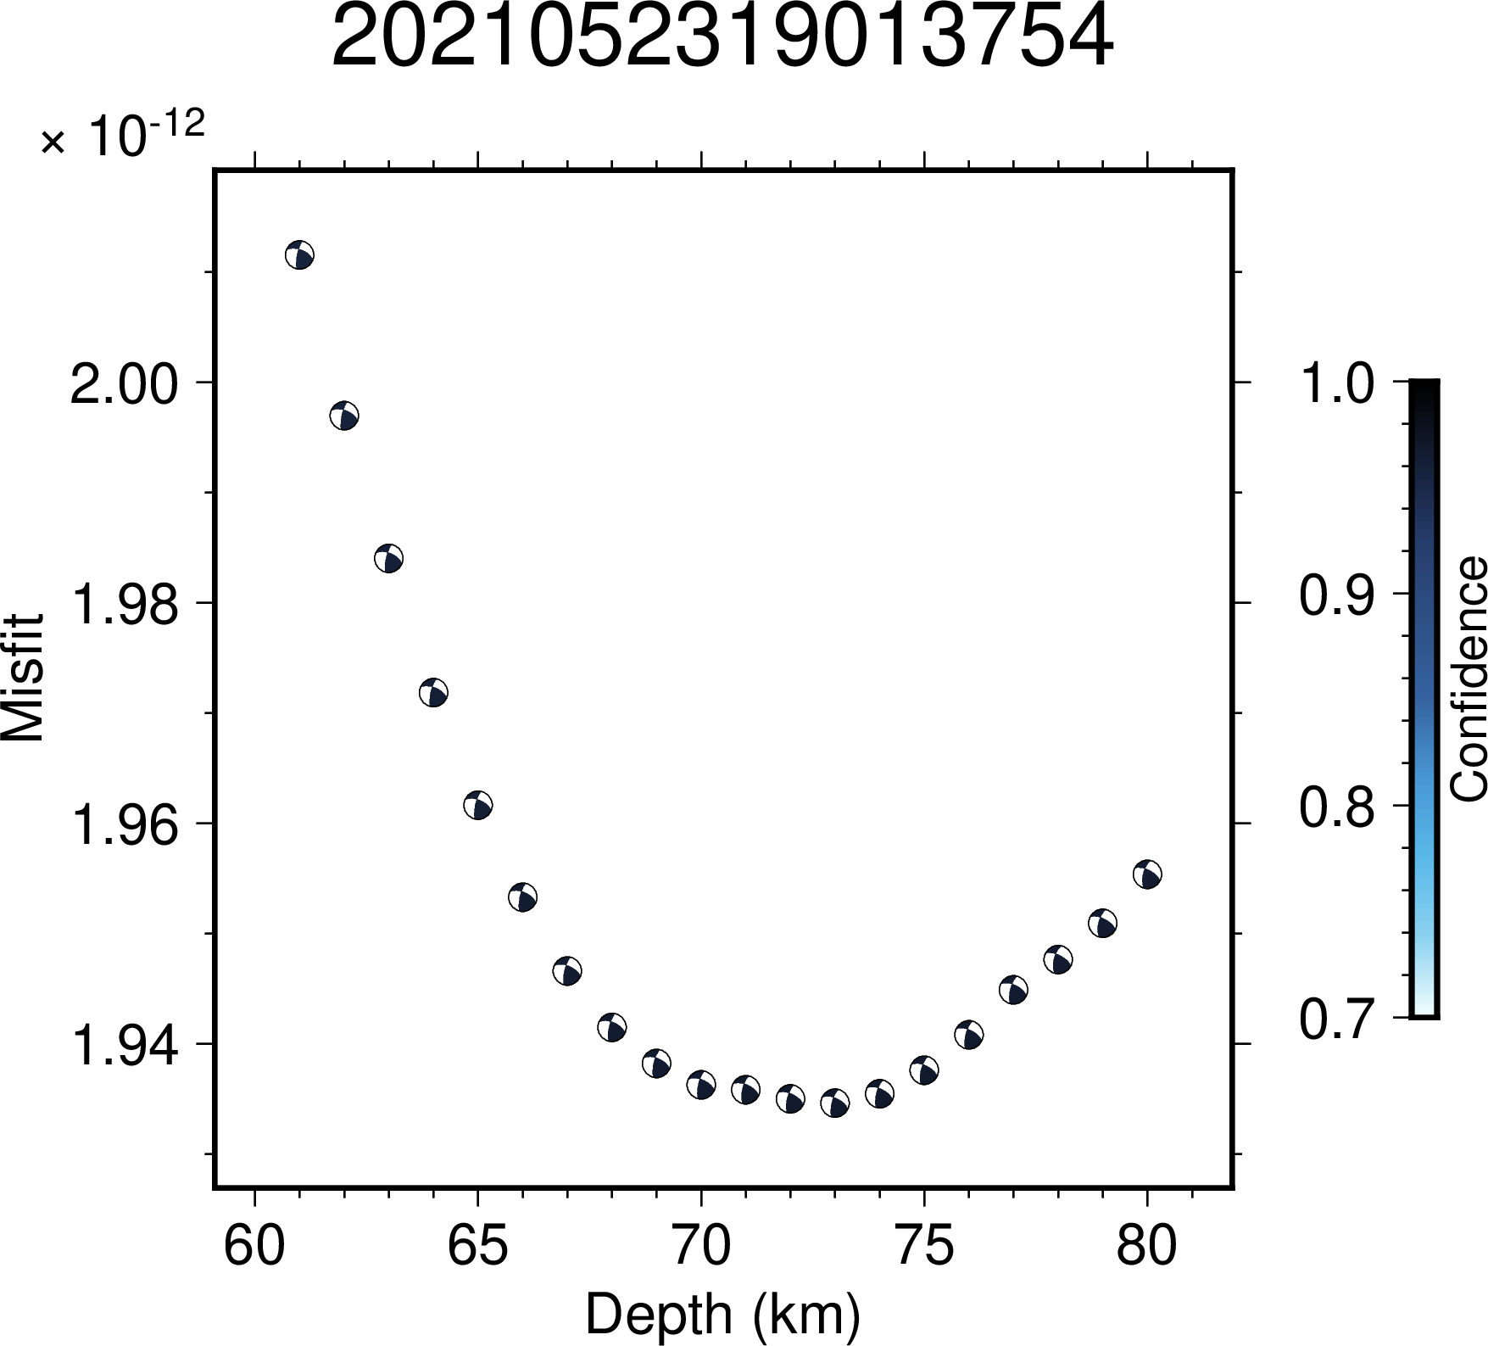Figure S3.29: Illustration of variation in confidence values across depth for the event 2021052319013754. The minimum value of misfit lies at the depth of 72 km.
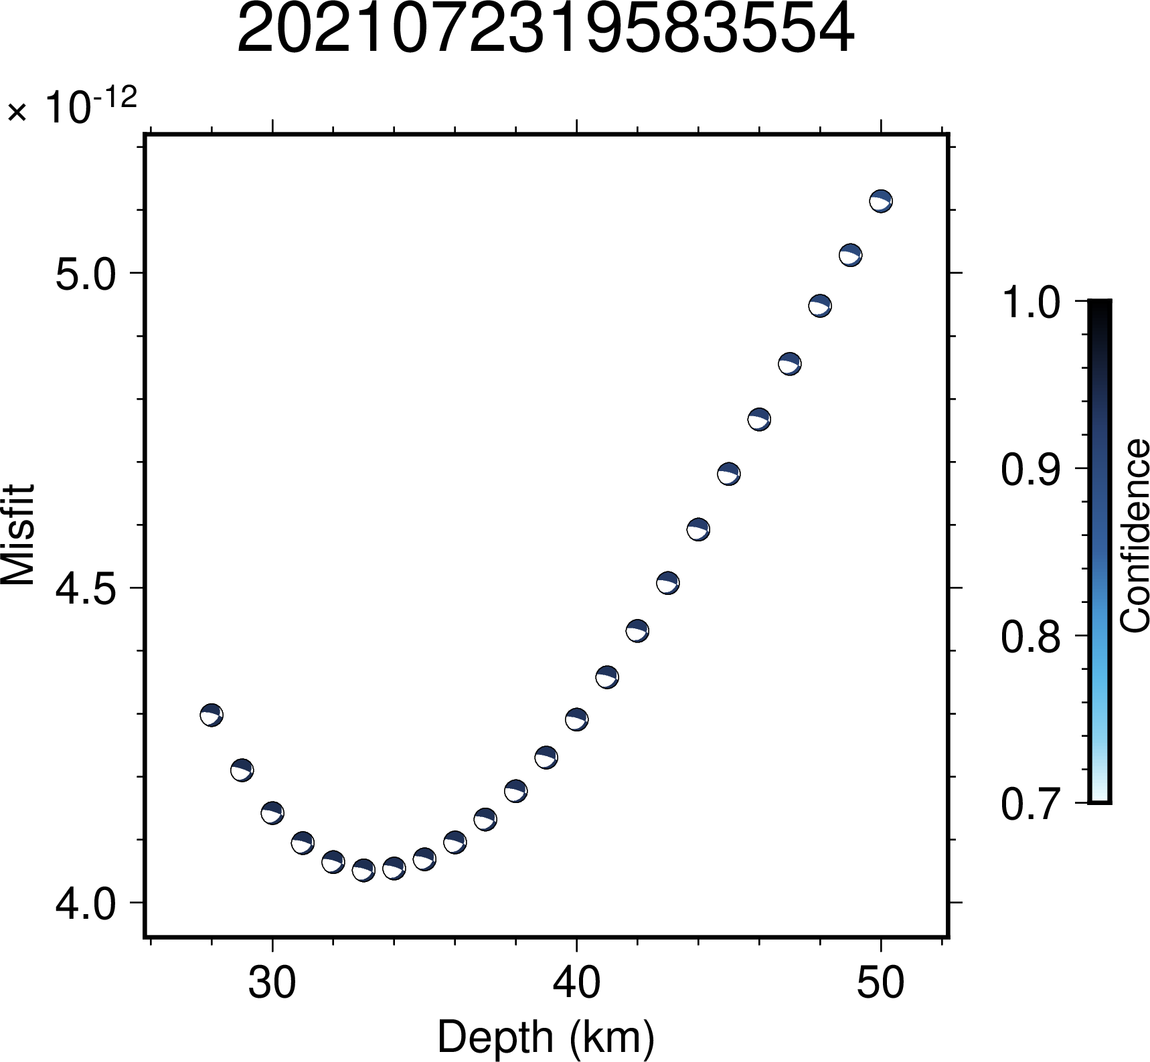Figure S3.30: Illustration of variation in confidence values across depth for the event 2021072319583554. The minimum value of misfit lies at the depth of 32 km.
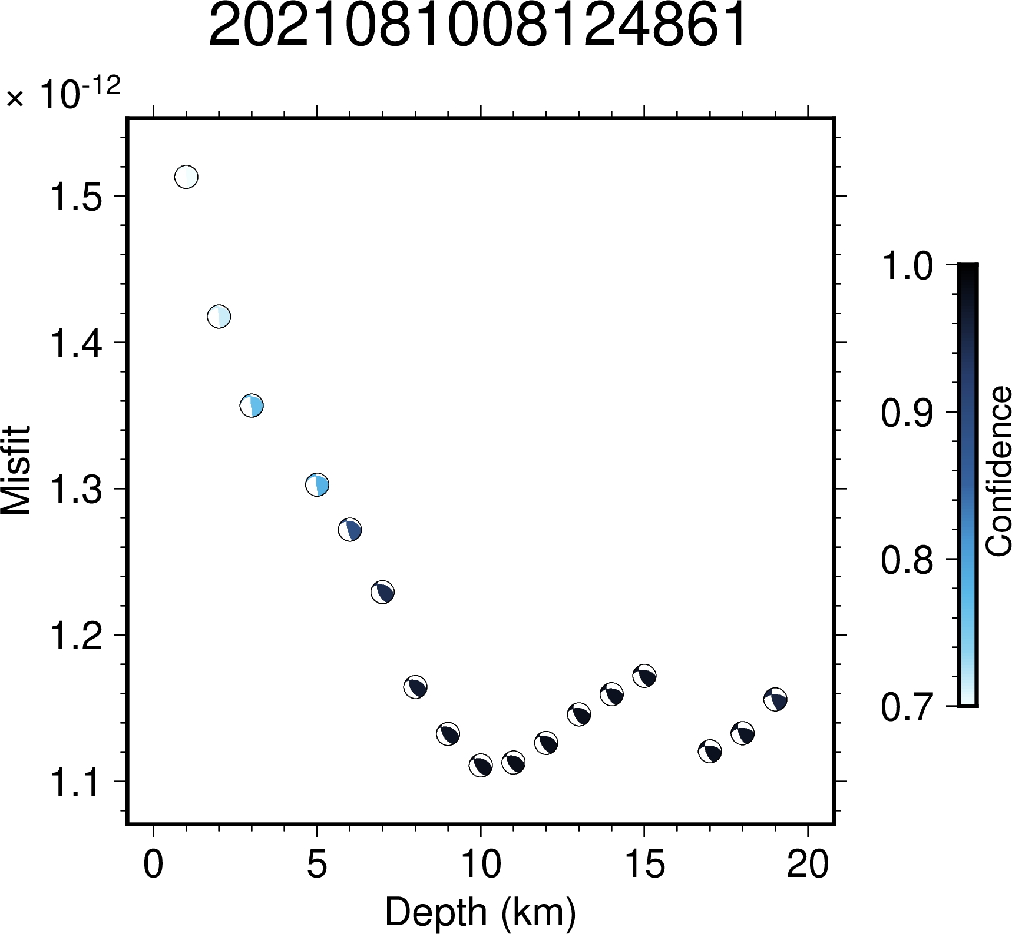Figure S3.31: Illustration of variation in confidence values across depth for the event 2021081008124861. The minimum value of misfit lies at the depth of 10 km.
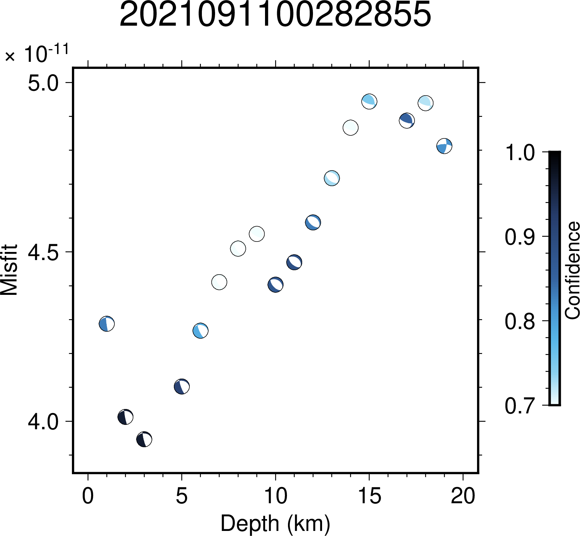
Figure S3.32: Illustration of variation in confidence values across depth for the event 2021091100282855. The minimum value of misfit lies at the depth of 3 km.
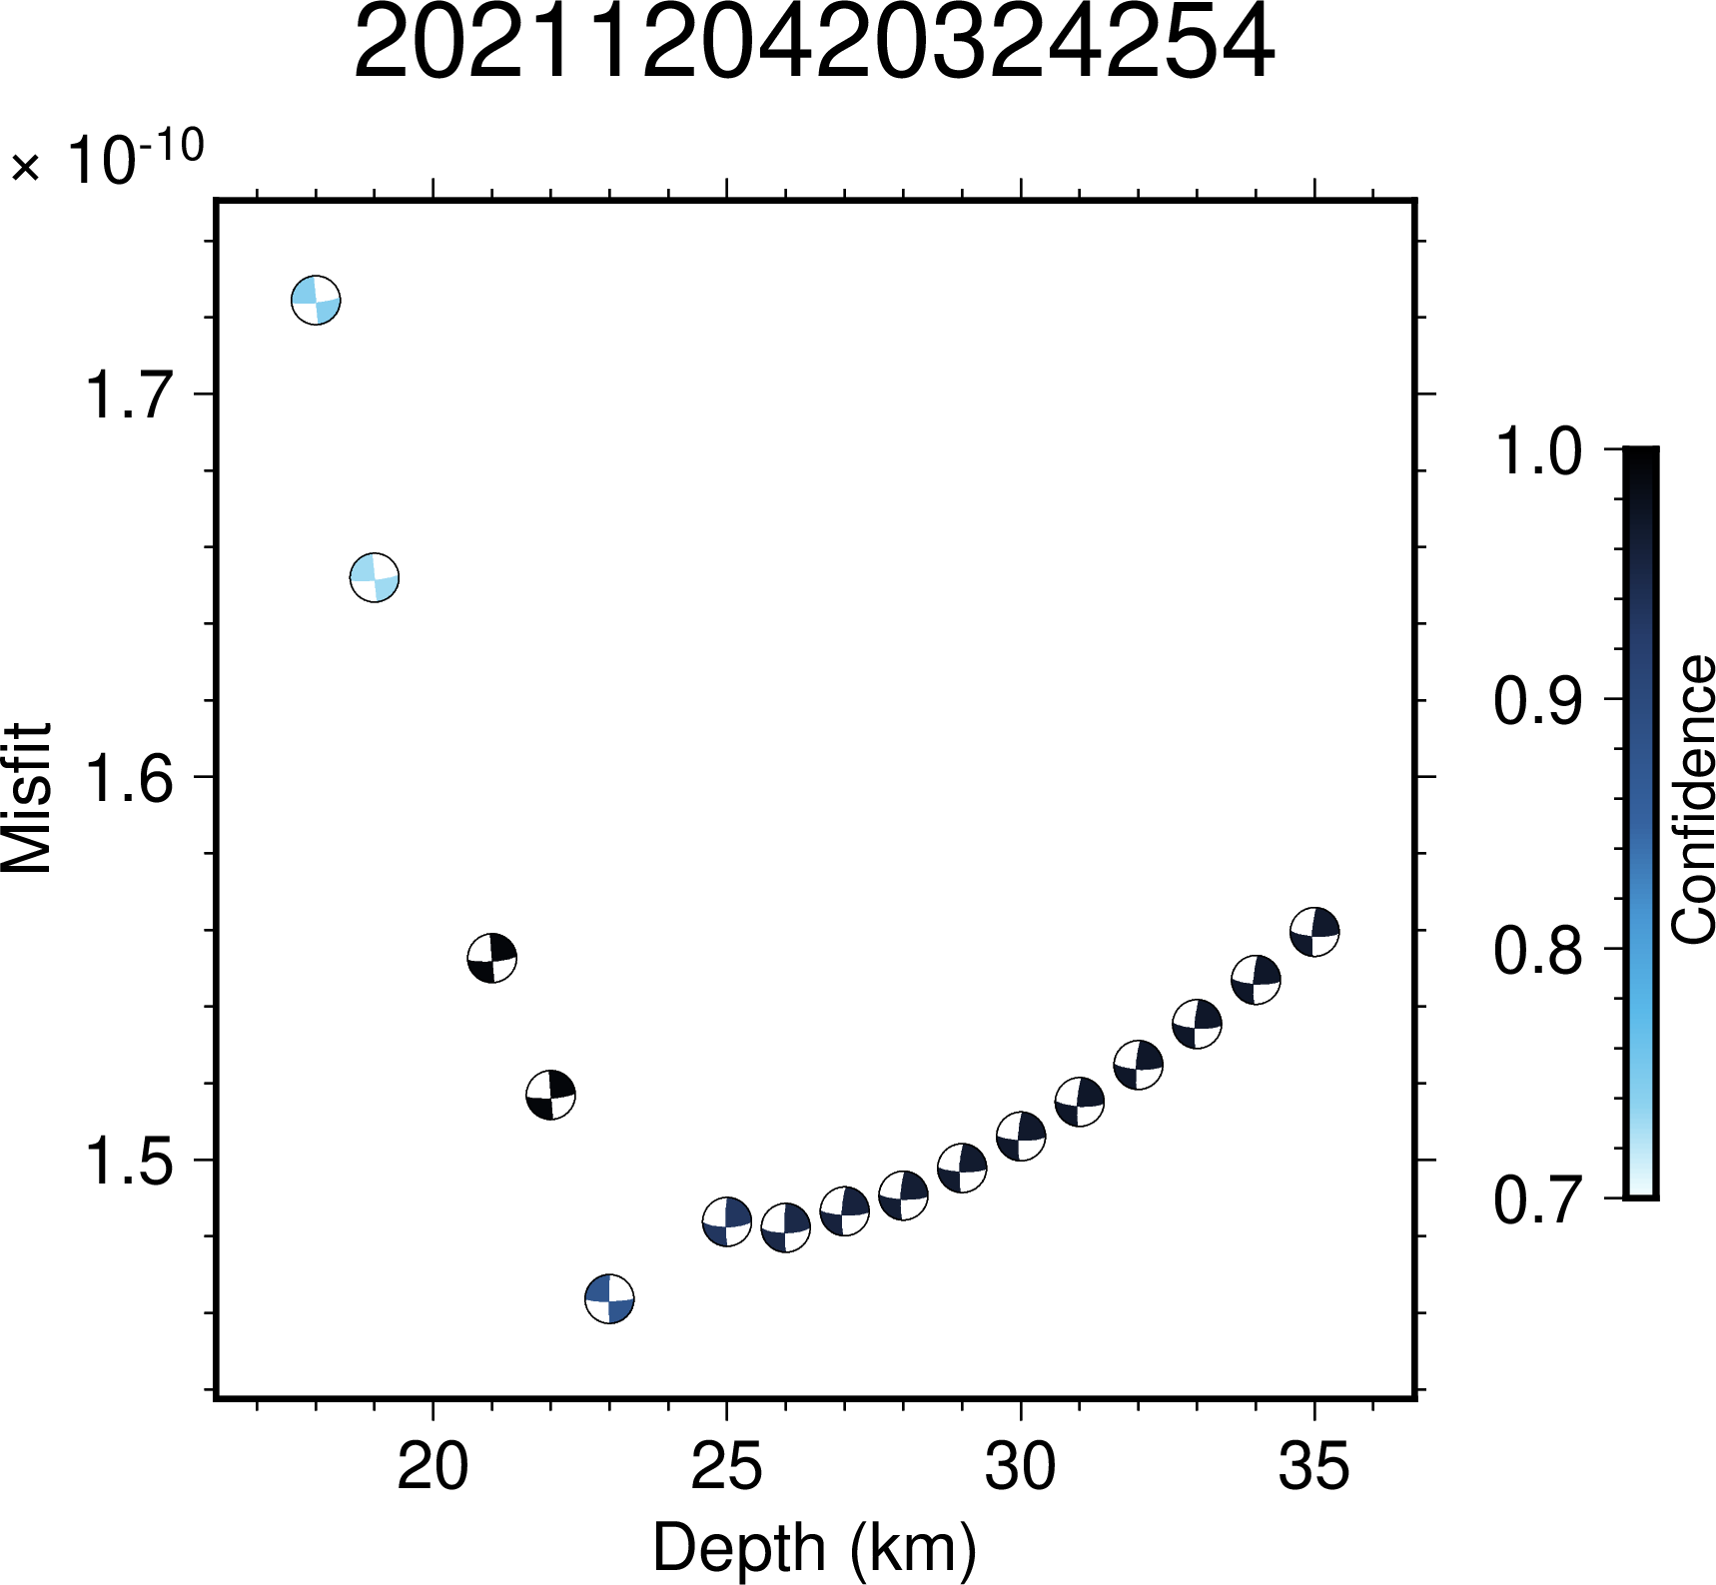
Figure S3.33: Illustration of variation in confidence values across depth for the event 2021120420324254. The minimum value of misfit lies at the depth of 23 km.
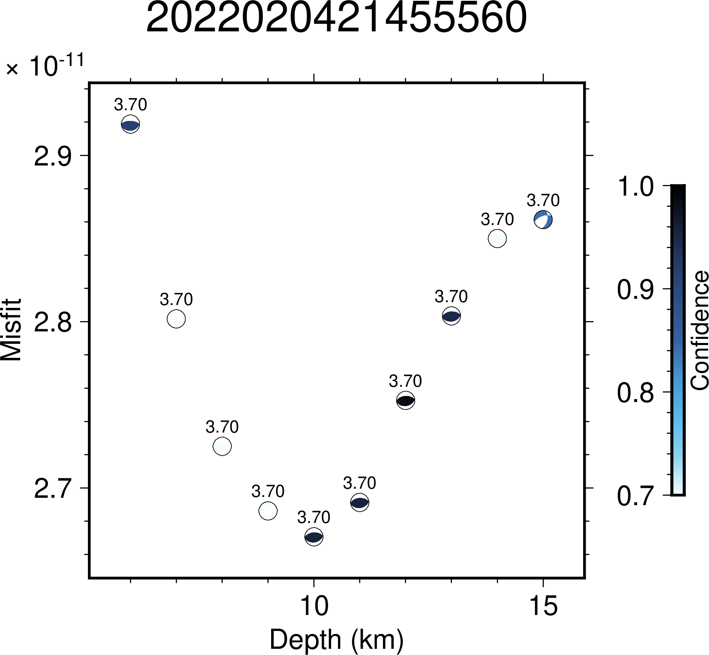
Figure S3.34: Illustration of variation in confidence values across depth for the event 2022020421455560. The minimum value of misfit lies at the depth of 10 km.
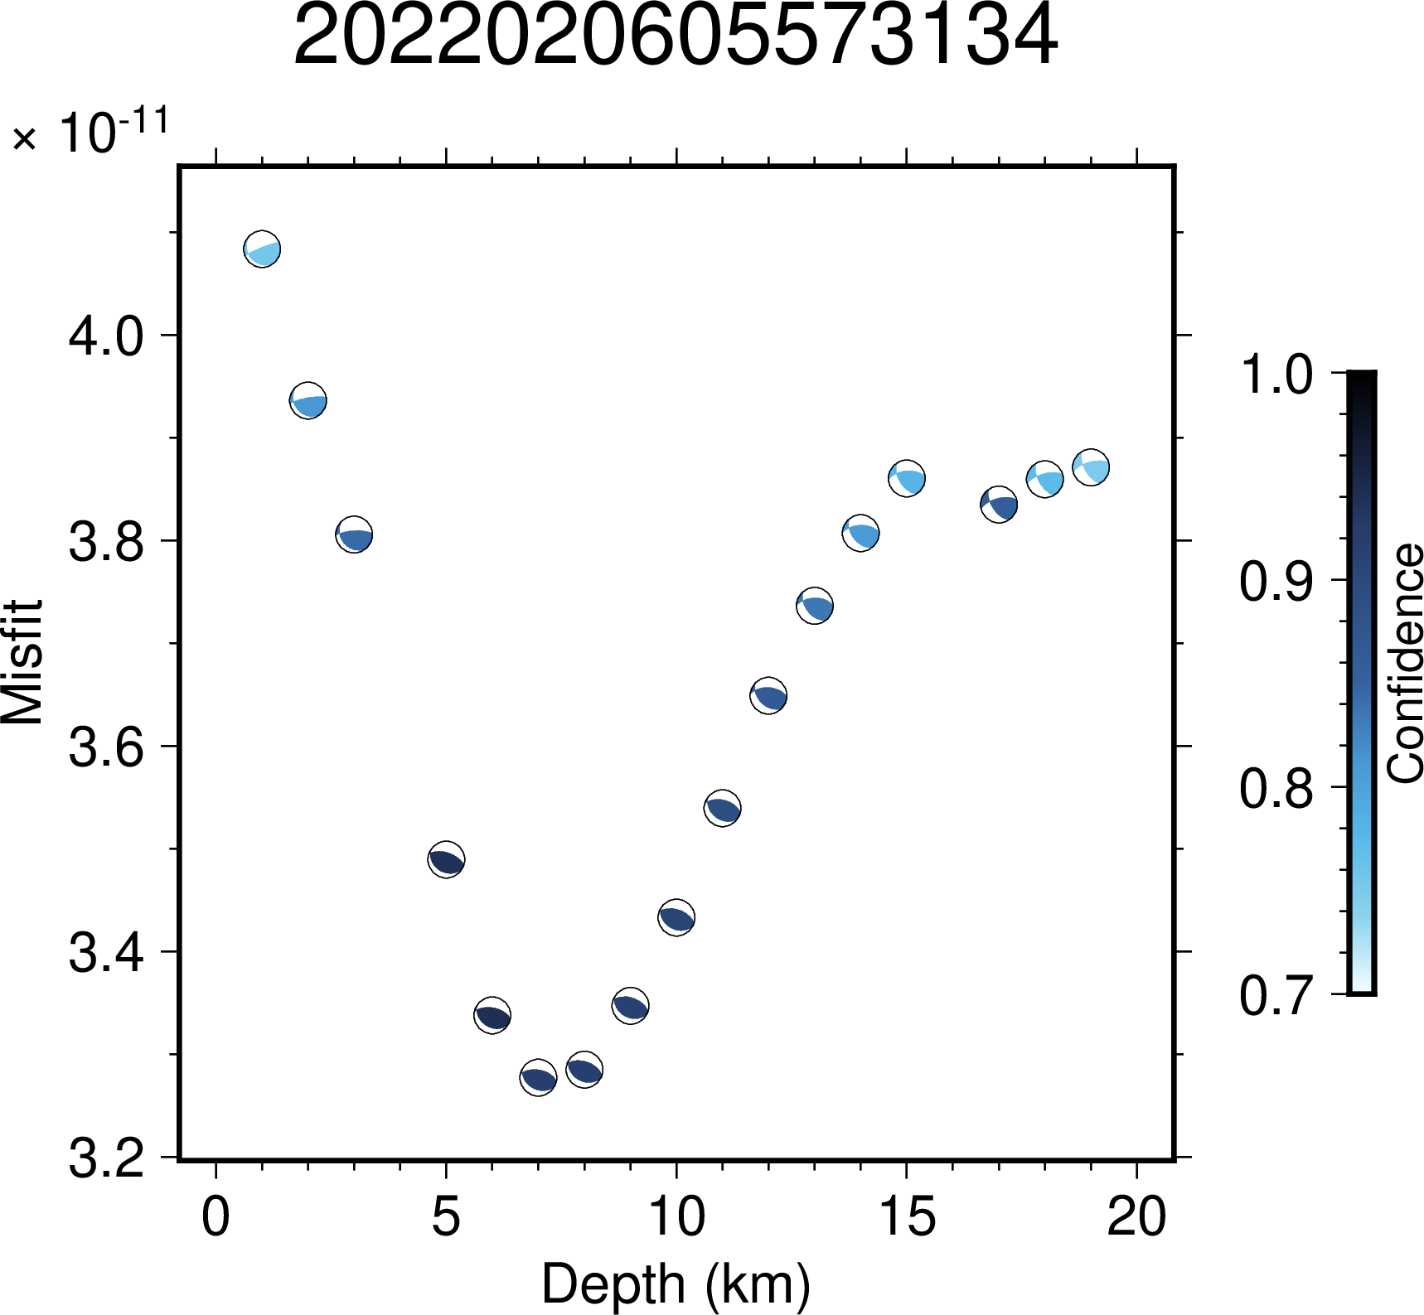Figure S3.35: Illustration of variation in confidence values across depth for the event 2022020605573134. The minimum value of misfit lies at the depth of 7 km.
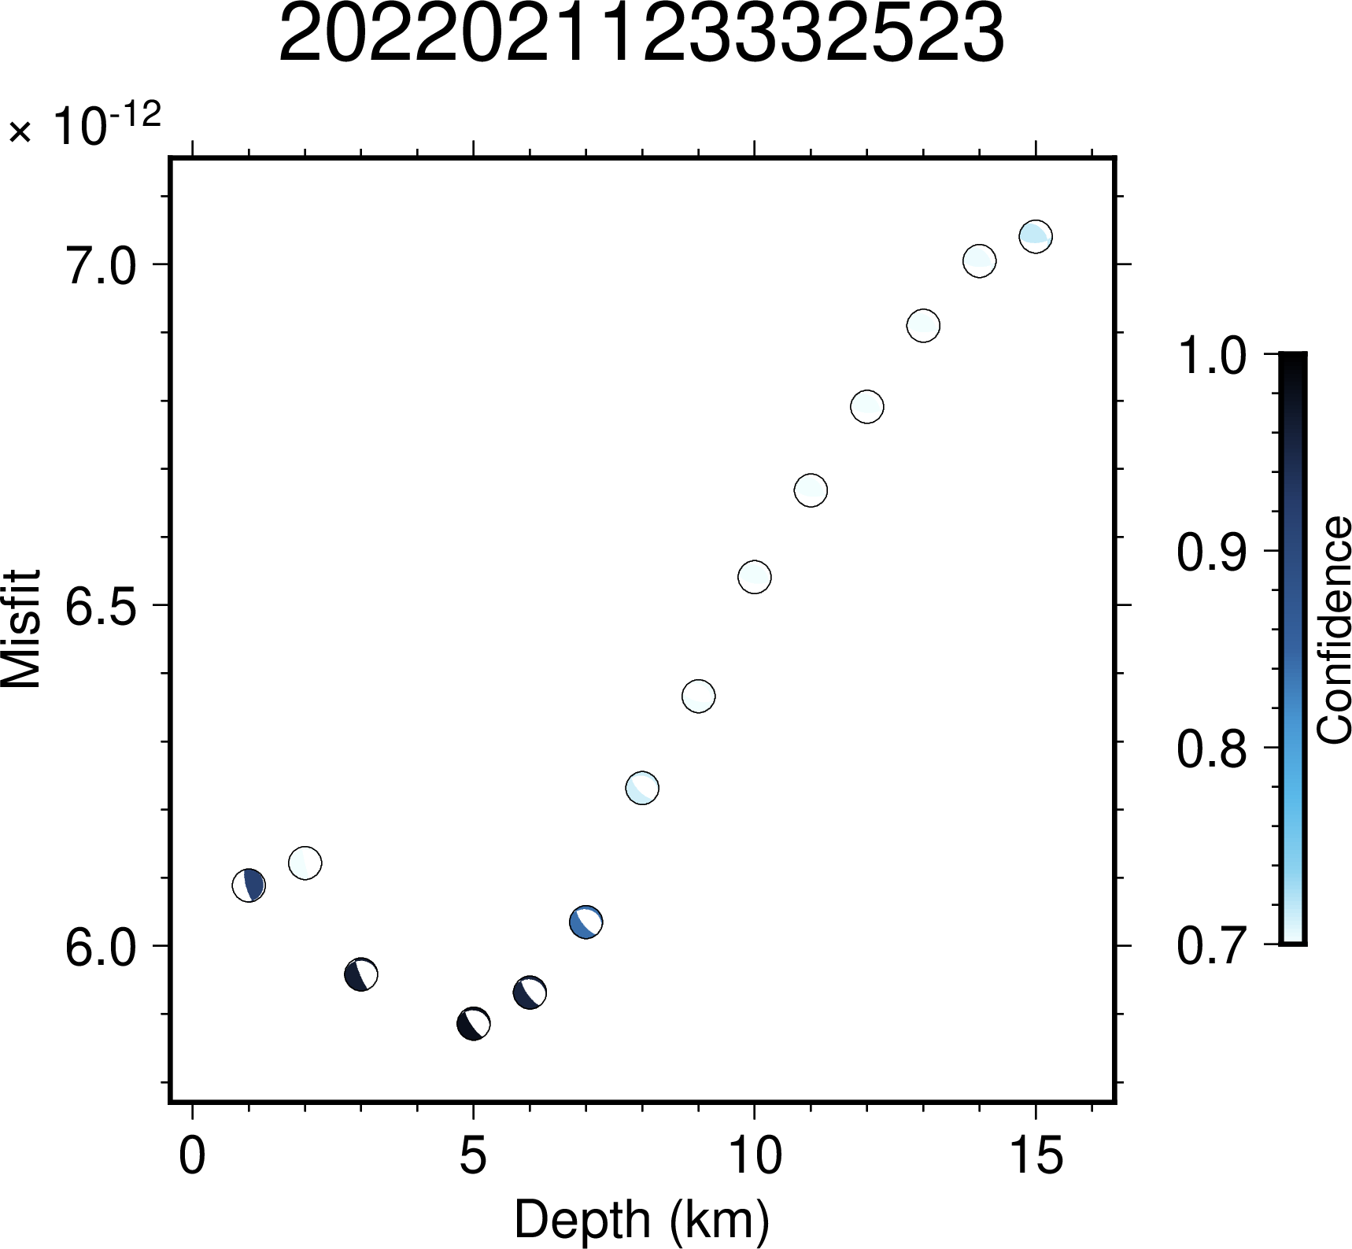Figure S3.36: Illustration of variation in confidence values across depth for the event 2022021123332523. The minimum value of misfit lies at the depth of 5 km.
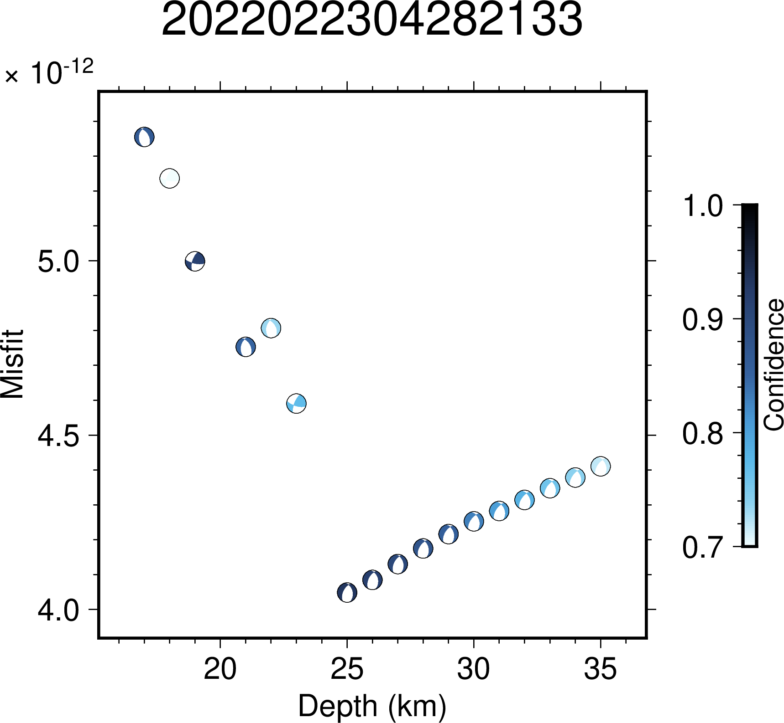Figure S3.37: Illustration of variation in confidence values across depth for the event 2022022304282133. The minimum value of misfit lies at the depth of 25 km.
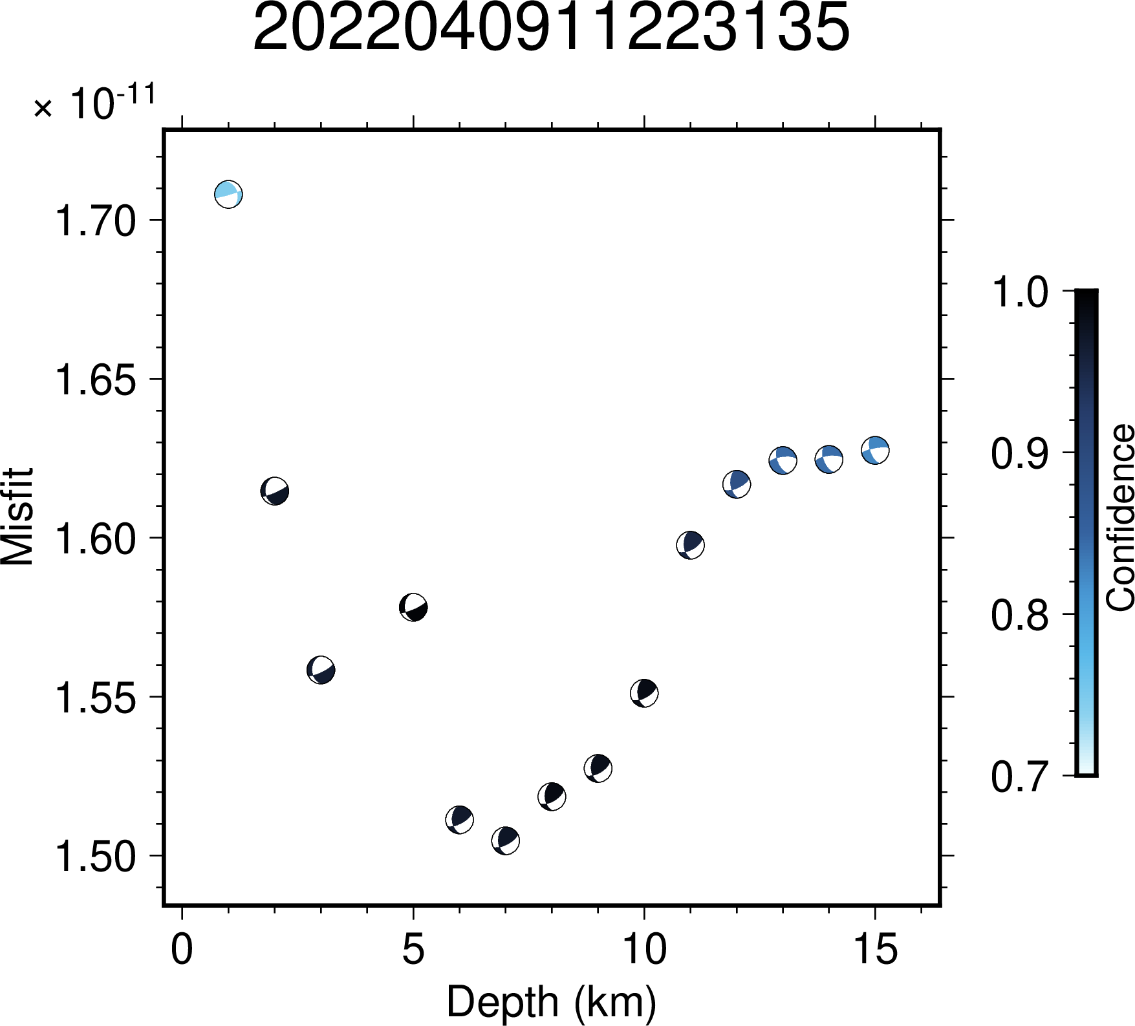Figure S3.38: Illustration of variation in confidence values across depth for the event 2022040911223135. The minimum value of misfit lies at the depth of 7 km.
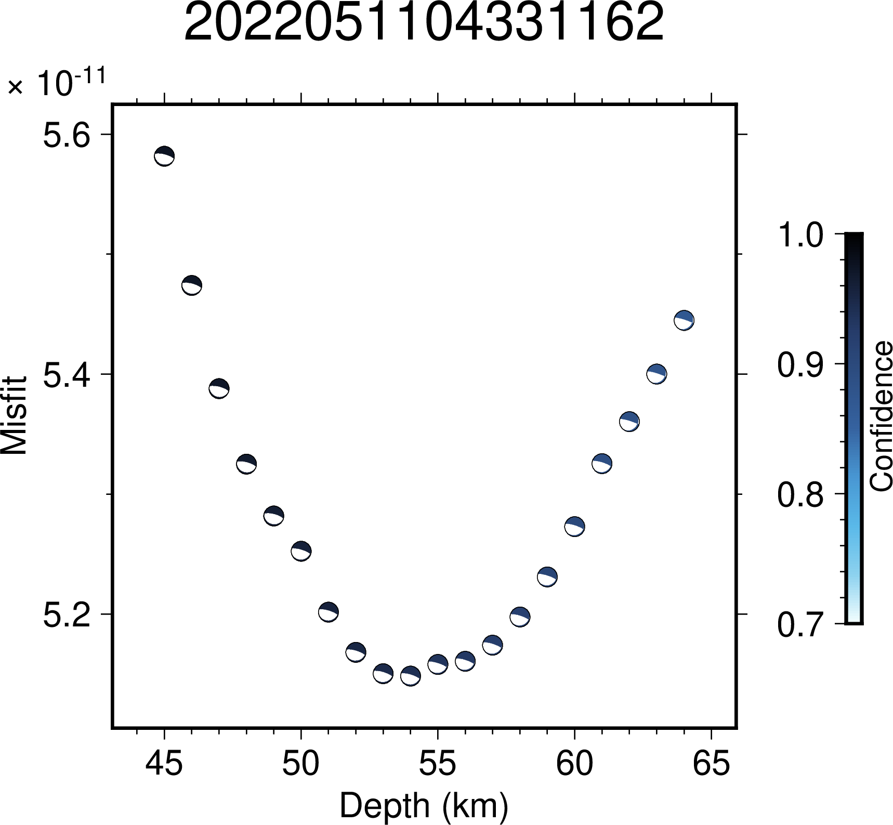
Figure S3.39: Illustration of variation in confidence values across depth for the event 2022051104331162. The minimum value of misfit lies at the depth of 54 km.
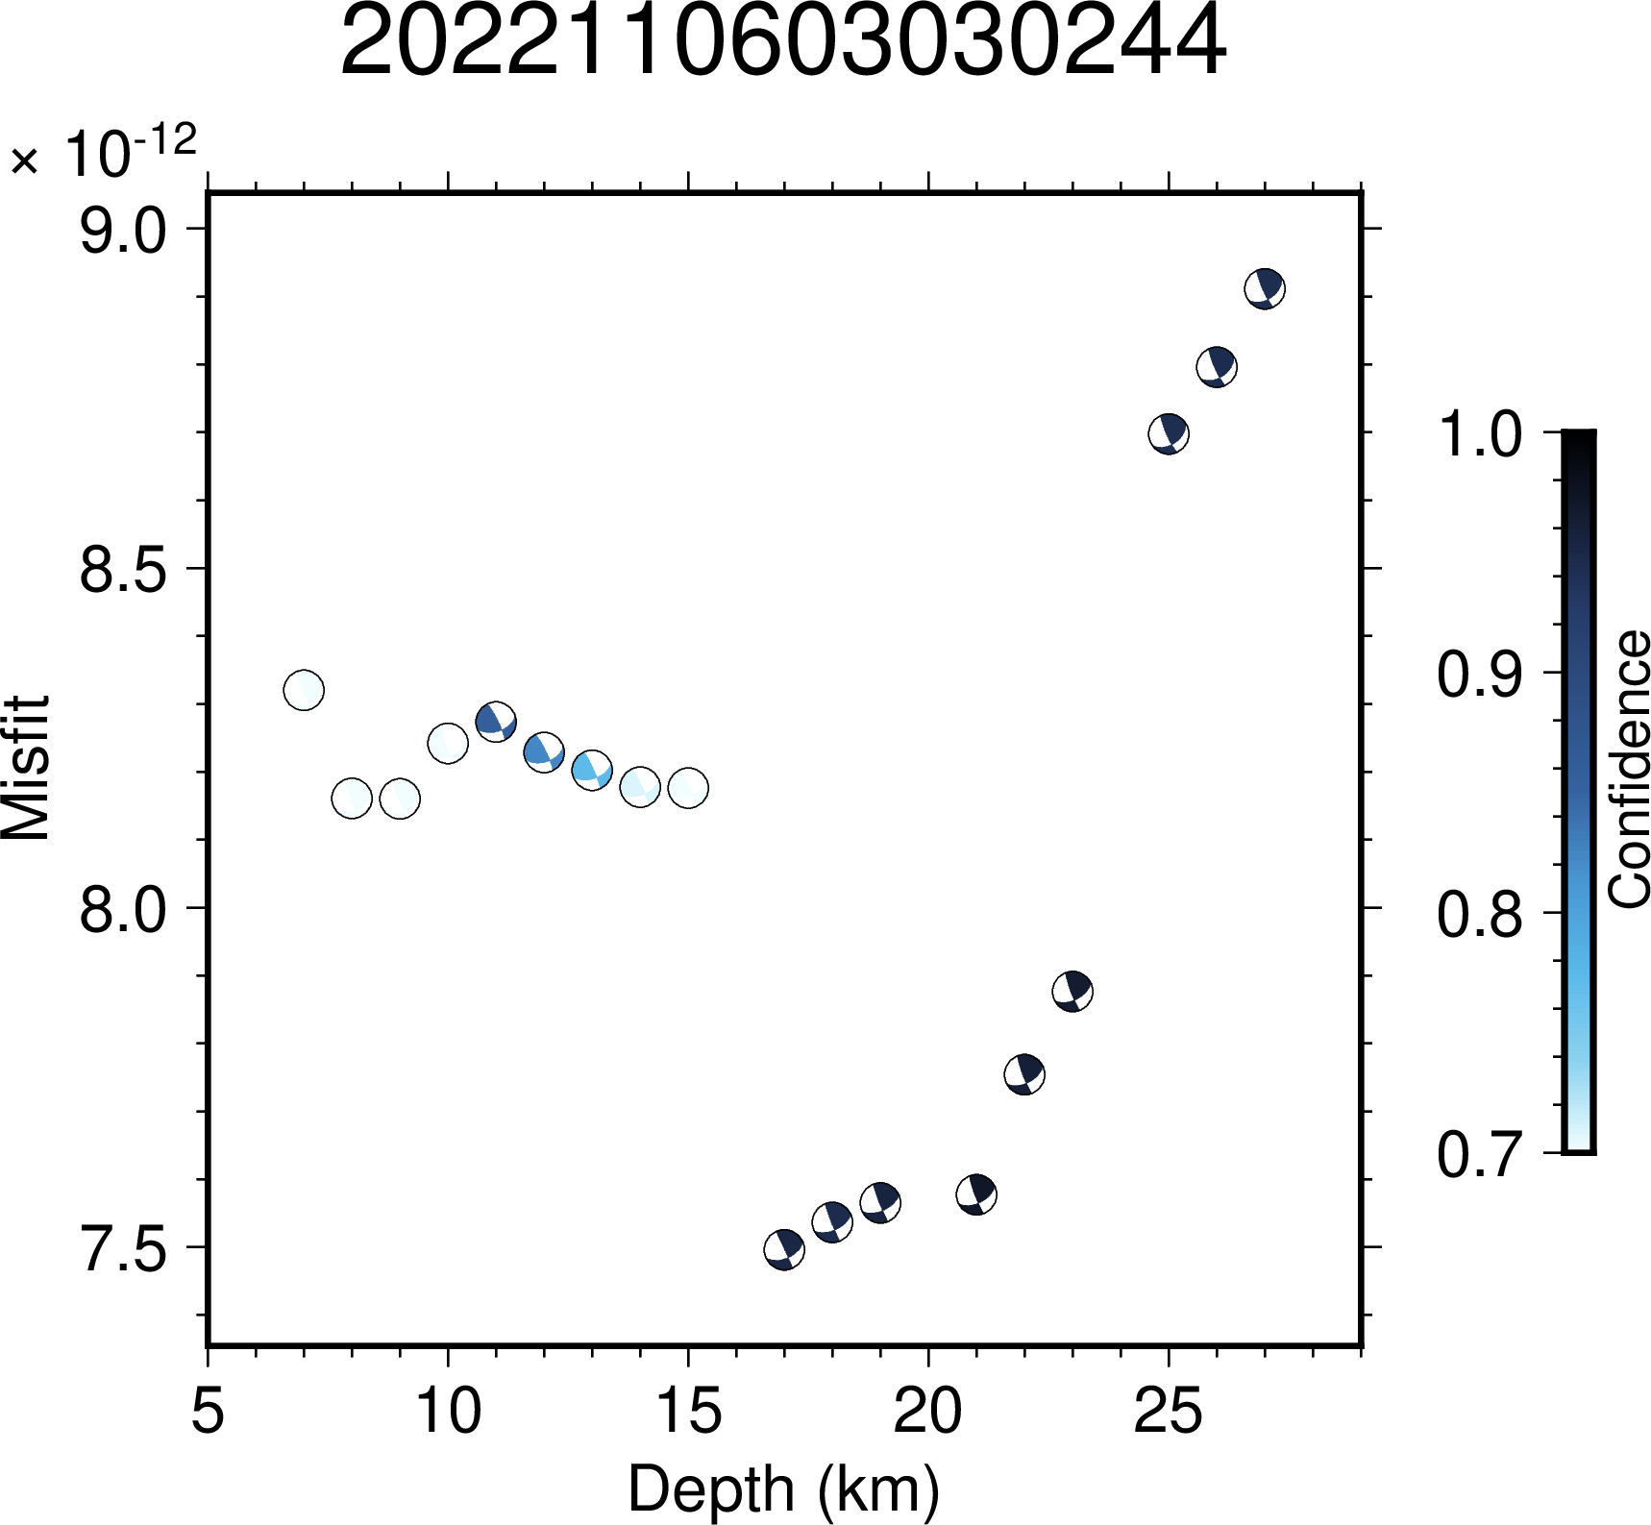Figure S3.40: Illustration of variation in confidence values across depth for the event 2022110603030244. The minimum value of misfit lies at the depth of 17 km.

