IJESRT
International Journal of Engineering Sciences & Research Technology
WI-FI AND ANDROID APPLICATION CONTROLLED MULTI-PURPOSE LAND ROVER
Maheshbabu P*¹, H Chandra Sekhar² & L Ramamurthy³
^{*1}PG Scholar, Dept. of ECE (ES), VEMU Institute of Technology,Chittor,AP,India,
²Assoc.Prof , Dept. Of ECE,VEMU Institute of Technology,Chittor,AP,India
³Prof & HOD, Dept. of ECE, VEMU Institute of Technology,Chittor,AP,India

DOI: 10.5281/zenodo.1252921

ABSTRACT
Now a days so many robotic systems are using for counteracts the terrorist attacks, and many robotic systems are using for locating victims under the debris during natural disasters, and robotic systems are using in the field of excavations in the department of archeology. These robots are designed with advanced processors and technology. And another disadvantage is we are getting limited benefits by spending lot of money on advanced processor. So wasting money is there and we are failing to utilize efficiency of high-end processors.. but when coming to its operation, now a days very old and basic approaches are using to operate them, like 1. by sending commands from pc (by typing letters from keyboard or by pressing arrow buttons) 2. by sending commands from the mobile phone. So we need to design a robot with low end processor with multi-purpose capacity ,user-friendly, advanced and dedication operation technique, which includes dedicated android application with data logger system(data regarding temperature , humidity ,smoke detection) and low cost development too. This can also be used in various real-time applications like home security, in mines and archaeological activities in addition to its usage in defense for terrorist counter attacks and rescue operations.

Keywords: Gesture, Arduino, Terrorist, Archaeology, Night vision, Exploration.

- INTRODUCTION
Human involvement in mine detection is risky to life. So an human less robot which is equipped with multi sensors, wireless camera to provides the Live video in order to search the suspicious regions and to guide the robot , multi sensors are useful to monitor the temperature in surrounding regions, for detecting the land mines and dangerous gases and to protect the people and soldiers from it. When the robot fails to provide the live video transmission, it need not be wait for manual commands, it should capable of taking the own decisions intellectually in the absence of manual commands and need to send the data about the status of robot and the environmental conditions. Controlling the movement of the robot easily. Joshua-MPL Robot is invented to satisfy the above needs.

- DEMERITS OF THE EXISTING SYSTEM

[A]Wired medium
When coming to its operation, it is done with wired medium. In case if it is operate with the help of the internet, it was done with LAN cable. Wired medium interfacing can lead to limited operation, which results decreases the overall performance.

[B]Failed in utilizing the processor efficiency
Actually the existed system is developed with arm11 based raspberry pi board. Actually it can have 1GB of RAM and supports many programming languages. But there robot can perform movements and transmit the data regarding environmental parameters through TCP/IP or WI-FI. For this application processor can take 5% strain out of 100%.the remaining 95% ability to do is wasted.

[C]No Night Vision
Existed system did not have the feature called night vision. Night vision means the ability of robot that it can work during night times with help of dedicated lamp. But existed system not useful during night and dark places due to lack of night vision.

[D]No Acknowledgement
The previous system did not have the feature called acknowledgement. Acknowledgement means giving reply to authenticated and operational commands. We cannot get the reply from the robot for its status. Hence acknowledgement can improve the system performance.

[E]High Cost
System is developed with the advanced high-end processor results high in cost.

[F] Non-User Friendly
This system is not user friendly, due to lack of dedication app for its operation. It is always difficult to operating them without specific tool or application. For Hassel-free operation GUI-Graphical-User-Interface based command window is necessary for fast and convenient operation of robot. No problem whatever the platform may be.

- OBJECTIVE
Joshua-MPLR is an iot based rover equipped with sensors like temperature sensor, smoke sensor, ultrasonic sensor, humidity sensor. And rover having the specially designed robotic arm for object picking. This robotic arm is designed with four servomotors. Video capturing feature is developed with this robot, so we can observe the visuals of surroundings on live video from the robot. For controlling rover and monitoring the status of the rover can be done only with specially designed android application over the WIFI network. This rover can be used in mines for detecting dangerous gaseous, in archeology for observing the inside view of dangerous caves and tunnels, can be used in defense for defusing land mines and locating terrorist, in weather forecast center as a remote data logger(hence temperature sensor for temperature detection, smoke sensor for fire and dangerous gas detection, humidity sensor is used to find the amount of humidity present in air), to identify the victims and civilians hidden under debris during rescue operations. And designed with low cost and lower end processor.

- PROPOSED SYSTEM

[A]WIFI interface
This robot is developed over the concept of protocol. Yes as its name mentioned it cannot work without WIFI connection. Yes it uses Wi-Fi and web page format for sending data and receiving command. It can give acknowledgement for connectivity and data transfer.

[B]Virtual joystick control
Earlier mentioned robotic arm can work with joystick. But actually joystick existed there, even dedicated android application, did not use mobile phones joystick. But all these done with program only.

[C]Mono platform development
this robot developed and can work only with android phone with dedicated android application used for it. But in future it will work with another platforms like. IOS, WINDOWS, LINUX.

[D]Video streaming
The robot supports Streaming video to manually analyze the surroundings at the remote station.

[E]Night vision
This robot is equipped with 1watt power led for supporting night vision. Which is very useful during night times and in dark places too.

[F]Used low-end processor for high end application
Here this is used atmega328 controller and NODE MCU module which are very basic controllers, but given high end results.
[G]Low-cost
This robot is developed with low budget. Due to using lower configuration processor it is achieved.

[H]All is JAP:
JAP is nothing but JUST AN APPLICATION. Yes by utilizing one android dedicated application we can control the entire rover and we can monitor the status of the robot as well as data logger parameters on the android mobile applications.

- BLOCK DIAGRAM OF PROPOSED SYSTEM

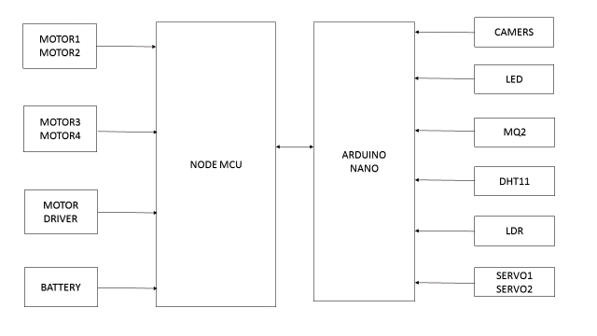
Fig.1 Block Diagram of Receiver Section

Figure 1 shows the Block diagram of receiver section, it is containing following blocks, which are: NODE-MCUmodule, NODE-MCU module includes ESP2866 WI-FI chip. And RF camera transmitter, Arduino Nano board, Arduino board includes At Mega 328 micro controller. Here NODE-MCU is the heart of the system in Receiver section. And which also contains motor drivers (L293D), Temperature sensor (LM35), Gas sensor (MQ2) and LDR sensor, Humidity sensor. For smooth operations of motors, the power provided by the controller is not sufficient for motors .so we are using external motor drivers, it is powered with 12Volts/1Ah current source. Gas sensor is extremely sensible to CO2 (Carbon di-oxide) and CO2 related gases. LDR sensor is used for light intensity measurement. LM35 is used for temperature measurement, having the sensitivity about 10mv/1°C. Humidity sensor is used for measurement amount of humidity present in the air. NODE-MCU establishes the Wireless communication between the Transmitter section and Receiver section, through wireless communication we can send and receive pre-defined commands and parameters monitoring purpose.
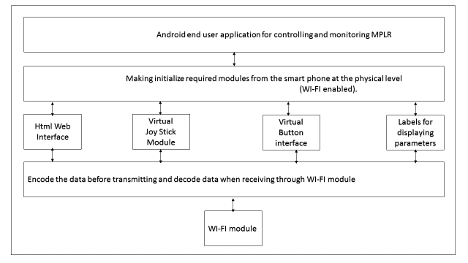
Fig.2 Block Diagram of Transmitter Section

Figure2.Block diagram of transmitter section, it is containing the mobile phone and an android app installed in it. This android application can interact with the so many virtual and physical modules of the mobile phone. The virtual modules covered under the android application are buttons to perform specific operations, labels for displaying the acknowledgements and data logger parameters, text boxes for giving input to the android application, check box for selecting the required components to be used, accelerometer for gesture control purpose, set of virtual joysticks are provided for robotic arm movement and finally WIFI interface. WI-FI interface is the heart of the system without it controlling and monitoring is not possible. Above stated all the components except Wi-Fi module remaining are purely virtual components (programmable).

- INTERFACING DETAILS

[A]Receiver Section

Table.1 interfacing of devices at rover end (node-mcu)
S.No | NODE-MCU Pin Number | Device
1. | TX | arduino | RX
1. | RX | arduino | TX
2. | 3 | MOTOR1_POSITIVE
2. | 4 | MOTOR1_NEGITIVE
3. | 5 | MOTOR2_POSITIVE
3. | 6 | MOTOR2_ NEGITIVE

Here the following table 1 gives the interfacing details at receiver section. Here the TX pin of the node-mcu module is connected to the Arduino board pin RX and similarly Rx pin of the node-mcu module is connected to the Arduino board pin TX. The Motor 1 Positive terminal connected to the node-mcu pin no 3 and Negative terminal connected to the node-mcu pin no 4. Motor 2 positive terminal is connected to the node-mcu pin no 5 and negative terminal connected to the node-mcu pin no 6.
Table.2 interfacing of devices at rover end (arduino)
S.No | Pin Number Of Arduino | Device
1. | 2 | Servo meter 1
2. | 3 | Servo meter2
3. | A0 | Temperature sensor
4. | A1 | Humidity sensor
5. | A2 | Light sensor
6. | A3 | Gas (CO2)sensor
7. | 12 | Ultrasonic sensor
8. | 6 | MOTOR3_POSITIVE
8. | 7 | MOTOR3_ NEGITIVE
9. | 9 | MOTOR4_POSITIVE
9. | 8 | MOTOR4_ NEGITIVE
10. | 10 | Camera  Motor(servo) | P
10. | 11 | Camera  Motor(servo) | N
11. | 2 | NIGHT LAMP
12. | RX | Node-mcu | Tx
12. | TX | Node-mcu | Rx

Here the following table 2.Gives the interfacing details at rover end. Here the TX pin of the node-mcu module is connected to the Arduino board RX pin and similarly Rx pin of the node mcu module is connected to the Arduino board TX pin.Node-mcu and Arduino nano are connected to perform serial communication. Here node mcu is mater.The Motor3 Positive is terminal connected to the Arduino nano pin no 6 and Negative terminal connected to the Arduino nano board pin no 7. Motor 4positive terminal is connected to the Arduino nano pin no 9 and negative terminal connected to the Arduino nano pin no 8.camera Motor positive terminal is connected to the Arduino nano pin no 10 and negative terminal connected to the Arduino nano pin no 11.The Power LED is used as the night lamp for supporting the camera during the night times. This is connected to the Arduino nano pin no 8.smoke Sensor output pin is connected to Arduino nano pin no 5.ultra sonic Sensor (trig pin) output pin is connected to Arduino nano pin no 12.Temperature Sensor LM35 is connected to analog input pin of the Arduino nano board A0.Humidity Sensor HD1 is connected to analog input pin of the Arduino nano board A1.LDR is connected to analog input pin of the Arduino nano board A3.MQ2(CO2) sensor is connected to analog input pin of the Arduino nano board A4.The servo Motor 1 output terminal is connected to the Arduino nano board pin no 5. The servo Motor 2 output terminal is connected to the Arduino nano board pin no 9.

- ADVANTAGES OF MPLROVER

[A]Detects the temperature variations in surroundings
It can detect the variations in the temperature around its surroundings.LM35 (a linear monolithic 3 pin IC) is used to acquire the surrounding temperature.

[B]Two dimensional camera rotation with 180 degrees in two axis.
This is the beauty of the robot ,the video camera which is fixed on the robot front side can rotate in two axis up to 0-180 degrees angle in both axis. Here servo motors are playing vital role in two dimensional camera rotation.

[C]Fully virtual control
Yes obviously it is fully virtual control including rover movement with virtual gestures (gesture control without physical presence of accelerometer), joystick control for robot movement is also pure virtual, because physical absence of the joystick. On screen data monitoring with settings is added another advantage.

[D]User-friendly
An android app specifically designed for this application is user friendly. With knowing commands and procedures we can control rover, it can give you the mobile gaming experience while operating the rover. All the things are possible with GUI based android application.

[E]Low development cost
Rover developed with the lower configuration processor (NODE MCU is WI-FI controlled Micro Controller Unit) results lower development cost. Processor cost around Rs350/- in Indian currency.

[F]As a multipurpose rover
This rover can be used for more than one purpose.
In military applications
In mine exploration
In weather forecasting centers.
In forests
In home
In archeology
In defense

[G]Independent and interrupt free video streaming
This rover can provide video visuals of surrounding areas up to limited distance (150 mts).but video broadcasting mechanism does not deal with any other operation and it did not depend on any other module or operation hence it is independent. So there will be no interrupt in video streaming.

[H]Transmitter is JAP
Transmitter is nothing but JUST AN APPLICATION. As mentioned above entire transmitter is a specially designed android application is running on android mobile phone (android 4.4 or above and Wi-Fi enabled).with android application we can perform all the functions of rover including connection establishment and connection de-establishment. Controlling rover and robotic ARM and monitoring status of the robot, data logger parameters can be done with this application.

- ANDROID APPLICATION

[A]Automatic Connection with the Android App.
From the fig 3 it shows the window after the android app is opened.it is showing the ip field for the entry of ip number of the MPL Rover. And “connect” button is provided for connection establishment.

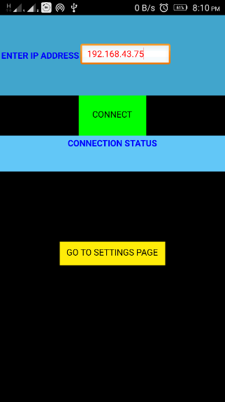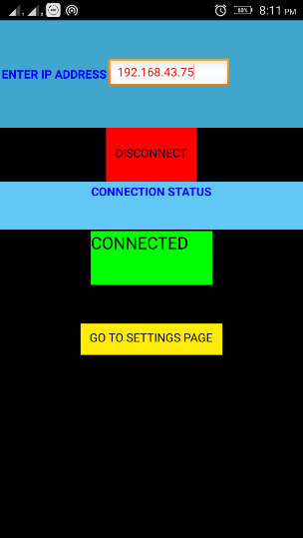
Fig 3 Connection Status of the MPL Rover

After entering the IP address which is “192.168.43.75” is IP address of the MPL Rover and by clicking the “connect” button, if it is successfully connected it will look like the screen below in fig 3b.“Connected” Field In The Screen Will Be In Green In Colour And The Connect Button Turns Into Disconnect And Will Be Red In Colour As Shown In Fig 3b Above. After Successfully Connected and Click On the Go to Settings Button to Enter Into the Main Settings Menu from the Settings Menu We Can Select Various Modes and Operations the Settings Menu Will Be Like As Shown In the Fig 3b.

[B] JOYSTICK MODE
From the fig 5 it shows JOYSTICK MODE, by clicking on the CONTROL button it will enter into the JOYSTICK MODE .and the resultant screen will be like below in fig 4.

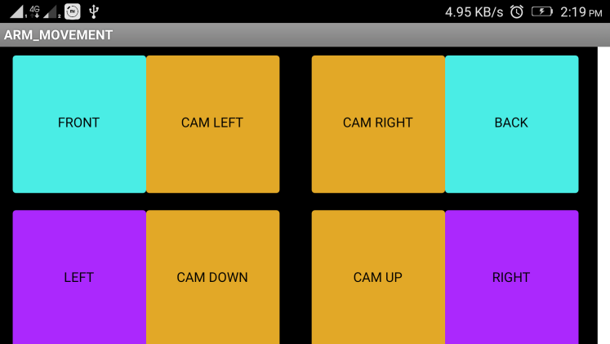
Fig 4joy Stick Mode

From the fig 4 it shows JOYSTICK MODE, by simply tilting the screen of the smart phone on this mode, we can control the robot movement like front, back, left and right in the tilt of corresponding directions. And the corresponding status will be displaying on the white label.

- PROTOTYPE OF MPL ROVER WITH NIGHT VISION SUPPORT
Figure 5.shows the glowing WHITE LED light mounted on front side to support the night vision.
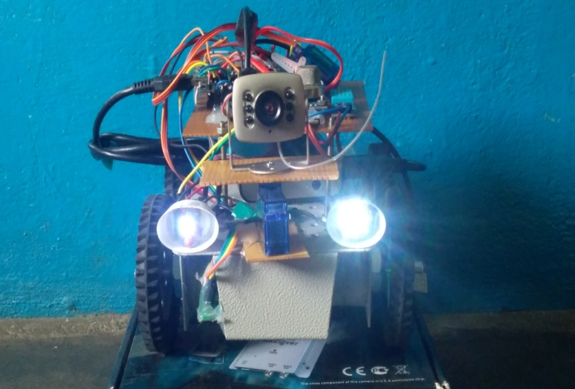
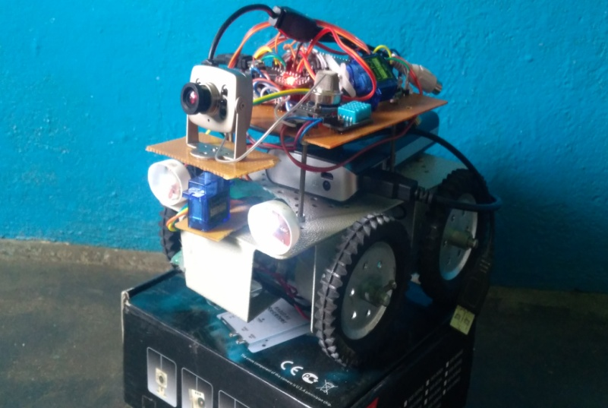
Figure 5. Snapshot of MPL Rover with Night Vision Mechanism

The main advancement in MPL Rover is camera steering mechanism. By using switches on control pad, we can send commands wirelessly to the MPL Rover. According to command received, the camera steering mechanism will rotates the camera to desired direction over 360 degrees coverage. So we can see around using RF camera without moving the Robot. The MPL Rover with Camera steering mechanism is shown in the figures 5.

- PARAMETER MONITOR

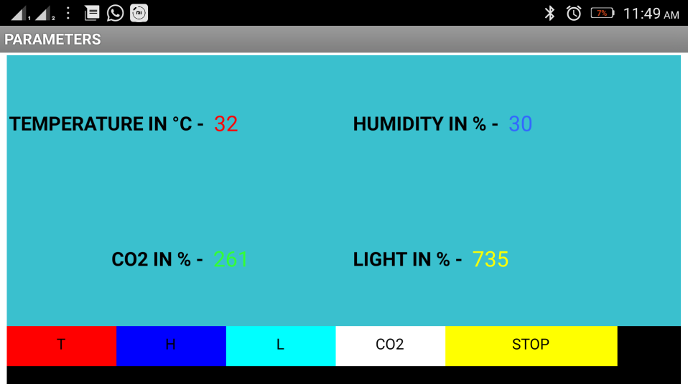
Figure 6.Snapshot of serial monitor

Here in fig6 .parameter monitor is used to monitor data about temperature, presence of landmine, dangerous gas leaks in the surroundings of the robot. The status of the robot: left, right, forward, backward and stop is also reported on to the parameter monitor. Moreover parameters of the surroundings: temperature, humidity in air, light intensity in percentage and co2 present in air can monitored using the parameters monitor window.

- APPLICATIONS

[A] For defusing Landmine.
In defence this robot can be used for land mine diffusion and extraction from the earth which is already arranged.

[B] In Mining.
This robot is used to monitor environmental conditions near mines and alerts the workers during fire accidents, temperatures which is not safe for humans.

[C] In Archaeology.
During excavations it can even enter in to the places where human cannot enter and reveals the hidden things. For inspecting the suspicious objects is possible with robotic arm and gathering the wanted objects is possible.

[D] In rescue operations.
It is difficult and time consuming to find the wound people under the building parts. It can find wound people under the debris very quickly to rescue wound people.

[E] As Remote Data Logger.
in weather forecast center this can be used as a remote data logger system.by driven this to a specific place we can monitor the environmental parameters like temperature detection,somke sensor for fire, finding the amount of humidity present in air)

[F] As Mine explorer.
Can be used as a mine explorer in mines.

[G] As A Spy Machine.
In some cases this rover can be used as a spy machine.

[H] As A Forest Guard.
In forests for locating the smugglers, naxalite, terrorists, animals. Identifying fire accidents is also possible.

[I] For Home Security.
Can be used in home for security purpose (including thefts, illegal entry of others).

- FUTURE SCOPE
MLP rover has a main advantages are flexibility and extendibility. As per our requirement we can extend the robot features .By adding additional sensors, communicating equipment in order to increase coverage area. In next five years, utility for unmanned robots in defense as well as in the commercial sector will grow. A modified MLP rover will be the reference for the upcoming human less vehicles.

- CONCLUSION
The MLP rover will effectively help in landmine diffusion, can be useful especially in the archaeology for inspecting suspicious objects, can be used as remote data logger, and can be rescue operation to save the people hidden under debris, as a forest guard. This robot is designed with multiple sensors: temperature, smoke sensor, humidity sensors for reliable data regarding environmental conditions. Fully controlled and monitored with dedicated android application. As our requirements we can vary Sensitivity of gesture control and joystick control. For effective utilization, MLP rover is equipped with battery backup system. We can use this robot with robotic arm for object picking, inspection of suspicious objects and diffusion of landmines.

- REFERENCES
- Fong, D.T.W et al., (WCICA 2004).” A Wireless Motion Sensing System Using ADXL MEMS Accelerometers for Sports Science Applications”.Proc.of the 5th World Congress on Intelligent Control and Automation (WCICA),2014, vol. 6, pp. 5635–5640.
- Lam, Lam et al. Motion Sensing system for Robot Hand using MIDS” Proceedings of the IEEE International Conf-erence on Robotics and Automation (ICRA), Taipei, 4-19 September 2003, pp. 3181–3186
- Nghia X, Tran et al.,”wireless data glove for gesture control” Space and Naval Warfare Systems Center, Pacific (SSC Pacific), San Diego, CA 92152-5001.
- http://www.analog.com/static/importedfiles/data_sheets/ADXL335.pdf
- http://arduino.cc/en/Reference/HomePage#.Ux2clqJP1kg
- http://users.ece.utexas.edu/~valvano/Datasheets /L293d.pf
- http://www1.electusdistribution.com.au/images_uploaded/optocoup.pdf
- http://www.pololu.com/file/0J309/MQ2.pdf
- http://www.ti.com/lit/ds/symlink/lm35.pdf.

CITE AN ARTICLE
It will get done by IJESRT Team

