IJESRT
International Journal of Engineering Sciences & Research Technology
INVESTIGATION OF CONTROLLED PLASMON RESONANCE FOR GOLD/HAFNIUM OXIDE NANOSHELL CONFIGURATION
A. SAMBOU^{1,*}, L. GOMIS², S. DIALLO², B. D. NGOM¹, Kh. TALLA¹, A. C. BEYE¹
¹Laboratoire de photonique et de Nano-Fabrication, Faculté des Sciences et Techniques Université Cheikh Anta Diop de Dakar (UCAD) B.P. 5005 Dakar-Fann Dakar, Sénégal
²Laboratoire de Physique des Plasmas et de Recherches Interdisciplinaires, Département de Physique, Université Cheikh Anta Diop de Dakar, BP 5005 Dakar-Fann, Dakar, Sénégal
DOI: 10.5281/zenodo.1241372

ABSTRACT
We report on the optical properties of gold/hafnium oxide core-shells configuration designed for biomedical application. The Surface Plasmon Resonance (SPR), have been investigated as function of the thickness of hafnium oxide and the core size. Drude model and Mie theory have been used to optimize the absorption as function of both the core size and the shell thickness. Making a comparison with our previous work on gold/silica core-shell configuration where the maximum absorption value was found at a wavelength of 530 nm, the maximum absorption was reached at a wavelength value of 610 nm for the gold/hafnium oxide core-shell. Our results show a high absorption value up to 71.27%, demonstrating that gold/hafnium core-shell nanoparticles could be a good candidate for biomedical applications.
KEYWORDS: Surface Plasmon Resonance, Gold nanoparticles, core-shell nanoparticles, hafnium oxide, optical windows
- INTRODUCTION
Progress in nanomaterials research for medical applications offers has opened the way for intense research into nanoparticles synthesis and engineering specifically metal nanoparticles in opening new ways towards better treatment of the tumor cells.
Nanoparticles have diameter approximately around 100 nm. When an energy source such as a laser producing non ionizing electromagnetic radiation is applied, conversion to heat energy occurs in metal nanoparticles owing to electron excitation and relaxation. Furthermore, laser can be specifically tuned using the surface plasmon resonance frequency of nanoparticles, which varies depending on the size, shape and composition of the nanoparticles [1, 2].
The optical properties of metals such as gold, silver and copper nanoparticles originate from localized surface plasmons. These phenomena occur when electromagnetic field interacts with conduction band electrons and induces the coherent oscillation of electrons. By definition, surface plasmons are collective excitations of the electrons at the interface between a conductor and an insulator and are described by evanescent electromagnetic waves that are not necessarily located at the interface. Surface Plasmons appear in a number of different phenomena, including the optical response of materials at different scales [2].
Most research has been focused on gold nanoparticles due their unique optical properties. These properties are conferred by the interaction of the light with electrons on the gold nanoparticle surface. Advantages of the noble metal nanoparticles, gold specially are not degraded under laser irradiation and allow also an important reduction laser power thanks to their high absorption cross section [3]. Another advantage of gold nanoparticles is that they are non-cytotoxic and the last most important benefit is regarding their surfaces, as they have large surface area due to which their surfaces are readily available for modification with targeting molecules or specific biomarkers and applicable in biomedical purpose [4].
Gold nanoparticles represent excellent biocompatibility and display unique structure, electronic [5, 6], catalytic [7], magnetic [8], optical [9] properties which have made them a very attractive material for numerous applications in nanomedicine and others fields such biosensor and chemosensory [1, 10, 11].
The ideal gold nanostructures are those displaying surface plasmon resonance bands in near infrared region (NIR) (i.e. from 650 nm to 950 nm). Because, near infrared light at the wavelengths ranging from 650 nm and 900 nm travels deep though tissues because hemoglobin and water exhibit relatively low light absorption in this region [12]. Tenability of the plasmon resonance wavelength in near infrared region is very important for applications in biology, because the light has highest transmission in human tissue in the near infrared region [13, 14].
Gold nanospheres are presented as strongly absorbing in visible spectrum, called the plasmon band or surface plasmon resonance (SPR). Gold nanospheres resonances are located about of 517 nm [15, 16]. N. G. Khlebtsov and al [17], have published in 2010, than gold nanospheres in water with a radius in the range of 5 nm < R < 20 nm, their plasmon resonance is observed at 520 nm. The resonance frequencies as well as the width of the plasmon absorption band depend on the nanoparticles size, surrounding medium and shape and many theories have been developed for to explain the observed behavior; for example Mie’s theory [1,18] for spherical particles and Gans’s theory [19] for to prolate and oblate spheroidal particles averaged over all orientations. Surface plasmon resonance peaks (moving from visible to near infrared region) is used for the designing and fabrication of nanoshells [20].
In order to optimize the nanoshells particles (core/shell) properties, we have used in this work hafnium oxide (HfO₂) nanoparticles. This material possesses appealing physical attributes for local cancer therapy and it is chemically inert in cellular and subcellular systems [21, 22]. Due to its electron density, crystalline hafnium oxide nanoparticles offer the possibility to deposit high amounts of energy within the cancer cells when activated by ionizing radiation [23].
Therefore we investigate the optical properties of gold particle as a core and nanoshell particles of thin film of hafnium oxide. Using the Mie theory and Drude model, the optical cross sections (absorption, scattering and extinction) of gold nanospheres, gold nanoshell (core/shell) at different size of core and shell thickness, are numerically performed using the Matlab software.
- MATERIALS AND METHODS
According to [24] and [25], the expression of the absorption (σ_{abs}) and scattering (σ_{sca}) as function of the polarizability defined by equation (1), are given by equations (2) and (3), respectively.
₍₁₎
Where ε_{o}=8.85 x10⁻¹² F/m is the permittivity of vacuum, ε_{m} is called the dielectric constant of the surrounding medium (ε_{m}=n²) with n is refraction index.

Core
Shell
$$ε_{a}$$
$$ε_{b}$$
$$ε_{m}$$
$$R_{1}$$
$$R_{2}$$
d

Figure 1: Spherical core/shell nanoparticle.
The dielectric function of core and shell are $ε_{a}=a+ib$ and $ε_{b}=c+if$and R₁ and R₂ are radius of core and shell, respectively.
We have the following expressions for the absorption and scattering cross sections.
₍₂₎
₍₃₎
where k depend of wavelength of the incident light noted λ and ε_{m} and given by the following expression.
₍₄₎
The extinction cross section can be calculated as the sum of the absorption and scattering cross sections as defined in the references [15, 25].
₍₅₎

The calculations of the extinction cross sections were performed using equation (5). In this study, we have also used the experimental data taken from DL Wood [26] for hafnium oxide in our simulation. In the Drude model, optical parameters of gold and procedure used are much detailed in our previous work published [27].

- RESULTS AND DISCUSSION

In this numerical aspect, optical properties were measured in the wavelengths region from visible to the near infrared region (300-1200 nm). These results are compared to the results gold coated with silica worked in article [27].
III.1. Reflectance, Transmittance and Absorption of gold nanoparticle film
The reflectance [R], transmittance [T] and absorption [A] characteristic of the gold nanoparticles film deposited on glace substrates were investigated using Matlab Software. The spectra of gold nanospheres film simulated with different radius, R=20 nm, R=30 nm and R=50 nm are presented in figure 2. We have deposed gold nanoparticles on substrate and are exposed to the air as considered to be the surrounding medium. We are investigating size effects on the optical properties: reflectance, transmittance and absorption. The model used to calculate the optical properties of the gold nanoparticles films is described in [28]. Theoretical analysis has shown that the reflectance, transmittance and absorption curves are sensitive to the size of the gold nanoparticle as illustrated in figure 2. From the simulation results at different radius, one can determine the absorption, reflectance and transmittance percentage.
It can be clearly seen from figure 2.c that high absorption in the visible range is obtained. The results give about 62.44%, 66.50% and 71.27% for 20, 30 and 50 nm radius. These results indicate that the intensity of the peaks (percentage) increases with the gold nanosphere radius. The data show two characteristics: strong at visible rang (400 to 500 nm) and weak in neighborhood of the infrared rang (550 to 800 nm). From figure 2.b, we can also see that the intensity of the peaks decrease with an increase of the gold radius. According to this figure, we have 24.99%, 11.0% and 1.79% for 20, 30 and 50 nm for gold radius values respectively.
Whereas reflectance (figure 2.a) spectrum signals show a weak percentage in the visible region around 30% and a very strong percentage in the infrared rang around 97%. The present results also proved that gold nanospheres films exhibit strong absorption percentage to the visible region depending on the particles size.

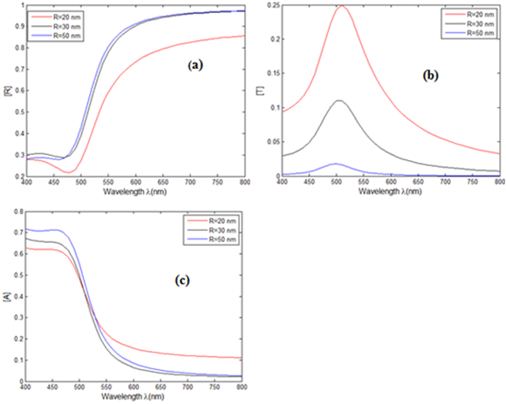
Figure 2: The optical properties of a gold nanosphere film as a function of radius: (a) reflectance [R], (b) transmittance [T] and (c) absorption [A].
III.2. Gold nanospheres
The optical proprieties of gold nanospheres are highly relative on the nanospheres size. The absorption, scattering and extinction cross section of gold nanopheres with the radius of 15 nm, 35 nm, 45 nm and 50 nm are displayed in the figure 3. All spectra have a pick resonance in the visible, caused by the oscillation of the nanosphere electrons on the surface. Peaks positions are near 515 nm to 530 nm, and this position is characteristic the formation of gold nanosphere particles.

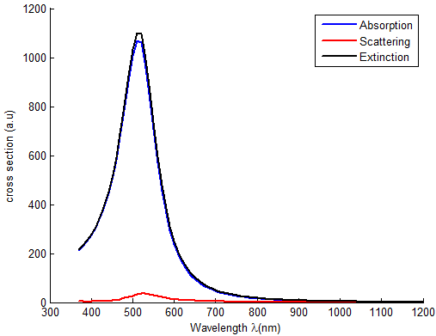
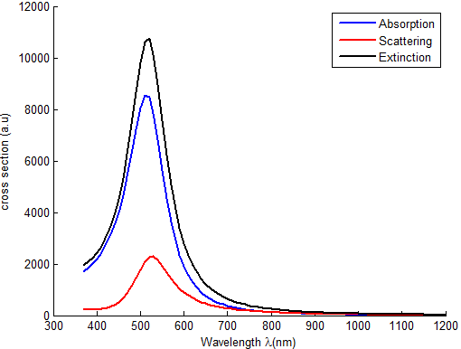
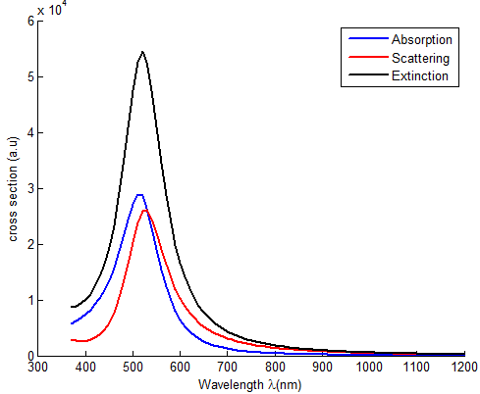
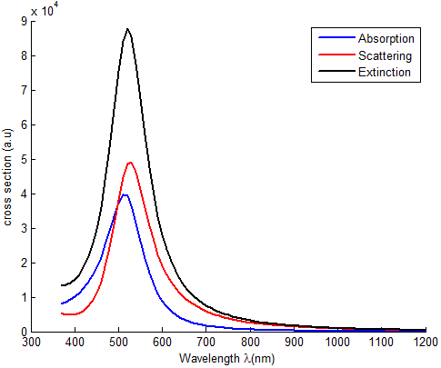
R=15 nm
R=30 nm
R=45 nm
R=50 nm
(a)
(b)
(c)
(d)

Figure 3: Cross section for gold nanospheres at varying radius and immersed in water (n=1.333).
Figure 3 illustrates the dependence of band intensity function of the size nanospheres. We can see that the ratio (intensity) of the extinction cross-section to absorption is the same for a radius nanosphere of 15 nm. We note that for small particles, the extinction is attributed to absorption (fig.3.a) and for large particles absorption intensity decreases while scattering increases.
As a consequence, small gold nanoparticles (with radius less than 15 nm) exhibit extinction that is primarily due to absorption. Larger particles tend to exhibit much stronger scattering. On the other hand, the calculated show that scattering are flitted more than absorption. From the results obtained with a radius of 30 nm, the resonance wavelength is 520 nm for absorption band while it is 530 nm for scattering band.
III.3. Hafnium oxide coating on gold nanosphere
The calculated absorption cross-section of gold/hafnium oxide nanoshell film as function of the shell thickness is reported in figure 4. The ratio corresponding to reach absorption maximum as function of core radius is reported in table 1. Shell thickness was varried from 0 nm to 100 nm and the core size is 30 nm of radius and particle is immerged in water with refraction index of 1.333. In our study, the purpose is the determination of the maximum of absorption.
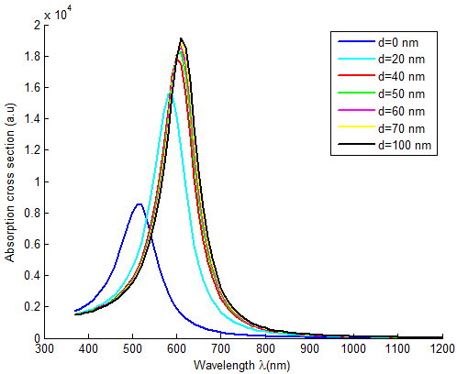
Figure 4: Absorption cross section for Au/HfO₂ core/shell.
Table 1: Ratio core/shell for to reach maximum absorption a surrounding medium function.

Au/HfO₂
Refraction index, n=1.333 | SPR_{max} (nm) | Refraction index, n=1.359 | SPR_{max} (nm)
5/8 | 610 | 5/8 | 610
10/16 | 610 | 10/15 | 610
20/32 | 610 | 20/30 | 610
30/46 | 610 | 30/45 | 610
40/61 | 610 | 40/60 | 610
50/77 | 610 | 50/75 | 610
The plot clearly indicates the resonance behavior of the absorption cross section with the maximum located in the visible region of the spectrum. From the simulation results shown in figure 4, it can be seen that the surface plasmon resonance shifts progressively toward the longer wavelength with increasing shell thickness.
For gold nanoparticles only (blue curve), the spectrum exhibits a maximum of absorption at 515 nm with less intense peaks than those of nanoshell particles. From 1.5 to 0.3 of the ratio nanoshells Au/HfO₂ (radius of core/shell thickness), the spectra exhibit a single maximum of absorption in the visible region. The corresponding wavelengths λ_{max} of the six nanoshells presented in figure 4 are 585 nm (d=20 nm), 600 nm (d=40 nm), 610 nm (d=50 nm), 610 nm (d=60 nm), 610 nm (d=70 nm) and 610 nm (d=100 nm). These results indicate that the resonance value becomes constant when thickness of shell is superior or equal to 50 nm. Study reveals that, after addition of hafnium oxide on, the nanoshell reaches maximum at 610 nm. We obtain 95 nm of displacement (i.e. the absorption cross section peak red shifted from 515 nm to 610 nm).
In order to investigate the optical properties of the core-shell nanoparticles, we have used six particles with different core radius, which varies from 5 nm to 50 nm. The present calculated absorption values of Au/HfO₂ nanoparticles dispersed in water (n=1.333) and in ethanol (n=1.359) are reported in table 1.
Interesting remark was obtained in the present theoretical work, as shown in figure 4 and illustrated in table 1. These results reveal that the maximum of absorption is reached at λ_{max}≈610 nm when the ratio Au/HfO₂ is approximately equaled at 0.66 ± 0.04 for the both medium. These results have shown also that the shell becomes large with an increase of the core size. But also, we remark a relatively decreasing of shell thickness when the refractive index increases.

III.4. Gold coating on hafnium oxide nanospheres
It is important in this step to notice that gold nanoparticles are been deposited on hafnium oxide nanospheres. Equation (2) is basic equation in the calculation of the resonance plasmon response function. The computed data of the resonance plasmon response function are shown in figure 5. Hafnium oxide nanoparticles are coated with various thicknesses of gold nanoparticles. To investigate the effect of the nanoshell size, a series of materials were optimized. Here, it appears that the core radius varies between 10 nm and 40 nm. It is also evident from figure 5 that thickness of gold nanoparticles layer was estimated to be 4 nm, 7 nm, 10 nm, 14 nm and 20 nm. All particles are immerged in water. Before coated, it is important to notice that hafnium oxide nanoparticles do not show any absorption peak from the visible region to the infrared one.
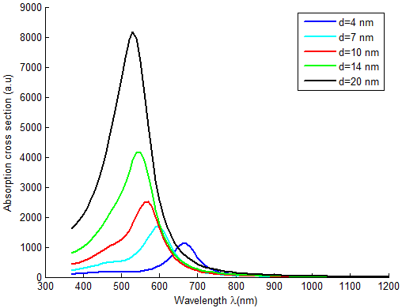
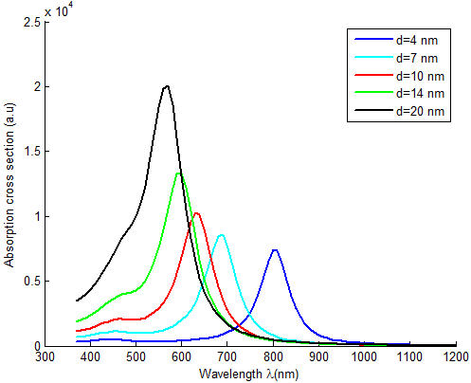
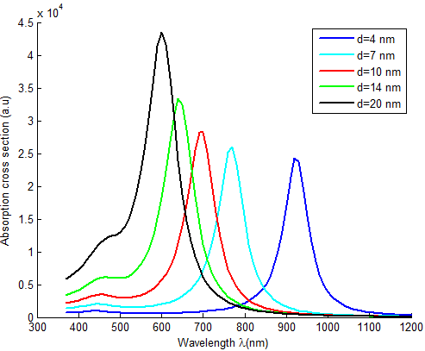
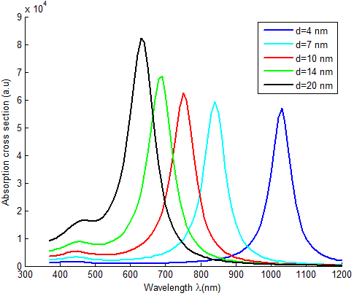


(a) R=10 nm
(b) R=20 nm
(c) R=30 nm
(d) R=40 nm
Increasing
Core/Shell Ratio
Increasing
Core/Shell Ratio
Increasing
Core/Shell Ratio
Increasing
Core/Shell Ratio

Figure 5: Absorption cross section for HfO₂/Au core/shell with a radius core increasing from 10 nm to 40 nm.
These figures indicate that, the peak positions of the surface plasmon much depend on the core radius/shell thickness ratio. We can observe an evolution of plasmon resonance band from the visible region to the near infrared region by decreasing of layer of shell. For example in figure 5 (c), the radius R is considered to be 30 nm and shell thickness takes the values 4, 7, 10, 14 and 20 nm. Consequently, the nanoshells ratios (radius of core/shell thickness) are about £=7.50, £=4.28, £=3.00, £=2.14 and £=1.50, respectively. And the corresponding peaks of these ratios are respectively observed at 920 nm, 770 nm, 695 nm, 640 nm and 600 nm.
We can conclude that the optical absorption spectrum shifts toward near infrared region with the increasing ratio. It is immediately clear from the figure 5 that the decreasing of ratio (i.e. increasing of shell thickness of gold) leads to the increasing intensity of the spectra band.
Figure 6 depicts the variation of the absorption cross section spectra in HfO₂/Au core/shell nanosphere as a function of both core radius and wavelength at fixed value of the shell thickness (d=7 nm). Here these particles are emerged in surrounding medium which was assumed to be constant and same as for water (i.e. H₂O, n=1.333). As seen from figure 6, we remark that the position of the maxima of the surface plasmon resonance band are shifted forward to large values of wavelength as core radius increases from 10 nm through 40 nm.
We note that here the surface plasmon resonance band increase in intensity for core radius R=10 nm and moves forward to R=40 nm.
These results demonstrate that the particles with the large core have interesting optical proprieties. It is well known through that the plasmon resonance is very sensitive to variation of the core size. We must take this great potential into consideration especially in medicine application. This result indicates that the best fits appear with the big core size. Our Theoretical study using 7 nm of shell thickness HfO₂/Au gives the resonant wavelength at 600 nm with a 10 nm radius. These resonant wavelengths are shifted at 690 nm, 770 nm and at 840 nm for 20 nm, 30 nm and 40 nm for radii values respectively.
In order to pull in this study a clear conclusion and to determine the effect of the nanoshell size on the optical properties, a series of simulation were performed for different radius with various shell thickness of gold (d=4 nm, 7 nm, 10 nm, 14 nm, 20 nm, 30 nm, 40 nm, 50 nm, 60 nm, 70 nm, 80 nm, 90 nm and 100 nm) and are dispersed in water (n=1.333) and in ethanol (n=1.359). The resonant wavelength of different nanoshell HfO₂/Au particles is summarized in table 2.
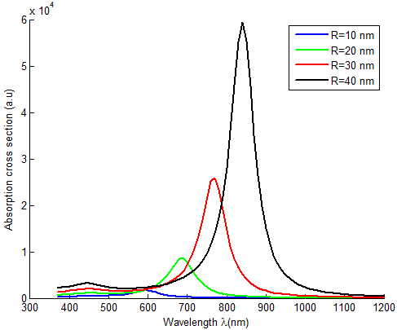
Figure 6: Absorption cross section for HfO₂/Au with different radius of core for shell thickness equal at 7 nm.
Table 2: Positioning of the resonance band according with the surrounding environment, shell thickness and core size.
Gold thickness(nm) | Resonant Wavelength (nm)
Gold thickness(nm) | Nanoshell: HfO₂/Au
Gold thickness(nm) | R=10 nm |  | R=20 nm |  | R=30 nm |  | R=40 nm
Gold thickness(nm) | n=1.333 | n=1.359 | n=1.333 | n=1.359 | n=1.333 | n=1.359 | n=1.333 | n=1.359
4 | 665 | 670 | 800 | 810 | 920 | 930 | 1030 | 1040
7 | 600 | 600 | 690 | 690 | 770 | 770 | 840 | 850
10 | 570 | 570 | 630 | 640 | 695 | 700 | 750 | 760
14 | 555 | 550 | 600 | 600 | 640 | 650 | 690 | 690
20 | 530 | 530 | 570 | 570 | 600 | 600 | 630 | 640
30 | 520 | 520 | 540 | 545 | 570 | 570 | 590 | 590
40 | 520 | 520 | 530 | 530 | 550 | 550 | 570 | 570
50 | 515 | 520 | 525 | 530 | 540 | 540 | 550 | 555
60 | 515 | 520 | 520 | 520 | 530 | 530 | 540 | 545
70 | 515 | 520 | 520 | 520 | 530 | 530 | 535 | 540
80 | 515 | 520 | 520 | 520 | 520 | 530 | 530 | 535
90 | 515 | 520 | 520 | 520 | 520 | 520 | 530 | 530
100 | 515 | 520 | 520 | 520 | 520 | 520 | 525 | 530
Important information can be pulling in the table 2. This table confirms that the peak values of the HfO₂/Au core/shell with a large core are larger than nanoshell with small core. The peak values increase with increasing core dielectric materiel. The resonance optical properties of HfO₂/Au nanoshell can be tuned in both the visible and near infrared by changing the size of core. Table 2 also reveals that the resonance variation become small with an increase of gold thickness for each two size core. For the radii values 10 nm and 20 nm, size dependent effects were clearly exposed with a plasmon band variation of 135 nm, 90 nm and of 60 nm for 4 nm, 7 nm and 10 nm for thicknesses values respectively. It should be noted that with the growth of shell thickness, the variation of the Plasmon resonance between two particles decreases.
The quantitative analysis of the optical spectra of various nanoshells of gold nanoparticles, compared to Au/SiO₂ nanoshell reveals that the present surface Plasmon resonance of the HfO₂/Au is localized at λ_{max}=610 nm whereas surface Plasmon resonance of Au/SiO₂ appears at λ_{max}=530 nm [27]. With the main aim to optimize the materials in near infrared region, the absorption characteristics of the HfO₂ deposited on gold nanosphere has the advantage because they shift to slightly longer wavelength. This can be explained by the difference of the dielectric constant between SiO₂ and HfO₂ (about 3.9 and 25, respectively) [29].
- CONCLUSION
We present in this work a complete study of the evolution of the optical proprieties as reflectance, transmittance and absorption. We have studied also Surface Plasmon Resonance of gold nanoparticles as function of the size and composition effect. This study also led to the determination of the conditions under which one of the absorption or scattering phenomena, as a function of size dominates the other. For the small particles, the diffusion is negligible in comparison with absorption cross section. Gold particles show a very important absorption in visible range and coated with hafnium oxide material are exhibit on Surface Plasmon Resonance toward near infrared which makes them good candidates for optical windows. Given the high tenability of gold nanoshell resonance from the visible to the infrared regime, hafnium oxide coupled gold nanoparticles are expected to expand their applications from biomedical field. The direct dependence of size, thickness and composition on Surface Plasmon Resonance values was demonstrated.

REFERENCES
- A. Moores and F. Goettmann, “The plasmon band in noble metal nanoparticles: an introduction to theory and application,” New J. Chem., 2006, pp. 1121-1132.
- C. Noguez, “Surface Plasmons on Metal Nanoparticles: The influence of Shape and Physical Environment,” J. Phys. Chem. C, 111, 2007, pp. 3806-3819.
- P. Chekuri, E. S. Glazer, S. A. Curley, “Targeted Hyperthermia Using Metal Nanoparticles,”Advanced Drug Delivery Review, 62, 2010, pp. 339-345.
- Z. Yu Juan, H. Rao, Z. XianFang, W. LianZhou, W. ChenXu, “Synthesis, properties and optical applications of noble metal nanoparticle-biomolecule conjugates,” Chinese Science Bulletin, 57, 2012, pp. 238-246.
- M. Lopes, “Etude de nanoantennes optiques : Application aux diffusions Raman exaltées de surface et par pointe,” Thèse Université de Technologie de Troyers, 2008, p. 170.
- M. Ganeshkumar, T P Sastry, M. K. Sathish, MG Dinesh, S. Kannappan, L. Suguna, “Sun light mediated synthesis of gold nanoparticles as carrier for 6-mercaptopurine: preparation, characterization and toxicity studies in zebrafish embryo model,” Mater Res Bull, 47, 2012, pp. 2113-2119.
- S. Tedesco, H. Doyle, J. Blasco, G. Redmond, D. Sheehan, “Oxidative stress and toxicity of gold nanoparticles in Mytilus edulis,” Aquatic Toxicol, 100, 2010, pp. 178-186.
- P. P. Edward and J.M. Thomas, “Gold in a Metallic Divided State-from Faraday to Present-Day Nanoscience,” Angew. Chem. Int. Ed, 46, 2007, pp. 5480.
- Y. B. Zheng, B. K. Juluri, X. Mao, T. R. Walker and T. J. Huang, “Systematic investigation of localized surface plasmon resonance of long-range ordered Au nanodisk arrays,” J. Appl. Phys. 103, 2008, pp. 014308-014318.
- A. Sanchez-Iglesias, I. Pastoriza Santos, J. Perez Juste, B. Rodriguez-Gonzalez, F. Javier Garcia de Abajo and L. M. Liz-Marzan,“Synthesis and Optical Properties of Gold Nanodecahedra with Size Control,” Adv. Mater., 18, 2006, pp. 2529-2534.
- P. C. Chen, S. C. Mwakwari and A. K. Oyelere, “Gold nanoparticles: From nanomedicine to nonosensing,” Nanotechnology, Science and Applications, 1, 2008, pp. 45-66.
- G. Strangman, D A Boas, J P Sutton, “Non-invasive neuroimaging using near-infrared light,” Biol Psychiat, 52, 2002, pp. 679-693.
- X. Huang, I. H. El-Sayed, W. Qian, M. A. El-Sayed, “Cancer cell imaging and photothermal therapy in the near-infrared region by using gold nanorods,” J. Am. Chem. Soc. 128, 2006, pp. 2115-2120.
- A. M. Gobin, M. H. Lee, N. J. Halas, W. D. James, R. A. Drezek, J. L. West, “Near-infrared Resonant Nanoshells for Combined Optical Imaging and Photothemal CancerTherapy,” Nano Lett. 7, 2007, pp. 1929-1934.
- A. Akbarzadeh, D. Zare, A. Farhangi, M. R. Mehrabi, D. Norouzian, “Synthesis and Characterization of Gold Nanoparticles by Tryptophane,” American Journal of Applied Sciences, 6, 2009, pp. 691-695.
- C. Wu, C. Yu and M. Chu, “A gold nonoshell with a silica inner shell synthesized using liposome templates for doxorubicin loading and near-infrared photothermal therapy,” International Journal of Nanomedicine, 6, 2011, pp. 807-813.
- N. G. Khlebtsov, L. A. Dykman, “Optical properties and biomedical applications of plasmonic nanoparticles,” Journal of Quantitative Spectroscopy & Radiative Transfer, 111, 2010, pp. 1-35.
- H. Horvath, “Gustav Mie and the scattering and absorption of light by particles: Historic developments and basics,” Journal of Quantitative Spectroscopy & Radiative Transfer, 110, 2009, pp. 787-799.
- M. Hu, J. Chen, Z. Y. Li, L. Au, G. V. Hartland, X. Li, M. Marquez and Y. Xia, “ Gold nanostructures: engineering their plasmonic properties for biomedical application,” Chem. Soc. Rev, 35, 2006, pp. 1084-1094.
- S. Kalele, S. W. Gosavi, J. Urban and S. K. Kulkarni, “Nanoshell particles: synthesis, properties and applications,” Current Science, 91, 2006, pp. 1038-1052.
- J. A. Field, A. L. Velasco, S. A. Boitano, F. Shadman, B. D. Ratner, C. Barnes, R. S. Alvarez, “Cytotoxicity and physicochemical properties of hafnium oxide nanoparticles,” Chemosphere, 85, 2011, pp. 1401-1407.
- C. Garcia-Saucedo, J. A. Field, L. Otero-Gonzalez, R. Sierra-Alvarez, “Low toxicity of HfO₂, SiO₂, Al₂O₃ and CeO₂ nanoparticles to the yeast, Saccharomyces cerevisiae,” Journal of Hazardous Materials, 192, 2011, pp. 1572-1579.
- J. Marill, N. M. Anesary, P. Zhang, S. Vivet, E. Borghi, L. Levy and A. Potier, Radiat Oncol, 9, 2014, pp. 9-150.
- G. Weng, J. Li, J. Zhu and J. Zhao, “Decreased resonance light scattering of citrate- stabilized gold nanoparticles by chemisorption of mercaptoacetic acid,” Colloids and Surfaces A: Physicochem. Eng. Aspects, 369, 2010, pp. 253-259.
- T. A. Erickson and J. W. Tunnell, “Gold Nanoshell in Biomedical Applications”.
- DL Wood, K. Nassau, Ty Kometani and DL Nash, “Optical properties of cubic hafnia stabilized with yttria,” Applied optic, 29, 1990, pp. 604-607.
- A. Sambou, B. D. Ngom, L. Gomis, A. C. Beye, “Turnability of the Plasmonic Response of the Gold Nanoparticles in Infrared Region,” American Journal of Nanomaterials, 4, 2016, pp. 63-69.
- V. A. Fedotov, V. I. Emel’yanov, K. F. MacDonald and N. I. Zheludev, “Optical properties of closely packed nanoparticle films: spheroids and nanoshells,” J. Opt. A: Pure Appl. Opt. 6, 2004, pp. 155-160.
- A. P. Huang, Z. C. Yang and P. K. Chu, “Hafnium-based High-k Gate Dielectrics,” Advances in Solid State Circuits Technologies, 2010, pp. 334-350.

