IJESRT
International Journal of Engineering Sciences & Research Technology
A REVIEW ARTICLE OF PV CELL BOOST CONVERTER EFFICIENCY ENHANCEMENT BY USING MULTILEVEL INVERTER
Bhawana Deshmukh¹ & Ritesh Diwan*²
¹Student of M.E. (Power Electronics)
^{*2} Associate Professor *(ET & T), M.E. (Power Electronics)

DOI: 10.5281/zenodo.1228613

ABSTRACT
The recent upsurge in the demand of PV systems is due to the fact that they produce electric power without hampering the environment by directly converting the solar radiation into electric power. However the solar radiation never remains constant. It keeps on varying throughout the day. The need of the hour is to deliver a constant voltage to the grid irrespective of the variation in multilevel inverter. We have designed a circuit such that it delivers constant and stepped up dc voltage to the load. We have studied the open loop characteristics of the PV array with variation in multilevel inverter levels. Then we coupled the PV array with the boost converter in such a way that with variation in load, the varying input current and voltage to the converter follows the open circuit characteristic of the PV array closely. At various isolation levels, the load is varied and the corresponding variation in the input voltage and current to the boost converter is noted. It is noted that the changing input voltage and current follows the open circuit characteristics of the PV array closely

KEYWORDS: Maximum power point tracking, Photovoltaic system, Buck boost converter, Perturb and Observe method, Direct current, Photovoltaic Panel.

- INTRODUCTION
The rapid increase in the demand for electricity and the recent change in the environmental conditions such as global warming led to a need for a new source of energy that is cheaper and sustainable with less carbon emissions. Solar energy has offered promising results in the quest of finding the solution to the problem. The harnessing of solar energy using PV modules comes with its own problems that arise from the change in insulation conditions. These changes in inasulation conditions severely affect the efficiency and output power of the PV modules [1-2].A great deal of research has been done to improve the efficiency of the PV modules. A number of methods of how to track the maximum power point of a PV module have been proposed to solve the problem of efficiency and products using these methods have been manufactured and are now commercially available for consumers [1-3]. Power electronic converters, especially DC/AC inverters have been extending their range of use in industrial application because they provide better system efficiency, reduced energy consumption and improved quality of power. The output voltage of inverter could be fixed or variable at a fixed or variable frequency and output waveform are therefore made up of discrete values, producing fast transition rather than smooth ones [2]. The ability to produce near sinusoidal waveform around the fundamental frequency is controlled by the modulation technique and using output filters. Common modulation technique includes pulse width modulation or the carrier-based technique, space-vector technique and the selective harmonic technique.

Multilevel voltage source inverter offer several advantages compared to their conventional counterparts. Cascaded H-bridge inverter provides Stepped AC voltage wave form with lesser harmonics at higher levels by combining different ranges of voltage DC sources and the filter components are reduced by increasing Step levels. By increasing the level of the inverter we can get several advantages: get a good voltage wave form, Very low THD, reduced volume and cost. The need of several sources on the DC side of the converter makes multilevel technology attractive for photovoltaic applications. This paper provides an overview of a multilevel inverter topology and investigates their suitability for single-phase photovoltaic systems. A simulation model is based on MATLAB/SIMULINK is developed. An experimental 40W prototype inverter was builted and tested. The results is experimentally validate for the proposed SPWM based three H-bridge 27 level cascaded multilevel inverter. The 27- level multilevel inverter for solar PV applications.
- CONCEPT OF MULTILEVEL INVERTER
Basic concept of multilevel inverter is differentiated from other regular inverter in a way that in multilevel inverter more than two steps are generated [4-5]. As the number of steps increases an almost sinusoidal waveform is obtained. The multilevel inverter operates at the fundamental switching frequency, which makes the multilevel inverter suitable for high power applications. Multilevel converters (MLC) commonly operate as inverters [6]. The term ‘level’ refers to the number of voltage steps (L) produced by an MLI in one-quarter of a cycle (between zero and ninety degrees of an electric cycle). Typically the number of levels in a cascaded MLI is computed by L = (2n+1), where ‘n’ is the number of DC sources. An MLI produces a staircase waveform from a single or multiple DC sources based on its topology. The switching frequency in a multilevel inverter is equal to the fundamental frequency (50 or 60 Hz). Hence, the loss due to frequency of switching is less. The switching losses in a solid-state device are proportional to the switching frequency and the number of switches in the system. The multilevel inverters have some disadvantages. One particular disadvantage is the great number of power switches needed. Although low voltage rating power switches can be utilized in a multilevel inverter, each switch requires a related gate driver circuits [6-7].

Inverters in some application area should be able to handle high voltage and large power. For this cause, two-level high-voltage and large power inverters have been planned with serial joined of switching power devices such as GTOs, IGCTs and IGBTs, because the series connection allows reaching abundant higher voltages. However, the sequence links of switching power devices has large trouble. As alternatives to effectively solve the preceding issues, many circuit typologies of multilevel inverter are researched and utilized. The output voltage of the MLI has many levels synthesize by several DC voltage sources. The standard of the output voltage is enhanced as the numeral of voltage levels increase, so the quality of output filter can be decreased.

An alternative topology, called Flying Capacitor Inverters, which basically replace the clamping diodes by flying capacitors, was proposed by Maynard and Foch in 1992. It naturally creates a degree of freedom to balance flying capacitor by using redundant states where the same output voltage level can be achieved by two or more switching combinations. However, the flying capacitors are submitted to different voltage levels similar to the blocking requirements of the clamping diodes. Hence, extra units must be required in series to divide equally the voltage stress across each capacitor.

- LITERATURE REVIWE AND ISSUES OF OLD ARTICLES
D. S. CHAUDHARI [1]: The solar photovoltaic is considered to be the one of the most promising energy source in many applications, due to its safety and high reliability. Residential that uses solar power as their alternative power supply will bring benefits to them. In order to increases the efficiency of system during rapid changing environmental conditions; system will adapt some Maximum Power Point Tracking (MPPT) methods. This paper presents a review on various MPPT methods for variable environmental conditions (i.e. variable temperature and irradiation level), their difficulty while tracking and how those difficulties can be overcome efficiently by the other techniques. Apart from all the methods, an open circuit and slope detection tracking technique is found to be an efficient technique with respect to tracking speed and accuracy.

PAWAN D. KALE [2]: These modern days that consume a lot of energy e.g. fuel-oil, gas, coal etc. that will deplete in its source one day so, much of the focus have been given on the topic of renewable energy. Renewable energies are energy that can be renewed or have no worries of depletion. For instance wind, thermal, bio-mass and solar energy are some of the examples for renewable energy [1]. Solar energy is one of the main renewable energy sources that are widely used in power generating application. Solar energy is an unlimited resource available in nature and set to become important in longer terms for providing heat energy and electricity to the user. This kind of energy resources does not create much pollution as the conventional power sources moreover it has the potential to be the major energy supply in future [1], [8].

GHISLAIN REMY [3]: This paper presents a review of maximum power point tracking (MPPT) techniques for photovoltaic systems (PV). After a brief introduction of the key factors for the power extraction of photovoltaic panel, a review of the commonly used MPPT techniques is presented and detailed with an overall approach. Then, a comparison of the main industrialized ones is discussed for a photovoltaic system. In the last part, the pros and cons of each of the considered MPPT techniques are presented.

MOHAMED AZAB [4]: In this paper a new maximum power point tracking algorithm for photovoltaic arrays is proposed. The algorithm detects the maximum power point of the PV. The computed maximum power is used as a reference value (set point) of the control system. ON/OFF power controller with hysteresis band is used to control the operation of a Buck chopper such that the PV module always operates at its maximum power computed from the MPPT algorithm. The major difference between the proposed algorithm and other techniques is that the proposed algorithm is used to control directly the power drawn from the PV. The proposed MPPT has several advantages: simplicity, high convergence speed, and independent on PV array characteristics.
M.S.SIVAGAMASUNDARI [5]: Energy especially alternative source of energy is vital for the development of a country. In future, the world anticipates developing more of its solar resource potential as an alternative energy source to overcome the persistent shortages and unreliability of power supply. In order to maximize the power output the system components of the photovoltaic system should be optimized.

SOLAR CELL MODELING
From the physical heavier and mechanism of a solar cell an equivalent electrical circuit is derived, worldwide two different circuits are accepted as equivalent electrical circuit of solar cell, the first one is a simplified model of a single solar cell that exhibits an approximate characteristic of a solar cell and second one having two diodes combination one for reflecting diffusion and other for carrier. The equivalent circuits are shown in figure.
A Photovoltaic cell is a device used to convert solar radiation directly into electricity signal. It consists of two or more thin layers of semiconducting material, and most commonly silicon. When the silicon is exposed to light, electrical charges are generated.

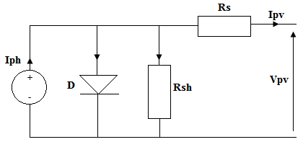
Fig: 3.12 Photovoltaic cell modelling as diode circuit

Fig: 1 Photovoltaic cell modelling as diode circuit.

The current sourcerepresents the cell photocurrent. In usually the value of is very large and that of is very small signal, hence they may be neglected to simplify the analysis. The photovoltaic (PV) cells are grouped in larger units called PV modules which are further interconnected in a parallel-series configuration to form PV arrays.
Modeling photo-current
$Iph=\left[Iscr+KiI(T-298)×δ/{1000}\right]$ (4.1)
Module reverse saturation current – Irs
$Irs={Iscr}/{\left[\exp\left(\frac{qVac}{NskAT}\right)-1\right]}$ (4.2)
The module saturation current varies with the cell which is given by
$I0=Irs\left[\frac{T}{Tr}\right]∆3 exp\left[\frac{q×Eg0}{BK}\left\{\frac{1}{Tr}-\frac{1}{T}\right\}\right]$ (4.3)
$Ipv=Np×Iph-Np×I0\left[exp\left\{\frac{q×(Vpv+IpvRs}{NskAT}\right\}\right]-1$ (4.4)
Where,
Vpv = Voc, Np = 1 and Ns = 36

Impact of Solar Irradiation on I-V Characteristic of a Solar Panel

The Highest solar irradiance on the earth ground level is 1000 W/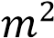. If the solar irradiance is decreases due to cloud, the earth movement or any other reason will reduce the output current of the solar panel because of the  is directly proportional to the sun irradiance while the variation on voltage is much smaller as shown in Figure 3.13.

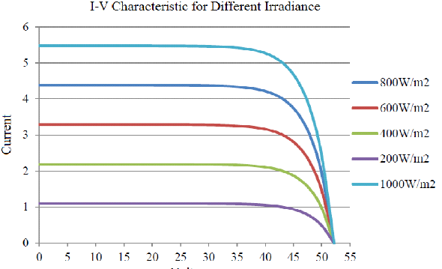
Fig: 2 Effect of radiation

Impact of Temperature on I-V Characteristic of a Solar Panel

Temperature affects the saturation current of solar cell and small effect on  so  has negative (-) temperature coefficient (for silicon –2.3mV/°C), figure 3.14 showing the I-V curve for different temperature variation.

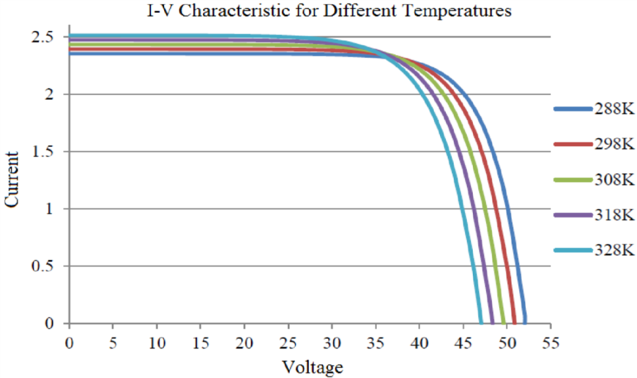
Fig: 3 I-V curve for Different Temperatures

- DIFFERENT TYPE METHODE OF BOOST CONVERTING SYSTEM

- MPPT Techniques
The motivation behind developing the various maximum power point tracking techniques was to increase the efficiency of the PV system at power stage i.e. an improvement in power efficiency. By considering this factor, different MPPT methods were proposed by the researchers. Each method is having their own features but some of them faces difficulties while tracking during rapidly change in the environmental condition. Maximum power point plays an important role in photovoltaic system because they maximize the power output from a PV system for a given set of conditions, and therefore maximize the array efficiency. There are different methods used to track the maximum power point are
  - Perturb and Observe method
  - Incremental Conductance method
  - Parasitic Capacitance method
  - Constant Voltage method

Among the different methods used to track the maximum power point, Perturb and Observe method is the most widely used method in PV MPPTs and is highly competitive against other MPPT methods.

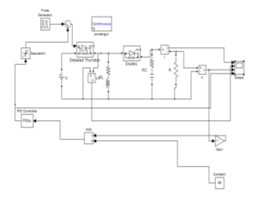
Fig: 4 MPPT technique

P&O method [3], [4], [9] is the most frequently used algorithm to track the maximum power due to its simple structure and fewer required parameters. This method finds the maximum power point of PV modules by means of iteratively perturbing, observing and comparing the power generated by the PV modules. It is widely applied to the maximum power point tracker of the photovoltaic system for its features of simplicity and convenience.

According to the structure of MPPT system shown in Fig. 1, the required parameters of the power-feedback type MPPT algorithms are only the voltage and current of PV modules. Shown in Fig. 2 is the relationship between the terminal voltage and output power generated by a PV module. It can be observed that regardless of the magnitude of sun irradiance and terminal voltage of PV modules, the maximum power point is obtained while the condition dP/dV= 0 is accomplished. The slope (dP/dV) of the power can be calculated by the consecutive output voltages and output currents, and can be expressed as follows,

- Boosting power of boost converter:
As photovoltaic cells are only able to produce more than 2V a cell, series and parallels are used in PV Array. But in order to reduce the losses in the energy transfer, it is better to boost the PV voltage using a DC-DC converter. Figure 1 shows a schematic of a classical Boost Converter, using the Power Systems Toolbox from the MATLAB software:

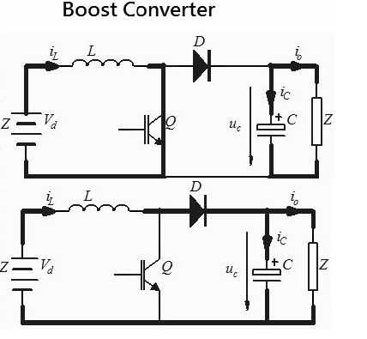
Fig:5 Power converter circuit.

The principle of the Constant Voltage (CV) Method is simple: the PV is supplied using a constant voltage. Temperature and Solar Irradiance impacts are neglected. The reference voltage is obtained from the MPP of the P(i) characteristic directly. Here, the MPP voltage is about 16.3V for the studied PV. Fig (4.2) shows the CV algorithm and the code of the Matlab embedded function.

The CV method requires the PV voltage measurement only. The Matlab embedded function is evaluated with a 1 kHz frequency. This Constant Voltage Method cannot be very effective regarding Solar Irradiance impact and certainly not regarding the temperature’s influence. Thus, some enhancements of the CV methods exist.

- The Open Voltage (OV) Method is based on the CV method, but it makes the assumption that the MPP voltage is always around 75% of the open-circuit voltage v_{OC}. So mainly, this technique takes into account the temperature. But it requests a special procedure to regularly disconnect the PV and to measure the open-circuit voltage. Besides, this technique can partially take into account the cell’s aging.
- The Temperatures Method is also an improvement of the OV Method: the open-circuit voltage is now considered to be related to the temperature by a linear function. Then, with a temperature sensor, the open-voltage measurement is no more necessary, because its value can be identified from the temperature value directly.

Short-Current Pulse (SC) Method:
The principle of the Short-Current Pulse (SC) Method is based on a simple relation: the MPP current is proportional to the Short-circuit current iSC, with some temperature and solar irradiance conditions. To simplify the Isc estimation, it is often considered as constant, even if the temperature varies between 0 and 60°C. The determination of the Short-circuit current iSCis in fact, done just before connecting the PV systems to the grid.
Fig.6 Simulink basic modeling.

In this paper, the simulation model is developed with MATLAB/SIMULINK. The simulation model of the proposed method .and the waveforms are shown in Fig (4.2). The proposed circuit needs independent dc source which is supplied from photovoltaic cell. The inputs are fed by voltage and current of the PV terminals, while the output provides duty cycle for the buck boost converter. The input voltage is 24V and the output voltage after being buck boosted up is 48.2V and shown in fig.6. Buck Boost converter controls the output voltage by varying the duty cycle k, of the switch and the value of k is 0.67 which is calculated using the formulae Vo = Vs*k / 1- k. If we vary the pulse width of the pulse generator various voltage ranges at the output can be obtained. Once the buck boost converter injected the power from the pv panel and the PID controller starts function, it varies the value of duty cycle which will change the input value that is sensed by the PID controller. By using the PID controller the error has been minimized in the system and the efficiency is improved. Below shows the output values for PV panel.

- PREVIOS RESULT AND SIMULATION
The PV cell temperature is maintained constant at 25 degree Celsius and the solar intensity is varied in steps up to the rated value of 1200W/meter square in Fig (5.1). That the current slightly increase with increasing intensity thereby increasing the power output of the solar cell.
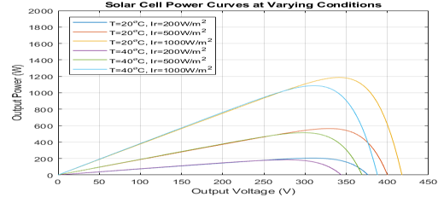
Fig 7 Output result Solar cell Power Curves.

- CONCLUSION
In the Present Work, the maximum power point tracking is successfully carried out by this research using perturb and observe method. The PV module working on photovoltaic effect actually improves the system efficiency. Compared to other methods of maximum power point tracking, the perturb and observe method seems to be easy for the optimization of the photovoltaic system using buck boost converter. By varying the duty cycle of the buck boost converter, the source impedance can be matched to adjust the load impedance which improves the efficiency of the system. The Performance has been studied by the MATLAB/Simulink. In future, the maximum power point tracking could be carried out without the use of controllers in order to reduce the cost and complications of hardware can be removed

REFERENCES
- N. Femia, et. Al. “Optimization of Perturb and observe Maximum Power Point tracking Method,” IEEE Trans. Power Electron., Vol. 20, pp 963-973, July 2005.
- E. Koutroulis; et. al , “ Development of a Microcontroller-based photovoltaic maximum power tracking control system”, IEEE Trans. On power Electron., Vol. 16, No. 1, pp. 46-54, 2001.
- J.A. Jianget. Al. , “Maximum Power Tracking for Photovoltaic Power Systems,” Tamkang Journal of Science and Engineering, Vol. 8, No. 2, pp. 147-153, 2005..
- S. Jain and V. Agarwal, “A New Algorithm for Rapid Tracking of Approximate Maximum Power Point in Photovoltaic Systems,” IEEE Power Electronic Letter.,Vol. 2, pp. 16-19, Mar. 2004.
- W. Xiao and W. G. Dunford,“A modified adaptive hill climbing MPPT method for photovoltaic power systems,” 35th. Annual IEEE Power Electron. Specialists Conf. , pp. 1957-1963, 2004.
- Y. Kuo, et. Al., “Maximum power point tracking controller for photovoltaic energy conversion system,” IEEE Trans. Ind. Electron., Vol. 48,pp. 594-601, 2001.
- Point Tracker for Fast-Changing Environmental Conditions,” IEEE Trans. On Industrial Electronics, Vol. 55, No. 7, pp. 2629−2637, July. 2008.
- Asmarashid Ponniran, Ammar Hashim, Ariffudd in Joret , “A Design of Low Power Single Axis Solar Tracking System Regardless of Motor Speed,” International Journal of Integrated Engineering, Vol. 3, No. 3, pp.5−9, Oct. 2011.
- Weidong Xiao, Magnus G. J. Lind, William G. Dunford, and Antoine Capel, “Real-Time Identification of Optimal Operating Points in Photovoltaic Power Systems,” IEEE Trans. On Industrial Electronics, Vol. 53, No. 4, pp.1017−1026, Aug. 2006..

CITE AN ARTICLE
It will get done by IJESRT Team

