Figure S1: 2D and 3D interaction view of potent Phyto compounds and their binding mode to ZIKA NS5 protein domain (RdRp- 5U04) with the ligands, those showed the higher binding affinity compared to the positive control. The complex structures were obtained through Autodock Vina.
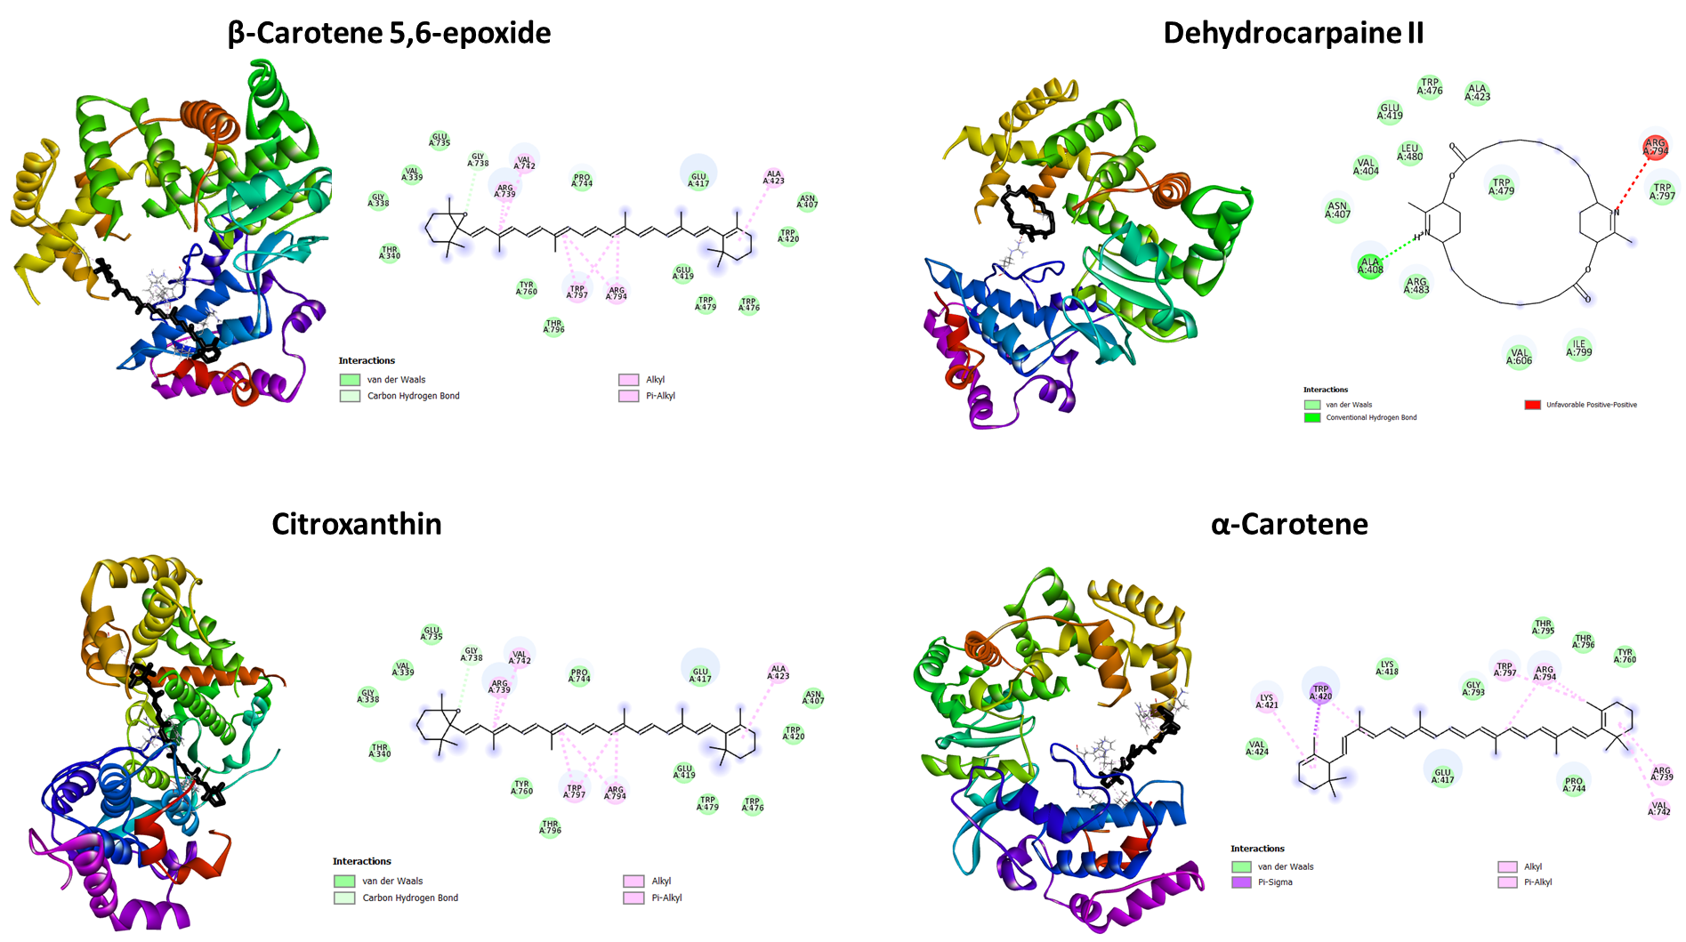
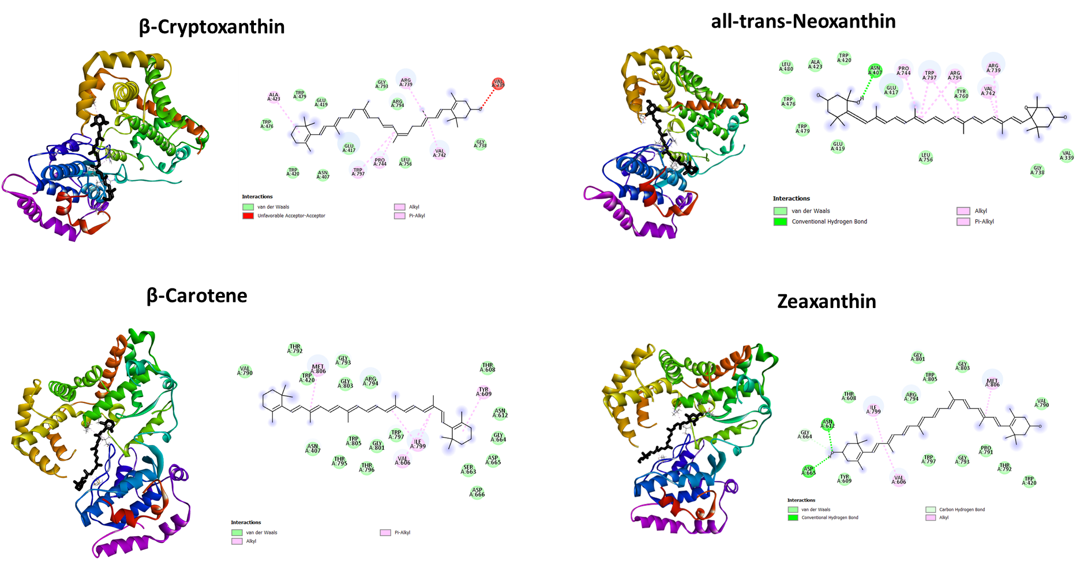

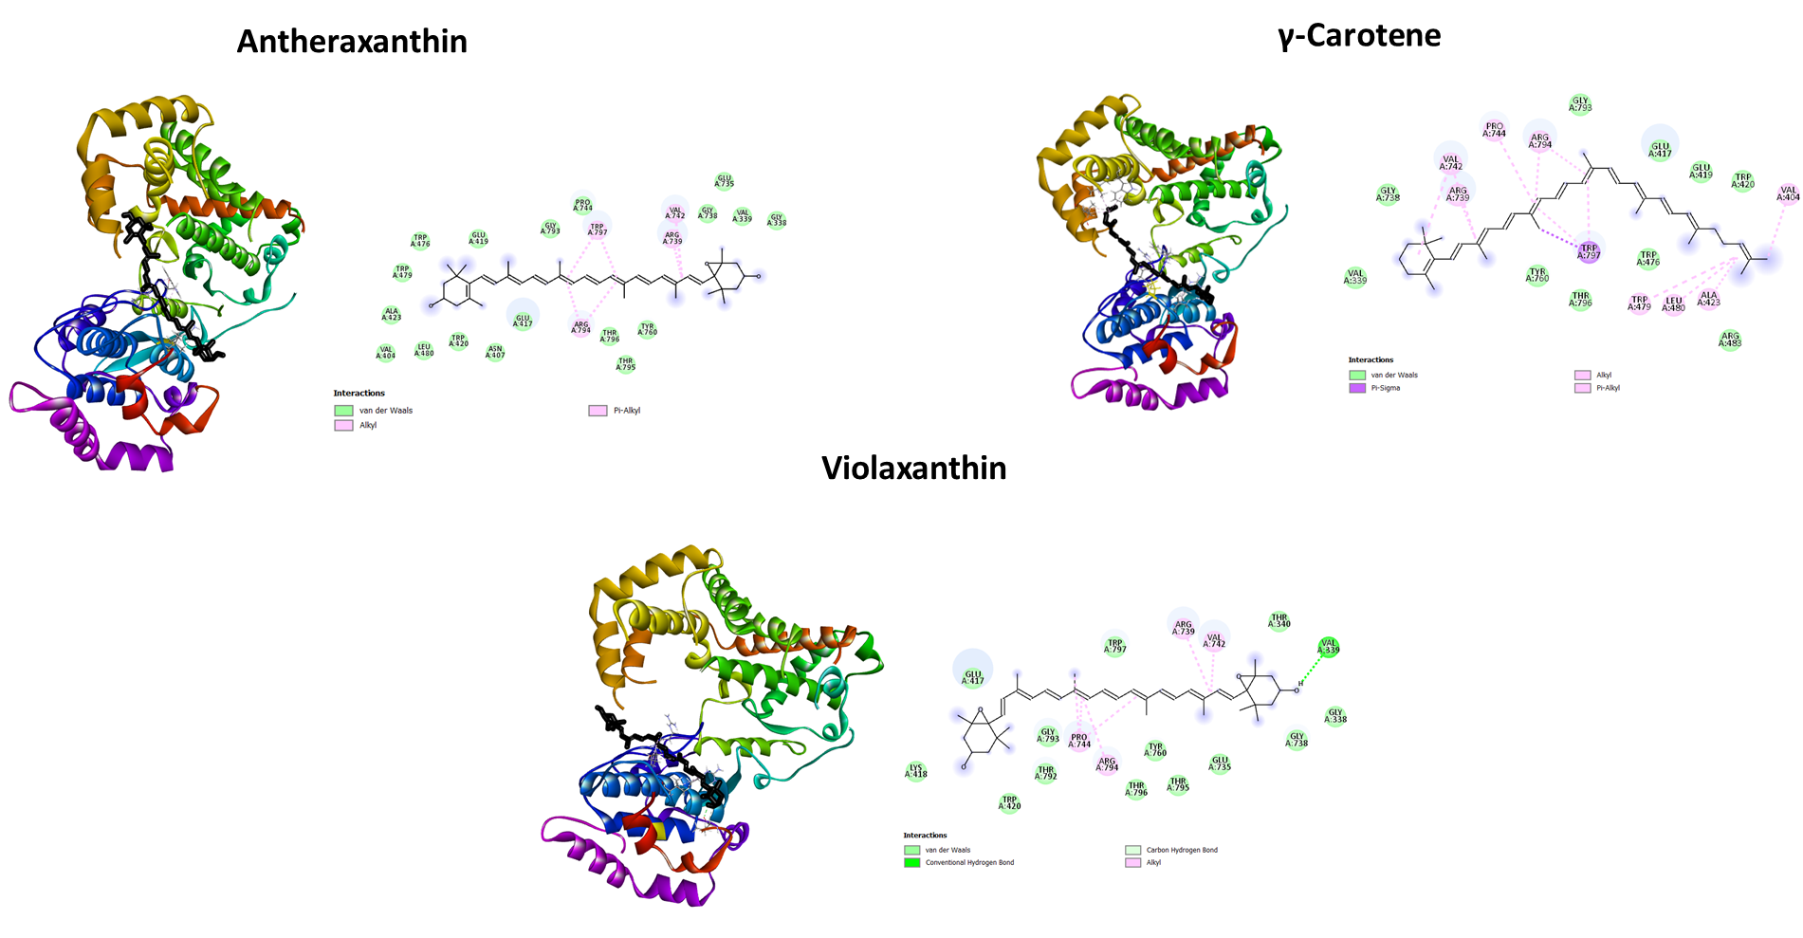

Figure S2: 2D and 3D interaction view of potent phyto compounds and their binding mode to ZIKA NS5 protein domain (MTase-5WXB) with the ligands, those showed the higher binding affinity compared to the positive control. The complex structures were obtained through Autodock Vina.

