IJESRT
International Journal of Engineering Sciences & Research Technology
EFFECT OF STEEL FIBERS ON PROPERTIES OF CONCRETE FLOORING
Kamal G. Sharobim*¹, Ehab M. Lotfy², Manar A. Alshakor³ & Sami K. Nagm⁴
^{*1} Professor of properties and Strength of materials, Civil Engineering Department, Faculty of Engineering, Suez Canal University, Ismailia, Egypt.
² Associate professor Civil Engineering Department, Faculty of Engineering, Suez Canal University, Ismailia, Egypt.
³ Assistant professor Civil Engineering Department, Faculty of Engineering, Suez Canal University, Ismailia, Egypt.
⁴Post graduate student at Faculty of Engineering, Suez Canal University, Ismailia, Egypt

DOI: 10.5281/zenodo.1202121

ABSTRACT
Concrete is a non-homogeneous material and it has high compressive strength but it is weak in tension. Cracks occur when tensile stresses exceeded. Improving of concrete properties by adding steel fibers to plain concrete to overcome the weakness of concrete. In this paper steel fibers (S.F) is added with (1mm) diameter and (50mm) long i.e. spect ratio (l/d=50) to plain concrete to study its effect on properties of concrete (workability, compressive strength, splitting tensile strength, flexural strength, abrasion resistance, and absorption). The tested variables are characteristics of concrete (f_{cu}30MPa and f_{cu}40MPa) with steel fibers content (0.4%, 0.5%, and 0.6%) by volume of concrete, and all specimens are tested at 28 days. The results show an increases in compressive strength by (6%, 12 % and 17%) for f_{cu}30 MPa and (8%, 13% and 16%) for f_{cu}40 MPa for fiber content 0.4, 0.5 and 0.6% respectively. The tensile strength increases by (38%, 59% and 67%) for f_{cu}30 and (21%, 35%, 53%) respectively for f_{cu}40. Abrasion resistance is increased by (14%, 29%, and 31%) for f_{cu}30 and (6%,25% and 26%) for f_{cu}40 respectively. The absoribtion of concrete is also enhanced by (7%, 14% and 26%) for f_{cu}30, and (25%, 33% and 55%) for f_{cu}40. The flexural strength is enhanced by (10%, 15%and 20%) for f_{cu}30 and (12%, 37%, 40%) f_{cu}40 respectively. While the workability decreases significantly for all mixes containing steel fiber compared to control mix.

Keywords: Steel fiber(SF), Volume fraction, Compressive strength, Splitting tensile strength, Flexural strength

- INTRODUCTION
Fibers are used since ancient times, it have been used to reinforce brittle materials. The straw was used to reinforce sun-baked bricks, and horse hair was used to reinforce mortars and plaster. Many engineering materials including ceramic, plastic, cement and gypsum products are armed with fibers to improve the properties of the mix. These properties include tensile strength, compressive strength, modulus of elasticity and cracking control. During the early 1960s in the United States, the first experiments were conducted to evaluate the potential of steel fibers in concrete reinforcement, Since then, a large amount of research developments, and experiments in industrial applications of steel fiber in concrete has been done. Fiber reinforced concrete (FRC) is normal concrete containing discontinuous discrete reinforcing ﬁbers, the length and diameter of the ﬁbers used in FRC don't exceed 76 mm and 1 mm, respectively [1]. This paper studies the effect of steel fibers on properties of concrete flooring. From the literature review, by using steel fibers the thickness of the road was reduced by (25-30)% with the increase in the residual strength of the road pavement [2]. The compressive strength enhanced and increased by increasing steel fibers content in concrete mix [3,4]. Splitting tensile strength increased when the steel fiber content increases in mixes for hooked, crimped and straight steel fibers [3, 5, 6]. It is found that steel fibers has higher effect on the flexural strength of SFRC than on either the compressive or tensile strength. The increases in flexural strength is especially sensitive, to the aspect ratio of the fiber and the length of fiber [4,6,7,8]. The materials selected have a large influence on the resistance level, as does the mix composition, strength gain, and construction can significantly improve a concrete’s ability to abrasion [9]. The abrasion resistance was increased with increasing the amount of crimped steel fibers and found that the shape of the steel fibers was not a significant factor but spect ration influencing factor to the abrasion resistance [10,11,12]. Steel fiber content reduces the initial absorption rate but in long term increases secondary absorption rate [13].

- EXPERIMENTAL WORK
The tested variables are characteristics of concrete (f_{cu}=30MPa and f_{cu}=40MPa) with and without steel fibers. Steel fiber of 1mm diameter and 50mm length are used. Dosage of (0.4%, 0.5%, and 0.6%) by volume of concrete. The experimental program is designed to test two groups of specimens, the concrete characteristic group 1 (G1) of (f_{cu} 30 MPa) and group 2 (G2) of (f_{cu} 40 MPa); to study the effect of steel fiber on properties of concrete (workability, compressive strength, splitting tensile strength, flexural strength, abrasion resistance, and absorption).

- MATERIALS
The fine aggregate used with grain size from 0.15 mm to 4.75 mm, a specific gravity 2.56 and bulk density 1.55 t/m³. Coarse aggregate graded from 4.75 mm to 20 mm with a specific gravity 2.69 and bulk density 1.36 t/m³ are used. The cement used is Suez sulphat resistant cement CEM/SR3 with the grade of 42.5 N. It is locally produced with a specific gravity of 3.14, the chemical and physical characteristics satisfy the Egyptian Standard Specification [14]. The water-reducing admixtures help in increasing the workability of concrete without adding water namely sikament-R 2004, and it complies with ASTM C494 type G [15]. All materials were obtained from the local markets in the city of Ismailia in the Arab Republic of Egypt. Figure(1) shows end hook steel fiber which is used in experimental work and table (1) shows the physical and mechanical properties of used steel fiber.

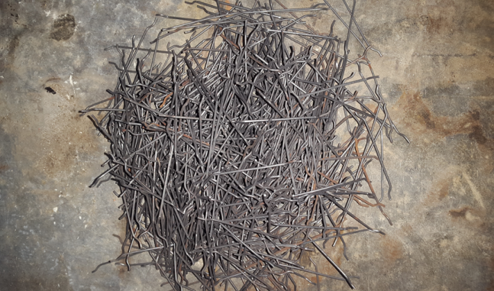 | 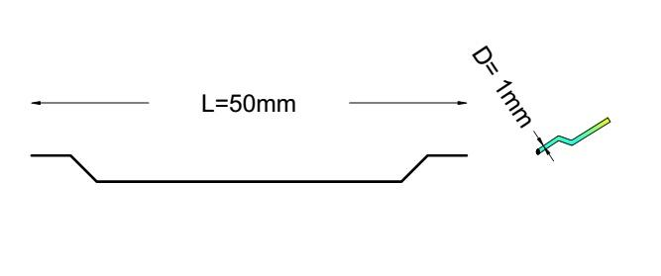
Figure (1) Shape of steel fiber use in this work

Table (1) Properties of steel fibers (from manufacture )
Item | Specifications
Relative density | 7800
Tensile strength | Minimum 1000 (MPa)
Modulus of Elasticity | 201 (G Pa)
Average length | 50 mm
Nominal diameter | 1 mm
Aspect ratio | 50

Mixing Design
Table (2) shows the mix proportions of the two concrete grades. Various concrete specimens ( 48 cubes 150x150x150 mm), ( 24 cylinders 200×100 mm), and (8 slabs 800×800×100 mm), were prepared, with different content of steel fibers proportion from volume of concrete (0.0%, 0.4%, 0.5% and 0.6%) for both G1 and G2. The workability of concrete is measured by slump tests for all mixes and their values are between (130-180mm) for G1 and (120-160 mm) for G2 as shown in figure (2).

Table (2) Proportions of mix design of f_{cu}=30 MPa and f_{cu}=40 MPa for1 m³
Group | Cement Kg/m³ | W/C | Coarse Aggregate  Kg/m³ | Fine Aggregate  Kg/m³ | Water  L/m³ | Admixture L/m³
G1 | 360 | 0.47 | 1280 | 615 | 170 | 6
G2 | 415 | 041 | 1250 | 600 | 170 | 6.9

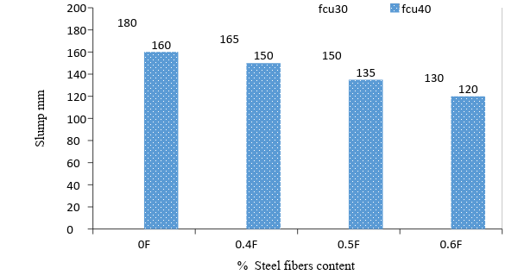
Figure (2) Slump of mix vs. different % steel fiber content

- TEST RESULTS AND DISCUSSIONS
The effect of different proportion of steel fibers in concrete on compressive strength, splitting tensile strength, flexure strength, abrasion resistance, and absorption were investigated.

Compressive strength
The compressive strength test was carried out according to ECP 203 - 2007 [17]. The compressive strength test of plain concrete and fiber reinforced concrete is conducted using a digital testing machine of 1500 KN. The results of the compressive strength test on concrete specimens containing different percentages of steel fibers are shown in table (3). Results of group 1 shows that the compressive strength of the specimens containing steel fiber in the proportions of 0.4%, 0.5% and 0.6 are increased by 6%, 12% and 17%, respectively, while the increase in compressive strength of the specimens in group 2 are 8%, 13%, and 16% respectively comparing with conventional concrete. Figure (3) shows that compressive strength increase by increasing steel fiber content in the concrete mix, these due to incorporating steel fibers and controlling cracks of concrete mix. From the figure it can be observed that using steel fiber adding with ratio (0.4-0.6) has significantly effect on increasing compressive strength of tested specimens more than as adding steel fiber with ratio 0.4%.
Table (3) Specimens test results of compressive strength
Group | Mix NO. | SF % | Compressive strength 28 days MPa | Increase in compressive strength %with SFR
G1 | 1 | 0.0 | 35 | Reference
G1 | 2 | 0.4 | 37 | 6
G1 | 3 | 0.5 | 39 | 12
G1 | 4 | 0.6 | 41 | 17
G2 | 5 | 0.0 | 44 | Reference
G2 | 6 | 0.4 | 47 | 8
G2 | `7 | 0.5 | 50 | 13
G2 | 8 | 0.6 | 51 | 16

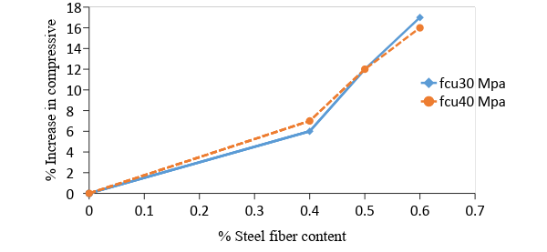
Figure (3) Compressive strength Vs. % steel fiber content at 28 days

Splitting tensile strength (Brazilian Test)
Splitting tensile strength test is carried out according to standard ASTM C 496-04 [18]. Table (4) shows the results of the splitting tensile strength test for the concrete specimens containing different percentages of steel fibers. For the group 1 containing 0.4%, 0.5% and 0.6% steel fiber, splitting tensile strength increased by 38%, 59% and 67%, respectively, while the increases in group 2 are 21%, 35% and 53% respectively, compared with conventional concrete. Also, it was noticed that the mode of failure of normal concrete without steel fiber was done by splitting the specimen into two parts with crashing some parts of the specimen while the specimen with steel fiber was splitted and still the parts together and there was lateral side cracks as shown in Figure (4). However, these failure indicate that fiberus concrete has higher ductility compared with control mix.

Table (4) Splitting tensile strength test results for specimens
Group | Steel fiber content % | Splitting tensile strength MPa | Increase in tensile strength %
G1 | 0.0 | 3.08 | Reference
G1 | 0.4 | 4.26 | 38
G1 | 0.5 | 4.9 | 59
G1 | 0.6 | 5.15 | 67
G2 | 0.0 | 3.85 | Reference
G2 | 0.4 | 4.65 | 21
G2 | 0.5 | 5.2 | 35
G2 | 0.6 | 5.9 | 53

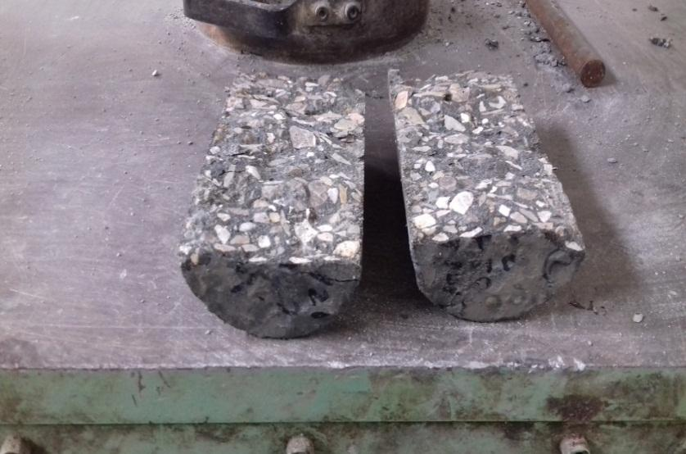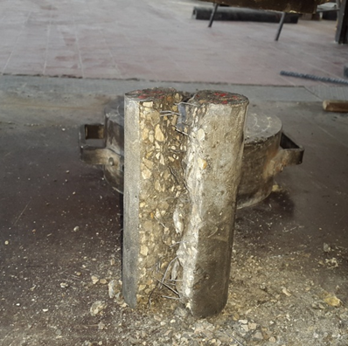
. (a) without steel fibers (b) with steel fibers
Figure (4) Mode of failure by splitting tensile strength (a) without steel fibers (b)with steel fiber

Figure (5), shows the relationship between splitting tensile strength and proportion fiber content where splitting tensile strength significantly increases due to the increase in volume fraction of steel fibers. This is due to the nature of binding effect of fiber available in concrete mix. From the figure it can be observed using steel fiber adding with ratio (0.4-0.6) has significantly effect on increasing tensile strength of tested specimens.

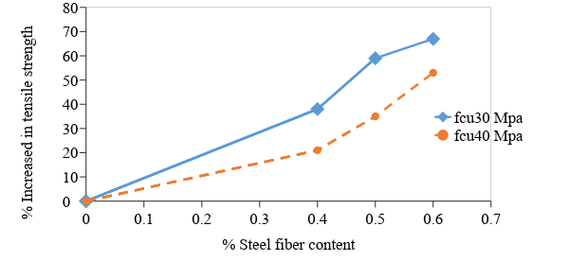
Figure (5) Effect of % steel fiber on the tensile strength of concrete

Flexural strength
The tested specimens are concrete specimens (800× 800×100) mm. They are tested in 4 points of loading using the hydraulic universal testing machine and the deflection of the mid span for the slab specimens is measured as shown in figure (6).

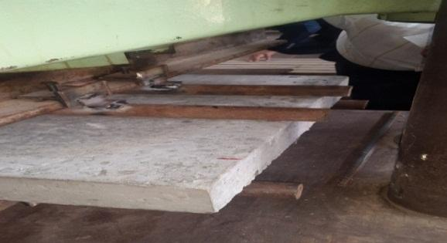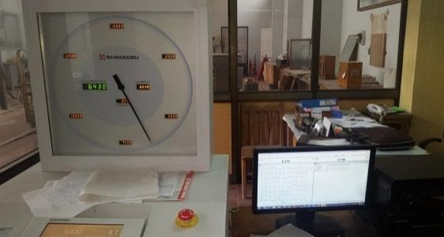
Figure (6) Test of flexural strength experimental setup

Table (5) shows the results of the flexural test on concrete specimens with different steel fibers proportion. For group 1 it is noticed that the amount of increasing in the flexural strength for specimens containing steel fiber as a proportions of 0.4%, 5% and 0.6% are 10%, 15% and 20% respectively, while the increase are 12%, 37% and 40% for group 2 compared with conventional concrete.

Table ( 5 ) flexural strength test results for specimens
Group | Mix No. | % Steel fiber of volume concrete mix | Flexural strength MPa | % Increase in flexural strength
G1 | 1 | 0.0 | 4.53 | Reference
G1 | 2 | 0.4 | 5 | 10%
G1 | 3 | 0.5 | 5.2 | 15%
G1 | 4 | 0.6 | 5.45 | 20%
G2 | 5 | 0.0 | 4.51 | Reference
G2 | 6 | 0.4 | 5.05 | 12%
G2 | 7 | 0.5 | 6.2 | 37%
G2 | 8 | 0.6 | 6.32 | 40%

Figure (7) shows the mode of failure of specimens with and without fiber. The reference specimen is suddenly failed in a brittle mode and isolated into two parts, while steel fiber concrete specimens have many cracks before the failure.

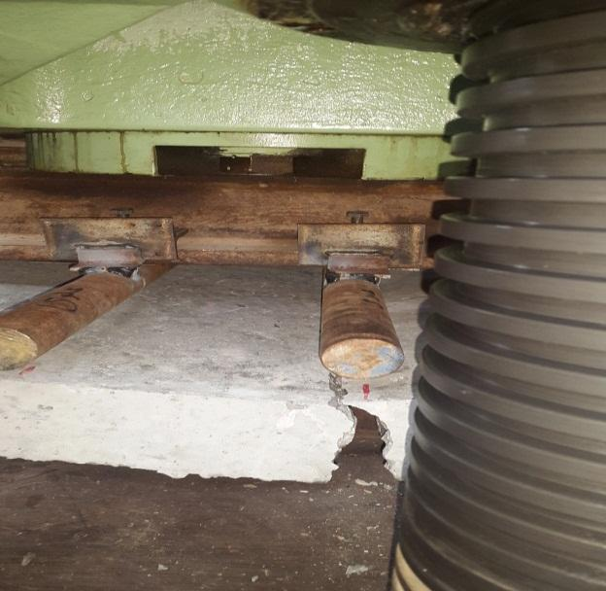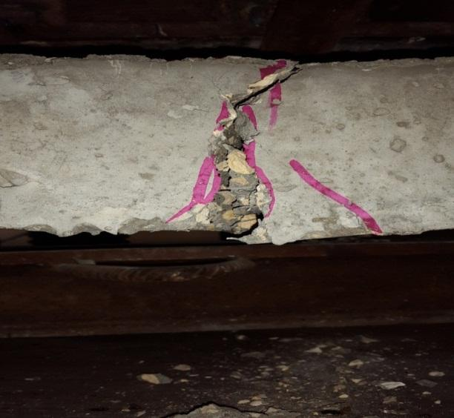
(a) Without steel fiber ( b) With steel fiber
Figure (7) Failure in flexural steel fiber concrete slab (a) without steel fiber( b) with steel fiber

Figure (8) shows that the flexural strength increases by increasing steel fiber content in the concrete. The increases in flexural strength may be due to the good mechanical contact of end hook steel fibers at their surface which leads to high bond strength between the fibers and the matrix specially at 0.6% steel fibers for two types of concrete mixes. From the figure it can be observed that using higher fiber content has significantly effect on increasing flexural strength of tested specimens more than lower fiber content.

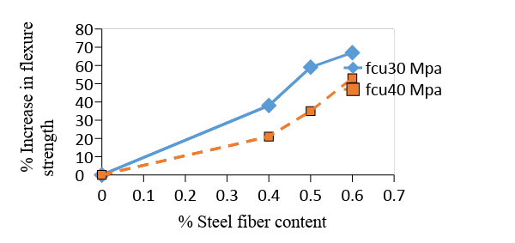
Figure (8) Effect of % steel fiber on flexure strength of concrete mixes

Figures (9) and (10) show that when increasing volume fraction of steel fibers, both load and deflection of two group mixes f_{cu}30 and f_{cu} 40 are increased as well as the toughness. This indicates that steel fiber improves the behavior of load-deflection curve and increases the toughness of concrete. From figures it can be observed that group 1 has deflection at maximum load more than group 2 for specimens containing steel fiber as a proportions of 0.4%, 5% and 0.6%.

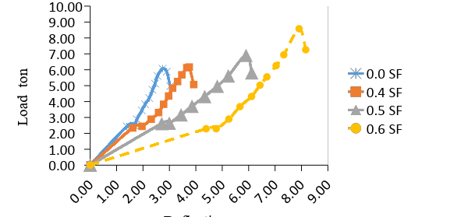
Figure (9) Load deflection for different % steel fiber ( concrete f_{cu}30 MPa)

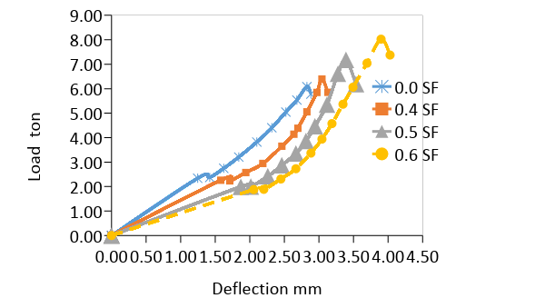
Figure (10) Load deflection for different % steel fiber ( concrete f_{cu}40 MPa)

Abrasion Resistance
Abrasion resistance is carried out according to Egyptian standard (ES-269-2/2006) [19]. Table (6) shows the test results of the thickness loss of each mix and the improvement in abrasion resistance for the two groups concrete mixes.
Table ) 6 ) Abrasion resistance for two types of mixes
Group | Steel fiber % content | Abrasion (loss in thickness mm) | Increase in abrasion resistance (%)
G1 | 0.0 | 1.75 | Reference
G1 | 0.4 | 1.53 | 14
G1 | 0.5 | 1.35 | 29
G1 | 0.6 | 1.34 | 31
G2 | 0.0 | 1.79 | Reference
G2 | 0.4 | 1.68 | 6
G2 | 0.5 | 1.34 | 25
G2 | 0.6 | 1.33 | 26

Figure (13) shows the effect of steel fibers volume fraction on the abrasion resistance of two concrete grades. From the figure it can be observed using steel fiber adding with ratio (0.4-0.5) has significantly effect on increasing abrasion resistance of tested specimens. When steel fibers are used with low content (0.4%), the increase in the abrasion resistance are 6% and 14% for G2 and G1 respectively compared with control mixes without fibers .
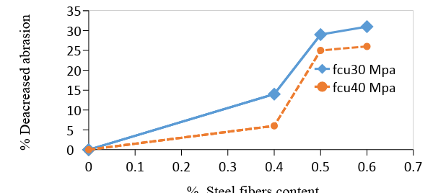
Figure (13) Effect of % steel fiber volume fraction on the abrasion resistance

Absorption

Absorption test is carried out in accordance with the Egyptian Standard, [ES-269-2 / 2006] [19]. Table (7) shows the results of water absorption test, for group 1 with steel fibers percentage 0.4% 0.5% and 0.6%. The absorption is reduced by 7%, 14% and 26% respectively compared with control specimen while for group 2 are 25%, 33% and 55% respectively compared with reference specimen.

Table ( 7 )The results of absorption for two grade mixes
Group | Steel fiber content of volume concrete % | % Absorption | % Decrease in absorption
G1 | 0.0 | 1.19 | Reference
G1 | 0.4 | 1.11 | 7%
G1 | 0.5 | 1.02 | 14%
G1 | 0.6 | 0.85 | 26%
G2 | 0.0 | 1.16 | Reference
G2 | 0.4 | 0.87 | 25%
G2 | 0.5 | 0.78 | 33%
G2 | 0.6 | 0.52 | 55%

Figure (14) shows the effect of steel fibers volume fraction on the absorption resistance of two groups concrete mixes. It was noted that increase in dosage of steel fibers decreases in absorption. From the figure it can be observed using steel fiber adding with ratio (0.4-0.6) has significantly effect on increasing absorption of tested specimens more than as adding steel fiber with ratio (0-0.4).

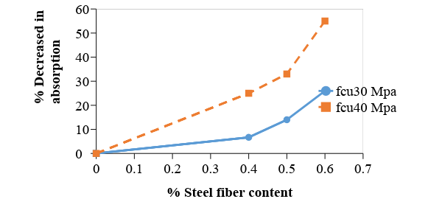
Figure (14) Effect % steel fiber on the absorption of concrete mixes

- CONCLUSIONS
According to the experimental results, where used (04%, 0.5% and 0.6%) steel fiber proportions of concrete volume. The following conclusions can be drawn:
- Compressive strength of concrete increases with increase of steel fiber volume fraction by (6%, 12% and 17%) for f_{cu}30 MPa and (8%, 13% and 16%) for f_{cu}40 MPa, comparing with control mixes.
- Workability decreased by (8%, 17% and 29%) for f_{cu}30 MPa and (7%, 16% and 25%) for f_{cu}40 Mpa, with increasing the fiber content comparing with control mixes.
- Splitting tensile strength increases with increase of steel fiber volume fraction by (38%, 59% and 67%) for f_{cu}30 MPa and (21%, 35% and 53%) for f_{cu}40 MPa, comparing with control mixes.
- The abrasion resistance enhanced directly with adding steel fiber volume fraction by (14%, 29%, and 31%) for f_{cu}30 and (6%, 25% and 26%) for f_{cu}40 comparing with control mixes.
- Water absorption decreased with adding steel fibers volume fraction by (7%, 14% and 26%) for f_{cu}30, and (25%, 33% and 55%) for f_{cu}40, compared with control specimens.
- Flexural strength increases with increase in fiber volume fraction by (10%, 15% and 20%) for f_{cu}30 and (12%, 37%, 40%) f_{cu}40, compared with control specimens.
- Adding steel fibers enhanced behavior of concrete slab by change its failure mode from sudden brittle mode of failure into a more ductile.
- The best amount of steel fibers is with volume fraction from (0.4% to 0.6%), enhances properties of concrete in compressive strength, splitting tensile, flexural strength, abrasion and absorption.
- Adding steel fibers increases maximum load and maximum deflection as well as increases the toughness.
- From the experimental results it seems that upgrade from f_{cu}30 MPa to f_{cu}40 Mpa has no significant effect on compressive strength and abrasion when adding different value of SF to the concrete mix. On the other hand, the effect of upgrading SF concrete from f_{cu}30 to f_{cu}40 on enhancing tensile strength, flexural strength and absorption.

- ACKNOWLEDGEMENT
We would like to express our deep appreciation and gratitude to all those helped us in Sues Canal Authority laboratory and Faculty of Engineering laboratories, Suez Canal University, Ismailia, Egypt

REFERENCES
- ACI 544.1R-96, "State-of-the-Art Report on Fiber Reinforced Concrete", (American concrete Institute,PP:1-66), Reapproved 2002.
- Abdul Ahad, Zishan Raza Khana and Shumank Deep Srivastava, "Application of Steel Fiber in Increasing the Strength, Life-Period and Reducing Overall Cost of Road Construction by Minimizing the Thickness of Pavement", Integral University, India, 2015, PP: 240-250.
- Mohammad Adnan Farooq and Dr Mohammad Shafi Mir, "Laboratory Characterisation of Steel Fiber Reinforced Concrete for varying Fiber Proportion and Aspect Ratio", International Journal of Emerging Technology and Advanced Engineering, India,2013, Vol. 3, PP: 75-80 .
- V.Milind Mohod, "Performance of Steel Fiber Reinforced Concrete", International Journal of Engineering and Science, 2012,ISSN:2278-4721, Vol.1, Issue 12, PP: 01-04 .
- Dr. Wasan I. Khalil, "Some Properties of Modified Reactive Powder Concrete", Journal of Engineering and Development, 2012, Vol. 16, No.4, PP: 66-87.
- Nguyen Van Chanh, "Steel fiber reinforced concrete", Faculty of Civil Engineering Ho chi minh City University of Technology, Vietnam, 2004, PP:108-116.‏
- I. Saaid Zaki, Khaled S. Ragab and Ahmed S. Eisa, "Flexural Behavoiur of Steel Fibers, Reinforced High Strength Self- Compacting Concrete Slabs", International Journal of Engineering, Zagazig University, Egypt, Inventions, 2013, Vol. 2, Issue 5, PP: 01-11.
- YE. Yinghua, Song HU, Bo DAIO, Songlin YANG and Zijian LIU, " Mechanical behavior of ultra-high performance concrete reinforced with hybrid different shapes of steel fiber", South China University of Technology, China, 2012, PP:3018-3028.
- D. Scott Benjamin Scott and Md. Safiuddin, "Abrasion Resistance of Concrete Design Construction and Case Study", Canada, 2015, PP 137-147.
- Ali Hasson Nahhab, "Impact and abrasion resistance of flax and steel fiber reinforced concrete", University of Babylon, Iraq, thesis of master, 2002.
- M. Setti, Taazount, S. Hammoudi, F. Setti and M. Achit-Henni, "Compressive, Flexural and Abrasive Performances of Steel Fiber Reinforced Concrete Elements", International Journal of Mechanical Engineering, 2013, PP: 69-77.
- V Vassou, "the influence of fibre reinforced on the abrasion resistance of industrial concrete floors", United Kingdom, 2005, PP: 23 - 24.
- Md. Belal Hossen, "Determination of optimum fiber content for fiber reinforced micro concrete," Bangladesh university of engineering and technology ,thesis of master, Bangladesh, 2016.
- ES 4756-1/ 2009.Cement.Part:(1). Composition, Specifications and conformity criteria for common cement, Egyptian Standards.
- ASTM C 494 - C 494M, (2005)." Chemical Admixtures for Concrete" American Society for Testing and Materials.
- ASTM A 820/A820M – 16, Standard Speciﬁcation for Steel Fibers for Fiber-Reinforced Concrete, American Society for Testing and Materials.
- ECP 203 -2007, "Method for Determination of Compressive strength of Concrete Cubes" Egyptian code for the design and implementation of concrete structures .
- ASTM C 496 - C 496M. (2004), " Splitting Tensile Strength of Cylindrical Concrete Specimens" American Society for Testing and Materials.
- ES 269-2, (2006), Egyptian Standards Specifications.

CITE AN ARTICLE
It will get done by IJESRT Team

