IJESRT
International Journal of Engineering Sciences & Research Technology
MICROWAVE MEDIATED GREEN SYNTHESIS OF LEAD (PB) NANOPARTICLES AND ITS POTENTIAL APPLICATIONS
N. Gandhi¹, D. Sirisha^{*2} and Smita Asthana³
^{1&*2}Centre for Environment and Climate Change, School of Environmental Science, Jawaharlal Nehru Institute of Advanced Studies (JNIAS), Hyderabad, Telangana.
^{2&3}Department of Chemistry, St. Ann’s College for Women, Hyderabad, Telangana

DOI: Will get Assigned by IJESRT Team

ABSTRACT
Nanotechnology is important and developing innovation with abundance of uses. It includes the blend and utilization of materials having one of the measurements in the scope of 1– 100 nm. A wide assortment of physico– synthetic methodologies are being utilized nowadays for the blend of nanoparticles (NPs). The size, orientation and physical properties of nanoparticles have reportedly shown to change the performance of any material. For several years, scientists have constantly explored different synthetic methods to synthesize nanoparticles. On the contrary, the green method of synthesis of nanoparticles is easy, efficient and eco-friendly in comparison to chemical-mediated or microwave mediated green synthesis. The chemical synthesis involves toxic solvents, high pressure, energy and high temperature conversion and microbe involved synthesis is not feasible industrially due to its lab maintenance. Since, green synthesis is the best option to opt for the synthesis of nanoparticles therefore the present research focuses on the cheapest and simplest method for the synthesis of Lead (Pb) Nanoparticles using the extract of Cuminum cyminum seed powder extract. The synthesized lead Nano particles were confirmed by UV – Visible spectroscopy, XRD, particle size analyzer. Results showed that lead nanoparticles size is of 87 nm and the synthesized nanoparticles were tested for their toxicity by studying their impact on germination of seed and their growth. The antimicrobial activities of lead nanoparticles were tested with pathogenic fungi, bacteria and photosynthetic algae. The synthesised nanoparticles showed efficient anti microbial activities against bacteria and pathogenic fungi. Similarly the synthesised nanoparticles showed efficient anti algal activity against Spirulina culture.

KEYWORDS: Green synthesis, Microwave, Lead (Pb) nanoparticles, Cuminum cyminum seed powder extract, Biological applications, anti microbial activity and impact on germination.

- INTRODUCTION
Metal nanoparticles have a high specific surface area and a high fraction of surface atoms. Because of the unique physicochemical characteristics of nanoparticles, including catalytic activity, optical properties, electronic properties, antibacterial properties, and magnetic properties [1-4] they are gaining the interest of scientist for their novel methods of synthesis. Over the past few years, the synthesis of metal nanoparticles is an important topic of research in modern material science. Nano-crystalline silver particles have been found tremendous applications in the fields of high sensitivity bio molecular detection, diagnostics, antimicrobials, therapeutics, catalysis and micro-electronics. The chemical, physical and fungal synthesis of silver and gold nanoparticles have been reported in literature but not much work is carried out on the synthesis of lead nanoparticles by using Cuminum cyminum seed powder extract and its potential application and positive, negative impact on seed germination. Hence, the present study aims green synthesis of lead nanoparticles, characterisation and potential applications.

Lead is highly poisonous heavy metal and it affects every organ and the system of the body. Lead poisoning results from the ingestion of food or water contaminated with lead. It can also enter into the body by the inhalation of lead based paint, leaded petrol, soil and dust. Hence, to understand the nano lead physical and chemical properties and its toxicity compare to lead metal. Generally the nanoparticles are designed with surface modifications tailored to meet the needs of specific applications they are going to be used for. The enormous diversity of the nanoparticles (Figure. 1) arising from their wide chemical nature, shape and morphologies, the medium in which the particles are present, the state of dispersion of the particles and most importantly, the numerous possible surface modifications the nanoparticles can be subjected to make this an important active field of science now-a-days.

In this universe of rising nanotechnology, one of the essential concerns is the potential condition effect of nanoparticles (NPs) [5]. A proficient method to assess nanotoxicity is to screen the reaction of microscopic organisms presented to these particles. Protection of microorganisms to bactericides, reaction of organisms to fungicides and anti-microbials has expanded as of late because of the improvement of safe strains. Some antimicrobial specialists are greatly aggravation and poisonous and there is much enthusiasm for discovering approach to define new sorts of safe and financially savvy biocidal materials. Past investigations have demonstrated that antimicrobial definitions as nanoparticles could be utilized as successful bacterial materials [6-7]. As of late, it has been illustrated, that very responsive metal oxide nanoparticles show incredible biocidal activity against gram positive and gram negative microscopic organisms [8]. Along these lines, the planning, portrayal, surface change and functionalization of nanosized inorganic particles open the likelihood of definition of another age of bactericidal and fungicidal materials [9]. Taking this factor in to consideration the present examination inspected for the green amalgamation of lead nanoparticles, charecterisation and it’s hostile to microbial action to contribute our discoveries to probability of plan of another formulation of bactericidal and fungicidal materials.

Figure-1: Various features contributing to the diversity of engineered nanoparticles. The same chemical can generate a wide variety of nanoparticles.

- MATERIALS AND METHODS

Preparation of Cuminum cyminum seed powder extract
Cuminum cyminum seeds, (Figure-2) were purchased from local market of Hyderabad, and washed several times with water to remove the dust particles and then sun dried to remove the residual moisture and grinded to form powder. Then seed extract was prepared by mixing 1% of extract with deionized water in a 250 ml of (Borosil, India) conical flask. Then the solution was incubated for 30 min. and then subjected to centrifuge for 30 min. at room temperature with 5000 rpm. The supernatant was separated and filtered with (whatt man filter paper) filter paper with the help of vaccume filters. Then the solution was used for the reduction of lead ions to lead nanoparticles.

Source of Lead (Pb)
1000 ml of 0.001 M lead (Pb) solution was prepared by using Lead Nitrate (PbNO₃), as precursor source for the synthesis of lead nanoparticles.

Preparation of Lead (Pb) Nanoparticles
The aqueous solution of 0.001M lead nitrate (PbNO₃) was prepared and used for the synthesis of lead nanoparticles. 10 ml of Cuminum cyminum seed powder extract was added into 90 ml of aqueous solution of 0.001M lead nitrate for reduction into Pb+ ions and kept for incubation period of 5 minutes in microwave oven at 700 watts. Here the filtrate acts as reducing and stabilizing agent for 0.001M of PbNO₃ (Figure-4).

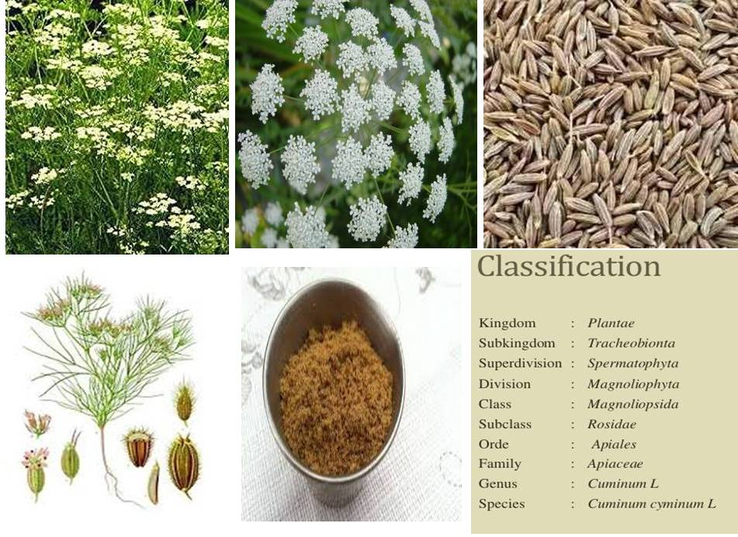
Figure-2: Classification and general information about Cuminum cyminum

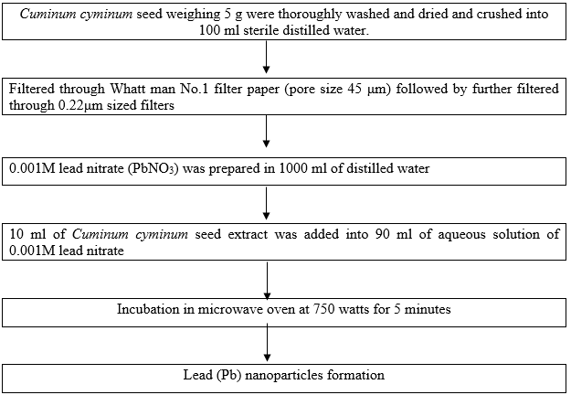

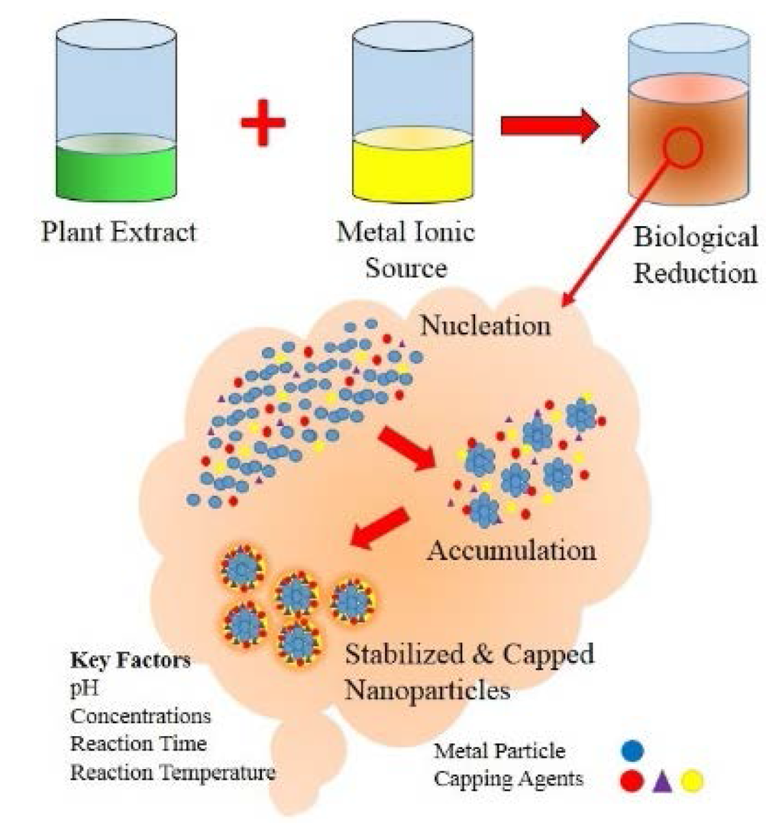
Figure-3: Method of Biological Synthesis of Lead Nanoparticles and detailed Mechanism
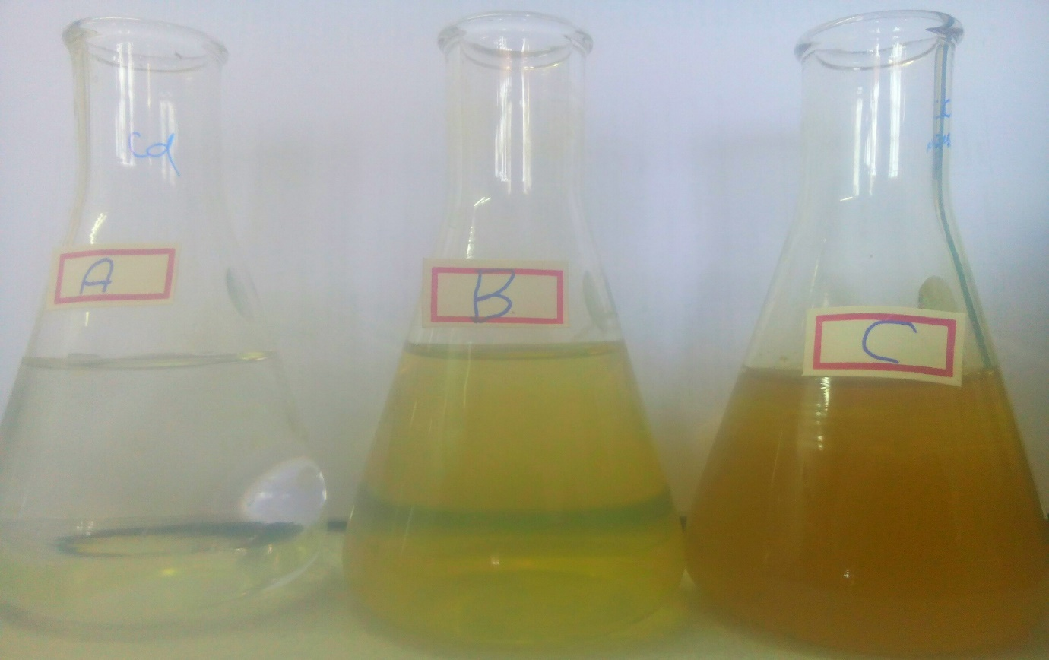
Figure-4: Green synthesis of Lead (Pb) nanoparticles A) PbNO₃ solution B) Cuminum cyminum seed extract and C) PbNP solution

Advantages of using Plant extracts
- The synthesis of nano particles using the concoction procedures has been raising stress among the tree huggers as they antagonistically affect their science, hereafter the use of plant removes for the game plan of nano particles is being favored due its salubrious nature towards the earth. To be sure, even in the business it conveys significantly less hurtful waste.
- The plants supplement both the diminishing and furthermore offsetting masters for the nanoparticles which by and large should be remotely included diverse procedures.
- The engineered methodology is being exhibited less monetarily profitable when stood out from the plant system as the help cost is fundamentally less and the waste exchange requires less effort among various factors.
- This method is shockingly superior to anything using the regular technique as the help of whole plant system is considerably not as much as a culture of tiny life forms which needs a swarm of wonders to be managed.
- Late examinations have shown that the accommodating effects of plants, from which the nano particles are being resolved, can in like manner be saturated upon the particles in this way giving us glorify vehicles to the therapeutic materials to catch up on the site of action and furthermore taking out the need to erroneously develop a medicine for that particular suffering

- CHARACTERIZATION OF LEAD (Pb) NANOPARTICLES

UV-Vis Analysis
The optical property of lead nanoparticles was determined by UV-Vis spectrophotometer (Lambda 35, Germany). After the addition of PbNO₃ to the seed extract, the spectras were taken in different time intervals i.e.1 – 5 minutes between 350 nm to 500 nm.

FTIR analysis
The chemical composition of the synthesized lead nanoparticles was studied by using FTIR spectrometer (Perkin-Elmer LS-55- Luminescence spectrometer). The solutions were dried at 75°C and the dried powders were characterized in the range 4000–400 cm ⁻¹ using KBr pellet method.
Particle Size Distribution
Colloidal Lead Nanoparticles synthesized with Cuminum cyminum seed extract were further characterized for Particle Size Distribution using Particle Size Analyzer of Microtrac-Model S3500, Jawaharlal Nehru Technological University Hyderabad, Kukatpally, Telangana. The size distribution is determined based on the dynamic scattering of red laser having wavelength 750 nm. The light is scattered due to Brownian motion of the colloidal PbNPs. Among the total percentage of size distribution, D-50 value, which is 50% size distribution, was taken into consideration.

XRD Analysis
The phase variety and grain size of synthesized lead nanoparticles was determined by X-ray diffraction spectroscopy (Philips PAN analytical). The synthesized lead nanoparticles were studies with CUKα radiation at voltage of 30 kV and current of 20 MA with scan rate of 0.030 /s. Different phases present in the synthesized samples were determined by X′ pert high score software with search and match facility. The particle size of the prepared samples were determined by using Scherrer′s equation as follows
𝐷 ≈ 0.9𝝀/ 𝛽cosθ
Where D is the crystal size, λ is the wavelength of X-ray, θ is the Braggs angle in radians and B is the full width at half maximum of the peak in radians.

Anti-Bacterial & Anti-Fungal Activity of Lead Nanoparticles
Pure cultures of all experimental bacteria and fungi were obtained from the Microbial Type Culture Collection and Gene Bank (MTCC), Institute of Microbial Technology (IMTECH), Chandigarh. The pure bacterial cultures were maintained on nutrient agar medium and fungal culture on potato dextrose agar (PDA) medium. Each bacterial and fungal culture was further maintained by sub-culturing regularly on the same medium and stored at 4°C before use in experiments.

Media Preparation & Its Sterilization
For agar well diffusion method [10-11] antimicrobial susceptibility was tested on solid (Agar-agar) media in petri plates. For bacterial assay nutrient agar (NA) (40 gm/L) and for fungus PDA (39 gm/L) was used for developing surface colony growth. The minimum inhibitory concentration (MIC), the minimum bactericidal concentration (MBC) and minimum fungicidal concentration (MFC) values were determined by serial micro dilution assay. The suspension culture, for bacterial cells growth was done by preparing 2% Lauria Broth (w/v), and for fungus cells growth, 2.4% (w/v) PDB (Potato dextrose broth) was taken for evaluation. All the media prepared was then sterilized by autoclaving the media at (121°C) for 20 min.

Agar well diffusion method
Agar well-diffusion method was followed to determine the antimicrobial activity. Nutrient agar (NA) and Potato Dextrose Agar (PDA) plates were swabbed (sterile cotton swabs) with 4 hour old - broth culture of respective bacteria and fungi. Wells (10 mm diameter and about 2 cm a part) were made in each of these plates using sterile cork borer. Stock solution of plant extract and PbNO₃ was prepared at a concentration of 1 mg/ml. About 10- 80 µl of different concentrations of PbNP were added sterile syringe into the wells and allowed to diffuse at room temperature for 2hrs. The two wells were incubated with the 100 µl of plant extract and PbNO₃ solutions to know the better activity of precursor agents used in the PbNP preparation. Control experiments comprising inoculums without plant extract & PbNP were set up. The plates were incubated at 37°C for 18-24 hours for bacterial pathogens and 28°C for 48 hours fungal pathogens. The diameter of the inhibition zone (mm) was measured and the activity index was also calculated. Triplicates were maintained and the experiment was repeated thrice, for each replicates the readings were taken in three different fixed directions and the average values were recorded.

Minimum Inhibitory concentration
The minimum inhibitory concentration is defined as the lowest concentration able to inhibit any visible bacterial growth on the culture plates. This was determined from readings on the culture plates after incubation. The most commonly employed methods are the tube dilution method and agar dilution methods. Serial dilutions are made of the products in bacterial and fungal growth media. The test organisms are then added to the dilutions of the products, incubated, and scored for growth. This procedure is a standard assay for antimicrobials. Minimum inhibitory concentrations are important in diagnostic laboratories to confirm resistance of microorganisms to an antimicrobial agent and also to monitor the activity of new antimicrobial agents. MIC is generally regarded as the most basic laboratory measurement of the activity of an antimicrobial agent against an organism.

Preparation of Inoculum
Test for antibacterial activity
The antibacterial assay was carried out by micro dilution method in order to determine the antibacterial activity of compounds tested against the pathogenic bacteria. The bacterial suspensions were adjusted with sterile saline to a concentration of 1.0 X 107 CFU/ml. The inocula were prepared and stored at 4°C until use. Dilutions of the inocula were cultured on solid medium to verify the absence of contamination and to check the validity of the inoculum. All experiments were performed in duplicate and repeated three times.

Test for Antifungal Activity
In order to investigate the antifungal activity of the extracts, a modified micro dilution technique was used. The fungal spores were washed from the surface of agar plates with sterile 0.85% saline containing 0.1% Tween 80 (v/v). The spore suspension was adjusted with sterile saline to a concentration of approximately 1.0 – 107 in a final volume of 100 µl per well. The inocula were stored at 4ºC determination of MIC for further use. Dilutions of the inocula were cultured on solid potato dextrose agar to verify the absence of contamination and to check the validity of the inoculum.

The minimum inhibitory concentrations (MIC)
MBC and MFCs were performed by a serial dilution technique using 96-well microtiter plates. The different concentrations of PbNP were taken and serial dilution of the extract with luria broth for bacterial culture and for fungus, potato dextrose broth medium with respective inoculum were used. The micro plates were incubated for 72 hours at 28°C, respectively. The lowest concentrations without visible growth (at the binocular microscope) were defined as MICs.

Determination of MBC
The MBCs were determined by serial sub-cultivation of 2 µl into microtitre plates containing 100 µl of broth per well and further incubation for 72 hours. The lowest concentration with no visible growth was defined as the MBC, indicating 99.5% killing of the original inoculum. The optical density of each well was measured at a wavelength of 655 nm by Microplate reader (Perlong, ENM8602) and compared with the standards Ampicillin for Bacteria (Hi-media lab, India) as the positive control. All experiments were performed in duplicate and repeated three times.

Determination of MFC
The fungicidal concentrations (MFCs) were determined by serial sub cultivation of a 2 µl into microtiter plates containing 100 µl of broth per well and further incubation 72 hours at 28°C. The lowest concentration with no visible growth was defined as MFC indicating 99.5% killing of the original inoculum. All experiments were performed in duplicate and repeated three times.

Anti Algal Activity of Lead Nanoparticles
Metals at little fixations are vital for algae cells to perform cellular functions. They go about as parts for photosynthetic electron transport proteins (Cu, Fe) and photosynthetic water oxidizing focuses (Mn) or are constituents of vitamins (Co) [12]. They additionally fill in as cofactors for catalysts taking an interest in CO₂ fixation (Zn in carbonic anhydrase) [13], DNA interpretation (Zn in RNA polymerase) and phosphorus obtaining (Zn in alkaline phosphatase) [14] or N₂ osmosis (Mo, Fe, V in nitrogenase) [15] and nitrate decrease (Mo in nitrate and Fe in nitrite reductase) [16]. Be that as it may, high convergences of these metals, and other superfluous substantial metals (Hg, As, Cd, Pb, Cr) cause negative impacts (debilitation of photosynthetic mechanism, blockage of cell division, restraint of catalyst action) in microalgae cells [17]. Metals additionally impact the morphology of algal cells. In the present investigation the antialgal potential of engineered PbNPs on toxic bloom forming cyanobacteria was assessed. Spirulina was used to investigate growth inhibitory effect by engineered lead nanoparticles. Cell density, change in fresh biomass weight, dry biomass weight, percentage of inhibition growth were employed to determine the toxic effect of PbNPs. The media used for the growth of Spirulina is listed in table-1.

Table-1: Chemical Components used in Media Preparation for Algal Growth
S.NO. | INGREDIENT | AMOUNT (g/L)
1. | NaHCO₃ | 16.8
2. | NaNO₃ | 2.5
3. | NaCl | 1.0
4. | K₂SO₄ | 1.0
5. | K₂HPO₄ | 0.5
6. | MgSO_{4.}7H₂O | 0.2
7. | FeSO_{4.}7H₂O | 0.01
8. | CaCl₂.2H₂O | 0.04
9. | EDTA | 0.08
10. | H₃BO₃ | 0.00286
11. | MnCl₂.4H₂O | 0.00181
12. | ZnO | 0.00022
13. | MoO₃ | 0.00001
14. | CuSO_{4.}5H₂O | 0.00008
15. | Distilled Water | 1000

All the experiments in present study were carried out in triplicates. Into a series of sterilised conical flask transfer 50 ml of prepared synthetic media and inoculated with 0.2 gm of dry spirullina culture. The conical flasks denoted with numerical 1,2,3,4,5,6 which contains 1 µg/ml to 3 µg/ml, lead nanoparticles respectively. These inoculated flasks were kept in BOD incubator and observed the toxicity of nanoparticles on Spirullina at regular time interval i.e. 15 days, 20 days and 25 days.

The toxicity of PbNPs was expressed as percent cyanobacteria growth inhibition, calculated using the following formula
$$cyanobacteria growth inhibition= \frac{Control-treatment}{Control} X 100$$

Impact of PbNPs on Seed Germination of Sorghum bicolour (L.).
The use of engineered nanomaterials has increased as a result of their positive impact on many sectors of the economy, including agriculture. Silver nanoparticles (AgNPs) are now used to enhance seed germination, plant growth, and photosynthetic quantum efficiency and as antimicrobial agents to control plant diseases. In this study, we examined the effect of PbNsP dosage on the seed germination of Sorghum bicolour (L.), to check the toxicity levels of Pb metal and PbNPs.

Selection of Seeds:
The seeds of Sorghum bicolor are selected to study the germination effect of PbNPs. 20 seeds of Sorghum bicolor are counted and selected based on floatation methods. The physicochemical characterization of soil was carried out before and after germination by using standard methods. The different concentrations of PbNPs were mixed 500 gm of soil by microwave digestion method.
$$Germination \%= \frac{Number of germinated seeds}{Total number of planted seed} X 100$$

- RESULTS & DISCUSSION

Physical Observation of formation of PbNPs
The formations of PbNPs were firstly concluded by colour change of the PbNO₃ solution when mixed with Cuminum cyminum seed extract. The different ratio of Cuminum cyminum seed extract shown different variations in color change shown in figure-5.
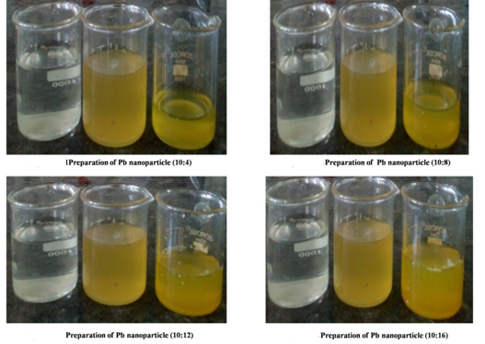
Figure-5: size reduction of lead (Pb) with different ratios of Cuminum cyminum seed extract

Uv- Visible Spectroscopy
Uv-visible absorption is the key tool to determine the structure and optical properties of metallic nanoparticles because the absorption bands associate the precise diameter and aspect ratio of metallic nanoparticles. Colloidal PbNPs have a distinctive yellowish orange colour solution. At nano size the surface electron cloud can vibrate and absorb the electromagnetic radiation of a particular energy. The samples of PbNPs were prepared by a chemical approach and the variation in the Uv-visible spectrum of the resultant solution was observed to analyze the size effect of metallic nanoparticles on Surface Plasmon Resonance (SPR). The figure- depicts the absorbance spectra of reaction mixture containing aqueous PbNO₃ solution (0.001 mM) and Cuminum cyminum seed extract. The absorption spectra obtained revel the production of PbNPs within 5 minutes under microwave irradiation when mixed with plant extract (Figure-4 & 5). On adding the above mentioned plant extracts to PbNO₃ solution the solution change from brown to yellowish brown. The final colour turn deep and finally a dark brownish with passage of time. The intensity of the absorbance was found to increase as reaction proceeded further.

PbNPs displaying intense brown colour in water arises from the Surface Plasmons. This is due to the dipole oscillation arising when electromagnetic field in the visible range is coupled to the collective oscillations of conduction electrons. It is an established fact that metal nanoparticles ranging from 2-10 nm in size demonstrate strong and broad surface Plasmon peak [18]. The optical absorption spectra of metal nanoparticles that are governed by surface plasmon resonances (SPR), move towards elongated wavelengths, with the increase in particle size. The absorption band position is also strongly dependent on dielectric constant of the medium and surface-adsorbed species [19].
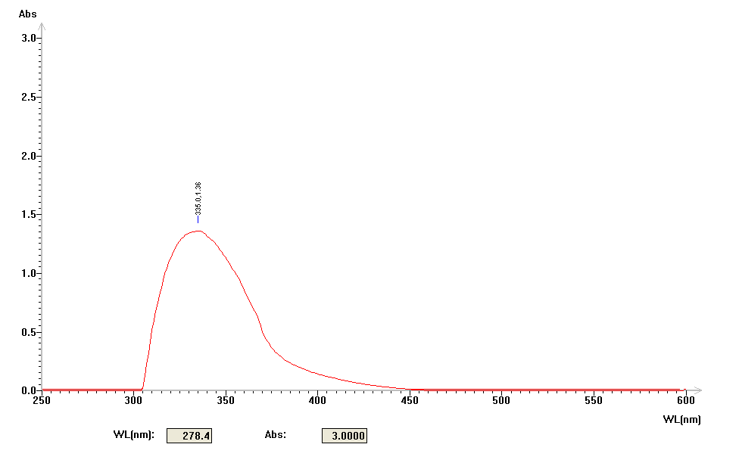
Figure-6: Uv- Visible Spectra of Lead Nanoparticles

Particle Size Analysis of PbNPs
The particle size of the synthesized lead nanoparticles was determined using dynamic light scattering measurement technique. Dynamic light scattering (DLS) is a technique for characterizing the size of colloidal dispersions which utilizes the illumination of a suspension of particles or molecules undergoing Brownian motion by a laser beam. The time-dependent fluctuations in the intensity of scattered light that occur are analyzed using an autocorrelator which determines the autocorrelation function of the signal [20]. The size distribution of the synthesized PbNPs is depicted in Figure 6. From the figure, it is observed that the particles obtained are polydisperse mixtures in the range 40 to 150 nm. The average size of the synthesized silver nanoparticles using red apple fruit extract is around 87 nm. Sizes and shapes of metal nanoparticles are influenced by a number of factors including pH, precursor concentration, reductant concentration, time of incubation, temperature as well as method of preparation. The zeta potential of the synthesized PbNPs was determined in water as dispersant. The zeta potential was found to be −68.07 mV. The high value confirms the repulsion among the particles and thereby increases in stability of the formulation [21]. The zeta potential value could be positive or negative; the negative potential value shown by PbNPs could be due to the possible capping of the bio-organic components present in the extract. Similarly described by Edison et al., 2012 [22] and Parameshwaran et al., 2013 [23].

Figure-7: Particle Size Analysis of Green Synthesized Lead Nanoparticles
FTIR Spectral Analysis

Figure-8: FTIR spectrum of Lead (Pb) nanoparticles

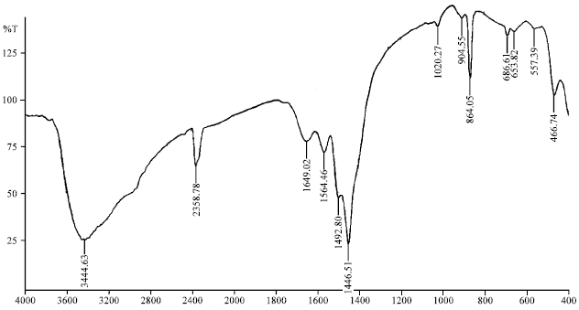
Figure-9: FTIR spectrum of Lead (Pb) nanoparticles

FTIR spectra for the lead nanoparticles are appeared in the Figure-9 by Alagar et al, 2012 [24]. The retention top at 466.74 cm-1 demonstrates the nearness of Pb-O extending and furthermore the top at 557.39 cm-1 shows the nearness of oxides. These two pinnacles are sharp. It is affirmed that the last item is the nearness of lead and oxide.

X-Ray diffraction studies of lead Nano particles
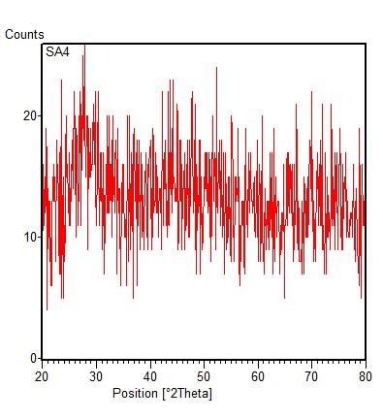
Figure-10: XRD Spectrum of Lead (Pb) nanoparticles

Powdered x-ray diffraction studies gives information on translational symmetry, size and shape of the unit cell for any compound. It is an important tool used in solid size chemistry and material science. It gives information on deviations from a perfect particle and defects extended from peak shapes and width.

Peak Indexing:
Unit cell dimensions can be calculated by the peak positions in XRD diffraction pattern. Miller indices (h, k, l) to each peak has to be assigned. Diffractogram of the entire data is shown in the figure and peak indexing is shown below (Table-2).

Table-2: XRD Spectrum, peak indexing and Reflections
S. No | Peak position=2θ | 1000 x sinθ | 1000 x sin²θ | Reflections | Remarks
1. | 31.37 | 73.040 | 3.0425 | (1,1,1) | 1²+1²+1²=3.
2. | 36.36 | 97.344 | 4.05 | (2,0,0) | 2²+0²+0²=4
3. | 62.26 | 267.180 | 11.13 | (3,1,1) | 3²+1²+1²=11
4. | 65.34 | 323.530 | 13.68 | (2,2,2) | 2²+2²+2²=12
5. | 77.083 | 387.50 | 16.14 | (4,0,0) | 4²+0²+0²=16

A number of strong Bragg’s reflections can be seen corresponding to (1, 1, 1) (2, 0, 0), (2, 2, 0) (3, 1, 1) (2, 2, 2) (4, 0, 0) represents the reflections of face centered cubic symmetry (FCC) lead. The peak at 31.37 from (1, 1, 1) lattice plane indicates the top crystal plane and it suggests lowest surface tension. The intensity of the peaks of lead Nanoparticles XRD reflects the formed Nanoparticles are crystalline and broad diffraction pattern indicates the crystalline state of lead Nanoparticles.

XRD- Lattice Constant
The FCC crystal structure of lead has a unit edge a = 4.9497Aº and this value is calculated theoretically by using the formula
a = 4√2xr
For lead r = 0.175 nm

The experimental lattice constant ‘a’ is calculated from the most intense peak (1, 1, 1) of the XRD is 4.936 Aº. Both theoretical and experimental lattice constant “a” are in agreement.

XRD Particle Size Calculations
Average particle size can be calculated using Debye- Scherrer formula ,
D = 0.9ʎ/β cosθ = 0.9x0.1540/β cosθ

Where ʎ is wave length of X- ray (0.1540 nm). β is FWHM (full width at half maximum). θ is the diffraction angle and D is particle diameter size.

Table-3: Particle size Calculation using XRD Spectrum
2θ= 77.0153  D= 0.9x0.1540/0.0039xcos38.5  D= 0.9x0.1540/0.0039x0.7826  = 45.41 | 2θ= 65.34  D= 0.9x0.1540/0.0039xcos34.67  D= 0.9x0.1540/0.0039x0.8405  = 42.26 | 2θ= 62.26  D= 0.9x0.1540/0.0039xcos31.13  D= 0.9x0.1540/0.0039x0.8559  = 41.52
2θ= 36.36  D= 0.9x0.1540/0.0039xcos18.18  D= 0.9x0.1540/0.0039x0.7840  =45.32 | 2θ= 31.37  D= 0.9x0.1540/0.0039xcos15.68  D= 0.9x0.1540/0.0039x0.09916  = 35.8

The calculated results indicate that the particle size is less than 45mm.

Calculation of d spacing:
The value of d (the inter planar spacing between the atoms is calculated using Bragg’s law
2d sinθ= n ʎ
Wave length ʎ=1.5418

Table-4: d spacing of Respective θ
2θ=77.0153  θ= 38.5  d= 0.1541/2sin 38.5  d= 0.1541/2x0.6225  = 0.1237 | 2θ=65.34  θ=31.67  d= 0.1541/2sin 31.67  d= 0.1541/2x0.2513  =0.3045 | 2θ=62.26  θ=31.13  d= 0.1541/2sin 31.13  d= 0.1541/2x0.0.045  = 1.7122
2θ=36.36  θ=18.18  d= 0.1541/2sin 18.18  d= 0.1541/2x0.3120  = 0.2469 | 2θ=62.74  θ=31.37  d= 0.1541/2sin 31.37  d= 0.1541/2x0.2671  =0.2886

Table-5: Experimental and standard diffraction angles of lead specimen
Experimental Diffraction Angle | Standard diffraction angle (2θ in degrees) JCPDS Lead
31.37 | 31.28
36.39 | 36.28
62.26 | 62.17
65.34 | 65.27
77.015 | 77.03

TGA/DTA Analysis of Lead Nanoparticles
The thermal properties of nanoparticles were studied from room temperature to 800 °C. A ceramic crucible was used for heating and measurements were carried out in inert nitrogen atmosphere at the heating rate of 10°C/min. It is observed from TGA curve that dominant weight loss of the sample occurred in temperature region between 500-800 °C. 60% loss of the substance is observed where the sample of 24.429 mg of the substance was taken and 11.54 mg which is remained attributed to the evaporation of water and organic components. Overall, TGA results show a loss of 60% up to 800 °C. DTA plot displays exothermic peaks at 300°C-400°C and in between 500 °C-600°C and in between 700 °C-800°C which can be attributed to the crystallisation of nanoparticles. DTA shows a complete thermal decomposition and crystallisation of lead nanoparticles.

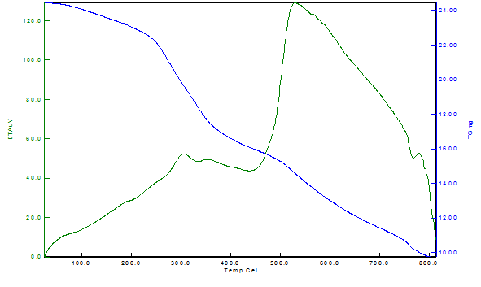
Figure-11: TGA/DTA spectrum of Lead (Pb) Nanoparticles by Cuminum cyminum seed extract

Anti Bacterial Activity
The antibacterial activity of PbNPs synthesized by Cuminum cyminum seed extract was examined against E.coli, gram negative bacteria, using agar well – diffusion method by keeping control ( 10 µl of PbNps, 10 µl of PbNO₃ and 10 µl of Cuminum cyminum seed extract). The antibacterial effect of PbNO₃ was determined on the basis of zone of inhibition (mm) shown in figure. From the figure it is concluding the Cuminum cyminum seed extract doesn’t shown antibacterial activity, the PbNPs shown high zone of inhibition than the aqueous PbNO₃ and Streptomycin antibiotic standard. E.coli is a gram negative bacterium and showed a maximum zone of inhibition of 18 mm with PbNPs.

Anti fungal Activity
The antifungal activity of PbNPs synthesized by Cuminum cyminum seed extract was examined against Candida albicans, using agar well – diffusion method by keeping control (10 µl of PbNps, 10 µl of PbNO₃ and 10 µl of Cuminum cyminum seed extract). The antifungal effect of PbNO₃ was determined on the basis of zone of inhibition (mm) shown in figure. From the figure-12, it is concluding the Cuminum cyminum seed extract doesn’t shown antibacterial activity, the PbNPs shown high zone of inhibition than the aqueous PbNO₃ and Streptomycin antibiotic standard. Candida albicans and showed a maximum zone of inhibition of 22 mm with PbNPs

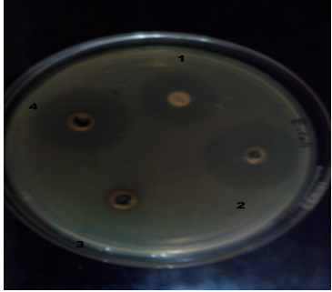
Figure-12: Anti Bacterial Activity of Lead (Pb) Nanoparticles against E.Coli

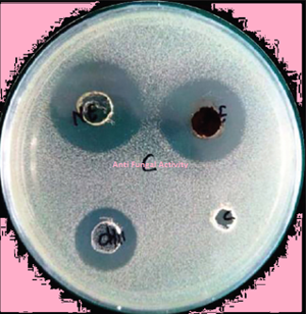
Figure-13: Determination of Anti Fungal Activity of Lead (Pb) Nanoparticles against Candida albicans

Determination of MIC, MBC and MFC Values:
Minimum Inhibitory Concentration (MIC), is defined as the highest dilution (or) least concentration of the PbNPs that inhibits growth of organisms. Determination of MIC is important in diagnostic laboratories because it helps in confirming resistance of microorganisms to an antimicrobial agent and it monitors the activity of new antimicrobial agents. The MBC and MFC was determined by sub culturing the dilution on to fresh solid medium and incubated further for 24 hours. The concentration of PbNps that completely killed the bacteria and fungi was taken as MBC and MFC respectively, shown in Table.

The discoveries of the present investigation agree with the past examinations, which are managing the antibacterial impacts of nanomaterials. The nanoparticles lead to the peroxidation of the phospholipid multi-ring compounds of the layer Lipid of microorganisms therefore the integrity of the cell membrane reduces, and ordinary cell exercises in a solid cell structure, for example, the respiratory exercises vanish and cell demise ends up plainly unavoidable. Nouram et al. in 2010 out of an examination entitled "Colloidal Silver as a New Antimicrobial Agent” detailed that antibacterial action of Colloidal silver has predominant impact against Escherichia coli and Salmonella typhimurium contrasted and different anti-infection agents [25]. The consequences of the antibacterial impact of silver nanoparticles in the Norns examine is reliable with this examination.

Shrivastava et al. in 2010 analyzed nanosilver antibacterial impact on Staphylococcus aureus and Salmonella typhimurium and demonstrated that Nanosilver antibacterial impact of the particles is reliant on the measurement, and these are more successful against gram-negative microscopic organisms than grampositive microbes [26], which is in correspondce with the consequences of this examination.

Lee Hu et al., in 2012, in an investigation entitled "Antibacterial study using nano silver doped high density polyethylene pipe” reasoned that HDPE - Ag Pipes have a potential antibacterial capacity [27], which compared with the consequences of this examination. Dutta R.K in 2012 in their investigation entitled Synthesis and assessment of potential antibacterial properties of zinc oxide, confirmed that the Antibacterial idea of the silver nanoparticles is affected by its fixation [28], which is in correspondce with the consequences of this exploration.

In the investigation of Selvam et al. in 2012 it was discovered that the rate of development inhibitory groupings of microbes fluctuates relying upon the sort of microscopic organisms [29], which is in correspondce with the aftereffects of this exploration. Matthews et al. In 2010, in an investigation entitled "Application of Nanomedicine in antibacterial medical therapeutics and diagnostics", expressed that Ag nanometer scale can be utilized to treat and totally restrains the development of high level of Gram-positive and Gram-negative bacterial species [30], which is in correspondce with the aftereffects of this exploration.
Lara in 2010, assessed the inhibitory impacts of silver nanoparticles on the microscopic organisms that show huge medication protection, and watched that Ag nanoparticles have critical bacteriostatic impact on these microbes [31], which is in correspondce with the aftereffects of this examination. Yin Guang Li et al. In 2007, in an investigation entitled "Amalgamation of nano-silver colloids and their antimicrobial impact" pronounced that huge parts of the microorganisms were pulverized by treatment by Ag nanoparticles, furthermore, with low centralizations of Ag nanoparticles, development hindrance is Comparing the antimicrobial impacts of silver and copper nanoparticles against pathogenic and safe microscopic organisms of Klebsiella pneumonia, Pseudomonas aeruginosa and Staphylococcus aureus 2545 made that outcomes in a noteworthy diminishment in the measure of live microorganisms contrasted with the control test [32], which is in correspondce with the consequences of this examination. Conceivable response components and the collaboration of nanomaterials with organic macromolecules is along these lines that nano materials discharge particles that respond with proteins on the surface of bacterial cells (- SH) Thiel. These proteins have swell from the layer of bacterial cells, and result in the exchange of supplements from the cell dividers. nanomaterials handicap these proteins, decrease the film penetrability and in the long run prompt cell passing [33].

Table-: The MIC and MBC of synthesized PbNPs against different microorganisms
S. No | Name of the Micro organism | MIC (µg/ml) | MBC (µg/ml)
01 | E. Coli | 2.5 | 26.4
02 | Candida. Sp | 5.1 | 20.3

Anti Algal Activity
Spirulina, which is known as the most common Cyanobacteria (CB), is found in eutrophic water environments. The use nanoparticles for algal growth control are a promising new technology for water remediation. In the present study, the use of PbNPs to control CB growth was investigated. In order to investigate the effects of PbNPs on Spirulina growth cells were exposed to a progressively increasing concentration of PbNPs from 1 to 3 mg/ 500 ml of medium for 0.2 gm of Spirulina. The growths were estimated at day 0, 15, 20 and 25 days of the exposure in the control and PbNPs treated. CB cell growths in term of biomass weight (Dry and fresh biomass) under different nanoparticle concentrations were plotted in figure . As illustrated by the chart diagram, from the figures it is concluded that the cells growth rate decreased with increasing concentration of PbNPs up to 15 days. When increasing the contact duration of the cell concentration of Spirulina is decreased due to higher toxicity a reduction of the cell growths were observed. At 25th day the cell growth rate became equilibrium when compare to control. The reason behind this is as the incubation period increased the biomass increased and the concentration of PbNPs used in present study were not sufficient to that growth rate and became constant. (p < 0.05). Nano metals at low concentration can be stimulatory for growth and production of target compounds, but metal overdose has detrimental and lethal effects on algae cultures. Hence, algal cultivation in nanometal polluted wastewaters should be designed in such a way to limit cell–metal interactions to the level at which metal concentration exerts only beneficial effects on algae growth and biosynthesis of crucial products. Algal cell response to nanometal presence depends on many factors such as conditions of cultivation, nutrient availability, presence of organic compounds and tolerance ability of particular strains.

Figure – 14: Effect on Biomass development of Spirullina under various concentrations of Lead (Pb) Nanoparticles (Dry weight).

Figure – 15: Effect on Biomass development of Spirullina under various concentrations of Lead (Pb) Nanoparticles (Fresh weight).
Impact on Seed Germination
The effect of nanoparticles in plants varies from plant to plant and species to species. Nanomaterials like nano silicon dioxide, carbon nanotubes and nano titanium oxide has a significant impact on germination of various crops. These findings are useful and important as increase in germination parameters has significant impact in increasing yield and sustainable crop production. Non toxicity is receiving more attention and these small size nanoparticles can modify the physical chemical properties of materials which can lead to adverse biological effect on living cells. The lead nanoparticles did not adversely affect the seed living process but they enhanced the process by comparison with control. This enhancement may be due to creation of nano holes on seed coats which must have resulted in the improved germination conditions and slow release of lead ions. It could be one of the reasons for lead nanoparticles to have no major effect on germination of seeds. This study reveals that seed germination was not greatly altered by nanoparticles. The lower concentration of lead nanoparticles did not have any adverse effect on plant species but higher concentration of nanoparticles has adverse effect on plant species. Germination was very low in Sorghum bicolour in comparison to control and seed germination and growth of germinated seeds was not much pronounced.
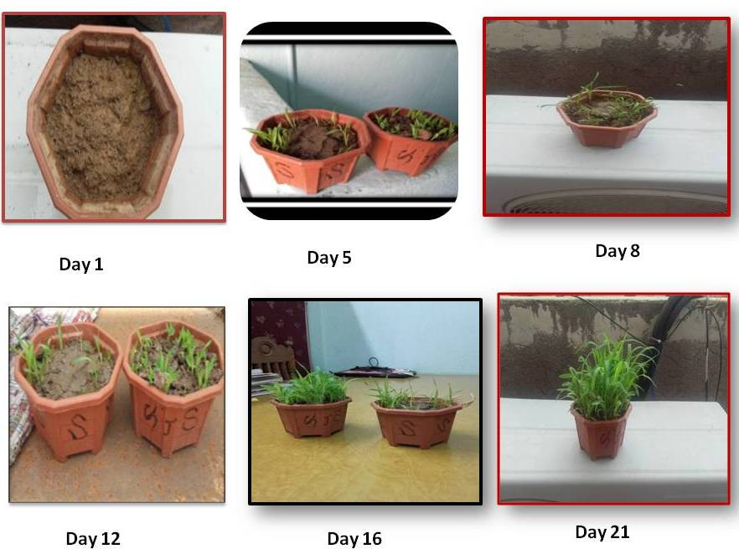
Figure – 16: Impact of Lead (Pb) Nanoparticles on Seed Germination of Sorghum bicolour

From the experiemnts it is observed the PbNP treated soils shown germination in 5 days but non treated samples (Control) the germination occurred within 48 hours and nanoparticles acted as stimulant for germination of Sorghum bicolour. Generally lead solutions show high toxic effects even at lower concentrations. The decrease in the toxicity with lead nanoparticles can benefit the society through their applications to agriculture and food systems. It is very important to focus on the study on impact of nanoparticles on soil-microbial systems. Further studies are needed because of the possibility of harmful effects of nanoparticles on plant growth which may be positive or negative depending on the dosage of nanoparticles, the time of treatment the plant species, the stage of development and many other factors. Physiological and visual toxicological effects in plants might not be sensitive indicator of toxicity studies at proteomic, genomic and metabolic levels are needed.

Possible Mechanism for formation of PbNPs
The use of plant and plant extricates in nanoparticle amalgamation is seen as beneficial over microbial based structure since it diminishes the unpredictable method of keeping up cell societies. The particle evaluate improvement can in like manner be controlled by changing mix conditions like pH, reductant concentration, temperature, mixing extent of the reactants etc. The plant based extracts should be possible either extracellularly or intracellularly. Intracellular extracts occurs inside the plant however the extracellular union occurs in vitro. The examinations reveal that extracellular extracts using plant isolates has been seen as better when appeared differently in relation to intracellular amalgamation [34] because it takes out the extraction and purification methodologies. Biosynthesis of PbNPs by plant removes, for instance, Zingiber officinale [35], Cocos nucifera [36], Coriandrum sativum [37], have been represented. Till date, some portion of papers has been appropriated around there which depicts the framework and part of dynamic biomolecules in extracts [38]. These examinations suggested that proximity of phytochemicals in plant isolates are the key section in diminishment and change of Leab (Pb) particles [38]. The phytochemicals which are responsible for decreasing are terpenoids, flavonoids, ketones, aldehydes, amides, and carboxylic acids. The water dissolvable metabolites, for instance, flavones, normal acids, and quinones are solely responsible for the bioreduction particles. A couple of investigators have uncovered that a keto-enol advance of anthraquinone is accountable for course of action of AgNPs in previous studies which is available in literature. It has been in like manner watched that mesophytes contain three sorts of benzoquinones: cyperoquinone, dietchequinone, and remirin which might be responsible for reducing of particles and advancement of AgNPs. The segment of diminishment of silver particles depends on the phytochemical show in the plants, Mechanism of course of action of silver nanoparticles, Silver particles are diminished by the diverse plant metabolites including terpenoids, polyhydroxyphenols, starches, alkaloids, phenolic blends, and proteins etc. The same phenomenon applicable for formation of Lead nanoparticles. Fourier transmission infrared spectroscopy (FTIR) spectroscopy of biosynthesized PbNPs has been used to display that biomolecules appear in extracts are responsible for blend of nanoparticles (Figure- 8 & 9). One of the biomolecule which fundamentally share is terpenoids. Terpenoids are generally called isoprene, a regularly happening common blends in plants, they contain five-carbon isoprene units. It has been researched by a couple of authorities that Cuminum cyminum seed extract contain terpenoids, which go about as noteworthy player in biosynthesis of PbNPs [39]. Comparative outcomes were found with Cinnamomum zeylanicum (cinnamon) evacuates contains eugenol which might be accountable for the diminishing silver nitrate to AgNPs [40]. In view of FTIR spectroscopy data (Figure- 8 & 9)., it have been suggested that the deprotonation of the hydroxyl molecule of eugenol provoke course of action of resonation offset structures which can also oxidized, by reducting metal particles into its nano broaden [40]. Another critical class of plant metabolite is flavonoids. Falvonoids are get-together of polyphenolic blends containing 15 carbon particles and are water dissolvable. Flavonoids can be assembled into: isoflavonoids, bioflavonoids and neoflavonoids, which can go about as chelating and reducing administrators for metal particles. The commonsense social affair introduce in flavonoids are solely responsible for nanoparticle game plan. The difference in flavonoids from the enol to the keto may provoke abatement of metal particles to outline nanoparticles [34]. Ahmad et al. detailed that Ocimum basilicum (sweet basil) remove contains of flavonoids, eugenol and polyphenols that accept enter part in the improvement of AgNPs from silver particles by tautomerization of enol to keto shape [41]. A couple of examinations have been exhibits that flavonoids can go about as chelating administrators for example quercetin is a flavonoid which can chelate at three positions including the carbonyl and hydroxyls at theC3 and C5 positions and the catechol total at the C3' and C4' site [34]. These assistants in understanding that flavonoids are related with begin of nanoparticle game plan (nucleation) and further amassing, despite the bioreduction sort out. It has been seen from FTIR spectroscopy that a carbonyl social affair of apiin has been joined to the nanoparticles, which exhibits that might be the sugars appear in plant evacuates are appreciating the diminishment and modification of metal particles into nanoparticles. Glucose a straight monosaccharides having free aldehydic social event can particularly go about as diminishing authorities while fructose which contains keto-get-together can go about as cell fortifications if tautomeric changes occurs from ketone to an aldehyde [34]. It has been represented that when glucose was used as a lessening master the nanoparticles with different morphologies were viewed while with fructose just monodispersed nanoparticles were viewed. It has been conjectured that aldehydic social occasion of sugar get oxidized into a carboxylic assembling by methods for the nucleophilic development of OH-, which in the end incite reduction of metal particles and mix of nanoparticles [34].

There are three rule stages which joined into the plant intervened amalgamation. Starting stage generally called sanctioning stage in the midst of which metal particles get diminished and the diminished metal particles get nucleated; another is the improvement organize in which unconstrained aggregation of minimal touching nanoparticles bounces out at outline particles of a greater estimation, which are thermodynamically more relentless; last stage is the end arrange which chooses the last condition of the nanoparticles [34,42]. Addition in the improvement organize, incite aggregate of nanoparticles into nanotubes, nanorods and nanotriangles etc. [34]. At last stage, nanoparticles encounter conformational change which is thermodynamically enduring, which attests the piece of plant think to settle metal nanoparticles.

- CONCLUSIONS
The synthesis of nanoparticles by using Cuminum cyminum seed extract has a significant potential over traditional methods of synthesis. The green synthesis of nanoparticles technology has to be scaled up to check the cost effectiveness. The process of synthesis is eco-friendly, rapid, followed green approach mechanism. The synthesised nanoparticles showed efficient anti microbial activities against bacteria and pathogenic fungi. Similarly the synthesised nanoparticles showed efficient anti algal activity against Spirulina culture. Many studies confirmed the plants can absorb lead from environment and it gets accumulated in roots and higher concentration of lead higher is the toxicity. It reduces the germination also to great extent due to presence of lead but this effect is not observed in the case of lead nanoparticles in where the toxicity is reduced. This is due to creation of nano holes on the seed coats. The crystalline nature of nanoparticles is evident from the sharp peaks in the XRD spectrum and average particle size is 87 nm. Therefore there is a need for more studies to evaluate and understand the actual plant-dependant mechanism. Similarly the germination studies have enhanced the work of toxicity checkups but it has further studied with respect to genomic proteomic and metabolic levels

- ACKNOWLEDGEMENTS
The authors are grateful to Dr. Shilpa Chakra, Head of the Department, Centre for Nano Science and Technology, Institute of Science and Technology, Jawaharlal Nehru Technological University Hyderabad, Kukatpally, Telanagana for providing instruments for the characterisation of green synthesized lead Nanoparticles

- REFERENCES
- Catauro M, R.M., De Gaaetano FD, Marotta A, "Sol–gel processing of drug delivery materials and release kinetics.". J Mater Sci Mater Med, 16(3)261-265, 2005.
- Crabtree JH, B.R., Siddiqi Ra, Huen IT, Handott LL, Fishman A, "The efficacy of silver-ion implanted catheters in reducing peritoneal dialysis-related infections.". Perit Dial Int, 23(4)368-374, 2003.
- Krolikowska A, K.A., Michota A, Bukowska J, "SERS studies on the structure of thioglycolic acid monolayers on silver and gold.". Surf Sci, 532, 227-232, 2003.
- Zhao G, S.J., "Multiple parameters for the comprehensiveevaluation of the susceptibility of Escherichia coli to the silver ion.". Biometals, 11, 27-34, 1998.
- Brayner R., 2008. The toxicological impact of nanopartcicles, Nano Today. 3, 48 – 55.
- Fresta M., G. Puglisi, G. Giammona, G. Cavallaro, N. Micali., Pefloxacine mesilate-loaded polyethyl cyano acrylate nanoparticles characterization of the colloidal drug carrier formulation. Journal of Phram. Sci. 84; 895-902, 1995.
- James G.V., Water treatment 4th Edition, Cleveland. CRC pres. 1971. P. 30.
- Stoimenov P.K., Klinger R.L., Marchin G.L., Klabunde K.J., Metal oxide nanoparticles as bactericidal agents. Langmuir, 18; 6679 – 6686, 2002.
- Sondi I., Sondi B.S., Silver nanoparticles as antimicrobial agents; a case study on E.coli as a model for gram negative bacteria. J. Colloid. Interf. Sci. 275; 177-182, 2004.
- Murray PR, Baron EJ, Pfaller MA, Tenover FC, Yolken HR Manual of Clinical Microbiology, 6th Ed. ASM Press, Washington DC, 15-18, 1995.
- Olurinola PF. A laboratory manual of pharmaceutical microbiology, Idu, Abuja, Nigeria, 69-105, 1996.
- Andersen, R.A. Algal Culturing Techniques; Elsevier Academic Press: San Diego, CA, USA, 2005.
- Moroney, J.V.; Bartlett, S.G.; Samuelsson, G. Carbonic anhydrases in plants and algae. Plant Cell Environ. 24, 141–153, 2001.
- Sunda, W.G. Feedback interactions between trace metal nutrients and phytoplankton in the ocean. Front. Microbiol. 2012.
- Bothe, H.; Schmitz, O.; Yates, M.G.; Newton, W.E. Nitrogen fixation and hydrogen metabolism in cyanobacteria. Microbiol. Mol. Biol. Rev. 74, 529–551, 2010.
- Vega, J.M.; Herrera, J.; Aparicio, P.J.; Paneque, A.; Losada, M. Role of molybdenum in nitrate reduction by Chlorella. Plant Physiol., 48, 294–299, 1971.
- Monteiro, C.M.; Castro, P.M.L.; Malcata, F.X. Metal uptake by microalgae: Underlying mechanisms and practical applications. Biotechnol. Prog. 28, 299–311, 2012.
- Prathap, S. C., Chaudhary, M., Pasricha, R., Ahmad A., Sastry M. Synthesis of gold nanotriangles and silver nanoparticles using Aloe vera plant extract. Biotechnol. Prog. 22, 577-586, 2006.
- Xia, Y.; Halas, N. J. Shape-controlled synthesis and surface plasmonic properties of metallic nanostructures. Mrs. Bull., 30, 338, 2005.
- Kaszuba M., McKnight D., Connah M.T., McNeil-Watson F.K., Nobbmann U., J. Measuring sub nanometer sizes using dynamic light scattering.Nanopart. Res. 10 823-829, 2008.
- Rao Y.S., Kotakadi V.S., Prasad T.N.V.K.V., Reddy A.V., Sai Gopal D. V.R. Green synthesis and spectral characterization of silver nanoparticles from lakshmi tulasi (Ocimum sanctum) leaf extract. Spectrochim. Acta Part A: Mol. Biomol. Spec. 103 156–159, 2013.
- Edison T.J.I., Sethuraman M.G., Instant Green Synthesis of Silver Nanoparticles Using Terminalia chebula Fruit Extract and Evaluation of Their Catalytic Activity on Reduction of Methylene Blue. Process Biochem. 47, 1351 – 1357, 2012.
- Parameshwaran R., Kalaiselvam S., Jayavel R., Green synthesis of silver nanoparticles using Beta vulgaris: role of process conditions on size distribution and surface structure. Mater. Chem. Phys. 140, 135 – 147,2013.
- Alagar M., Theivasanthi T., Kubera raj A. Chemical synthesis of nano-sized particles of lead oxide and their charecterization studies. Journal of Applied Sciences, 12;398-401, 2012.
- Nouran HA., Haram MH., Colloidal Silver as a new antimicrobial agent. International Journal of microbiological research. 1(1);33-36,2010.
- Shrivastava, S; jyung, woo; lungue, M; Characterization of Enhanced Antibacterial Effects of Nano Silver Nano Particles, J Nanotechnology, 25(12):103– 125, 2010.
- Hu T.L., Jin Z.H., W.F. Chang, J.J. Wu. Anti bacterial study using nanosilver droped high density polyethylene pipe. Sustain. Environ. Res. 22(3), 153-158, 2012.
- Dutta, R.K,. "Studies on Antibacterial Activity of ZnO Nanoparticles by ROS Induced Lipid Peroxidation", Colloids Surf.B Biointerfaces. 94:143-50, 2012.
- Selvam, S, Rajiv Gandhi R, Suresh J, Gowri S, Ravi kumar S, Sundrarajan M. "Antibacterial Effect of Novel Synthesized Sulfated Beta-Cyclodextrin Crosslinked Cotton Fabric and Its Improved Antibacterial Activities with ZnO, TiO2 And Ag Nanoparticles Coating." Int.J.Pharm. 434.1-2: 366-374, 2012.
- Matthews L, Rupinder KK, Shufong Z, Vasu P, Jagat R.K. Applications of Nanomedicine in antibacterial, medical therapeutics and diagnostics. The open tropical medicine journal. 3, 1-9, 2010.
- Lara, H.H., Ayala-Núnez, N.V., Ixtepan Turrent, L.C., Rodríguez Padilla, C., Bactericidal effect of silver nanoparticles against multidrug-resistant bacteria. World Journal of Microbiology and Biotechnology, 26(4):615-21, 2010.
- Guangyin, Lei;Synthesis of Nano-Silver Colloids and Their Anti Microbial Effects Master of Science In Materials Science & Engineering. Blacksburg, Virginia, November 8(2007).
- Nabipour Y.S., Rostamzad A. Comparing the antimicrobial effects of silver and copper nanoparticles against pathogenic and resistant bacteria Klebsiella pneumonia, Pseudomonas aeruginosa and Staphylococcus aureus. Cumhuriyt University Faculty of Science Journal, 36(3) 2540-2546, 2015.
- Makarov V.V., Love A.J., Sinitsyna O.V., Makarova S.S., Yaminsky I.V. "Green" nanotechnologies: Synthesis of metal nanoparticles using plants. Acta naturae 6, pp.35-43, 2014.
- Delma B.T., Vijila B., Jaya Rajan M. Green Synthesis of copper & lead nanoparticles using zingiber officinale stem extract. International journal of scientific and research publication. 6(11), 134-137, 2016.
- Elango G., Roopom S.M. Green synthesis, spectroscopic investigation & photocatalytic activity of lead nanoparticles. Spectrochimca acta part-A. Molecular & Biomolecular spectroscopy.139. 367-373, 2015.
- Devendra K., Adya J., Neelam. Green chemistry approach, synthesis, charecterisation and thermal studies of nanocomposites of lead oxide nanoparticles. Journal of Chemical & pharmaceutical research, 8(10), 86-93, 2016.
- Parashar U.K., Kumar V., Bera T., Saxena P.S., Nath G. Study of mechanism of enhanced antibacterial activity by green synthesis of silver nanoparticles. Nanotechnol 22, pp. 1-13, 2011
- Shankar S.S., Ahmad A., Sastry M. Geranium leaf assisted biosynthesis of silver nanoparticles. Biotechnol Prog 19, pp.1627-1631, 2003.
- Sathishkumar M., Sneha K., Won S.W., Cho C.W., Kim S. Cinnamon zeylanicum bark extract and powder mediated green synthesis of nanocrystalline silver particles and its bactericidal activity. Colloids Surf B Biointerfaces 73, pp.332-338, 2009.
- Ahmad N., Sharma S., Alam M.K., Singh V.N., Shamsi S.F., Rapid synthesis of silver nanoparticles using dried medicinal plant of basil. Colloids Surf B Biointerfaces 81, pp. 81-86, 2010.
- Si S., Mandal T.K. Tryptophan-based peptides to synthesize gold and silver nanoparticles: a mechanistic and kinetic study. Chem Eur J 13, pp.3160- 3168, 2007

CITE AN ARTICLE
It will get done by IJESRT Team

