GC-MS Combined with Fast GC e-nose for the Analysis of Volatile Components of Chamomile (Matricaria chamomilla L.)
Lu Jia-yu ¹, Qu Cheng ^{1,}*, Yu Dai-xin ¹, and Wu Qi-nan ^{1,}*
¹ Nanjing University of Chinese Medicine, Nanjing 210023, China;
lujiayu5210@163.com (J.-Y.L.); qucheng@njucm.edu.cn (C.Q.);yudaixin0616@163.com (D.-X.Y.); wuqn@njucm.edu.cn (Q.-N.W.)
* Correspondence: qucheng@njucm.edu.cn (C.Q.); wuqn@njucm.edu.cn (Q.-N.W.)

Table S1
The formula, and sensory description of flavor components in chamomile by fast GC e-nose.

MXT-5 |  | MXT-1701 |  | CAS | Formula | Nmae | Score | Sensory descriptors
RT | RI | RT | RI
15.94 | 418 | 14.50 | 576 | 107-01-7 | C₄H₈ | 2-Butene | 86.81 | Aromatic
16.96 | 439 | 14.50 | 576 | 107-02-8 | C₃H₄O | Propenal | 75.19 | Almond; Cherry
18.16 | 463 | 14.54 | 577 | 64-17-5 | C₂H₆O | Ethanol | 95.25 | Spicy; Ethanol
22.64 | 552 | 18.12 | 694 | 71-23-8 | C₃H₈O | 1-Propanol | 86.95 | Spicy; Ethanol
26.10 | 621 | 15.18 | 598 | 110-54-3 | C₆H₁₄ | Hexane | 90.58 | Gasoline; Alkane
26.98 | 639 | 16.34 | 636 | 96-37-7 | C₆H₁₂ | methylcyclopentane | 81.25 | Gasoline; Gasoline
37.08 | 761 | 25.72 | 834 | 623-43-8 | C₅H₈O₂ | Methyl crotonate | 95.03 | Fruity; Green
39.32 | 781 | 27.16 | 853 | 105-54-4 | C₆H₁₂O₂ | Ethyl butyrate | 83.57 | Fruity; Sweety
41.90 | 804 | 30.26 | 895 | 6789-80-6 | C₆H₁₀O | (Z)-3-hexenal | 87.58 | Fruity; Oak
47.04 | 855 | 32.28 | 919 | 7452-79-1 | C₇H₁₄O₂ | Butanoic acid | 96.01 | Fruity; Apple
52.52 | 911 | 44.24 | 1066 | 109-52-4 | C₅H₁₀O₂ | Pentanoic acid | 72.63 | Spicy; Sweety
54.16 | 932 | 38.06 | 985 | 7785-26-4 | C₁₀H₁₆ | a-pinene | 83.14 | Resin; Terpenoids
55.74 | 951 | 48.72 | 1130 | 620-02-0 | C₆H₆O₂ | 5-Methylfurfural | 83.93 | Spicy; Almond
57.04 | 967 | 39.82 | 1006 | 127-91-3 | C₁₀H₁₆ | β-Pinene | 95.16 | Resin; Wooden
58.69 | 987 | 33.47 | 932 | 123-35-3 | C₁₀H₁₆ | Myrcene | 91.60 | Fruity; Lemon
59.16 | 993 | 47.16 | 1106 | 124-13-0 | C₈H₁₆O | Octanal | 88.77 | Fruity; Orange
59.74 | 1000 | 42.00 | 1036 | 99-83-2 | C₁₀H₁₆ | a-Phellandrene | 79.98 | Spicy; Orange
62.45 | 1041 | 56.66 | 1263 | 19322-27-1 | C₅H₆O₃ | norfuraneol | 70.04 | Sweety; Caramel
63.19 | 1055 | 47.70 | 1115 | 99-85-4 | C₁₀H₁₆ | γ-Terpinene | 91.29 | Fruity; Orange
64.42 | 1070 | 51.32 | 1170 | 925-78-0 | C₉H₁₈O | 3-Nonanone | 93.95 | Fruity; Vegetable
65.94 | 1093 | 50.30 | 1155 | 1195-32-0 | C₁₀H₁₂ | p-Cymenene | 79.12 | Fruity; Orange
66.64 | 1104 | 51.38 | 1171 | 124-19-6 | C₉H₁₈O | n-nonanal | 92.44 | Fruity; Orange
68.62 | 1138 | 59.76 | 1323 | 21195-59-5 | C₁₀H₁₄ | 1,3,8 para-Menthatriene | 84.39 | Terpenoids; Sulfurous
69.40 | 1152 | 59.76 | 1323 | 76-22-2 | C₁₀H₁₆O | Camphor | 77.12 | Camphor; Green
70.90 | 1178 | 60.98 | 1348 | 1197-01-9 | C₁₀H₁₄O | Cymen-8-ol | 85.77 | Fruity; Coumarin
71.78 | 1194 | 61.92 | 1368 | 33512 | C₈H₁₀O₃ | 2,6-dimethoxy-phenol | 97.70 | Wooden; Smoke
74.24 | 1241 | 61.92 | 1368 | 1197-07-5 | C₁₀H₁₆O | trans-Carveol | 93.64 | Coriander; Green
80.46 | 1370 | 65.10 | 1438 | 31501-11-8 | C₁₂H₂₂O₂ | (Z)-3-Hexenyl hexanoate | 91.47 | Fruity; Green
82.50 | 1415 | 65.10 | 1438 | 6378-65-0 | C₁₂H₂₄O₂ | N-hexyl-hexanoate | 91.74 | Fruity; Apple
83.56 | 1440 | 75.96 | 1683 | 140-10-3 | C₉H₈O₂ | (E)-Cinnamic acid | 88.00 | Sweety; Vegetable
84.71 | 1468 | 69.05 | 1528 | 19700-21-1 | C₁₂H₂₂O | Geosmin | 86.13 | Beet; Soil
85.68 | 1489 | 68.68 | 1519 | 87-44-5 | C₁₇H₂₈ | β-Caryophyllene | 92.74 | Fruity; Green
86.30 | 1504 | 68.68 | 1519 | 473-13-2 | C₁₅H₂₄ | a-Selinene | 91.27 | Amber; Orange
86.82 | 1517 | 72.92 | 1614 | 111-82-0 | C₁₃H₂₆O₂ | Methyl dodecanoate | 96.13 | Fruity; Fatty
87.38 | 1531 | 68.68 | 1519 | 22306-28-1 | C₁₆H₃₄ | 8-methyl pentadecane | 94.28 | -
87.84 | 1543 | 66.66 | 1473 | 5471-51-2 | C₁₀H₁₂O₂ | Rheosmin | 97.55 | -
88.52 | 1560 | 77.70 | 1722 | 112-70-9 | C₁₃H₂₈O | 1-Tridecanol | 87.18 | -
91.54 | 1636 | 77.70 | 1722 | 124-25-4 | C₁₄H₂₈O | Tetradecanal | 95.62 | Amber; Orange
94.36 | 1707 | 80.08 | 1775 | 2345-28-0 | C₁₅H₃₀O | 2-Pentadecanone | 96.45 | Spicy; Vegetable
95.80 | 1743 | 81.08 | 1797 | 124-10-7 | C₁₅H₃₀O₂ | Methyl tetradecanoate | 83.77 | Coconut; Fatty
98.78 | 1818 | 84.32 | 1870 | 638-59-5 | C₁₆H₃₂O₂ | Tetradecyl acetate | 91.46 | Fatty; Waxy
¹ RT, MXT-5 and RT, MXT-1701: Retention time measured in column MXT-5 or MXT-1701; RI, MXT-5 and RI, MXT-1701: Retention index measured by n-alkanes in column MXT-5 or MXT-1701;CAS: Chemical Abstracts Service registry number.

Table S2
Volatile oil composition of chamomile.
Compound | RT | RI-m | RI-r | CAS | S1 | S2 | S3 | S4 | S5 | S6 | S7 | S8 | S9 | S10 | S11 | S12 | S13 | S14 | S15 | S16 | S17 | S18
(E)-beta-farnesene | 22.05 | 1459 | 1448 | 18794-84-8 | 1.02 | 1.14 | 1.47 | 0.63 | 1.28 | 1.06 | 2.00 | 1.94 | 0.77 | 1.27 | 0.08 | 0.07 | 0.07 | 0.00 | 0.00 | 0.03 | 0.06 | 0.13
Dehydrosesquicineole | 22.33 | 1471 | 1473 | 211237-38-6 | 0.00 | 0.00 | 0.00 | 0.00 | 0.00 | 0.00 | 0.00 | 0.00 | 0.00 | 0.00 | 0.02 | 0.00 | 0.00 | 0.00 | 0.00 | 0.00 | 0.00 | 0.00
Germacrene D | 22.68 | 1485 | 1477 | 23986-74-5 | 0.04 | 0.10 | 0.09 | 0.06 | 0.11 | 0.07 | 0.36 | 0.38 | 0.15 | 0.18 | 0.00 | 0.00 | 0.00 | 0.00 | 0.00 | 0.00 | 0.00 | 0.00
Bicyclogermacrene | 23.06 | 1500 | 1492 | 24703-35-3 | 0.00 | 0.10 | 0.00 | 0.00 | 0.12 | 0.07 | 0.38 | 0.41 | 0.16 | 0.18 | 0.00 | 0.00 | 0.00 | 0.00 | 0.00 | 0.00 | 0.00 | 0.00
Spathulenol | 25.21 | 1592 | 1568 | 6750-60-3 | 0.00 | 0.48 | 0.15 | 0.27 | 0.23 | 0.14 | 0.19 | 0.18 | 0.25 | 0.23 | 0.55 | 0.49 | 0.59 | 0.36 | 0.68 | 0.08 | 0.06 | 0.06
γ-Eudesmol | 25.90 | 1622 | 1630 | 1209-71-8 | 0.00 | 0.10 | 0.00 | 0.10 | 0.09 | 0.09 | 0.10 | 0.12 | 0.08 | 0.08 | 0.10 | 0.07 | 0.09 | 0.08 | 0.15 | 0.05 | 0.03 | 0.04
β-Bisabolol | 26.29 | 1640 | 1758 | 15352-77-9 | 0.00 | 0.05 | 0.00 | 0.00 | 0.00 | 0.05 | 0.00 | 0.05 | 0.00 | 0.00 | 0.03 | 0.04 | 0.04 | 0.00 | 0.06 | 0.00 | 0.00 | 0.00
γ-Cadinol | 26.49 | 1649 | 1639 | 5937-11-1 | 0.00 | 0.05 | 0.06 | 0.00 | 0.00 | 0.00 | 0.03 | 0.03 | 0.00 | 0.00 | 0.00 | 0.00 | 0.00 | 0.00 | 0.00 | 0.00 | 0.00 | 0.00
α-Bisabolol oxide B | 26.82 | 1663 | 1644 | 26184-88-3 | 0.67 | 2.92 | 0.70 | 2.34 | 2.82 | 2.62 | 2.30 | 2.62 | 3.36 | 2.63 | 1.51 | 1.40 | 1.44 | 0.88 | 2.04 | 1.17 | 1.26 | 0.83
Bisabolol oxide B | 26.86 | 1665 | 1666 | 55399-12-7 | 0.00 | 0.21 | 0.14 | 0.15 | 0.00 | 0.00 | 0.11 | 0.00 | 0.00 | 0.00 | 0.00 | 0.00 | 0.00 | 0.00 | 0.00 | 0.06 | 0.04 | 0.06
α-Bisabolone oxide A | 27.37 | 1688 | 1670 | 22567-38-0 | 0.39 | 1.31 | 0.60 | 1.41 | 0.98 | 1.04 | 1.47 | 1.31 | 2.14 | 1.76 | 1.21 | 1.07 | 1.22 | 0.72 | 1.38 | 0.45 | 0.54 | 0.31
α-Bisabolol | 27.53 | 1695 | 1684 | 515-69-5 | 0.01 | 0.00 | 0.00 | 0.00 | 0.01 | 0.01 | 0.00 | 0.00 | 0.00 | 0.00 | 0.01 | 0.01 | 0.01 | 0.00 | 0.01 | 0.00 | 0.00 | 0.00
Chamazulene | 28.42 | 1737 | 1707 | 529-05-5 | 0.09 | 1.08 | 0.17 | 1.28 | 0.93 | 0.57 | 1.92 | 2.05 | 3.79 | 2.37 | 0.52 | 0.51 | 0.57 | 0.17 | 0.47 | 0.18 | 0.31 | 0.17
α-Bisabolol oxide A | 28.90 | 1759 | 1758 | 22567-36-8 | 0.61 | 0.31 | 0.85 | 0.32 | 0.23 | 0.25 | 0.39 | 0.40 | 0.44 | 0.42 | 0.25 | 0.26 | 0.21 | 0.13 | 0.25 | 0.25 | 0.32 | 0.21
(Z)-ene-yne-Dicycloether | 31.00 | 1855 | 1849 | 4575-53-5 | 0.07 | 0.08 | 0.08 | 0.06 | 0.12 | 0.06 | 0.07 | 0.08 | 0.16 | 0.09 | 0.07 | 0.07 | 0.05 | 0.02 | 0.08 | 0.00 | 0.00 | 0.00
(Z)-18-Octadec-9-enolide | 36.47 | 2157 | 2158 | 74992-69-1 | 0.04 | 0.04 | 0.00 | 0.00 | 0.03 | 0.00 | 0.00 | 0.00 | 0.00 | 0.00 | 0.05 | 0.05 | 0.07 | 0.05 | 0.06 | 0.12 | 0.15 | 0.10
Heptacosane | 42.29 | 2502 | 2500 | 593-49-7 | 0.07 | 0.07 | 0.08 | 0.07 | 0.07 | 0.07 | 0.08 | 0.07 | 0.10 | 0.05 | 0.14 | 0.14 | 0.20 | 0.16 | 0.14 | 0.10 | 0.03 | 0.06
Essential oil (%) |  |  |  |  | 0.75% | 0.90% | 1.00% | 0.77% | 0.92% | 0.91% | 1.20% | 1.10% | 0.86% | 1.00% | 0.63% | 0.55% | 0.52% | 0.44% | 0.43% | 0.66% | 1.05% | 0.93%
² RT: relative retention time in GC-MS; RI-m: the actual retention index calculated by n-alkanes; RI-r: the theoretical retention index in the NIST 14 library; CAS: Chemical Abstracts Service registry number; S1~S18: the content of each sample compared with the internal standard(μg/mL).

Table S3
Electronic nose raw data.
ID | S1 | S2 | S3 | S4 | S5 | S6 | S7 | S8 | S9
2-Butene | 759.73 | 65103.63 | 1926.23 | 913.93 | 1101.27 | 1098.17 | 17751.00 | 1334.97 | 22260.40
Propenal | 0.00 | 1874.43 | 0.00 | 2095.53 | 1734.67 | 2144.97 | 3113.40 | 1542.33 | 2181.33
Ethanol | 0.00 | 0.00 | 0.00 | 0.00 | 0.00 | 0.00 | 1331.93 | 1345.47 | 1215.23
1-Propanol | 0.00 | 1812.70 | 0.00 | 0.00 | 0.00 | 1086.30 | 0.00 | 0.00 | 1039.83
Hexane | 1413.77 | 1442.03 | 0.00 | 1842.60 | 1701.47 | 2573.47 | 1375.23 | 2227.33 | 1316.00
Methylcyclopentane | 1101.57 | 1025.63 | 0.00 | 1141.00 | 1544.90 | 1630.97 | 0.00 | 1506.77 | 0.00
Ethylbutyrate | 1288.90 | 1442.63 | 2349.67 | 1655.70 | 2217.40 | 2232.27 | 0.00 | 1999.20 | 2163.43
(Z)-3-hexenal | 0.00 | 0.00 | 0.00 | 0.00 | 0.00 | 0.00 | 0.00 | 0.00 | 0.00
Butanoicacid | 39825.90 | 36090.40 | 64121.77 | 47016.93 | 52171.73 | 63605.33 | 30753.70 | 85530.10 | 87087.07
Pentanoicacid | 1541.80 | 2946.93 | 2015.40 | 1996.03 | 3305.83 | 3454.83 | 1886.03 | 3532.13 | 3321.63
α-pinene | 3964.10 | 12011.33 | 5066.50 | 9059.00 | 11462.07 | 6641.10 | 12468.67 | 16600.90 | 12740.53
5-Methylfurfural | 10386.57 | 10242.27 | 16823.20 | 10652.50 | 12929.70 | 14065.03 | 9431.53 | 18276.87 | 17622.17
β-Pinene | 2825.27 | 0.00 | 3759.80 | 0.00 | 0.00 | 0.00 | 0.00 | 0.00 | 0.00
Myrcene | 0.00 | 0.00 | 0.00 | 0.00 | 0.00 | 1411.57 | 0.00 | 0.00 | 0.00
Octanal | 5071.87 | 5695.73 | 8308.40 | 3830.50 | 4472.23 | 4511.77 | 5300.87 | 8600.37 | 6826.03
α-Phellandrene | 0.00 | 4068.90 | 0.00 | 2417.53 | 2901.03 | 3362.17 | 3352.40 | 4638.93 | 3901.97
Norfuraneol | 13087.60 | 29475.40 | 26534.43 | 12418.77 | 15652.10 | 19603.53 | 14096.07 | 23196.83 | 22225.17
γ-Terpinene | 3934.27 | 15148.43 | 6726.33 | 12691.27 | 19262.80 | 11272.73 | 22346.10 | 30543.47 | 21975.97
3-Nonanone | 19686.63 | 53662.37 | 31473.97 | 44372.27 | 54650.00 | 58637.87 | 58901.03 | 81433.23 | 75145.13
p-Cymenene | 1686.13 | 4190.17 | 2799.60 | 3223.77 | 4061.13 | 4378.00 | 5590.67 | 7329.37 | 5053.70
n-nonanal | 1560.13 | 1899.97 | 2609.00 | 1967.13 | 1848.50 | 2787.47 | 2879.03 | 4546.57 | 2688.83
1,3,8para-Menthatriene | 0.00 | 0.00 | 1088.83 | 0.00 | 1237.03 | 0.00 | 2007.83 | 2998.63 | 1786.87
camphor | 0.00 | 0.00 | 0.00 | 974.83 | 0.00 | 1373.33 | 1576.70 | 2549.07 | 1742.67
Cymen-8-ol | 1108.40 | 0.00 | 1104.30 | 0.00 | 0.00 | 0.00 | 0.00 | 0.00 | 0.00
2,6-dimethoxy-phenol | 1438.27 | 1109.00 | 1981.37 | 0.00 | 0.00 | 0.00 | 0.00 | 0.00 | 0.00
trans-Carveol | 0.00 | 0.00 | 1761.77 | 0.00 | 0.00 | 0.00 | 0.00 | 0.00 | 0.00
(Z)-3-Hexenylhexanoate | 0.00 | 0.00 | 0.00 | 0.00 | 1431.77 | 1001.40 | 2276.87 | 3302.57 | 0.00
N-hexyl-hexanoate | 0.00 | 0.00 | 0.00 | 0.00 | 1064.13 | 885.43 | 0.00 | 1270.37 | 0.00
(E)-Cinnamicacid | 0.00 | 0.00 | 1596.70 | 0.00 | 0.00 | 1066.33 | 0.00 | 1034.03 | 0.00
Geosmin | 55573.73 | 60881.90 | 112647.80 | 53439.87 | 89852.30 | 112605.77 | 114816.70 | 129848.17 | 40686.50
β-Caryophyllene | 0.00 | 3165.20 | 1211.83 | 3023.50 | 2076.07 | 3725.37 | 4616.73 | 5347.63 | 1834.57
α-Selinene | 0.00 | 1076.03 | 1023.40 | 920.90 | 1422.33 | 1468.30 | 1794.07 | 2091.00 | 976.57
Methyldodecanoate | 1141.80 | 1871.83 | 1953.47 | 2264.87 | 2651.07 | 3926.50 | 3601.00 | 5437.80 | 1375.33
8-methylpentadecane | 0.00 | 1386.10 | 3178.50 | 1246.83 | 1850.03 | 2136.53 | 3247.63 | 4391.73 | 1331.03
Rheosmin | 1580.07 | 1732.53 | 0.00 | 1565.50 | 2461.57 | 2460.23 | 3832.57 | 5646.20 | 1310.87
1-Tridecanol | 0.00 | 1235.83 | 1502.37 | 1177.00 | 1655.07 | 1926.73 | 2619.20 | 3772.20 | 1025.37
Tetradecanal | 0.00 | 1214.87 | 1275.77 | 0.00 | 2401.50 | 1869.07 | 2514.83 | 2116.43 | 1598.35
2-Pentadecanone | 2512.53 | 2492.53 | 3742.90 | 1322.43 | 9398.00 | 5122.23 | 8470.77 | 7775.10 | 8841.70
Methyltetradecanoate | 2041.27 | 2530.77 | 2690.80 | 2151.07 | 4356.57 | 4535.70 | 7265.13 | 5108.70 | 6779.10
Tetradecylacetate | 2114.10 | 0.00 | 3467.87 | 0.00 | 1709.83 | 0.00 | 2113.90 | 0.00 | 0.00
ID | S10 | S11 | S12 | S13 | S14 | S15 | S16 | S17 | S18
2-Butene | 15453.90 | 413.00 | 326.94 | 541.57 | 437.23 | 361.97 | 69229.50 | 73239.37 | 11689.13
Propenal | 1687.17 | 1656.57 | 0.00 | 0.00 | 0.00 | 1196.13 | 2680.07 | 1976.20 | 3484.53
Ethanol | 1307.40 | 0.00 | 0.00 | 0.00 | 0.00 | 0.00 | 0.00 | 0.00 | 0.00
1-Propanol | 1260.07 | 0.00 | 0.00 | 1079.27 | 0.00 | 2470.63 | 2685.50 | 3379.37 | 1027.57
Hexane | 1062.37 | 1305.40 | 1275.99 | 0.00 | 0.00 | 1103.63 | 0.00 | 0.00 | 0.00
Methylcyclopentane | 0.00 | 1241.27 | 0.00 | 0.00 | 0.00 | 0.00 | 0.00 | 0.00 | 0.00
Ethylbutyrate | 2113.10 | 0.00 | 0.00 | 0.00 | 1057.57 | 0.00 | 0.00 | 0.00 | 0.00
(Z)-3-hexenal | 0.00 | 1720.70 | 0.00 | 0.00 | 0.00 | 2890.20 | 3723.83 | 0.00 | 2307.57
Butanoicacid | 91001.33 | 7112.23 | 3888.48 | 5250.17 | 20890.07 | 13121.03 | 0.00 | 0.00 | 0.00
Pentanoicacid | 2813.30 | 1172.67 | 0.00 | 1295.67 | 1381.90 | 1494.97 | 0.00 | 0.00 | 0.00
α-pinene | 10498.73 | 3970.93 | 1658.28 | 1774.40 | 4717.53 | 4330.73 | 0.00 | 0.00 | 0.00
5-Methylfurfural | 16116.10 | 1809.30 | 840.39 | 1142.87 | 4081.90 | 3074.50 | 0.00 | 0.00 | 0.00
β-Pinene | 0.00 | 0.00 | 0.00 | 0.00 | 0.00 | 0.00 | 0.00 | 0.00 | 0.00
Myrcene | 0.00 | 0.00 | 0.00 | 0.00 | 0.00 | 0.00 | 0.00 | 0.00 | 0.00
Octanal | 5815.93 | 0.00 | 0.00 | 0.00 | 0.00 | 0.00 | 1254.50 | 1946.27 | 2810.00
α-Phellandrene | 3433.43 | 0.00 | 0.00 | 0.00 | 0.00 | 0.00 | 0.00 | 0.00 | 0.00
Norfuraneol | 18564.70 | 1271.47 | 553.15 | 623.50 | 1925.73 | 1635.27 | 3386.67 | 6801.70 | 0.00
γ-Terpinene | 17006.97 | 4203.13 | 2975.24 | 2987.33 | 5673.67 | 5740.60 | 0.00 | 1350.00 | 0.00
3-Nonanone | 60307.17 | 11423.87 | 5198.19 | 6392.27 | 21668.47 | 18359.43 | 4088.63 | 4111.10 | 2843.93
p-Cymenene | 4424.33 | 901.27 | 0.00 | 0.00 | 1764.83 | 1468.80 | 0.00 | 0.00 | 0.00
n-nonanal | 2093.33 | 0.00 | 0.00 | 0.00 | 0.00 | 0.00 | 0.00 | 0.00 | 0.00
1,3,8para-Menthatriene | 1481.30 | 0.00 | 0.00 | 0.00 | 0.00 | 0.00 | 0.00 | 0.00 | 0.00
camphor | 1343.37 | 0.00 | 0.00 | 0.00 | 0.00 | 0.00 | 0.00 | 0.00 | 0.00
Cymen-8-ol | 0.00 | 0.00 | 0.00 | 0.00 | 0.00 | 0.00 | 1399.50 | 0.00 | 1290.00
2,6-dimethoxy-phenol | 0.00 | 0.00 | 0.00 | 0.00 | 0.00 | 0.00 | 0.00 | 0.00 | 0.00
trans-Carveol | 0.00 | 0.00 | 0.00 | 0.00 | 0.00 | 0.00 | 0.00 | 0.00 | 0.00
(Z)-3-Hexenylhexanoate | 0.00 | 0.00 | 0.00 | 0.00 | 0.00 | 0.00 | 0.00 | 0.00 | 0.00
N-hexyl-hexanoate | 0.00 | 0.00 | 0.00 | 0.00 | 0.00 | 0.00 | 0.00 | 0.00 | 0.00
(E)-Cinnamicacid | 0.00 | 0.00 | 0.00 | 0.00 | 0.00 | 0.00 | 0.00 | 0.00 | 0.00
Geosmin | 44809.70 | 10433.40 | 19981.88 | 6580.30 | 8910.20 | 8476.73 | 30665.90 | 82372.40 | 25840.80
β-Caryophyllene | 2881.97 | 0.00 | 0.00 | 0.00 | 0.00 | 0.00 | 0.00 | 0.00 | 0.00
α-Selinene | 763.30 | 0.00 | 0.00 | 0.00 | 0.00 | 0.00 | 0.00 | 0.00 | 0.00
Methyldodecanoate | 1754.87 | 0.00 | 1237.49 | 0.00 | 0.00 | 0.00 | 0.00 | 1416.80 | 0.00
8-methylpentadecane | 1399.57 | 0.00 | 1268.35 | 0.00 | 0.00 | 0.00 | 1463.33 | 4185.30 | 0.00
Rheosmin | 1362.10 | 0.00 | 0.00 | 0.00 | 0.00 | 0.00 | 0.00 | 0.00 | 2156.43
1-Tridecanol | 1034.13 | 0.00 | 0.00 | 0.00 | 0.00 | 0.00 | 0.00 | 1094.47 | 0.00
Tetradecanal | 0.00 | 0.00 | 1525.54 | 1368.37 | 870.03 | 1571.03 | 0.00 | 0.00 | 0.00
2-Pentadecanone | 2631.07 | 1457.70 | 1502.56 | 1718.83 | 1054.37 | 2089.23 | 3408.67 | 5812.40 | 4252.50
Methyltetradecanoate | 3956.00 | 2571.93 | 3466.89 | 3800.03 | 1721.23 | 3065.97 | 1468.40 | 2271.27 | 1852.00
Tetradecylacetate | 0.00 | 0.00 | 1103.28 | 0.00 | 0.00 | 0.00 | 1027.77 | 2104.77 | 1017.13
³ ID: S1-S18 represent different chamomile samples; the leftmost column lists the name of identified compounds for each peak; the data represent the signal peak areas analysed by the Rapid Gas Chromatography Electronic Nose.

Figur S1
Results of Permutation
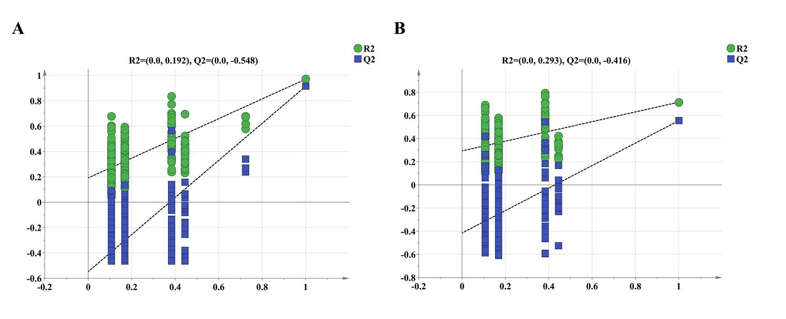
⁴ A: PLSDA Permutation result of GC-MS; B: PLSDA Permutation result of electronic nose.

Figur S2
Results of Single-Factor Investigations

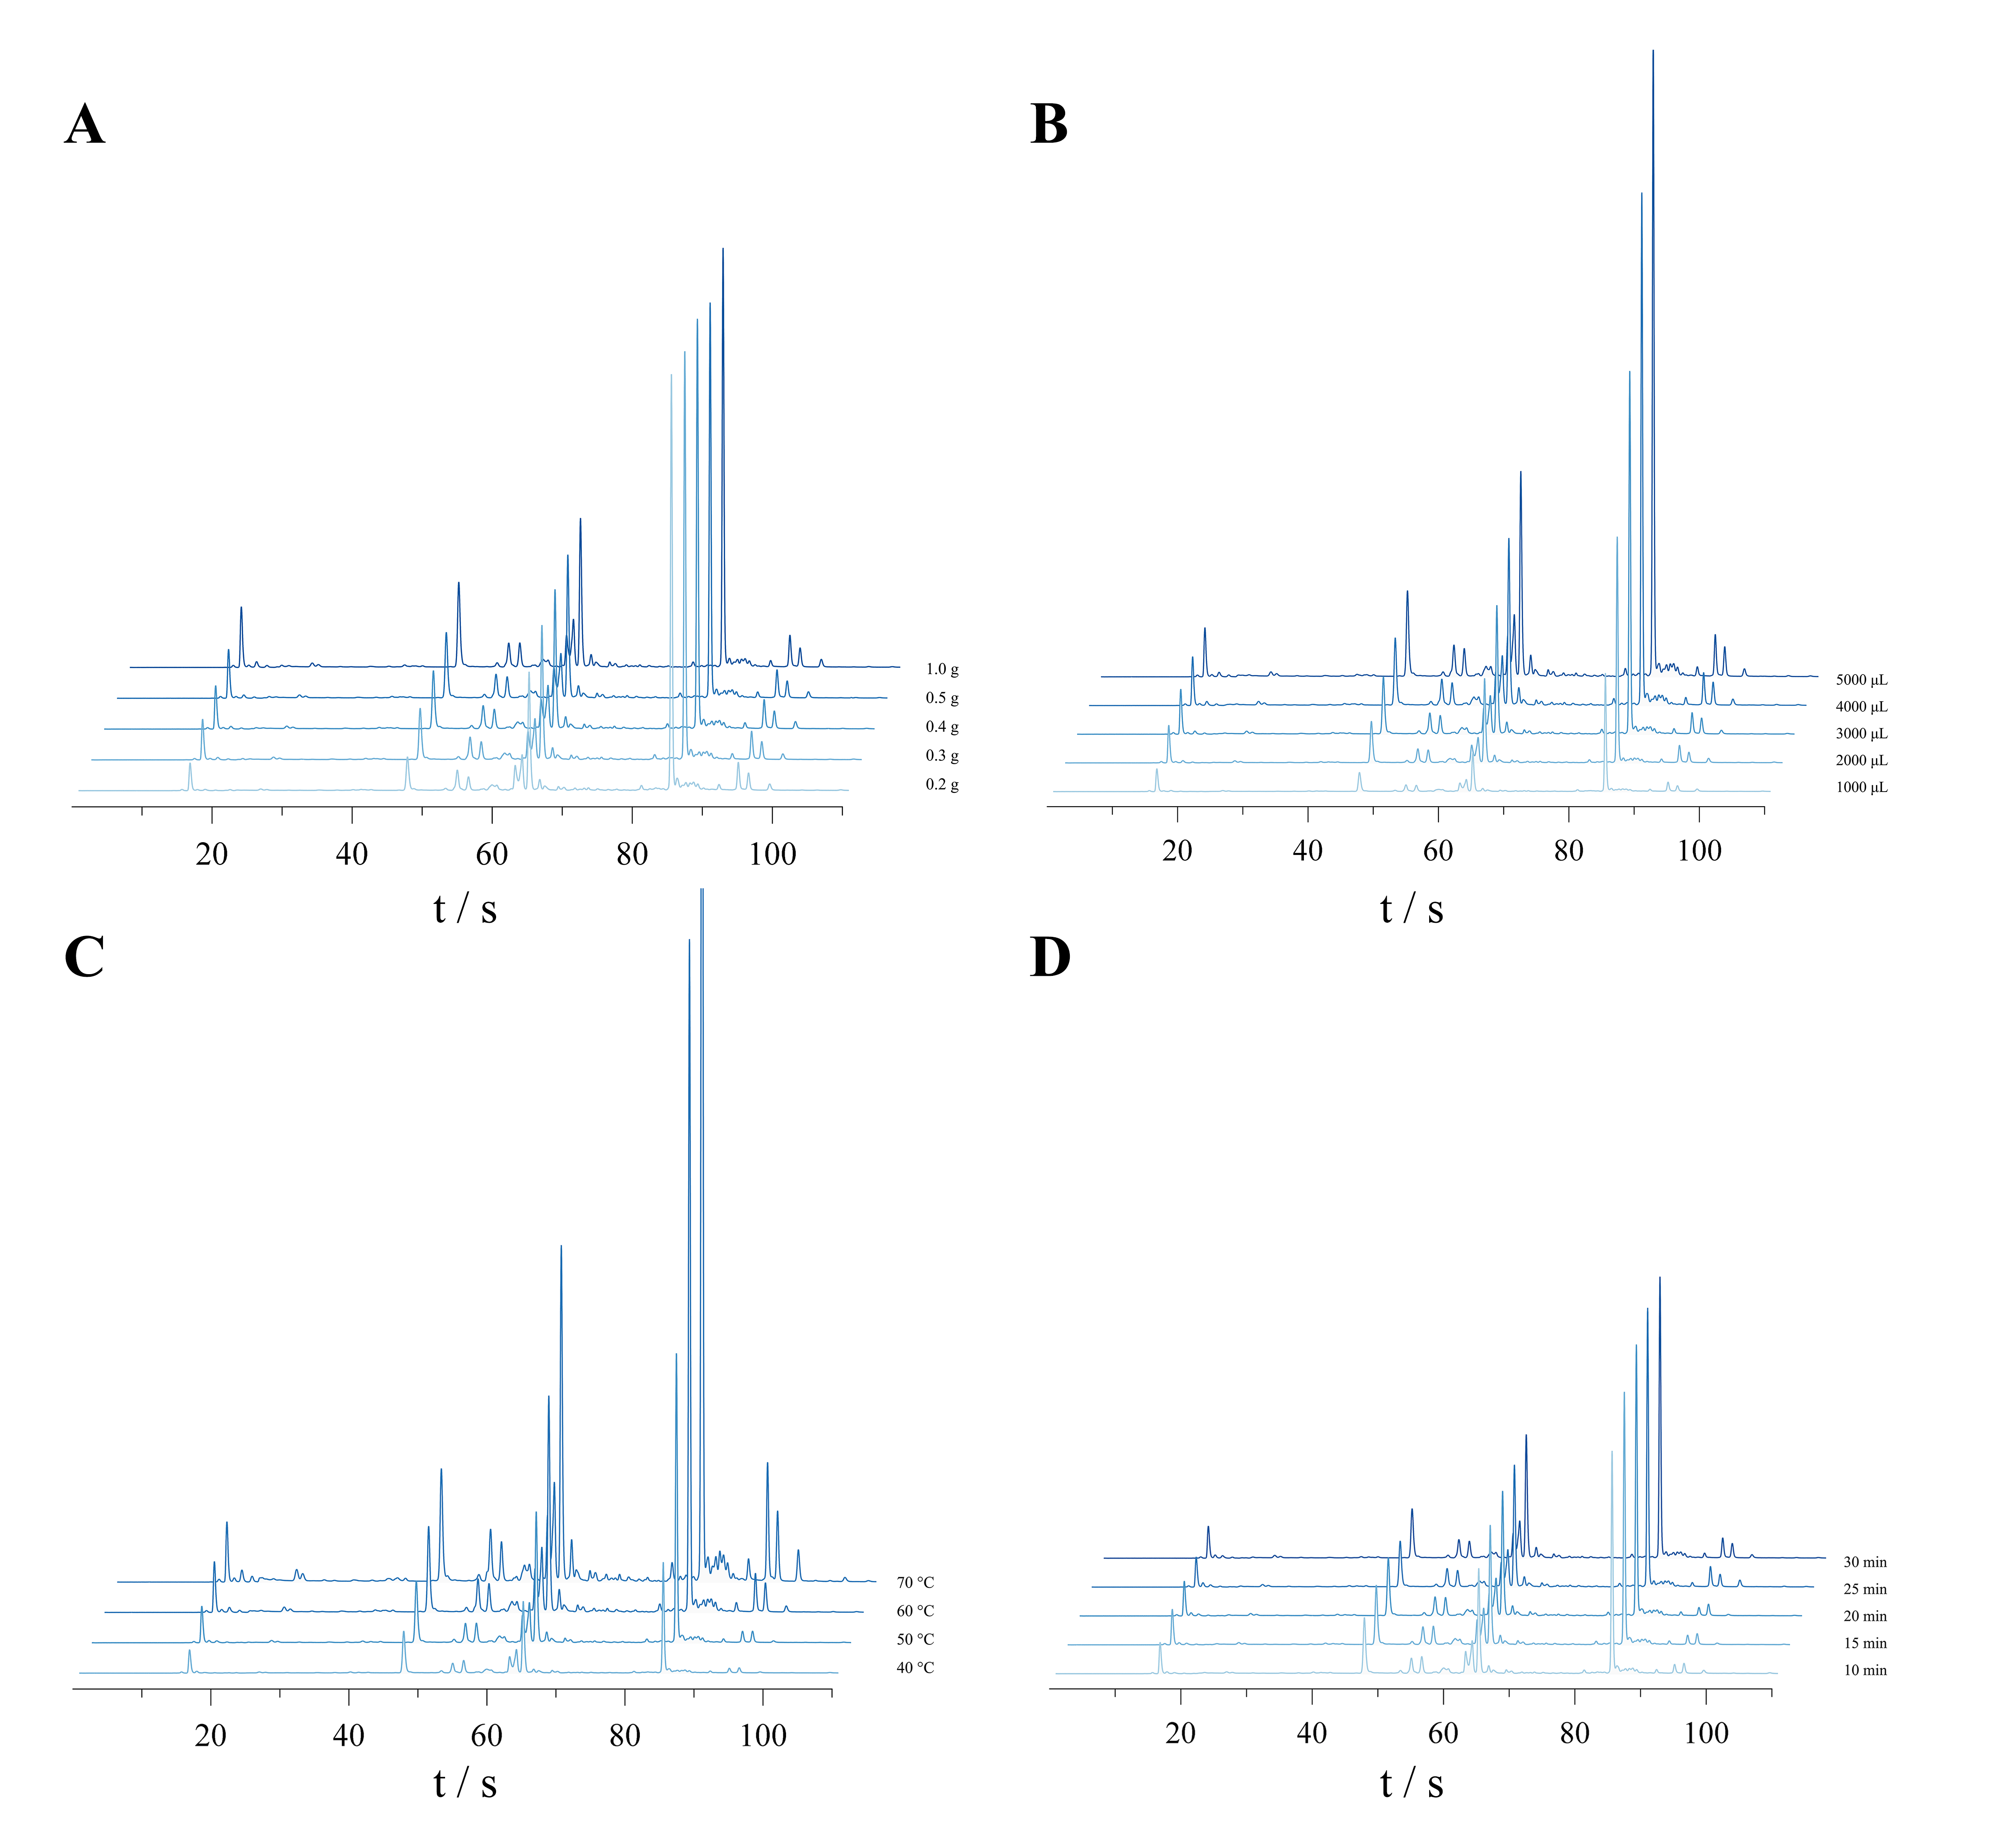
⁵ A: Chromatograms of Sample Quantity; B: Chromatograms of Injection Volume; C: Chromatograms of Incubation Temperature; D: Chromatograms of Incubation Time.

