Model figures 4, S2, S3, S5-S8, Movies S1-S3.
All these figures show several composite views (plan views and elevation views) of the adjusted source 3D models corresponding to different epochs. These figures have been elaborated using a Matlab code, developed ad hoc, which works reading the model files and drawn the figure corresponding to the distribution of cells of the adjusted 3D deformation source structure. For instance, the file “MD202200.txt” corresponds to epoch 2022.00 and contains the adjusted 3D model for the deformation source structure as it is obtained from the inversion software.
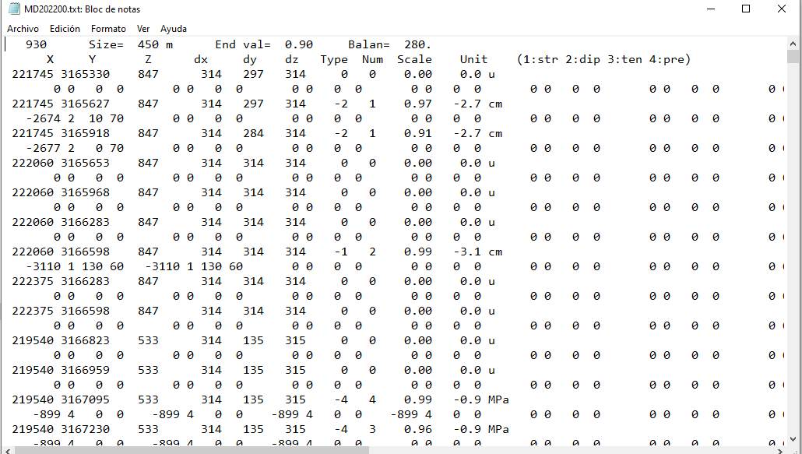
In this file, first line contains the number of aggregated cells (930 in this case) and other values for the SAR data inversion. Second line is a line of titles. Successive lines correspond to the prismatic cells that constitute the 3D model. Just two successive lines for each model.
For each cells, first line contains: cell center (UTM meters, X, Y, Z), lateral sides (meters, dx, dy, dz) of the prismatic cell, type (and sign) (“Type”) of the deformation source (1-strike, 2-dip, 3-tensile, 4-pressure), magnitude (“Num”) as times the unit value, a scale value (“Scale”) for internal use, and the unit value (“Unit”) (cm o MPa) used to represent the source strength for that source cell. La second line contains, for each cell, some internal values in the inversion approach.

Figure S2.
This composite figure shows the observed, modelled and residual values for the LOS components for an arbitrary epoch (07/08/2022). It has obtained from a data file that comes directly as output from the inversion approach: file “Fil.txt” showed in the attached figure. On it, the two initial lines correspond to titles. Then, next lines correspond to data pixels. For each line we have the following values: UTM coordinates X, Y, Z (meters), and observed, modelled and residual values for the LOS ascending and LOS descending rates(cm/yr). When the observed value is zero for the ascending component it means that there is not observed value for this component. And the same for the descending component. The file includes other values from the inversion approach.
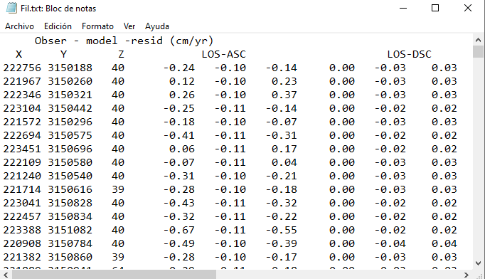

Model figure S8.
This composite figure corresponds to a schedule view of the evolution of the adjusted models for deformation sources. It represents the time-depth-strength evolution of the source elements +pressure, + dip slip, - strike slip and –dip slip. This figure has been elaborated using a simple Fortran code, developed ad hoc, which works reading the model files and drawn the figure corresponding to the time-depth-strength evolution. The data files are the successive adjusted model files obtained as output of the inversion approach: MD202095.txt, MD202100.txt, MD202105, …. These model files are provided.

