Supplementary File 1. SEHA Research Ethics Committee - SEHA Research Oversight Committee

Supplementary File 2. The Informed Consent
Informed Consent - موافقة على الاشتراك في بحث علمي
1. General Consent
I, the undersigned, hereby acknowledge with my approval of all medical procedures or counselling or other ones dedicated to my case of illness according to the doctor’s recommendations made by the treating doctor and put into action by other pharmacists, nurses and health care providers.

2. Financial Consent
The Establishment is permitted to send and collect invoices of diagnosis and/or treatment from the insurer for the services provided to me.
Please read and complete this acknowledgement carefully before you decide to participate in this evaluation study.
The purpose of this Acknowledgment is to inform patients who desirous of participating in this evaluation study and notify them of the study details and any cost (if present) related to diagnosis and/or treatment as stated for each case.

4. Disclosure of Medical Information
- I acknowledge that the relevant insurer, courts or official investigation bodies are fully permitted to see my medical file for the purposes of reviewing or making treating costs or as needed including having a photocopy of the file contents in full or in part.
- I undersigned hereby acknowledge my full consent to release to the below mentioned persons the medical information about my medical condition:
1-……………………………………………………………
2-…………………………………………………………
□ I refuse that anyone (relative or very close friends) receives verbal or copies of my medical record (electronic or manual) without my written consent.

3. Valuable Personal Items
I am aware that the facility or any of its employees shall not be liable for any damage and/or loss of any of my personal items.
- Medical Data for Clinical Research & Review:
I also permit and agree on using my medical information for purposes of clinical check, scientific surveys and review, if necessary, provided that my identity shall not be disclosed and privacy shall be respected.
- Legal Clause
A) I understand that I have the right to ask questions and I hereby certify that I have been given the opportunity to ask all my questions and that any such questions have been answered to my satisfaction.
- I understand that no guarantees, assurances, or promises have been made to me concerning the results of this study.
- I acknowledge that this Acknowledge may be fully used as a proof of accepting all what has been indicated herein together with paying any financial agreement.
- Unless prescribed here in above, the UAE applicable law shall be referred to upon signing this Acknowledge.
- By signing this form, I acknowledge that I have read it carefully or explained to me and that I understand its content and hereby voluntarily consent and approve to perform study procedures.
- The period of this consent is indefinite unless the undersigned requests a renewal.

الرجاء قراءة هذا الاقرار بعناية قبل الموافقة بالمشاركة في هذه الدراسة التقييمية:
الغرض من هذه الاقرار بالموافقة هو إبلاغ المرضى الذي لديهم رغبة في المشاركة في هذه الدراسة التقييمية عن تفاصيل الدراسة وإخطارهم بأي تكلفة تشخيصية او علاجية (ان وجدت) متصلة بهذه الدراسة.
1. موافقة عامة:
أقر انا الموقع ادناه بالموافقة على جميع الاجراءات الطبية أو الاستشارية أو غيرها من تلك المخصصة لحالتي المرضية وفقا لتوصيات الطبيب التي أدلى بها الطبيب المعالج ووضعها موضع التنفيذ من قبل أحد الصيادلة او الممرضات او أحد مقدمي الرعاية الصحية.
2. الموافقة المالية
يسمح للمؤسسة لإرسال وجمع الفواتير من التشخيص و / أو العلاج من شركة التأمين للخدمات المقدمة لي.
3. بنود المتعلقات الشخصية
أنا أدرك أن المنشأة الصحية أو أي من موظفيها غير مسؤولين عن أي تلف او فقدان لأي من المتعلقات الشخصية اثناء تواجدي فترة الدراسة.
4. الكشف عن المعلومات الطبية
أ) أنا أقر بأن شركة التأمين، أو المحاكم المختصة أو هيئات التحقيق الرسمية مسموح لها بالاطلاع على الملف الطبي الخاص بي لأغراض المراجعة أو لتكاليف العلاج أو حسب الحاجة بما في ذلك اخذ نسخة من محتويات الملف الخاص بي بالكامل أو جزئيا.
ب) أنا الموقع ادناه اقر بموافقتي الكاملة للإفراج عن المعلومات الطبية حول حالتي الطبية للأشخاص المذكورين أدناه:
- ..........................................................................
- ..........................................................................
□ أنا أرفض أن أي شخص (قريب أو الأصدقاء المقربين جدا) يتسلم نسخة من السجل الطبي الخاص بي (إلكترونيا أو ورقيا) بدون موافقة خطية مني.
5. البيانات الطبية للبحوث والمراجعة السريرية والبحثية:
كما أيضا أوافق على استخدام المعلومات الطبية لأغراض الاختبارات السريرية والبحوث العلمية إذا لزم الأمر شريطة أن هويتي او اي معلومات شخصية لا يتم الكشف عنها مع الاحترام الكامل لخصوصياتي.
6. بند قانوني
أ) أفهم وأدرك انه من حقي الاستفسار وطرح الأسئلة، وعليه أقر بموجبه انه قد اتيحت لي فرصة طرح جميع أسئلتي وأنه قد تمت الاجابة عنها وشرحت لي على نحو يرضيني
ب) أفهم وأدرك انني لم اعط أية ضمانات أو تأكيدات أو وعود بخصوص النتائج المتعلقة بهذه الإجراءات خلال هذه الدراسة التقييمية.
ت) أقر بأن هذا الاعتراف يمكن أن تستخدم كدليل على قبول كل ما أشير هنا إلى جانب دفع أي اتفاق مالي.
جـ) ما لم يذكر أعلاه، فان القانون المعمول به في دولة الأمارات يعد كمرجعية عند توقيع هذا الاعتراف.
د) بتوقيعي على هذه الاستمارة اقر انني قرأتها بعناية او قُرأت لي وانني افهم ما جاء فيها واوافق عليها طواعية والقيام بالإجراءات المذكورة من قبل فريق البحث.
هـ) فترة هذه الموافقة هي لأجل غير مسمى ما لم يوقع اسفله طلب للتجديد.

9. المشاركة الطوعية في الدراسة:
مشاركتكم في هذه الدراسة هو تطوعي تماما. وإذا اخترت عدم المشاركة في هذه الدراسة لن يكون له أي تأثير على خدمات الطبية أو الفوائد التي تحصلون عليها حاليا. كما لكم الحق في الرفض عن الإجابة عن أي من الأسئلة التي نطرحها عليكم ولكم الحق في انهاء المقابلة في أي وقت.
Who to contact if you have questions about the study or about your rights as a research participant in the study:
Marwan El-Deyarbi – Study Coordinator Pharmacist
Tel: +971-50-7936700
E-mail: med.counseling@gmail.com

10.Confidentiality: Your medical record information will be confidential, your name and information will not be published or accessed through other channels.

Your identity will be kept confidential to the extent provided by law. Your child information will be assigned a code number that is unique to this study. The list connecting the name to this number will be kept in a locked file in the clinic and only the study director and other researchers will be able to see the list or the interview you participated in. No one other than the study research team will be able to see your interview or even know whether you and your child participated in this study. When the study is completed and the data have been analysed, the list will be destroyed. Study findings will be presented only in summary form and your name will not be used in any report.

9. Voluntary participation:
Your participation in this study is completely voluntary. If you choose not to participate in this study, this will have no effect on the services or benefits you are currently receiving. You may refuse to answer any of the questions we ask you and you may stop or end the interview at any time.

10. السرية: أن المعلومات الطبية الخاصة بك سوف تكون سرية، ولن يتم نشر الاسم أو المعلومات الخاصة بك ولا يمكن الوصول إليها من خلال أي قنوات أخرى.

وستبقى هويتك سرية إلى الحد المنصوص عليه في القانون. سيتم تعيين المعلومات الخاصة بطفلك برمز برمجي خاص وهو فريد من نوعه لهذه الدراسة وستبقى قائمة ربط الاسم إلى هذا الرمز في ملف مؤمن بكلمات سرية في العيادة ولن يستطيع غير مدير الدراسة أو أحد الباحثين المسجلين قادرا على رؤية القائمة أو المقابلة التي شاركت فيه ولن يستطيع أحد معرفة ما إذا كان طفلك شارك في هذه الدراسة. عندما يتم الانتهاء من الدراسة وتحليل البيانات، سيتم تدمير هذه القائمة، وستعرض نتائج الدراسة فقط في شكل موجز ولن يتم استخدام اسمك في أي تقرير.

إذا كان لديك أسئلة عن الدراسة أو عن حقوقك كمشارك في الدراسة:
يرجى الاتصال بالصيدلي/ مروان محمد الدياربي
هاتف متحرك:
+971-50-7936700
ايميل:
med.counseling@gmail.com

7. Patient’s Rights Document
I am aware of my rights and responsibilities as a patient as posted in the clinic and explained by health care professionals.
8. Right to withdraw from the study:
You may choose to stop participating in the study at any time.

7. وثيقة حقوق المرضى
إنني أدرك حقوقي ومسؤولياتي كمريض كما هو موضح في العيادة وتم شرحه لي من العاملين في مجال الرعاية الصحية.

8. الحق في الانسحاب من الدراسة:
يمكنك اختيار التوقف عن المشاركة في الدراسة في أي وقت.

7. وثيقة حقوق المرضى
إنني أدرك حقوقي ومسؤولياتي كمريض كما هو موضح في العيادة وتم شرحه لي من العاملين في مجال الرعاية الصحية.

8. Right to withdraw from the study:
You may choose to stop participating in the study at any time.

Other Notes: …………………………………………………………………………………ملاحظات أخرى:

YOU WILL BE GIVEN A COPY OF THIS
سوف تحصل على نسخة من هذا الاقرار عند الموافقة في الاشتراك في الدراسة
FORM WHETHER OR NOT YOU AGREE
TO PARTICIPATE.
عند الموافقة للاشتراك في الدراسة يرجى التوقيع ادناه
If you agree to participate in this study, please sign on.
اقرار:
بتوقيعي على هذه الاستمارة اقر انني قرأت الدراسة بعناية،
وأوافق طواعية بالمشاركة فيها والقيام بالإجراءات المذكورة فيه،
وأنني استلمت نسخة من هذا الاقرار.

Acknowledge:
I have read the study procedure described above.
I voluntarily agree to participate in the study, and
I have received a copy of this Acknowledge
Patient’s name: _______________________________________________________________ اسم المريض:
Patient’s signature: _______________________________________________________________ توقيع المريض:
Mobile Number: ___________________________________________________________رقم الهاتف المتحرك:
File Number: ___________________________ Best day/time for calling: ____________________________
Principal Investigator: ___________________________________ Date: ____________________________
CODE #......................

Supplementary File 3. Participant information sheet (English)
The effects of multifactorial pharmacist-led intervention protocol on medication optimisation and adherence among patients with type 2 diabetes: A randomised control trial.
We would like to invite you to take part in our research study. Before you decide, it is important that you understand why the research is being done and what it would involve for you. Please take time to read this information and discuss it with others if you wish. If there is anything that is not clear, or if you would like more information, please ask us.

Who is organizing and funding the study?
- AHS, SEHA is sponsoring and funding this medical research, and all research members follow the AHS and SEHA clinical practice guidelines.
- AHS research ethics committee in SEHA, has reviewed and approved this study, and given favourable opinion that this study may reduce diabetic burden, medication cost in UAE and improve patient satisfaction by reducing or delaying microvascular complication and the progression of diabetic kidney disease in diabetic patients
What is the purpose of the study?
The study will measure your adherence to your medication, diet and lifestyle modification and their effects on your diabetes.

Why have I been invited?
- You have invited in this study because you are diabetic and may have low adherence to your medication.
- As well, diabetic patients attending the endocrine and CDC clinics in Oud Al Touba clinic and sharing the characteristics will be also involved.

Do I have to take part?
- The answer is ‘No’: It should be clear that taking part is entirely voluntary.
- Participant can withdraw if he/she later changes his/her mind, without giving a reason.
- Withdrawal will not affect clinical care (if participants are patients).

What are the possible benefits of taking part?
- You will receive additional comprehensive monitoring and counselling sessions in addition to, the routine recommended medical care.
- During the study you will receive a thorough counselling regarding prescribed medications and devices. A counselling hotline will be provided to you during and after the study for patient follow up.
- However, you should be aware that we do not know what are the short- or long-term outcome advantages will be, and therefore we are conducting the research.
What will happen to me if I decide to take part?
- You will attend your normal appointments with your physician every 3 months, with additional visits to our nutrition consultant for diet and exercise education every 3 months, and we will follow-up your improvement for one year.
- You may receive additional nutritional and medication counselling if you joined the intervention group, or you may receive the normal clinical care if you have been allocated to the control group.
- Your physician may ask you to make more frequent laboratory tests every 3 months. The blood sample collected will be in our standard labs and they will follow the same usual procedure.
- Our physician, dietitian and pharmacist will follow-up your condition for one year and they will provide long-term monitoring to your results and adherence during the study period.
- Your physician may prescribe additional medication according to your condition or blood sugar level, when needed.
What should I consider?
- You cannot participate in the study if you have blood, kidney or cardiac problems. Also, pregnant or nursing women are excluded from the study.
- If any participating women get pregnant, they should inform the research team as they may stop participating in the study.
- You can continue to take your regular chronic medication or other prescribed or over-the-counter medicines; but you should adhere to the dietitian and pharmacist recommendations
- You can participate in our study even if you are involved in other research studies.
Are there any possible disadvantages or risks from taking part?
Procedures:
- Frequent laboratory testing every three months may cause some usual problems when blood samples are drawn from a vein in patient’s arm, during the routinely laboratory blood sample collection. Some of these problems are pain, bruising, bleeding, feeling dizzy and in rare cases infection.
- Per- and post- nutritional assessment interviews and/or the adherence questionnaires may cause some distress: questions such as how much potassium do, we need almost daily? and on how many of the last seven days did you take your nutritional supplements as prescribed by the doctor? will be asked, and you have the right to stop or postpone the interview if you become upset at any time.
Will my taking part in the study be kept confidential?
- Protected Health Information (PHI) will be recorded electronically. The electronic coding log sheet with any results will be stored and saved securely with the principal investigator only in a PC inside the clinic.
- No one other than the study research team have access to data, during the study period only (one year), however, responsible members of the AHS ethics committee may be given access to data for monitoring and/or audit of the study to ensure that the research is complying with applicable regulations.
- The electronic coding log sheet and data table will be saved on the computer inside the clinic, which has limited access to authorized personnel only. The computer is password protected and so the sheets are password protected for opening. After submitting the results to AHS, SEHA, the data related to patients’ codes will be permanently deleted.
- Your identity will be kept confidential to the extent provided by law. Your information will be assigned a code number that is unique to this study. The list connecting the name to this number will be kept in a locked file in the clinic and only the study director and other researchers will be able to see the list or the interview you participated in. No one other than the study research team will be able to see your interview or even know whether you have participated in this study or not. When the study is completed and the data have been analysed, the list will be destroyed. Study findings will be presented only in summary form and your name will not be used in any report. There is a related mandatory point on the consent form.
Will I be reimbursed for taking part?
- Although you will not be compensated for your extra time during the interviews, inconvenience may result from taking extra medications or for having blood test every three months, but your will receive a thorough counselling regarding prescribed medications and devices and a counselling hotline will be provided to you during and after the study for patient follow up.
- Your insurance accompany (Thiqa) will cover all your expenses such as regular clinical appointments, laboratory tests and counselling sessions.
What will happen to the samples I give?
- Your blood sample test that will be requested during the research will follow the same routinely laboratory blood sample collection procedure and all blood samples will be sent to SEHA central laboratory, and the results will be saved in your medical record.
What will happen if I do not want to carry on with the study?
- You may choose to stop participating in the study at any time without any penalty or reduction in the usual clinical services provided. The study reserve patient's right to refuse any medical procedure, counselling or to answer any of the adherence related questions and may stop or end the interview at any time, without any effect on the services or medical benefits he is currently receiving.
- If you withdraw from the study, we will destroy all your identifiable data, but will use the data collected up to your withdrawal. You are free to request that your blood tests or adherence data not used at any time during or after the study.
What will happen to my data?
- We will be using information from your medical record in order to undertake this study. Research is a task that we perform in the medical interest. Oud Al Touba Clinic, as sponsor, is the data controller. This means that we, as Oud Al Touba Clinic researchers, are responsible for looking after your information and using it properly. We will use the minimum personally identifiable information possible. We will not keep identifiable information about you after the study has finished. We will store the anonymized research data and any research documents with personal information, such as consent forms, securely at the Oud Al Touba Clinic during the study.
- After submitting, the results to Oud Al Touba Clinic manger and AHS ethics committee, SEHA, any data or related patient’s codes will be permanently deleted.
- Your rights to access, change, or move your personal information may be limited, as we need to manage your information in specific ways in order for the research to be reliable and accurate.
- Further information about your rights with respect to your personal data and how we use your information you can contact the principal investigator.
What will happen to the results of this study or when the study ends?
- The results of the study will be communicated to Oud Al Touba clinic manager and AHS ethics committee. Results of the study will be sent to AHS, SEHA for review and approval for publication or presenting you are the finding at conferences.
- At the end of the study, you may request feeding back about your findings from your physician or the principal investigator to participants themselves, and other information on how we are presenting them.
What if we find something unexpected?
- In case of clinical significance abnormal laboratory results such as sever hypokalaemia or hypomagnesaemia or having sever adherence problem, you will be referred directly to proper management pathway by our physician, which may require referral to other specialty doctor or other hospital to resolve these incidental findings. This will typically move you out of our study to ensure that you will receive the most proper clinical care required.
What if there is a problem?
- If you wish to complain, or have any concerns about any aspect of the way you have been approached or treated during the course of this study, you should contact Mr. Marwan El-Deyarbi (Principle investigator) on phone number: 0506634066 or email: med.counseling@gmail.com
Participation in future research:
- You may be contacted about ethically approved research studies for which you may be suitable. You should also understand that agreeing to be contacted does not oblige you to participate in any further studies. Your contact details would be held separately from this study in a password protected computer in Oud Al Touba Clinic
Further information and contact details:
Please contact Mr. Marwan El-Deyarbi (Principal investigator) on phone number: 0507936700 or by email: med.counseling@gmail.com

Thank you for reading this information, and for considering taking part.

Supplementary File 4. Medication adherence questionnaire

Are there any factors affecting your medication adherence? ما هي العوامل او الأسباب التي قد تؤثر سلباً على التزامك بالأدوية الموصوفة؟
___________________________________________________________________________________________________________________________________________________________________________________________________________________________________________________________________________________________________________________________

Supplementary File 5. Fixed total medication possession ratio (MPRt) calculation.

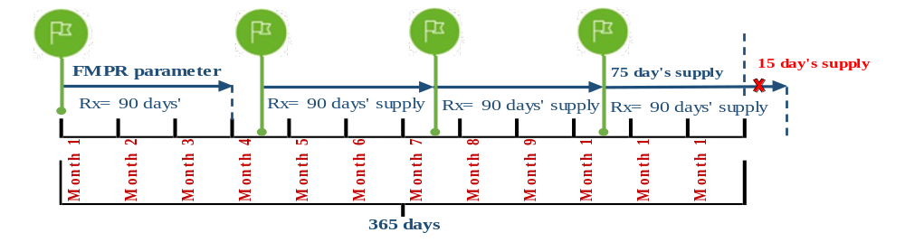
$\text{MPRt }\text{=}$

For the above example, if the patient had a medication supply equal to 345 days (90 days + 75 days) during the fixed follow-up period of 365 days, the MPRt was calculated as 345/365 = 0.95.

Supplementary File 6. Patient’s Medication Booklet.

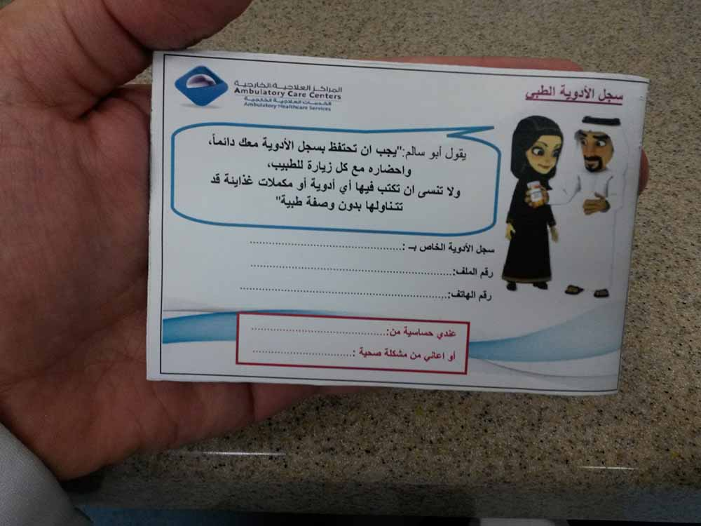
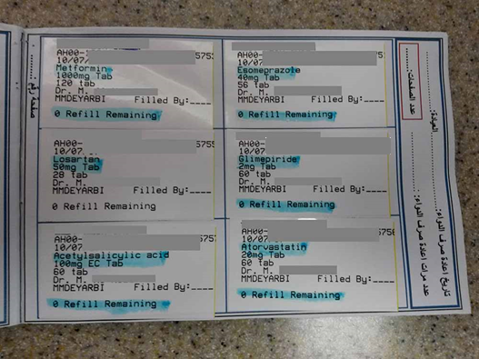

Supplementary File 7. SEHA mobile and booklet use questionnaire.

