Supplementary material
Table A1. : Abbreviations and vegetation type correspondences.
Vegetation number | Abbreviation vegetation | Type of vegetation | Type of area
1 | 000Magua | Continental water | /
18 | Ag+Pahs | Agropastoralism + Pioneer formation with fluvial and/or lacustrine herbaceous influence without palm trees | Dominant Anthropic Area
25 | Ag+Vss+Db | Agropastoralism + Secondary vegetation without palm trees + Lowlands | Dominant Anthropic Area
29 | Ag+Vss+Pa.D | Agropastoralism + Secondary vegetation without palm trees + Vegetation with a dense fluvial and/or lacustrine influence | Dominant Anthropic Area
60 | Ap+Pa+Vss.F | Cattle (grazing) + Vegetation with fluvial and/or lacustrine influence + Secondary vegetation without palm trees + Seasonal semi-deciduous forest | Dominant Anthropic Area
76 | Ap+Vss+Db | Cattle (pasture) + Secondary vegetation without palms + Lowlands | Dominant Anthropic Area
78 | Ap+Vss+Ds | Cattle (grazing) + Secondary vegetation without palms + Dense submontane rainforest | Dominant Anthropic Area
79 | Ap+Vss+Fb | Livestock (grazing) + Secondary vegetation without palms + Seasonal semi-deciduous lowland forest | Dominant Anthropic Area
91 | Da+Vss | Dense alluvial rainforest + Secondary vegetation without palms | Dominant Natural Vegetation
92 | Db+Vss | Lowland + Secondary vegetation without palms | Dominant Natural Vegetation
94 | Db+Vss+Ap | Lowlands + Secondary vegetation without palms + Livestock (grazing) | Dominant Natural Vegetation
105 | Dm+Vss | Dense rainforest + secondary vegetation without palms | Dominant Natural Vegetation
106 | Dm+Vss+Ar | Dense rainforest + secondary vegetation without palms + rocky outcrops | Dominant Natural Vegetation
113 | Ds+Vss | Dense submontane rainforest + Secondary vegetation without palms | Dominant Natural Vegetation
119 | Fb+Vss | Seasonal lowland semi-deciduous forest + Secondary vegetation without palms | Dominant Natural Vegetation
121 | Iu.D | Urban influence. Densa rainforest | Dominant Anthropic Area
124 | Iu.P | Urban influence + Palm trees | Dominant Anthropic Area
175 | Pahs+Iu | No palm trees + Urban influence | Dominant Anthropic Area
180 | Pfm | Pioneer formation with fluvial influence - arboricultural | Dominant Natural Vegetation
186 | Pma | Pioneer formation with marine arboreal influence | Dominant Natural Vegetation
247 | Vss+Da | Secondary vegetation without palms + Dense alluvial rainforest | Dominant Anthropic Area
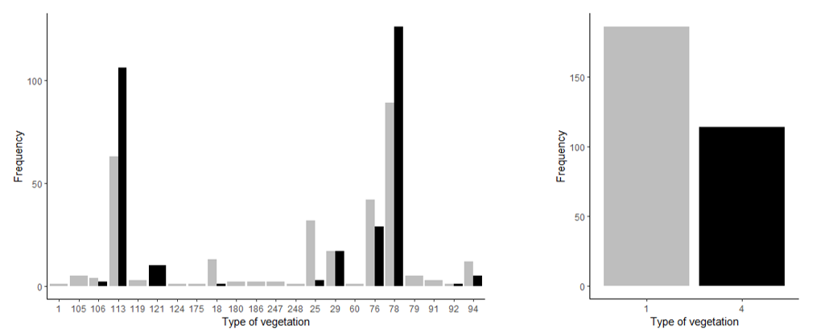
B plot_anth <- ggplot(presence_anth, aes(x = presence, fill = presence)) +
geom_bar(position = ‘dodge’) +
scale_fill_manual(values = c(‘lightgreen’, ‘darkgreen’),
labels = c(‘Dominant anthropic area’, ‘Dominant natural vegetation’)) +
labs(x = ‘Type of vegetation’, y = ‘Frequency’) +
ggtitle("Distribution of marmosets according to vegetation type: anthropic or natural") +
theme_classic() +
guides(fill = guide_legend(title = NULL)) + # Supprimer le titre de la légende
theme(legend.position = ‘right’) # Positionner la légende en dessous

plot_anth
A

Fig.A1: Histograms showing the presence (black) or absence (grey) of marmosets as a function of vegetation type (A), and the origin of the vegetation occupied (B) : dominant anthropic area (grey) or dominant natural vegetation (black) .

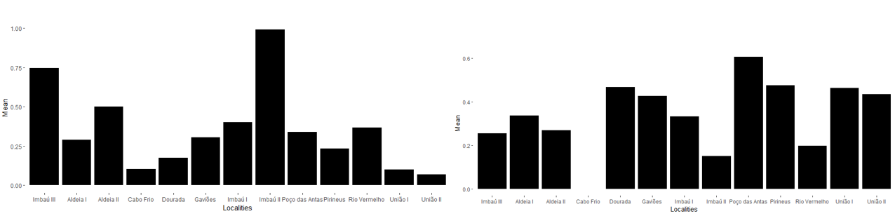
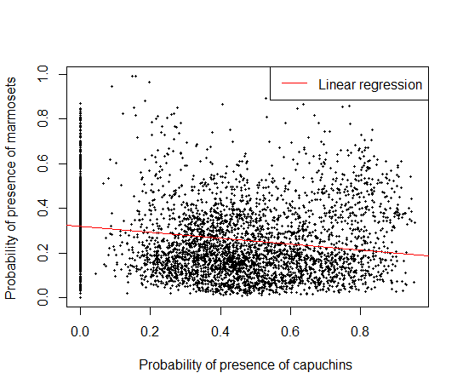
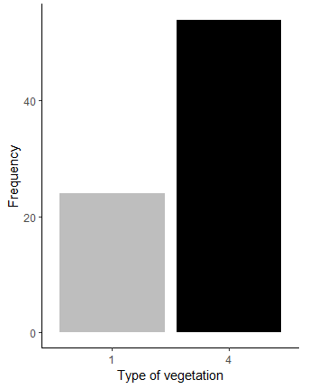
Fig.A4: Means of probabilities of presence of marmosets (A) and capuchins (B) in each forest fragment.
A
B
Fig.A3: Graph of correlations between the probabilities of presence of marmosets and capuchins at each pixel
Fig.A2: Histograms illustrating the presence of the capuchin monkey according to vegetation type: area with dominant anthropogenic influence (1) or area with dominant natural vegetation (4).

